[Institute / University Name]
Department of [Computer Science and Engineering]

Bookstore Inventory and Online Sales Management System
Database Management Systems (DBMS) – Project Report
Submitted by | [Student Name 1] – [Roll No.][Student Name 2] – [Roll No.][Student Name 3] – [Roll No.]
Course | Database Management Systems ([Course Code])
Faculty | [Faculty Name]
Academic Year | [2026 – 2027]

Table of Contents
- Abstract
- Introduction and Problem Statement
- Objectives and Scope
- Software and Hardware Requirements
- ER Diagram
- Relational Schema and Normalization
- Data Dictionary
- SQL Commands Used (DDL, DML) with Sample Outputs
- Queries with Outputs
- UI Design and Screenshots
- Implementation Details
- Testing
- Conclusion and Future Enhancements
- References
- Contribution of Each Member
- Appendix: GitHub Repository Link

1. Abstract
Small bookstores often track inventory and sales manually or in disconnected spreadsheets, which makes stock tracking, order handling and record retrieval slow and error-prone. This project presents a Bookstore Inventory and Online Sales Management System that keeps all of this data in one relational database.
The database is implemented in MySQL 8 with six normalized tables (categories, authors, books, customers, orders and order items). Primary keys, foreign keys, unique, check and not-null constraints enforce integrity. Triggers reduce stock automatically when an order line is inserted and block overselling. Indexes and views support fast retrieval. A Node.js + Express server with the mysql2 driver exposes a REST API, and a browser-based interface built with HTML, CSS and JavaScript lets staff manage books, authors, categories and customers and place and track online orders.
The report documents the design (ER diagram, relational schema, normalization, data dictionary), the SQL used, sample queries with outputs, the user interface, the implementation and the tests performed.
Keywords: DBMS, MySQL, inventory management, online orders, triggers, Node.js, Express.

2. Introduction and Problem Statement

2.1 Background
A bookstore must know at every moment which titles it has, how many copies are in stock, who ordered what, and how much has been sold. When this information lives in notebooks or separate files, it is easy to lose track of stock, sell a book that is no longer available, or spend a long time finding a record.

2.2 Problem statement
Small bookstores may keep inventory and sales records manually or in disconnected systems. This makes stock tracking, order management and record retrieval difficult.

2.3 Proposed solution
A centralized database-driven application in which:
- the inventory, authors, categories, customers and orders are stored in related tables;
- online orders are placed through a web interface;
- stock is reduced automatically by the database whenever a sale is recorded;
- records can be searched and retrieved quickly with SQL queries, indexes and views.

3. Objectives and Scope

3.1 Objectives
- Maintain a centralized bookstore inventory.
- Store customer, author and category data.
- Manage online orders.
- Automatically reduce stock after sales.
- Provide fast database-based retrieval.
- Maintain integrity with primary keys, foreign keys and constraints.

3.2 Intended users
User | Use of the system
Bookstore administrator | Maintains books, authors, categories; reviews dashboard and revenue
Store staff | Adds and updates stock, looks up books
Online customers / orders management staff | Place orders; track and update order status

3.3 Scope
In scope: book inventory, customers, authors, categories, orders and order items, with a web interface for these.
Out of scope (see future enhancements): payment gateway, user login and roles, shipping integration, returns and refunds, purchase orders from suppliers.

4. Software and Hardware Requirements

4.1 Software
Component | Details
Database | MySQL 8.x (MySQL Workbench used for design and verification)
Back end | Node.js (LTS), Express 4, mysql2 3, dotenv, cors
Front end | HTML5, CSS3, JavaScript (no framework)
Browser | Any current browser (Chrome, Edge, Firefox, Safari)
Operating system | Windows, macOS or Linux (developed and tested on macOS)

4.2 Hardware (minimum)
Component | Requirement
Processor | Dual-core, 2 GHz
Memory | 4 GB RAM
Storage | 1 GB free disk space
Network | Not needed for local use; LAN or internet for multi-user access

5. ER Diagram
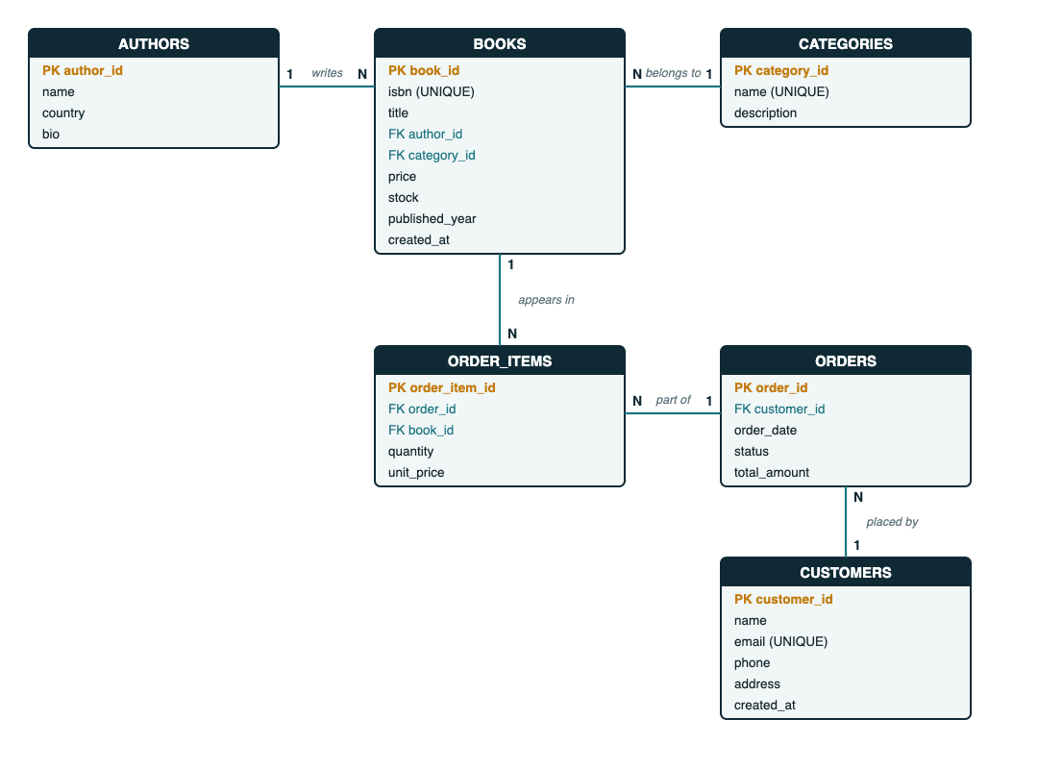
Entity-Relationship diagram of the Bookstore database

5.1 Entities
CATEGORIES, AUTHORS, BOOKS, CUSTOMERS, ORDERS, ORDER_ITEMS.

5.2 Relationships
Relationship | Cardinality | Implemented by
Author writes Book | One author, many books (1 : N) | books.author_id → authors.author_id
Category contains Book | One category, many books (1 : N) | books.category_id → categories.category_id
Customer places Order | One customer, many orders (1 : N) | orders.customer_id → customers.customer_id
Order has Order item | One order, many items (1 : N) | order_items.order_id → orders.order_id
Book appears in Order item | One book, many items (1 : N) | order_items.book_id → books.book_id
ORDERS and BOOKS have a many-to-many relationship, resolved by the associative entity ORDER_ITEMS (which also stores quantity and unit_price).

6. Relational Schema and Normalization

6.1 Relational schema
Primary keys are underlined in the usual notation and shown here in bold; foreign keys are marked with FK.
- categories (category_id, name, description)
- authors (author_id, name, country, bio)
- books (book_id, isbn, title, author_id FK, category_id FK, price, stock, published_year, created_at)
- customers (customer_id, name, email, phone, address, created_at)
- orders (order_id, customer_id FK, order_date, status, total_amount)
- order_items (order_item_id, order_id FK, book_id FK, quantity, unit_price)

6.2 Normalization
First Normal Form (1NF). Every attribute holds a single atomic value and every table has a primary key. A book has exactly one author and one category column; an order’s several books are stored as separate rows in order_items instead of a repeating group.
Second Normal Form (2NF). All tables use a single-column surrogate primary key, so no non-key attribute can depend on part of a key. For order_items, quantity and unit_price depend on the whole order line. A unique key on (order_id, book_id) prevents the same book appearing twice in one order.
Third Normal Form (3NF). There are no transitive dependencies:
- author details (country, bio) are in authors, not repeated in books;
- category description is in categories;
- customer details are in customers, not repeated in each order.
Deliberate denormalization. Two attributes store data that could be recomputed, for good reasons:
- order_items.unit_price keeps the price at the time of sale. If the book’s price changes later, old orders must not change.
- orders.total_amount stores the order total so that order lists do not need to sum the items every time. It is calculated once, inside the same transaction that inserts the items.

7. Data Dictionary

7.1 categories
Column | Data type | Constraints | Description
category_id | INT | PRIMARY KEY, AUTO_INCREMENT | Category identifier
name | VARCHAR(80) | NOT NULL, UNIQUE | Category name
description | VARCHAR(255) | NULL | Short description

7.2 authors
Column | Data type | Constraints | Description
author_id | INT | PRIMARY KEY, AUTO_INCREMENT | Author identifier
name | VARCHAR(120) | NOT NULL, UNIQUE | Author name
country | VARCHAR(80) | NULL | Country
bio | VARCHAR(500) | NULL | Short biography

7.3 books
Column | Data type | Constraints | Description
book_id | INT | PRIMARY KEY, AUTO_INCREMENT | Book identifier
isbn | VARCHAR(20) | NOT NULL, UNIQUE | ISBN
title | VARCHAR(200) | NOT NULL, INDEX | Title
author_id | INT | NOT NULL, FK → authors, ON DELETE RESTRICT, ON UPDATE CASCADE | Author
category_id | INT | NOT NULL, FK → categories, ON DELETE RESTRICT, ON UPDATE CASCADE | Category
price | DECIMAL(10,2) | NOT NULL, CHECK (price >= 0) | Selling price
stock | INT | NOT NULL, DEFAULT 0, CHECK (stock >= 0) | Copies in stock
published_year | SMALLINT | NULL | Year of publication
created_at | TIMESTAMP | NOT NULL, DEFAULT CURRENT_TIMESTAMP | Record creation time

7.4 customers
Column | Data type | Constraints | Description
customer_id | INT | PRIMARY KEY, AUTO_INCREMENT | Customer identifier
name | VARCHAR(120) | NOT NULL | Customer name
email | VARCHAR(120) | NOT NULL, UNIQUE | Email address
phone | VARCHAR(20) | NULL | Phone number
address | VARCHAR(255) | NULL | Delivery address
created_at | TIMESTAMP | NOT NULL, DEFAULT CURRENT_TIMESTAMP | Registration time

7.5 orders
Column | Data type | Constraints | Description
order_id | INT | PRIMARY KEY, AUTO_INCREMENT | Order identifier
customer_id | INT | NOT NULL, FK → customers, ON DELETE RESTRICT, ON UPDATE CASCADE | Customer
order_date | TIMESTAMP | NOT NULL, DEFAULT CURRENT_TIMESTAMP, INDEX | Date and time of order
status | ENUM | NOT NULL, DEFAULT ‘PLACED’ (PLACED, SHIPPED, DELIVERED, CANCELLED) | Order status
total_amount | DECIMAL(12,2) | NOT NULL, DEFAULT 0, CHECK (total_amount >= 0) | Order total

7.6 order_items
Column | Data type | Constraints | Description
order_item_id | INT | PRIMARY KEY, AUTO_INCREMENT | Line identifier
order_id | INT | NOT NULL, FK → orders, ON DELETE CASCADE, ON UPDATE CASCADE | Order
book_id | INT | NOT NULL, FK → books, ON DELETE RESTRICT, ON UPDATE CASCADE | Book
quantity | INT | NOT NULL, CHECK (quantity > 0) | Copies ordered
unit_price | DECIMAL(10,2) | NOT NULL, CHECK (unit_price >= 0) | Price per copy at time of sale
UNIQUE (order_id, book_id) prevents duplicate lines in one order.

7.7 Table structures as shown by MySQL (DESCRIBE)
mysql> DESCRIBE categories;
+-------------+--------------+------+-----+---------+----------------+
| Field | Type | Null | Key | Default | Extra |
+-------------+--------------+------+-----+---------+----------------+
| category_id | int | NO | PRI | NULL | auto_increment |
| name | varchar(80) | NO | UNI | NULL | |
| description | varchar(255) | YES | | NULL | |
+-------------+--------------+------+-----+---------+----------------+
mysql> DESCRIBE authors;
+-----------+--------------+------+-----+---------+----------------+
| Field | Type | Null | Key | Default | Extra |
+-----------+--------------+------+-----+---------+----------------+
| author_id | int | NO | PRI | NULL | auto_increment |
| name | varchar(120) | NO | UNI | NULL | |
| country | varchar(80) | YES | | NULL | |
| bio | varchar(500) | YES | | NULL | |
+-----------+--------------+------+-----+---------+----------------+
mysql> DESCRIBE books;
+----------------+---------------+------+-----+-------------------+-------------------+
| Field | Type | Null | Key | Default | Extra |
+----------------+---------------+------+-----+-------------------+-------------------+
| book_id | int | NO | PRI | NULL | auto_increment |
| isbn | varchar(20) | NO | UNI | NULL | |
| title | varchar(200) | NO | MUL | NULL | |
| author_id | int | NO | MUL | NULL | |
| category_id | int | NO | MUL | NULL | |
| price | decimal(10,2) | NO | | NULL | |
| stock | int | NO | | 0 | |
| published_year | smallint | YES | | NULL | |
| created_at | timestamp | NO | | CURRENT_TIMESTAMP | DEFAULT_GENERATED |
+----------------+---------------+------+-----+-------------------+-------------------+
mysql> DESCRIBE customers;
+-------------+--------------+------+-----+-------------------+-------------------+
| Field | Type | Null | Key | Default | Extra |
+-------------+--------------+------+-----+-------------------+-------------------+
| customer_id | int | NO | PRI | NULL | auto_increment |
| name | varchar(120) | NO | | NULL | |
| email | varchar(120) | NO | UNI | NULL | |
| phone | varchar(20) | YES | | NULL | |
| address | varchar(255) | YES | | NULL | |
| created_at | timestamp | NO | | CURRENT_TIMESTAMP | DEFAULT_GENERATED |
+-------------+--------------+------+-----+-------------------+-------------------+
mysql> DESCRIBE orders;
+--------------+--------------------------------------------------+------+-----+-------------------+-------------------+
| Field | Type | Null | Key | Default | Extra |
+--------------+--------------------------------------------------+------+-----+-------------------+-------------------+
| order_id | int | NO | PRI | NULL | auto_increment |
| customer_id | int | NO | MUL | NULL | |
| order_date | timestamp | NO | MUL | CURRENT_TIMESTAMP | DEFAULT_GENERATED |
| status | enum('PLACED','SHIPPED','DELIVERED','CANCELLED') | NO | | PLACED | |
| total_amount | decimal(12,2) | NO | | 0.00 | |
+--------------+--------------------------------------------------+------+-----+-------------------+-------------------+
mysql> DESCRIBE order_items;
+---------------+---------------+------+-----+---------+----------------+
| Field | Type | Null | Key | Default | Extra |
+---------------+---------------+------+-----+---------+----------------+
| order_item_id | int | NO | PRI | NULL | auto_increment |
| order_id | int | NO | MUL | NULL | |
| book_id | int | NO | MUL | NULL | |
| quantity | int | NO | | NULL | |
| unit_price | decimal(10,2) | NO | | NULL | |
+---------------+---------------+------+-----+---------+----------------+

8. SQL Commands Used (DDL, DML) with Sample Outputs
The complete script is in database/schema.sql.

8.1 DDL – database and tables
CREATE DATABASE bookstore_db CHARACTER SET utf8mb4 COLLATE utf8mb4_unicode_ci;
USE bookstore_db;
CREATE TABLE categories (
category_id INT AUTO_INCREMENT PRIMARY KEY,
name VARCHAR(80) NOT NULL UNIQUE,
description VARCHAR(255)
) ENGINE=InnoDB;
CREATE TABLE authors (
author_id INT AUTO_INCREMENT PRIMARY KEY,
name VARCHAR(120) NOT NULL,
country VARCHAR(80),
bio VARCHAR(500),
UNIQUE KEY uq_author_name (name)
) ENGINE=InnoDB;
CREATE TABLE books (
book_id INT AUTO_INCREMENT PRIMARY KEY,
isbn VARCHAR(20) NOT NULL UNIQUE,
title VARCHAR(200) NOT NULL,
author_id INT NOT NULL,
category_id INT NOT NULL,
price DECIMAL(10,2) NOT NULL,
stock INT NOT NULL DEFAULT 0,
published_year SMALLINT,
created_at TIMESTAMP NOT NULL DEFAULT CURRENT_TIMESTAMP,
CONSTRAINT chk_book_price CHECK (price >= 0),
CONSTRAINT chk_book_stock CHECK (stock >= 0),
CONSTRAINT fk_book_author FOREIGN KEY (author_id) REFERENCES authors(author_id)
ON UPDATE CASCADE ON DELETE RESTRICT,
CONSTRAINT fk_book_category FOREIGN KEY (category_id) REFERENCES categories(category_id)
ON UPDATE CASCADE ON DELETE RESTRICT,
INDEX idx_book_title (title),
INDEX idx_book_author (author_id),
INDEX idx_book_category (category_id)
) ENGINE=InnoDB;
CREATE TABLE customers (
customer_id INT AUTO_INCREMENT PRIMARY KEY,
name VARCHAR(120) NOT NULL,
email VARCHAR(120) NOT NULL UNIQUE,
phone VARCHAR(20),
address VARCHAR(255),
created_at TIMESTAMP NOT NULL DEFAULT CURRENT_TIMESTAMP
) ENGINE=InnoDB;
CREATE TABLE orders (
order_id INT AUTO_INCREMENT PRIMARY KEY,
customer_id INT NOT NULL,
order_date TIMESTAMP NOT NULL DEFAULT CURRENT_TIMESTAMP,
status ENUM('PLACED','SHIPPED','DELIVERED','CANCELLED') NOT NULL DEFAULT 'PLACED',
total_amount DECIMAL(12,2) NOT NULL DEFAULT 0,
CONSTRAINT chk_order_total CHECK (total_amount >= 0),
CONSTRAINT fk_order_customer FOREIGN KEY (customer_id) REFERENCES customers(customer_id)
ON UPDATE CASCADE ON DELETE RESTRICT,
INDEX idx_order_customer (customer_id),
INDEX idx_order_date (order_date)
) ENGINE=InnoDB;
CREATE TABLE order_items (
order_item_id INT AUTO_INCREMENT PRIMARY KEY,
order_id INT NOT NULL,
book_id INT NOT NULL,
quantity INT NOT NULL,
unit_price DECIMAL(10,2) NOT NULL,
CONSTRAINT chk_item_qty CHECK (quantity > 0),
CONSTRAINT chk_item_price CHECK (unit_price >= 0),
CONSTRAINT fk_item_order FOREIGN KEY (order_id) REFERENCES orders(order_id)
ON UPDATE CASCADE ON DELETE CASCADE,
CONSTRAINT fk_item_book FOREIGN KEY (book_id) REFERENCES books(book_id)
ON UPDATE CASCADE ON DELETE RESTRICT,
UNIQUE KEY uq_order_book (order_id, book_id),
INDEX idx_item_book (book_id)
) ENGINE=InnoDB;

8.2 DDL – triggers (automatic stock control)
DELIMITER $$
CREATE TRIGGER trg_items_before_insert
BEFORE INSERT ON order_items
FOR EACH ROW
BEGIN
DECLARE available INT;
SELECT stock INTO available FROM books WHERE book_id = NEW.book_id FOR UPDATE;
IF available IS NULL OR available < NEW.quantity THEN
SIGNAL SQLSTATE '45000' SET MESSAGE_TEXT = 'Insufficient stock for requested book';
END IF;
END$$
CREATE TRIGGER trg_items_after_insert
AFTER INSERT ON order_items
FOR EACH ROW
BEGIN
UPDATE books SET stock = stock - NEW.quantity WHERE book_id = NEW.book_id;
END$$
CREATE TRIGGER trg_items_after_delete
AFTER DELETE ON order_items
FOR EACH ROW
BEGIN
UPDATE books SET stock = stock + OLD.quantity WHERE book_id = OLD.book_id;
END$$
DELIMITER ;
Triggers installed in the database:
mysql> SELECT TRIGGER_NAME, EVENT_MANIPULATION AS event, ACTION_TIMING AS timing, EVENT_OBJECT_TABLE AS tbl FROM information_schema.TRIGGERS WHERE TRIGGER_SCHEMA='bookstore_db';
+-------------------------+--------+--------+-------------+
| TRIGGER_NAME | event | timing | tbl |
+-------------------------+--------+--------+-------------+
| trg_items_before_insert | INSERT | BEFORE | order_items |
| trg_items_after_insert | INSERT | AFTER | order_items |
| trg_items_after_delete | DELETE | AFTER | order_items |
+-------------------------+--------+--------+-------------+

8.3 DDL – views
CREATE VIEW v_book_catalog AS
SELECT b.book_id, b.isbn, b.title, b.price, b.stock, b.published_year,
a.author_id, a.name AS author, c.category_id, c.name AS category
FROM books b
JOIN authors a ON a.author_id = b.author_id
JOIN categories c ON c.category_id = b.category_id;
CREATE VIEW v_order_summary AS
SELECT o.order_id, o.order_date, o.status, o.total_amount,
cu.customer_id, cu.name AS customer, cu.email,
COALESCE(SUM(oi.quantity), 0) AS total_items
FROM orders o
JOIN customers cu ON cu.customer_id = o.customer_id
LEFT JOIN order_items oi ON oi.order_id = o.order_id
GROUP BY o.order_id, o.order_date, o.status, o.total_amount,
cu.customer_id, cu.name, cu.email;

8.4 DML – inserting data
INSERT INTO categories (name, description) VALUES
('Fiction', 'Novels and short stories'),
('Science', 'Popular science and textbooks'),
('Technology', 'Programming and computing'),
('History', 'Historical works and biographies'),
('Self-Help', 'Personal development');
INSERT INTO authors (name, country, bio) VALUES
('George Orwell', 'United Kingdom', 'Author of dystopian classics'),
('Yuval Noah Harari', 'Israel', 'Historian and bestselling author'),
('Robert C. Martin', 'United States', 'Software engineer and author of Clean Code'),
('Paulo Coelho', 'Brazil', 'Novelist, author of The Alchemist'),
('James Clear', 'United States', 'Writer on habits and self-improvement'),
('Stephen Hawking', 'United Kingdom', 'Theoretical physicist');
INSERT INTO books (isbn, title, author_id, category_id, price, stock, published_year) VALUES
('9780451524935', '1984', 1, 1, 299.00, 25, 1949),
('9780452284241', 'Animal Farm', 1, 1, 199.00, 30, 1945),
('9780062316097', 'Sapiens', 2, 4, 499.00, 18, 2011),
('9780132350884', 'Clean Code', 3, 3, 699.00, 12, 2008),
('9780061122415', 'The Alchemist', 4, 1, 349.00, 40, 1988),
('9780735211292', 'Atomic Habits', 5, 5, 599.00, 22, 2018),
('9780553380163', 'A Brief History of Time', 6, 2, 449.00, 15, 1988),
('9780134494166', 'Clean Architecture', 3, 3, 749.00, 9, 2017);
INSERT INTO customers (name, email, phone, address) VALUES
('Aarav Mehta', 'aarav@example.com', '9876500001', '12 MG Road, Pune'),
('Diya Sharma', 'diya@example.com', '9876500002', '45 Park Street, Kolkata'),
('Rohan Verma', 'rohan@example.com', '9876500003', '8 Lake View, Bengaluru');
Sample output after the load and three demo orders:
mysql> SELECT * FROM categories;
+-------------+------------+----------------------------------+
| category_id | name | description |
+-------------+------------+----------------------------------+
| 1 | Fiction | Novels and short stories |
| 2 | Science | Popular science and textbooks |
| 3 | Technology | Programming and computing |
| 4 | History | Historical works and biographies |
| 5 | Self-Help | Personal development |
+-------------+------------+----------------------------------+
mysql> SELECT author_id, name, country FROM authors;
+-----------+-------------------+----------------+
| author_id | name | country |
+-----------+-------------------+----------------+
| 1 | George Orwell | United Kingdom |
| 2 | Yuval Noah Harari | Israel |
| 3 | Robert C. Martin | United States |
| 4 | Paulo Coelho | Brazil |
| 5 | James Clear | United States |
| 6 | Stephen Hawking | United Kingdom |
+-----------+-------------------+----------------+
mysql> SELECT book_id, isbn, title, price, stock FROM books;
+---------+---------------+-------------------------+--------+-------+
| book_id | isbn | title | price | stock |
+---------+---------------+-------------------------+--------+-------+
| 1 | 9780451524935 | 1984 | 299.00 | 24 |
| 2 | 9780452284241 | Animal Farm | 199.00 | 30 |
| 3 | 9780062316097 | Sapiens | 499.00 | 15 |
| 4 | 9780132350884 | Clean Code | 699.00 | 10 |
| 5 | 9780061122415 | The Alchemist | 349.00 | 36 |
| 6 | 9780735211292 | Atomic Habits | 599.00 | 20 |
| 7 | 9780553380163 | A Brief History of Time | 449.00 | 15 |
| 8 | 9780134494166 | Clean Architecture | 749.00 | 9 |
+---------+---------------+-------------------------+--------+-------+

8.5 DML – placing an order (insert, update)
The application runs these statements in one transaction. The trigger checks and reduces the stock when the order line is inserted.
START TRANSACTION;
INSERT INTO orders (customer_id) VALUES (1);
INSERT INTO order_items (order_id, book_id, quantity, unit_price) VALUES (1, 4, 2, 699.00);
INSERT INTO order_items (order_id, book_id, quantity, unit_price) VALUES (1, 1, 1, 299.00);
UPDATE orders SET total_amount = 1697.00 WHERE order_id = 1;
COMMIT;
Stock after the three demo orders (Clean Code 12 → 10, 1984 25 → 24, Sapiens 18 → 15, Atomic Habits 22 → 20, The Alchemist 40 → 36):
mysql> SELECT book_id, title, stock FROM books WHERE book_id IN (1,3,4,5,6);
+---------+---------------+-------+
| book_id | title | stock |
+---------+---------------+-------+
| 1 | 1984 | 24 |
| 3 | Sapiens | 15 |
| 4 | Clean Code | 10 |
| 5 | The Alchemist | 36 |
| 6 | Atomic Habits | 20 |
+---------+---------------+-------+

8.6 DML – update and delete
UPDATE books SET price = 649.00, stock = stock + 10 WHERE book_id = 4; -- price change and restock
UPDATE orders SET status = 'SHIPPED' WHERE order_id = 2; -- order status
DELETE FROM books WHERE book_id = 9; -- remove a book never ordered

8.7 Constraint violations (sample outputs)
mysql> INSERT INTO books (isbn,title,author_id,category_id,price,stock) VALUES ('X1','Bad',1,1,-5,1);
ERROR 3819 (HY000) at line 1: Check constraint 'chk_book_price' is violated.
mysql> INSERT INTO customers (name,email) VALUES ('Dup','aarav@example.com');
ERROR 1062 (23000) at line 1: Duplicate entry 'aarav@example.com' for key 'customers.email'
mysql> INSERT INTO order_items (order_id,book_id,quantity,unit_price) VALUES (1,2,999,199);
ERROR 1644 (45000) at line 1: Insufficient stock for requested book
mysql> DELETE FROM authors WHERE author_id=1;
ERROR 1451 (23000) at line 1: Cannot delete or update a parent row: a foreign key constraint fails (`bookstore_db`.`books`, CONSTRAINT `fk_book_author` FOREIGN KEY (`author_id`) REFERENCES `authors` (`author_id`) ON DELETE RESTRICT ON UPDATE CASCADE)

9. Queries with Outputs
All outputs below were produced by MySQL 8.4 on the project database after three demo orders were placed.
Q1. Books in the Technology category (using a view).
mysql> SELECT book_id, title, author, price, stock FROM v_book_catalog WHERE category='Technology';
+---------+--------------------+------------------+--------+-------+
| book_id | title | author | price | stock |
+---------+--------------------+------------------+--------+-------+
| 4 | Clean Code | Robert C. Martin | 699.00 | 10 |
| 8 | Clean Architecture | Robert C. Martin | 749.00 | 9 |
+---------+--------------------+------------------+--------+-------+
Q2. Books priced between ₹300 and ₹600, most expensive first.
mysql> SELECT title, price FROM books WHERE price BETWEEN 300 AND 600 ORDER BY price DESC;
+-------------------------+--------+
| title | price |
+-------------------------+--------+
| Atomic Habits | 599.00 |
| Sapiens | 499.00 |
| A Brief History of Time | 449.00 |
| The Alchemist | 349.00 |
+-------------------------+--------+
Q3. Book, author and category (three-table join).
mysql> SELECT b.title, a.name AS author, c.name AS category FROM books b JOIN authors a USING(author_id) JOIN categories c USING(category_id) ORDER BY a.name;
+-------------------------+-------------------+------------+
| title | author | category |
+-------------------------+-------------------+------------+
| 1984 | George Orwell | Fiction |
| Animal Farm | George Orwell | Fiction |
| Atomic Habits | James Clear | Self-Help |
| The Alchemist | Paulo Coelho | Fiction |
| Clean Code | Robert C. Martin | Technology |
| Clean Architecture | Robert C. Martin | Technology |
| A Brief History of Time | Stephen Hawking | Science |
| Sapiens | Yuval Noah Harari | History |
+-------------------------+-------------------+------------+
Q4. Number of titles and units per author (LEFT JOIN, GROUP BY).
mysql> SELECT a.name AS author, COUNT(b.book_id) AS titles, SUM(b.stock) AS units FROM authors a LEFT JOIN books b ON b.author_id=a.author_id GROUP BY a.author_id ORDER BY titles DESC;
+-------------------+--------+-------+
| author | titles | units |
+-------------------+--------+-------+
| George Orwell | 2 | 54 |
| Robert C. Martin | 2 | 19 |
| Yuval Noah Harari | 1 | 15 |
| Paulo Coelho | 1 | 36 |
| James Clear | 1 | 20 |
| Stephen Hawking | 1 | 15 |
+-------------------+--------+-------+
Q5. Categories with more than 40 units in stock (HAVING).
mysql> SELECT c.name AS category, ROUND(AVG(b.price),2) AS avg_price, SUM(b.stock) AS stock FROM categories c JOIN books b USING(category_id) GROUP BY c.category_id HAVING SUM(b.stock) > 40;
+----------+-----------+-------+
| category | avg_price | stock |
+----------+-----------+-------+
| Fiction | 282.33 | 90 |
+----------+-----------+-------+
Q6. Order summary (view).
mysql> SELECT order_id, customer, status, total_items, total_amount FROM v_order_summary ORDER BY order_id;
+----------+-------------+---------+-------------+--------------+
| order_id | customer | status | total_items | total_amount |
+----------+-------------+---------+-------------+--------------+
| 1 | Aarav Mehta | PLACED | 3 | 1697.00 |
| 2 | Diya Sharma | SHIPPED | 3 | 1497.00 |
| 3 | Rohan Verma | PLACED | 6 | 2594.00 |
+----------+-------------+---------+-------------+--------------+
Q7. Order lines with line totals.
mysql> SELECT oi.order_id, b.title, oi.quantity, oi.unit_price, oi.quantity*oi.unit_price AS line_total FROM order_items oi JOIN books b USING(book_id) ORDER BY oi.order_id;
+----------+---------------+----------+------------+------------+
| order_id | title | quantity | unit_price | line_total |
+----------+---------------+----------+------------+------------+
| 1 | Clean Code | 2 | 699.00 | 1398.00 |
| 1 | 1984 | 1 | 299.00 | 299.00 |
| 2 | Sapiens | 3 | 499.00 | 1497.00 |
| 3 | Atomic Habits | 2 | 599.00 | 1198.00 |
| 3 | The Alchemist | 4 | 349.00 | 1396.00 |
+----------+---------------+----------+------------+------------+
Q8. Customer-wise orders and amount spent.
mysql> SELECT cu.name AS customer, COUNT(o.order_id) AS orders, SUM(o.total_amount) AS spent FROM customers cu LEFT JOIN orders o USING(customer_id) GROUP BY cu.customer_id ORDER BY spent DESC;
+-------------+--------+---------+
| customer | orders | spent |
+-------------+--------+---------+
| Rohan Verma | 1 | 2594.00 |
| Aarav Mehta | 1 | 1697.00 |
| Diya Sharma | 1 | 1497.00 |
+-------------+--------+---------+
Q9. Top 3 books by revenue.
mysql> SELECT b.title, SUM(oi.quantity) AS units_sold, SUM(oi.quantity*oi.unit_price) AS revenue FROM order_items oi JOIN books b USING(book_id) GROUP BY b.book_id ORDER BY revenue DESC LIMIT 3;
+---------------+------------+---------+
| title | units_sold | revenue |
+---------------+------------+---------+
| Sapiens | 3 | 1497.00 |
| Clean Code | 2 | 1398.00 |
| The Alchemist | 4 | 1396.00 |
+---------------+------------+---------+
Q10. Books with below-average stock (subquery).
mysql> SELECT title, stock FROM books WHERE stock < (SELECT AVG(stock) FROM books) ORDER BY stock;
+-------------------------+-------+
| title | stock |
+-------------------------+-------+
| Clean Architecture | 9 |
| Clean Code | 10 |
| Sapiens | 15 |
| A Brief History of Time | 15 |
+-------------------------+-------+
Q11. Books never ordered (NOT IN subquery).
mysql> SELECT title FROM books WHERE book_id NOT IN (SELECT book_id FROM order_items);
+-------------------------+
| title |
+-------------------------+
| A Brief History of Time |
| Animal Farm |
| Clean Architecture |
+-------------------------+
Q12. Orders per status.
mysql> SELECT status, COUNT(*) AS orders, SUM(total_amount) AS amount FROM orders GROUP BY status;
+---------+--------+---------+
| status | orders | amount |
+---------+--------+---------+
| PLACED | 2 | 4291.00 |
| SHIPPED | 1 | 1497.00 |
+---------+--------+---------+

10. UI Design and Screenshots
The interface is a single-page web application with a sidebar for navigation (Dashboard, Books, Orders, Customers, Authors, Categories). Colours follow the project presentation: navy, teal and orange. Data is loaded from the REST API; every change is saved in MySQL.

10.1 Dashboard
Shows the number of titles, units in stock, low-stock titles (5 or fewer), customers, active orders and revenue, plus low-stock and recent-order tables.
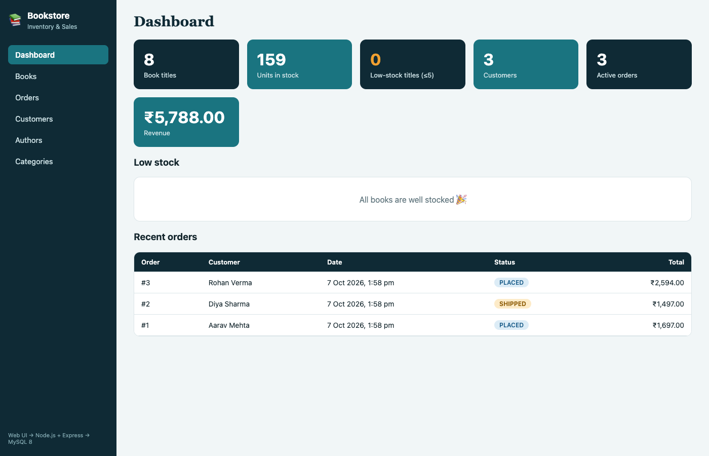
Dashboard

10.2 View Books
Lists all books with search by title, author or ISBN and filters by category and author. Stock is colour-coded.
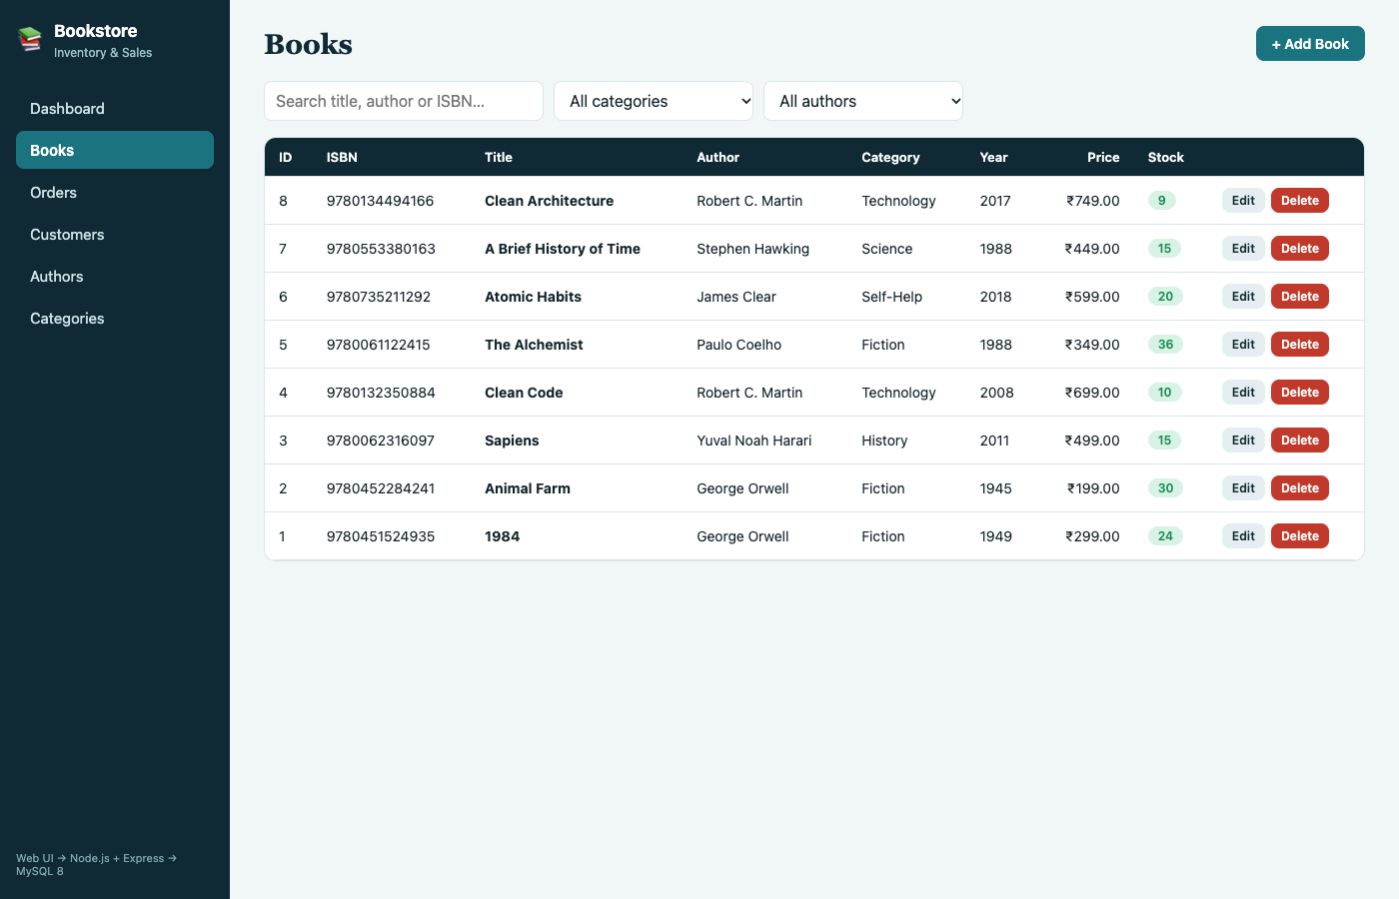
Books screen

10.3 Add Book
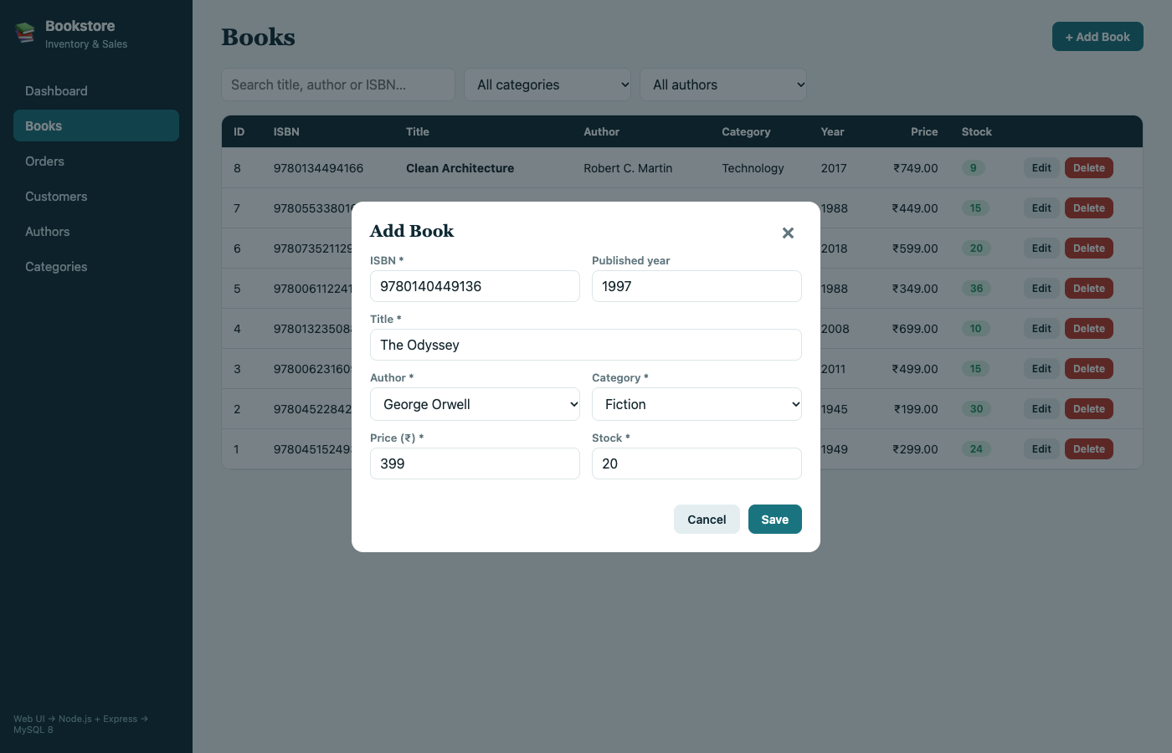
Add Book form
After saving, the new book appears at the top of the list (here “The Odyssey”).
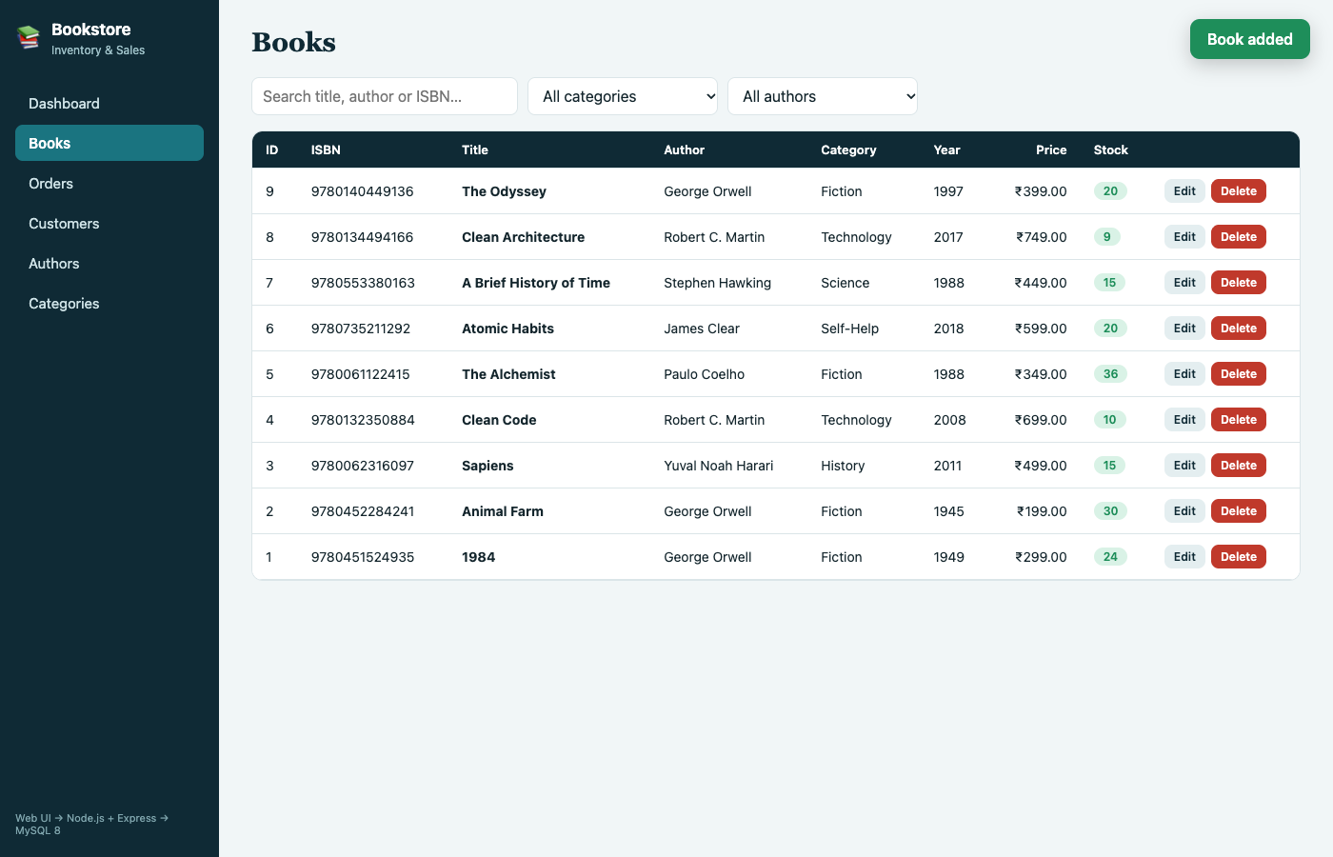
Book added

10.4 Delete Book
After the Delete button is confirmed, the book is removed from the list and from MySQL.
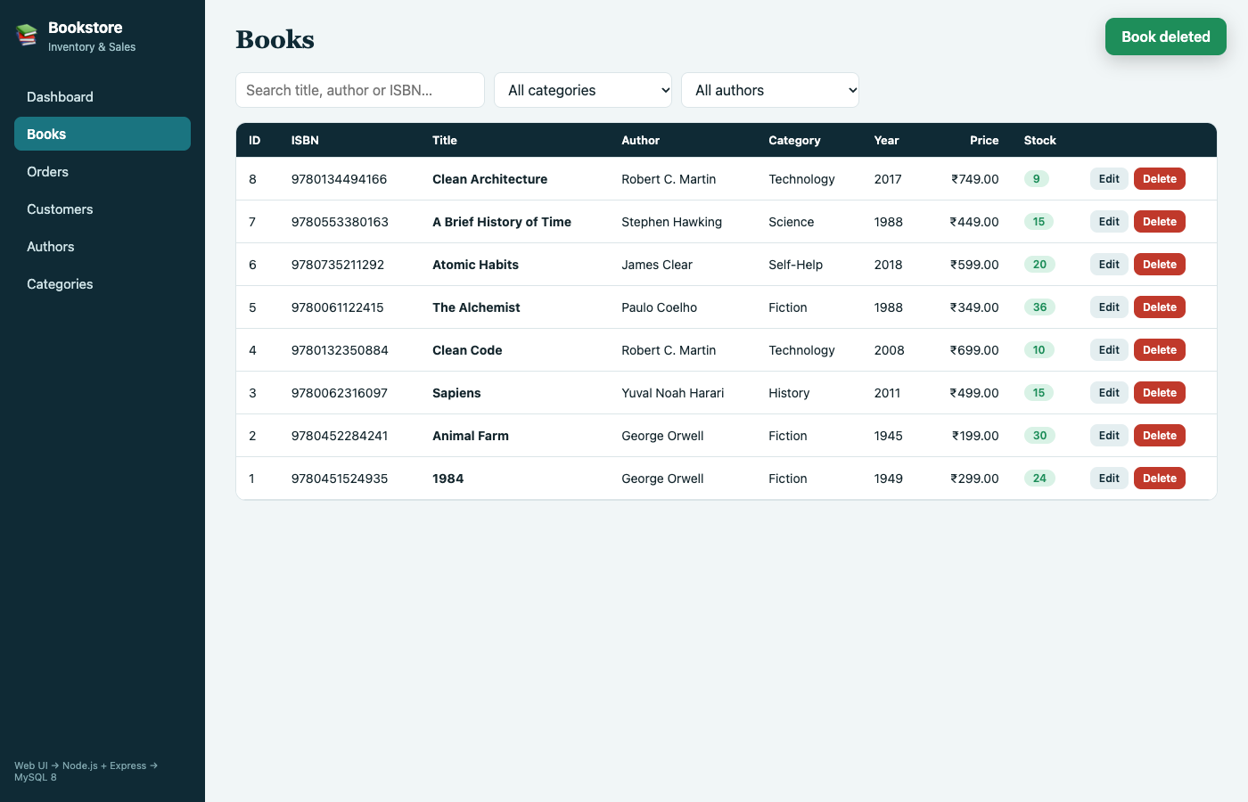
Book deleted

10.5 Orders
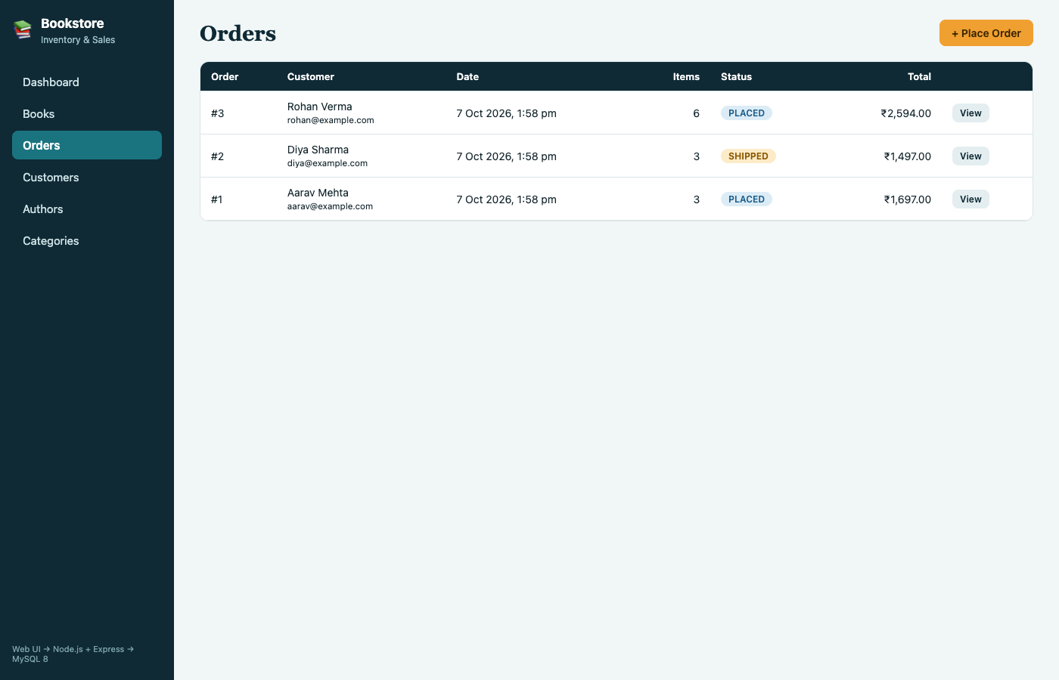
Orders screen

10.6 Place Order
The user selects a customer and one or more books with quantities; the total is calculated live. Only books with stock are offered.
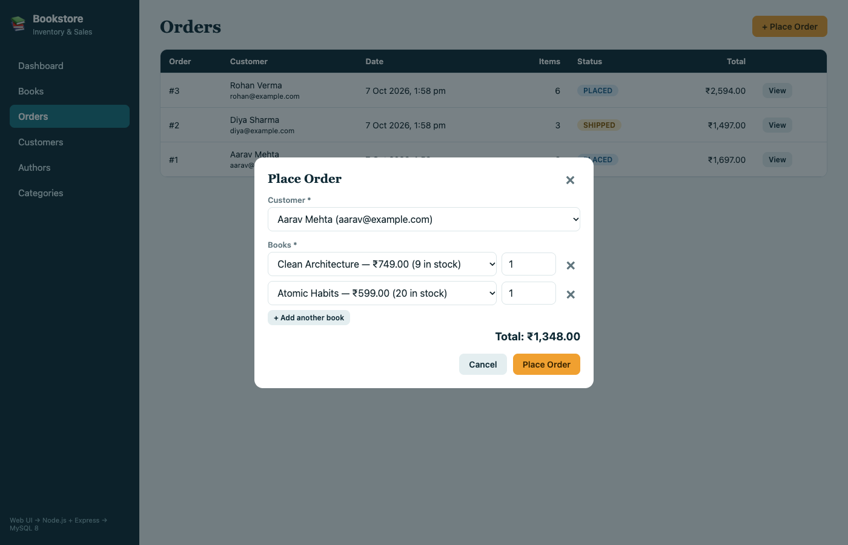
Place Order form

10.7 Order details
Shows the order lines and allows the status to be moved to Shipped or Delivered, or the order to be cancelled (stock is returned).
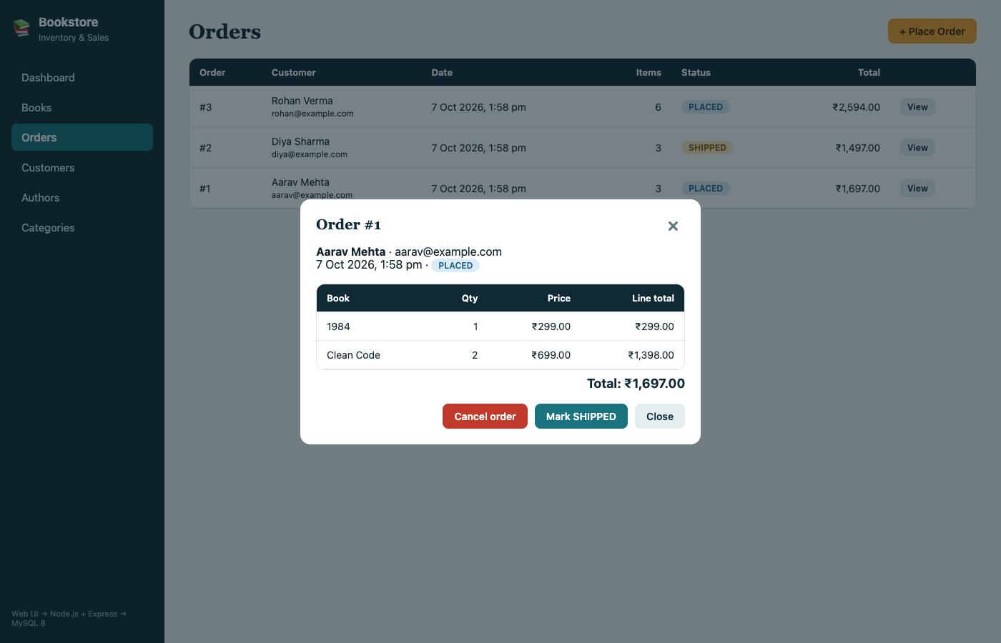
Order detail

10.8 Customers and Authors
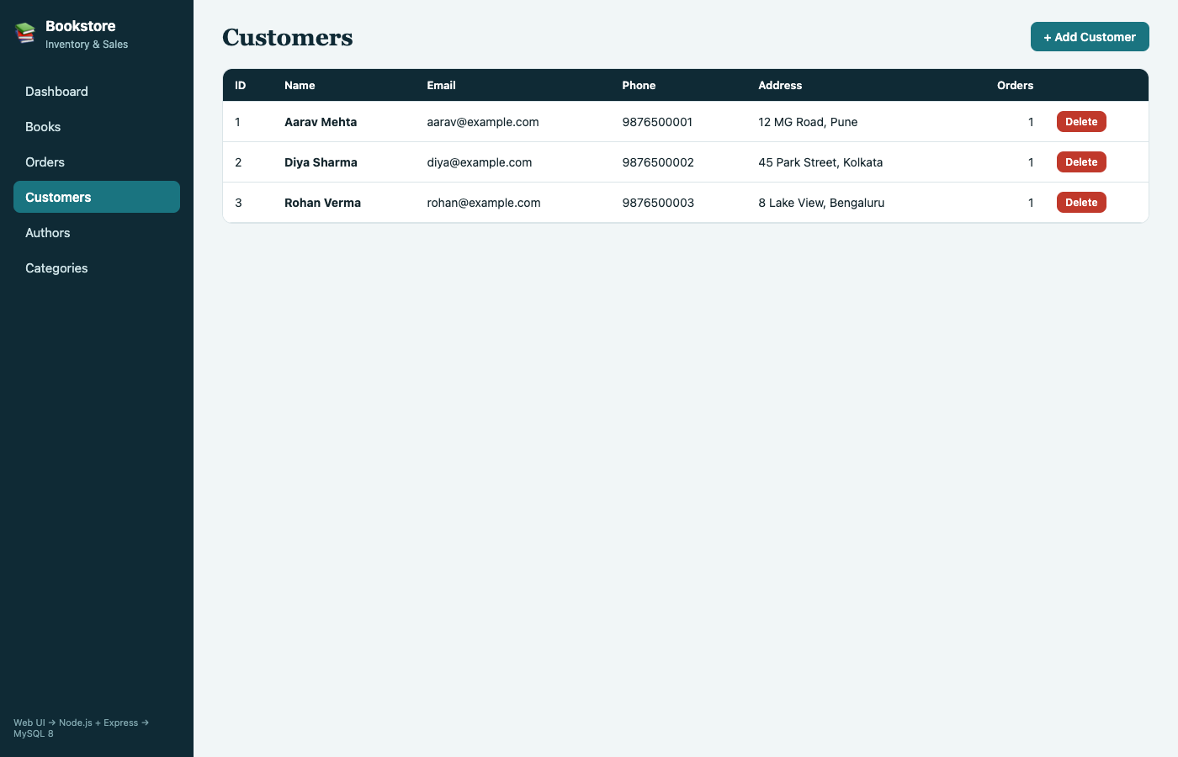
Customers screen
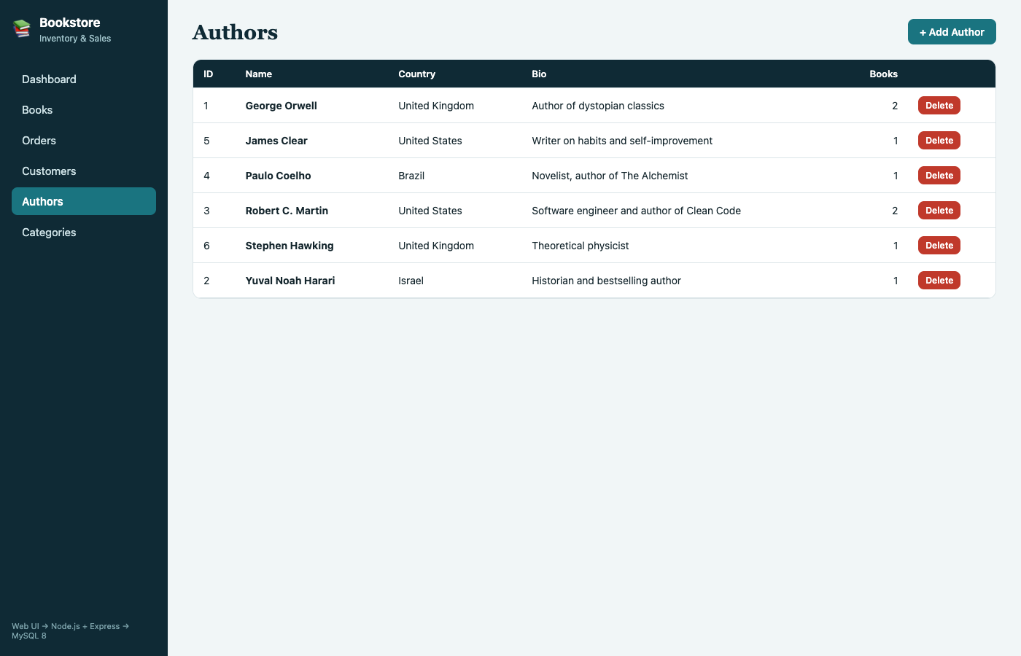
Authors screen

11. Implementation Details

11.1 Architecture
Web UI (HTML · CSS · JavaScript) ──HTTP/JSON──▶ Node.js + Express ──mysql2──▶ MySQL 8
public/ server.js, db.js bookstore_db

11.2 Project structure
File | Purpose
database/schema.sql | Tables, constraints, triggers, views and sample data
database/setup.js | Runs schema.sql from Node (npm run setup-db)
db.js | MySQL connection pool
server.js | Express server and REST API
public/index.html, style.css, app.js | Front end
.env | Database host, user, password, name and port

11.3 Database connectivity (db.js)
const mysql = require('mysql2/promise');
const pool = mysql.createPool({
host: process.env.DB_HOST || 'localhost',
port: Number(process.env.DB_PORT) || 3306,
user: process.env.DB_USER || 'root',
password: process.env.DB_PASSWORD || '',
database: process.env.DB_NAME || 'bookstore_db',
waitForConnections: true,
connectionLimit: 10,
decimalNumbers: true,
});
module.exports = pool;
All queries use placeholders (?), so user input is never concatenated into SQL, which protects against SQL injection.

11.4 REST API
Method | Endpoint | Action
GET, POST | /api/books | List (with search and filters) / add a book
PUT, DELETE | /api/books/:id | Update / delete a book
GET, POST, DELETE | /api/authors, /api/categories, /api/customers | Manage reference data
GET, POST | /api/orders | List / place an order
GET | /api/orders/:id | Order with its lines
PATCH | /api/orders/:id/status | Ship, deliver or cancel
GET | /api/stats | Dashboard figures

11.5 Key code – placing an order with a transaction
const conn = await pool.getConnection();
try {
await conn.beginTransaction();
const [o] = await conn.query('INSERT INTO orders (customer_id) VALUES (?)', [customer_id]);
let total = 0;
for (const [bookId, qty] of merged) {
const [[book]] = await conn.query('SELECT price, title FROM books WHERE book_id = ?', [bookId]);
// the trigger rejects the line if stock is insufficient, and reduces stock otherwise
await conn.query(
'INSERT INTO order_items (order_id, book_id, quantity, unit_price) VALUES (?, ?, ?, ?)',
[o.insertId, bookId, qty, book.price]);
total += book.price * qty;
}
await conn.query('UPDATE orders SET total_amount = ? WHERE order_id = ?', [total.toFixed(2), o.insertId]);
await conn.commit();
} catch (e) {
await conn.rollback(); // nothing is saved if any line fails
throw e;
} finally {
conn.release();
}
If any line fails (for example, not enough stock), the whole order is rolled back, so the database never holds a half-saved order or a wrong stock figure.

11.6 Key code – cancelling an order
Cascaded deletes do not fire triggers in MySQL, so cancellation is done explicitly: the stock of every line is added back and the status is set, in one transaction.
await conn.query(
`UPDATE books b JOIN order_items oi ON oi.book_id = b.book_id
SET b.stock = b.stock + oi.quantity WHERE oi.order_id = ?`, [req.params.id]);
await conn.query('UPDATE orders SET status = ? WHERE order_id = ?', [status, req.params.id]);

11.7 Error handling
MySQL error codes are translated into clear messages for the user: duplicate entries (ER_DUP_ENTRY), deleting a referenced record (ER_ROW_IS_REFERENCED_2), check-constraint failures and the trigger’s “Insufficient stock” message.

11.8 How to run
cd bookstore
npm install
cp .env.example .env # set the MySQL password
npm run setup-db # creates bookstore_db with sample data
npm start # open http://localhost:3000

12. Testing
Tests were run on the running application (API and browser) and directly in MySQL.
# | Test case | Input / action | Expected result | Actual result | Status
1 | View books | Open Books screen | All 8 seeded books listed | 8 books listed | Pass
2 | Add book | Add “The Odyssey” via form | New row in books, shown in list | Added and listed | Pass
3 | Delete book | Delete “The Odyssey” | Row removed from list and table | Removed | Pass
4 | Search | Search “clean” | Clean Code, Clean Architecture | Both returned | Pass
5 | Place order | Customer 1: 2 × Clean Code, 1 × 1984 | Order saved, total ₹1,697, stock reduced | Order #1, ₹1,697; stock 12→10 and 25→24 | Pass
6 | Automatic stock reduction | Order #2: 3 × Sapiens | Sapiens stock 18 → 15 | 15 | Pass
7 | Overselling blocked | 999 × Animal Farm | Rejected, stock unchanged | “Insufficient stock for requested book”; stock still 30 | Pass
8 | Empty order | Order with no items | Rejected | “Add at least one book to the order” | Pass
9 | Cancel order | Cancel order #3 | Status CANCELLED, stock returned | Alchemist 36→40, Atomic Habits 20→22, status CANCELLED | Pass
10 | Edit cancelled order | Mark order #3 as shipped | Rejected | “Cancelled orders cannot be changed” | Pass
11 | Negative price | Insert book with price −5 | Check constraint violation | ERROR 3819, chk_book_price | Pass
12 | Duplicate email | Insert customer with existing email | Unique violation | ERROR 1062 | Pass
13 | Duplicate ISBN | Add book with existing ISBN via API | Rejected with message | “Duplicate value: that record already exists” | Pass
14 | Delete referenced author | Delete George Orwell | Foreign-key violation | ERROR 1451 | Pass
15 | Delete ordered book | Delete Clean Code via API | Rejected with message | “Cannot delete: this record is referenced by other records” | Pass
Raw output of tests 9 to 15:
== stock before cancel (books 5,6)
+---------+---------------+-------+
| book_id | title | stock |
+---------+---------------+-------+
| 5 | The Alchemist | 36 |
| 6 | Atomic Habits | 20 |
+---------+---------------+-------+
== cancel order 3
{"updated":true}
+---------+---------------+-------+
| book_id | title | stock |
+---------+---------------+-------+
| 5 | The Alchemist | 40 |
| 6 | Atomic Habits | 22 |
+---------+---------------+-------+
+----------+-----------+
| order_id | status |
+----------+-----------+
| 1 | PLACED |
| 2 | SHIPPED |
| 3 | CANCELLED |
+----------+-----------+
== change cancelled
{"error":"Cancelled orders cannot be changed"}
== empty order
{"error":"Add at least one book to the order"}
== dup isbn
{"error":"Duplicate value: that record already exists (9780451524935)"}
== delete ordered book
{"error":"Cannot delete: this record is referenced by other records (e.g. orders or books)"}
== search
['Clean Architecture', 'Clean Code']
mysql> INSERT INTO books (isbn,title,author_id,category_id,price,stock) VALUES ('X1','Bad',1,1,-5,1);
ERROR 3819 (HY000) at line 1: Check constraint 'chk_book_price' is violated.
mysql> INSERT INTO customers (name,email) VALUES ('Dup','aarav@example.com');
ERROR 1062 (23000) at line 1: Duplicate entry 'aarav@example.com' for key 'customers.email'
mysql> INSERT INTO order_items (order_id,book_id,quantity,unit_price) VALUES (1,2,999,199);
ERROR 1644 (45000) at line 1: Insufficient stock for requested book
mysql> DELETE FROM authors WHERE author_id=1;
ERROR 1451 (23000) at line 1: Cannot delete or update a parent row: a foreign key constraint fails (`bookstore_db`.`books`, CONSTRAINT `fk_book_author` FOREIGN KEY (`author_id`) REFERENCES `authors` (`author_id`) ON DELETE RESTRICT ON UPDATE CASCADE)
Limitations of testing: tests were manual, on a single user and a small data set. Concurrent orders for the last copy of a book were not load-tested; the trigger takes a row lock (SELECT ... FOR UPDATE) to make this safe.

13. Conclusion and Future Enhancements

13.1 Conclusion
The project delivers a working bookstore inventory and online sales system on top of a normalized MySQL database. All six objectives are met:
Objective | How it is achieved
Centralized inventory | books table and Books screen
Customer, author, category data | Three tables and screens
Online orders | orders and order_items, Orders screen with status tracking
Automatic stock reduction | Triggers inside a transaction; cancellation returns stock
Fast retrieval | Indexes on title, author, category, customer and date; two views
Integrity | Primary and foreign keys, unique, check and not-null constraints

13.2 Future enhancements
- User login with roles (administrator, staff, customer).
- Online payment gateway integration.
- Customer-facing storefront with a shopping cart.
- Supplier and purchase-order management to restock automatically.
- Returns, refunds and discount coupons.
- Sales reports and charts, and export to Excel or PDF.
- Low-stock email alerts.
- Barcode scanning of ISBNs.

14. References
- MySQL 8.0 Reference Manual – https://dev.mysql.com/doc/refman/8.0/en/
- Node.js Documentation – https://nodejs.org/docs/latest/api/
- Express.js Guide – https://expressjs.com/
- mysql2 package documentation – https://sidorares.github.io/node-mysql2/docs
- R. Elmasri and S. Navathe, Fundamentals of Database Systems, Pearson.
- A. Silberschatz, H. Korth and S. Sudarshan, Database System Concepts, McGraw-Hill.
- MDN Web Docs (HTML, CSS, JavaScript, Fetch API) – https://developer.mozilla.org/

15. Contribution of Each Member
Member | Roll No. | Contribution
[Student Name 1] | [Roll No.] | [e.g. Database design, ER diagram, schema, triggers]
[Student Name 2] | [Roll No.] | [e.g. Back-end API and database connectivity]
[Student Name 3] | [Roll No.] | [e.g. Front-end, testing, report]

16. Appendix: GitHub Repository Link
Repository: [https://github.com/<username>/<repository-name>]
Contents: database/schema.sql, server.js, db.js, public/, README.md.

