May problem sa Biometrics nila, na makaka apekto sa system na ginagawa natin.

Instead na TO PROCESS into a data nalang ang DAT File, nag double check pa tayo ng BioNum kung may existing Time IN and Time OUT ang BioNum which is not recommended for this kind of application, it’s very unnecessary for the application to do all this thing. I have some recommendations but it’s a company problem not mine.

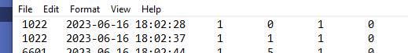

* 2023-06-16 18:02:28 1 TIME IN
* 2023-06-16 18:02:37 1 TIME OUT



* Processed Data



* Duplicate Time IN



* Upon checking 1022 have a one Time OUT
* So upon processing it into a data, it processed the most recent Time IN or Time OUT

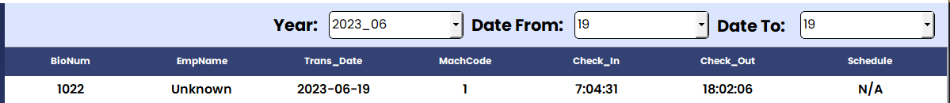

For FILE201 and NTP which both excel file, dito naman nagkaroon kami ng maraming issue for relating the emp_id and empl_id

(SIDE BY SIDE COMPARISON)

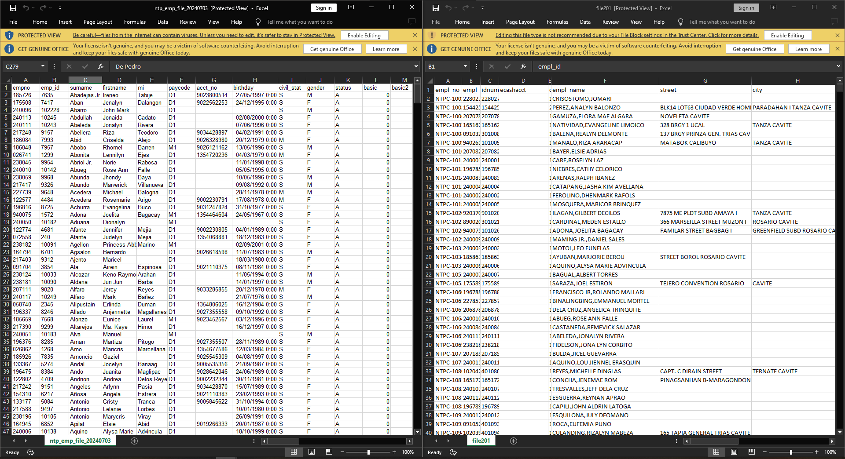

Here’s the following issues that we manually fixed but not entirely completely:

* We added the column which is missing from FILE201 that we have in NTP which is takes a very long time to do because we manually checked it.
* Upon relating the NTP column empno to empl_id in FILE201 we just getting a related 700 something to relate so not all have data from NTP.
* We didn’t use some data/column from NTP because it’s gonna make the system error for example in column birthday it’s very inappropriate, also from this following column:
* 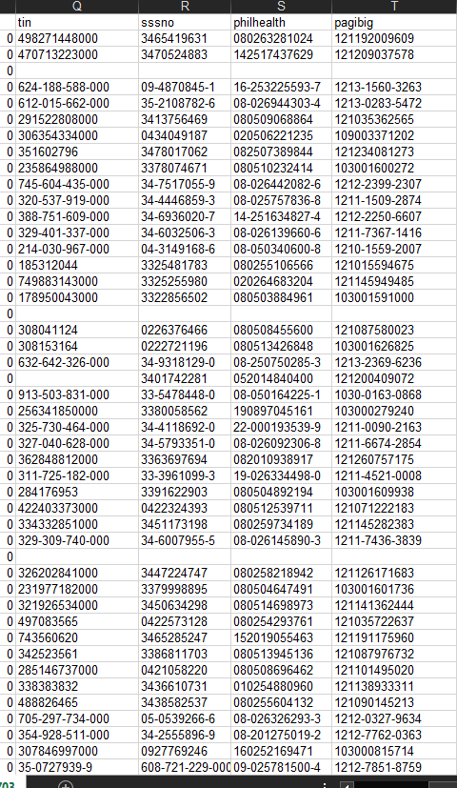Why is it have dashes? we didn’t use this column

In terms of communication with Developers and with you Ma’am Tes, we having a really hard time to communicate together since most of the time you’re busy sa ibang bagay instead of give a proper time to manage the team most importantly the application we’re developing/building, example of this communication:

* When we’re requesting for the company data to examine and test it to the application takes too long to send to us, above at page 2, I gave an example of data which is FILE201 and NTP which is same employee data, but different structure, dito kami halos nadadale since ang hirap magkaroon ng relation and manually naming inayos.
* For the application requirements, we don’t have a clear instruction; yes, nae-explain naman yung dapat gawin namin, but pa isa-isa sya, so yung code mag iiba nanaman. Which is also very time-consuming, lalo na we’re developing an application to AUTOMATE.
* The missing thing also in our communication is feedback from you since you’re the project manager and we’re your developers. We need feedback from you since we need to address it as soon as possible because when debugging or updating the system, it will be very time-consuming, depending on the revision.
* When you want to add a feature to the application, sometimes it will revise the entire code structure, which is not very ideal to do since a lot of functions will also change. The target po naten is magkaroon ng clear and maayos na application, so I suggest that when giving a project, give the entire plan, flow of the system, how it works, and so on.
* When we’re suggesting automating something from their old application or system, you say we cannot apply it to the application we’re building. Since we want to develop an application, why can't we do an automation? That’s what I (Maze) want to happen since an automated process from our application is very useful when marketing an application.

For your developers which is starting for Maze Clarion Badlon, Jhay-Em S. Calleja, and Rodel Q. Cuyag. We’re student of BSIT and BSCS that really appreciate the opportunity you gave to us, we really love the idea to work as a company, as a team, and start to learn when it comes how real world developer works, how industry potentially help us, and to build an solution for the company that needs this kind of application, but we’re student and we’re just helping you like intern not as employee, we having a lot of stress and hard time since the data we’re handling is very prone to error when it comes to building an application, as of 3rd year student your developers will face a capstone/thesis, me and this 2 person I mentioned decided to quit at this project since it’s almost ready to deploy and we’re getting a anxiety and stress so much lately also.

We are apologizing since we’re leave this project a 60%-70% done.