Codeforces Performance Analyzer
ML Results Report — Classification & Regression

Target User: mo.zarad

1. Project Overview
This report presents the machine learning results of the Codeforces Performance Analyzer. Given a Codeforces handle, the system: (1) fetches the user's submission history from the API, (2) computes tag-level strength scores, (3) classifies the user into a cluster of 50 similar users via K-Nearest Neighbors, and (4) recommends unsolved problems prioritized by predicted success probability and tag weakness.
Dataset: 2,869 users · 819,242 submission records · 20 problem tags · 8 CF rank classes.

2. Dataset Summary
Total users (with tag data) | 2,869
Total submission records | 819,242
Problem tags used as features | 20
CF rank classes | 8 (Newbie → Grandmaster)
Rating range | 900 – 2598
Avg. first-try success rate | 0.600 ± 0.117

CF Rank | User Count | % of Dataset
Newbie | 340 | 11.9%
Pupil | 372 | 13.0%
Specialist | 408 | 14.2%
Expert | 556 | 19.4%
Candidate Master | 477 | 16.6%
Master | 432 | 15.1%
International Master | 114 | 4.0%
Grandmaster | 170 | 5.9%

3. Feature Engineering — Tag Strength Score
Each user is represented as a 20-dimensional vector of tag strength scores (one per problem category). Each score is computed from five weighted components:
Component | Weight | Description
Acceptance Rate | 30% | Smoothed AC / total attempts for this tag
Difficulty Score | 30% | Avg. rating of solved problems / 3500
Rating Boost | 20% | (CF rating + max rating) / (2 × 3500)
Specialization | 10% | Tag AC count / total AC count (focus signal)
Efficiency Score | 7.5% | First-try solve rate
Volume Score | 7.5% | log(1 + ac_count) / log(51) — breadth of practice

4. Classification Model — K-Nearest Neighbors
A KNN classifier (k = 50, Euclidean distance) is trained on the 20-dimensional tag strength vectors to predict CF rank. Performance is evaluated with 5-fold stratified cross-validation.

4.1 Overall Results
Algorithm | K-Nearest Neighbors (k = 50)
Distance metric | Euclidean
Feature space | 20 tag strength scores
Evaluation | 5-fold stratified cross-validation
Overall accuracy | 34.3%

4.2 Per-Class Accuracy
Adjacent ranks (e.g. Specialist ↔ Expert) are naturally harder to distinguish because their tag profiles overlap significantly. Extreme ranks (Newbie, Grandmaster) are better separated.
CF Rank | Accuracy (diagonal)
Newbie | 29.1%
Pupil | 49.1%
Specialist | 17.6%
Expert | 1.8%
Candidate Master | 28.5%
Master | 71.2%
International Master | 24.7%
Grandmaster | 20.6%

4.3 Key Cluster Drivers (PCA Loading Analysis)
Principal Component Analysis on the tag strength matrix reveals which tags contribute most to separating user clusters. The top drivers of PC1 (51.9% of variance) are:
Probabilities | +0.3639
Flows | +0.3335
Trees | +0.2987
Fft | +0.2900
Combinatorics | +0.2642

5. Regression Model — Success Rate Prediction
A Random Forest Regressor predicts a user's first-try success rate (fraction of problems solved on the first submission attempt) from the 20 tag strength features. Evaluated with 5-fold cross-validation.

5.1 Model Performance
Algorithm | Random Forest (100 trees)
Target variable | First-try success rate [0, 1]
Feature space | 20 tag strength scores
Evaluation | 5-fold cross-validation
R² score | 0.5840 (58.4% variance explained)
MAE | 0.0583 (avg. error ≈ 5.8 percentage points)
Residual std | 0.0751
Residual mean | -0.00131 (near-zero → no systematic bias)

5.2 Top Predictive Tags
The Random Forest assigns importance scores to each tag based on how much it reduces prediction error across all trees. The three most predictive tags for success rate are:
Math | 0.2786 (27.9% importance)
Impl | 0.1739 (17.4% importance)
Greedy | 0.1176 (11.8% importance)

These foundational tags (math, implementation, greedy) are consistent predictors of solving efficiency — users who handle them well tend to solve problems correctly on the first attempt more often across all tag categories.

6. Results for mo.zarad

6.1 Tag Strength Profile
mo.zarad's tag strengths are computed live from their latest 500 submissions benchmarked against all 2,877 users in the peer dataset.
Tag | Strength (0–100) | Solved / Tried | Acceptance Rate
Impl | 86.2 | 61 / 67 | 91.0%
Number Theory | 83.3 | 10 / 10 | 100.0%
Two Pointers | 80.9 | 9 / 11 | 81.8%
Binary Search | 80.3 | 12 / 15 | 80.0%
Strings | 78.8 | 17 / 20 | 85.0%
Math | 78.6 | 42 / 47 | 89.4%
Data Structures | 78.4 | 12 / 14 | 85.7%
Graphs | 75.5 | 6 / 8 | 75.0%
Greedy | 71.3 | 29 / 35 | 82.9%
Sortings | 70.0 | 10 / 13 | 76.9%
Combinatorics | 67.3 | 1 / 1 | 100.0%
Constructive | 65.2 | 10 / 13 | 76.9%
Bitmasks | 63.6 | 2 / 2 | 100.0%
Dp | 62.4 | 11 / 16 | 68.8%
Trees | 59.2 | 2 / 3 | 66.7%
Games | 47.7 | 1 / 2 | 50.0%
Geometry | 0.0 | 0 / 2 | 0.0%

6.2 KNN — 50 Nearest Neighbors
The KNN found 50 users most similar to mo.zarad in tag-strength space. Top 5 closest neighbors:
#1 Vincella | Distance: 0.6362
#2 Go_Goat_Goal | Distance: 0.6923
#3 148814881489_is_prime | Distance: 0.6945
#4 MatchingGraph | Distance: 0.7140
#5 rumputlautmamasukaa | Distance: 0.7441

6.3 Top 5 Recommended Problems
Problems are sourced from what the 50 nearest neighbors have solved but the target user has not. They are then ranked by a composite score: 60% success probability (difficulty fit) + 40% weakness boost (growth potential).
Problem ID | Rating | Success Prob. | Weakness Boost | Final Score
2120_B | 1000 | 0.506 | 1.000 | 0.704
1951_A | 900 | 0.700 | 0.264 | 0.526
1941_B | 1000 | 0.683 | 0.270 | 0.518
1674_C | 1000 | 0.702 | 0.223 | 0.510
2132_C1 | 1000 | 0.663 | 0.234 | 0.492

7. Visualizations
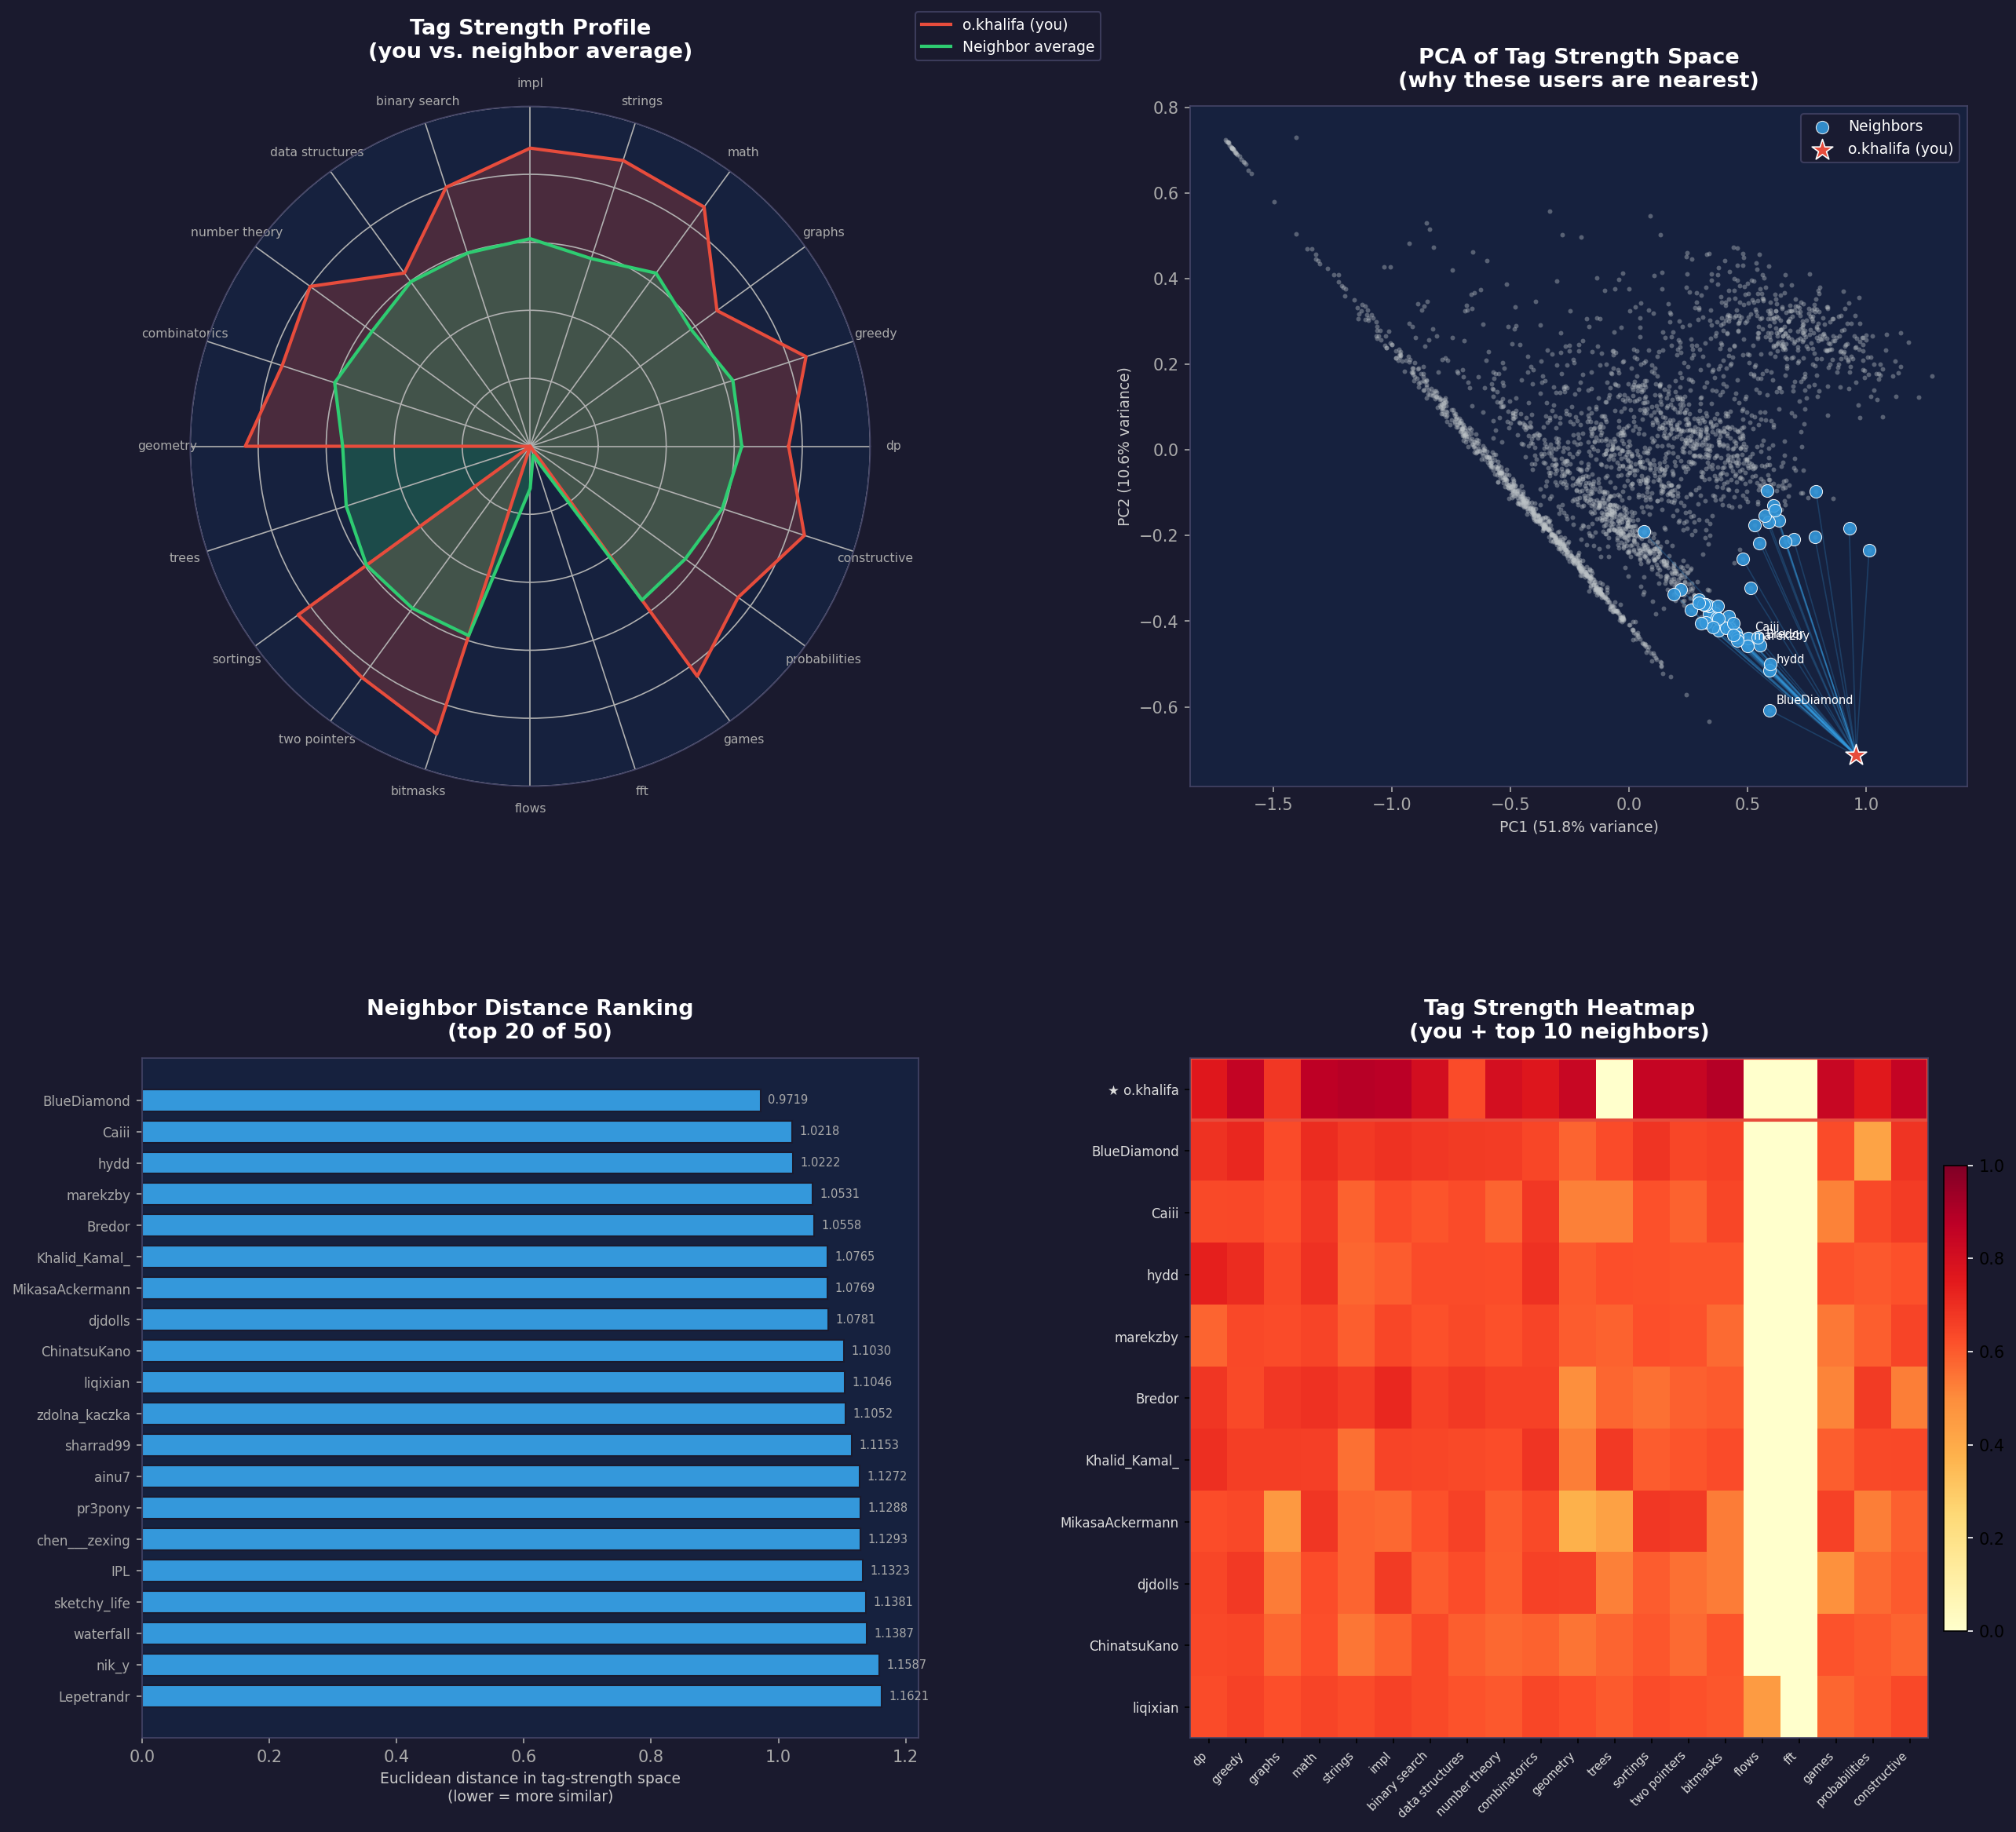
Figure 1 — KNN Visualization: radar chart, PCA scatter, distance ranking, and tag heatmap for o.khalifa.

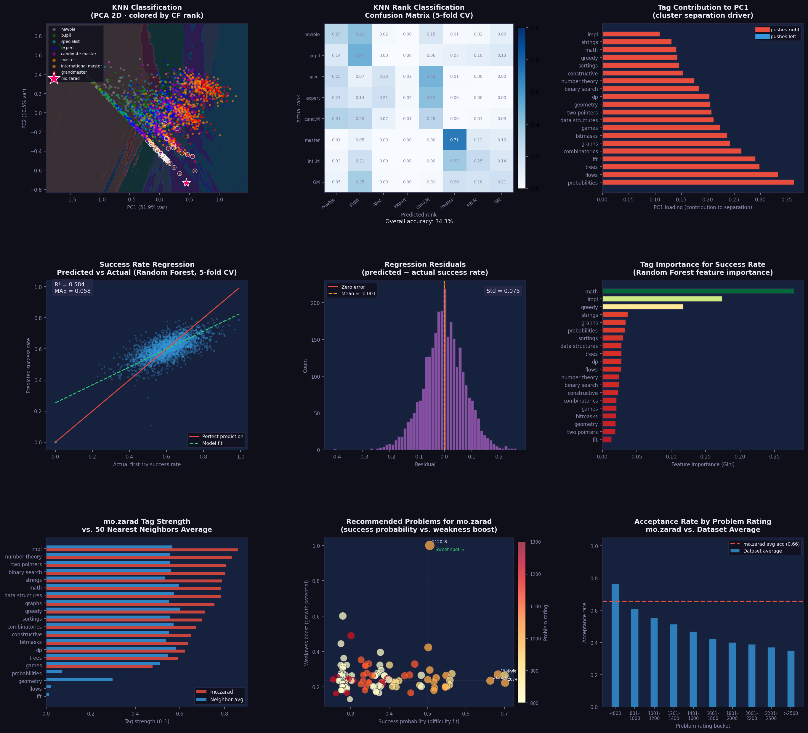
Figure 2 — ML Results: KNN decision boundary, confusion matrix, feature importance, regression predicted vs. actual, residuals, and o.khalifa focus charts.

8. Conclusions
The KNN classifier achieves 34.3% overall accuracy in predicting CF rank from tag strength profiles alone, with the main confusion occurring between adjacent ranks — a natural limitation given the continuous nature of user skill progression.
The Random Forest regression model predicts first-try success rate with R² = 0.584 and MAE = 0.058 (5.8 percentage points), confirming that tag strength is a meaningful predictor of problem-solving efficiency.
For mo.zarad: strongest tags are impl, number theory, two pointers, with an overall acceptance rate of 65.5%. The system identified 50 similar users and recommended 113 unsolved problems ranked by personalized difficulty fit and growth potential.

