Cardiovascular Disease Prediction Report

1. Executive Summary
The notebook explores cardiovascular disease prediction with five final models: Random Forest, AdaBoost, SVM, ANN / MLP, and a modified 1D CNN adapted from the reference paper. Based on the latest executed outputs, ANN / MLP is the strongest all-around model because it achieved the highest accuracy (0.7333), the highest recall (0.7004), and the highest F1-score (0.7222). The modified 1D CNN is very competitive and gives the best ROC-AUC (0.8005), but its recall is lower (0.6645), so it misses more true disease cases than the MLP at the default threshold. Compared with the research paper, the notebook follows the same family of models but works on a smaller feature space and a different dataset setup, so the best model is not exactly the same.

2. Dataset and EDA Steps
The notebook loads a tabular cardiovascular dataset with 68,783 rows and 12 columns. The target variable is CARDIO_DISEASE, where class 1 means disease is present and class 0 means disease is absent. The early EDA steps include shape checking, data types, descriptive statistics, missing-value inspection, unique-value counts, outlier inspection, class-distribution plots, pairwise plots, and correlation heatmaps.
- Initial inspection: the notebook printed dataset shape, info, describe, missing values, and unique-value counts for all columns.
- Outlier screening: boxplots highlighted unusual values in HEIGHT, WEIGHT, AP_LOW, and AP_HIGH.
- Cleaning and feature engineering: the notebook created BMI, PULSE_PRESSURE, MAP, RISK_SCORE, METABOLIC_RISK, and AGE_BP_RISK.
- Visualization: class distribution plots and correlation heatmaps were used to understand relationships with the disease label.

2.1 Main EDA Findings
Finding | Notebook evidence / interpretation
Raw dataset size | 68,783 rows x 12 columns.
Working original vs cleaned shapes | A later notebook printout shows Original shape: 68,530 x 12 and Cleaned shape: 62,513 x 12.
Outliers reported | HEIGHT: 507 (0.74%), WEIGHT: 1,748 (2.54%), AP_LOW: 3,599 (5.23%), AP_HIGH: 1,068 (1.55%).
Cleaned class balance | Class 0 = 31,639 and Class 1 = 30,874, so the cleaned set is close to balanced.
Feature engineering rationale | The new variables combine blood pressure, age, and metabolic information into more interpretable cardiovascular-risk indicators.

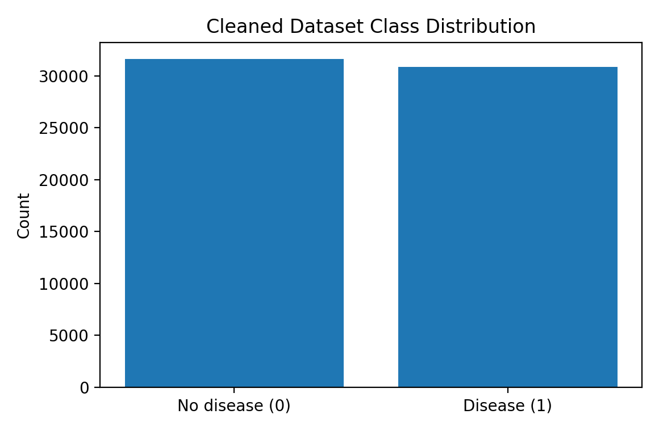
Figure 1. Cleaned dataset class distribution extracted from the notebook outputs.

2.2 Current Interpretability Evidence Already Present in the Notebook
Even before adding SHAP or permutation importance, the notebook already contains a simple form of interpretability through engineered-feature correlations with the disease label. AGE_BP_RISK (0.4175) and MAP (0.4142) show the strongest positive relationship with cardiovascular disease, followed by PULSE_PRESSURE (0.3456). BMI (0.1789) and METABOLIC_RISK (0.1850) are still positively related, but more weakly. These findings suggest that blood-pressure-related engineered features carry the clearest signal among the newly created variables.
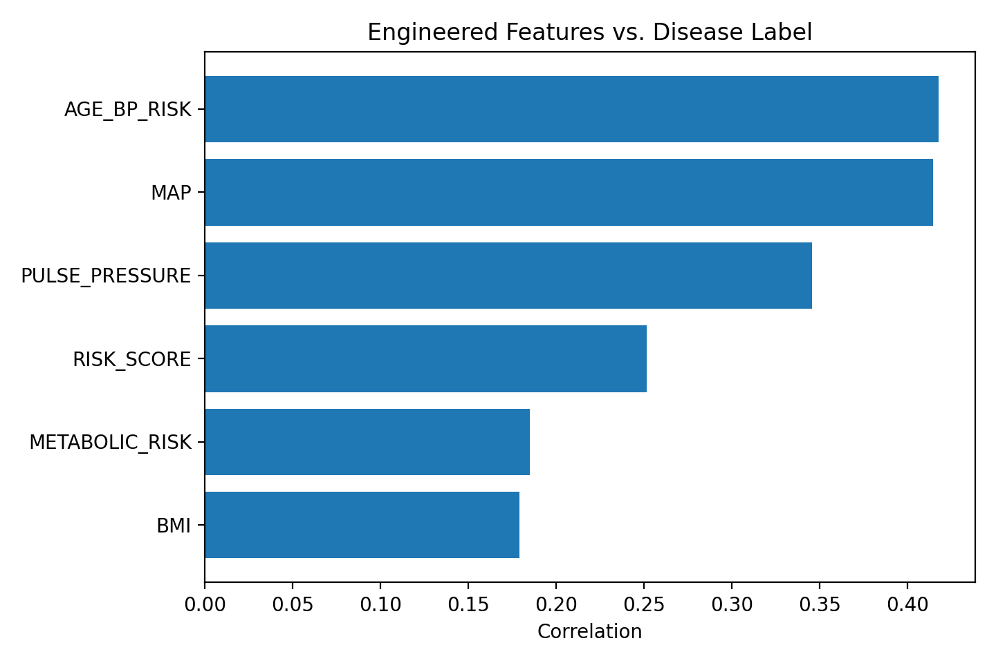
Figure 2. Correlation of engineered features with CARDIO_DISEASE from the executed notebook cells.

3. Model Results from the Notebook
The latest notebook export contains a final comparison block for five models trained on the original feature set. The table below reports the exact values printed in the notebook output.
Model | Accuracy | Precision | Recall | F1-score | ROC-AUC
Random Forest | 0.7258 | 0.7363 | 0.6953 | 0.7152 | 0.7870
AdaBoost | 0.7153 | 0.7650 | 0.6135 | 0.6809 | 0.7873
SVM | 0.7327 | 0.7628 | 0.6677 | 0.7121 | 0.7913
ANN / MLP | 0.7333 | 0.7455 | 0.7004 | 0.7222 | 0.8002
Modified 1D CNN | 0.7330 | 0.7653 | 0.6645 | 0.7113 | 0.8005

3.1 Comparison Between the Models
- ANN / MLP is the strongest all-around model in the current notebook output. It has the highest accuracy (0.7333), the highest recall (0.7004), and the highest F1-score (0.7222). In disease prediction terms, it catches the largest share of real positive cases among the final models.
- The modified 1D CNN is a very close second. It achieves 0.7330 accuracy and the best ROC-AUC (0.8005). This means its probability ranking is slightly better than the MLP, but at the default threshold it misses more true disease cases than the MLP.
- SVM performs competitively, with 0.7327 accuracy and 0.7121 F1-score, but its recall (0.6677) is still lower than MLP.
- Random Forest is stable and reasonably balanced, but it falls behind MLP and CNN on the strongest summary metrics.
- AdaBoost has respectable precision, but it has the weakest recall (0.6135), so it misses the largest number of actual disease cases.

3.2 What Recall Means for a Disease Model
Recall answers the question: out of all patients who truly have cardiovascular disease, how many did the model correctly identify as diseased? In medical classification, recall matters a lot because a low-recall model creates more false negatives. A false negative means a patient who actually has the disease is predicted as healthy. That is usually more dangerous than a false alarm, because the patient may be missed for follow-up or treatment.
Model | Recall | Meaning for disease detection
ANN / MLP | 0.7004 | Best at catching true disease cases among the final models; it identifies about 70.0% of actual positives.
Random Forest | 0.6953 | Identifies about 69.5% of true disease cases; relatively strong recall, but lower overall summary performance than MLP.
SVM | 0.6677 | Identifies about 66.8% of true disease cases; similar to the CNN but still below MLP.
Modified 1D CNN | 0.6645 | Identifies about 66.5% of real disease cases; good, but it misses more positives than the MLP.
AdaBoost | 0.6135 | Identifies only about 61.4% of real disease cases, so it has the highest risk of missed disease among the compared models.

4. Difference Between This Work and the Research Paper
The uploaded notebook is clearly inspired by the reference paper, but the two studies are not identical. The main differences are in the dataset, feature space, feature-selection stage, and final model ranking. These differences are enough to change which model comes out on top.
Research paper | Current work
NHANES-based clinical dataset collected over multiple survey years, with many more relevant clinical and lab variables; the CHD model used 40 encoded inputs after selection. | A smaller tabular cardiovascular dataset with 12 original columns. The latest executed comparison block uses the original feature set, while engineered features are explored mainly in EDA.
Severe class imbalance was a central challenge, so the paper used undersampling analysis and class weighting. | The cleaned class counts are close to balanced, so the notebook does not face the same imbalance severity.
The paper used ensemble feature selection (mRMR + RFE + elastic net) before the final deep-learning model. | The current notebook export does not yet show an executed final feature-selection block in its outputs.
The paper reported the modified 1D CNN as the best overall CHD model, with about 80% accuracy and strong emphasis on low false negatives. | In the current notebook, ANN / MLP is the best all-around model by accuracy, recall, and F1, while the modified 1D CNN is strongest only in ROC-AUC.
The paper explicitly noted lack of interpretability as a limitation of the deep-learning approach. | The notebook currently contains feature-level interpretability through engineered correlations, but not yet full model-based interpretability outputs such as SHAP or permutation importance.

4.1 Why the Final Rankings Are Different
- The paper used a richer clinical feature space. With more selected features, the dense-reshape-Conv1D design had more opportunity to learn feature interactions.
- Your notebook uses a smaller tabular feature space, which can favor strong tabular learners such as MLP, SVM, and tree-based models.
- The paper devoted more attention to feature selection and imbalance handling. Those components are not yet fully visible in the current notebook export.
- Because the dataset and feature space differ from the paper, it is completely normal that your modified 1D CNN is competitive without being the best overall model.

5. Interpretability Techniques and Results
The report requirement asks for interpretability techniques and results. In the current notebook export, the directly available interpretability results are the engineered-feature correlations discussed earlier. The most appropriate next techniques for this project are Random Forest feature importance, permutation importance, SHAP, and PDP / ICE plots, but those output cells are not present in the latest executed notebook export used to build this report.
- Available result now: AGE_BP_RISK and MAP are the most informative engineered signals in the executed notebook.
- What this tells us: combining age with blood-pressure information appears more informative than relying on single raw variables alone.
- Recommended next step: apply permutation importance and SHAP to the best model (ANN / MLP) and to Random Forest so the final report includes both global and local explanations.
A fair and honest interpretation is that the notebook already started the interpretability story through medically meaningful feature engineering, but the model-level explainability block is still the next step rather than a completed output in the current export.

6. Final Conclusion
The notebook shows a solid workflow: initial EDA, outlier analysis, cleaning, medically meaningful feature engineering, and a fair comparison of five classifiers. In the latest executed outputs, ANN / MLP is the safest overall choice because it gives the best balance between accuracy, disease recall, and F1-score. The modified 1D CNN remains highly competitive and gives the best ROC-AUC, which means its ranking ability is strong, but its lower recall means it would miss more true disease cases than the MLP at the current decision threshold. Compared with the paper, the differences are driven mainly by dataset design, feature count, and the absence of a finalized feature-selection and model-based interpretability block in the current notebook export.

7. References
Mamun, M.M.R.K., & Elfouly, T. (2023). Detection of Cardiovascular Disease from Clinical Parameters Using a One-Dimensional Convolutional Neural Network. Bioengineering, 10(7), 796.

