BAKG Project Tutorial

This tutorial focuses on the various choices you have for installing and run BAKG framework. You can find BAKG here:

https://github.com/bmwhi5/BAKG

This BAKG tutorial consists two parts as following:

* Installation

Please cite the following papers if you use BAKG tools:

1. Alobaidi, M., Malik, K. M., & Hussain, M. (2018). Automated ontology generation framework powered by linked biomedical ontologies for disease-drug domain. *Computer methods and programs in biomedicine*, *165*, 117-128.
2. Alobaidi, M., Malik, K. M., & Sabra, S. (2018). Linked open data-based framework for automatic biomedical ontology generation. *BMC bioinformatics*, *19*(1), 319.

Installation

In order to "install" and "run" BAKG in your environment you need to do the following:

1. Installing Eclipse ID (tested with KEPLER)
2. Installing Java SDK 1.8.0 or later
3. Downloading Brain Aneurysm Knowledge Graph (BAKG) from Github
4. Importing BAKG framework project in Eclipse IDE
5. Downloading dependency JARs
   1. A zip file called "Vendor" can be found in the same site of the project in Github
6. Adding dependency JARs files to your Classpath application
7. Installing MetaMap server ( if you want to use UMLS mapping )
   1. https://metamap.nlm.nih.gov/JavaApi.shtml

Running

1) Run the mainView class as java application from Eclipse. Figure 1 shows the app start dialog.

To extract non-hierarchy relations of the discovered concepts

To extract synonyms of the discovered concepts

To extract titles from PubMed repository

To extract hierarchies of the discovered concepts

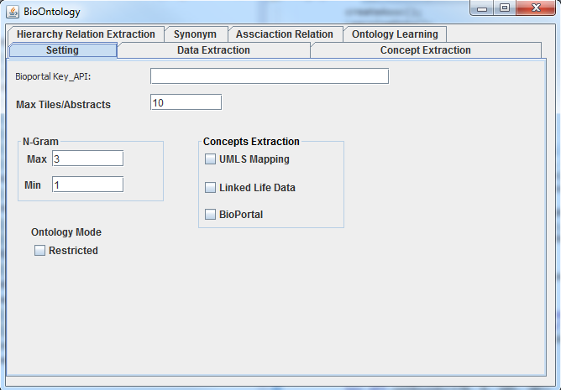

Concepts extraction

Bioportal key_API

The number of titles the will be extracted in Data Extraction tab

Set the methods that the framework uses

Figure 1.

Not used yet

To set the min & max window size for N-gram Method that the framework uses