**Unlocking Consumer Trends: Insights Into Black Friday Sales**

**By: Thasin Wahid – Jairo Onate – Mazen Alhaffar**

Understanding consumer behavior is essential for businesses to optimize their marketing strategies and boost profitability. This analysis focuses on using socioeconomic variables—such as gender, occupation, and marital status—to predict Black Friday sales, one of the most critical shopping events of the year. By examining how these factors influence purchasing patterns, businesses can tailor their promotions and product offerings to better meet the needs of diverse consumer groups. This approach not only enhances customer satisfaction but also maximizes sales potential by ensuring resources are allocated to the most impactful strategies. Insights gained from this study can be instrumental in helping retailers make data-driven decisions and gain a competitive edge in the fast-paced retail landscape.

1. **Summary Statistics:**

The dataset consists of 537,577 observations with demographic, product, and purchase information. Most users are male (75%) and belong to the 26–35 age group. Occupation 4 is the most common, and City Category B has the highest representation. The data on product categories show a significant portion of missing values in Product_Category_2 (31%) and Product_Category_3 (69%). Purchases range from $185 to $23,961, with a median of $8,062 and an average of $9,334. Marital Status is skewed towards singles (59%), and Product Category 5 is the most frequently purchased item. This summary highlights key demographic and purchase behavior trends while identifying gaps due to missing values.

1. **Model Performance Insights**

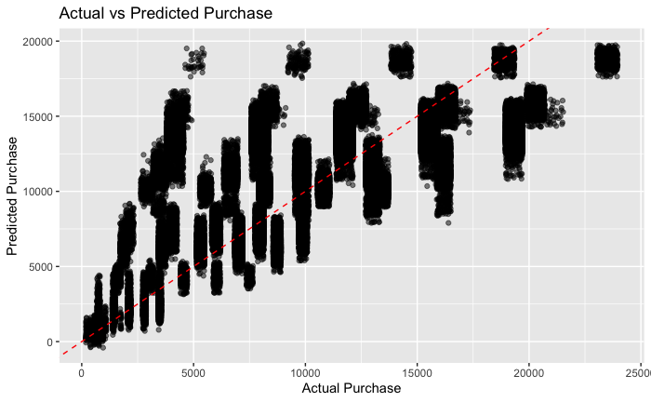

The graph indicates that the model performs well at predicting low to mid-range purchase values (0–10,000), where most points closely align with the red line, demonstrating accuracy. However, at higher purchase values (above 15,000), the model consistently underpredicts, as evidenced by points falling below the line. Additionally, clusters of predictions at specific values suggest the model might lack granularity or is oversimplifying the prediction range. These patterns highlight a need for refinement, particularly in handling high purchase values and improving feature differentiation to enhance prediction accuracy across the entire range.

1. **Key Insights**

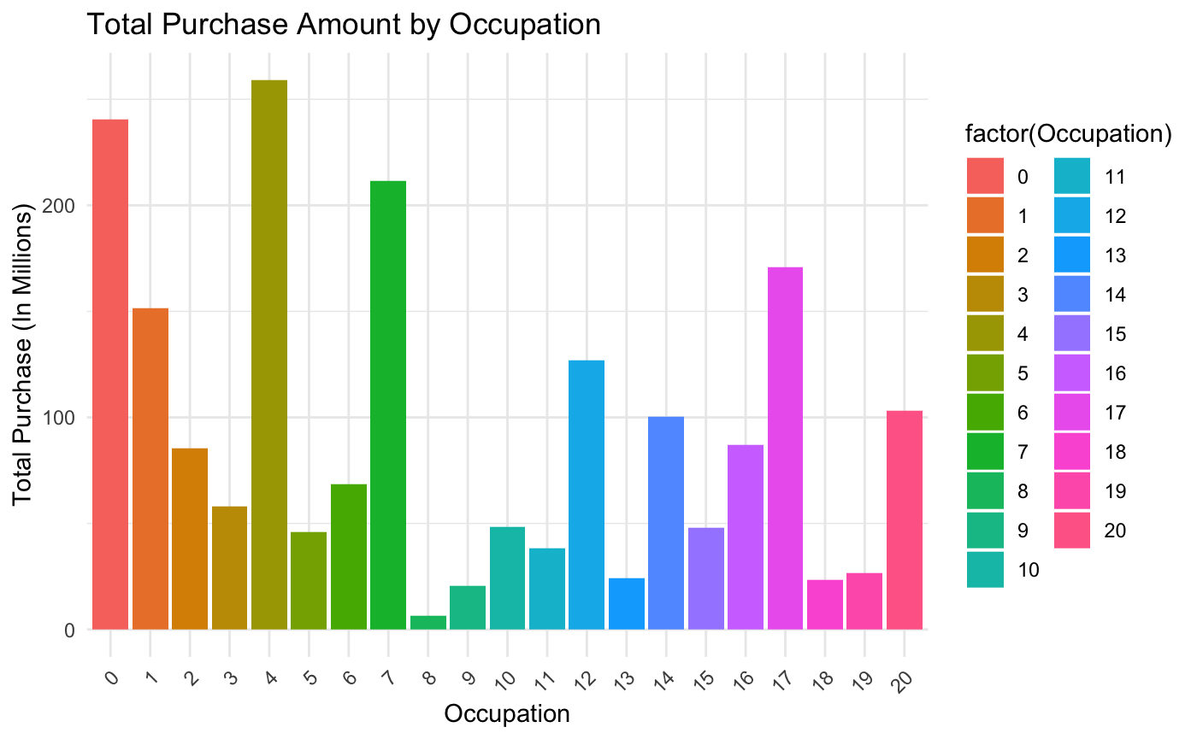

This chart shows the total purchase amounts, measured in millions, for different occupations during Black Friday. Occupation groups 0, 4, and 17 stand out as the highest contributors, each generating over 200 million in total purchases, suggesting these groups have strong purchasing power or participation in Black Friday sales. In contrast, occupations such as 8, 10, and 14 show significantly lower total purchases, indicating lower engagement or spending. The variation in total purchase amounts across occupations highlights differences in consumer behavior or income levels among these groups. This insight can help tailor marketing strategies to target high-spending occupations more effectively.

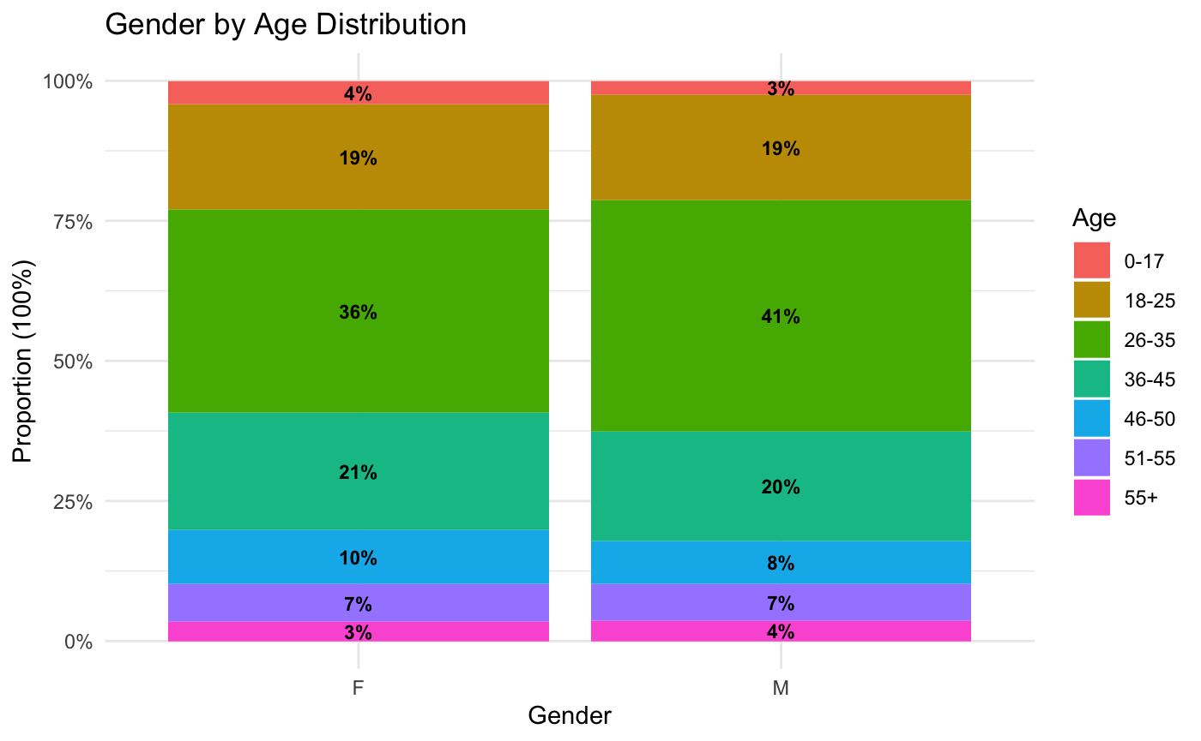

This graph represents the proportion of age groups across genders during Black Friday sales, normalized to 100%. Both male and female distributions show a similar pattern, with the 26-35 age group being the largest segment, comprising 36% of females and 41% of males. The 36-45 age group follows, representing 21% of females and 20% of males. Younger groups (0-17 and 18-25) and older groups (46-55 and 55+) account for smaller proportions, with minimal variation between genders. This suggests that middle-aged adults, particularly those in the 26-35 range, dominate Black Friday participation across both genders.

1. **Conclusion**

In conclusion, the analysis of Black Friday sales data highlights valuable insights into consumer behavior, emphasizing the role of socioeconomic factors such as age, gender, and occupation in shaping purchasing patterns. Middle-aged adults, particularly those in the 26-35 age range, emerged as the most active shoppers, with males comprising a significant portion of the consumer base. Occupation groups 0, 4, and 17 stood out as the highest spenders, while product preferences leaned heavily toward electronics and clothing. These findings provide a roadmap for businesses to design targeted promotions and allocate resources effectively to maximize sales during such events.

Despite these insights, certain limitations must be addressed. The predictive model performed well for low to mid-range purchases but underpredicted at higher values, indicating a need for refinement to improve accuracy for outliers. Additionally, the analysis relied on aggregated data, which may mask regional variations or other nuances in consumer preferences. Future studies incorporating granular data and additional variables could provide a more comprehensive understanding of purchasing behaviors, enabling businesses to stay ahead in the competitive retail landscape.