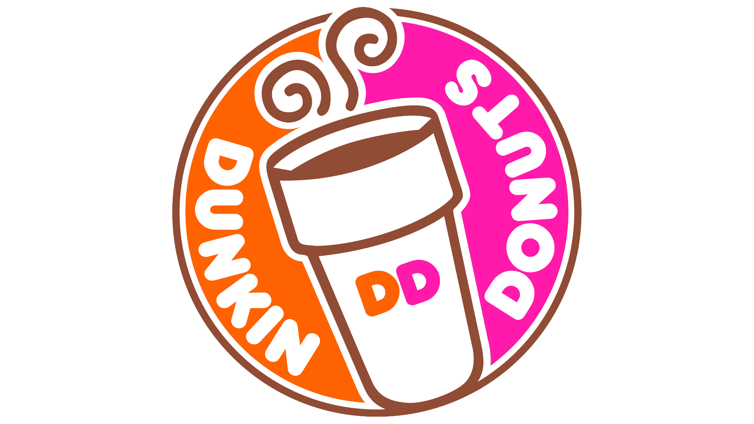

**Dunkin Donuts Simulation Report**

By:

Thasin Wahid

Sharon Nancy

Mazen Alhaffar

Performed under:

Dr. Ehsan Ahmadi

Management Analytics BDA 612

Mercer University

Stetson Hatcher School of Business

**Table of Contents**

**1. Executive Summary:**

**2. Problem Description:**

**3. Model Implementation:**

**a. Process Flow:**

**b. Data Collection and Statistical Analysis:**

**c. Assumptions:**

**d. Simulation Model:**

**e. Simulation Run:**

**4. Simulation Results:**

**5. Conclusion and Recommendation:**

# Executive Summary:

The purpose of our research project was focused on optimizing the operations of Dunkin Donuts through simulation analysis. By evaluating key factors such as queue length (customer waiting line), ordering processing time, and staffing levels in both the drive thru and in store operations, we aim to determine strategies to improve business flow and reduce the bottleneck of our coffee shop. Through our findings, we offer a plan of action that will promote growth in the company and increase customer satisfaction.

# Problem Description:

Like many busy coffee shops and bakery stores, Dunkin Donuts is fortunate to serve a high volume of customers in the drive-thru; therefore, the lines and wait times are exponential and cause customers to look negatively at the store. To make up for the busy hours of the store, employees are overworked, which causes issues with burnout and less time for quality service. We hope to combat these issues through our simulation.

# Model Implementation:

## Process Flow:

Dunkin Donuts has both a drive-thru and in-store option for their customers, the popular option being drive-thru. A typical operations process for the drive occurs when a customer arrives at the drive-thru line in his/her vehicle and supplies their order to their first contact, the drive-thru order taker. The employee takes the order, makes the coffee, and packages the donut; this is the processing for the first employee. Once the order has been placed, the customer will then proceed forward to the drive-thru window to be greeted by the second employee who is the drive-thru cashier. This employee receives the order and hands it to the customer while also taking a form of payment. This is the second employee's processing activity. Once the customer has received their product, they can leave the drive-thru line and exit the system.

The other option for ordering occurs in stores which begins with the customer entering the store and being greeted by the storefront cashier. The customer places their order, and the employee at the front charges the order, makes the coffee, and packages the donut; this is the employees' processing activity. The customer receives the order and then has the option to eat in-store or take it to go. The customer who takes it to go will leave after receiving the food. Comparatively, the customer who dines in will wait for an empty table, finish the food, and then leave the system. The process flow can be depicted in the below image:

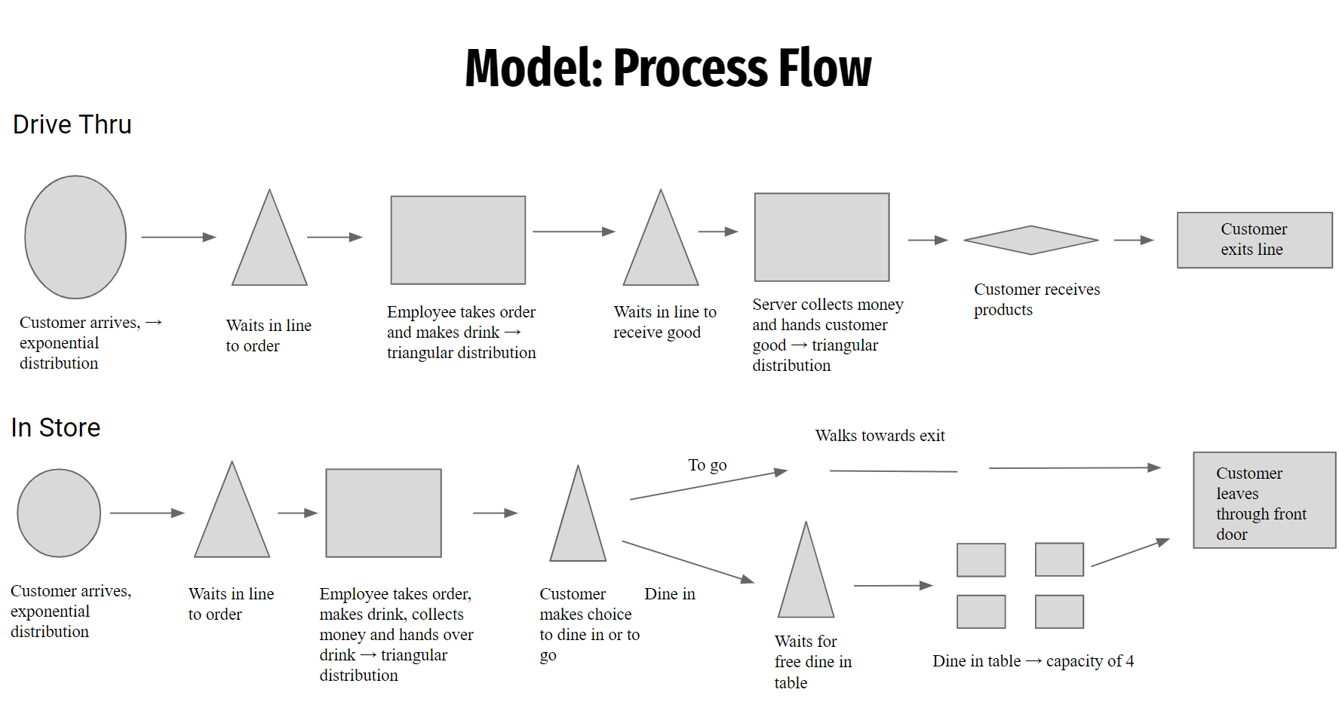

## Data Collection and Statistical Analysis:

In order to collect the data from the specific Dunkin Donuts, we reached out to the store owner to ask for permission to collect data for our simulation research and asked to interview to gather more details from an expert in the industry. The store owner granted us permission to collect insightful data on customer arrival times at both the drive-thru and in-store. They also allowed us to collect data on the processing time for each employee in the process flow, that being the order taker and cashier at the drive-thru, and the cashier at the front. The only request the owner had was that we do not collect data on how long the customer sits and eats at the dining table, as this may not be comfortable for the customers and be seen negatively. This will be further described in our assumptions. We collected the data over a 10-hour period to gather meaningful data on the daily operations of Dunkin. We were present from 6 am to 4 pm. As this is usually the busiest times; 6-9 am being the busiest, and 9-4 slowing down but still relatively busy.

By collecting the data, we were able to have statistical input on customer arrival time and processing time for the employees. The other distribution we gathered was through our questions with the store owner; he has told us that of the customers that arrive in-store 90% will take to go and 10% will sit and sip their coffee or consume donuts. This can be seen in the table below:

|  |  |  |
| --- | --- | --- |
| Part of Process Flow | Time | Distribution |
| Drive-thru Customer Arrival Time | Min = 1 min  Max = 20 mins  Mean = 9 min | Exponential Distribution |
| In In-store Customer Arrival Time | Min = 1 min  Max = 12 mins  Mean = 6.244 min | Exponential Distribution |
| In-store Employee Processing Time | Min = 2 mins  Max = 6 mins  Mean = 3.5 mins | Triangular Distribution |
| Drive-thru Cashier Processing Time | Min = 1 min  Max = 3 mins  Mean = 1.5 mins | Triangular Distribution |
| Drive-thru Order Taker Processing Time | Min = 1 min  Max = 3 mins  Mean = 2 mins | Triangular Distribution |
| Dine-in vs To Go | 10% Dine-in vs. 90% To Go | Discrete Distribution |

The distributions for all besides the discrete distribution were determined by performing a statistical analysis on the data collected, followed by graphing the data to demonstrate the distribution. The statistical analysis included finding average times, minimum times, maximum times, and standard deviation of times.

## Assumptions:

Assumptions are utilized to simplify the model. Due to time constraints as well, the model is limited in ways. Our first assumption occurs that if a customer enters the system, either drive-thru or in-store, they will buy a good. This is justified because in reality, if a person walks into Dunkin Donuts, they plan to purchase a coffee or a donut. If the option they desire is not present, the employee will offer an alternative. The other assumption is that the few customers who choose to dine in will all stay at the dining tables for the same time. This was mainly due to the store owner not feeling comfortable with the possibility of us watching the customers eat and making them uncomfortable. He also mentioned the time to consume a donut is negligible, so we accounted the same time for all that dine-in. The last two assumptions are:

* Homogeneous Behavior: All customers behave similarly and follow the same path while at Dunkin
* Fixed Service Capacities: The number of employees remains constant during the simulation.

## Simulation Model:

The following entities were utilized in the JaamSim simulation:

* **SimEntities:** these represent the customers arriving at Dunkin. There are two to represent those who are arriving via drive-thru or in-store.
* **EntityGenerators:** these are utilized to generate customers and are attached to a distribution to determine the inter-arrival time. There are two of these as well for the same reason as mentioned above.
* **Servers:** The server represents the employees of the store. There are 3: one represents the in-store employee who serves the customers arriving in-store, one represents the drive-thru order taker who takes the order and makes the goods, and the last represents the drive-thru cashier who takes payment and hands off the product.
* **Queues:** the queues represent the periods in which there may be a waiting line/time. There are four to represent the wait for the cashier at the front, the wait for a dining table, the wait to place an order at the drive-thru, and the wait to receive an order at the drive-thru line.
* **EntityProcessor:** this is similar to a server in JaamSim and represents the dining tables. The dining tables are very similar to a server as they are a resource to use. Entityprocesor was used, along with a resource entity, to have a capacity of four dining tables.
* **Branch:** represents when there is a decision to be made. In our simulation, the decision comes from whether the customer wants to carry out the food or dine in once inside the store.
* **EntityConveyer:** represents when the entity moves from one point to another within the process flow. This was used 3 times to represent when the customer is leaving the system.
* **EntitySink:** this represents when an entity has left the system. In this case, there are 2 to represent when a customer leaves the drive-thru line after receiving food and when the customer leaves the store.
* **Distributions:** these were used to demonstrate the inter-arrival times for customers, the processing time for servers, and the discrete distribution for customers who chose to carry out their order or dine in.

These can all be depicted in the below simulation model:

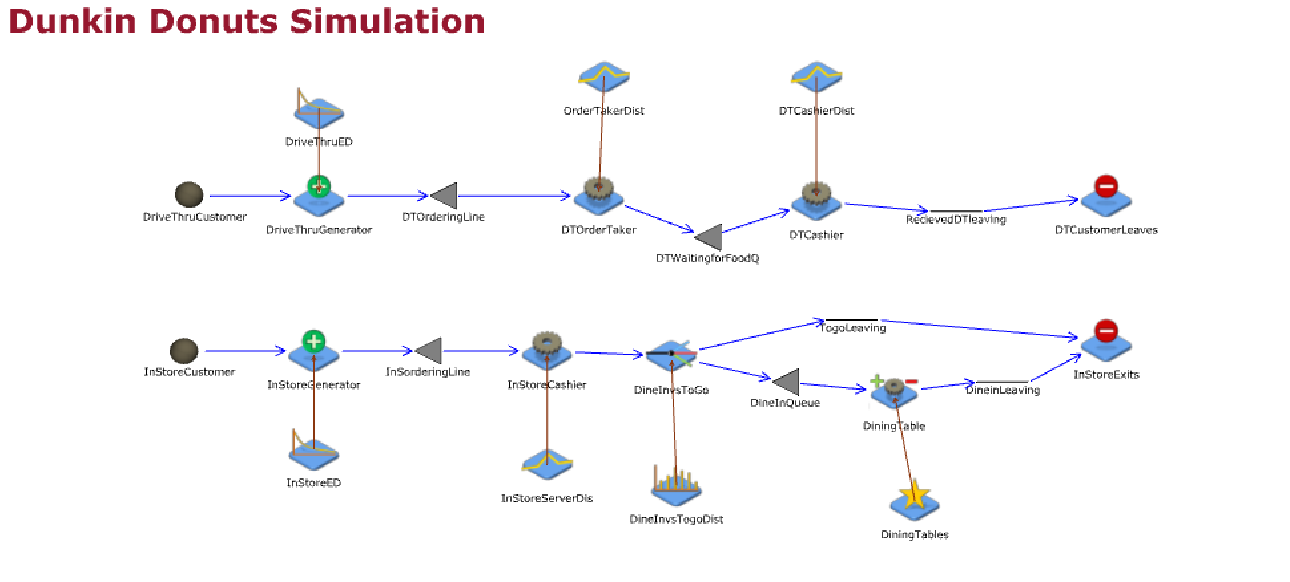

# 

## Simulation Run:

The model was replicated 10 times. The simulation was conducted over an 8-hour period to grasp a meaningful insight into the daily operations of Dunkin Donuts.

# Simulation Results:

The table below summarizes the key results of the simulation model:

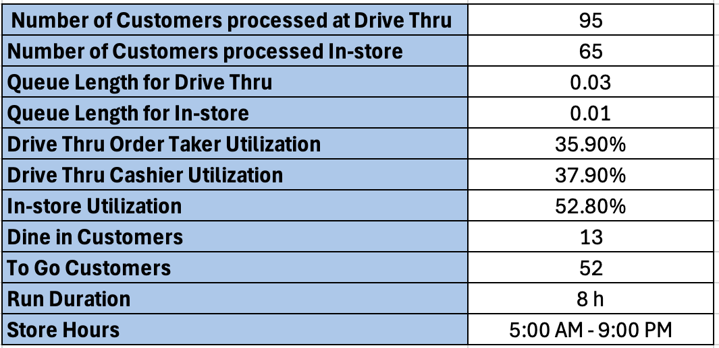

These numbers above are the confidence interval percentages for the 7 categories

The main key findings were the 95 customers entering through drive thru, 65 customers entering through in store, and 0.03 for the queue length in the drive thru. Our goal is to optimize the model by improving the queue length.

The following simulation model shows the fix we implemented to the previous model:

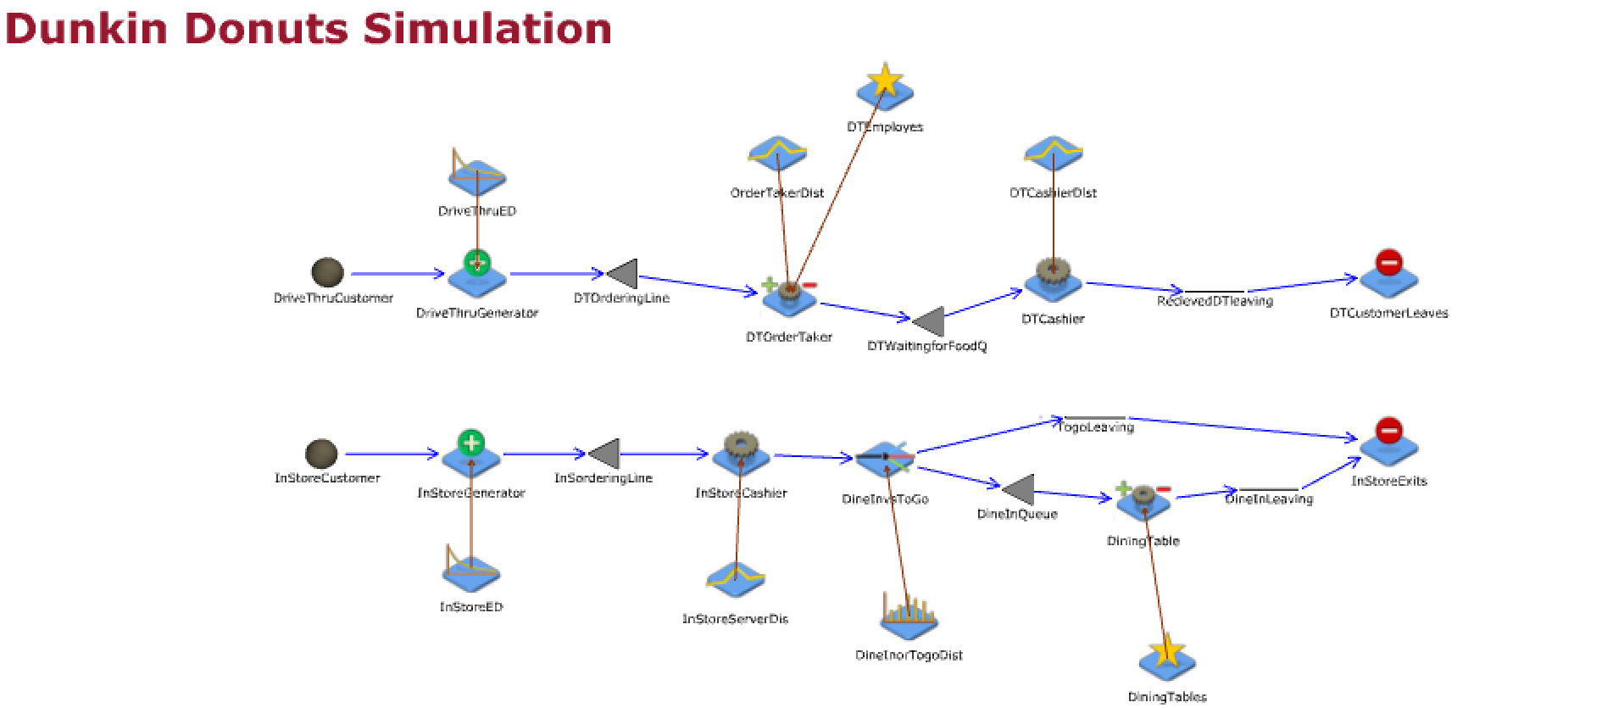

The table shows a comparison of the data after making the improvement:

# 

# 

As seen in the table, we have significantly lowered our queue length. Even though the queue length was already short for the previous model, we have significant evidence that we can make it lower in case of busier times like during rush hours.

# Conclusion and Recommendation:

Although the queue length for the drive-thru and utilization of the drive-thru order taker is not too high, the fact is during the busiest time of the store between 6-9 am, the store experiences long queues and the drive-thru order taker’s utilization is much higher. Thus, the fix will be to hire a second part-time employee at the drive-thru ordering process so we can increase the amount of customers’ orders taken, reduce wait times, generate more profits, and increase customer satisfaction. Based on an interview with the store owner, the pay rate for a drive-thru order taker is $8/hr. By adding an employee, we are confident it will be cost-effective to hire and still make a return on hire. Conversely, the in-store customers are not as busy as the drive-thru, so it does not make sense to hire an employee for the front counter at this time. The most optimal solution would be to hire a second part time drive-thru order taker as that job role serves as the “bottleneck” during the rush hours.

We do have to consider that the model does have its limitations. The main limitation is the time intervals and the data. Since the data was collected from 6 am to 4 pm, the times for interarrival time will be skewed. The interarrival time would be shorter and more often during the rush hour before customers head to work from 6 am to 9 am. The interarrival time increases during lunchtime because customers come less frequently. This means customers might be coming in anywhere from 10-20 mins apart from one another because the store is not as busy. Due to this, this makes the utilization seem very low for the employees, and a second employee is not needed. However, the utilization will be very high during the morning and then lower during the not busy times. This is why we would benefit from a part time employee added during the rush hour for drive thru order taking. After the busy hour, the employee is off and utilization for the full-time employee working will be low and does not require extra help. Next steps would be to hire a part time employee for the morning rush. The costs of onboarding would be negligible in comparison to the amount returned from higher volume of customers and satisfied customers.

Through these recommendations, we can see that the operations of Dunkin can benefit greatly and continue to be a successful coffee and donut shop.