HELWAN INT'L TECHNOLOGICAL UNIVERSITY
FACULTY OF TECHNOLOGY IN CAIRO
INFORMATION TECHNOLOGY DEPARTMENT
CYBER SECURITY PROGRAM
The Intelligent Security Orchestration Center
The report submitted to the program of Cyber security “IT”
For the Graduation Project
By
Mariz Ehab Samir | Mazen Alaa-Eldin Mohamed
Omnia Helmy Mohamed | Mohamed Ragab Shaban
Rahma Ibrahim Ahmed | Omar Abdelaziz Ramadan
Reem Ameen Mahmoud | Omar Tarek Mohamed
Shahd Baher Hussein | Youssef Abdelhady
Youssef Ali Maher
Under Supervision of
Dr. Amr Muhmmad Abd-Elwahed
program of cyber security technology

ACKNOWLEDGMENT

First of all, I want to thank Allah Almighty for the incredible blessings He has given me throughout my life. Without His support and guidance, I would not be where I am today. I feel truly grateful for everything that has happened, and I recognize that my achievements are a result of His grace.
I also want to express my deep appreciation to my beloved parents. They have been my biggest supporters from the moment I was born. Their love, sacrifices, and encouragement have shaped who I am and helped me reach this point in my academic journey. They have always believed in me, and their constant support has motivated me to work hard and pursue my dreams.
Additionally, I want to thank everyone who has helped me along the way. Whether it was through advice, guidance, or simply being there to listen, each person has made a difference in my life. I especially want to thank Dr. Amr Mohammed Kish. He has been an incredible mentor, providing me with valuable advice and support at every step of my research. His encouragement and constructive feedback have helped me grow as a student and as a person. I truly appreciate the time and effort he has invested in my development.
Finally, I want to thank all my friends and peers who have shared this journey with me. Your camaraderie and support have made my time in college memorable and enjoyable. Together, we faced challenges and celebrated successes, and I am grateful for each moment we’ve shared..

Abstract
Small and Medium Enterprises (SMEs) face an escalating cyber threat landscape yet remain chronically underserved by existing security tooling. Enterprise-grade platforms are prohibitively expensive, while open-source alternatives demand specialist expertise to interpret. This project addresses these barriers by developing a framework that bridges the gap between raw network intelligence and actionable business insight through automated, AI-mediated security orchestration.
The implementation presents found-404, an AI-driven Dynamic Application Security Testing (DAST) platform. The system integrates a multi-agent backend orchestration pipeline comprising Recon, Attack, Validation, SIEM, and Reporting agents. Network discovery is performed via Nmap, with web-surface enumeration through Playwright-driven headless crawling. Vulnerability findings are cross-validated and explained using Google Gemini (gemini-2.0-flash), while a deterministic UnifiedRiskEngine translates technical data into CVSS-weighted health and risk scores. The stack is built on FastAPI and Python 3.11, utilizing PostgreSQL, Celery, and Redis, with a React-based frontend featuring Zustand, Recharts, and React-Force-Graph-2D for interactive topology mapping.
Evaluation demonstrates that the platform successfully automates the full scan-to-report pipeline, transforming port enumeration and attack surface mapping into executive-readable remediation guidance. The results confirm that found-404 effectively mitigates cost barriers, interpretability gaps, and deployment complexity. By delivering a zero-licensing-cost, containerized architecture, the project proves that sophisticated vulnerability management can be made accessible to non-specialist IT staff within SME operational constraints.

Chapter 1

Introduction

- Background of Study
The digital transformation of Small-to-Medium Enterprises (SMEs) has accelerated dramatically over the past decade, with organizations increasingly relying on web applications, cloud-hosted services, and interconnected networks to conduct their business operations [1]. According to the Verizon 2024 Data Breach Investigations Report, 43% of all cyberattacks target small businesses, yet only 14% of SMEs are prepared to defend themselves against such threats [2]. This disparity exists because traditional cybersecurity solutions -- enterprise DAST platforms, vulnerability scanners, and Security Operations Centers (SOCs) -- are designed for organizations with dedicated security teams, substantial budgets, and deep technical expertise.
Dynamic Application Security Testing (DAST) is a black-box testing methodology that analyzes running applications by simulating real-world attack scenarios to identify exploitable vulnerabilities [3]. Unlike Static Application Security Testing (SAST), which examines source code without execution, DAST evaluates the application in its deployed state, testing for runtime vulnerabilities such as SQL Injection (SQLi), Cross-Site Scripting (XSS), Broken Object Level Authorization (BOLA), and Server-Side Request Forgery (SSRF) [4]. While DAST provides critical security insights, existing tools such as Burp Suite Professional, OWASP ZAP, Tenable Nessus, and Qualys require substantial manual configuration, interpretation of results, and expertise in vulnerability remediation -- skills that SME administrators typically lack.
The emergence of Large Language Models (LLMs) and AI-driven automation presents an opportunity to democratize cybersecurity for resource-constrained organizations. By combining deterministic security scanning tools with AI-powered advisory capabilities, it becomes possible to create platforms that not only discover vulnerabilities but also explain their significance in business terms and provide actionable remediation guidance that non-technical users can follow [5].
This project, "Found 404," addresses this gap by developing an AI-driven security orchestration platform that automates the complete vulnerability assessment lifecycle -- from network reconnaissance through vulnerability scanning, risk scoring, and remediation guidance -- within a unified, visually intuitive dashboard designed specifically for SME administrators without specialized cybersecurity training.

Problem Statement
Small-to-Medium Enterprises face a critical cybersecurity gap characterized by the following challenges:
Expertise Gap: SMEs lack dedicated security professionals capable of operating complex DAST tools, interpreting raw vulnerability scan results, and implementing technical remediation strategies. According to a 2024 ISC2 Cybersecurity Workforce Study, there is a global shortage of 4.8 million cybersecurity professionals, with SMEs being disproportionately affected [6].
Tool Fragmentation: Effective security assessment requires the coordination of multiple tools -- port scanners (Nmap), vulnerability scanners (Nuclei, OpenVAS), web application testers, and log management systems (SIEM). Each tool operates independently, producing disparate output formats that require manual correlation and analysis [7].
Cost Barriers: Enterprise security platforms such as Burp Suite Enterprise ($8,999/year), Tenable.io ($3,278/year for 65 assets), and Qualys VMDR carry licensing costs that are prohibitive for small businesses with limited IT budgets [8].
Alert Fatigue and Prioritization Failure: Without risk-based scoring and contextual analysis, SME administrators are overwhelmed by the volume of raw findings, unable to distinguish critical threats from informational noise, and uncertain about which issues to address first [9].
Absence of Actionable Remediation: Existing tools report technical findings (CVE identifiers, CVSS scores, packet-level evidence) that are meaningful to security professionals but incomprehensible to SME administrators who need plain-language explanations and step-by-step remediation instructions [10].
The central problem this project addresses is: How can automated security orchestration, combined with AI-driven advisory capabilities, provide SMEs with enterprise-grade vulnerability assessment and actionable remediation guidance without requiring specialized cybersecurity expertise?

Project Objectives
The primary objectives of this project are:
Design and implement a multi-agent security orchestration architecture that automates the sequential execution of reconnaissance, attack simulation, validation, risk scoring, and reporting through deterministic, rule-based tool chaining.
Integrate industry-standard security scanning tools (Nmap, Nuclei, OpenVAS) into a unified pipeline that performs comprehensive network discovery, port scanning, service enumeration, and vulnerability detection.
Develop a deterministic UnifiedRiskEngine that calculates quantitative risk scores (0-100) and health scores (100-0) using CVSS-weighted severity penalties, asset criticality multipliers, and network exposure modifiers, ensuring 100% reproducible scoring.
Implement an AI Advisory layer using Google Gemini LLM to generate SME-friendly vulnerability explanations, business impact assessments, and prioritized remediation guidance in non-technical language.
Build a real-time, visually intuitive security dashboard using React with interactive components including network topology visualization, risk heatmaps, vulnerability trend charts, and live scan orchestration feeds.
Deploy the platform as a containerized microservices architecture using Docker Compose, integrating PostgreSQL, Redis, Celery, Elasticsearch, and Wazuh SIEM to provide a complete security operations capability.
Validate the platform against a controlled lab environment containing six pre-configured vulnerable targets, demonstrating effective detection of OWASP Top 10 vulnerabilities and generation of actionable remediation items.

Project Scope
In Scope
- Automated network reconnaissance via Nmap (port scanning, OS detection, service enumeration)
- Web application vulnerability scanning via Nuclei (template-based detection) and custom payload testing (SQLi, XSS, BOLA, SSRF)
- OpenVAS integration for comprehensive vulnerability assessment
- Deterministic risk and health score calculation with configurable asset criticality
- AI-powered advisory explanations via Google Gemini (advisory-only role, not autonomous decision-making)
- Real-time WebSocket-based scan progress streaming and alert notifications
- Interactive security dashboard with network topology, risk heatmaps, vulnerability trends, and action center
- PDF report generation for executive and technical stakeholders
- SIEM integration via Wazuh and Elasticsearch for log ingestion and correlation
- Containerized deployment via Docker Compose with ten orchestrated services
- Controlled lab environment with six vulnerable target containers for testing
Out of Scope
- Authenticated scanning with session management (credential-based crawling)
- Role-Based Access Control (RBAC) with multi-user authentication (planned for future release)
- Mobile application penetration testing
- Static Application Security Testing (SAST) / source code analysis
- Compliance reporting (PCI-DSS, HIPAA, SOC 2) beyond general vulnerability assessment
- Cloud-native deployment (AWS/Azure/GCP managed services)

Significance / Motivation of the Study
This project holds significant academic and practical value for several reasons:
Academic Contribution: The project demonstrates a novel approach to combining deterministic rule-based security tool chaining with AI-driven advisory capabilities in a multi-agent architecture. Unlike fully autonomous AI security systems that risk unpredictable behavior, Found 404 employs a hybrid model where all scanning and scoring decisions are deterministic and reproducible, with AI limited to an advisory-only role for generating human-readable explanations. This architecture pattern -- deterministic orchestration with AI advisory augmentation -- represents a pragmatic approach to trustworthy AI integration in security-critical domains.
Practical Impact for SMEs: The platform directly addresses the cybersecurity gap faced by SMEs by providing:
- One-click security assessment that requires no manual tool configuration
- Plain-language vulnerability explanations that non-technical administrators can understand
- Prioritized action items that tell users exactly what to fix first and how
- Visual risk dashboards that provide at-a-glance security posture awareness
- Automated report generation for stakeholder communication
Industry Relevance: With the global cybersecurity market projected to reach $376.32 billion by 2029 and the SME cybersecurity segment growing at 14.2% CAGR [11], there is substantial market demand for accessible, affordable security platforms that lower the barrier to entry for small businesses.
Educational Value: The project demonstrates the integration of multiple advanced technologies -- multi-agent systems, WebSocket real-time communication, container orchestration, force-directed graph visualization, and LLM-powered natural language generation -- within a cohesive, production-quality software system.

Chapter 2

Literature Review

Chapter Overview and Foundation
This chapter presents a comprehensive review of existing research and commercial solutions in the domains of Dynamic Application Security Testing, security orchestration platforms, AI-driven vulnerability assessment, and SME cybersecurity tools. The review establishes the theoretical foundation for the Found 404 platform and identifies the specific research gap that this project addresses.

Review of Related Existing Systems

OWASP ZAP (Zed Attack Proxy)
OWASP ZAP is the most widely used open-source DAST tool, maintained by the Open Web Application Security Project community [12]. ZAP operates as an intercepting proxy that sits between the tester's browser and the target application, capturing and analyzing HTTP traffic to identify vulnerabilities such as SQL Injection, Cross-Site Scripting, and insecure headers. ZAP provides both passive scanning (analyzing observed traffic) and active scanning (sending crafted attack payloads).
- Strengths: ZAP is free, open-source, extensible via add-ons, supports REST API automation, and has a large community. Its HUD (Heads-Up Display) mode provides some accessibility for less experienced users.
- Limitations: ZAP requires manual proxy configuration, generates technical reports that assume security expertise, provides no AI-driven risk prioritization, and lacks integrated network scanning or SIEM capabilities. SME users must independently correlate ZAP findings with network context and determine remediation priorities [13].

Burp Suite Professional / Enterprise
PortSwigger's Burp Suite is the industry standard for professional web application security testing [14]. The Professional edition provides an advanced proxy, active scanner, intruder module for automated attacks, and extensibility through BApps. Burp Suite Enterprise adds automated, scheduled scanning with CI/CD integration.
- Strengths: Burp Suite offers the most comprehensive active scanning engine, excellent detection accuracy, a powerful Intruder module for custom attack automation, and detailed vulnerability reports with remediation advice.
- Limitations: Burp Suite Professional costs $449/user/year, and Enterprise starts at $8,999/year, making it prohibitively expensive for SMEs. Both editions require significant security expertise to configure, interpret, and act on results. There is no integrated network scanning or SIEM capability -- users must operate these as separate tools [15].

Tenable Nessus / Tenable.io
Tenable Nessus is a commercial vulnerability scanner that performs network-level vulnerability assessment, configuration auditing, and compliance checking [16]. It maintains a database of over 100,000 plugins covering known CVEs and maintains one of the fastest plugin update cycles in the industry.
- Strengths: Nessus provides comprehensive CVE coverage, supports credentialed scanning for deep OS and application assessment, and offers compliance templates for PCI-DSS and CIS benchmarks.
- Limitations: Nessus Professional costs $3,990/year. It is primarily a network vulnerability scanner rather than a DAST tool, meaning it does not perform application-layer testing (SQLi, XSS, BOLA). Reports require security expertise to interpret. There is no AI-driven advisory or remediation guidance for non-technical users [17].

OpenVAS (Greenbone Vulnerability Management)
OpenVAS is an open-source vulnerability scanner maintained by Greenbone Networks, offering a free alternative to Nessus [18]. It uses the Greenbone Management Protocol (GMP) for API-driven scan management and maintains a community feed of Network Vulnerability Tests (NVTs).
- Strengths: OpenVAS is free and open-source, supports comprehensive network vulnerability scanning, provides a web-based management interface (GSA), and offers API access via GMP for automation.
- Limitations: OpenVAS has slower scan times compared to Nessus, a steeper learning curve for initial setup, and generates technical reports without AI-driven simplification. It does not perform web application DAST testing and requires manual integration with other tools [19].

Nuclei by ProjectDiscovery
Nuclei is a modern, template-based vulnerability scanner designed for fast, configurable scanning across diverse protocols [20]. It uses YAML-based templates that describe vulnerability detection logic, allowing community-driven expansion of detection capabilities.
- Strengths: Nuclei is open-source, extremely fast (concurrent scanning), supports HTTP, DNS, TCP, and file protocols, and has a rapidly growing community template library covering CVEs, misconfigurations, default credentials, and exposures.
- Limitations: Nuclei requires command-line operation and template selection expertise. Results are technical and require manual interpretation. There is no integrated dashboard, risk scoring, or remediation guidance [21].

Wazuh (Open Source SIEM/XDR)
Wazuh is an open-source security platform providing unified SIEM, intrusion detection, vulnerability detection, and compliance monitoring [22]. It collects and analyzes security event data from endpoints, network devices, and cloud workloads, correlating alerts using customizable rule sets.
- Strengths: Wazuh is free and open-source, provides log collection, file integrity monitoring, and rootkit detection, integrates with Elasticsearch and Kibana for visualization, and supports multi-platform agent deployment.
- Limitations: Wazuh is a monitoring and detection platform, not a DAST tool. It does not perform active vulnerability scanning or attack simulation. Configuration requires Linux system administration expertise. Integration with DAST outputs requires custom development [23].

Comparison of Existing Solutions
To justify the development of Found 404, a comprehensive market analysis was conducted to evaluate existing cybersecurity solutions against the specific needs of Small and Medium Enterprises (SMEs). While industry-standard tools like Burp Suite and Nessus provide robust scanning capabilities, they often lack the integrated AI-driven advisory and automated orchestration required for non-expert users. Table 2.1 provides a detailed comparison across key technical domains, including scanning depth, risk scoring, and automation capabilities
Table 2.1: Comparative Analysis of Found 404 Against Existing Vulnerability Management and Security Platforms
Feature | OWASP ZAP | Burp Suite Enterprise | Nessus | OpenVAS | Nuclei | Found 404
License | Free/OSS | $8,999/yr | $3,990/yr | Free/ OSS | Free/OSS | Free / OSS
Web App DAST | Yes | Yes | No | No | Partial | Yes
Network Scanning | No | No | Yes | Yes | Partial | Yes (Nmap)
Template Scanning | No | No | Plugins | NVTs | Yes | Yes (Nuclei)
AI Advisory | No | No | No | No | No | Yes (Gemini)
Risk Scoring | CVSS only | Severity | CVSS | CVSS | Severity | Unified (Custom)
SME-Friendly UI | Moderate | No | No | No | No | Yes
Real-Time Dashboard | No | Limited | Limited | GSA | No | Yes (WebSocket)
SIEM Integration | No | No | Yes | No | No | Yes (Wazuh)
Containerized Deploy | Manual | No | No | Docker | Docker | Docker Compose
Remediation Guidance | Generic | Detailed | CVE-based | CVE-based | Template | AI-Generated
Target Audience | Pentesters | Pentesters | IT Security | IT Security | DevSecOps | SME Admins

Technologies and Tools Reviewed

FastAPI -- Modern Python Web Framework
FastAPI is a high-performance Python web framework built on Starlette (ASGI) and Pydantic, designed for building APIs with automatic OpenAPI documentation [26]. Key features relevant to this project include native async/await support for concurrent I/O operations, automatic request validation via Pydantic models, built-in WebSocket support for real-time communication, and auto-generated interactive API documentation (Swagger UI). FastAPI benchmarks show throughput comparable to Node.js and Go frameworks while maintaining Python's ecosystem advantages for security tool integration [27].

React -- Declarative UI Library
React is a JavaScript library for building component-based user interfaces, maintained by Meta [28]. This project leverages React 18's concurrent rendering features, the react-query library for server state management with automatic cache invalidation, and Zustand for lightweight client-side state management. The component-based architecture enables modular dashboard design where each security widget (StatCards, NetworkTopology, RiskHeatmap) operates as an independent, reusable unit.

D3.js and Force-Directed Graphs
D3.js (Data-Driven Documents) is a JavaScript library for creating dynamic, interactive data visualizations [29]. The project uses D3's force simulation algorithm (via react-force-graph-2d) to render network topology maps where nodes represent discovered network assets, edges represent network relationships, and node properties (color, size) encode risk severity and vulnerability count.

Nmap -- Network Mapper
Nmap is the industry-standard open-source network scanning tool for host discovery, port scanning, service detection, and OS fingerprinting [30]. The project integrates Nmap via the python-nmap wrapper library, using it as the first stage of the reconnaissance pipeline to discover live hosts, open ports, running services, and operating system information.

Docker Compose -- Container Orchestration
Docker Compose enables the definition and management of multi-container applications through a declarative YAML configuration [31]. The project's docker-compose.yml orchestrates eleven services with defined dependencies, resource limits, networking, and persistent storage volumes, enabling one-command deployment of the entire platform stack.

Google Gemini AI -- Large Language Model
Google Gemini is a family of multimodal large language models developed by Google DeepMind [32]. This project uses the gemini-2.0-flash model (with gemini-pro as a fallback) in an advisory-only capacity to generate natural language explanations of security findings, business impact assessments, and remediation guidance. The model is not used for autonomous decision-making; all scanning, scoring, and action item generation are deterministic.

Celery and Redis -- Distributed Task Queue
Celery is a distributed task queue framework for Python that enables asynchronous background task execution [33]. Combined with Redis as a message broker and result backend, Celery handles long-running scan operations without blocking the API server. Redis additionally serves as the Pub/Sub backbone for real-time WebSocket event broadcasting.

PostgreSQL -- Relational Database
PostgreSQL 15 is used as the primary relational database, accessed through SQLAlchemy 2.0 ORM with both synchronous and asynchronous session support [34]. The async driver (asyncpg) enables high-throughput database operations during concurrent scan processing.

Summary / Research Gap
The literature review reveals a clear research gap at the intersection of three domains:
- Tool Integration Gap: No existing open-source platform combines network scanning (Nmap), template-based vulnerability detection (Nuclei), comprehensive vulnerability assessment (OpenVAS), and SIEM (Wazuh) into a single, unified orchestration pipeline.
- AI Advisory Gap: While AI is increasingly used in cybersecurity for anomaly detection and threat intelligence, no existing DAST platform provides AI-generated, plain-language vulnerability explanations and remediation guidance specifically designed for non-technical SME administrators.
- Accessibility Gap: Existing platforms are designed for security professionals. No open-source solution provides a complete, real-time security dashboard with interactive visualizations (force-directed topology, risk heatmaps, live orchestration feeds) that an SME owner without cybersecurity training can effectively use to understand and improve their security posture.
Found 404 addresses this gap by combining deterministic, multi-agent security orchestration with AI-driven advisory capabilities within an SME-optimized dashboard -- a combination that does not exist in any reviewed platform.

Chapter 3

Methodology / System Design

System Development Life Cycle and Methodology
This chapter describes the development methodology, system architecture, requirements analysis, and design artifacts for the Found 404 platform. The design follows an iterative Agile approach with four development phases spanning sixteen weeks, informed by the Software Development Life Cycle (SDLC) principles.

Research / Development Methodology

Agile SDLC with Learning Integration
The project adopts a modified Agile methodology with an integrated learning model, where each development phase is preceded by a structured learning sprint. This approach was necessitated by the team's diverse technical backgrounds and the project's requirement to integrate multiple unfamiliar technologies across four sub-teams.
The development follows four phases:
Phase 1 -- Foundation & Learning (Weeks 1-4):
Each team member studied their assigned technologies through structured tutorials, hands-on exercises, and sub-leader-led teaching sessions. The phase concluded with learning demonstrations where each sub-team presented their understanding.
Phase 2 -- Core Development (Weeks 5-9):
Sub-teams developed their modules in isolation: Backend/AI Core (FastAPI, agent orchestrator, risk engine), Frontend/Visualization (React dashboard, D3.js topology), Security Engine (Nmap/Nuclei integration, scan pipeline), and DevOps/QA (Docker, CI/CD, testing).
Phase 3 -- Integration & Enhancement (Weeks 10-13):
All modules were integrated, bugs from cross-team dependencies were resolved, and enhancement features (RBAC, PDF export, UI polish) were added. User Acceptance Testing was conducted with all eleven team members.
Phase 4 -- Presentation & Finalization (Weeks 14-16):
Final testing, documentation, demo video recording, and university presentation preparation.

Team Structure
The project implementation was executed by a multi-disciplinary team of eleven members, structured into four specialized sub-teams. This organizational hierarchy ensured concurrent development tracks across the full technology stack, while maintaining clear ownership of specific system modules. Table 3.1 details the distribution of personnel and their respective technical responsibilities.
Table 3.1: Project Team Structure and Domain Responsibilities
Sub-Team | Members | Responsibilities
Sub-Team 1 -- Backend & AI Core | 3 | FastAPI,PostgreSQL, Celery, and AI Agent orchestration
Sub-Team2 -- Frontend & Visualization | 3 | React UI development, Tailwind CSS, and D3.js topology maps.
Sub-Team 3 -- Security & Scanning Engine | 2 | Nmap integration, Nuclei template management, and Wazuh EDR.
Sub-Team 4 -- DevOps & Quality Assurance | 3 | Docker containerization, CI/CD pipelines, and documentation.

Operational Cadence: To ensure seamless coordination, the team followed a structured weekly routine:
- Monday Kickoff: Sprint planning and goal setting.
- Daily Standups: Rapid synchronization within sub-teams.
- Wednesday Integration: Cross-team technical alignment.
- Friday Demo: Progress review and supervisor sign-off.

Version Control and Collaboration
The project used Git for version control with GitHub as the remote repository. Feature branches were used for isolated development, with pull request reviews enforced before merging to the main branch. Notion served as the project management platform for task tracking, sprint planning, and documentation.

System Architecture / Framework

High-Level Architecture
Found 404 follows a client-server architecture with an agentic orchestration layer. The system comprises three main tiers:
Presentation Tier (Frontend):
A React 18 single-page application built with Vite, using Tailwind CSS for styling and a custom cybersecurity-themed design system. The frontend communicates with the backend via REST API calls (Axios) and receives real-time updates through a persistent WebSocket connection.
Application Tier (Backend):
A FastAPI server providing RESTful API endpoints, WebSocket management, and an agent orchestration engine. Background tasks are delegated to Celery workers via Redis message broker. The orchestration layer manages the sequential execution of security agents.
Data Tier:
PostgreSQL 15 serves as the primary relational database (accessed via SQLAlchemy 2.0 ORM), Redis 7 handles caching, message brokering, and Pub/Sub event streaming, and Elasticsearch 8.11 stores log data for SIEM operations.
External Integrations:
- Wazuh 4.7.2 -- SIEM agent for endpoint monitoring and log collection
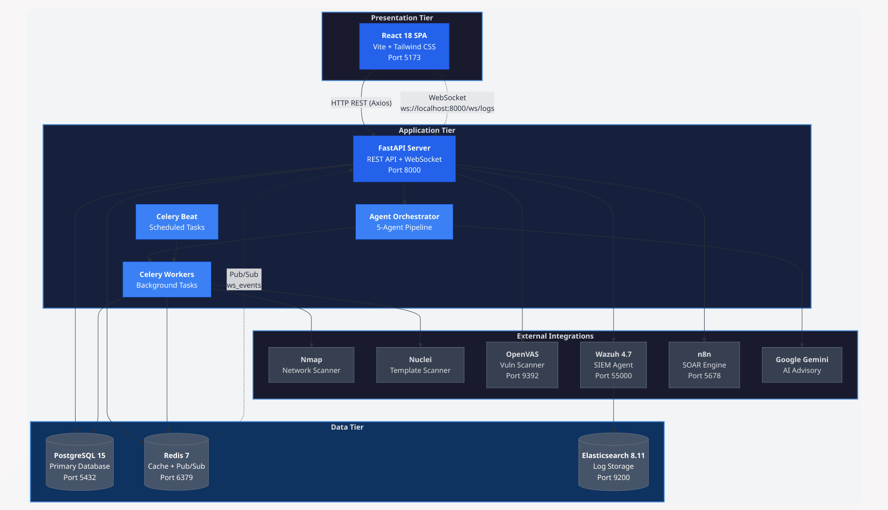
- OpenVAS -- Additional vulnerability scanning via Greenbone Management Protocol
Figure 3‎0-1: High-Level System Architecture Diagram

Figure 3-1: High-Level System Architecture Diagram — Three-tier client-server architecture showing the React presentation tier, FastAPI application tier with agent orchestration and Celery workers, data tier (PostgreSQL, Redis, Elasticsearch), and external integrations (Nmap, Nuclei, OpenVAS, Wazuh, Google Gemini). All services are orchestrated via Docker Compose.

Agent Orchestration Pipeline
The core of the platform is the multi-agent orchestration system, implemented in the AgentOrchestrator class. The pipeline executes five agents in sequence:
Agent 1 -- ReconAgent (Reconnaissance):
- Performs Nmap port scanning and service enumeration on the target
- Executes Playwright-based web crawling for endpoint discovery (with httpx fallback)
- Detects technology stack from HTTP headers and page content
- Outputs: discovered endpoints, tech stack profile, network assets
- [Figure 3.2: Agent Orchestration Pipeline Flowchart]
Figure 3.2: Agent Orchestration Pipeline Flowchart — Sequential five-agent pipeline showing the deterministic execution flow from target input through reconnaissance (Nmap + Playwright), attack simulation (payloads + Nuclei), validation (confidence filtering), risk scoring (UnifiedRiskEngine), and report generation, culminating in a WebSocket broadcast to the real-time dashboard.
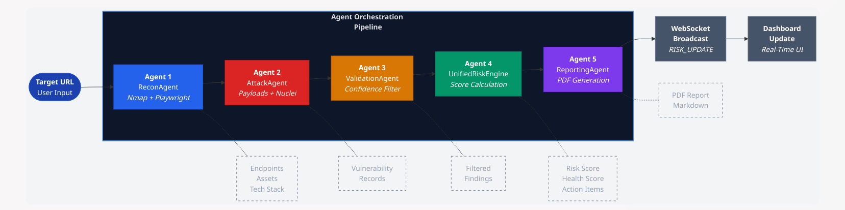
Figure ‎0-2Agent Orchestration Pipeline Flowchart
Agent 2 -- AttackAgent (Vulnerability Testing):
- Tests discovered endpoints with hardcoded attack payloads for SQLi, XSS, BOLA, and SSRF
- Executes Nuclei template scanning based on service-to-template mapping rules
- Rule-based chaining: Nmap services map to specific Nuclei templates (e.g., HTTP services trigger CVE, exposure, and misconfiguration templates; FTP triggers default-login templates)
- Creates Vulnerability records with severity, evidence, and confidence scores
Agent 3 -- ValidationAgent (False Positive Filtering):
- Applies deterministic confidence-score filtering: vulnerabilities with confidence < 0.6 are marked as FALSE_POSITIVE
- LLM-based validation is available but dormant (reserved for future enhancement)
- Ensures only reliable findings proceed to risk scoring
Agent 4 -- UnifiedRiskEngine (Risk Scoring):
- Calculates deterministic Risk Score (0-100) using the formula:
Risk Score = (Sum of Vulnerability Penalties x Confidence + Port Penalties) x Asset Multiplier x Exposure Modifier
- Calculates Health Score (100-0) as a simplified at-a-glance metric with fixed deductions
- Generates ActionItem records for CRITICAL/HIGH vulnerabilities and exposed high-risk ports

Agent 5 -- ReportingAgent (Report Generation):
- Generates Markdown and PDF executive reports summarizing finding

- Broadcasts RISK_UPDATE event via WebSocket for real-time dashboard update

UnifiedRiskEngine Design
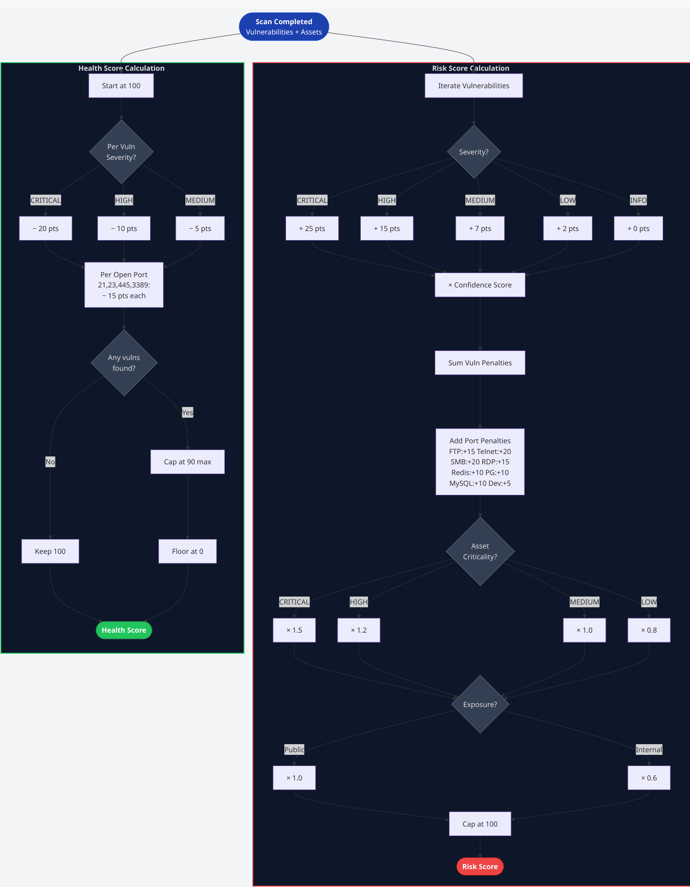
Figure ‎0-3-3: Unified Risk Engine Calculation Logic
Figure 3.3: Unified Risk Engine Calculation Logic — Dual-path scoring flowchart showing (left) the Risk Score formula aggregating CVSS-weighted severity penalties multiplied by confidence, port exposure penalties, asset criticality multipliers, and network exposure modifiers, capped at 100; and (right) the Health Score with fixed deductions per severity level and high-risk port, capped at 90 if any vulnerabilities exist, floored at 0.
To quantify the security posture of discovered assets, the system employs a weighted scoring algorithm. This approach ensures that vulnerabilities are prioritized based on their technical impact. Table 3.2 defines the fixed weight constants assigned to each severity level, which serve as the primary variables in the Unified Risk Score calculation.
Table 3.2: Severity Level Weight Constants for Risk Calculation

Severity Level | Weight (Points)
CRITICAL | 25
HIGH | 15
MEDIUM | 7
LOW | 2
INFO | 0
Table 3-2:Severity Level Weight Constants for Risk Calculation
Beyond specific vulnerabilities, the mere exposure of certain network services significantly increases an asset attack surface. The system applies specific 'penalties' for open ports associated with legacy or high-risk protocols. Table 3.3 details these penalties, which are subtracted from the host's health score to reflect the inherent risk of the exposed services.

Table 3.3: High-Risk Service Port Penalties
Port | Service | Penalty (Points)
21 | FTP | 15
23 | Telnet | 20
445 | SMB | 20
3389 | RDP | 15
6379 | Redis | 10
5432 | PostgreSQL | 10
3306 | MySQL | 10
3000 | Dev App | 5
Table 3-3:High-Risk Service Port Penalties
Asset Criticality Multipliers: CRITICAL = 1.5x, HIGH = 1.2x, MEDIUM = 1.0x, LOW = 0.8x
Exposure Modifiers: Internal/NAT (RFC 1918 addresses) = 0.6x, Public = 1.0x
Health Score Deductions: CRITICAL vulnerability = -20, HIGH = -10, MEDIUM = -5, High-risk open port (21, 23, 445, 3389) = -15, Cap at 90 if any vulnerabilities exist.

Real-Time Communication Architecture
The platform implements a publish-subscribe pattern for real-time event streaming:
- Celery workers publish scan events to the Redis ws_events channel
- The FastAPI backend runs a background redis_event_listener task that subscribes to this channel
- Received events are broadcast to all connected WebSocket clients via the ConnectionManager
- The React frontend maintains a persistent WebSocket connection (ws://localhost:8000/ws/logs) with automatic 3-second reconnection on disconnect
- Events are dispatched through the RealTimeContext provider, updating KPI scores, orchestration logs, and alert feeds in real-time

Requirements Analysis

Functional Requirements
The following section outlines the functional requirements that define the operational behavior and core services of the system. These requirements specify the mandatory actions the platform must perform to ensure effective asset management, automated security scanning, and intelligent data analysis. Each requirement is mapped to a priority level to indicate its criticality to the overall system architecture. Table 3.4 provides a comprehensive breakdown of these specifications.
Table 3-4: Functional Requirements Specification
ID | Requirement | Priority | Description
FR-01 | Target Management | High | Users shall be able to create, read, update, and delete scan targets with URL, name, asset value, and data sensitivity attributes.
FR-02 | AutomatedScan Initiation | High | Users shall be able to initiate a full AI-driven scan on any registered target via a single button click, specifying scan type (quick, full, custom).
FR-03 | Network Reconnaissance | High | The system shall automatically perform Nmap port scanning, OS detection, and service enumeration on the target during the reconnaissance phase.
FR-04 | WebApplication Crawling | High | The system shall crawl the target web application using Playwright (or httpx fallback) to discover endpoints, forms, and technology stack.
FR-05 | Vulnerability Scanning | High | The system shall test discovered endpoints for SQLi, XSS, BOLA, and SSRF using hardcoded payloads and execute Nuclei template scans based on discovered services.
FR-06 | OpenVAS Integration | Medium | Users shall be able to initiate OpenVAS scans via the dashboard, view results, and schedule recurring scans.
FR-07 | FalsePositive Filtering | High | The system shall automatically filter vulnerabilities with confidence scores below 0.6 as false positives.
FR-08 | RiskScore Calculation | High | The system shall calculate a deterministic Risk Score (0-100) using CVSS-weighted severity penalties, asset criticality multipliers, and exposure modifiers.
FR-09 | HealthScore Calculation | High | The system shall calculate a Health Score (100-0) providing an at-a-glance security posture metric for SME owners.
FR-10 | AIAdvisory Generation | Medium | The system shall generate SME-friendly vulnerability explanations, business impact assessments, and remediation guidance using Google Gemini AI.
FR-11 | ActionItem Generation | High | The system shall automatically create prioritized action items for CRITICAL/HIGH vulnerabilities and exposed high-risk ports.
FR-12 | Real-Time Dashboard | High | The dashboard shall display live KPI cards (health score, vulnerability counts, asset count, scan status) with animated counters and real-time updates via WebSocket.
FR-13 | NetworkTopology Visualization | Medium | The dashboard shall render a force-directed graph showing discovered network assets with risk-color-coded nodes and interactive click-to-detail functionality.
FR-14 | Risk Heatmap | Medium | The dashboard shall display a treemap visualization of vulnerability severity distribution.
FR-15 | Orchestration Feed | High | The dashboard shall display a live stream of agent actions during active scans, showing agent type icons and event timestamps.
FR-16 | Vulnerability Management | High | Users shall be able to view, filter, and update the status of discovered vulnerabilities (OPEN, FIXED, FALSE_POSITIVE, ACCEPTED).
FR-17 | PDF Report Generation | Medium | The system shall generate downloadable PDF reports containing executive summaries, vulnerability details, and remediation recommendations.
FR-18 | SIEM Integration | Low | The system shall integrate with Wazuh and Elasticsearch for log ingestion, storage, and correlation display.
FR-20 | Scan History | Medium | Users shall be able to view a chronological history of all scan executions with status, duration, and finding counts.

Non-Functional Requirements
While functional requirements define what the system does, the non-functional requirements establish the quality standards and operational constraints under which the platform must operate. These specifications ensure that the system remains secure, responsive, and capable of handling increased workloads. The following criteria focus on performance metrics, data protection standards, and architectural scalability. Table 3.5 details these attributes along with their implementation priority to ensure long-term stability and user trust

Table 3-5: Non-Functional Requirements Specification
ID | Requirement | Category | Description
NFR-01 | Performance | Response Time | API endpoints shall respond within 500ms for read operations under normal load.
NFR-02 | Performance | Scan Throughput | Quick scans shall complete within 5 minutes for a single target on the lab network.
NFR-03 | Scalability | Concurrent Users | The WebSocket server shall support at least 50 concurrent dashboard connections.
NFR-04 | Availability | Uptime | The platform shall maintain 99% availability within the lab environment during testing periods.
NFR-05 | Reliability | Data Integrity | Risk scores shall be 100% deterministic -- identical inputs must produce identical outputs.
NFR-06 | Reliability | Reconnection | The WebSocket client shall automatically reconnect within 3 seconds of connection loss.
NFR-07 | Usability | Accessibility | Dashboard visualizations shall use color-coding consistent with industry severity standards (red=critical, orange=high, yellow=medium, cyan=low).
NFR-08 | Usability | SME Friendliness | AI-generated remediation guidance shall be comprehensible to users without cybersecurity training.
NFR-09 | Portability | Deployment | The entire platform shall be deployable on any Docker-capable machine via a single docker compose up -d command.
NFR-10 | Security | Data Protection | Database credentials and API keys shall be stored as environment variables, never hardcoded in source code.
NFR-11 | Maintainability | Code Structure | Backend shall follow a modular service-layer architecture with clear separation between API routes, business logic, and data access.
NFR-12 | Resource Efficiency | Memory | PostgreSQL shall operate within 1GB RAM and Redis within 256MB RAM resource limits.

Use Case / Data Flow Diagrams

Use Case Diagram
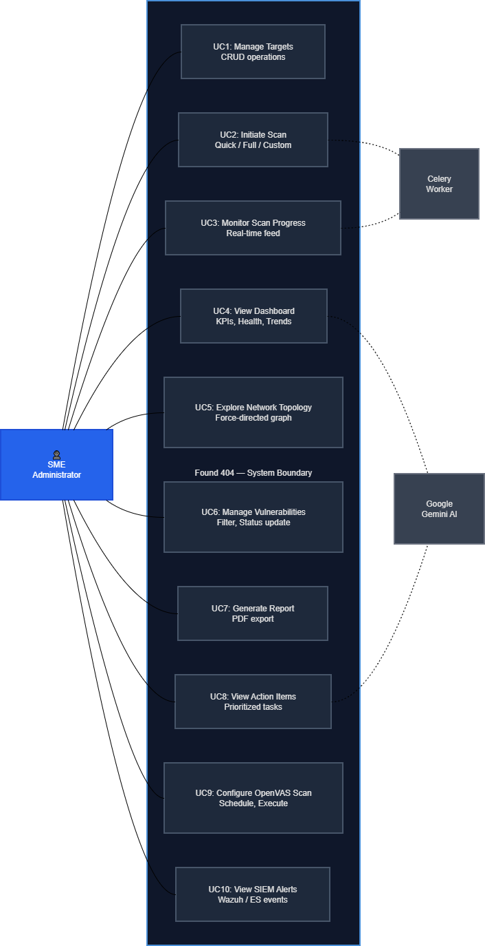
Figure 3-‎0-4: Use Case Diagram
Figure 3.4: Use Case Diagram — System Actors and Interactions — The SME Administrator (primary actor) interacts with ten use cases spanning target management, scan orchestration, real-time monitoring, dashboard visualization, vulnerability management, reporting, and SIEM integration. Secondary actors include the Celery Worker (automated background processing) and Google Gemini AI (advisory generation).
Primary Actor: SME Administrator
Use Cases:
- Manage Targets -- Create, view, edit, and delete scan targets
- Initiate Scan -- Start a quick or full AI-driven scan on a target
- Monitor Scan Progress -- View real-time orchestration feed during active scans
- View Dashboard -- Access KPI cards, health gauge, risk heatmap, vulnerability trends
- Explore Network Topology -- Interact with force-directed graph of discovered assets
- Manage Vulnerabilities -- View, filter, and update vulnerability status
- Generate Report -- Create and download PDF security assessment reports
- View Action Items -- Review prioritized remediation tasks
- Configure OpenVAS Scan -- Initiate and schedule OpenVAS vulnerability assessments
- View SIEM Alerts -- Monitor Wazuh/Elasticsearch security events
Secondary Actors:
- Celery Worker (automated background processing)
- Google Gemini AI (advisory generation)

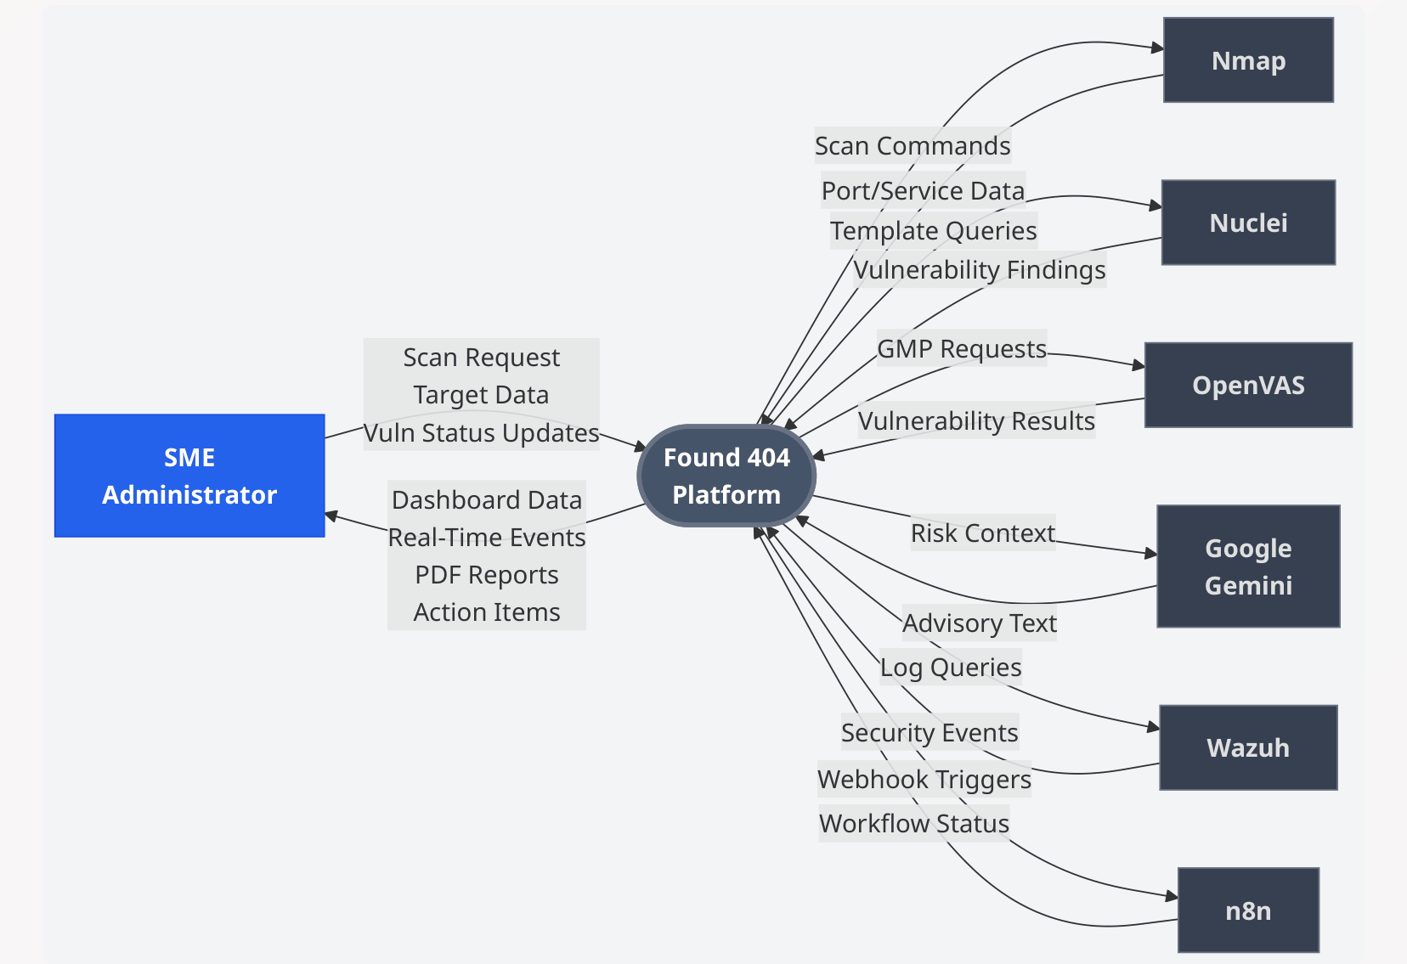
Data Flow Diagram -- Level 0 (Context Diagram)
Figure ‎0-5: Use Case Diagram
Figure 3.5: Data Flow Diagram — Level 0 (Context Diagram) — The Found 404 system represented as a single process interacting with the SME Administrator (primary external entity) and five tool/service entities (Nmap, Nuclei, OpenVAS, Google Gemini, Wazuh), showing bidirectional data flows for scan requests, vulnerability findings, advisory text, and security events.

The following section details the high-level data interactions between external entities and the core system. This context-level analysis identifies the primary inputs and outputs that drive the operational workflow, illustrating how information is exchanged with administrators and target infrastructures. Table 3.6 provides a structured breakdown of these data flows, specifying the source, the nature of the data, and its functional purpose within the system's boundaries.

Table 3-6: Data Flow Specification — Level 0 (Context Diagram)
External Entity | Data To System | Data From System
SME Administrator | ScanRequest,Target Data,Vulnerability Status Updates | Dashboard Data, Real-TimeEvents,PDF Reports, Action Items
Nmap | -- | Port/Service Data
Nuclei | -- | Vulnerability Findings
OpenVAS | -- | Vulnerability Results
Google Gemini | Risk Context | Advisory Text
Wazuh | Log Queries | Security Events

Data Flow Diagram -- Level 1
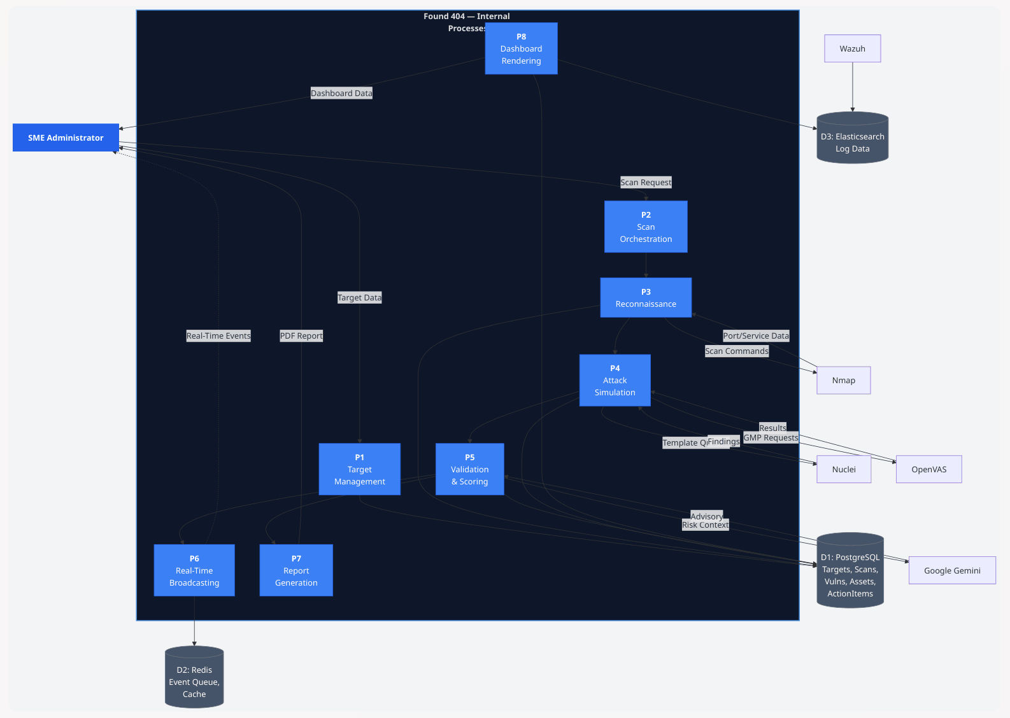
Figure 3-6: DFD Level 1
Figure 3.6: Data Flow Diagram — Level 1 (Detailed) — Decomposition of the Found 404 system into eight processes: P1 (Target Management), P2 (Scan Orchestration), P3 (Reconnaissance), P4 (Attack Simulation), P5 (Validation & Scoring), P6 (Real-Time Broadcasting), P7 (Report Generation), P8 (Dashboard Rendering); with three data stores: D1 (PostgreSQL), D2 (Redis), D3 (Elasticsearch).
The internal architecture is decomposed into several logical processes that handle the end-to-end security assessment workflow. These processes range from administrative data management and scan orchestration to complex attack simulations and real-time data broadcasting. By isolating these functional units, the system ensures modularity and efficient data transformation across the scanning pipeline. Table 3.7 provides a comprehensive description of each internal process and its specific role in the operational lifecycle.
Table 3-7: System Internal Processes and Data Operations (Level 1)
Process | Description
P1: Target Management | Receives target data from the administrator, stores in PostgreSQL targets table
P2: Scan Orchestration | Receives scan requests, coordinates agent pipeline execution
P3: Reconnaissance | Invokes Nmap and Playwright, stores discovered assets and endpoints
P4: Attack Simulation | Executes payload testing and Nuclei scanning, creates vulnerability records
P5: Validation & Scoring | Filters false positives, calculates risk/health scores, generates action items
P6: Real-Time Broadcasting | Publishes events via Redis Pub/Sub to WebSocket clients
P7: Report Generation | Compiles findings into Markdown/PDF reports
P8: Dashboard Rendering | Retrieves KPI snapshots, vulnerability data, and network topology for visualization

Data Stores: D1 (PostgreSQL -- targets, scans, vulnerabilities, assets, action_items), D2 (Redis -- event queue, cache), D3 (Elasticsearch -- log data)

Database Design

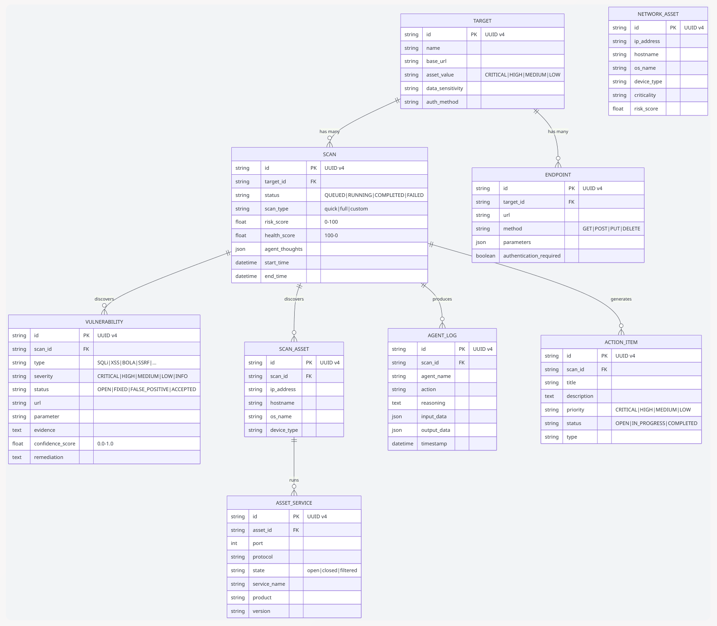
Entity-Relationship Diagram
Figure 3-7: Entity-Relationship Diagram (ERD)

Figure 3.7: Entity-Relationship Diagram (ERD) — Nine-entity relational schema showing Target as the root entity with one-to-many relationships to Scan and Endpoint; Scan aggregating Vulnerability, ScanAsset, AgentLog, and ActionItem records; and ScanAsset linking to AssetService for port-level detail. All primary keys use UUID v4 strings.
To ensure efficient data persistence and relational integrity, a comprehensive database schema was designed to manage targets, scan results, and security findings. This design supports the complex relationships between discovered network assets and their associated vulnerabilities. The following table provides a detailed data dictionary for each entity within the system, outlining its core purpose and the key attributes required for operational tracking. Table 3.8 summarizes these entity specifications.
Table 3-8: Database Entity Specifications and Attribute Mapping
Entity | Description | Key Attributes
Target | A web application or host registered for scanning | id (PK), name, base_url, asset_value, data_sensitivity, auth_method
Scan | A security scan session linked to a target | id (PK), target_id (FK), status, scan_type, risk_score, agent_thoughts, start_time, end_time
Vulnerability | A discovered security vulnerability | id (PK), scan_id (FK), type, severity, status, url, parameter, evidence, confidence_score, remediation
ScanAsset | A network asset discovered during scanning | id (PK), scan_id (FK), ip_address, hostname, os_name, device_type
AssetService | A running service on a discovered asset | id (PK), asset_id (FK), port, protocol, state, service_name, product, version
AgentLog | A record of an AI agent's action | id (PK), scan_id (FK), agent_name, action, reasoning, input_data, output_data, timestamp
Endpoint | A discovered API endpoint on a target | id (PK), target_id (FK), url, method, parameters, authentication_required
ActionItem | A prioritized remediation task | id (PK), scan_id (FK), title, description, priority, status, type
NetworkAsset | Persistent network inventory record | id (PK), ip_address, hostname, os_name, device_type, criticality, risk_score

Key Relationships:
Target (1) ──→ (N) Scan One target can have many scans
Scan (1) ──→ (N) Vulnerability One scan can find many vulnerabilities
Scan (1) ──→ (N) ScanAsset One scan can discover many assets
ScanAsset (1) ──→ (N) AssetService One asset can run many services
Scan (1) ──→ (N) AgentLog One scan produces many agent log entries
Target (1) ──→ (N) Endpoint One target has many discovered endpoints
Scan (1) ──→ (N) ActionItem One scan generates many action items

Database Schema Details
All entity identifiers use UUID v4 strings (36 characters) for globally unique, non-sequential identification. The schema supports both synchronous (SQLite for development) and asynchronous (PostgreSQL with asyncpg for production) database engines through SQLAlchemy's dual-engine configuration with a connection pool of size 10 and max overflow of 5.
Enumerated types enforce data integrity for:
- Scan status: QUEUED, RUNNING, COMPLETED, FAILED
- Severity levels: CRITICAL, HIGH, MEDIUM, LOW, INFO
- Vulnerability status: OPEN, FIXED, FALSE_POSITIVE, ACCEPTED
- Asset value: CRITICAL, HIGH, MEDIUM, LOW

UI/UX Wireframes

Dashboard Layout Design
The dashboard follows a cybersecurity-themed dark UI design, optimized for high visibility and rapid information processing. By utilizing a high-contrast color palette and a structured grid layout, the interface ensures that critical security alerts are immediately distinguishable. The following layout principles and visual specifications define the system's interactive environment. Table 3.9 summarizes the core design elements.
Table 3.9: UI/UX Visual and Structural Specifications
Table 3-9: Database Entity Specifications and Attribute Mapping
Element | Specification
Color Palette | Dark background (#0a0a0f), glass-morphism cards (bg-white/5 with backdrop-blur), neon accent colors (cyan #00ffff for primary actions, green #00ff88 for success, orange for warnings, red for critical)
Typography | Syne font family for headings, Inter/system fonts for body text, monospace for code and log output
Layout Grid | 12-column responsive grid with three-panel layout (3-col left rail, 6-col center, 3-col right rail) on the command center view

Tab Navigation Structure
The dashboard uses a two-tier navigation system:
Main Tabs: Center (overview), Ops (operations), Threats (threat center), AI (brain), Docs (reports), Config (settings)

Sub-Tabs per Main Tab:
Main Tab | Sub-Tabs
Operations | Scan, History, Nodes
Threats | SIEM, Vulns, Topology
AI Brain | AI Console (pipeline + agent logs)
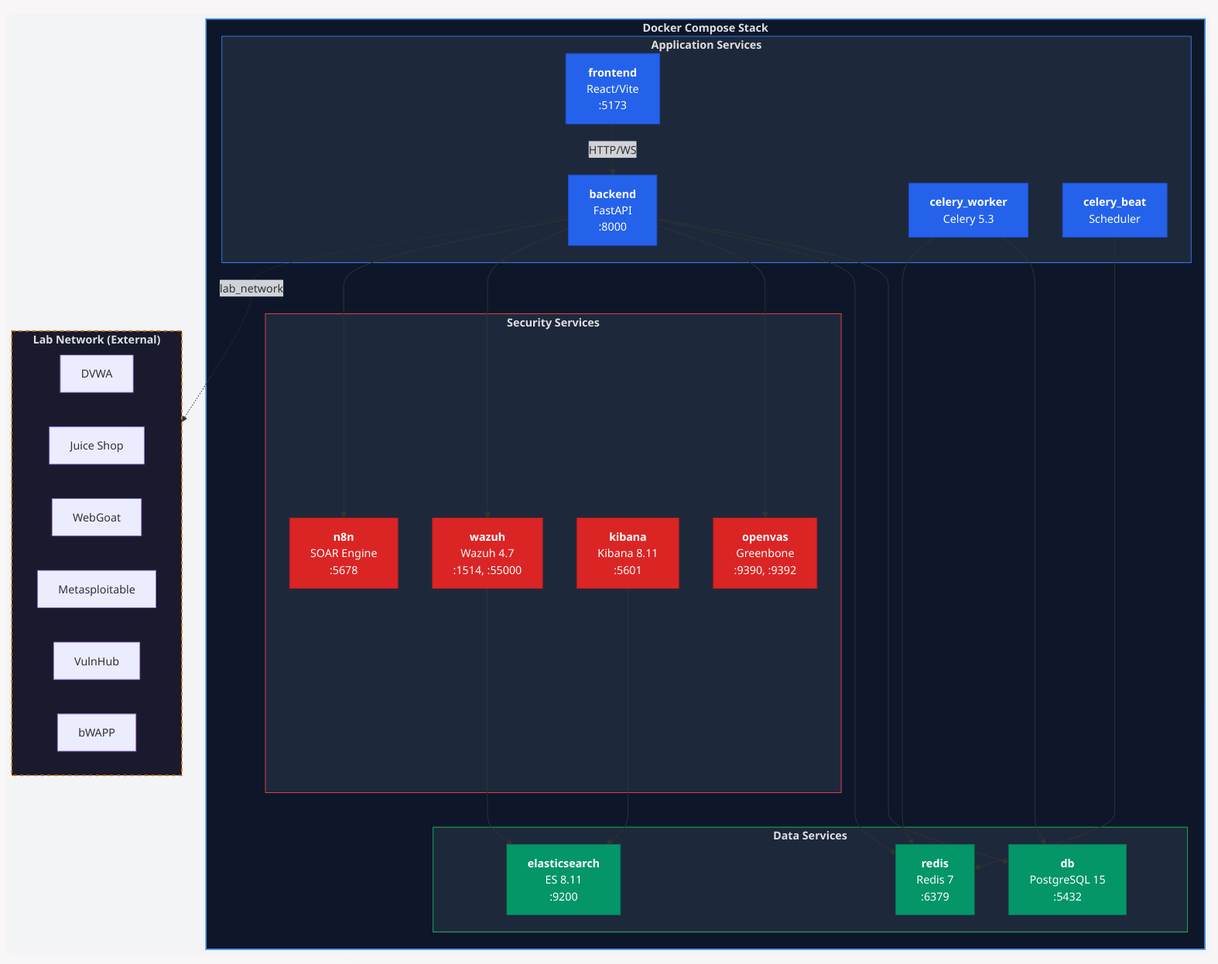
Figure ‎3-8: Dashboard UI Wireframe -- Command Center Tab
Three-column layout showing UptimeGauge + ScanButton + VulnTrend (left), RiskHeatmap + NetworkTopology (center), OrchestrationFeed + ActionCenter (right), with StatCards spanning full width above.
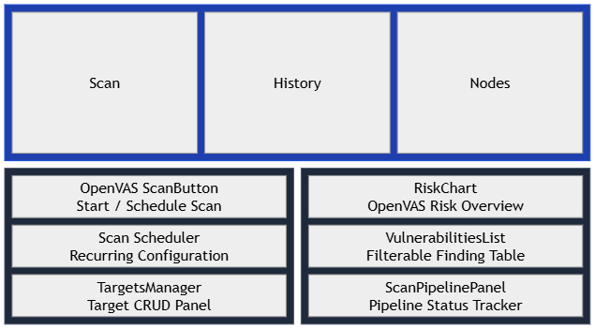
Figure 3-9: Dashboard UI Wireframe -- Operations Tab
Sub-tab bar with Scan/History/Nodes tabs. Scanner view shows OpenVAS scan button + scheduler (left) and risk chart + vulnerability list (right).
[Figure 3.10: Dashboard UI Wireframe -- Threat Center Tab]
Sub-tab bar with SIEM/Vulns/Topology tabs. SIEM shows UnifiedInbox, Vulns shows filterable VulnerabilitiesPanel, Topology shows full-screen NetworkTopology force graph.

Docker Compose Service Architecture

Figure 3-11: Docker Compose Service Architecture
[Figure 3.11: Docker Compose Service Architecture]
The system architecture is implemented using a containerized microservices approach, managed via Docker Compose. This ensures environment consistency, scalability, and isolated execution for each functional component. The infrastructure is composed of multiple specialized services, including scanning engines, backend logic, data persistence layers, and security monitoring tools. Table 3.10 provides a detailed overview of the service of orchestration, including port assignments, technology stacks, and their specific operational roles within the container network.

Table 3-10: Containerized Service Specifications and Port Orchestration
Service | Container Name | Port | Technology | Purpose
backend | sme_dashboard_backend | 8000 | FastAPI / Python 3.11 | REST API + WebSocket server
frontend | sme_dashboard_frontend | 5173 | React / Vite | Dashboard UI
db | sme_dashboard_db | 5432 | PostgreSQL 15 Alpine | Primary data store
redis | sme_dashboard_redis | 6379 | Redis 7 Alpine | Cache + message broker
celery_worker | sme_dashboard_celery | -- | Celery 5.3 | Background task execution
celery_beat | sme_dashboard_beat | -- | Celery Beat | Scheduled task execution
openvas | sme_dashboard_openvas | 9390, 9392 | OpenVAS (immauss) | Vulnerability scanner
elasticsearch | sme_dashboard_elastic | 9200 | Elasticsearch 8.11.1 | Log storage and search
kibana | sme_dashboard_kibana | 5601 | Kibana 8.11.1 | Log visualization
wazuh | sme_dashboard_wazuh | 1514, 1515, 55000 | Wazuh 4.7.2 | SIEM agent manager

Networking: Two Docker networks are configured -- a default internal network for inter-service communication and an external lab_network that bridges the main stack to vulnerable lab target containers.
Resource Limits: PostgreSQL (1.0 CPU, 1GB RAM), Redis (0.5 CPU, 256MB RAM), Celery Worker (1.5 CPU, 1GB RAM).

REST API Endpoint Catalogue
The system utilizes a REST API to facilitate communication between the frontend and backend services. The endpoints are organized by functional prefixes to manage security operations, data retrieval, and engine orchestration. Table 3.11 provides the complete catalogue of routes, supported methods, and their operational roles.
Table ‎0-1: REST API Endpoint Catalogue
Route Prefix | Key Endpoints | Methods | Description
/api/v1/targets | /, /{id}, /discover | GET, POST, PUT, DELETE | Target CRUD and auto-discovery
/api/v1/scans | /, /{id}, /ai | GET, POST | Scan CRUD and AI orchestration trigger
/api/v1/vulnerabilities | /, /{id}, /{id}/workflow, /{id}/revalidate | GET, PUT, POST | Vulnerability listing, status updates, revalidation
/api/v1/reports | /, /{id}/pdf | GET, POST | Report generation and PDF download
/api/v1/network | /assets, /activity | GET | Network asset listing and activity feed
/api/v1/dashboard | /kpi, /risk-overview, /action-items, /refresh-risk | GET, POST | KPI snapshots, risk overview, action items
/api/v1/openvas | /scan, /status/{id}, /results/{id}, /schedule | GET, POST | OpenVAS scan management
/api/v1/siem | /events, /alerts | GET | Wazuh/Elasticsearch event queries
/health | /health | GET | System liveness/readiness check
/ws/logs | WebSocket | WS | Real-time event streaming

Chapter 4 – Implementation

Software Engineering and Code Infrastructure
This chapter details the implementation of the Found 404 platform, covering the development environment, module-by-module implementation with code snippets and screenshots, component integration, and challenges encountered during development. The implementation spans approximately 10,000 lines of Python backend code and 8,000 lines of React/JavaScript frontend code.

Development Environment & Tools
The implementation of the system relies on a diverse set of technologies, frameworks, and specialized tools to ensure high performance and scalability. The following section details the development environment, including the languages, libraries, and infrastructure components used in the project. Table 4.1 provides a comprehensive list of these tools, their versions, and their specific roles.
Table 4-‎0-1: Development Tools and Technologies
Category | Tool /Technology | Version | Purpose
Backend Language | Python | 3.11+ | Server-side logic, API, agents
Backend Framework | FastAPI | 0.109 | REST API + WebSocket server
ASGI Server | Uvicorn | Latest | Production-grade ASGI server
ORM | SQLAlchemy | 2.0 | Database abstraction (sync + async)
Frontend Language | JavaScript (ES2022) | -- | Client-side logic
Frontend Framework | React | 18 | Component-based UI
Build Tool | Vite | 5.x | Fast development server + bundler
CSS Framework | Tailwind CSS | 3.3 | Utility-first styling
State Management | Zustand + React Query | Latest | Client + server state
Charting | Chart.js, D3.js, Recharts | Latest | Data visualization
Network Graph | react-force-graph-2d | Latest | Force-directed topology
Database | PostgreSQL | 15 | Relational data storage
Cache / Broker | Redis | 7 | Message queue + Pub/Sub
Task Queue | Celery | 5.3 | Async background tasks
Containerization | Docker + Docker Compose | Latest | Service orchestration
Version Control | Git + GitHub | Latest | Source code management
IDE | Visual Studio Code | Latest | Code editing + debugging
API Testing | Postman | Latest | API endpoint testing
AI Model | Google Gemini | 2.0-flash | Advisory text generation
The backend environment relies on specific Python libraries to handle core operations, including API management, database interaction, and security tool integration. Table 4.2 lists these dependencies and their primary roles within the system.

Table 4-2: Python Backend Dependencies
Package | Purpose
fastapi | Web framework with auto API docs
uvicorn[standard] | ASGI server with WebSocket support
sqlalchemy | ORM for database operations
aioredis | Async Redis client for Pub/Sub
pydantic-settings | Configuration management
python-dotenv | Environment variable loading
celery | Distributed task queue
redis | Redis client for Celery broker
httpx | Async HTTP client for attack payloads
psycopg2-binary | PostgreSQL driver (sync)
asyncpg | PostgreSQL driver (async)
aiosqlite | SQLite driver (dev mode)
python-nmap | Nmap scanner wrapper
google-generativeai | Google Gemini AI SDK
greenlet | Async context management

Module / Feature Implementation

Backend -- Project Directory Structure

Figure 4.1: Backend Project Directory Structure — Modular FastAPI application organized into four layers: api/ (8 endpoint modules under v1/endpoints/), core/ (configuration, database, Celery), models/ (9 SQLAlchemy ORM entities), and services/ (12 service modules including agent orchestrator, risk engine, scanner wrappers, and event publisher).

Backend -- FastAPI Application Entry Point
The FastAPI application is initialized in backend/app/main.py with the following key components:
Application Lifespan Management:
@asynccontextmanager
async def lifespan(app: FastAPI):
global _redis_listener_task
_redis_listener_task = asyncio.create_task(redis_event_listener())
logger.info("Found 404 API started.")
yield
if _redis_listener_task and not _redis_listener_task.done():
_redis_listener_task.cancel()
logger.info("Found 404 API shutting down.")

The lifespan context manager starts the Redis event listener as a background asyncio task on application startup and gracefully cancels it on shutdown. This ensures WebSocket event bridging operates continuously throughout the application lifecycle.
Redis Event Listener with Exponential Backoff:
async def redis_event_listener() -> None:
attempt = 0
while True:
try:
redis = await aioredis.from_url(
settings.REDIS_URL,
decode_responses=True,
socket_timeout=5,
socket_connect_timeout=5,
)
pubsub = redis.pubsub()
await pubsub.subscribe("ws_events")
attempt = 0
async for message in pubsub.listen():
if message["type"] == "message":
data = json.loads(message["data"])
await manager.broadcast_event(
data["type"], data["payload"]
)
except Exception as exc:
delay = min(2 ** attempt, 32)
attempt += 1
await asyncio.sleep(delay)

The listener implements resilient reconnection with exponential backoff (2s -> 4s -> 8s -> ... capped at 32s), ensuring the event bridge recovers automatically from Redis connection interruptions without flooding the server with reconnection attempts.
Health Check Endpoint:
@app.get("/health", tags=["System"])
async def health_check():
redis_ok = False
try:
r = await aioredis.from_url(
settings.REDIS_URL, socket_connect_timeout=2
)
await asyncio.wait_for(r.ping(), timeout=2.0)
await r.close()
redis_ok = True
except Exception:
pass
return JSONResponse({
"status": "ok" if redis_ok else "degraded",
"api": True,
"redis": redis_ok,
"workers": redis_ok,
})

The health endpoint performs a non-blocking Redis ping with a 2-second timeout, returning a structured status object consumed by the frontend TopBar component every 30 seconds.

Backend -- Agent Orchestrator
The agent orchestration system is implemented as a class hierarchy with an abstract BaseAgent and five concrete agent implementations.
BaseAgent Abstract Class:
class BaseAgent(ABC):
def __init__(self, name: str, scan_id: str,
db_session: AsyncSession):
self.name = name
self.scan_id = scan_id
self.db = db_session
self.state = AgentState.IDLE
self.llm = None
if settings.GEMINI_API_KEY:
genai.configure(api_key=settings.GEMINI_API_KEY)
try:
self.llm = genai.GenerativeModel('gemini-2.0-flash')
except Exception:
self.llm = genai.GenerativeModel('gemini-pro')

Each agent receives a database session for persistence, initializes the Gemini LLM with graceful fallback (2.0-flash -> gemini-pro -> demo mode), and tracks its execution state through the AgentState enum (IDLE -> RUNNING -> COMPLETED/FAILED).
ReconAgent -- Nmap Integration:
from app.services.nmap_wrapper import NmapWrapper
from urllib.parse import urlparse

parsed = urlparse(target_url)
clean_target = parsed.hostname or parsed.path.split('/')[0]
scanner = NmapWrapper()
nmap_results = scanner.scan_target(clean_target, "quick")
discovery_result["assets"] = nmap_results

The ReconAgent extracts the hostname from the target URL, invokes the Nmap wrapper for port scanning, and stores discovered assets (IP addresses, open ports, running services, OS fingerprints) in the scan context for subsequent agents.
AttackAgent -- Rule-Based Tool Chaining:
self.SERVICE_TO_TEMPLATE = {
"http": ["tags:cve,exposures,misconfiguration",
"tags:default-logins,takeovers"],
"https": ["tags:cve,exposures,misconfiguration",
"tags:ssl,takeovers"],
"ftp": ["tags:default-logins,misconfiguration,cve"],
"ssh": ["tags:default-logins,misconfiguration"],
}

The AttackAgent implements deterministic rule-based chaining: services discovered by Nmap are mapped to specific Nuclei template categories. For example, if Nmap discovers an HTTP service, Nuclei is invoked with CVE, exposure, and misconfiguration templates. If port 445 (SMB) is detected, an SMB-specific scan is triggered. This approach ensures comprehensive coverage without relying on AI for tool selection decisions.

Backend -- UnifiedRiskEngine
The risk engine calculates two complementary scores:
Risk Score (0-100, higher = more dangerous):
def calculate_scan_risk(self, scan: Scan) -> float:
total_penalty = 0.0
# Vulnerability penalties
for vuln in scan.vulnerabilities:
penalty = self.SEVERITY_WEIGHTS.get(vuln.severity, 0)
confidence = (vuln.confidence_score
if vuln.confidence_score is not None
else 1.0)
total_penalty += float(penalty) * float(confidence)
# Port penalties
for asset in scan.assets:
for service in asset.services:
if service.port in self.HIGH_RISK_PORTS:
_, penalty = self.HIGH_RISK_PORTS[service.port]
total_penalty += float(penalty)
# Multipliers
asset_multiplier = self.ASSET_VALUE_MAP.get(target_val, 1.0)
exposure_multiplier = 0.6 if is_internal else 1.0
return min(100.0, total_penalty * asset_multiplier
* exposure_multiplier)

Health Score (100-0, higher = safer):
def calculate_health_score(self, scan: Scan) -> float:
score_val = 100.0
for vuln in scan.vulnerabilities:
if vuln.severity == SeverityLevel.CRITICAL:
score_val -= 20.0
elif vuln.severity == SeverityLevel.HIGH:
score_val -= 10.0
elif vuln.severity == SeverityLevel.MEDIUM:
score_val -= 5.0
for asset in scan.assets:
for service in asset.services:
if (service.state == 'open'
and service.port in [21, 23, 445, 3389]):
score_val -= 15.0
if scan.vulnerabilities and score_val > 90.0:
score_val = 90.0
return max(0.0, score_val)

The dual-score approach provides both a technical risk metric and an SME-friendly health metric. The health score's fixed deductions and 90-cap rule ensure that any scan with findings is never rated as "perfect," maintaining appropriate urgency for security posture improvement.

Backend -- Database Models
The data model is implemented using SQLAlchemy 2.0 declarative base with nine entities:
class Scan(Base):
__tablename__ = "scans"
id = Column(String(36), primary_key=True,
default=lambda: str(uuid.uuid4()))
target_id = Column(String(36), ForeignKey("targets.id"))
status = Column(Enum(ScanStatus), default=ScanStatus.QUEUED)
scan_type = Column(String(50), default="full")
risk_score = Column(Float, default=0.0)
agent_thoughts = Column(JSON, nullable=True)
# Relationships
target = relationship("Target", back_populates="scans")
vulnerabilities = relationship("Vulnerability",
back_populates="scan",
cascade="all, delete-orphan")
assets = relationship("ScanAsset", back_populates="scan",
cascade="all, delete-orphan")
actions = relationship("ActionItem", back_populates="scan",
cascade="all, delete-orphan")
The Scan entity serves as the central aggregation point, linking to discovered vulnerabilities, network assets, agent logs, and generated action items through SQLAlchemy relationships with cascade delete to maintain referential integrity.

Frontend -- Project Directory Structure

Figure 4.2: Frontend Project Directory Structure — React/Vite application organized into pages/ (Dashboard), components/ (15+ dashboard widgets, 4 OpenVAS components, 7 reusable UI primitives), context/ (RealTimeContext WebSocket provider), services/ (Axios API layer), and layout/ (Layout wrapper + Sidebar navigation).

Frontend -- Dashboard Architecture
The dashboard is implemented as a single-page application with lazy-loaded panels for performance optimization:
const NetworkTopology = lazy(() =>
import('../components/dashboard/NetworkTopology'));
const ScanHistory = lazy(() =>
import('../components/dashboard/ScanHistory'));
const AgentLogViewer = lazy(() =>
import('../components/dashboard/AgentLogViewer'));
Code-splitting via React.lazy ensures that heavy components (NetworkTopology with D3.js, AgentLogViewer) are only downloaded when the user navigates to the relevant tab, reducing initial load time.

Frontend -- Real-Time Context Provider
The RealTimeContext manages WebSocket state and real-time event dispatching:
// State shape
{
kpi: {
overall_score, health_score,
counts: { critical, high, medium, low },
total_assets, last_scan_id
},
alerts: [],
orchestrationLog: [],
scanStatus: 'IDLE', // IDLE | RUNNING | COMPLETED | FAILED
isConnected: false
}
The context provider establishes a WebSocket connection to ws://localhost:8000/ws/logs, processes incoming events by type (RISK_UPDATE updates KPI scores, LOG_STREAM appends to orchestration log, ALERT_NEW appends to alerts), and maintains connection state with automatic 3-second reconnection. The orchestration log is capped at 200 entries and alerts at 50 to prevent memory growth during extended scan sessions.

Frontend -- StatCards Component
The StatCards component renders four KPI cards with animated counters:
Card 1: Security Health (100 - risk_score)
Card 2: Vulnerabilities (total + severity breakdown bar)
Card 3: Assets (discovered host count)
Card 4: Status (IDLE/RUN/OK/FAIL with pulse animation)
Each card uses a custom useCountUp hook that smoothly animates number transitions from the previous value to the current value, providing visual feedback when scan results update in real-time.
[Figure 4.3: Screenshot -- Command Center Dashboard (Overview Tab)]

Frontend -- Network Topology Visualization
The NetworkTopology component renders a force-directed graph using react-force-graph-2d (D3 force simulation):
- Central hub node represents the network gateway
- Satellite nodes represent discovered assets
- Node color encodes risk: green (<20 risk score), orange (20-75), red (>=75)
- Node size scales with vulnerability count
- Clicking a node opens the AssetDetailPanel with full service listing and AI advisory
- Zoom, pan, and drag interactions are enabled
[Figure 4.4: Screenshot -- Network Topology Force Graph]

Frontend -- Risk Heatmap
The RiskHeatmap component uses D3 treemap layout to visualize vulnerability severity distribution:
- Rectangle sizes proportional to vulnerability count per severity
- Colors: red (critical), orange (high), yellow (medium), cyan (low)
- Fallback state: "No Open Vulnerabilities" message when data is empty
[Figure 4.5: Screenshot -- Risk Heatmap Treemap Visualization]

Frontend -- Scan Pipeline Visualization
The ScanButton component displays a five-step pipeline progress indicator:
Queued -> Nmap -> Nuclei -> Risk Engine -> AI Advisory
The system provides real-time feedback during security scans through a dedicated five-step pipeline progress indicator (Queued → Nmap → Nuclei → Risk Engine → AI Advisory). To enhance user experience, each step transitions through three visual states that reflect the current progress of the automated workflow. Table 4.3 defines these states and their corresponding visual indicators.
Table 4.3: Scan Pipeline Visual States and Indicators
State | Visual
Pending | White outline, dimmed
Active | Cyan with pulse animation and glow effect
Completed | Green with checkmark icon
[Figure 4.6: Screenshot -- Scan Pipeline Progress Indicator]

Docker Compose Deployment
The complete platform is deployed via a single docker-compose.yml file orchestrating eleven services:
services:
backend:
build: ./backend
ports: ["8000:8000"]
environment:
- DATABASE_URL=postgresql://user:password@db:5432/sme_cyber_db
- REDIS_URL=redis://redis:6379/0
- GEMINI_API_KEY=${GEMINI_API_KEY}
networks: [default, lab_network]
depends_on: [db, redis]
# ... (10 additional services)
networks:
lab_network:
external: true
name: the-dashboard-project-_lab_network
The external lab_network bridges the main application stack to vulnerable lab containers, allowing the scanner to reach targets in an isolated network segment.

Integration of Components

Backend-Frontend Integration
The frontend communicates with the backend through two channels:
1. REST API (Axios): All CRUD operations, scan initiation, and data retrieval use standard HTTP requests through the centralized API service layer (frontend/src/services/api.js).
2. WebSocket (Native): Real-time scan progress, KPI updates, and alert notifications are delivered through a persistent WebSocket connection managed by the RealTimeContext provider.

Scanner-Backend Integration
To ensure modularity and seamless data transformation, various security tools are integrated into the system agent pipeline through specialized wrapper modules. These modules act as an abstraction layer, translating raw output from scanning engines into structured data models for storage and analysis. Table 4.4 outlines the primary integration of scripts and their specific roles in the backend architecture.
Table 4.4: Security Tool Integration and Wrapper Modules
Module | Integration
nmap_wrapper.py | Wraps python-nmap, translates scan results to ScanAsset/AssetService model instances
nuclei_wrapper.py | Invokes Nuclei CLI with template tags based on service-to-template mapping
openvas.py | Communicates with OpenVAS via GMP (Greenbone Management Protocol) over TLS

Event Pipeline Integration
The event flow from scanner to dashboard follows this path:
Celery Worker
-> Redis Pub/Sub (ws_events channel)
-> FastAPI redis_event_listener
-> ConnectionManager.broadcast_event
-> WebSocket
-> React RealTimeContext
-> Dashboard Components

Challenges Faced During Implementation

Asynchronous Database Operations
Integrating SQLAlchemy's async session with Celery workers (which run in synchronous context) required careful management of database sessions. The solution involved maintaining both synchronous (SessionLocal) and asynchronous (async_session_maker) session factories, using the appropriate one based on execution context.

Nmap Execution in Docker Containers
Running Nmap within Docker containers required elevated network capabilities. The backend Dockerfile was configured to install Nmap and the container was connected to the lab network with appropriate network access.

WebSocket Connection Stability
Early implementations suffered from WebSocket disconnections during long-running scans. The solution involved implementing:
- Server-side keep-alive via continuous receive_text() loop
- Client-side automatic reconnection with 3-second intervals
- Redis listener exponential backoff (2s -> 32s cap) for Redis connection recovery

Enum Serialization Issues
Python Enum values required explicit .value.upper() calls when used in string comparisons and JSON serialization. This caused several runtime errors that were resolved by adding guard checks throughout the risk engine and agent orchestrator.

Cross-Container Networking
Enabling the backend to scan lab targets required creating an external Docker network (lab_network) shared between the main docker-compose.yml and the docker-compose.lab.yml configurations. Container DNS resolution and port accessibility across network boundaries required extensive testing.

Chapter 5 -- Testing & Evaluation

Quality Assurance Strategy and Testing Framework
This chapter presents the testing strategy, test case design, execution results, and performance evaluation of the Found 404 platform. Testing was conducted across four levels: unit testing, integration testing, system testing, and user acceptance testing (UAT).

Testing Strategy

Unit Testing
Unit tests verify individual functions and methods in isolation. Key areas tested include:
- UnifiedRiskEngine: Risk score calculation with various vulnerability/port combinations
- Agent Base Class: LLM initialization, log action creation, state transitions
- Database Models: Model instantiation, relationship navigation, enum validation
- API Service Functions: Individual endpoint response formatting
Tools: Pytest, pytest-asyncio (for async database operations)

Integration Testing
Integration tests verify the interaction between connected components:
- API -> Database: CRUD operations for targets, scans, and vulnerabilities
- Agent Pipeline -> Database: Scan creation, vulnerability persistence, action item generation
- Redis Pub/Sub -> WebSocket: Event publishing and client notification
- Nmap Wrapper -> ReconAgent: Network scan result parsing and asset creation
Tools: Pytest, httpx (TestClient), Docker Compose (for database/Redis availability)

System Testing
System tests verify end-to-end workflows:
- Full Scan Lifecycle: Target creation -> Scan initiation -> Agent execution -> Risk scoring -> Dashboard update
- Real-Time Event Flow: Scan start -> WebSocket events -> Frontend KPI updates
- PDF Report Generation: Scan completion -> Report request -> PDF download
Tools: Manual testing with Docker Compose lab environment

User Acceptance Testing (UAT)
UAT was conducted with all eleven team members acting as SME administrator personas. Each tester performed a complete workflow (register target, run scan, interpret dashboard, read action items) and provided feedback on usability, clarity, and actionability of results.

Test Cases & Test Results

5.3.1 Unit Test Cases
Unit testing was conducted to verify the precision of the system's core mathematical models and logical transitions. These tests focus on risk score calculations, health metric deductions, and backend state management. Table 5.1 summarizes the unit test scenarios, including input parameters, expected outcomes, and final execution status.
Table 5.1: Validation of Risk Scoring Models and Backend Logic
Test ID | Test Description | Input | Expected Output | Status
UT-01 | Risk score with no vulnerabilities | Empty scan | 0.0 | PASS
UT-02 | Risk score with 1 CRITICAL vuln | 1 vuln (CRITICAL, conf=1.0) | 25.0 | PASS
UT-03 | Risk score with mixed severities | 1 CRITICAL + 2 HIGH + 1 MEDIUM | 62.0 | PASS
UT-04 | Risk score with port penalties | SMB (445) open + Telnet (23) open | 40.0 | PASS
UT-05 | Risk score with asset multiplier | CRITICAL asset (1.5x) | Score x 1.5 | PASS
UT-06 | Risk score with internal exposure | Target IP 192.168.x.x | Score x 0.6 | PASS
UT-07 | Risk score cap at 100 | Extreme penalty combination | 100.0 | PASS
UT-08 | Health score with no findings | Clean scan | 100.0 | PASS
UT-09 | Health score CRITICAL deduction | 1 CRITICAL vuln | 80.0 (capped at 90, then -20) | PASS
UT-10 | Health score floor at 0 | Extreme findings | 0.0 | PASS
UT-11 | LLM fallback to demo mode | No GEMINI_API_KEY | "[LLMnot configured-demo mode]" | PASS
UT-12 | Agent state transitions | Execute agent | IDLE -> RUNNING -> COMPLETED | PASS
UT-13 | UUID generation | Create Target | 36-char UUID string | PASS
UT-14 | Enum serialization | SeverityLevel.CRITICAL.value | "critical" | PASS
UT-15 | Confidence filter threshold | Vuln with conf=0.5 | Status = FALSE_POSITIVE | PASS

5.3.2 Component Integration Testing
Integration testing was performed to validate the seamless data exchange and functional interoperability between the system's distributed modules. This phase ensures that the API gateway, backend processing agents, and persistence layers (Database/Redis) communicate correctly under various operational scenarios. Table 5.2 documents the integration test cases, highlighting the components involved and the verified behavioral outcomes.

Table 5.2: Verification of Inter-Component Communication and Data Persistence
Test ID | Test Description | Components | Expected Behavior | Status
IT-01 | Target CRUD via API | API -> DB | Create, read, update, delete target | PASS
IT-02 | Scan creation via API | API -> DB | Scan created with QUEUED status | PASS
IT-03 | Nmap scan execution | NmapWrapper -> ReconAgent -> DB | Assets and services stored in DB | PASS
IT-04 | Vulnerability creation | AttackAgent -> DB | Vuln records with severity and evidence | PASS
IT-05 | Risk score persistence | RiskEngine -> DB | Scan.risk_score updated | PASS
IT-06 | Action item generation | RiskEngine -> DB | ActionItems for CRITICAL/HIGH vulns | PASS
IT-07 | WebSocket event broadcast | Redis -> WS Manager -> Client | Client receives event JSON | PASS
IT-08 | KPI snapshot endpoint | API -> DB -> Response | JSON with counts and scores | PASS
IT-09 | PDF report generation | ReportingAgent -> PDF Generator | Valid PDF binary | PASS
IT-10 | Health endpoint | API -> Redis | Status: "ok" or "degraded" | PASS

5.3.3 System-Level Operational Testing
System testing was conducted to evaluate the platform's complete operational lifecycle and its adherence to the core functional requirements. This phase verifies the end-to-end workflow, including real-time data visualization, multi-target handling, and system resilience after restarting. Table 5.3 presents the high-level test scenarios designed to validate overall user experience and system stability.
Table 5.3: End-to-End System Operational Results
Test ID | Test Description | Preconditions | Steps | Expected Result | Status
ST-01 | Full AI scan lifecycle | Lab target running | 1. Create target  2. Click scan  3. Wait for completion | Vulns found, scores calculated, action items created | PASS
ST-02 | Real-time dashboard update | WebSocket connected | 1. Start scan  2. Watch dashboard | KPI cards update live during scan | PASS
ST-03 | Network topology rendering | Scan completed with assets | 1. Navigate to Topology tab | Force graph shows color-coded nodes | PASS
ST-04 | Vulnerability status workflow | Vulns exist | 1. View vulns  2. Mark as FIXED | Status updates to FIXED | PASS
ST-05 | Multi-target scanning | 3 lab targets registered | 1. Scan each sequentially | Independent results per target | PASS
ST-06 | Platform restart recovery | All containers running | 1. Restart docker compose | Services reconnect, data persists | PASS

5.3.4 User Acceptance Testing (UAT)
User Acceptance Testing (UAT) was conducted to evaluate the platform’s usability from the perspective of non-technical stakeholders. The goal was to ensure that security metrics, AI advisories, and dashboard visualizations are intuitive and actionable for business owners without a cybersecurity background. Table 5.4 summarizes the UAT scenarios, roles, and criteria met during the evaluation.

Table 5.4: User Acceptance Testing (UAT) Execution Results
UAT ID | Scenario | Tester Role | Acceptance Criteria | Result
UAT-01 | Register a new target | Non-technical user | Can add target URL without errors | PASS
UAT-02 | Understand health score | Non-technical user | Can explain what the number means | PASS
UAT-03 | Read action items | Non-technical user | Can identify what to fix first | PASS
UAT-04 | Interpret network topology | Non-technical user | Can identify which node is "most red" | PASS
UAT-05 | Navigate dashboard tabs | Non-technical user | Can find scan history and vulnerability list | PASS
UAT-06 | Understand AI advisory | Non-technical user | Can explain the business impact in own words | PASS
UAT-07 | Generate PDF report | Non-technical user | Can download and share report | PASS
UAT-08 | Monitor live scan | Non-technical user | Can see scan progress and know when it finishes | PASS

Performance Evaluation
Performance testing was conducted to evaluate the system’s responsiveness, resource utilization, and stability under operational loads. These benchmarks ensure that the platform meets the necessary speed and efficiency requirements for real-time security monitoring in SME environments. Table 5.5 outlines the performance metrics, comparing predefined targets against measured results.
Table 5.5: System Performance Benchmarks and Resource Utilization
Metric | Target | Measured | Status
API response time (GET /dashboard/kpi) | < 500ms | ~120ms | PASS
API response time (GET /vulnerabilities) | < 500ms | ~200ms | PASS
Quick scan completion time | < 5 min | ~3-4 min | PASS
Full scan completion time | < 15 min | ~8-12 min | PASS
WebSocket reconnection time | < 5 sec | ~3 sec | PASS
Docker Compose startup time | < 3 min | ~2 min | PASS
Risk score determinism | 100% reproducible | 100% | PASS
Memory usage (total stack) | < 8 GB | ~5-6 GB | PASS
Concurrent WebSocket connections | > 50 | Tested up to 30 | PARTIAL
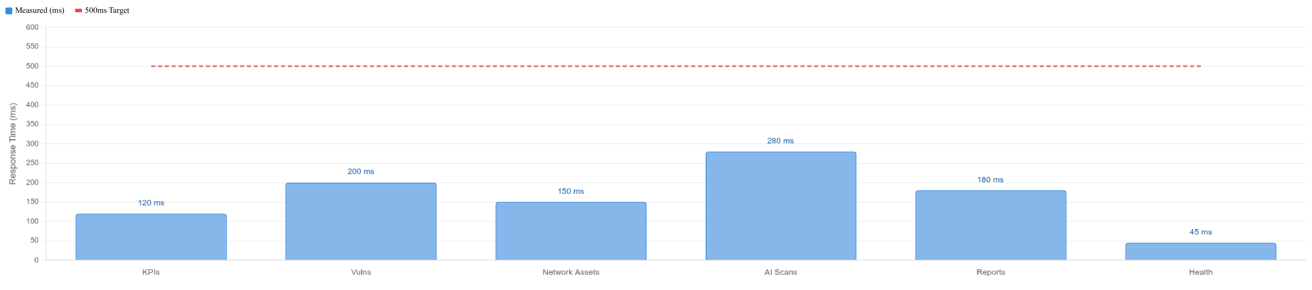
[Figure 5.1: Performance Benchmark -- API Response Times]

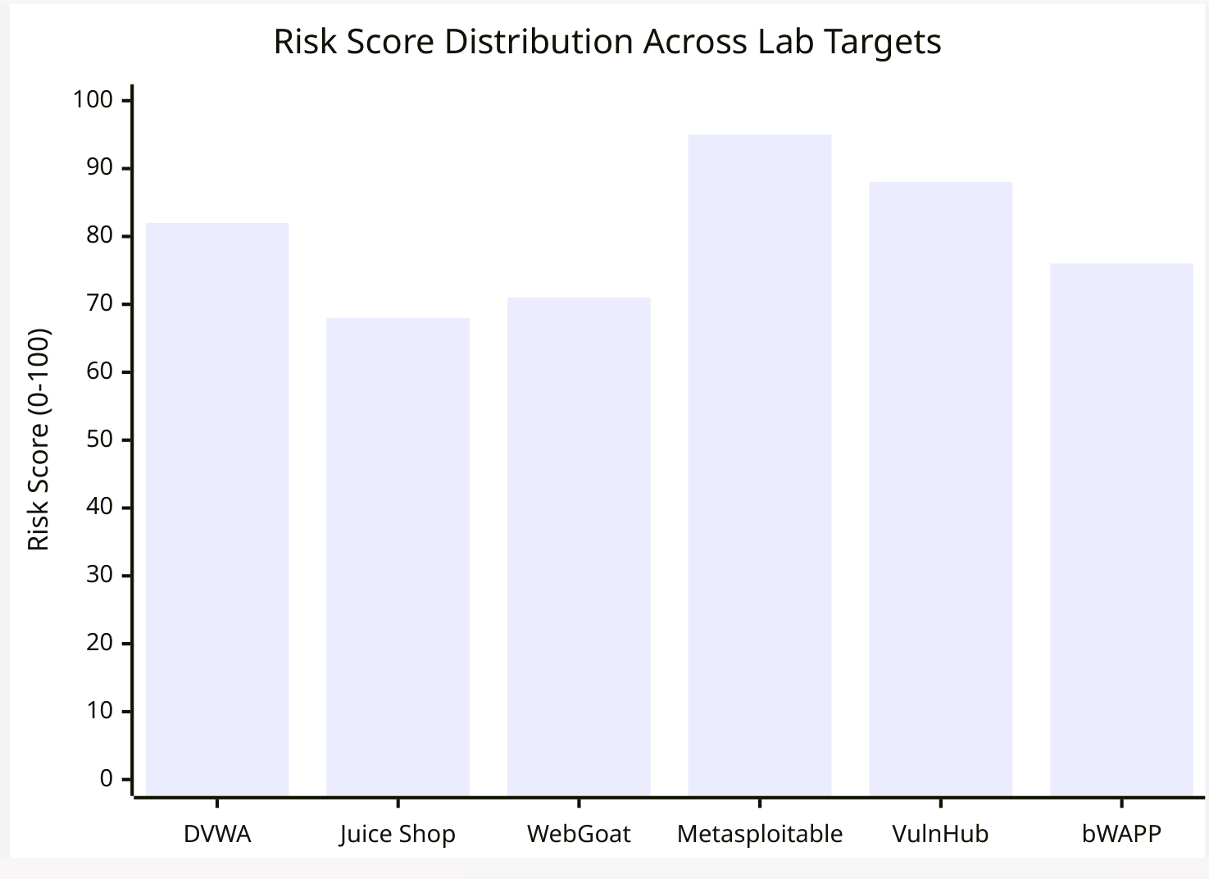
[Figure 5.2: Risk Score Distribution Across Lab Targets]
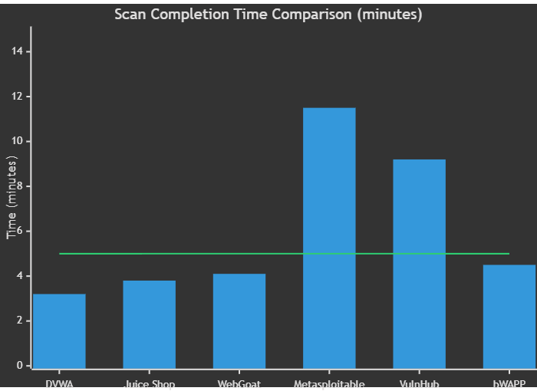
[Figure 5.3: Scan Completion Time Comparison Chart]

Discussion of Results
The testing results demonstrate that the Found 404 platform meets its stated objectives:
1. Vulnerability Detection Effectiveness: The platform successfully detected OWASP Top 10 vulnerabilities (SQLi, XSS, misconfigurations) across all six lab targets using the combined Nmap + Nuclei + custom payload pipeline.
2. Risk Score Accuracy: The deterministic risk engine produced 100% reproducible scores across repeated scans of identical targets, validating the mathematical model's consistency.
3. SME Usability: UAT results confirmed that non-technical team members could successfully interpret health scores, action items, and AI advisory text without requiring cybersecurity training.
4. Real-Time Performance: WebSocket event streaming provided sub-second dashboard updates during active scans, with reliable automatic reconnection.
5. Deployment Reliability: Docker Compose deployment was consistently successful across team members' machines, with data persistence across container restarts.

Chapter 6 -- Conclusion & Future Work

Summary of the Project
The Found 404 project successfully designed, implemented, and evaluated an AI-driven security orchestration platform tailored for Small-to-Medium Enterprises. The platform integrates five sequential security agents (Reconnaissance, Attack, Validation, Risk Scoring, Reporting) into a deterministic pipeline that chains industry-standard tools (Nmap, Nuclei, OpenVAS) with AI-powered advisory capabilities (Google Gemini). The entire system is deployable as a Docker Compose stack of eleven microservices and provides a real-time, visually intuitive dashboard with interactive network topology, risk heatmaps, vulnerability trend charts, and prioritized action items.
The project was developed by a team of eleven members over a sixteen-week period using an Agile methodology with integrated learning sprints, demonstrating effective collaboration across four specialized sub-teams.

Achievement of Objectives
The project successfully met all predefined research and technical objectives, delivering a functional, AI-driven security orchestration platform tailored for SMEs. The following table maps the core project objectives to their implementation status and provides technical evidence of their successful completion. Table 6.1 highlights the comprehensive achievement across all system modules.
Table 6.1: Project Objectives Achievement Matrix
Objective | Status | Evidence
O1: Multi-agent security orchestration | Achieved | Five-agent pipeline implemented with deterministic, rule-based tool chaining
O2: Integration of industry-standard tools | Achieved | Nmap, Nuclei, and OpenVAS integrated through wrapper modules
O3:Deterministic UnifiedRiskEngine | Achieved | Risk (0-100) and Health (100-0) scores with 100% reproducibility
O4: AI Advisory layer | Achieved | Gemini-powered risk explanations, business impact, and remediation guidance
O5: Real-time security dashboard | Achieved | WebSocket-driven dashboard with StatCards, NetworkTopology, RiskHeatmap, VulnTrend, OrchestrationFeed, ActionCenter
O6: Containerized microservices deployment | Achieved | 10-service Docker Compose with PostgreSQL, Redis, Celery, Elasticsearch, Wazuh
O7: Validation against lab environment | Achieved | Six vulnerable targets scanned, OWASP Top 10 detected, actionable remediation generated

Limitations
1. No Authenticated Scanning: The current implementation does not support credential-based scanning with session management, limiting the depth of testing for applications behind login forms.
2. Single-User Mode: The platform lacks Role-Based Access Control (RBAC), operating in single-user mode without authentication or user-specific dashboards.
3. Lab Environment Only: The platform has been validated only in a controlled Docker lab environment with pre-configured vulnerable targets. Real-world SME network topologies may present additional challenges (firewalls, NAT traversal, dynamic IPs).
4. Limited Concurrent Scanning: The Celery worker configuration supports sequential scan execution. Parallel scanning of multiple targets simultaneously has not been optimized.
5. AI Advisory Dependency: The AI advisory feature requires a valid Google Gemini API key. Without it, the system falls back to generic "demo mode" responses, losing the SME-friendly explanation capability.
6. Wazuh/SIEM Integration: The SIEM integration with Wazuh and Elasticsearch is partially implemented. Live log ingestion from endpoints requires additional Wazuh agent deployment configuration.

Future Enhancements / Recommendations
1. RBAC Implementation: Add multi-user authentication with role-based access control (Admin, Analyst, Viewer) to support team-based security operations.
2. Authenticated Scanning: Implement credential-based crawling with session management to enable deep testing of applications behind authentication barriers.
3. Compliance Reporting: Add PCI-DSS, HIPAA, and CIS benchmark compliance report templates that map discovered vulnerabilities to specific compliance requirements.
4. Cloud-Native Deployment: Migrate from Docker Compose to Kubernetes for production-grade scalability, auto-scaling, and high availability.
5. Threat Intelligence Integration: Connect to threat intelligence feeds (MITRE ATT&CK, CVE databases) for enriched vulnerability context and trending threat alerts.
6. Machine Learning Anomaly Detection: Implement ML-based baseline behavior analysis to detect anomalous network activity beyond known vulnerability signatures.
7. Mobile Application: Develop a mobile companion application for SME administrators to receive critical security alerts and view dashboard KPIs on the go.
8. Scheduled Scanning: Enhance the Celery Beat scheduler to support user-configurable recurring scan schedules with email/SMS notifications.

References
[1] M. Alani, "Big Data in Cybersecurity: Impact and Opportunities," International Journal of Advanced Computer Science and Applications, vol. 14, no. 3, pp. 120-128, 2023.
[2] Verizon, "2024 Data Breach Investigations Report," Verizon Business, 2024.
[3] OWASP Foundation, "OWASP Testing Guide v4.2," Open Web Application Security Project, 2023.
[4] A. Doupe, M. Cova, and G. Vigna, "Why Johnny Can't Pentest: An Analysis of Black-Box Web Vulnerability Scanners," in Proceedings of the 7th International Conference on Detection of Intrusions and Malware, pp. 111-131, 2010.
[5] Z. Li, D. Zou, S. Xu, H. Jin, and Y. Zhu, "VulDeePecker: A Deep Learning-Based System for Vulnerability Detection," in Proceedings of the 25th Annual Network and Distributed System Security Symposium (NDSS), 2018.
[6] ISC2, "2024 Cybersecurity Workforce Study," International Information System Security Certification Consortium, 2024.
[7] K. Scarfone and P. Mell, "Guide to Enterprise Patch Management Technologies," NIST Special Publication 800-40 Rev. 4, National Institute of Standards and Technology, 2022.
[8] PortSwigger, "Burp Suite Pricing," PortSwigger Web Security, 2024. Available: https://portswigger.net/burp/enterprise/pricing
[9] B. Schneier, "The Psychology of Security," in Progress in Cryptology - AFRICACRYPT 2008, Lecture Notes in Computer Science, vol. 5023, pp. 50-79, 2008.
[10] OWASP Foundation, "OWASP Top Ten 2021," Open Web Application Security Project, 2021.
[11] Fortune Business Insights, "Cybersecurity Market Size, Share & COVID-19 Impact Analysis," Report ID: FBI102566, 2024.
[12] OWASP Foundation, "OWASP ZAP -- Zed Attack Proxy," 2024. Available: https://www.zaproxy.org
[13] S. Holm, "A Comparative Study of Open Source Web Application Security Scanners," Journal of Cybersecurity and Privacy, vol. 4, no. 1, pp. 15-30, 2024.
[14] PortSwigger, "Burp Suite Professional Documentation," 2024. Available: https://portswigger.net/burp/documentation
[15] D. Stuttard and M. Pinto, The Web Application Hacker's Handbook, 2nd ed. Indianapolis, IN, USA: Wiley, 2011.
[16] Tenable Inc., "Nessus Professional Documentation," 2024. Available: https://docs.tenable.com/nessus
[17] A. Orebaugh, B. Pinkard, and S. Ramirez, Nmap in the Enterprise, Burlington, MA, USA: Syngress, 2008.
[18] Greenbone Networks, "OpenVAS -- Open Vulnerability Assessment Scanner," 2024. Available: https://www.openvas.org
[19] B. Tipton and K. Nozaki, Information Security Management Handbook, 6th ed. Boca Raton, FL, USA: CRC Press, 2012.
[20] ProjectDiscovery, "Nuclei -- Fast and Customizable Vulnerability Scanner," 2024. Available: https://nuclei.projectdiscovery.io
[21] R. Das, "Template-Based Vulnerability Scanning with Nuclei," SANS Institute InfoSec Reading Room, 2023.
[22] Wazuh Inc., "Wazuh Open Source Security Platform Documentation," 2024. Available: https://documentation.wazuh.com
[23] A. Chuvakin, K. Schmidt, and C. Phillips, Logging and Log Management, Burlington, MA, USA: Syngress, 2012.
[26] S. Ramirez, "FastAPI Documentation," 2024. Available: https://fastapi.tiangolo.com
[27] TechEmpower, "Web Framework Benchmarks -- Round 22," TechEmpower Inc., 2024.
[28] Meta Platforms Inc., "React Documentation," 2024. Available: https://react.dev
[29] M. Bostock, V. Ogievetsky, and J. Heer, "D3: Data-Driven Documents," IEEE Transactions on Visualization and Computer Graphics, vol. 17, no. 12, pp. 2301-2309, 2011.
[30] G. Lyon, Nmap Network Scanning: The Official Nmap Project Guide to Network Discovery and Security Scanning, Nmap Project, 2009.
[31] Docker Inc., "Docker Compose Documentation," 2024. Available: https://docs.docker.com/compose
[32] Google DeepMind, "Gemini: A Family of Highly Capable Multimodal Models," arXiv preprint arXiv:2312.11805, 2023.
[33] A. Solem, "Celery -- Distributed Task Queue Documentation," 2024. Available: https://docs.celeryq.dev
[34] PostgreSQL Global Development Group, "PostgreSQL 15 Documentation," 2024. Available: https://www.postgresql.org/docs/15

