Milestone 6 Roadmap
Waymo External Validation and Generalization Analysis
Implementation checklist for the IEEE T-IV object detection project.

Current baseline: Milestones 4 and 5 are complete, audited, committed, and pushed. Latest known commit: 9a23567 on main.
Milestone 6 is not a training milestone. It is the cross-dataset external validation milestone: locked KITTI-trained models are evaluated directly on Waymo.

1. Objective and Scope
Milestone 6 evaluates how well the KITTI-trained detectors generalize to Waymo without retraining. The output should be usable as a paper-ready external validation section.
- Apply the locked YOLO, RT-DETR, RetinaNet, and Faster R-CNN checkpoints directly to the Waymo representative subset.
- Measure domain-shift degradation by comparing Milestone 5 KITTI validation metrics with Milestone 6 Waymo external validation metrics.
- Compute Generalization Ratio = mAP_Waymo / mAP_KITTI for detector-level and class-level stability.
- Identify which class suffers the largest degradation: Vehicle, Pedestrian, or Cyclist.
- Generate tables, figures, a DOCX report, and a final audit before committing.

2. Overall Pipeline
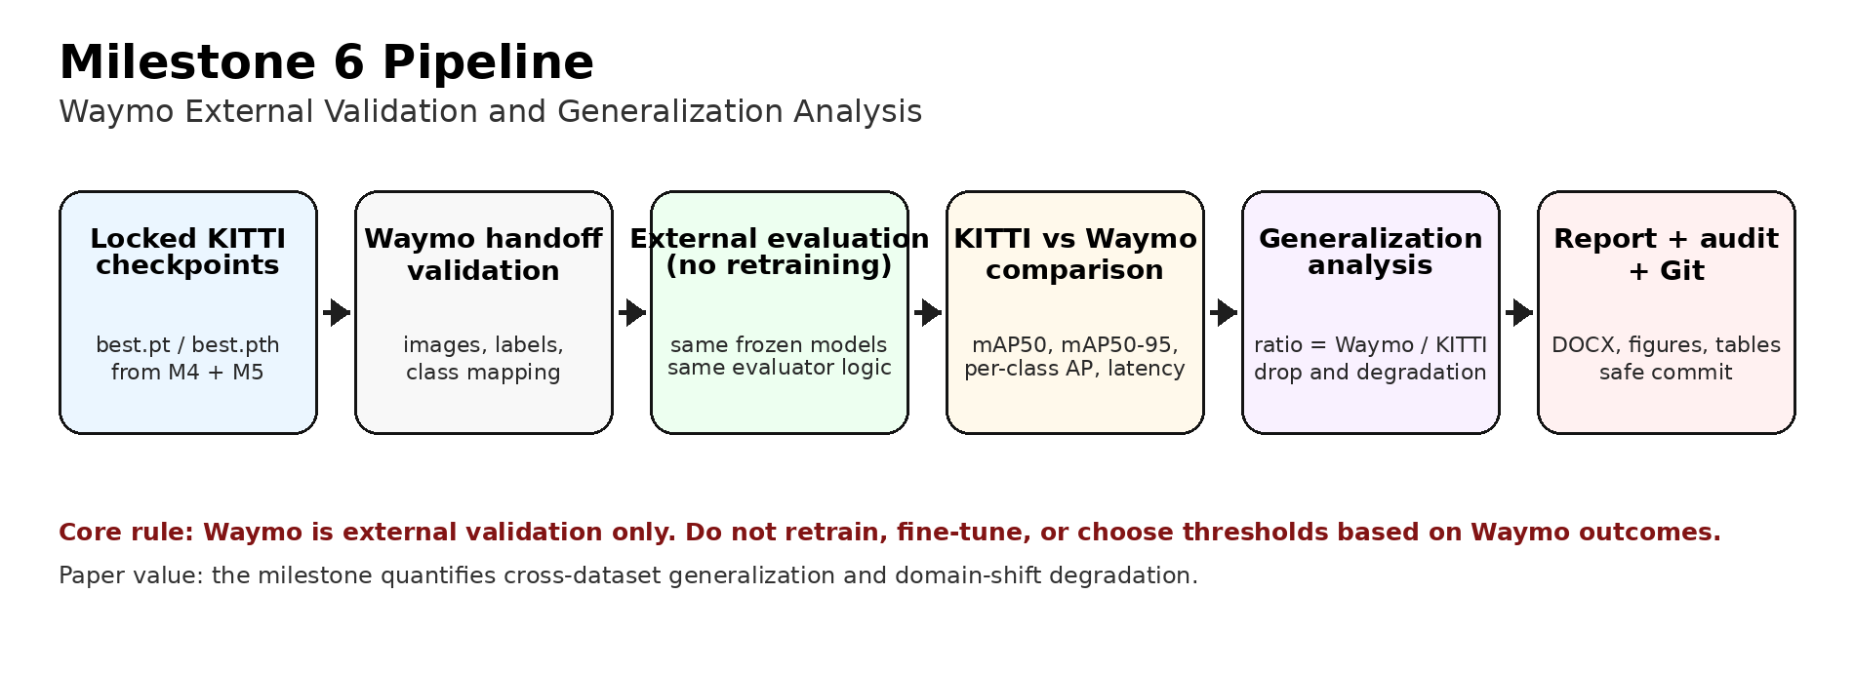
Figure 1. Milestone 6 pipeline from locked checkpoints to Waymo evaluation, generalization analysis, report writing, final audit, and Git commit.

3. Definition of Done
- [ ] Repository starts from a clean Git state.
- [ ] Waymo handoff is validated: image count, label count, image-label pairing, bbox format, and class IDs.
- [ ] No-retraining external validation policy is documented.
- [ ] All four locked KITTI-trained detectors are evaluated on Waymo.
- [ ] KITTI vs Waymo comparison table is created.
- [ ] Generalization Ratio table is created.
- [ ] Class-wise degradation chart is created.
- [ ] Domain-shift analysis subsection is written.
- [ ] Milestone 6 DOCX report is generated under docs/milestone_6.
- [ ] Final audit passes and Git danger check returns no output.
- [ ] Milestone 6 commit is pushed to GitHub safely.

4. Phase 0 - Start Safely
Start from the clean repository state already confirmed after Milestone 4/5. Pull the remote branch and create the Milestone 6 workspace.
git status --short
git pull --ff-only
Create folders:
mkdir scripts\milestone_6
mkdir docs\milestone_6
mkdir outputs\milestone_6
mkdir outputs\milestone_6\handoff_validation
mkdir outputs\milestone_6\waymo_external_validation
mkdir outputs\milestone_6\generalization_analysis
mkdir outputs\milestone_6\figures
mkdir outputs\milestone_6\final_audit
Optional branch workflow:
git checkout -b milestone-6-waymo-validation

5. Phase 1 - Validate Waymo Handoff
notepad scripts\milestone_6\00_validate_waymo_handoff.py
Purpose: verify that the Waymo external subset is complete and ready for evaluation before any model is run.
- Check image count and label count.
- Check that each image has the expected matching label file.
- Inspect image dimensions and a representative sample of label files.
- Validate bbox values and confirm there are no invalid normalized values.
- Confirm supported classes only: Vehicle, Pedestrian, Cyclist.
- Write waymo_handoff_summary.json and waymo_handoff_summary.md under outputs/milestone_6/handoff_validation.

6. Phase 2 - Create Milestone 6 Configs
mkdir configs\datasets\milestone_6
mkdir configs\evaluation\milestone_6
Create these config files:
- configs/datasets/milestone_6/waymo_external_subset.yaml - Waymo subset path, class names, sample count, and selection notes.
- configs/evaluation/milestone_6/external_validation_policy.yaml - no-retraining rule, locked checkpoints, input size, confidence/IoU policy, and hardware notes.
- configs/evaluation/milestone_6/generalization_metrics.yaml - KITTI vs Waymo comparison columns and Generalization Ratio formulas.
7. Phase 3 - Inspect Waymo Format and Class Mapping
notepad scripts\milestone_6\01_inspect_waymo_format.py
Purpose: confirm the exact label format before adapting the Milestone 5 evaluator to Waymo.
- Expected class mapping: 0 = Vehicle, 1 = Pedestrian, 2 = Cyclist.
- Expected label format: class_id x_center y_center width height.
- Expected bbox representation: YOLO normalized coordinates.
- Expected output: outputs/milestone_6/handoff_validation/waymo_format_inspection.json.
- If class IDs differ, create a mapping file before evaluation and document it in the report.

8. Phase 4 - Smoke Test Models on Waymo
notepad scripts\milestone_6\02_smoke_test_waymo_models.py
Purpose: load all four locked checkpoints and run a tiny Waymo sample, such as 10 to 20 images, before the full external validation.
- Read checkpoint paths from outputs/milestone_4/locked_final_checkpoints/final_checkpoint_registry.json.
- Load YOLO and RT-DETR through ultralytics.YOLO.
- Load RetinaNet and Faster R-CNN using the same Torchvision model definitions used in Milestone 5.
- Confirm that each model returns predictions with usable class IDs and bounding boxes.
- Write smoke_test_summary.json under outputs/milestone_6/waymo_external_validation.

9. Phase 5 - Full Waymo External Validation
notepad scripts\milestone_6\03_run_waymo_external_validation.py
Purpose: evaluate the locked KITTI-trained models on Waymo without retraining. This script should reuse the Milestone 5 evaluator logic and only switch the dataset from KITTI validation to Waymo external validation.
- Inputs: locked final checkpoints from Milestone 4/5.
- Inputs: Waymo external images and labels after handoff validation.
- Metrics: mAP50, mAP50-95, per-class AP, and mean inference time.
- Do not tune thresholds using Waymo results unless the policy explicitly states a fixed threshold before evaluation.
- Write one metrics JSON file per detector under outputs/milestone_6/waymo_external_validation/metrics.
- Write waymo_external_summary.csv and waymo_external_summary.json under outputs/milestone_6/waymo_external_validation/tables.
10. Phase 6 - Generalization Analysis
notepad scripts\milestone_6\04_create_generalization_analysis.py
Purpose: join the KITTI baseline from Milestone 5 with the Waymo results from Milestone 6 and quantify domain shift.
Required inputs:
- outputs/milestone_5/final_kitti_validation/tables/comparison_summary_full.csv
- outputs/milestone_6/waymo_external_validation/tables/waymo_external_summary.csv
Required calculations:
- KITTI mAP50 vs Waymo mAP50.
- KITTI mAP50-95 vs Waymo mAP50-95.
- Absolute drop = KITTI metric - Waymo metric.
- Generalization Ratio = Waymo metric / KITTI metric.
- Class-wise AP50-95 degradation for Vehicle, Pedestrian, and Cyclist.
- Best generalizing detector and worst generalizing detector.
- Largest degraded class.
Required outputs:
- outputs/milestone_6/generalization_analysis/tables/kitti_vs_waymo_comparison.csv
- outputs/milestone_6/generalization_analysis/tables/generalization_ratio_table.csv
- outputs/milestone_6/generalization_analysis/tables/class_wise_degradation.csv
- outputs/milestone_6/generalization_analysis/generalization_analysis_summary.json

11. Phase 7 - Generate Figures
notepad scripts\milestone_6\05_create_waymo_generalization_figures.py
Required figures:
- outputs/milestone_6/figures/kitti_vs_waymo_map50_95.png - main KITTI vs Waymo comparison.
- outputs/milestone_6/figures/generalization_ratio_map50_95.png - cross-dataset stability visualization.
- outputs/milestone_6/figures/class_wise_degradation.png - Vehicle/Pedestrian/Cyclist degradation chart.
- outputs/milestone_6/figures/waymo_inference_time_comparison.png - Waymo inference time comparison.
12. Phase 8 - Write the Milestone 6 DOCX Report
notepad scripts\milestone_6\06_write_milestone_6_report.py
Purpose: create a paper-ready and injection-ready Milestone 6 report. The report should explain the external validation methodology, include all final Waymo results, and write the domain-shift discussion in manuscript style.
Expected outputs:
docs\milestone_6\Milestone_6_Waymo_External_Validation_Report.docx
docs\milestone_6\Milestone_6_Waymo_External_Validation_Report.md
Required report sections:
- Milestone 6 Objective.
- External Validation Methodology.
- Dataset and Waymo Subset Description.
- No-Retraining Policy.
- Model Checkpoints Used.
- Class Mapping.
- Evaluation Metrics.
- KITTI Baseline Summary.
- Waymo External Validation Results.
- KITTI vs Waymo Comparison.
- Generalization Ratio Analysis.
- Class-Wise Degradation Analysis.
- Domain-Shift Discussion.
- Paper-Ready External Validation Subsection.
- Limitations and Threats to Validity.
- Generated Artifacts.

13. Phase 9 - Final Audit
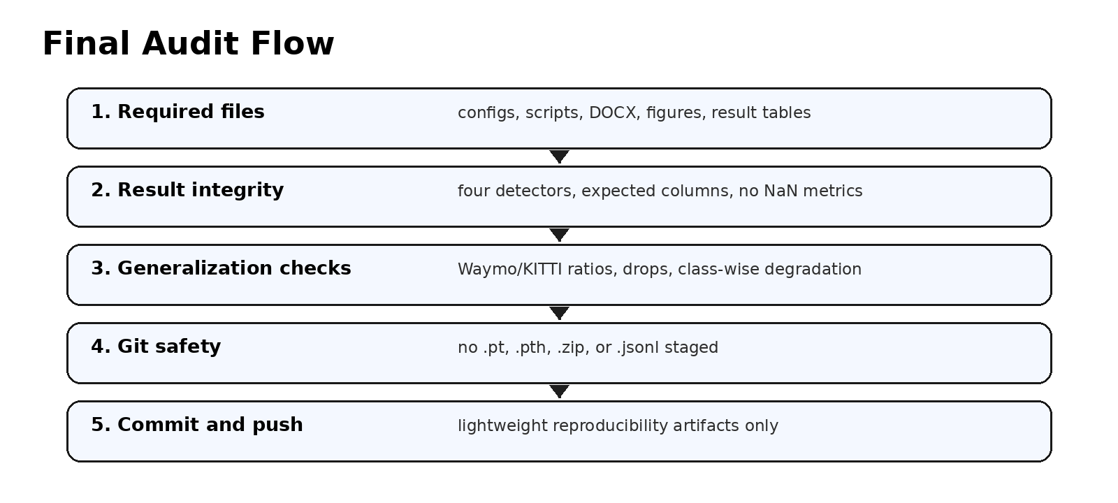
Figure 2. Final audit flow for Milestone 6.
notepad scripts\milestone_6\07_final_audit.py
Expected audit outputs:
outputs\milestone_6\final_audit\final_audit.json
outputs\milestone_6\final_audit\FINAL_AUDIT.md
The audit should check:
- Required configs exist.
- Waymo handoff summary and format inspection exist.
- Waymo metrics exist for all four detectors.
- KITTI vs Waymo comparison table exists.
- Generalization Ratio table exists.
- Class-wise degradation chart exists.
- Milestone 6 DOCX and Markdown reports exist.
- Audit status is PASSED.
- No checkpoint files, ZIP files, or raw prediction JSONL files are staged.

14. Final Git Commands
After the final audit passes, commit only source/config/documentation files and lightweight result evidence.
Check status:
git status --short
Add safe Milestone 6 files:
git add configs\datasets\milestone_6
git add configs\evaluation\milestone_6
git add docs\milestone_6
git add scripts\milestone_6
Force-add lightweight outputs if outputs/ is ignored:
git add -f outputs\milestone_6\handoff_validation
git add -f outputs\milestone_6\waymo_external_validation\metrics
git add -f outputs\milestone_6\waymo_external_validation\tables
git add -f outputs\milestone_6\generalization_analysis
git add -f outputs\milestone_6\figures
git add -f outputs\milestone_6\final_audit
Danger check. Expected result: no output.
git diff --cached --name-only | findstr /R "\.pt$ \.pth$ \.zip$ \.jsonl$"
Review staged files:
git diff --cached --stat
git diff --cached --name-only
Commit and push:
git commit -m "Add Milestone 6 Waymo external validation analysis"
git push

15. Files That Should Not Be Committed
- outputs/milestone_4/checkpoints/
- outputs/milestone_4/kaggle_packages/verified_zips/
- outputs/milestone_6/waymo_external_validation/predictions/
- *.pt
- *.pth
- *.zip
- *.jsonl

