Beyond In-Domain Accuracy: Cross-Dataset Generalization and Deployment Analysis of Object Detectors for Autonomous Driving
Author Name

Abstract
Reliable object detection is essential for autonomous-driving perception, yet most detectors are evaluated primarily on data drawn from the same benchmark used for model development. Such in-domain evaluation may overestimate deployment reliability when geographic context, camera characteristics, scene density, object scale, and annotation policies change. This study presents a controlled cross-dataset evaluation of four representative detection paradigms: a YOLO-family real-time one-stage detector, Faster R-CNN, RetinaNet, and RT-DETR. All models are trained on harmonized KITTI data and evaluated first on a held-out KITTI validation split and then on a representative Waymo front-camera subset without retraining, fine-tuning, or target-domain adaptation. Vehicle, Pedestrian, and Cyclist categories are aligned across datasets to support consistent comparison. The evaluation combines mAP, precision, recall, F1-score, per-class AP, absolute and relative performance degradation, and a generalization ratio, together with safety-oriented analyses of false negatives, small and occluded objects, and vulnerable road users. Deployment suitability is assessed using batch-one latency, throughput, parameter count, and model size on common hardware. The results show a severe and architecture-dependent accuracy drop under target-free transfer: mAP@[0.50:0.95] falls from 0.538–0.690 on KITTI to 0.065–0.097 on Waymo, with generalization ratios between 0.095 and 0.180. The in-domain ranking inverts across domains: YOLOv8s is strongest in-domain but least stable, while RetinaNet is weaker in-domain yet most stable out-of-domain. On the external dataset, small objects and vulnerable road users are the dominant failure mode, with pedestrian-plus-cyclist false-negative rates of 0.81–0.93 even for the most accurate detector. By unifying external validation, safety-relevant failure analysis, and efficiency measurement, the proposed framework determines whether strong in-domain accuracy translates into robust and practical intelligent-vehicle perception.
Index Terms— cross-dataset generalization, object detection, autonomous driving, domain shift,

1. Introduction
Modern object detectors achieve strong results on autonomous-driving benchmarks, but these results are typically reported under in-domain evaluation, in which the training and test data are drawn from the same dataset distribution. This setting can hide sensitivity to dataset bias and may not reflect how reliably a detector behaves when deployed in a different environment [1, 2]. In practice, a perception system trained in one city or on one sensor configuration must operate in scenes with different camera characteristics, traffic density, object-scale distributions, and annotation conventions, and it remains unclear whether a high in-domain score translates into robust performance under such shift.
This uncertainty is particularly important for safety-critical classes such as pedestrians and cyclists, and for small, distant, occluded, and crowded objects. A detector that attains a strong aggregate mean Average Precision (mAP) may still miss a large fraction of vulnerable road users after a domain shift, an effect that aggregate metrics conceal. Deployment constraints introduce a further dimension: a highly accurate detector may be impractical at the required frame rate, while a very fast detector may be insufficiently reliable for safety-critical perception [3, 4]. A unified assessment of accuracy, external generalization, safety-oriented failure, and computational efficiency is therefore needed to identify a defensible accuracy–generalization–efficiency trade-off.
This study investigates the external generalization of object detectors trained on the KITTI dataset [1] and evaluated, without retraining, fine-tuning, or target-domain adaptation, on a representative front-camera subset of the Waymo Open Dataset [2]. Four detector families spanning representative detection paradigms are considered: YOLOv8s (real-time one-stage CNN), Faster R-CNN [5] (two-stage region proposal), RetinaNet [6] (dense one-stage with focal loss), and RT-DETR [7] (real-time transformer). All models are trained on the same harmonized three-class task (Vehicle, Pedestrian, and Cyclist) under a common experimental protocol, and evaluated in-domain on KITTI and externally on Waymo with a frozen operating point. The evaluation combines in-domain accuracy, absolute and relative cross-dataset degradation, a generalization ratio, class-wise behavior, safety-oriented failure analysis, and same-hardware efficiency measurement.
The main contributions of this work are:
1. Controlled cross-family comparison. A harmonized benchmark is developed for four representative detection paradigms under identical data, class, and evaluation rules.
2. Target-free external validation. Models trained exclusively on KITTI are evaluated directly on Waymo with no retraining, fine-tuning, domain adaptation, or target-dependent selection.
3. Dataset and class harmonization. A transparent class-mapping procedure aligns KITTI and Waymo annotations into the common Vehicle, Pedestrian, and Cyclist classes (Section 3).
4. Cross-dataset generalization analysis. Generalization is quantified using in-domain and external mAP, absolute and relative degradation, a generalization ratio, and class-wise AP changes (Section 6).
5. Safety-oriented failure analysis. False negatives, vulnerable road users, small and distant objects, and error types are examined alongside aggregate accuracy (Section 6).
6. Deployment-oriented efficiency evaluation. Latency, throughput, parameter count, and model size are reported on common hardware (Section 6).
The remainder of this paper is organized as follows. Section 2 reviews related work, Section 3 describes dataset preparation and class harmonization, Section 4 details the preprocessing and validation pipeline, Section 5 presents the training and evaluation protocol, Section 6 reports the results, Section 7 discusses their implications, Section 8 describes threats to validity, and Section 9 concludes.

2. Related Work

2.1. Autonomous-Driving Datasets and Benchmark Bias
Progress in autonomous-driving perception has been strongly shaped by public benchmarks. The KITTI Vision Benchmark Suite established one of the earliest widely adopted real-world evaluation platforms for road-scene understanding by combining synchronized cameras, LiDAR, and vehicle-localization sensors [1]. Its object-detection benchmark enabled reproducible comparison of cars, pedestrians, and cyclists and remains influential in the field. However, KITTI is comparatively compact and reflects a limited set of geographic, traffic, camera, and environmental conditions, so strong performance on a KITTI validation split does not by itself demonstrate robustness outside the source distribution.
Later datasets broadened the scale and diversity of driving perception. The Waymo Open Dataset provides large-scale camera and LiDAR recordings collected across multiple cities and driving environments [2]. BDD100K contributes extensive geographic, weather, illumination, and scene variation across a large collection of driving videos and multiple perception tasks [8]. nuScenes further expands benchmark diversity through a full sensor suite, 360-degree coverage, radar data, and dense multimodal annotations [9]. Together, these datasets show that autonomous-driving benchmarks differ not only in size but also in viewpoint, image characteristics, traffic density, object-size distribution, class frequency, annotation ontology, and operating environment.
These differences create a meaningful benchmark-bias problem. A detector can exploit regularities specific to its training dataset—camera height, road layout, background appearance, and class prevalence—while appearing highly accurate under an in-domain split. Cross-dataset testing is therefore a necessary complement to conventional validation. Nevertheless, dataset papers mainly define benchmarks and evaluation tasks; they do not provide a controlled comparison in which detectors trained under the same protocol on KITTI are transferred directly to a harmonized Waymo subset. This limitation motivates the external-validation setting adopted here.

2.2. CNN-Based Object Detection
Convolutional object detectors are commonly organized into two-stage and one-stage paradigms. Faster R-CNN integrated a Region Proposal Network with a region-based detector, allowing proposal generation and classification to share convolutional features [5]. This design established a strong accuracy-oriented baseline and remains relevant when localization quality is prioritized, although its proposal and per-region processing stages can increase computational cost relative to compact one-stage architectures.
RetinaNet addressed a central limitation of dense one-stage detection: the extreme imbalance between background locations and foreground objects. Focal loss reduces the contribution of easy negatives and concentrates learning on difficult examples [6], allowing a one-stage detector to achieve competitive accuracy with a simpler dense prediction pipeline. This formulation is particularly relevant to road scenes, where the image contains large background regions and comparatively few small foreground instances. The original work, however, focused on standard in-domain benchmarks and did not evaluate how focal-loss-based detection behaves when transferred between autonomous-driving datasets.
The YOLO family represents the real-time one-stage paradigm; YOLOv7, for example, introduced architectural and training refinements designed to improve accuracy without proportionally increasing inference cost [10]. Such models are attractive for autonomous vehicles because of their high throughput and compact deployment footprint. Published comparisons among YOLO, Faster R-CNN, and RetinaNet are difficult to interpret directly because studies frequently differ in datasets, input resolutions, backbones, pretraining sources, hardware platforms, precision modes, and latency definitions. A controlled same-data and same-hardware evaluation is therefore required to determine whether speed-oriented CNN detectors preserve their advantages under cross-dataset shift.

2.3. Transformer-Based and End-to-End Detection
Transformer-based detectors introduced a substantially different formulation of object detection. DETR treated detection as direct set prediction and used bipartite matching to associate predicted objects with ground-truth instances [11]. By combining a convolutional backbone with a transformer encoder–decoder, DETR removed several hand-designed components, including anchor generation and non-maximum suppression. This end-to-end formulation simplified the pipeline, but the original model required long training schedules and was less effective for small objects, which are common and safety-relevant in driving scenes.
Deformable DETR improved the efficiency of transformer attention by sampling a sparse set of relevant spatial locations across multi-scale feature maps [12], accelerating convergence and improving small-object performance. RT-DETR extended this direction by explicitly targeting real-time end-to-end detection through an efficient hybrid encoder and flexible speed control [7], providing an appropriate modern transformer baseline for comparison with real-time CNN detectors.
Despite their architectural differences, CNN and transformer detectors are commonly compared only on the benchmark on which each model was developed. It remains uncertain whether global or selective attention, end-to-end set prediction, region proposals, and dense convolutional prediction produce different robustness patterns under natural autonomous-driving domain shift. This question is addressed by evaluating RT-DETR and representative CNN families under one harmonized KITTI-to-Waymo protocol.

2.4. Domain Shift and Cross-Dataset Generalization
Domain shift arises when the distribution encountered during deployment differs from the distribution used for model development. In object detection this shift may involve appearance, weather, illumination, camera geometry, object scale, traffic density, class balance, or annotation conventions. Domain-adaptation research attempts to reduce this mismatch by using information from the target domain: Domain Adaptive Faster R-CNN introduced image-level and instance-level adversarial alignment for an unlabeled target domain [13], and the Cross-Domain Adaptive Teacher later used teacher–student learning with target-domain pseudo-labels [14]. These methods are valuable when target images are available during training, but they answer a different question from target-free external validation.
Direct cross-dataset studies provide evidence that benchmark-specific performance may not generalize. Hasan et al. showed that pedestrian detectors with strong within-dataset results can degrade substantially when evaluated on other pedestrian datasets [15], exposing the risk of dataset-specific design choices, although the principal focus is pedestrian detection rather than a unified comparison across detector paradigms. The SHIFT dataset enables controlled investigation of continuous changes in weather, time of day, and traffic conditions [16], while weather-robust detection studies analyze real and synthetic adverse-weather transformations [17]. Such work clarifies individual sources of degradation but does not fully represent the combined geographic, camera, ontology, and scene-distribution differences between independent real-world datasets.
The present study therefore distinguishes three evaluation settings. Domain adaptation modifies training using labeled or unlabeled target-domain information. Domain generalization typically modifies training to improve performance on unspecified unseen domains. Target-free external validation, which is used here, leaves the trained detector unchanged and measures its direct transfer to an independently constructed target dataset. This setting reveals the natural external reliability of standard detectors before adaptation is introduced and supports a fair analysis of architecture-dependent degradation.

2.5. Safety-Oriented and Deployment-Aware Evaluation
Mean Average Precision is indispensable but insufficient for safety-oriented autonomous-driving evaluation. Similar mAP values can arise from different error profiles, including misclassification, poor localization, duplicate detections, background false positives, and missed objects. TIDE formalized this distinction through a model-agnostic decomposition of object-detection errors [18]. Such analysis is particularly important for pedestrians and cyclists, because a moderate aggregate score can conceal a high number of safety-critical false negatives; object size, distance, occlusion, crowding, and class frequency should therefore be examined alongside overall accuracy.
Deployment constraints introduce an additional evaluation dimension. Streaming-perception work demonstrated that processing delay changes the effective quality of online predictions because a delayed result may describe an earlier scene state [3], and the ASAP benchmark similarly incorporated latency into vision-centric autonomous-driving evaluation, showing that strong offline models may behave differently under streaming conditions [4]. These findings motivate measuring detector performance on common hardware using batch-one latency, throughput, and, where possible, latency percentiles rather than reporting only theoretical speed. A deployment-oriented comparison should also report parameter count, computational complexity, model size, and memory requirements.

2.6. Research Gap and Positioning
The reviewed literature provides strong foundations in autonomous-driving datasets, CNN and transformer detection, domain adaptation, error analysis, and latency-aware evaluation, but these streams remain fragmented. Dataset studies emphasize scale and diversity; detector papers prioritize in-domain architectural performance; adaptation methods use target-domain information; cross-dataset studies often focus on one class or one shift type; and deployment studies usually examine latency separately from external robustness. There is limited evidence from a controlled target-free experiment in which proposal-based, dense one-stage, real-time CNN, and real-time transformer detectors are trained on the same source dataset and evaluated on a distinct real-world dataset using harmonized classes and common implementation rules. The proposed study addresses this gap by training YOLO, Faster R-CNN, RetinaNet, and RT-DETR on KITTI and externally validating them on a representative Waymo front-camera subset without retraining or adaptation, jointly considering in-domain accuracy, absolute and relative degradation, class-wise generalization, false negatives, difficult-object conditions, and same-hardware efficiency.

3. Dataset Preparation and Harmonization
This study uses the KITTI Object Detection dataset [1] as the primary source for model training and in-domain validation, while a representative subset of the Waymo Open Dataset [2] is used exclusively for external cross-dataset evaluation. This design allows the evaluated detectors to be compared under both familiar and shifted driving conditions without using Waymo data for training, fine-tuning, hyperparameter selection, or model selection. Table 1 summarizes the composition and roles of the three frozen partitions, and Table 2 records the class-harmonization rules.
Table 1. Dataset composition and experimental roles of the three frozen partitions.
Metric | KITTI (all) | KITTI train | KITTI val. | Waymo ext.
Experimental role | Source labeled benchmark | Model training | In-domain validation | External validation only
Source split | Official labeled training set | Project train split | Project validation split | Official Waymo validation split
Images | 7481 | 5985 | 1496 | 996
Driving segments | --- | --- | --- | 25
Target boxes | 39086 | 31294 | 7792 | 24819
Vehicle boxes | 32750 | 26278 | 6472 | 16928
Pedestrian boxes | 4709 | 3729 | 980 | 7127
Cyclist boxes | 1627 | 1287 | 340 | 764
Images with no target boxes | 0 | 0 | 0 | 12
Camera | Left color camera (image\_2) | Left color camera (image\_2) | Left color camera (image\_2) | FRONT
Sampling rule | Use all official labeled images | Frozen stratified split | Frozen stratified split | every\_5th\_front\_frame\_starting\_at\_first
Random seed | --- | 42 | 42 | ---

Table 2. Class harmonization mapping KITTI and Waymo annotations into the common Vehicle, Pedestrian, and Cyclist task.
Dataset | Source class | Action | Unified class
KITTI | Car | map | Vehicle
KITTI | Van | map | Vehicle
KITTI | Truck | map | Vehicle
KITTI | Pedestrian | map | Pedestrian
KITTI | Person\_sitting | map | Pedestrian
KITTI | Cyclist | map | Cyclist
KITTI | Tram | ignore | ---
KITTI | Misc | ignore | ---
KITTI | DontCare | ignore | ---
Waymo | Vehicle | map | Vehicle
Waymo | Pedestrian | map | Pedestrian
Waymo | Sign | ignore | ---
Waymo | Cyclist | map | Cyclist

3.1. KITTI Dataset Preparation
The KITTI object-detection benchmark was selected as the primary labeled dataset. The official object-detection training set contains 7,481 left-color camera images stored in the image_2 directory, together with 7,481 corresponding annotation files in label_2 and 7,481 camera-calibration files. In KITTI terminology, image_2 denotes the left color camera stream, and the corresponding camera projection matrix is represented by P₂ in the calibration files.
The official KITTI testing set was not included in the local experimental evaluation because its ground-truth annotations are not publicly available. Consequently, the official labeled training set was divided into project-specific training and validation partitions. Before splitting, all images, annotation files, and calibration files were subjected to an integrity-verification procedure, which confirmed that all 7,481 samples had matching image, label, and calibration identifiers; that all images were readable; that all 51,865 annotation rows had valid structures; and that no invalid bounding boxes were found.
Special handling was applied to KITTI DontCare annotations, which may contain placeholder truncation and occlusion values of -1 that are valid for ignored regions and were therefore not treated as annotation errors. DontCare regions were preserved for later evaluation handling but were not treated as a target object class. The verified KITTI dataset contains 51,865 original annotation rows, with an original class distribution of 28,742 Car, 2,914 Van, 1,094 Truck, 4,487 Pedestrian, 222 Person_sitting, 1,627 Cyclist, 511 Tram, 973 Misc, and 11,295 DontCare annotations.
A fixed stratified split was created using a random seed of 42, preserving the presence of the Vehicle, Pedestrian, and Cyclist classes in addition to the distribution of mapped target-object density. This produced 5,985 training images and 1,496 in-domain validation images. The training partition contains 26,278 Vehicle boxes, 3,729 Pedestrian boxes, and 1,287 Cyclist boxes; the validation partition contains 6,472 Vehicle boxes, 980 Pedestrian boxes, and 340 Cyclist boxes. The same frozen split is used for all detectors to ensure a fair comparison.

3.2. Waymo Representative External-Validation Subset
The Waymo Open Dataset was used to construct an external-validation subset representing a broader range of locations, traffic densities, illumination conditions, and weather conditions, considering only the official Waymo validation split. The selection process began with metadata from all 202 validation segments, analyzing time of day, location, weather, object counts, and traffic-density characteristics for each segment. The original catalog contained 160 daytime, 23 dawn/dusk, and 19 nighttime segments; 93 Phoenix, 88 San Francisco, and 21 other-location segments; and 201 sunny versus a single rainy segment.
A broad candidate pool of 70 segments was first selected to maximize coverage of rare and important conditions, including all available nighttime and dawn/dusk segments, the only rainy segment, pedestrian-rich scenes, cyclist-rich scenes, and daytime scenes balanced across location and density groups. The 2D camera annotations of the candidates were then analyzed using only the Waymo FRONT camera, and an optimization-based selection procedure produced a final frozen set of 25 representative driving segments. The final segment set contains 14 daytime, six dawn/dusk, and five nighttime segments; 12 San Francisco, 11 Phoenix, and two other-location segments; and ten high-density, eight low-density, and seven medium-density segments, with pedestrians in 22 segments and cyclists in 18 segments.
After the segment list was frozen, the corresponding camera images and calibration files were downloaded. To reduce temporal redundancy, the FRONT-camera frames in each segment were sorted chronologically and sampled uniformly by retaining every fifth frame, yielding 996 images. The selected images were matched with their 2D camera boxes using the segment identifier, frame timestamp, and camera identifier; only Vehicle, Pedestrian, and Cyclist annotations were retained, with Sign annotations excluded. The final Waymo subset contains 24,819 target boxes (16,928 Vehicle, 7,127 Pedestrian, and 764 Cyclist), and 12 images with no target boxes are retained intentionally as negative samples for false-positive analysis.
The Waymo subset is used only for external evaluation and is not used for model training, retraining, fine-tuning, validation-based checkpoint selection, threshold selection, or hyperparameter optimization. This separation prevents information leakage and allows the external results to reflect direct cross-dataset generalization.

3.3. Class Harmonization
To enable a consistent comparison, both datasets were mapped into a common three-class detection task—Vehicle, Pedestrian, and Cyclist. For KITTI, Car, Van, and Truck were merged into Vehicle; Pedestrian and Person_sitting were merged into Pedestrian; and Cyclist was mapped directly to Cyclist. Tram, Misc, and DontCare were excluded from the target classes, with DontCare retained as an ignored region where appropriate. For Waymo, Vehicle, Pedestrian, and Cyclist were mapped directly to their corresponding unified classes, while Sign annotations were ignored (Table 2).
Following harmonization, KITTI contains 39,086 target boxes (32,750 Vehicle, 4,709 Pedestrian, and 1,627 Cyclist), with a further 12,779 annotations retained as ignored. The Waymo representative subset contains 24,819 target boxes under the same three-class definition. This harmonization ensures that all detector families are trained and assessed using an identical class order and semantic task definition.

3.4. Dataset Statistics and Visual Verification
Image-level and object-level statistics were generated for the complete KITTI dataset and for its training and validation partitions, including original and harmonized class distributions, object density, bounding-box dimensions, normalized area, occlusion, truncation, and descriptive KITTI difficulty categories. Bounding boxes were additionally divided into small, medium, and large descriptive groups according to the lower and upper thirds of the normalized target-box area distribution; these project-specific groups are used for dataset analysis and do not replace the official KITTI difficulty definitions. Visual-inspection samples were generated for Vehicle, Pedestrian, Cyclist, mixed, crowded, occluded, truncated, and DontCare scenes, with equivalent checks for the Waymo subset, confirming that the generated annotations corresponded to the source labels and that class harmonization was applied correctly. Overall, the final protocol consists of 5,985 KITTI images for training, 1,496 KITTI images for in-domain validation, and 996 Waymo FRONT-camera images for external cross-dataset evaluation.

4. Unified Preprocessing and Validation Pipeline
Before any detector was initialized or trained, the frozen KITTI and Waymo data were transformed into a single, reproducible object-detection pipeline. The work standardized image geometry, bounding-box coordinates, class identities, annotation formats, region-handling rules, augmentation behavior, framework configuration, and model-ready data loading, so that every later model would receive semantically equivalent data under a controlled experimental protocol. The complete preprocessing and validation sequence is summarized in Figure 1.
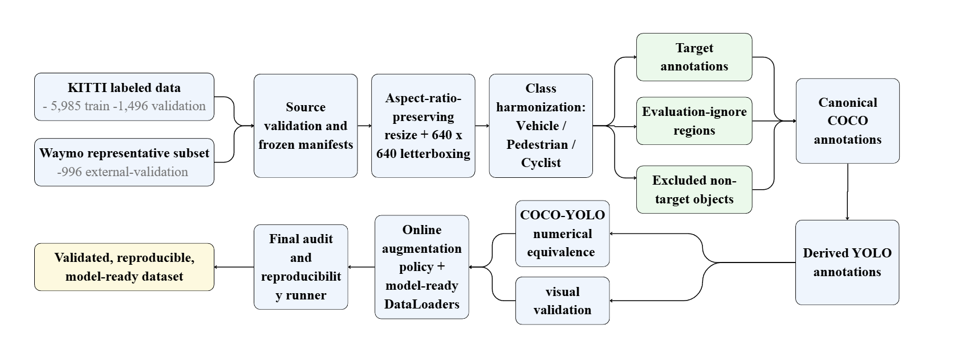
Figure 1. Unified preprocessing and validation pipeline. Frozen KITTI training and
validation partitions and the Waymo external-validation subset are processed through
common image standardization, class harmonization, annotation conversion, independent
validation, controlled augmentation, model-ready loading, and a final reproducibility
audit.

4.1. Experimental Roles and Leakage Prevention
The experimental roles of the three partitions were fixed before model development. KITTI train (5,985 images) is the only partition permitted to update model parameters. KITTI validation (1,496 images) is reserved for in-domain validation, checkpoint comparison, and model-development decisions. The representative Waymo subset (996 FRONT-camera images from 25 driving segments) is reserved exclusively for final cross-dataset evaluation. Waymo data are not used for training, fine-tuning, early stopping, hyperparameter optimization, threshold selection, checkpoint selection, or augmentation-source sampling, preventing external-domain information from influencing the learned parameters or the selection of the final model. The information-flow boundary is illustrated in Figure 2.
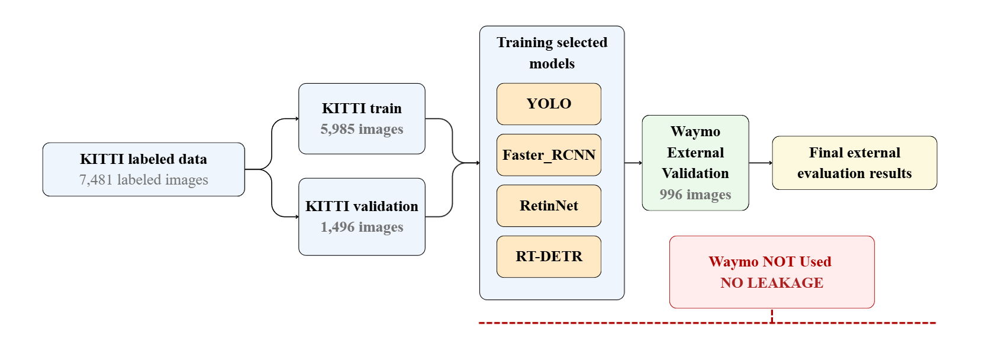
Figure 2. Experimental partition roles and information-flow restrictions. KITTI train
supports parameter learning, KITTI validation supports in-domain model development, and
Waymo remains isolated until the final external evaluation of the selected model.
The Waymo subset preserves twelve images with no Vehicle, Pedestrian, or Cyclist annotations; these target-negative scenes are retained intentionally because they support later false-positive analysis under shifted driving conditions, and their empty labels are treated as valid annotations rather than missing data.

4.2. Image Standardization and Bounding-Box Transformation
The source datasets have substantially different image geometries: KITTI object-detection images are typically wide road scenes close to 1,200×370 pixels, whereas the selected Waymo FRONT-camera images have dimensions of 1,920×1,280 pixels. Every source image was therefore converted to a common 640×640 representation using aspect-ratio-preserving letterboxing. For an image of width W and height H, the resize factor was defined as min(640/W, 640/H); the resized image was centered within a 640×640 canvas, and unused pixels were filled with the neutral gray value 114 in each channel. This procedure avoids geometric stretching while providing a fixed input size for all detector families. The processed images were saved as PNG files to avoid additional lossy compression.
Every bounding box was transformed using the exact scale and padding offsets applied to its image, and transformed coordinates were checked against the processed-image boundary. Across the complete set of 8,477 images, preprocessing produced no missing outputs, no invalid target boxes, no out-of-bound target boxes, and no clipped target boxes. Typical KITTI images were resized to approximately 640×193 pixels with about 223 pixels of top padding and 224 pixels of bottom padding, while Waymo images were resized to approximately 640×427 pixels with about 106 pixels of top and bottom padding. Independent dry-run images confirmed that road content remained undistorted and that transformed boxes remained attached to their source objects.

4.3. Annotation Harmonization and Region Policy
A common three-class taxonomy was frozen for the entire project. In the canonical COCO representation these classes use identifiers 1, 2, and 3, while in the derived YOLO representation they use identifiers 0, 1, and 2; the distinction preserves compatibility with Torchvision, where class zero is reserved for background, and with YOLO, where foreground classes begin at zero. The resulting combined target set contains 49,678 Vehicle boxes, 11,836 Pedestrian boxes, and 2,391 Cyclist boxes, for a total of 63,905 target annotations.
Target annotations were kept separate from two additional region types. KITTI DontCare annotations were preserved as evaluation-ignore regions because eligible detections inside these areas may be suppressed during evaluation instead of being counted as false positives. KITTI Tram and Misc annotations were preserved as excluded non-target audit regions; they are not project targets and do not automatically suppress false positives. Waymo Sign and Unknown are assigned to the excluded category if encountered. The finalized sidecars contain 11,295 evaluation-ignore regions and 1,484 excluded non-target regions, none of which is inserted into the canonical COCO or derived YOLO target labels, ensuring that training targets, evaluation suppression rules, and audit-only regions cannot be confused by later model code.

4.4. Canonical COCO and Derived YOLO Representations
COCO was selected as the canonical target representation because it provides explicit image and annotation identifiers, absolute pixel coordinates, named categories, and broad framework compatibility. Three partition-specific files were created (kitti_train.json, kitti_val.json, and waymo_external.json) with bounding boxes in the standard [x, y, w, h] representation in absolute coordinates on the processed 640×640 images. The canonical files contain 5,985 KITTI training images with 31,294 annotations, 1,496 KITTI validation images with 7,792 annotations, and 996 Waymo external images with 24,819 annotations (all 996 Waymo records retained, including the twelve with zero target annotations).
YOLO labels were derived from the canonical COCO files rather than generated independently from the original sources. Each row stores the class identifier followed by normalized center-x, center-y, width, and height values, serialized with ten decimal places, with one label file per processed image (so the twelve target-negative Waymo images have valid empty label files rather than absent labels). A framework adapter mirrors the validated YOLO files beneath sibling images and labels directories expected by Ultralytics-style pipelines; the adapter files are byte-identical to the canonical YOLO labels and do not introduce a second ground-truth source.

4.5. Numerical and Visual Validation
A complete numerical equivalence test compared all 63,905 canonical COCO boxes with their serialized YOLO counterparts. Each YOLO box was reconstructed in processed-image pixel coordinates and matched to the corresponding COCO box by image and class using minimum-cost bipartite matching, so the result did not depend on annotation order. All 63,905 boxes were matched and classified as equivalent, with zero mismatched images; the maximum normalized coordinate error was approximately 5.0×10^-11, the maximum reconstructed pixel error approximately 4.8×10^-8 pixels, and the minimum reconstructed intersection-over-union 0.9999998. Visual comparisons for crowded, cyclist-rich, pedestrian-rich, mixed, and target-negative scenes coincided between COCO and YOLO overlays, with no boxes entering the gray letterbox padding.

4.6. Augmentation Policy and Model-Ready Data Loading
A conservative online augmentation policy was frozen for training. Augmentation is enabled only for KITTI train and is disabled for KITTI validation and Waymo external evaluation; no permanent augmented dataset is created. The permitted transformations are horizontal flipping (probability 0.50), brightness and contrast adjustment (0.50), HSV adjustment (0.30), and mild Gaussian blur (0.10). Vertical flipping, random cropping, arbitrary rotation, perspective transformation, random scaling, shear, Mosaic, MixUp, Copy-Paste, and Cutout are disabled, reducing unrealistic road geometry and preventing one detector family from receiving framework-specific augmentation advantages. The random state is derived from the base seed 42, the training epoch, and the global image identifier, making each augmented view reproducible.
A framework-neutral PyTorch dataset loader was implemented from the canonical COCO files, returning a three-channel 640×640 float tensor, absolute XYXY boxes, canonical labels, image and source identifiers, box areas, crowd flags, evaluation-ignore boxes, excluded-object boxes, partition metadata, and an augmentation trace when training augmentation is enabled, together with a detection-specific collation function supporting variable numbers of objects per image. Smoke tests confirmed the expected partition lengths, valid tensor and box shapes, finite values, correct class IDs, deterministic validation behavior, valid target-negative handling, and a guard that prevents augmentation from being enabled on validation or external partitions.

4.7. Final Dataset Composition and Audit
The final prepared dataset contains 8,477 processed images and 63,905 target annotations, occupying approximately 2.1 GiB. A read-only final audit combined the outputs of all earlier validation stages with direct checks of physical images, COCO files, canonical YOLO labels, framework labels, sidecar regions, manifests, issue files, and visual artifacts, confirming exact class totals, valid empty labels for the twelve negative images, zero partition overlap, complete COCO–YOLO equivalence, and correct DataLoader behavior. The audit concluded with zero unresolved issues and a final status of PASSED.

5. Experimental Setup

5.1. Detectors
Four representative detectors spanning the main detection paradigms were selected: YOLOv8s (Ultralytics), a real-time one-stage CNN detector; RT-DETR-L (Ultralytics), a real-time end-to-end transformer detector [7]; RetinaNet (Torchvision), a dense one-stage detector with focal loss [6]; and Faster R-CNN (Torchvision), a two-stage region-proposal detector [5]. All four operate on the same three-class task and the same 640×640 letterboxed input, and all use ImageNet-pretrained backbones.

5.2. Training Protocol
Training ran on Kaggle GPU notebooks (NVIDIA Tesla T4) across two compute slots, with evaluation, benchmarking, and checkpoint locking performed locally. All models used an effective batch size of 32 (RT-DETR-L: 16), a fixed random seed of 42 (deterministic mode), an input size of 640×640, target epochs of 200, and early stopping with patience 20 epochs on mAP@[0.50:0.95]. A 10.5-hour runtime guard and checkpoint/resume-state packaging supported interruption-expected runs; RT-DETR, RetinaNet, and Faster R-CNN used validated multi-session resume chains. The online augmentation policy described in Section 4.6 was applied to KITTI train only.

5.3. Evaluation Protocol
The primary evaluation metric is COCO Average Precision. mAP@[0.50:0.95] is computed over ten IoU thresholds from 0.50 to 0.95 in steps of 0.05, together with AP50, AP75, and per-class AP for Vehicle, Pedestrian, and Cyclist. Object size follows the COCO definition: small (<32² px), medium (32²–96² px), and large (>96² px).
In addition to the AP curve, a fixed operating point (confidence ≥ 0.25, IoU ≥ 0.50) is used to compute precision, recall, F1-score, detections per image, and false positives per image. KITTI-specific ignore rules suppress a predicted box that overlaps a DontCare region of the same class family by IoU ≥ 0.50, so that it is neither counted as a true positive nor as a false positive; Tram and Misc are excluded non-target classes. Waymo has no DontCare-style ignore regions, and Sign boxes are excluded as a non-target class.
For the Torchvision-based detectors (RetinaNet and Faster R-CNN), the training pipeline applied ImageNet normalization through Albumentations in addition to the normalization performed internally by the Torchvision detection models; evaluation therefore used the same preprocessing configuration to avoid a train–evaluation distribution mismatch. The Ultralytics-based YOLOv8s and RT-DETR models did not exhibit this issue. Confidence thresholds and operating points were defined a priori and were not tuned using Waymo results.

5.4. External-Validation Methodology
Waymo external validation reuses the frozen evaluation stack unchanged: predictions are produced by the same adapters and metrics are computed with the same pycocotools COCO evaluator, with only the dataset swapped from KITTI validation (1,496 images) to the Waymo external subset (996 images). The AP-curve confidence threshold is 0.001 (fixed before evaluation), and no threshold is tuned on Waymo. Per-image inference time is measured during evaluation to produce the mean inference time metric, while dummy-input latency, throughput, parameter count, and checkpoint size are measured on the local GPU for the efficiency comparison.

6. Results

6.1. In-Domain Accuracy on KITTI
Table 3 reports the KITTI in-domain results for the four detectors. YOLOv8s achieves the highest accuracy on every axis, with mAP@[0.50:0.95] of 0.690, AP50 of 0.925, and AP75 of 0.780. The accuracy ranking is YOLOv8s (0.690) > RT-DETR-L (0.606) > Faster R-CNN (0.589) > RetinaNet (0.537). Pedestrian is the weakest class across all four detectors (0.392–0.530), consistent with the class's small object size and limited training instances, while Vehicle is the strongest (0.703–0.849).
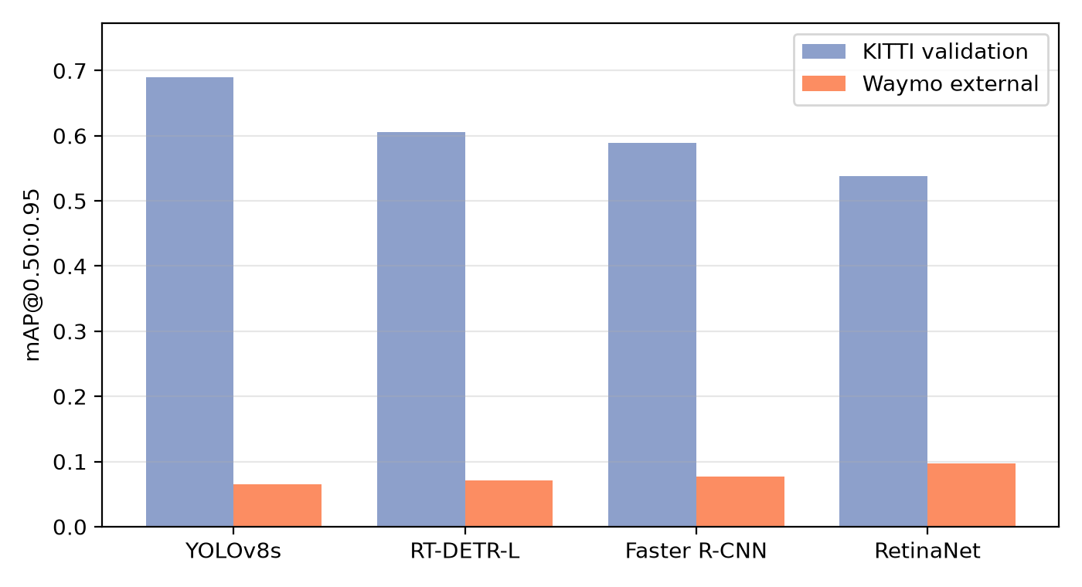
Figure 3. KITTI in-domain versus Waymo external mAP@[0.50:0.95] under target-free
transfer. All detectors degrade sharply, and the in-domain ranking does not transfer to
the external setting.
Table 3. KITTI in-domain detection results on the frozen validation split (1,496 images). Values are COCO Average Precision.
Detector | mAP@0.50:0.95 | mAP@0.50 | mAP@0.75 | Vehicle AP | Pedestrian AP | Cyclist AP
YOLOv8s | 0.690 | 0.925 | 0.780 | 0.849 | 0.530 | 0.691
RT-DETR-L | 0.606 | 0.906 | 0.679 | 0.730 | 0.490 | 0.597
Faster R-CNN | 0.589 | 0.879 | 0.666 | 0.741 | 0.432 | 0.594
RetinaNet | 0.537 | 0.839 | 0.577 | 0.703 | 0.392 | 0.518

6.2. Computational Efficiency
Table 4 summarizes the deployment-oriented efficiency comparison on the local GPU. YOLOv8s is by far the most efficient detector: 11.1M parameters, a 21.5 MB checkpoint, 12.36 ms latency, and 94.77 FPS. RT-DETR-L offers the second-best accuracy but is considerably slower (55.29 ms, 18.73 FPS). The two heaviest detectors carry a large efficiency penalty: Faster R-CNN (41.3M parameters, 315.68 MB, 91.22 ms) and RetinaNet (36.4M parameters, 278.0 MB, 75.25 ms).
Table 4. Deployment-oriented efficiency comparison on the local GPU.
Detector | Parameters (M) | Checkpoint (MB) | Latency (ms) | FPS
YOLOv8s | 11.1 | 21.50 | 12.36 | 94.77
RT-DETR-L | 32.8 | 63.15 | 55.29 | 18.73
Faster R-CNN | 41.3 | 315.68 | 91.22 | 11.24
RetinaNet | 36.4 | 278.00 | 75.25 | 13.70

6.3. Operating-Point Behavior
At the fixed operating point (confidence ≥ 0.25, IoU ≥ 0.50, Table 5), YOLOv8s attains the highest precision (0.926) with a high recall (0.947). RT-DETR-L emits many low-confidence detections (DETR-style 300 queries), so it achieves the highest recall (0.969) but the lowest precision (0.482) and the most false positives per image (5.431). Faster R-CNN and RetinaNet fall between these two extremes.
Table 5. Operating-point metrics on KITTI validation (confidence ≥ 0.25, IoU ≥ 0.50).
Detector | Precision | Recall | F1 | FP/image
YOLOv8s | 0.926 | 0.947 | 0.936 | 0.40
RT-DETR-L | 0.482 | 0.969 | 0.643 | 5.43
Faster R-CNN | 0.876 | 0.928 | 0.901 | 0.69
RetinaNet | 0.777 | 0.907 | 0.837 | 1.35

6.4. Cross-Dataset External Validation on Waymo
Table 6 reports the Waymo external-validation results obtained by applying the four KITTI-trained checkpoints directly to the frozen Waymo subset with no retraining. All detectors degrade sharply: mAP@[0.50:0.95] falls to 0.065–0.097, an order of magnitude below the KITTI baseline (Figure 3). RetinaNet achieves the highest Waymo accuracy (0.097), followed by Faster R-CNN (0.077), RT-DETR-L (0.071), and YOLOv8s (0.065), the reverse of the in-domain ranking.
Table 6. Waymo external-validation results (996 front-camera images, no retraining).
Detector | mAP@0.50 | mAP@0.50:0.95 | Vehicle AP | Pedestrian AP | Cyclist AP | Mean inf. (ms)
YOLOv8s | 0.142 | 0.065 | 0.106 | 0.049 | 0.042 | 34.21
RT-DETR-L | 0.151 | 0.071 | 0.116 | 0.058 | 0.041 | 62.57
Faster R-CNN | 0.175 | 0.077 | 0.123 | 0.070 | 0.038 | 92.07
RetinaNet | 0.215 | 0.097 | 0.144 | 0.075 | 0.072 | 77.50

Table 7 quantifies the degradation and the generalization ratio (Waymo mAP divided by KITTI mAP). Relative mAP@[0.50:0.95] drops range from 82.0% (RetinaNet) to 90.5% (YOLOv8s), and generalization ratios range from 0.095 (YOLOv8s) to 0.180 (RetinaNet), as shown in Figure 4. The best generalizing detector is RetinaNet and the worst is YOLOv8s.
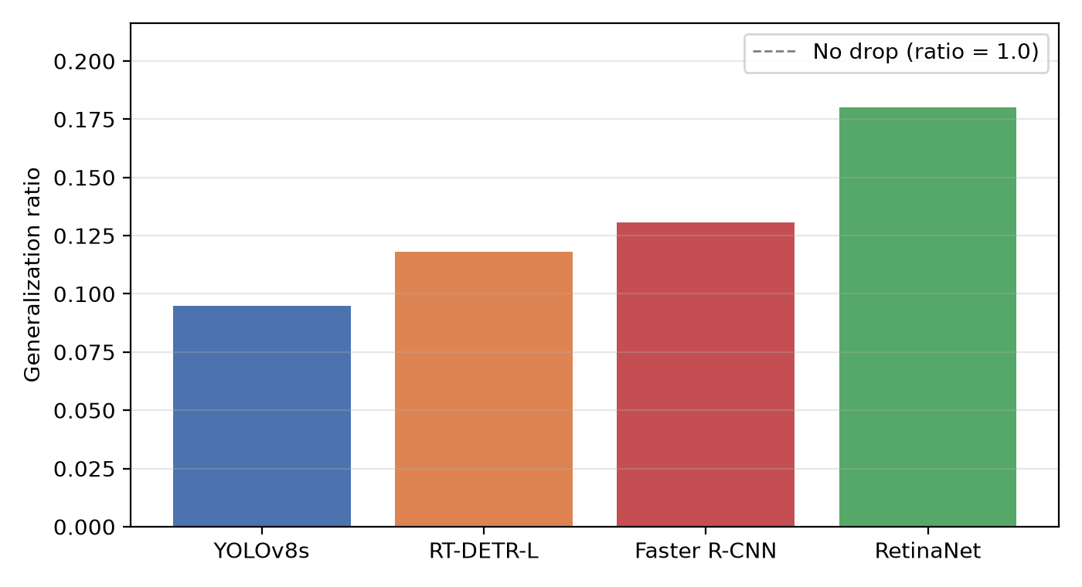
Figure 4. Generalization ratio (Waymo mAP@[0.50:0.95] / KITTI mAP@[0.50:0.95])
for the four detectors. Higher values indicate greater cross-domain stability.
Table 7. KITTI-to-Waymo degradation in mAP@0.50:0.95 and generalization ratio.
Detector | KITTI mAP | Waymo mAP | Abs. drop | Drop (\%) | Gen. ratio
YOLOv8s | 0.690 | 0.065 | 0.625 | 90.52 | 0.095
RT-DETR-L | 0.606 | 0.071 | 0.534 | 88.21 | 0.118
Faster R-CNN | 0.589 | 0.077 | 0.512 | 86.92 | 0.131
RetinaNet | 0.538 | 0.097 | 0.441 | 81.98 | 0.180

6.5. Class-Wise Degradation
Table 8 reports per-class AP@[0.50:0.95] on both datasets together with the absolute and relative drop. Vehicle exhibits the largest absolute drop across detectors (Figure 5), reflecting its high in-domain score combined with a large distributional shift in scale and appearance on Waymo. Cyclist shows the largest relative drop (up to 94.0%), while Pedestrian degrades least in absolute terms but from a low baseline.
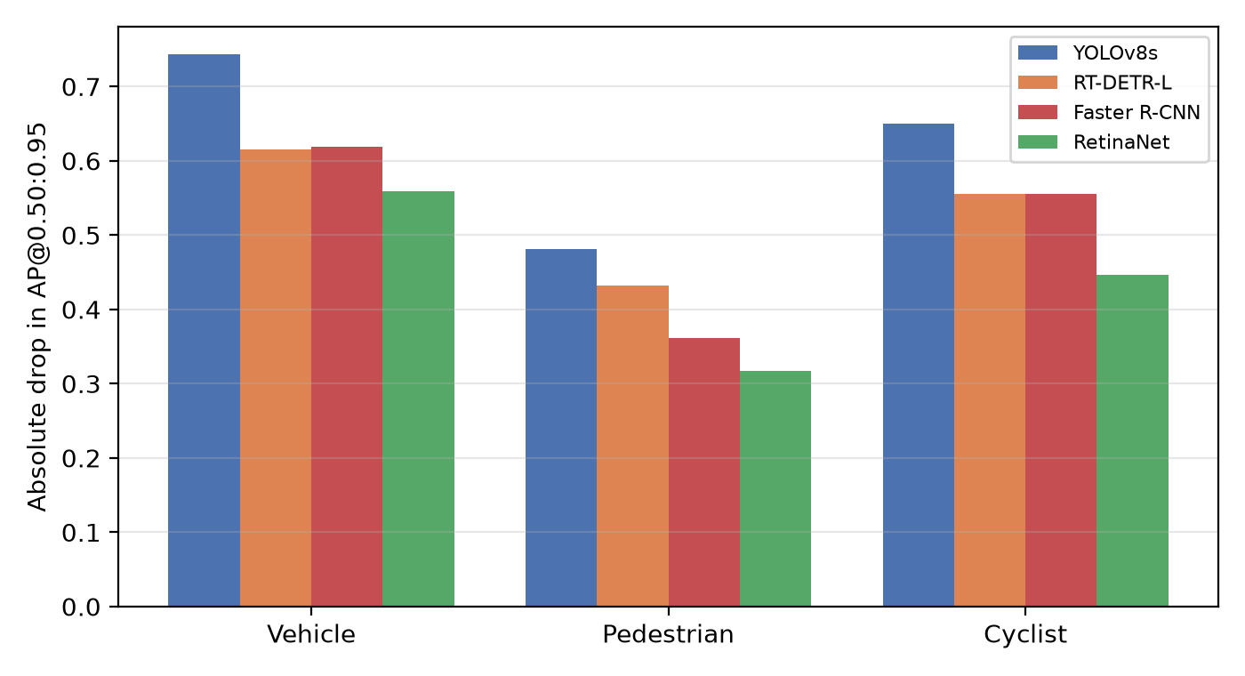
Figure 5. Class-wise absolute degradation in AP@[0.50:0.95] (KITTI minus Waymo) by
detector.
Table 8. Class-wise cross-dataset degradation in AP@0.50:0.95.
Detector | Class | KITTI AP | Waymo AP | Abs. drop | Drop (\%)
YOLOv8s | Vehicle | 0.849 | 0.106 | 0.743 | 87.56
 | Pedestrian | 0.530 | 0.049 | 0.481 | 90.74
 | Cyclist | 0.691 | 0.042 | 0.649 | 93.98
RT-DETR-L | Vehicle | 0.730 | 0.116 | 0.615 | 84.17
 | Pedestrian | 0.490 | 0.058 | 0.432 | 88.20
 | Cyclist | 0.597 | 0.041 | 0.556 | 93.15
Faster R-CNN | Vehicle | 0.741 | 0.123 | 0.619 | 83.46
 | Pedestrian | 0.432 | 0.070 | 0.362 | 83.74
 | Cyclist | 0.594 | 0.038 | 0.556 | 93.54
RetinaNet | Vehicle | 0.703 | 0.144 | 0.559 | 79.54
 | Pedestrian | 0.391 | 0.075 | 0.317 | 80.93
 | Cyclist | 0.518 | 0.072 | 0.446 | 86.08

6.6. Robustness and Safety-Oriented Analysis

6.6.1. Object-Size Analysis
Recall and miss rate were computed per detector, dataset, and size category at the operating point (Table 9). On KITTI, recall declines with object size but remains high for all detectors (0.88–0.96 small-object recall); on Waymo, small-object recall collapses, reaching 0.045–0.132 across detectors (Figure 6). This indicates that small objects are the dominant failure mode under domain shift, consistent with Waymo containing many more small and distant objects.
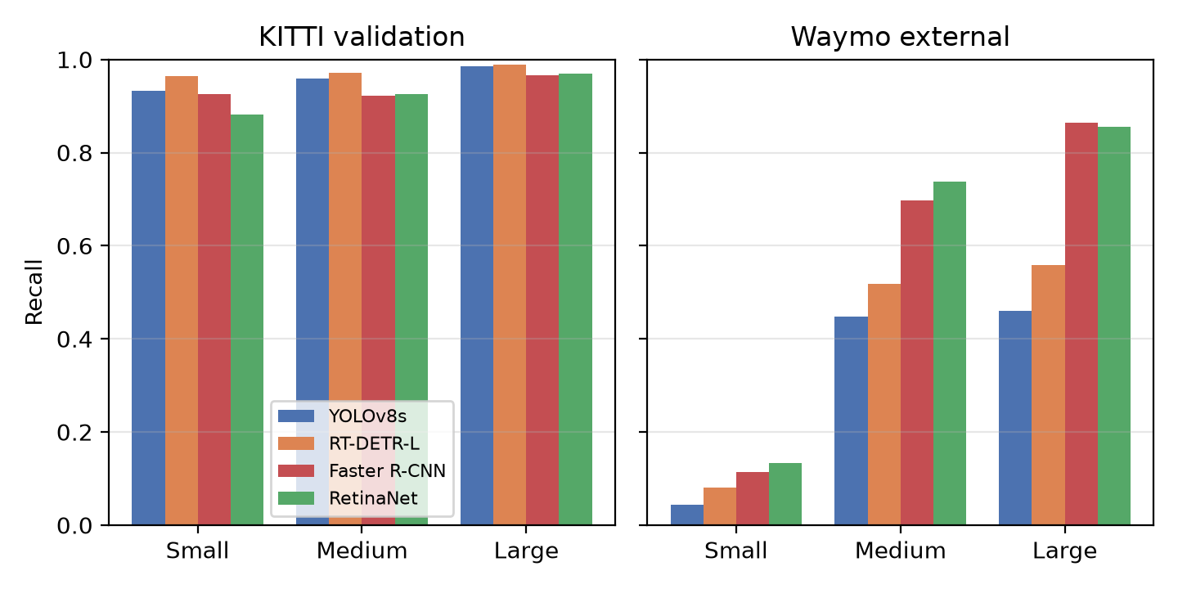
Figure 6. Recall by object-size category at the operating point for KITTI (left) and
Waymo (right).
Table 9. Class-agnostic recall by object-size category at the frozen operating point (confidence ≥ 0.25, IoU ≥ 0.50).
Detector | KITTI recall |  |  | Waymo recall
 | Small | Medium | Large | Small | Medium | Large
YOLOv8s | 0.932 | 0.958 | 0.985 | 0.045 | 0.448 | 0.460
RT-DETR-L | 0.964 | 0.971 | 0.989 | 0.081 | 0.517 | 0.558
Faster R-CNN | 0.925 | 0.923 | 0.966 | 0.115 | 0.697 | 0.865
RetinaNet | 0.881 | 0.926 | 0.970 | 0.132 | 0.737 | 0.855

6.6.2. Safety-Critical False Negatives
False-negative rates for the safety-priority classes (Pedestrian and Cyclist) were computed separately from overall accuracy (Table 10). On Waymo, the combined pedestrian-plus-cyclist false-negative rate is 0.81–0.93 for all detectors (Figure 7), a safety-relevant result that is not visible from average mAP alone: even the detector with the best Waymo mAP misses the large majority of vulnerable road users.
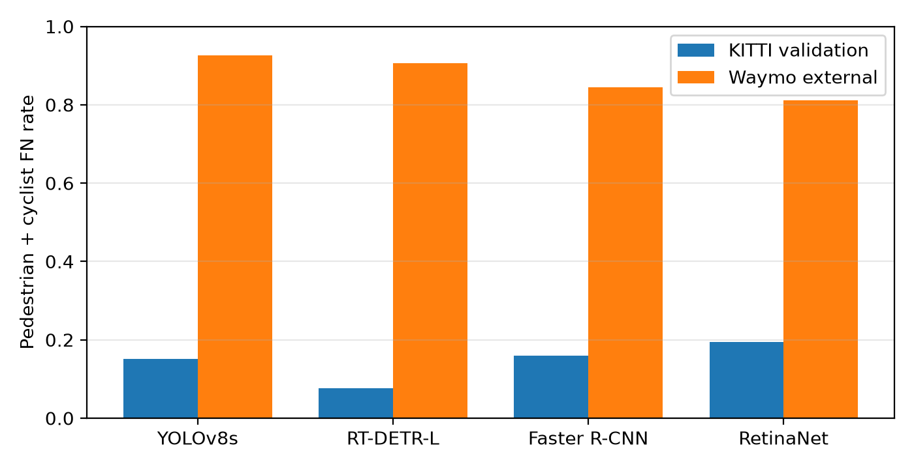
Figure 7. Safety-critical false-negative rate for pedestrians and cyclists at the
operating point, for KITTI and Waymo.
Table 10. Safety-critical false-negative rate for pedestrians and cyclists (operating point, confidence ≥ 0.25, IoU ≥ 0.50).
Detector | KITTI FN rate | Waymo FN rate
YOLOv8s | 0.152 | 0.926
RT-DETR-L | 0.077 | 0.906
Faster R-CNN | 0.159 | 0.844
RetinaNet | 0.194 | 0.811

6.6.3. Failure-Type Decomposition
Table 11 decomposes detections into true positives, missed detections, false positives, localization errors, class confusions, and over-detections. On KITTI, RT-DETR-L emits the most false positives and by far the most over-detections, consistent with its low operating-point precision. On Waymo, missed detections dominate for every detector, again reflecting the collapse of small-object recall.
Table 11. Failure-type decomposition at the operating point for KITTI and Waymo.
Dataset | Detector | TP | Miss (FN) | FP | Localization | Confusion | Over-detect.
KITTI | YOLOv8s | 7,382 | 410 | 163 | 272 | 15 | 142
 | RT-DETR-L | 7,551 | 241 | 777 | 1,620 | 82 | 5,646
 | Faster R-CNN | 7,231 | 561 | 241 | 592 | 96 | 98
 | RetinaNet | 7,069 | 723 | 425 | 1,165 | 161 | 274
Waymo | YOLOv8s | 2,721 | 22,098 | 20 | 132 | 56 | 27
 | RT-DETR-L | 3,769 | 21,050 | 40 | 446 | 132 | 743
 | Faster R-CNN | 5,269 | 19,550 | 292 | 1,263 | 366 | 78
 | RetinaNet | 5,771 | 19,048 | 328 | 2,007 | 561 | 216

6.7. Deployment Trade-Off
Table 12 and Figure 8 jointly summarize in-domain accuracy, external accuracy, latency, and vulnerable-road-user (VRU) safety on Waymo (the VRU false-negative rate and the small-object recall restricted to pedestrians and cyclists). No single detector simultaneously optimizes accuracy, generalization, latency, and safety: YOLOv8s is fastest and most accurate in-domain but least stable and safety-reliable out-of-domain, while RetinaNet generalizes best and is most safety-reliable on Waymo but is slower and weaker in-domain.
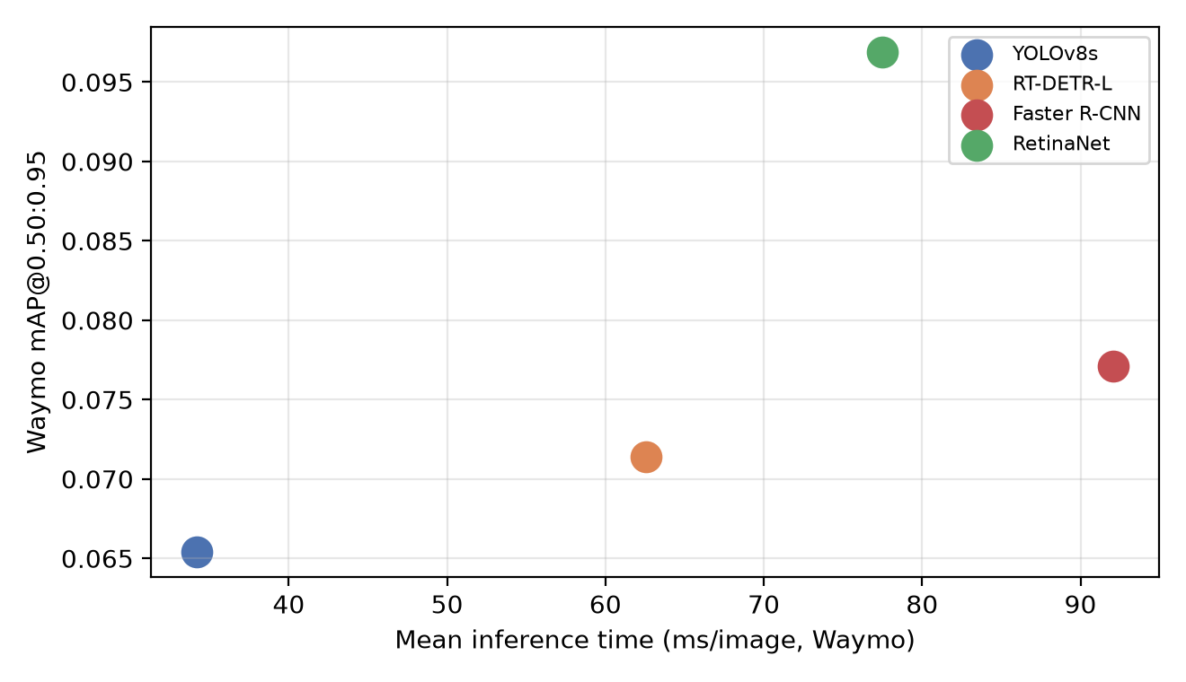
Figure 8. Deployment trade-off between mean inference time and Waymo mAP@[0.50:0.95].
Table 12. Deployment trade-off: in-domain accuracy, external accuracy, latency, and vulnerable-road-user (VRU) safety on Waymo.
Detector | KITTI mAP | Waymo mAP | Latency (ms) | Waymo VRU FN | Waymo VRU small recall
YOLOv8s | 0.690 | 0.065 | 34.21 | 0.926 | 0.029
RT-DETR-L | 0.606 | 0.071 | 62.57 | 0.906 | 0.047
Faster R-CNN | 0.589 | 0.077 | 92.07 | 0.844 | 0.097
RetinaNet | 0.537 | 0.097 | 77.50 | 0.811 | 0.127

7. Discussion

7.1. Domain Shift and Ranking Inversion
All four detectors experience a severe accuracy drop when transferred from KITTI to Waymo, with mAP@[0.50:0.95] falling by roughly 80–90% relative to the in-domain baseline. This is expected for a direct, no-retraining cross-dataset transfer: KITTI and Waymo differ in camera calibration, sensor position, scene composition, object-scale distribution, and annotation density. More consequential is the inversion of the detector ranking across domains. YOLOv8s, the strongest in-domain detector, shows the lowest generalization ratio (0.095), while RetinaNet, the weakest in-domain detector, generalizes best (0.180). This inversion is a candidate indicator of overfitting to KITTI-specific statistics for the higher-capacity detectors, and it demonstrates that the in-domain ranking does not transfer to the out-of-domain setting.
The pattern is consistent with the architecture families. The real-time CNN and transformer detectors (YOLOv8s and RT-DETR) achieve the highest in-domain accuracy but the strongest relative degradation, whereas the two Torchvision detectors trained with a conservative, fixed augmentation policy degrade less in relative terms. This does not establish a causal mechanism, but it suggests that the choice of training regime and architecture interacts with domain shift in a way that in-domain validation alone cannot reveal.

7.2. Small Objects and Vulnerable Road Users
The safety-oriented analysis shows that the dominant failure mode is missed detection of small objects, and that this is far more severe on Waymo than on KITTI. On KITTI, small-object recall is 0.88–0.96 across detectors, whereas on Waymo it is 0.03–0.13. Consequently, the pedestrian-plus-cyclist false-negative rate on Waymo reaches 0.81–0.93 for all detectors. This result is invisible in average mAP: the detector with the highest Waymo mAP is not the most safety-reliable, because average precision is dominated by large, easily detected vehicles. For intelligent-vehicle perception, small-object and pedestrian/cyclist recall should therefore be treated as first-class deployment metrics alongside mAP, and safety-critical evaluation should be reported at a fixed operating point rather than only as an AP curve.

7.3. Deployment Implications
The efficiency results reinforce the need for a joint accuracy–efficiency–safety assessment. YOLOv8s provides an order-of-magnitude latency advantage and the best in-domain accuracy but the least external stability and safety reliability, making it attractive only when latency is the binding constraint and in-domain statistics match deployment. RetinaNet offers the best external generalization and safety-oriented recall but at substantially higher latency and model size, making it attractive when out-of-domain reliability is prioritized over speed. RT-DETR-L suffers from a large number of low-confidence over-detections at the fixed operating point, and Faster R-CNN is the slowest detector despite mid-range accuracy. The practical implication is that detector selection must be based on external validation and safety metrics rather than KITTI mAP alone, and that the choice depends on the deployment priority: latency, in-domain accuracy, or out-of-domain safety.

7.4. Interpretation and Limitations of the Comparison
These findings are descriptive and correlational: the study quantifies how, where, and why the four detectors fail under a controlled target-free transfer, but it does not isolate the causal contribution of architecture, capacity, or training regime. The relative stability of RetinaNet, for instance, could reflect its conservative training setup as much as its architecture. Nevertheless, the results provide a reproducible evidence base for deployment-oriented perception and a concrete motivation for domain-robust training or adaptation strategies [13, 14], which the target-free setting deliberately leaves out.

8. Threats to Validity
Several limitations bound the interpretation of these results.
Subset size and coverage. The Waymo external subset (996 images) is smaller than the KITTI validation split (1,496 images) and represents a single camera view (FRONT) sampled every fifth frame from 25 segments. The subset was selected to maximize coverage of rare conditions (night, dawn/dusk, the single rainy segment), but it cannot represent the full diversity of the Waymo dataset, and conclusions should not be generalized beyond this configuration.
Operating point. The robustness and safety analyses are confined to the frozen operating point (confidence 0.25, IoU 0.50); results may differ at other operating points, and no threshold is tuned on Waymo, so operating-point precision/recall reflect the a priori threshold rather than an optimized one.
Inference-time comparability. Waymo inference time is measured per real image including first-image warmup, and is not directly comparable to the dummy-input benchmark latency reported in the efficiency comparison; the two measures serve different purposes.
Failure-type classification. The failure-type decomposition uses documented IoU-based heuristics, and ambiguous cases are resolved by a fixed priority order. The classification is therefore descriptive rather than definitive, and counts of localization errors, confusions, and over-detections should be interpreted relative to each other rather than as absolute error frequencies.
Preprocessing note. The Torchvision-based detectors applied training-time ImageNet normalization through Albumentations in addition to the normalization performed internally by the detection models, and evaluation used the same configuration. This avoids a train–evaluation mismatch but means the exact preprocessing path differs across frameworks, a practical characteristic of a cross-family comparison.
Scope. Results are specific to the locked checkpoints, the frozen split, the three-class task, and the evaluated hardware. The study makes no causal claims and does not claim state-of-the-art performance or a novel architecture; the contribution is a reproducible external-validation methodology and evidence base.

9. Conclusion
This study presented a controlled target-free cross-dataset evaluation of four detector families—YOLOv8s, Faster R-CNN, RetinaNet, and RT-DETR—trained on KITTI and externally validated on a representative Waymo front-camera subset. The evaluation unified in-domain accuracy, absolute and relative cross-dataset degradation, a generalization ratio, class-wise behavior, safety-oriented failure analysis, and same-hardware efficiency under a harmonized three-class protocol.
The results show that strong in-domain accuracy does not translate into robust external performance. All detectors degrade sharply under target-free transfer, with mAP@[0.50:0.95] falling from 0.538–0.690 on KITTI to 0.065–0.097 on Waymo and generalization ratios of 0.095–0.180. The in-domain ranking inverts: YOLOv8s is strongest in-domain yet least stable, while RetinaNet is weakest in-domain yet most stable out-of-domain. Safety-oriented analysis further shows that small objects and vulnerable road users dominate the failures, with pedestrian-plus-cyclist false-negative rates of 0.81–0.93 on Waymo even for the most accurate detector. No single detector simultaneously optimizes accuracy, generalization, latency, and safety.
These findings indicate that detector selection for intelligent-vehicle perception should be based on external validation and safety metrics rather than in-domain mAP alone, and they motivate domain-robust training or adaptation strategies as a natural next step. By preserving a reproducible pipeline from raw results to paper tables and figures, the study also provides an evidence base that can be regenerated as the underlying datasets, models, or evaluation protocol evolve.

References
[1] A. Geiger, P. Lenz, and R. Urtasun, "Are we Ready for Autonomous Driving? The KITTI Vision Benchmark Suite," in Proceedings of the IEEE Conference on Computer Vision and Pattern Recognition (CVPR), 2012.
[2] P. Sun, H. Kretzschmar, X. Dotiwalla, A. Chouard, V. Patnaik, P. Tsui, J. Guo, Y. Zhou, Y. Chai, B. Caine, et al., "Scalability in Perception for Autonomous Driving: Waymo Open Dataset," in Proceedings of the IEEE/CVF Conference on Computer Vision and Pattern Recognition (CVPR), 2020.
[3] J. Yang, S. Liu, Z. Li, X. Li, and J. Sun, "Real-Time Object Detection for Streaming Perception," in Proceedings of the IEEE/CVF Conference on Computer Vision and Pattern Recognition (CVPR), 2022.
[4] X. Wang, Z. Zhu, Y. Zhang, G. Huang, Y. Ye, W. Xu, Z. Chen, and X. Wang, "Are We Ready for Vision-Centric Driving Streaming Perception? The ASAP Benchmark," in Proceedings of the IEEE/CVF Conference on Computer Vision and Pattern Recognition (CVPR), 2023.
[5] S. Ren, K. He, R. Girshick, and J. Sun, "Faster R-CNN: Towards Real-Time Object Detection with Region Proposal Networks," in Advances in Neural Information Processing Systems (NeurIPS), 2015.
[6] T.-Y. Lin, P. Goyal, R. Girshick, K. He, and P. Dollár, "Focal Loss for Dense Object Detection," in Proceedings of the IEEE International Conference on Computer Vision (ICCV), 2017.
[7] Y. Zhao, W. Lv, S. Xu, J. Wei, G. Wang, Q. Dang, Y. Liu, and J. Chen, "DETRs Beat YOLOs on Real-Time Object Detection," in Proceedings of the IEEE/CVF Conference on Computer Vision and Pattern Recognition (CVPR), 2024.
[8] F. Yu, H. Chen, X. Wang, W. Xian, Y. Chen, F. Liu, V. Madhavan, and T. Darrell, "BDD100K: A Diverse Driving Dataset for Heterogeneous Multitask Learning," in Proceedings of the IEEE/CVF Conference on Computer Vision and Pattern Recognition (CVPR), 2020.
[9] H. Caesar, V. Bankiti, A. H. Lang, S. Vora, V. E. Liong, Q. Xu, A. Krishnan, Y. Pan, G. Baldan, and O. Beijbom, "nuScenes: A Multimodal Dataset for Autonomous Driving," in Proceedings of the IEEE/CVF Conference on Computer Vision and Pattern Recognition (CVPR), 2020.
[10] C.-Y. Wang, A. Bochkovskiy, and H.-Y. M. Liao, "YOLOv7: Trainable Bag-of-Freebies Sets New State-of-the-Art for Real-Time Object Detectors," in Proceedings of the IEEE/CVF Conference on Computer Vision and Pattern Recognition (CVPR), 2023.
[11] N. Carion, F. Massa, G. Synnaeve, N. Usunier, A. Kirillov, and S. Zagoruyko, "End-to-End Object Detection with Transformers," in Proceedings of the European Conference on Computer Vision (ECCV), 2020.
[12] X. Zhu, W. Su, L. Lu, B. Li, X. Wang, and J. Dai, "Deformable DETR: Deformable Transformers for End-to-End Object Detection," in International Conference on Learning Representations (ICLR), 2021.
[13] Y. Chen, W. Li, C. Sakaridis, D. Dai, and L. Van Gool, "Domain Adaptive Faster R-CNN for Object Detection in the Wild," in Proceedings of the IEEE/CVF Conference on Computer Vision and Pattern Recognition (CVPR), 2018.
[14] Y.-J. Li, X. Dai, C.-Y. Ma, Y.-C. Liu, K. Chen, B. Wu, Z. He, K. Kitani, and P. Vajda, "Cross Domain Adaptive Teacher for Object Detection," in Proceedings of the IEEE/CVF Conference on Computer Vision and Pattern Recognition (CVPR), 2022.
[15] I. Hasan, S. Liao, J. Li, S. U. Akram, and L. Shao, "Generalizable Pedestrian Detection: The Elephant in the Room," in Proceedings of the IEEE/CVF Conference on Computer Vision and Pattern Recognition (CVPR), 2021.
[16] T. Sun, M. Segu, J. Postels, Y. Wang, L. Van Gool, B. Schiele, F. Tombari, and F. Yu, "SHIFT: A Synthetic Driving Dataset for Continuous Multi-Task Domain Adaptation," in Proceedings of the IEEE/CVF Conference on Computer Vision and Pattern Recognition (CVPR), 2022.
[17] R. Gupta, B. Li, A. Bélisle, L. Paull, J. S. Talukdar, B. Saha, and S. Wang, "Robust Object Detection in Challenging Weather Conditions," in Proceedings of the IEEE/CVF Winter Conference on Applications of Computer Vision (WACV), 2024.
[18] D. Bolya, S. Foley, J. Hays, and J. Hoffman, "TIDE: A General Toolbox for Identifying Object Detection Errors," in Proceedings of the European Conference on Computer Vision (ECCV), 2020.

