III. DATASET PREPARATION AND HARMONIZATION
This study uses the KITTI Object Detection dataset as the primary source for model training and in-domain validation, while a representative subset of the Waymo Open Dataset is used exclusively for external cross-dataset evaluation. This design allows the evaluated detectors to be compared under both familiar and shifted driving conditions without using Waymo data for training, fine-tuning, hyperparameter selection, or model selection. The complete dataset preparation and evaluation protocol is summarized in Fig. 1.
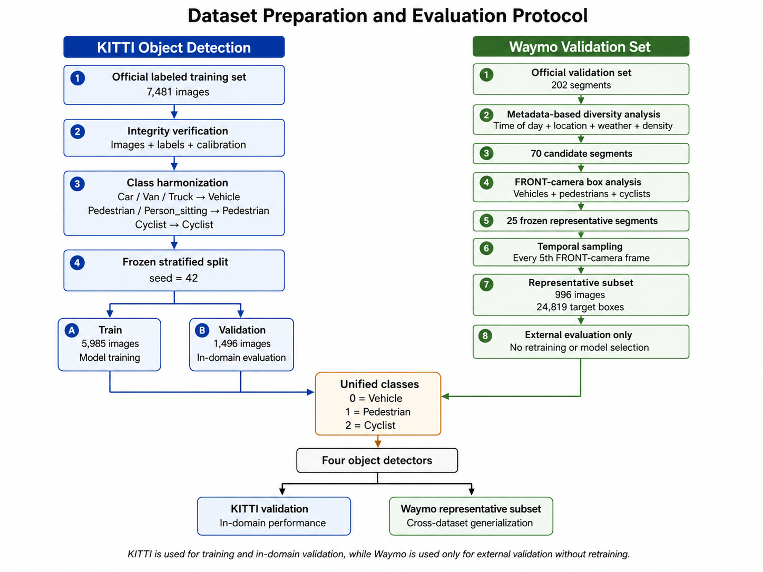
Fig. 1. Dataset preparation and evaluation protocol. KITTI is divided into fixed training and in-domain validation partitions, while a diverse representative subset of the Waymo validation set is constructed for external evaluation without retraining. Both datasets are harmonized into the common Vehicle, Pedestrian, and Cyclist classes.

A. KITTI Dataset Preparation
The KITTI Object Detection benchmark [1] was selected as the primary labeled dataset. The official object-detection training set contains 7,481 left-color camera images stored in the image_2 directory, together with 7,481 corresponding annotation files in label_2 and 7,481 camera-calibration files. In KITTI terminology, image_2 denotes the left color camera stream, and the corresponding camera projection matrix is represented by P2 in the calibration files.
The official KITTI testing set was not included in the local experimental evaluation because its ground-truth annotations are not publicly available. Consequently, the official labeled training set was divided into project-specific training and validation partitions. Before splitting, all images, annotation files, and calibration files were subjected to an integrity-verification procedure. The verification confirmed that all 7,481 samples had matching image, label, and calibration identifiers. All images were readable, all 51,865 annotation rows had valid structures, no invalid bounding boxes were found, and all calibration files contained valid projection information.
Special handling was applied to KITTI DontCare annotations. These annotations may contain placeholder truncation and occlusion values of -1, which are valid for ignored regions and were therefore not treated as annotation errors. DontCare regions were preserved for later evaluation handling but were not treated as a target object class.
The verified KITTI dataset contains 51,865 original annotation rows. The original class distribution consists of 28,742 Car, 2,914 Van, 1,094 Truck, 4,487 Pedestrian, 222 Person_sitting, 1,627 Cyclist, 511 Tram, 973 Misc, and 11,295 DontCare annotations.
A fixed stratified split was created using a random seed of 42. The split preserved the presence of Vehicle, Pedestrian, and Cyclist classes, in addition to the distribution of mapped target-object density. This produced 5,985 training images and 1,496 in-domain validation images. The training partition contains 26,278 Vehicle boxes, 3,729 Pedestrian boxes, and 1,287 Cyclist boxes. The validation partition contains 6,472 Vehicle boxes, 980 Pedestrian boxes, and 340 Cyclist boxes. The same frozen split is used for all object-detection models to ensure a fair comparison.
No KITTI image was found to be target-empty or ignored-only after class harmonization; every labeled image contains at least one Vehicle, Pedestrian, or Cyclist annotation. Ignored annotations and background regions remain available for appropriate false-positive and evaluation handling.

B. Waymo Representative External-Validation Subset
The Waymo Open Dataset [2] was used to construct an external validation subset representing a broader range of locations, traffic densities, illumination conditions, and weather conditions. Only the official Waymo validation split was considered.
The selection process began with metadata from all 202 validation segments. For each segment, time of day, location, weather, object counts, and traffic-density characteristics were analyzed. The original catalog contained 160 daytime segments, 23 dawn/dusk segments, and 19 nighttime segments. It also contained 93 Phoenix segments, 88 San Francisco segments, and 21 segments categorized as other locations. Weather diversity was highly imbalanced, with 201 sunny segments and only one rainy segment.
A broad candidate pool of 70 segments was first selected to maximize coverage of rare and important conditions. The candidate pool included all available nighttime and dawn/dusk segments, the only rainy segment, pedestrian-rich scenes, cyclist-rich scenes, and daytime scenes balanced across location and density groups.
The 2D camera annotations of the 70 candidates were then analyzed using only the Waymo FRONT camera. Candidate segments were evaluated according to Vehicle, Pedestrian, and Cyclist coverage, object frequency, and bounding-box size characteristics. An optimization-based selection procedure then produced a final frozen set of 25 representative driving segments.
The final segment set contains 14 daytime, six dawn/dusk, and five nighttime segments. It includes 12 San Francisco segments, 11 Phoenix segments, and two segments from other locations. The density distribution contains ten high-density, eight low-density, and seven medium-density segments. Twenty-two selected segments contain pedestrians, and 18 contain cyclists. The final subset also preserves the only rainy segment available in the validation metadata.
After the final segment list was frozen, the corresponding camera images and calibration files were downloaded. To reduce temporal redundancy, the FRONT-camera frames in each selected segment were sorted chronologically and sampled uniformly by retaining every fifth frame, beginning with the first available frame. This procedure resulted in 996 images.
The selected images were matched with their corresponding 2D camera boxes using the segment identifier, frame timestamp, and camera identifier. Only Vehicle, Pedestrian, and Cyclist annotations were retained; Sign annotations were excluded because traffic signs are outside the common three-class detection task.
The final Waymo representative subset contains 24,819 target boxes, including 16,928 Vehicle boxes, 7,127 Pedestrian boxes, and 764 Cyclist boxes. Twelve images contain no target boxes and were intentionally retained as negative samples for false-positive analysis. All 996 images were successfully extracted and validated. No missing images, unreadable images, invalid boxes, out-of-bound boxes, or manifest-to-annotation count mismatches were found.
The Waymo subset is used only for external evaluation. It is not used for model training, retraining, fine-tuning, validation-based checkpoint selection, threshold selection, or hyperparameter optimization. This separation prevents information leakage and allows the external results to reflect direct cross-dataset generalization.

C. Class Harmonization
To enable a consistent comparison between KITTI and Waymo, both datasets were mapped into a common three-class detection task: class 0, Vehicle; class 1, Pedestrian; and class 2, Cyclist.
For KITTI, Car, Van, and Truck were merged into Vehicle. Pedestrian and Person_sitting were merged into Pedestrian, while Cyclist was mapped directly to Cyclist. Tram, Misc, and DontCare were excluded from the target classes, with DontCare retained as an ignored region where appropriate. For Waymo, Vehicle, Pedestrian, and Cyclist were mapped directly to their corresponding unified classes, while Sign annotations were ignored.
Following harmonization, KITTI contains 39,086 target boxes: 32,750 Vehicle, 4,709 Pedestrian, and 1,627 Cyclist boxes. A further 12,779 KITTI annotations are retained as ignored annotations. The Waymo representative subset contains 24,819 target boxes under the same three-class definition.
This harmonization ensures that all detector families are trained and assessed using an identical class order and semantic task definition. All models use the same KITTI training split, the same KITTI validation split, and the same frozen Waymo external-validation subset.

D. Dataset Statistics and Visual Verification
Image-level and object-level statistics were generated for the complete KITTI dataset and for its training and validation partitions. These statistics include original and harmonized class distributions, object density, bounding-box dimensions, normalized bounding-box area, occlusion, truncation, and descriptive KITTI difficulty categories.
Bounding boxes were additionally divided into small, medium, and large descriptive groups according to the lower and upper thirds of the normalized target-box area distribution. These project-specific groups are used for dataset analysis and do not replace the official KITTI difficulty definitions.
Visual inspection samples were generated for Vehicle, Pedestrian, Cyclist, mixed, crowded, occluded, truncated, and DontCare scenes. Equivalent visual checks were produced for the Waymo representative subset. These checks confirmed that the generated annotations corresponded to the source dataset labels and that class harmonization was applied correctly.
The visual-verification scripts display dataset ground truth rather than model predictions. Consequently, an object visible in an image may not receive a box if it was not annotated by the original dataset. For example, parked bicycles without riders may not be labeled as Cyclist in KITTI, whereas a person riding a bicycle is typically annotated as Cyclist.
Overall, the final experimental protocol consists of 5,985 KITTI images for training, 1,496 KITTI images for in-domain validation, and 996 Waymo FRONT-camera images for external cross-dataset evaluation.

