Milestone 4 + 5 Comprehensive Final Report
Kaggle Training, Resume Control, Local KITTI Evaluation, and Benchmarking
Prepared for final-paper draft injection

Field | Value
Project root | C:\Users\Mazen\Desktop\AAST\Research\Autonomous research
Report generated | 2026-08-14 20:31
Training environment | Kaggle GPU sessions, with local machine as source of truth
Evaluation environment | Local GPU: NVIDIA GeForce RTX 3060 Laptop GPU
Scope | KITTI in-domain validation only; Waymo deferred to Milestone 6

Contents
1. Executive summary
2. Roadmap status and evidence basis
3. Dataset handoff and preprocessing
4. Methodology: model setup, class mapping, and fairness rules
5. Experimental setup: compute, hyperparameters, reproducibility
6. Training execution and checkpoint locking
7. Local KITTI evaluation implementation
8. Results: KITTI in-domain validation
9. Discussion, limitations, and paper-ready insertion notes
10. Appendices: artifacts and source traceability

1. Executive summary
Milestone 4 + 5 completed the controlled training and in-domain evaluation of four detector families: YOLO, RT-DETR, RetinaNet, and Faster R-CNN. The experiment used the frozen Milestone 3 KITTI train/validation split, excluded Waymo from all training and checkpoint-selection decisions, packaged the training dataset and configs for Kaggle, ran GPU training with resume-aware sessions, imported verified output packages locally, locked final checkpoints, and evaluated all detectors with a shared local KITTI validation script.
- Best overall model by strict localization accuracy: yolo with mAP50-95=0.6910.
- Best AP50: rtdetr with mAP50=0.9213; the margin over YOLO was small.
- Fastest local inference: yolo with 15.99 ms/image on the local RTX 3060 Laptop GPU.
- All four final detector ZIP packages were SHA-verified before extraction, and final best/last checkpoints were locked in a local registry.
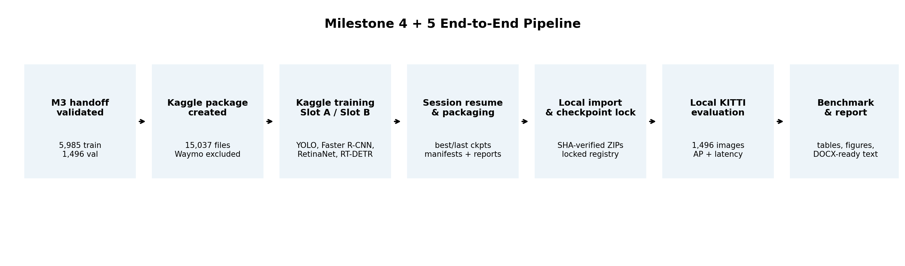
Figure 1. Milestone 4 + 5 end-to-end pipeline from Milestone 3 handoff through final reporting.

2. Roadmap status and evidence basis
The implementation roadmap is complete through Step 31 preparation. Steps 25-30 were executed locally after all four Kaggle output ZIP packages were downloaded and verified. The DOCX report itself corresponds to Step 31.
Step(s) | Work item | Status
1-6 | Local folder creation, policy/config freeze, M3 handoff validation, upload-set decision, Kaggle package creation | Complete
7-13 | Kaggle upload, notebook structure, Kaggle environment and data validation, slot-aware configs, resume-aware runner, manifests | Complete
14-24 | Tiny/pilot/full training by Slot A and Slot B, resume packaging, output packaging | Complete
25 | Import Slot A and Slot B output ZIP packages locally | Complete
26-27 | Validate resume chain and lock final checkpoints locally | Complete
28 | Build local prediction adapters and evaluator; inspect formats and smoke-load all models | Complete
29 | Run final local KITTI validation on 1,496 images | Complete
30 | Create benchmark tables, rankings, and figures | Complete
31 | Write comprehensive DOCX documentation | This report
32-34 | Final audit, Git safety checks, commit and push | Pending after report review

2.1 Source files used
This report was compiled from the uploaded Milestone 4 + 5 source bundle and the Kaggle notebook. The source bundle contained configs, manifests, reports, local evaluator scripts, final metrics, benchmark tables, and generated figures. The uploaded notebook was sufficient as a representative run notebook because it contains the generic detector selector, environment validation, configuration writer, resume-aware training runner creation, dry-run validation, training dispatch, output verification, and download cells. No additional notebooks are required unless a later audit needs person-specific interface evidence.
Evidence group | Path/source | Used for
Configs | configs/datasets/milestone_3 and configs/models/milestone_4 | Dataset, class mapping, preprocessing, fair comparison, compute, training, and evaluation policies
M3 validation report | outputs/milestone_4/reports/milestone_3_handoff_validation.json | Dataset counts and handoff validation status
Kaggle package manifests | outputs/milestone_4/manifests/kaggle_*manifest.* | Package file counts, SHA, group inclusion/exclusion
Training reports/manifests | outputs/milestone_4/reports and manifests/*final* | Run IDs, status, resume checkpoints, durations, epoch completion
Local lock registry | outputs/milestone_4/locked_final_checkpoints/final_checkpoint_registry.json | Canonical checkpoints and SHA hashes
Local evaluator outputs | outputs/milestone_5/final_kitti_validation and benchmark_comparison | Metrics, ranking tables, and figures
Notebook | notebook772d1180c8.ipynb | Shared Kaggle run notebook and train-runner definition

3. Dataset handoff and preprocessing
The local Milestone 3 handoff was validated before packaging. The validation report passed all configured checks and confirmed the frozen KITTI split sizes and annotation counts used for this milestone.
Split | Images | Target annotations | Missing images | Wrong-size images | Checked sizes
kitti_train | 5985 | 31294 | 0 | 0 | 5985
kitti_val | 1496 | 7792 | 0 | 0 | 1496

- M3 handoff checks: 34/34 passed; final status PASSED.
- KITTI train: 5,985 images and 31,294 target annotations.
- KITTI validation: 1,496 images and 7,792 target annotations.
- Waymo external validation remained excluded from Milestone 4 + 5 and is deferred to Milestone 6.
Preprocessing item | Protocol
Target image size | 640 x 640
Resize policy | centered_letterbox
Aspect ratio | preserved with centered letterbox padding
Padding value | [114, 114, 114]
Output image format | PNG (.png)
Canonical annotation format | COCO
YOLO label format | cxcywh_normalized_float
Evaluation image policy | validation images deterministic and unaugmented

Training transform | Enabled | Probability | Key parameters
horizontal_flip | True | 0.5
brightness_contrast | True | 0.5 | brightness_limit=0.15, contrast_limit=0.15
hsv_adjustment | True | 0.3 | hue_shift_limit_opencv=5, saturation_scale={'minimum': 0.85, 'maximum': 1.15}, value_scale={'minimum': 0.9, 'maximum': 1.1}
gaussian_blur | True | 0.1 | kernel_choices=[3, 5], sigma={'minimum': 0.1, 'maximum': 1.2}

The online augmentation policy was limited to the KITTI training partition. KITTI validation and Waymo external validation were explicitly kept deterministic and unaugmented. The stored processed images remained unchanged; augmentation was performed during training only.

4. Methodology: model setup, class mapping, and fairness rules

4.1 Target classes and class mapping
Class | Canonical / Torchvision ID | YOLO / Ultralytics ID | Notes
Vehicle | 1 | 0 | Torchvision foreground ID 1 (background=0)
Pedestrian | 2 | 1 | Torchvision foreground ID 2 (background=0)
Cyclist | 3 | 2 | Torchvision foreground ID 3 (background=0)

Torchvision detectors were trained with four classes including background: background=0, Vehicle=1, Pedestrian=2, Cyclist=3. Ultralytics detectors were trained with three zero-based classes: Vehicle=0, Pedestrian=1, Cyclist=2. During final local evaluation, Torchvision predictions were mapped back by subtracting one from the foreground class label, giving the same semantic class order as YOLO and RT-DETR.

4.2 Detector setup
Detector | Family | Model | Slot | Optimizer | LR | Momentum | Weight decay
yolo | ultralytics | yolo26s.pt | slot_a | auto | ultralytics_auto
rtdetr | ultralytics | rtdetr-l.pt | slot_b | auto | ultralytics_auto
faster_rcnn | torchvision | fasterrcnn_resnet50_fpn | slot_a | SGD | 0.005 | 0.9 | 0.0005
retinanet | torchvision | retinanet_resnet50_fpn | slot_a | AdamW | 0.0001 |  | 0.0001

4.3 Fair comparison rules
- Fixed constants: image size 640, nominal batch size 16, epochs 120, patience 20, seed 42.
- All detectors used the same frozen KITTI train/validation split and the same three target classes.
- Allowed differences were restricted to optimizer, learning rate, and native detector-family training loop.
- Waymo was forbidden during final training, checkpoint selection, and hyperparameter tuning.
- Torchvision DataParallel was disabled; device 0 was used to avoid channel-splitting issues for detection model inputs.
- Controlled memory exception: RT-DETR final resume log records batch=8, imgsz=640, epochs=120, device=0, seed=42, patience=20, and time=None.

5. Kaggle package and upload boundary
Before any cloud training, the upload boundary was frozen to ensure only allowed files entered Kaggle. The package included KITTI train/validation processed data, configs, documentation, and scripts. It explicitly excluded Waymo external validation data, model checkpoints, pretrained weights, local secrets, and prior Kaggle output ZIP packages.
Package item | Value
Upload manifest status | PASSED
Upload manifest total files | 15,036
Upload manifest size | 1.74 GB
Excluded Waymo files | 1,997
Kaggle ZIP status | PASSED
Kaggle ZIP files packaged | 15,037
Kaggle ZIP size | 1.67 GB
Kaggle ZIP SHA256 | 17698b9411b83e115b82010012c16819b1192af0b76a7a3fd09317b64e6a6b3c

Package group | Files | Uncompressed size
required_single_file | 8 | 0.02 MB
source_code | 9 | 0.03 MB
milestone_3_dataset_configs | 5 | 0.01 MB
processed_images | 7,481 | 1745.42 MB
coco_annotations | 2 | 16.39 MB
yolo_labels | 7,481 | 2.01 MB
ignore_regions | 2 | 4.27 MB
excluded_objects | 2 | 1.67 MB
m3_manifests | 10 | 13.79 MB
m3_reports | 32 | 0.10 MB
documentation | 4 | 0.01 MB
package_metadata | 1 | 0.00 MB

6. Experimental setup: compute, hyperparameters, and reproducibility

6.1 Compute allocation and hardware policy
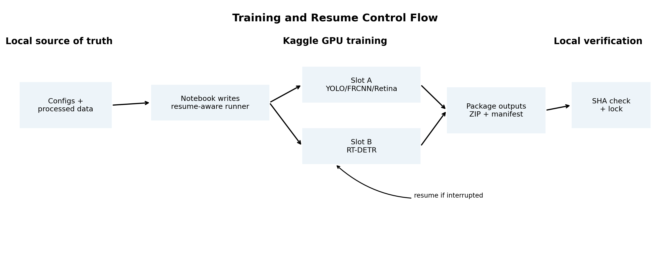
Figure 2. Kaggle training and resume control flow.
Slot | Description | Assigned detectors | Expected completion
slot_a | Kaggle training slot for shorter detector families | yolo, faster_rcnn, retinanet | {'yolo': 'single_session', 'faster_rcnn': 'single_session', 'retinanet': 'single_session'}
slot_b | Kaggle training slot reserved for RT-DETR because it may exceed one session | rtdetr | {'rtdetr': 'multi_session_resume_required_or_likely'}

Kaggle was used for GPU training only. The local machine remained the source of truth for packaging, output import, checkpoint locking, final KITTI evaluation, benchmarking, documentation, and Git control. Kaggle sessions used a 10.5-hour safe runtime guard for Torchvision detectors, package-on-exit, session manifests, best/last checkpoints, and save-every-5-epochs checkpointing.

6.2 Reproducibility snapshot
Reproducibility item | Value
Local Python | 3.12.10
Local torch | 2.11.0+cu128
Local torchvision | 0.26.0+cu128
Local Ultralytics | 8.4.117
Local OpenCV | 4.13.0
Local NumPy / Pandas | 2.4.6 / 3.0.3
Local CUDA available | True
Local GPU | NVIDIA GeForce RTX 3060 Laptop GPU
NVIDIA driver / CUDA runtime | 592.27 / 13.1
Git branch / upstream | main / up to date with origin/main
Latest listed commit | 8dd6d17

6.3 Kaggle notebook and runner behavior
Notebook component | Role
Reusable detector selector | DETECTOR_TO_RUN supports faster_rcnn, retinanet, yolo, and rtdetr
Resume policy | auto/new/resume; final_resume_if_needed used when checkpoints existed
Device policy | device 0 for consistency; Torchvision restricted to one GPU
Environment validation | Python, torch, torchvision, ultralytics, CUDA, GPU count, and disk space recorded
Config generation | Notebook wrote training_runs.yaml, detector_hyperparameters.yaml, yolo_data.yaml, and fair_comparison_policy.yaml
Training runner | Notebook wrote scripts/milestone_4/train.py with Ultralytics and Torchvision branches
Dry run and output gate | Notebook dry-run cell checked command dispatch; post-training cell checked checkpoints, reports, and ZIP packages

Runner behavior | Implementation detail
Ultralytics branch | YOLO(model or resume checkpoint).train(data=yolo_data.yaml, epochs=120, imgsz=640, batch=16 nominal, patience=20, seed=42, deterministic=True, amp=True, save_period=5, resume flag as needed).
Torchvision branch | COCO-based Dataset over processed KITTI images and annotations; list[Tensor] collate; Faster R-CNN/RetinaNet ResNet-50 FPN; num_classes=4 including background.
Torchvision optimization | Faster R-CNN: SGD lr=0.005, momentum=0.9, wd=0.0005; RetinaNet: AdamW lr=0.0001, wd=0.0001.
Runtime guard | Torchvision final sessions stop safely after completing an epoch when max_runtime_hours is reached; outputs are packaged on exit.
Training-time validation | Torchvision sessions used a lightweight one-batch validation forward pass; final mAP/latency is isolated to local evaluation.

7. Training execution and checkpoint locking
Detector | Run ID | Slot | Run type | Final status | Result | Start epoch | Last epoch | Hours | Resumed
YOLO | yolo_final_20260813_153831 | slot_a | final | PASSED | TRAINING_FINISHED |  |  | 4.776 | no
RT-DETR | rtdetr_final_resume_if_needed_20260814_100816 | slot_b | final_resume_if_needed | PASSED | TRAINING_FINISHED |  |  | 3.044 | yes
RetinaNet | retinanet_final_resume_if_needed_20260814_100422 | slot_a | final_resume_if_needed | PASSED | TRAINING_FINISHED | 88 | 120 | 4.517 | yes
Faster R-CNN | faster_rcnn_final_resume_if_needed_20260814_100004 | slot_a | final_resume_if_needed | PASSED | TRAINING_FINISHED | 67 | 120 | 8.816 | yes

The final local registry locked the canonical best checkpoint for each model and recorded the corresponding best/last checkpoint SHA256 values. The final ZIP SHA values were already verified before local extraction.
Detector | Locked run ID | Status | Last epoch | Canonical checkpoint | Best SHA | ZIP SHA
yolo | yolo_final_20260813_153831 | PASSED | None | outputs\milestone_4\checkpoints\yolo\yolo_final_20260813_153831\weights\best.pt | ede748e1d612... | 640065001122...
rtdetr | rtdetr_final_resume_if_needed_20260814_100816 | PASSED | None | outputs\milestone_4\checkpoints\rtdetr\rtdetr_final_20260813_215051\weights\best.pt | c075d80823a5... | ea91fc6541f1...
retinanet | retinanet_final_resume_if_needed_20260814_100422 | PASSED | 120 | outputs\milestone_4\checkpoints\retinanet\retinanet_final_resume_if_needed_20260814_100422\best.pth | fb1abedb441c... | 435534a09f7b...
faster_rcnn | faster_rcnn_final_resume_if_needed_20260814_100004 | PASSED | 120 | outputs\milestone_4\checkpoints\faster_rcnn\faster_rcnn_final_resume_if_needed_20260814_100004\best.pth | 2748e67138e7... | e074de839050...

8. Local KITTI evaluation implementation
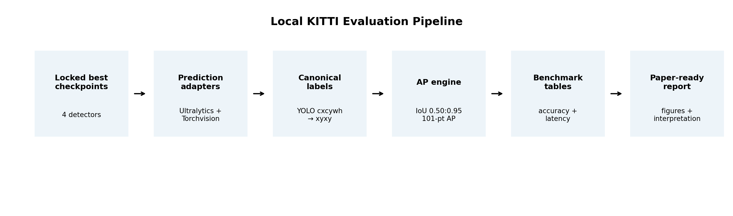
Figure 3. Local evaluation pipeline used to standardize predictions across detector families.
The final evaluation was performed locally against the frozen KITTI validation split. The evaluator loaded the locked best checkpoint for each detector, generated predictions for all 1,496 validation images, converted all predictions and labels into a canonical xyxy pixel-coordinate representation, and computed AP over IoU thresholds 0.50:0.95.
Evaluation item | Implementation
Evaluation split | KITTI validation
Images / target labels | 1,496 images / 7,792 target annotations
Classes | Vehicle, Pedestrian, Cyclist
Input image size | 640 x 640 processed PNGs
Prediction adapters | Ultralytics.YOLO for YOLO and RT-DETR; Torchvision constructors for RetinaNet and Faster R-CNN
Label parser | YOLO normalized cxcywh converted to xyxy pixel boxes
AP thresholds | 0.50, 0.55, ..., 0.95
Confidence threshold for AP | 0.001
Maximum detections | 300 per image in inference settings
Latency metric | Mean wall-clock inference time per image on local GPU

Detector | Confirmed loader | Checkpoint epoch | Sample predictions | Top labels
yolo | ultralytics.YOLO |  | 2 | 0, 0
rtdetr | ultralytics.YOLO |  | 2 | 0, 0
retinanet | retinanet_resnet50_fpn(num_classes=4) | 105 | 2 | 1, 1
faster_rcnn | fasterrcnn_resnet50_fpn(num_classes=4) | 120 | 2 | 1, 1

The smoke-load step verified that RetinaNet matched retinanet_resnet50_fpn(num_classes=4) and Faster R-CNN matched fasterrcnn_resnet50_fpn(num_classes=4). Torchvision foreground predictions were converted from IDs 1-3 to evaluation IDs 0-2.

9. Results: KITTI in-domain validation
The following results are the standardized local KITTI validation results from the shared evaluator. They are the primary in-domain comparison outputs for Milestone 5.
Detector | Images | mAP50 | mAP50-95 | Mean ms/image
yolo | 1,496 | 0.9206 | 0.6910 | 15.99
rtdetr | 1,496 | 0.9213 | 0.6314 | 43.49
faster_rcnn | 1,496 | 0.8609 | 0.5396 | 59.02
retinanet | 1,496 | 0.8078 | 0.5081 | 54.77

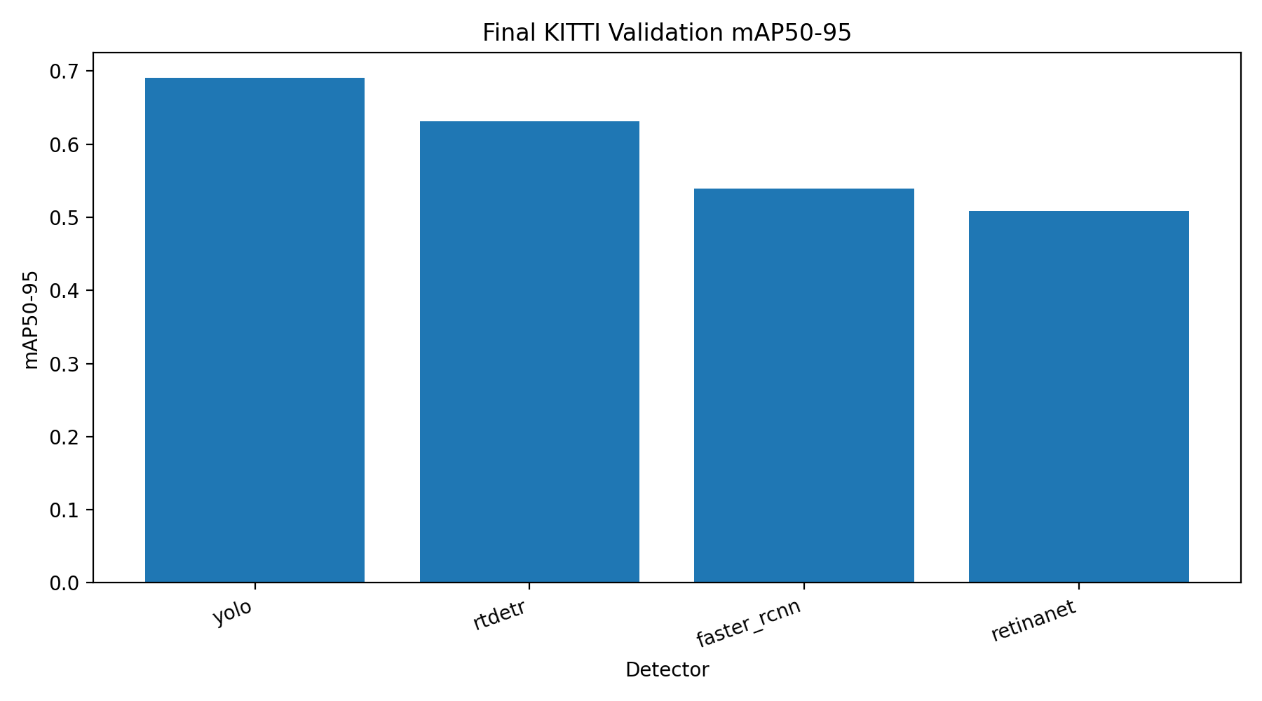
Figure 4. Final KITTI validation mAP50-95 comparison.
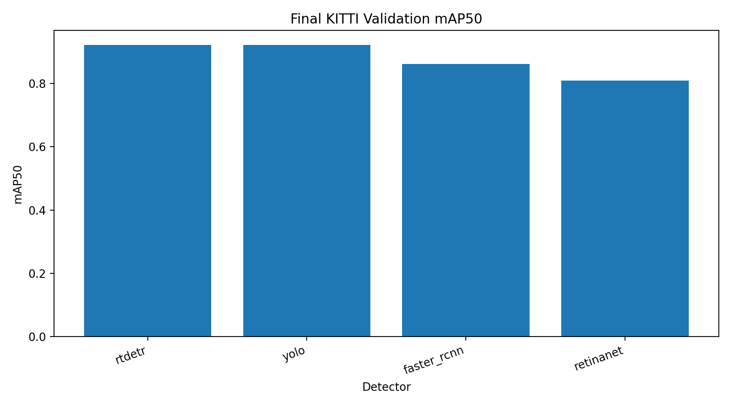
Figure 5. Final KITTI validation mAP50 comparison.
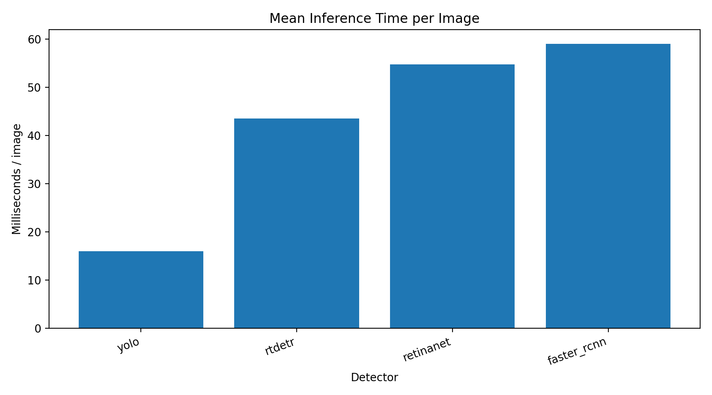
Figure 6. Mean inference time per validation image.

9.1 Class-level results
Detector | Vehicle AP50-95 | Pedestrian AP50-95 | Cyclist AP50-95 | Vehicle AP50 | Pedestrian AP50 | Cyclist AP50
yolo | 0.8515 | 0.5281 | 0.6934 | 0.9774 | 0.8616 | 0.9229
rtdetr | 0.7672 | 0.5010 | 0.6261 | 0.9670 | 0.8773 | 0.9196
retinanet | 0.6913 | 0.3742 | 0.4589 | 0.9237 | 0.7306 | 0.7692
faster_rcnn | 0.7181 | 0.3893 | 0.5115 | 0.9480 | 0.7752 | 0.8595

9.2 Ranking and accuracy-speed tradeoff
Detector | Rank mAP50-95 | Rank mAP50 | Rank speed | Combined score
yolo | 1 | 2 | 1 | 1.0000
rtdetr | 2 | 1 | 2 | 0.7773
faster_rcnn | 3 | 3 | 4 | 0.6534
retinanet | 4 | 4 | 3 | 0.6245

- YOLO produced the best strict localization result (mAP50-95=0.6910) and the lowest latency (15.99 ms/image).
- RT-DETR produced the highest mAP50 (0.9213) but had lower mAP50-95 than YOLO and higher latency.
- Faster R-CNN outperformed RetinaNet in both mAP50 and mAP50-95, but it was the slowest model in the local benchmark.
- RetinaNet was slightly faster than Faster R-CNN but had the lowest accuracy among the four final detectors.

10. Discussion and paper-ready insertion notes

10.1 Suggested final-paper paragraph: experimental methodology
For the in-domain detector comparison, all experiments used the frozen Milestone 3 KITTI train/validation split with 5,985 training images and 1,496 validation images. Images were resized to 640 x 640 using centered letterbox padding while preserving aspect ratio, and all detector families shared the same three-class ontology: Vehicle, Pedestrian, and Cyclist. YOLO and RT-DETR used zero-based Ultralytics class IDs, whereas Torchvision-based RetinaNet and Faster R-CNN used a background class at ID 0 and foreground IDs 1-3. Predictions were mapped back to a shared class space before evaluation. Waymo data was excluded from training, checkpoint selection, and hyperparameter tuning for Milestone 4 + 5 and was deferred to external validation in Milestone 6.

10.2 Suggested final-paper paragraph: training setup
Training was executed on Kaggle GPU sessions using a resume-aware notebook and training runner while the local repository remained the source of truth for package creation, output import, final evaluation, documentation, and Git control. The fixed comparison constants were 640-pixel input size, nominal batch size 16, 120 epochs, patience 20, and seed 42. YOLO used yolo26s.pt, RT-DETR used rtdetr-l.pt, Faster R-CNN used fasterrcnn_resnet50_fpn, and RetinaNet used retinanet_resnet50_fpn. Torchvision detectors used ImageNet-pretrained ResNet-50 backbones and detector-specific optimizers: SGD for Faster R-CNN and AdamW for RetinaNet. RT-DETR used a documented batch-size reduction during the final resume run to remain within T4 memory limits.

10.3 Suggested final-paper paragraph: results
On the final KITTI validation evaluation, YOLO achieved the strongest overall tradeoff with mAP50-95=0.6910 and 15.99 ms/image average latency. RT-DETR achieved the highest mAP50 (0.9213) but lower mAP50-95 (0.6314) and higher latency. Faster R-CNN reached mAP50-95=0.5396, while RetinaNet reached mAP50-95=0.5081. These results indicate that YOLO is the preferred detector for the current in-domain setting, especially when both localization quality and inference speed are considered.

10.4 Limitations and audit notes
- The reported comparison is KITTI in-domain only; external Waymo validation is intentionally deferred to Milestone 6.
- The local evaluator standardized all four models, so final local results are preferred over framework-native training console metrics for cross-family comparison.
- Training-time validation for Torchvision models was a lightweight forward pass and was not used as the final performance metric.
- The policy files define additional evaluation outputs such as AP75, operating-point precision/recall/F1, object-size metrics, and DontCare suppression. The current local evaluator delivered AP50, mAP50-95, class AP, prediction files, and latency; additional policy metrics can be implemented if required by the final paper.
- Kaggle output ZIPs and checkpoint files should remain outside Git; metrics, manifests, configs, documentation, and lightweight reports are suitable for commit.

11. Appendix A: generated artifacts
Artifact | Path
Final checkpoints registry | outputs/milestone_4/locked_final_checkpoints/final_checkpoint_registry.json
Full comparison table | outputs/milestone_5/final_kitti_validation/tables/comparison_summary_full.csv
Per-detector metrics | outputs/milestone_5/final_kitti_validation/metrics/*_metrics_full.json
Prediction files | outputs/milestone_5/final_kitti_validation/predictions/*_predictions_full.jsonl (not included in report bundle)
Benchmark ranking | outputs/milestone_5/benchmark_comparison/tables/detector_ranking_full.csv
Figures | outputs/milestone_5/benchmark_comparison/figures/*.png
Smoke-load summary | outputs/milestone_5/smoke_tests/final_model_smoke_load_summary.json
Format inspection | outputs/milestone_5/inspection/eval_format_inspection.json

12. Appendix B: checkpoint and package hashes
Detector | Verified ZIP SHA256 | Best checkpoint SHA256 | Last checkpoint SHA256
yolo | 64006500112291690c42d254011f4a6725177a86df36663db9e4185336a5e38d | ede748e1d6122a3b7ab56e70cbf280156f530d1d49e812b3b4eaf457a799f261 | f779a76c2977029277229a7cf5ae56ac89421e37f96d1d67c0382fd1f9d82ae7
rtdetr | ea91fc6541f1fa868504e643b4eaf585e710b32916be63c8249c4fab9c9c1ae7 | c075d80823a580c9369859e36536a8c5507a4ee4f00487e0c90ee01c23fc6eb5 | 2fa1835803f87c9bad67057502999b7ccda65ea244ccff75f317d474e47111f5
retinanet | 435534a09f7b7245bff1c782ca7f8781d16279e4b24d6d01899710339db8d234 | fb1abedb441cdddcac699519445126889669782fa0cc7db89922e1fcc0fb4121 | ba6b3f7a206468bd759e2e3f0a0150ac5839ec8ca24b4fac7744d424e6d2deee
faster_rcnn | e074de8390506ff7d1e5b3be7dc238985de4bba6d0f481692782250cf13a0288 | 2748e67138e7a8de29722a3c66aa0d7d7b0984c2d759aa7c4100148646b23961 | 2748e67138e7a8de29722a3c66aa0d7d7b0984c2d759aa7c4100148646b23961

13. Appendix C: source-control status at report generation
Git branch: main; upstream: up to date with origin/main; latest listed commit before generated M5 artifacts: 8dd6d17.
The environment log indicated untracked files after local M5 generation, which is expected before the final audit, Git safety checks, commit, and push steps.

