Milestone 6: Waymo External Validation and Generalization Analysis
Injection-ready report for IEEE T-IV draft integration
Generated from uploaded Milestone 6 source bundle | 2026-08-14 21:40

Executive Summary
Milestone 6 evaluates the four locked KITTI-trained object detectors directly on the Waymo external subset without retraining, fine-tuning, architecture changes, or Waymo-based threshold tuning. The experiment measures cross-dataset generalization by comparing Waymo external-validation performance against the Milestone 5 KITTI in-domain baseline.
- Waymo handoff passed with 996 images, 996 labels, 996 matched pairs, and 24819 target annotations.
- The external subset uses the same three-class mapping as Milestone 5: 0 = Vehicle, 1 = Pedestrian, 2 = Cyclist.
- The best Waymo detector by mAP50-95 was RetinaNet with Waymo mAP50-95 = 0.0788.
- The strongest mAP50-95 generalization ratio was achieved by RetinaNet with ratio = 0.1550.
- The fastest detector on the Waymo subset was YOLO at 20.03 ms/image.
- All detectors suffered large performance drops from KITTI to Waymo, supporting the core Milestone 6 claim that in-domain accuracy alone is not a reliable indicator of external-domain stability.
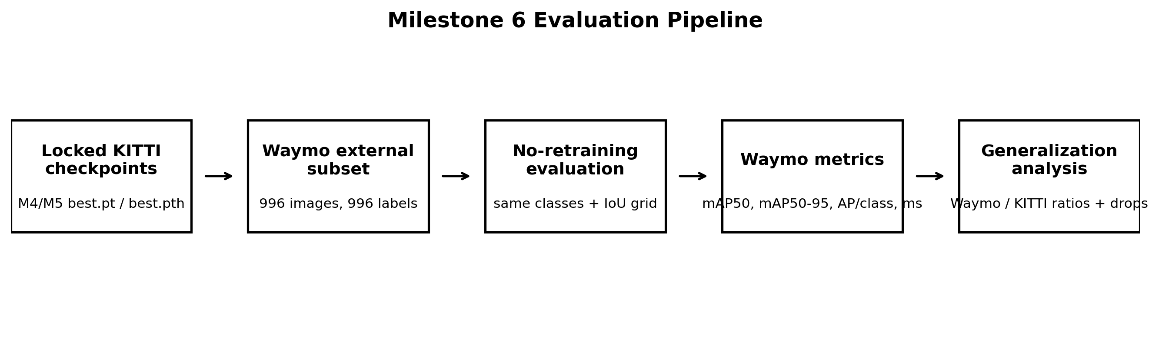
Figure 1. Milestone 6 external-validation pipeline.

1. Milestone Objective and Paper Role
The role of Milestone 6 is to turn the trained detector benchmark into a cross-dataset generalization study. Rather than reporting only KITTI validation results, the milestone tests whether the same trained detectors remain reliable when exposed to an external Waymo subset. This is the central novelty bridge for the final paper: it shifts the work from a simple in-domain comparison toward a domain-shift and external-validation analysis relevant to intelligent-vehicle perception.
The experiment is intentionally strict: Waymo data is used only for external validation. No model is retrained or fine-tuned on Waymo, and no detector is given a Waymo-specific advantage through architecture changes or threshold tuning. Therefore, the Waymo results should be interpreted as external-domain transfer behavior of KITTI-trained perception models.

Definition of Done
- Validate the Waymo image/label handoff and class mapping.
- Load all four locked KITTI-trained checkpoints and confirm inference works on Waymo samples.
- Run full Waymo external validation for YOLO, RT-DETR, RetinaNet, and Faster R-CNN.
- Compare KITTI baseline results against Waymo external results.
- Compute aggregate and class-wise Generalization Ratio values.
- Generate paper-ready figures and tables for domain-shift discussion.
- Produce an injection-ready report section for the final IEEE T-IV draft.

2. Source Bundle and Traceability
This report was generated from the uploaded Milestone 6 source bundle. The bundle intentionally excludes raw prediction JSONL files, model checkpoint weights, and ZIP checkpoint packages. It includes the configuration files, scripts, metric JSON files, summary tables, figures, and Milestone 4/5 checkpoint registry required to reproduce the report content.

Table 1. Source-bundle traceability summary
Item | Value
Bundle files copied | 74
Bundle SHA256 | 4a4013cd8f9a31ac612ce76e344bedbd3f9dd282fa7f45b0f596d9f33a2685c8
Excluded large artifacts | .jsonl, .pt, .pth, .pyc, .tmp, .zip
Excluded folders | .git, .ipynb_checkpoints, AVenv, __pycache__, checkpoints, predictions, verified_zips
Last pushed baseline commit before M6 work | 9a23567 Add Milestone 4 and 5 final evaluation artifacts

3. Waymo External Subset Handoff
The handoff validation script checked that the external Waymo image and label directories exist, that every image has a matching label file, that label values follow the expected YOLO-normalized format, and that all class IDs are within the three-class contract. The validation passed and found no label-format issues.

Table 2. Waymo external subset handoff summary
Handoff item | Value
Image directory | data/processed/milestone_3/images/waymo/external
Label directory | data/processed/milestone_3/labels/waymo/external
Images | 996
Labels | 996
Matched image-label pairs | 996
Images without labels | 0
Labels without images | 0
Total annotations | 24819
Empty label files | 12
Handoff status | PASSED

Table 3. Waymo class distribution after handoff validation
Class ID | Class name | Waymo annotations
0 | Vehicle | 16928
1 | Pedestrian | 7127
2 | Cyclist | 764

4. Experimental Policy and Fairness Rules
The Milestone 6 policy is based on external validation rather than model development. The same locked checkpoints used for Milestone 5 are evaluated on the same Waymo subset under the same class mapping and AP metric definitions. The policy forbids retraining, fine-tuning, architecture changes, and Waymo-based threshold tuning.

Table 4. External-validation fairness policy
Rule | Milestone 6 setting
Training on Waymo | Forbidden
Fine-tuning on Waymo | Forbidden
Architecture changes | Forbidden
Waymo threshold tuning | Forbidden
Checkpoint selection | Locked best checkpoint per detector from Milestone 4/5 registry
Input size | 640
Confidence threshold | 0.001
NMS IoU for Ultralytics models | 0.70
Primary metric | mAP50-95
Secondary metrics | mAP50, per-class AP50, per-class AP50-95, mean inference time

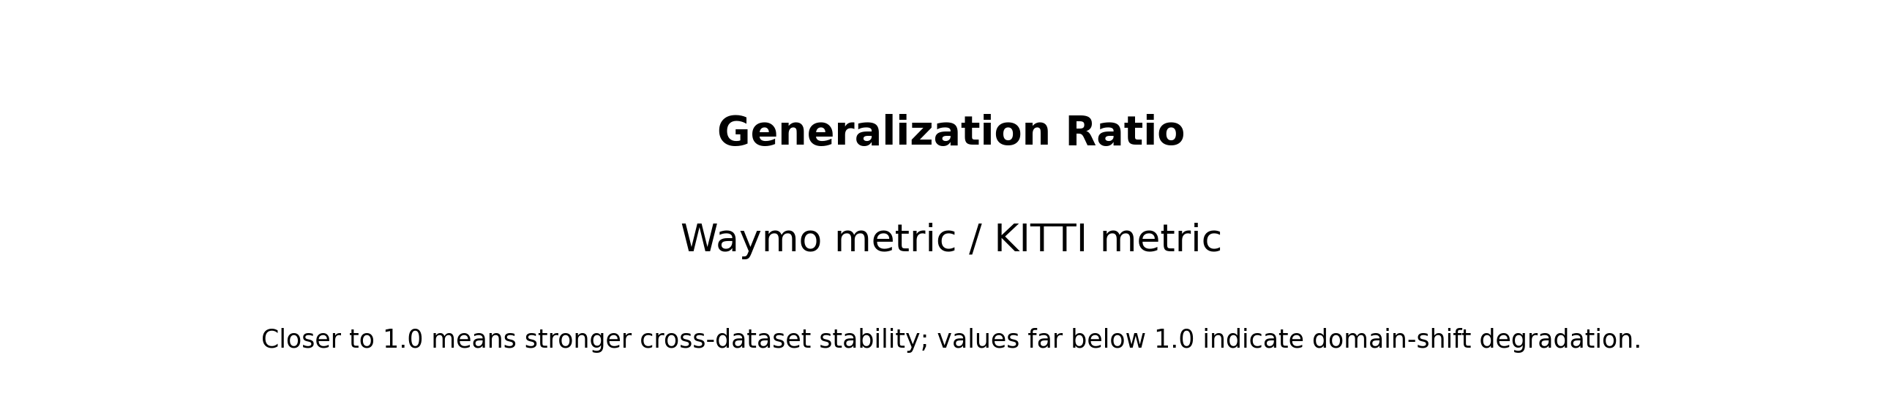
Figure 2. Generalization Ratio definition used for Milestone 6.

5. Locked Model Checkpoints
All four detectors are evaluated using the canonical locked checkpoints from Milestone 4/5. These checkpoints were previously imported from verified Kaggle packages and recorded in the final checkpoint registry. Torchvision detectors use four output classes internally, including the background class, while the published evaluation maps predictions back to the three foreground classes.

Table 5. Locked checkpoint registry used for external validation
Detector | Run ID | Canonical checkpoint | Status | Best SHA256 prefix | Last epoch
YOLO | yolo_final_20260813_153831 | outputs\milestone_4\checkpoints\yolo\yolo_final_20260813_153831\weights\best.pt | PASSED | ede748e1d6122a3b... | N/A
RT-DETR | rtdetr_final_resume_if_needed_20260814_100816 | outputs\milestone_4\checkpoints\rtdetr\rtdetr_final_20260813_215051\weights\best.pt | PASSED | c075d80823a580c9... | N/A
RetinaNet | retinanet_final_resume_if_needed_20260814_100422 | outputs\milestone_4\checkpoints\retinanet\retinanet_final_resume_if_needed_20260814_100422\best.pth | PASSED | fb1abedb441cdddc... | 120
Faster R-CNN | faster_rcnn_final_resume_if_needed_20260814_100004 | outputs\milestone_4\checkpoints\faster_rcnn\faster_rcnn_final_resume_if_needed_20260814_100004\best.pth | PASSED | 2748e67138e7a8de... | 120

6. Implementation Scripts

Table 6. Milestone 6 implementation scripts
Script | Role
00_validate_waymo_handoff.py | validate image/label counts, label format, class IDs, and handoff readiness
01_create_milestone_6_configs.py | write dataset, external validation, and generalization metric policy files
02_smoke_test_waymo_models.py | smoke-load all four locked checkpoints and run sample Waymo predictions
03_run_waymo_external_validation.py | run full Waymo evaluation and save metrics/prediction summaries
04_create_generalization_analysis.py | compare KITTI and Waymo results; compute ratios and degradation
05_create_waymo_generalization_figures.py | generate report figures for domain shift and generalization analysis

7. Reproducibility Environment
The external-validation run was executed locally on the user workstation. Inference-time values in this report therefore describe the local evaluation environment and should not be mixed with Kaggle training-time measurements without explicit qualification.

Table 7. Local reproducibility environment
Component | Version / value
Python | Python 3.12.10
PyTorch | 2.11.0+cu128
Torchvision | 0.26.0+cu128
Ultralytics | 8.4.117
OpenCV | 4.13.0
NumPy | 2.4.6
Pandas | 3.0.3
CUDA availability | True
GPU | NVIDIA GeForce RTX 3060 Laptop GPU
NVIDIA driver | 592.27

8. Evaluation Methodology
Ground-truth annotations were read from YOLO-normalized labels and converted to pixel-space xyxy boxes using the corresponding image dimensions. The evaluation uses the same semantic class contract as the KITTI in-domain benchmark: Vehicle, Pedestrian, and Cyclist. AP is computed separately for each class using sorted confidence predictions and one-to-one greedy matching at each IoU threshold. The mAP50 value averages class AP at IoU 0.50, while mAP50-95 averages AP across the IoU thresholds 0.50 to 0.95 in increments of 0.05.
- Ultralytics models: YOLO and RT-DETR checkpoints are loaded with the Ultralytics YOLO API.
- Torchvision models: RetinaNet and Faster R-CNN checkpoints are loaded with num_classes = 4, including background.
- Torchvision labels are converted from raw labels 1/2/3 to evaluation class IDs 0/1/2.
- Waymo prediction JSONL files were generated locally but excluded from the upload bundle to avoid committing or sharing large artifacts.
- The final report uses the metric JSON files, summary CSV/JSON tables, and generated figures included in the uploaded bundle.

9. Smoke Test Before Full Evaluation
The smoke test status was PASSED. It loaded all four locked checkpoints and produced predictions on 5 Waymo sample images before running the full 996-image external-validation pass.

Table 8. Smoke-test confirmation
Detector | Status | Mean elapsed ms | Sample images | Checkpoint
YOLO | PASSED | 245.63 | 5 | outputs\milestone_4\checkpoints\yolo\yolo_final_20260813_153831\weights\best.pt
RT-DETR | PASSED | 131.91 | 5 | outputs\milestone_4\checkpoints\rtdetr\rtdetr_final_20260813_215051\weights\best.pt
RetinaNet | PASSED | 66.26 | 5 | outputs\milestone_4\checkpoints\retinanet\retinanet_final_resume_if_needed_20260814_100422\best.pth
Faster R-CNN | PASSED | 71.37 | 5 | outputs\milestone_4\checkpoints\faster_rcnn\faster_rcnn_final_resume_if_needed_20260814_100004\best.pth

10. Milestone 5 KITTI Baseline
The KITTI baseline is the Milestone 5 in-domain validation result table. These values are the denominator for the Generalization Ratio calculations in Milestone 6.

Table 9. KITTI in-domain baseline summary
detector | num_images | mAP50 | mAP50_95 | mean_inference_ms | Vehicle_AP50_95 | Pedestrian_AP50_95 | Cyclist_AP50_95
YOLO | 1496 | 0.9206 | 0.6910 | 15.9886 | 0.8515 | 0.5281 | 0.6934
RT-DETR | 1496 | 0.9213 | 0.6314 | 43.4884 | 0.7672 | 0.5010 | 0.6261
RetinaNet | 1496 | 0.8078 | 0.5081 | 54.7681 | 0.6913 | 0.3742 | 0.4589
Faster R-CNN | 1496 | 0.8609 | 0.5396 | 59.0178 | 0.7181 | 0.3893 | 0.5115

11. Waymo External Validation Results
The table below reports direct Waymo external-validation performance for each locked KITTI-trained detector. The values are substantially lower than the KITTI baseline, confirming significant transfer degradation under the no-retraining protocol.

Table 10. Waymo external-validation summary
detector | num_images | mAP50 | mAP50_95 | mean_inference_ms | Vehicle_AP50_95 | Pedestrian_AP50_95 | Cyclist_AP50_95
YOLO | 996 | 0.1094 | 0.0539 | 20.0261 | 0.0962 | 0.0372 | 0.0283
RT-DETR | 996 | 0.1661 | 0.0768 | 48.5091 | 0.1219 | 0.0662 | 0.0423
RetinaNet | 996 | 0.1680 | 0.0788 | 51.9362 | 0.1161 | 0.0635 | 0.0568
Faster R-CNN | 996 | 0.1220 | 0.0545 | 58.8757 | 0.0916 | 0.0459 | 0.0260

12. KITTI vs Waymo Aggregate Comparison
Milestone 6 directly compares the KITTI and Waymo values for each detector. The most important columns are the absolute mAP50-95 drop, the percentage drop, and the mAP50-95 Generalization Ratio.

Table 11. KITTI-to-Waymo aggregate degradation
detector | rank_by_mAP50_95_generalization | KITTI_mAP50_95 | Waymo_mAP50_95 | mAP50_95_absolute_drop | mAP50_95_drop_percent | mAP50_95_generalization_ratio | KITTI_mAP50 | Waymo_mAP50 | mAP50_generalization_ratio
RetinaNet | 1 | 0.5081 | 0.0788 | 0.4294 | 84.4989 | 0.1550 | 0.8078 | 0.1680 | 0.2080
RT-DETR | 2 | 0.6314 | 0.0768 | 0.5546 | 87.8316 | 0.1217 | 0.9213 | 0.1661 | 0.1803
Faster R-CNN | 3 | 0.5396 | 0.0545 | 0.4851 | 89.9018 | 0.1010 | 0.8609 | 0.1220 | 0.1417
YOLO | 4 | 0.6910 | 0.0539 | 0.6371 | 92.1964 | 0.0780 | 0.9206 | 0.1094 | 0.1189

13. Generalization Ratio Ranking
The Generalization Ratio ranks detectors by external-domain stability rather than in-domain accuracy. RetinaNet ranks first by mAP50-95 Generalization Ratio even though YOLO was the strongest in-domain KITTI detector by mAP50-95. This reversal is important for the final paper because it shows that the best in-domain detector is not necessarily the most stable external-domain detector.

Table 12. Generalization Ratio table
rank_by_mAP50_95_generalization | detector | KITTI_mAP50_95 | Waymo_mAP50_95 | mAP50_95_absolute_drop | mAP50_95_drop_percent | mAP50_95_generalization_ratio | mAP50_generalization_ratio
1 | RetinaNet | 0.5081 | 0.0788 | 0.4294 | 84.4989 | 0.1550 | 0.2080
2 | RT-DETR | 0.6314 | 0.0768 | 0.5546 | 87.8316 | 0.1217 | 0.1803
3 | Faster R-CNN | 0.5396 | 0.0545 | 0.4851 | 89.9018 | 0.1010 | 0.1417
4 | YOLO | 0.6910 | 0.0539 | 0.6371 | 92.1964 | 0.0780 | 0.1189

14. Class-Wise Degradation
The class-wise analysis identifies which semantic categories are most fragile under cross-dataset transfer. In absolute AP50-95 drop, Vehicle produces the largest absolute degradation for all detectors because it also starts with high KITTI AP. In relative stability terms, Cyclist has the lowest AP50-95 generalization ratio for every detector, making it the most fragile class in this external-validation setting.

Table 13. Largest class-level degradation by detector
detector | largest_absolute_degradation_class | largest_absolute_degradation | largest_absolute_degradation_percent | lowest_generalization_ratio_class | lowest_class_generalization_ratio
Faster R-CNN | Vehicle | 0.6265 | 87.2464 | Cyclist | 0.0508
RetinaNet | Vehicle | 0.5752 | 83.2078 | Cyclist | 0.1237
RT-DETR | Vehicle | 0.6453 | 84.1067 | Cyclist | 0.0676
YOLO | Vehicle | 0.7553 | 88.6996 | Cyclist | 0.0408

Table 14. Full class-wise AP50-95 degradation table
detector | class_name | KITTI_value | Waymo_value | absolute_drop | drop_percent | generalization_ratio
YOLO | Vehicle | 0.8515 | 0.0962 | 0.7553 | 88.6996 | 0.1130
YOLO | Pedestrian | 0.5281 | 0.0372 | 0.4909 | 92.9509 | 0.0705
YOLO | Cyclist | 0.6934 | 0.0283 | 0.6651 | 95.9162 | 0.0408
RT-DETR | Vehicle | 0.7672 | 0.1219 | 0.6453 | 84.1067 | 0.1589
RT-DETR | Pedestrian | 0.5010 | 0.0662 | 0.4347 | 86.7791 | 0.1322
RT-DETR | Cyclist | 0.6261 | 0.0423 | 0.5837 | 93.2387 | 0.0676
RetinaNet | Vehicle | 0.6913 | 0.1161 | 0.5752 | 83.2078 | 0.1679
RetinaNet | Pedestrian | 0.3742 | 0.0635 | 0.3107 | 83.0407 | 0.1696
RetinaNet | Cyclist | 0.4589 | 0.0568 | 0.4022 | 87.6329 | 0.1237
Faster R-CNN | Vehicle | 0.7181 | 0.0916 | 0.6265 | 87.2464 | 0.1275
Faster R-CNN | Pedestrian | 0.3893 | 0.0459 | 0.3434 | 88.2065 | 0.1179
Faster R-CNN | Cyclist | 0.5115 | 0.0260 | 0.4855 | 94.9197 | 0.0508

15. Figures
The following figures are generated from the Milestone 6 tables and are suitable for use in the results and discussion sections. They visualize aggregate degradation, Generalization Ratio values, class-level fragility, and local inference-time behavior.
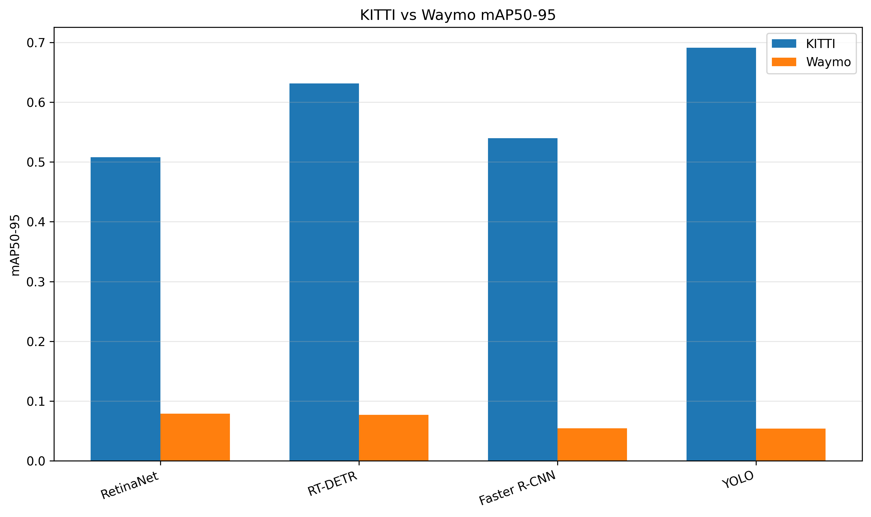
Figure 3. KITTI vs Waymo mAP50-95.
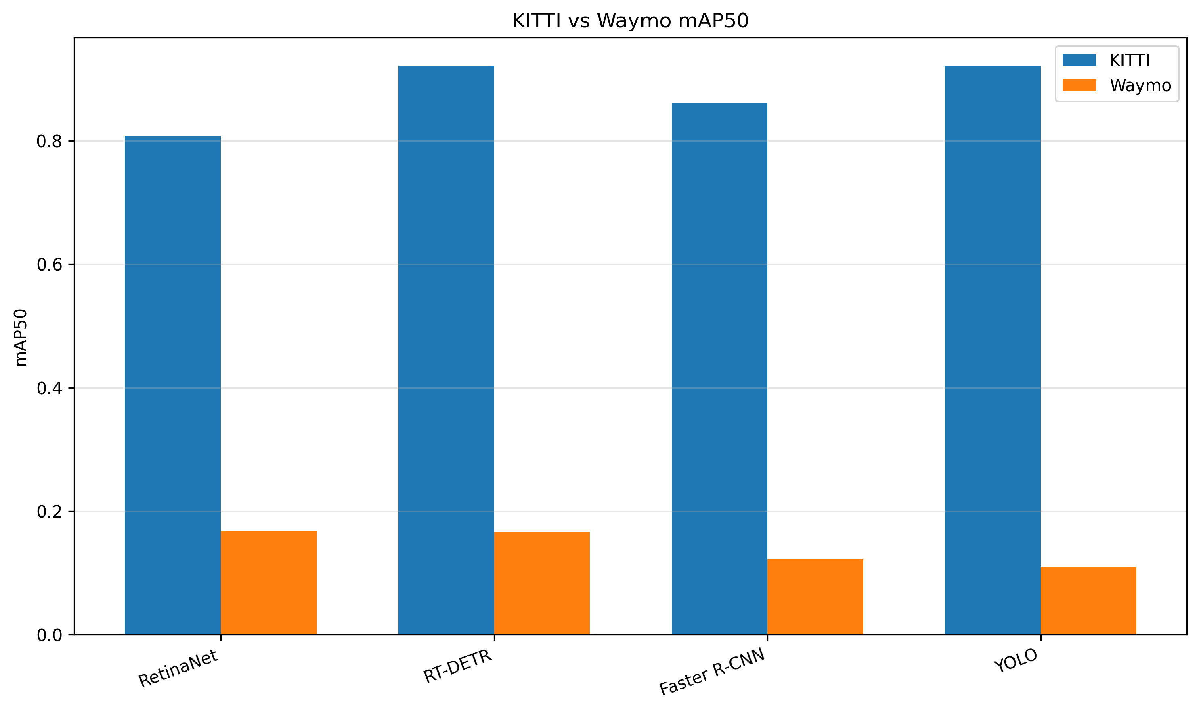
Figure 4. KITTI vs Waymo mAP50.

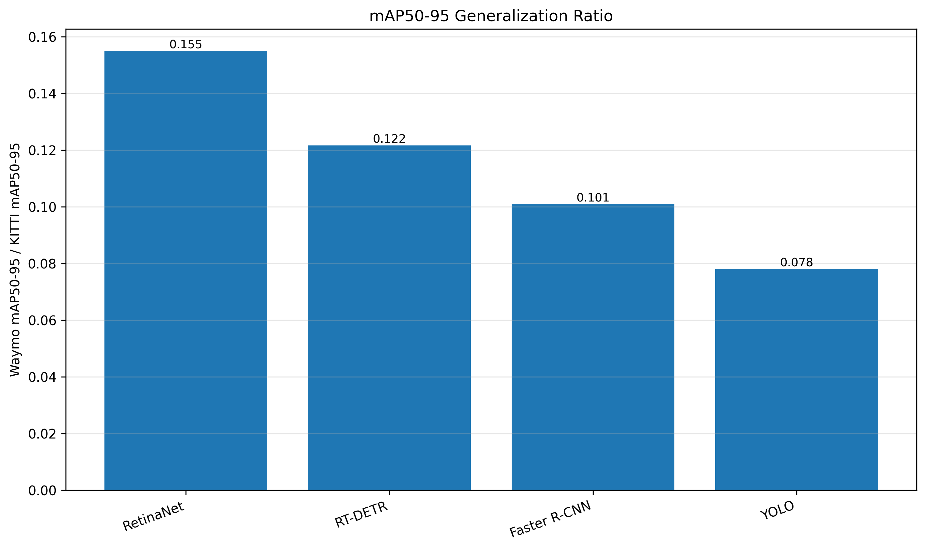
Figure 5. mAP50-95 Generalization Ratio.
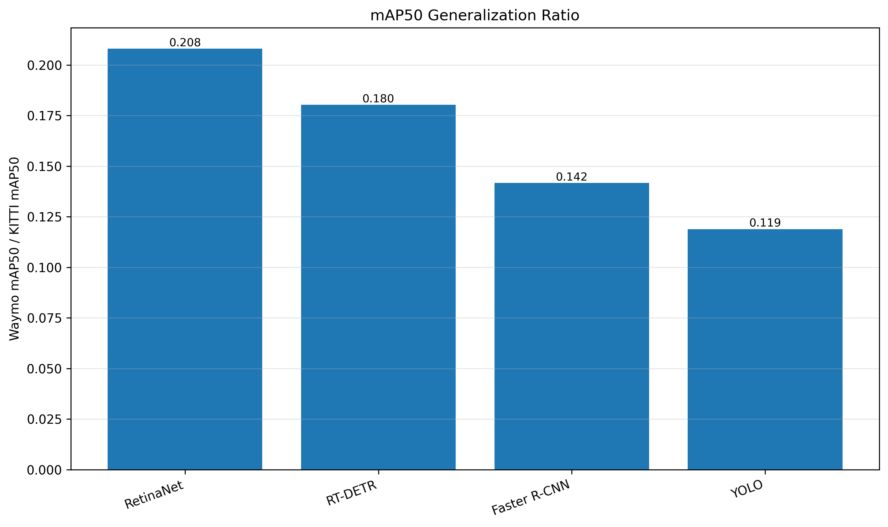
Figure 6. mAP50 Generalization Ratio.

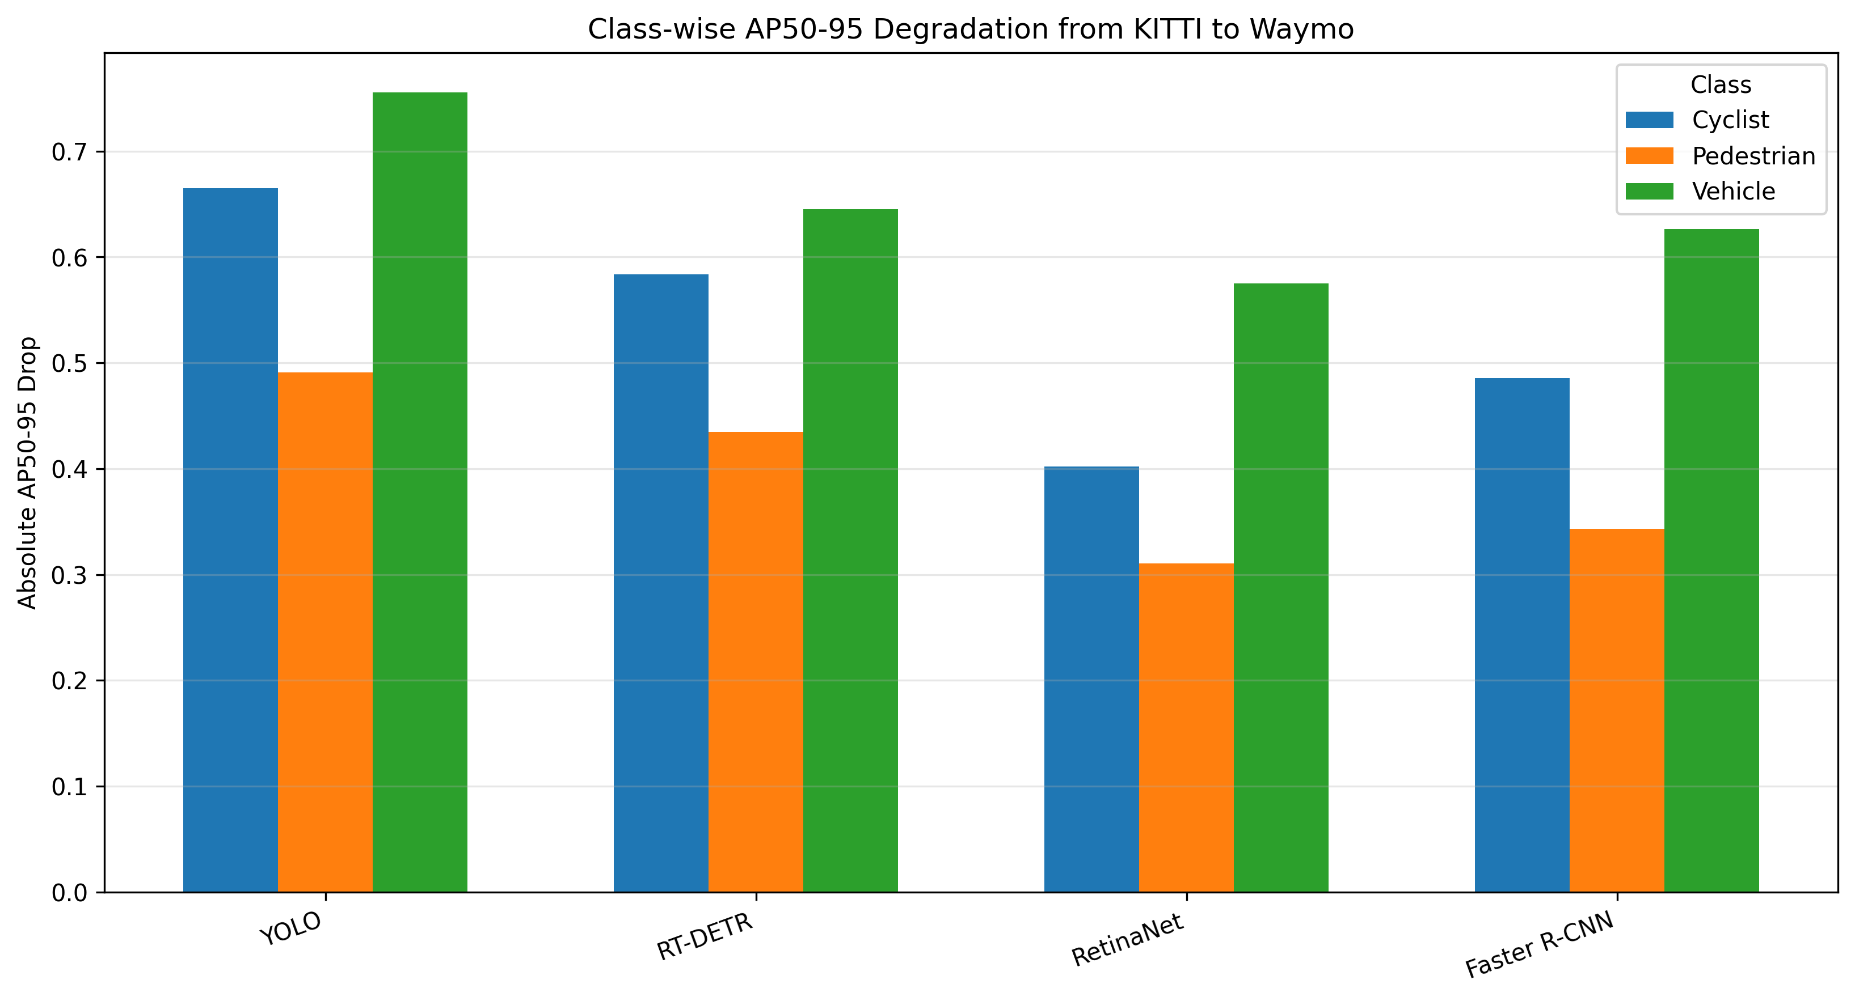
Figure 7. Class-wise AP50-95 Degradation.
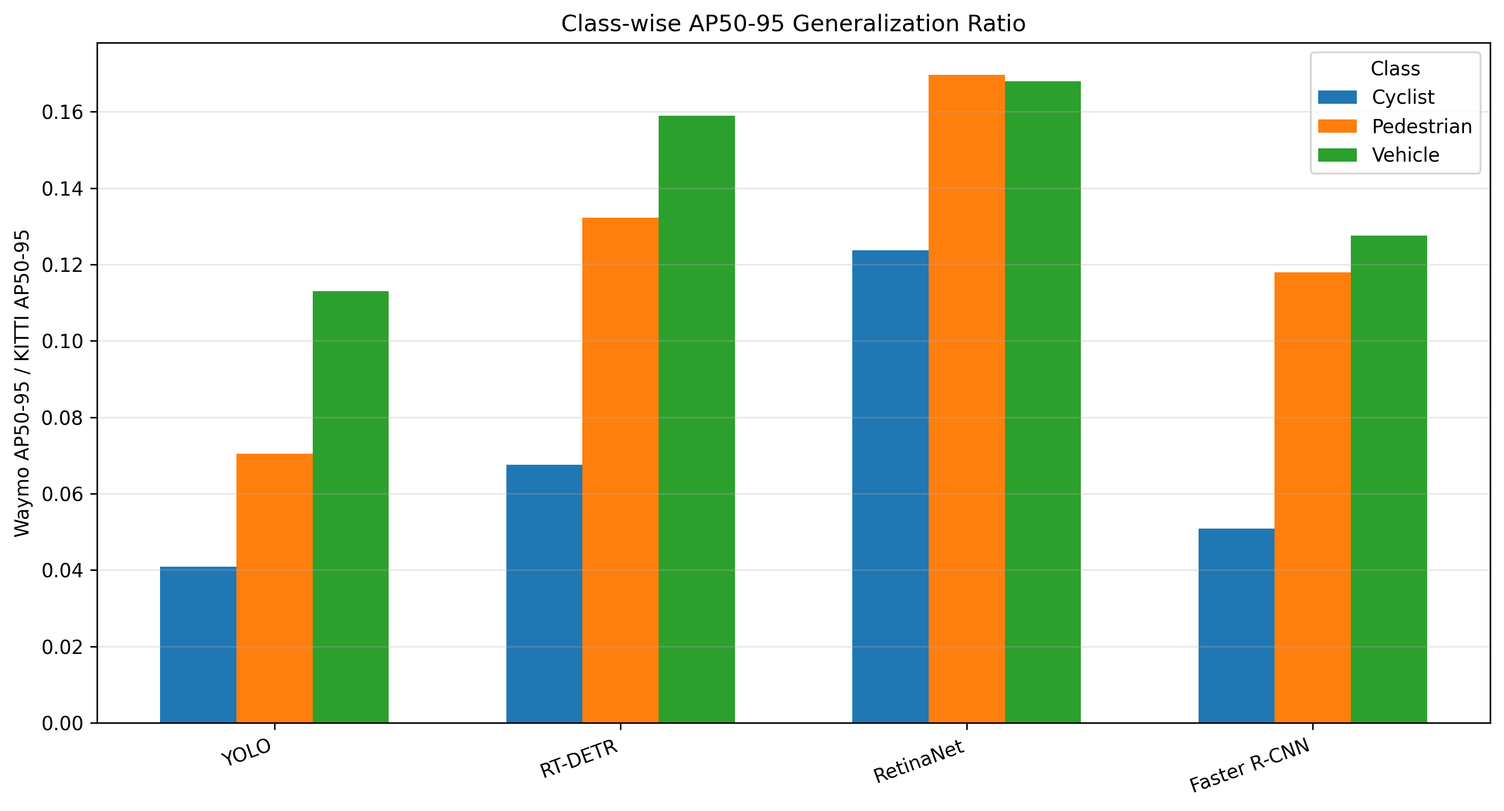
Figure 8. Class-wise AP50-95 Generalization Ratio.

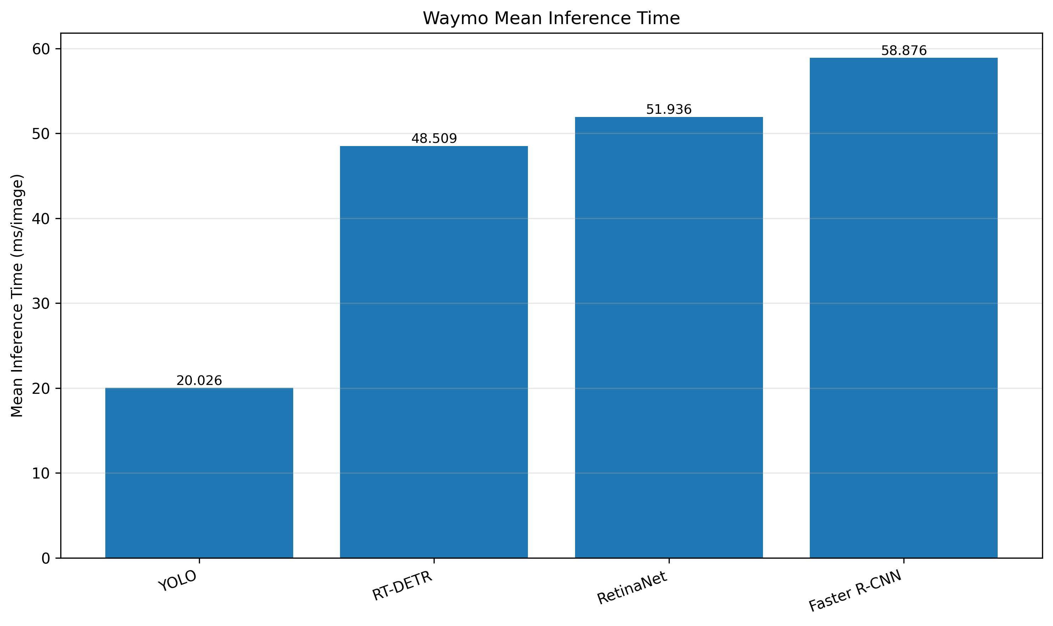
Figure 9. Waymo Inference Time Comparison.
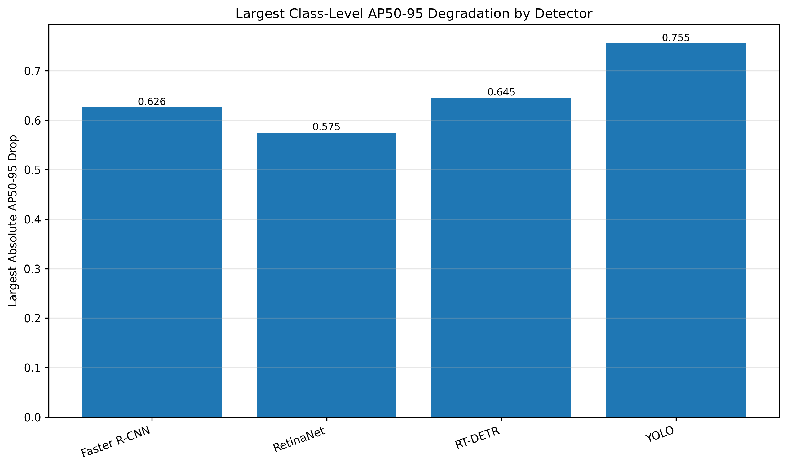
Figure 10. Largest Class-Level Degradation by Detector.

16. Main Findings for the Final Paper
- All detectors suffered severe cross-dataset degradation when transferred from KITTI to Waymo without retraining. The mAP50-95 drops ranged from 84.50% to 92.20%.
- RetinaNet achieved the strongest mAP50-95 Generalization Ratio (0.1550) and the highest Waymo mAP50-95 (0.0788).
- YOLO remained the fastest Waymo detector at 20.03 ms/image, but it ranked last by mAP50-95 Generalization Ratio.
- The detector ranking changes when the evaluation objective changes from in-domain performance to external-domain stability.
- Cyclist is the most fragile class by AP50-95 Generalization Ratio across all four detectors.
- The result supports a safety-oriented argument: reporting a strong KITTI baseline is not sufficient for intelligent-vehicle perception unless external-domain stability and vulnerable road-user performance are also analyzed.

17. Domain-Shift Discussion
The observed Waymo results should not be interpreted as a failed training outcome. They are the expected measurement target of Milestone 6 because the protocol deliberately forbids retraining and threshold adaptation. The very low Waymo mAP50-95 values show that the detectors learned representations and localization behavior that transfer poorly from KITTI to the selected Waymo subset under the fixed evaluation configuration.
The class-wise result is especially important. Vehicle has the largest absolute AP50-95 drop because the KITTI baseline for vehicles is high, but Cyclist has the weakest ratio-based stability across all detectors. This distinction is useful for the final paper: absolute degradation identifies where most AP is lost, while ratio-based degradation identifies which class retains the smallest fraction of its in-domain performance.
This analysis does not isolate the exact causal factors behind the domain shift. Possible contributors include differences in camera viewpoint, scene composition, geographic environment, annotation policy, object scale distribution, and class frequency. The current milestone measures the effect; causal isolation would require controlled ablations in a later robustness or failure-case milestone.

18. Injection-Ready Paper Subsection
External Validation on Waymo.
To evaluate cross-dataset generalization, the four KITTI-trained detectors were applied directly to a representative Waymo external subset without retraining, fine-tuning, architecture changes, or Waymo-specific threshold tuning. The external subset contained 996 images and 996 matched label files, with 24,819 total annotations across Vehicle, Pedestrian, and Cyclist classes. The same foreground class mapping used for the KITTI evaluation was retained, and detections were evaluated using mAP50, mAP50-95, class-wise AP, and mean inference time. Generalization was quantified using the ratio between the Waymo metric and the corresponding KITTI metric.
The external-validation results show substantial degradation for all four detectors. RetinaNet obtained the highest Waymo mAP50-95 (0.0788) and also achieved the strongest mAP50-95 Generalization Ratio (0.1550). In contrast, YOLO achieved the lowest mAP50-95 Generalization Ratio (0.0780) despite being the strongest KITTI detector by mAP50-95 in the previous milestone. This ranking shift indicates that high in-domain accuracy does not necessarily imply external-domain stability.
Class-wise degradation further highlights the safety relevance of the external validation. Vehicle categories produce the largest absolute AP50-95 loss for all detectors, while Cyclist shows the lowest class-level Generalization Ratio across the evaluated models. These results suggest that vulnerable road-user categories require particular attention when evaluating intelligent-vehicle perception systems under domain shift.

19. Limitations and Threats to Validity
- The Waymo subset is an external validation subset, not a full-dataset evaluation.
- The bundle does not include raw prediction JSONL files, so this report summarizes the saved metrics and tables rather than reproducing per-image examples.
- No causal ablation was performed to isolate whether degradation comes from object scale, scene type, sensor differences, annotation policy, or other dataset factors.
- Inference time reflects the local RTX 3060 Laptop GPU evaluation environment, not the Kaggle T4 training environment.
- Waymo scores are intentionally evaluated without retraining or calibration; they measure direct transfer performance only.

20. Generated Artifacts and Repository Placement
The following files should be kept as lightweight Milestone 6 evidence. Large prediction dumps and checkpoint weights should remain local artifacts unless Git LFS or another artifact storage mechanism is intentionally used.

Table 15. Artifact placement recommendations
Artifact group | Recommended repository location
M6 scripts | scripts/milestone_6/
M6 dataset config | configs/datasets/milestone_6/waymo_external_subset.yaml
M6 evaluation config | configs/evaluation/milestone_6/
Handoff summary | outputs/milestone_6/handoff_validation/
Waymo metric summaries | outputs/milestone_6/waymo_external_validation/metrics and tables
Generalization tables | outputs/milestone_6/generalization_analysis/tables/
Figures | outputs/milestone_6/figures/
Report | docs/milestone_6/Milestone_6_Waymo_External_Validation_Injection_Ready_Report.docx

21. Final Status
Based on the uploaded bundle, Milestone 6 has completed the core scientific work: handoff validation, smoke testing, full Waymo external validation, KITTI-vs-Waymo comparison, Generalization Ratio computation, class-wise degradation analysis, and figure generation. A repository final-audit step should still be run locally before commit and push to confirm that only lightweight artifacts are staged and that no .pt, .pth, .zip, or .jsonl files are committed by accident.

