Milestone 7 Report
Robustness, Failure-Case and Safety-Oriented Analysis
Cross-Dataset Object Detection for Autonomous-Vehicle Perception

Item | Value
Primary datasets | KITTI validation and Waymo external subset
Detectors | YOLO, RT-DETR, RetinaNet, Faster R-CNN
Main focus | Small objects, vulnerable road users, failure cases, deployment trade-offs
Report generated from | Milestone 7 source bundle: 64 files, 10 figures, 3 failure panels
Generated on | 2026-08-16

Injection-ready narrative for the manuscript/results chapter.

1. Executive Summary
Milestone 7 extends the benchmark from aggregate mAP into a robustness and safety analysis. The evidence shows a sharp cross-dataset degradation when models trained and selected on KITTI are evaluated on Waymo. The most important deployment-related weakness is not only the drop in average precision, but the high false-negative rate for vulnerable road users, especially small pedestrians and cyclists in the Waymo external subset.
- RT-DETR ranks first under the safety-weighted deployment trade-off score. It has the lowest Waymo vulnerable-road-user false-negative rate, but it remains research-only because the miss rate is still high.
- YOLO is the fastest model on Waymo at 49.935 FPS, but it has the weakest vulnerable-road-user safety recall and should be treated as a speed baseline rather than a safety-ready detector.
- RetinaNet provides the highest Waymo mAP50-95 and the best mAP50-95 generalization ratio, making it useful as an external-generalization reference.
- Faster R-CNN shows moderate safety behavior, but its slower Waymo inference and lower overall trade-off score make it less attractive for real-time deployment.
- All four detectors are classified as research only / not deployment-ready because external-domain vulnerable-road-user false-negative rates remain high.
Table 1. Safety-weighted deployment ranking.
Rank | Detector | Score | Waymo mAP50-95 | Waymo FPS | VRU FNR | Small VRU FNR | Tier
1 | RT-DETR | 0.197 | 0.077 | 20.6 | 0.738 | 0.775 | research only / not deployment-ready
2 | YOLO | 0.168 | 0.054 | 49.9 | 0.901 | 0.941 | research only / not deployment-ready
3 | RetinaNet | 0.158 | 0.079 | 19.3 | 0.833 | 0.873 | research only / not deployment-ready
4 | Faster R-CNN | 0.128 | 0.054 | 17.0 | 0.855 | 0.892 | research only / not deployment-ready

2. Inputs and Analysis Policy
Table 2. Evaluation data used in Milestone 7.
Dataset | Split | Images | Labels / target boxes | Use in Milestone 7
KITTI | Validation | 1496 | 7792 | In-domain reference and baseline failure behavior
Waymo | External subset | 996 | 24819 | Cross-dataset generalization and safety stress test

Prediction inventory. Milestone 7 uses the full prediction JSONL files from Milestone 5 and Milestone 6, then builds an event-level detection error index. The final validated index contains 1,401,946 rows, with 50,385 true-positive rows and 1,351,561 non-true-positive failure rows.
Table 3. Detection error policy.
Policy item | Value
Primary TP matching IoU | 0.50
Localization-error IoU range | 0.10 <= IoU < 0.50
Class-confusion overlap threshold | IoU >= 0.30 with wrong predicted class
Duplicate-detection threshold | IoU >= 0.50 with an already matched GT
Safety-critical classes | Pedestrian and Cyclist
High-confidence FP threshold | score >= 0.25

3. Object-Size Robustness Analysis
Object size is defined by normalized target-box area: bbox_area / image_area. The small/medium/large bins were defined using target-box normalized-area quantiles computed from 39,086 target boxes. This method avoids using a fixed pixel threshold and makes the analysis more comparable across different image resolutions.
Table 4. Object-size bin definitions.
Size bin | Definition
Small | normalized_area <= 0.004157071390230814
Medium | 0.004157071390230814 < normalized_area <= 0.015589650670960799
Large | normalized_area > 0.015589650670960799

Table 5. Ground-truth object distribution by class and size.
Dataset | Images | Objects | Vehicle | Pedestrian | Cyclist | Small | Medium | Large
KITTI | 1496 | 7792 | 6472 | 980 | 340 | 4981 | 1740 | 1071
WAYMO | 996 | 24819 | 16928 | 7127 | 764 | 21933 | 1978 | 908

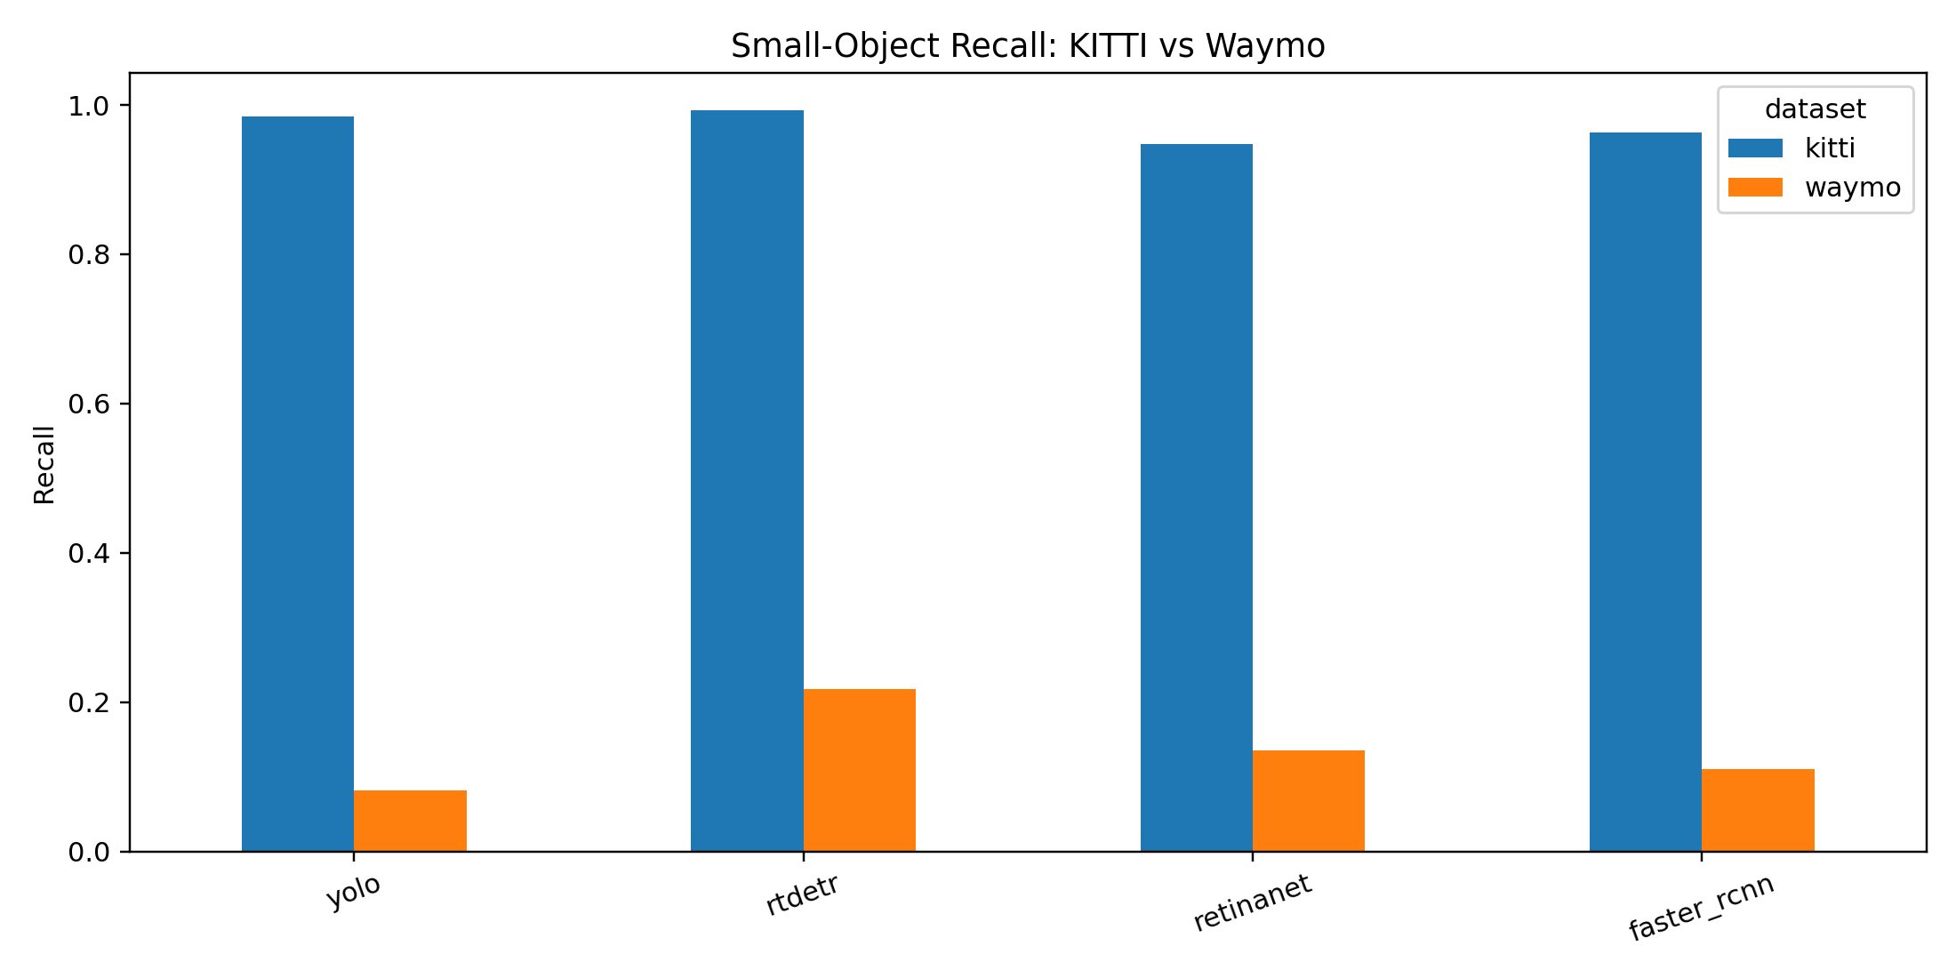
Figure 1. Small-object recall drop from KITTI to Waymo.
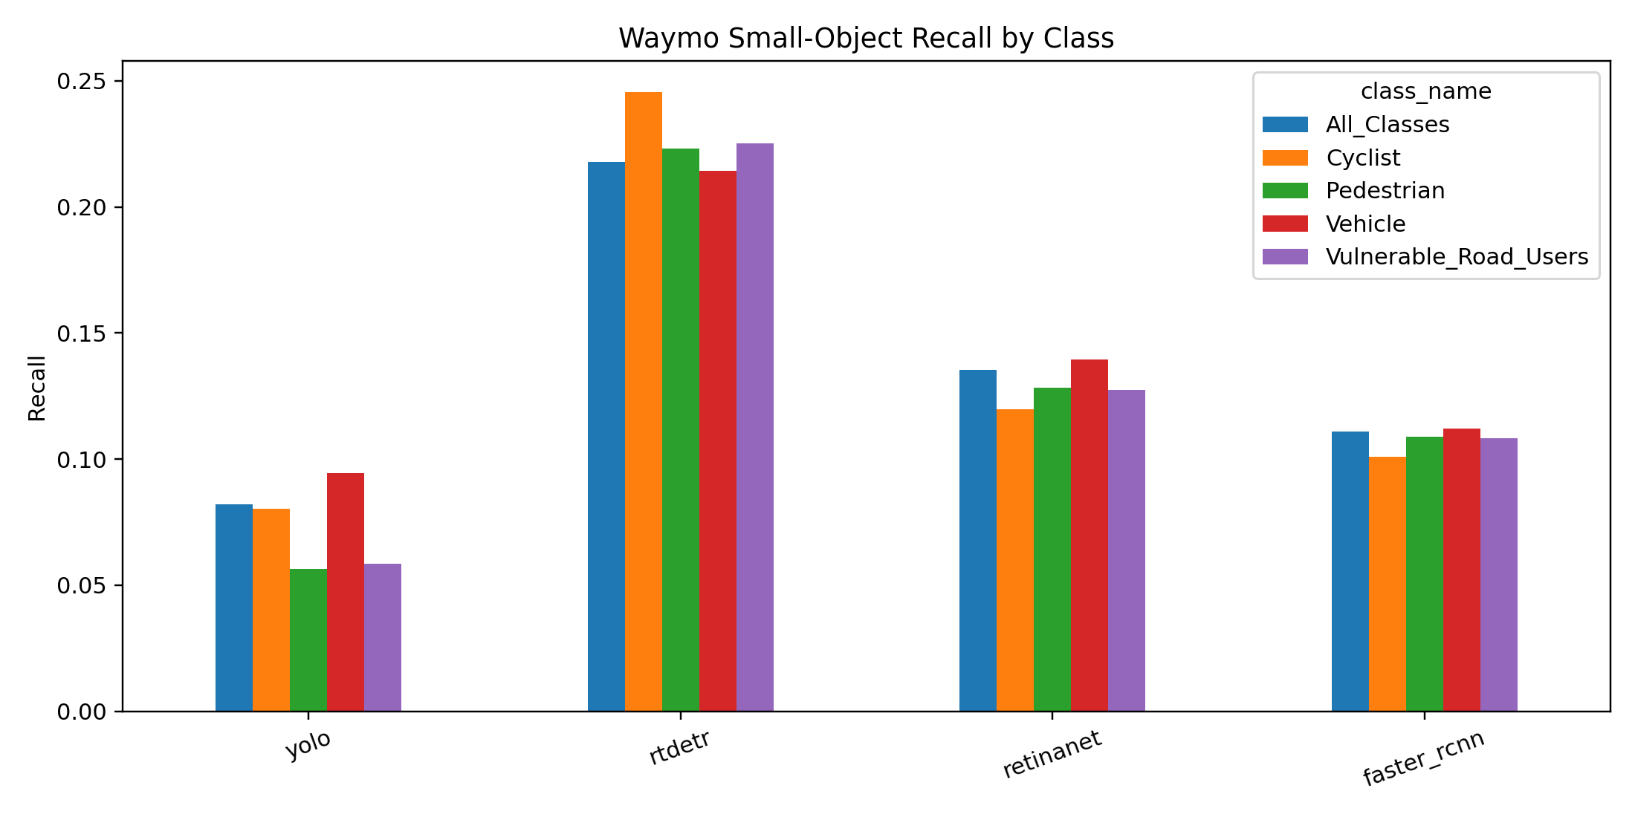
Figure 2. Waymo small-object recall by class and detector.
Table 6. Small-object recall for all classes.
Dataset | Detector | Small-object recall | Small-object FNR | GT objects
KITTI | YOLO | 0.985 | 0.015 | 4981
KITTI | RT-DETR | 0.993 | 0.007 | 4981
KITTI | RetinaNet | 0.948 | 0.052 | 4981
KITTI | Faster R-CNN | 0.963 | 0.037 | 4981
WAYMO | YOLO | 0.082 | 0.918 | 21933
WAYMO | RT-DETR | 0.218 | 0.782 | 21933
WAYMO | RetinaNet | 0.135 | 0.865 | 21933
WAYMO | Faster R-CNN | 0.111 | 0.889 | 21933

4. Safety-Oriented Vulnerable-Road-User Analysis
The safety analysis focuses on false negatives for pedestrians and cyclists. In an autonomous-driving perception stack, these missed detections are more safety-critical than many false positives because they can remove a road user from the planner input entirely.
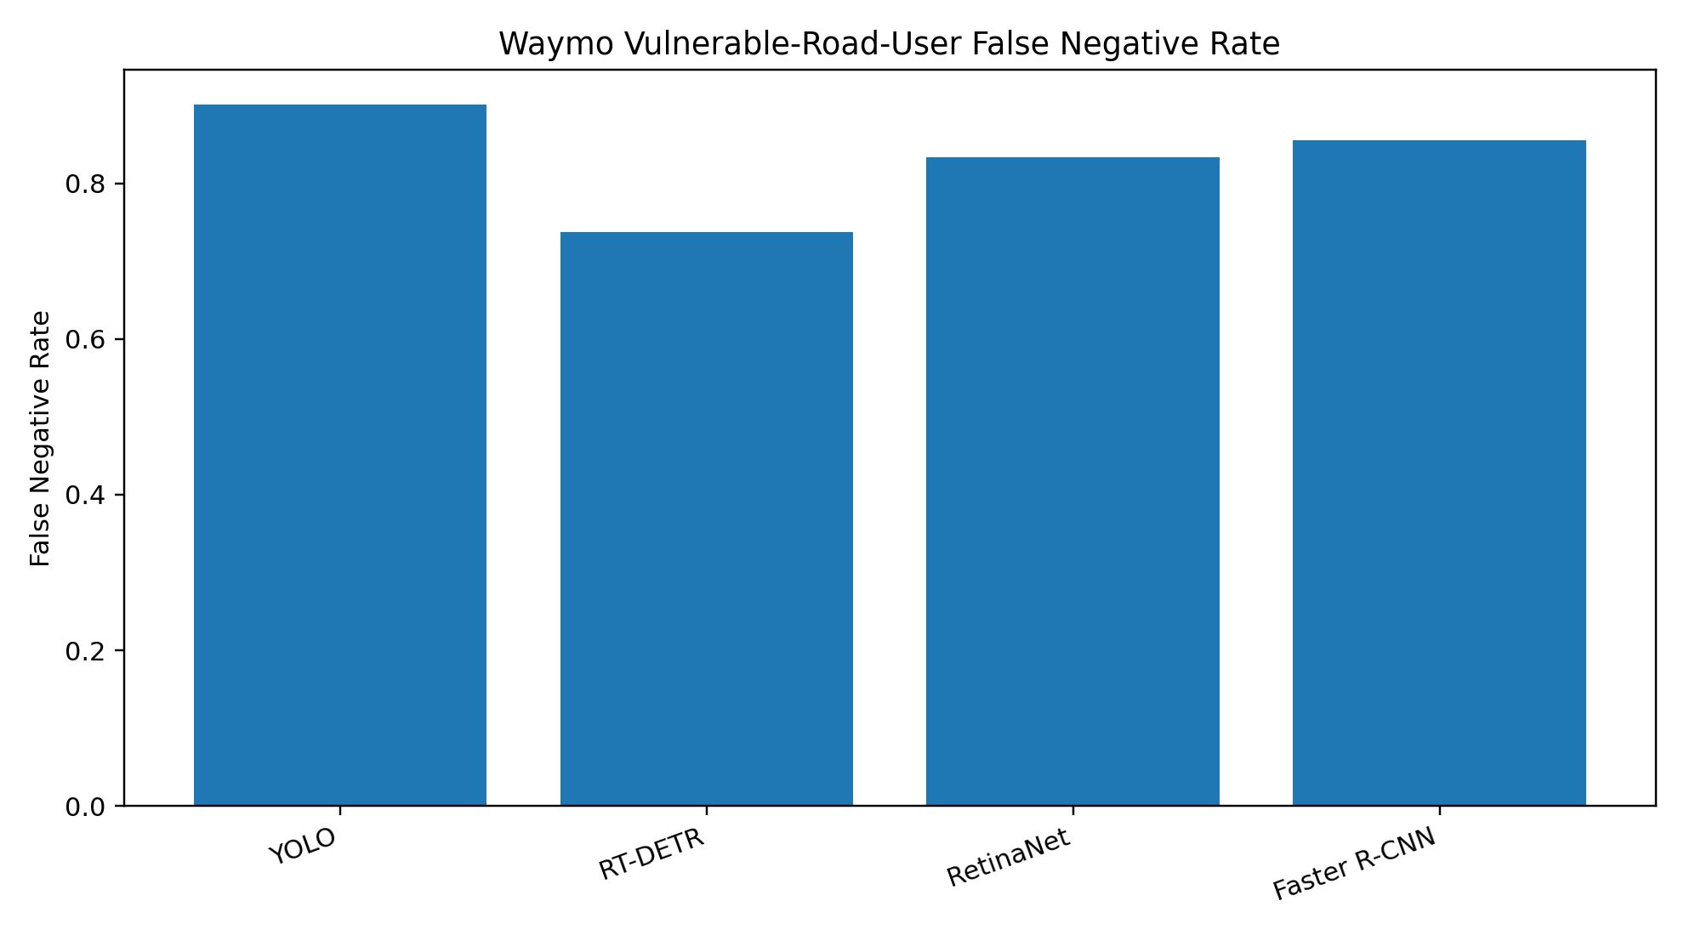
Figure 3. Waymo vulnerable-road-user false-negative rate across all object sizes.
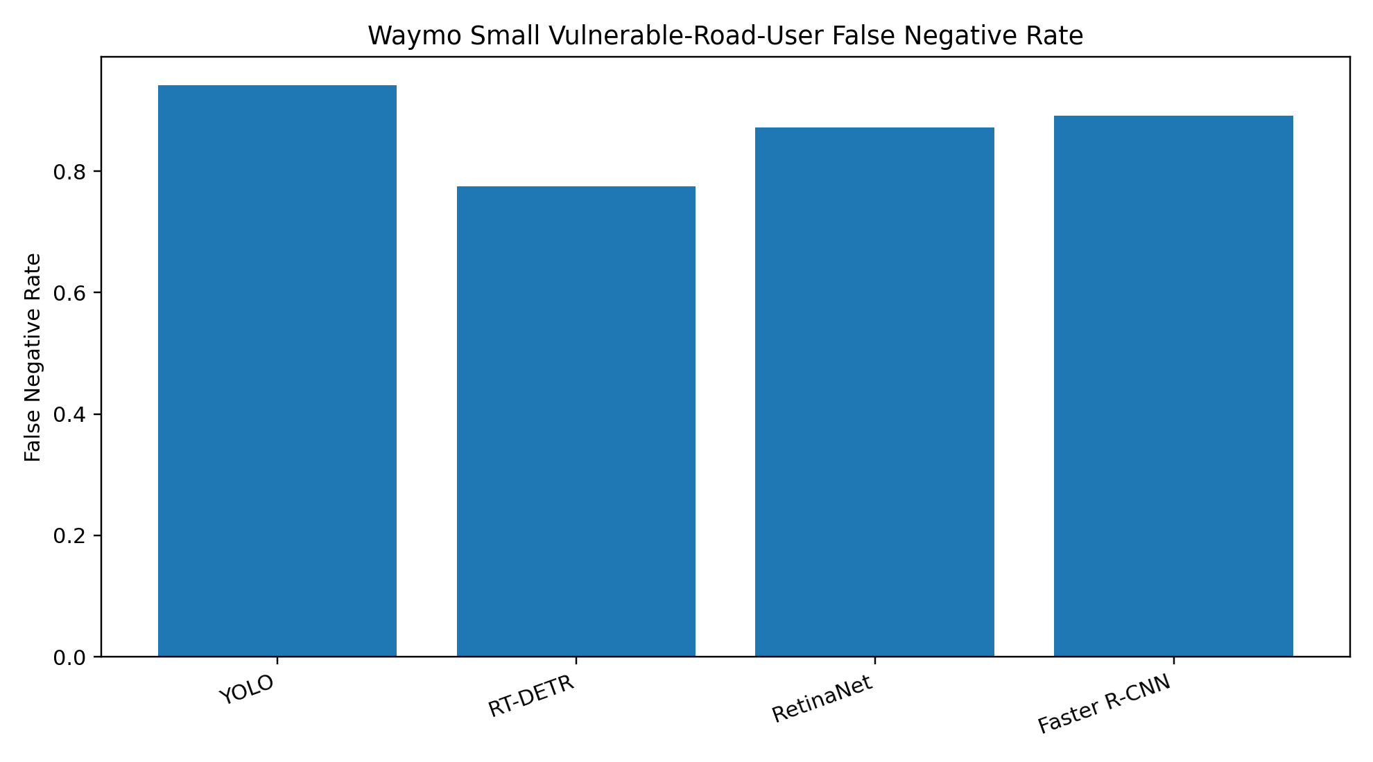
Figure 4. Waymo small vulnerable-road-user false-negative rate.
Table 7. Waymo vulnerable-road-user false-negative rate, all sizes.
Detector | TP | FN | GT | Recall | FNR
YOLO | 782 | 7109 | 7891 | 0.099 | 0.901
RT-DETR | 2071 | 5820 | 7891 | 0.262 | 0.738
RetinaNet | 1317 | 6574 | 7891 | 0.167 | 0.833
Faster R-CNN | 1144 | 6747 | 7891 | 0.145 | 0.855

Table 8. Waymo small vulnerable-road-user false-negative rate.
Detector | TP | FN | GT | Recall | FNR
YOLO | 435 | 6995 | 7430 | 0.059 | 0.941
RT-DETR | 1673 | 5757 | 7430 | 0.225 | 0.775
RetinaNet | 947 | 6483 | 7430 | 0.127 | 0.873
Faster R-CNN | 804 | 6626 | 7430 | 0.108 | 0.892

RT-DETR is the strongest detector on this safety-oriented criterion, with a Waymo vulnerable-road-user FNR of 0.738 and a small-VRU FNR of 0.775. However, these rates are still too high for deployment claims. YOLO provides the fastest inference but misses the largest fraction of vulnerable road users in the external domain.

5. Failure-Type Analysis
The failure-type analysis separates false negatives, false positives, localization errors, class confusion, and duplicate detections. This provides a more actionable explanation of why cross-dataset performance degrades. Waymo errors are dominated by missed objects and small-object localization problems; RT-DETR additionally generates many low-confidence proposals, which inflates raw false-positive counts.
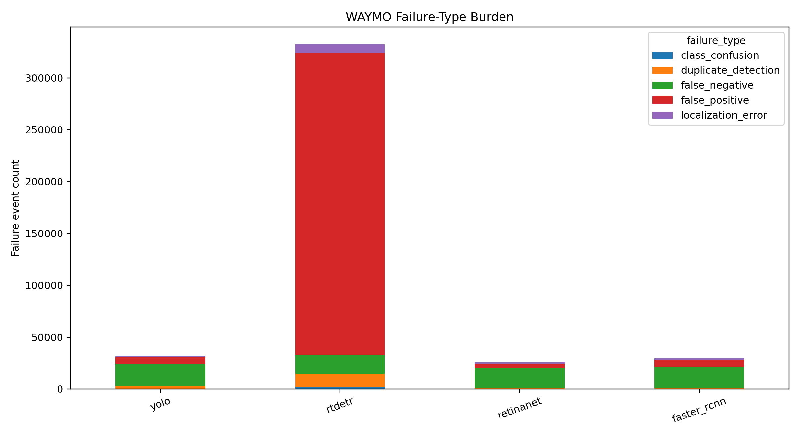
Figure 5. Waymo failure-type burden by detector.
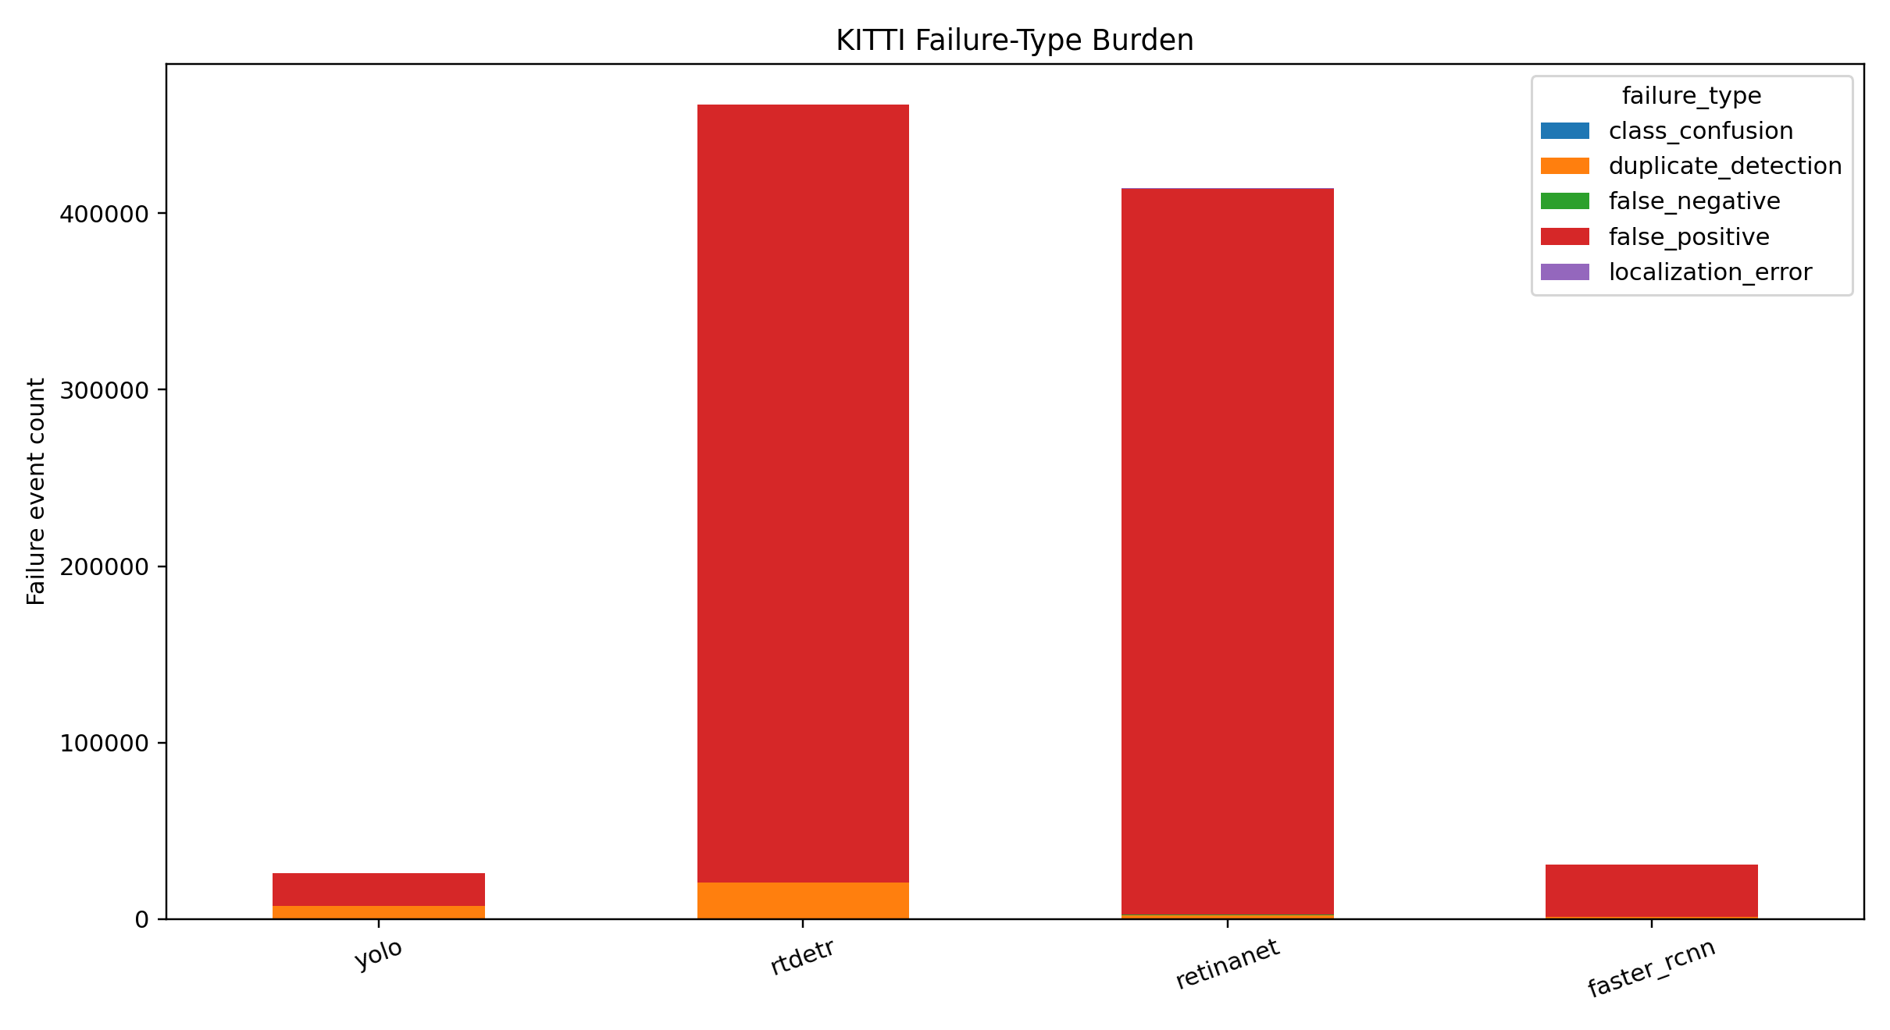
Figure 6. KITTI failure-type burden by detector.
Table 9. Failure event totals by dataset and detector.
Dataset | Detector | FN | FP | Localization | Class confusion | Duplicate
KITTI | YOLO | 96 | 18558 | 61 | 9 | 7253
KITTI | RT-DETR | 39 | 441047 | 33 | 27 | 20400
KITTI | RetinaNet | 309 | 411624 | 266 | 203 | 1804
KITTI | Faster R-CNN | 279 | 29225 | 199 | 114 | 958
Waymo | YOLO | 21298 | 6561 | 888 | 159 | 2457
Waymo | RT-DETR | 17687 | 291668 | 8030 | 1774 | 13185
Waymo | RetinaNet | 19779 | 3851 | 1660 | 241 | 260
Waymo | Faster R-CNN | 20572 | 6666 | 1765 | 319 | 237

Table 10. Top class-confusion groups.
Dataset | Detector | GT class | Pred class | Size | Count | Mean IoU | Mean score
WAYMO | RT-DETR | Vehicle | Pedestrian | small | 631 | 0.396 | 0.010
WAYMO | RT-DETR | Pedestrian | Cyclist | small | 422 | 0.393 | 0.027
WAYMO | RT-DETR | Pedestrian | Vehicle | small | 277 | 0.405 | 0.013
WAYMO | RT-DETR | Vehicle | Cyclist | small | 205 | 0.397 | 0.010
WAYMO | Faster R-CNN | Pedestrian | Cyclist | small | 124 | 0.450 | 0.377
WAYMO | RT-DETR | Cyclist | Pedestrian | small | 107 | 0.416 | 0.026
WAYMO | RetinaNet | Pedestrian | Cyclist | small | 80 | 0.466 | 0.324
WAYMO | Faster R-CNN | Vehicle | Pedestrian | small | 71 | 0.380 | 0.279

Table 11. Top localization-error groups.
Dataset | Detector | Class | Size | Count | Mean IoU | Mean score
WAYMO | RT-DETR | Vehicle | small | 5099 | 0.258 | 0.026
WAYMO | RT-DETR | Pedestrian | small | 2336 | 0.276 | 0.022
WAYMO | RetinaNet | Vehicle | small | 878 | 0.287 | 0.422
WAYMO | Faster R-CNN | Pedestrian | small | 747 | 0.271 | 0.429
WAYMO | Faster R-CNN | Vehicle | small | 712 | 0.284 | 0.509
WAYMO | RetinaNet | Pedestrian | small | 553 | 0.303 | 0.356
WAYMO | YOLO | Vehicle | small | 417 | 0.278 | 0.072
WAYMO | RT-DETR | Vehicle | medium | 294 | 0.309 | 0.021

6. Failure-Case Gallery
The gallery converts numerical failure types into visual evidence. It includes safety-critical composite miss examples, individual false negatives, false positives, localization errors, class confusions, and duplicate detections. The final balanced gallery contains 160 generated images: 96 Waymo examples and 64 KITTI examples.
Table 12. Failure-case gallery coverage.
Gallery item | Count
Total generated images | 160
Waymo examples | 96
KITTI examples | 64
Safety composites | 16
False negatives | 16
False positives | 32
Localization errors | 32
Class confusions | 32
Duplicate detections | 32

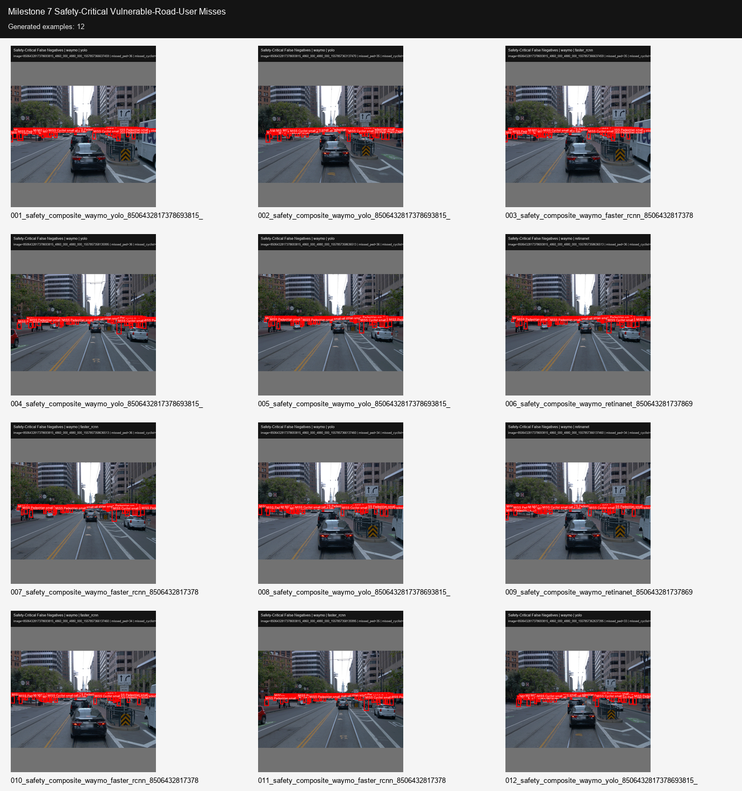
Figure 7. Safety-critical vulnerable-road-user miss panel.
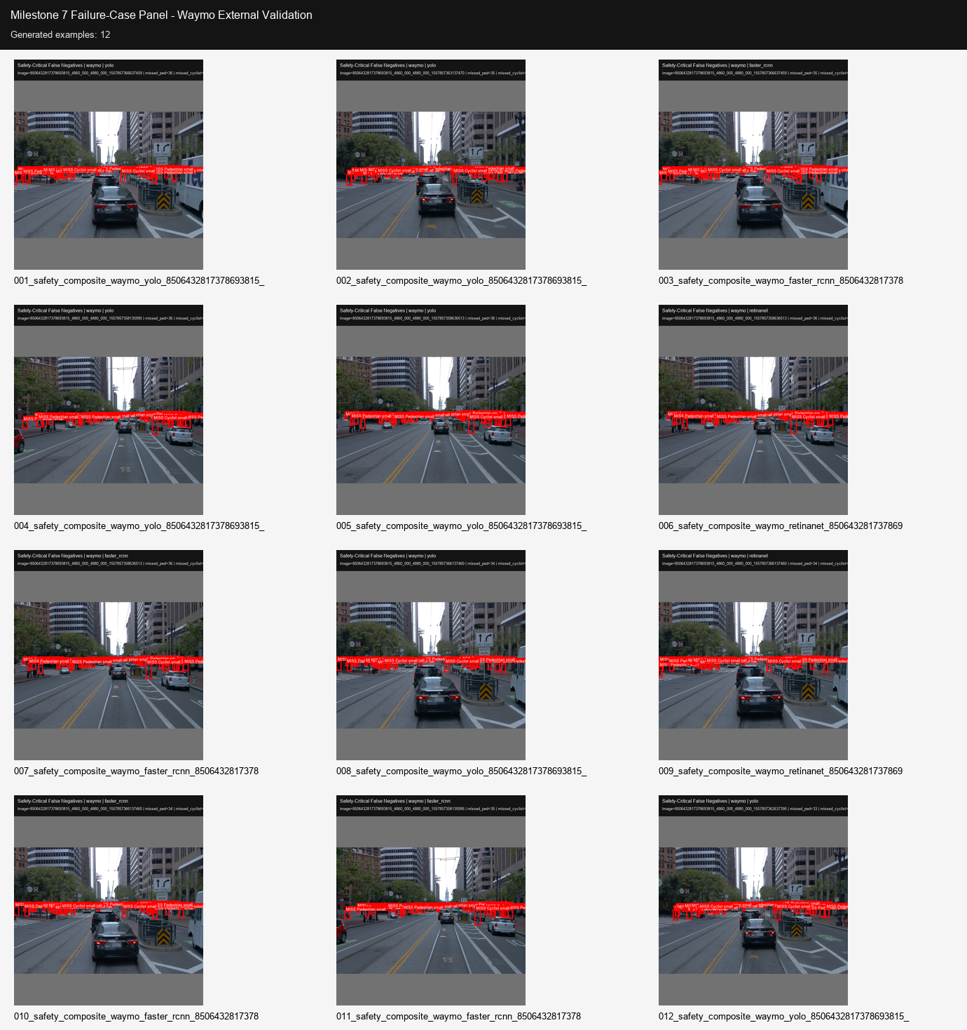
Figure 8. Waymo failure-case panel.
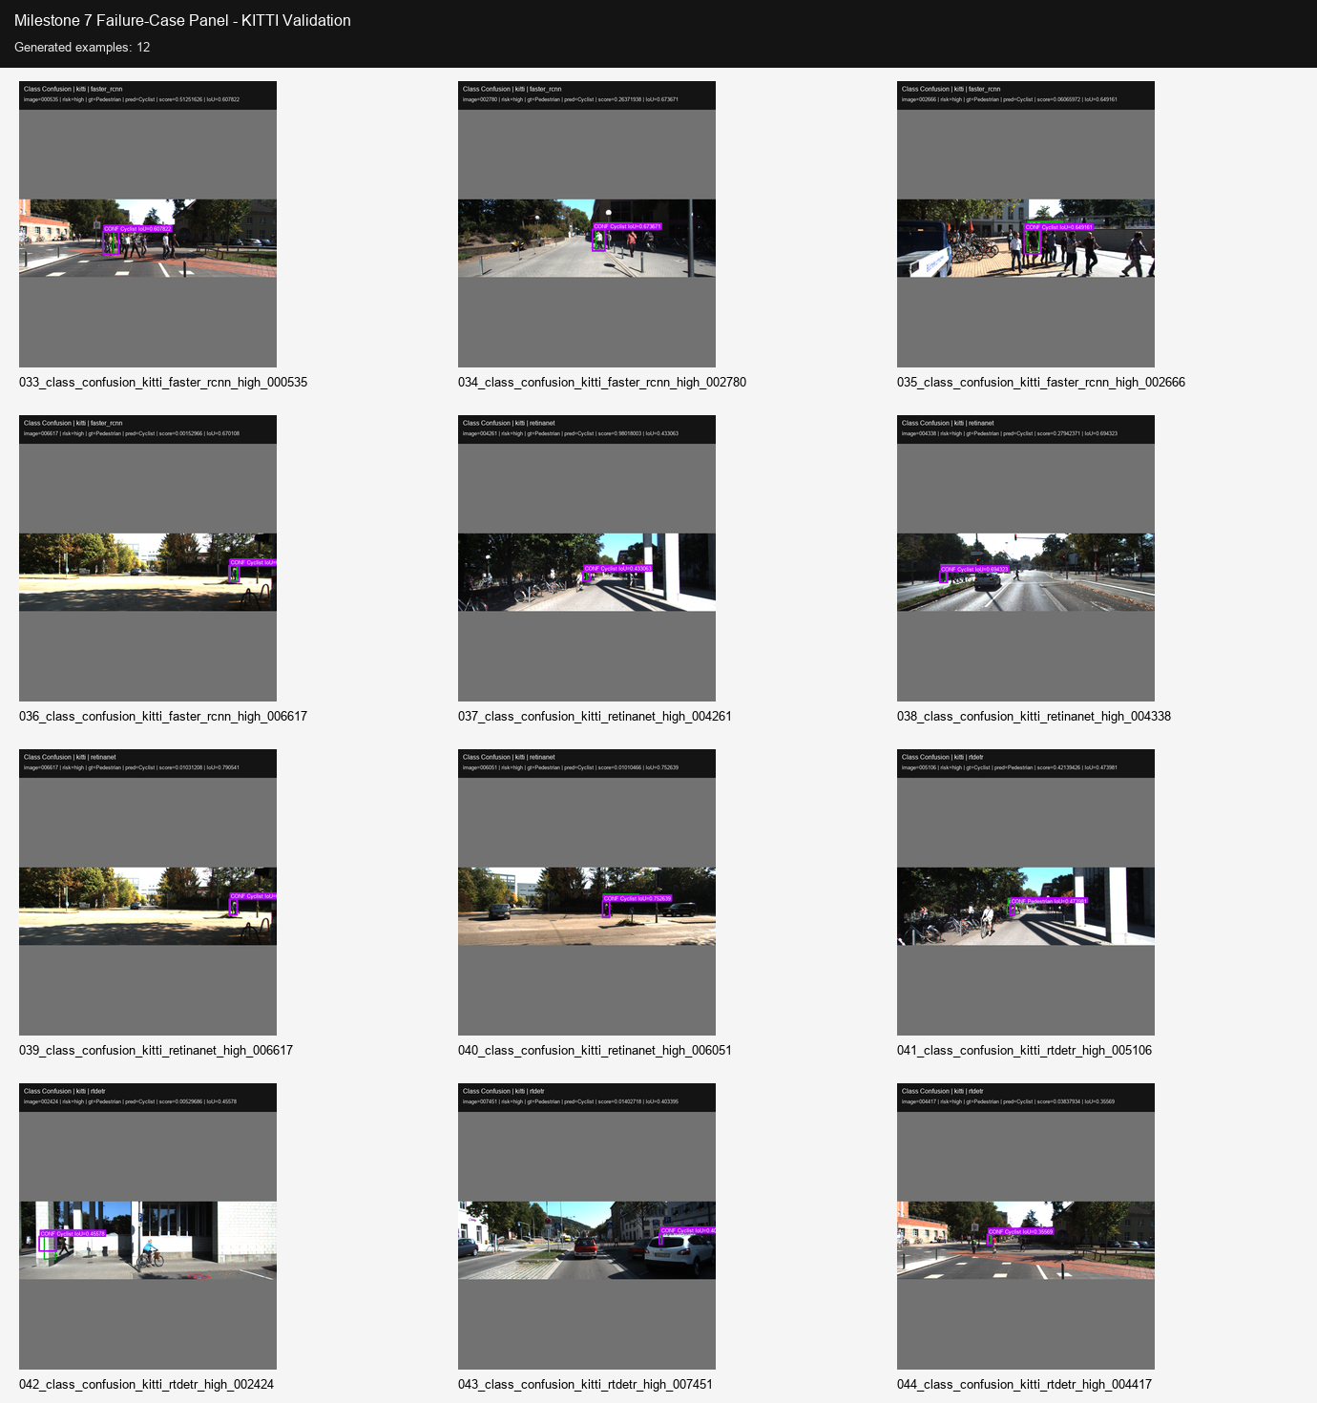
Figure 9. KITTI failure-case panel.

7. Deployment Suitability and Trade-off Analysis
The deployment analysis combines external accuracy, generalization ratio, speed, vulnerable-road-user false-negative rate, small-VRU safety, and failure evidence. The score is a decision-support summary, not an official benchmark score. It is intentionally safety-weighted so that a fast model with poor vulnerable-road-user recall is not overvalued.
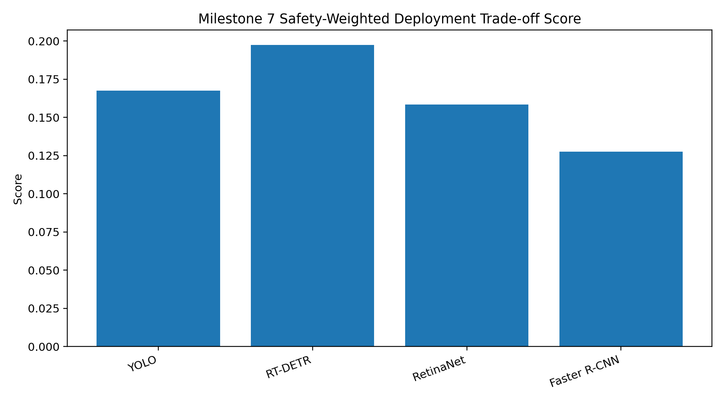
Figure 10. Safety-weighted deployment trade-off score.
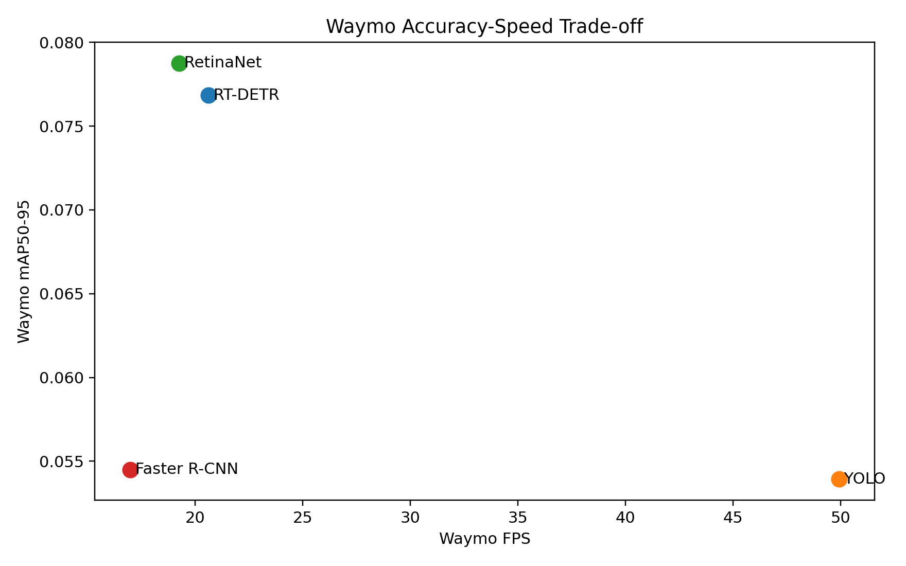
Figure 11. Waymo accuracy-speed trade-off.
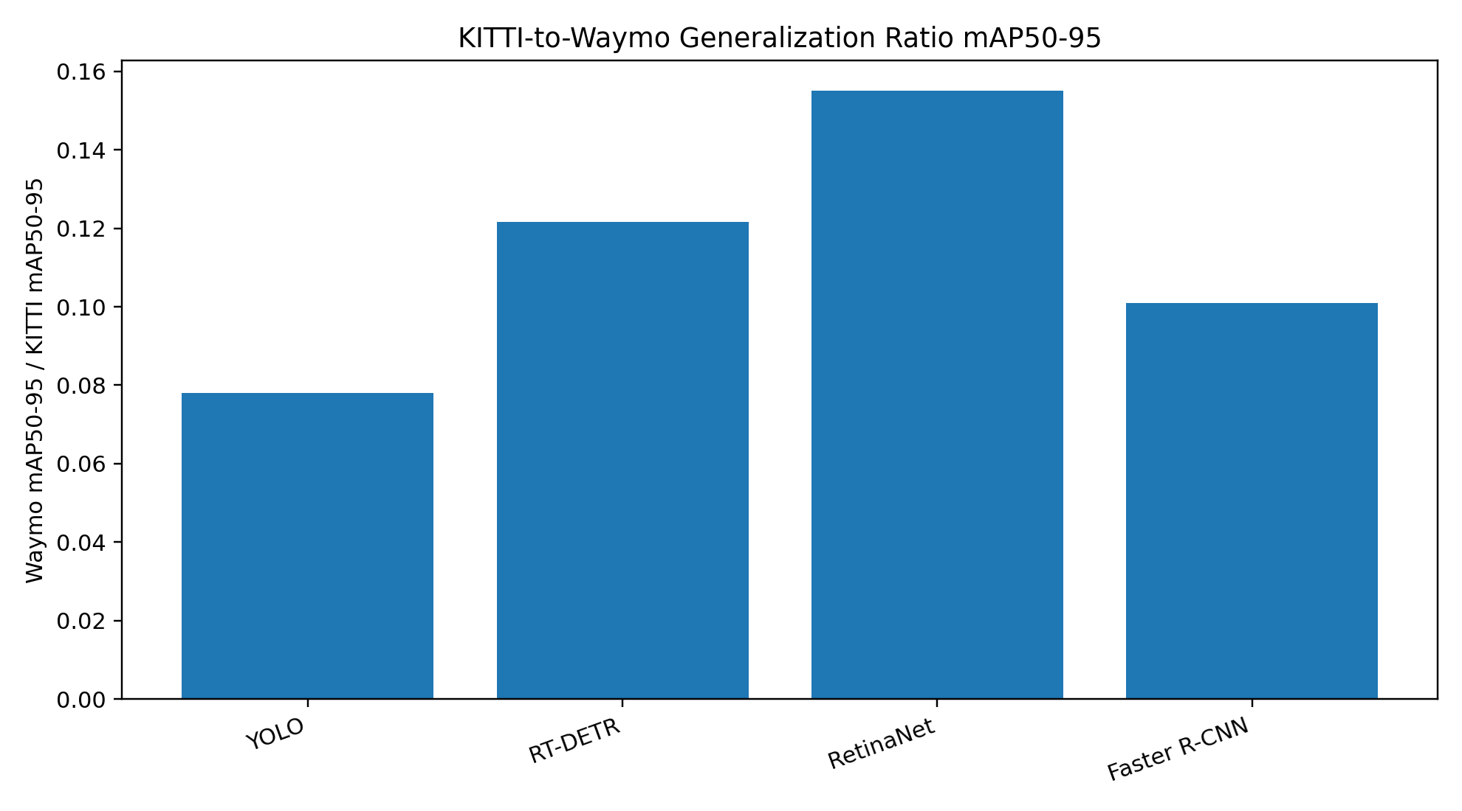
Figure 12. KITTI-to-Waymo mAP50-95 generalization ratio.
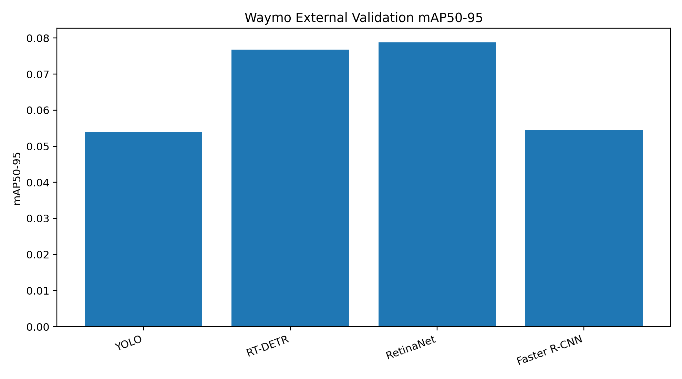
Figure 13. Waymo external validation mAP50-95.
Table 13. Deployment trade-off metrics.
Detector | KITTI mAP50-95 | Waymo mAP50-95 | Gen. ratio | Waymo FPS | VRU FNR | Small VRU FNR | Rank
RT-DETR | 0.631 | 0.077 | 0.122 | 20.6 | 0.738 | 0.775 | 1
YOLO | 0.691 | 0.054 | 0.078 | 49.9 | 0.901 | 0.941 | 2
RetinaNet | 0.508 | 0.079 | 0.155 | 19.3 | 0.833 | 0.873 | 3
Faster R-CNN | 0.540 | 0.054 | 0.101 | 17.0 | 0.855 | 0.892 | 4

8. Practical Recommendations
- Use RT-DETR as the main robustness-improvement candidate. It gives the best Waymo vulnerable-road-user recall and the strongest safety-oriented score, despite slower speed.
- Use YOLO as the real-time speed baseline. It is the fastest model on Waymo, but its vulnerable-road-user false-negative rate is too high for safety-critical use.
- Use RetinaNet as the external-generalization reference. It has the strongest Waymo mAP50-95 and generalization ratio, but still misses many vulnerable road users.
- Do not claim any detector is deployment-ready. The external-domain safety failure rates, especially small pedestrian/cyclist false negatives, remain high.
- Improve with domain adaptation, threshold calibration, small-object augmentation, and safety-focused loss/reweighting. Milestone 6 and Milestone 7 both show that cross-dataset generalization and small vulnerable-road-user detection are the main weaknesses.
The central recommendation is to treat RT-DETR as the main robustness-improvement candidate, YOLO as the real-time speed baseline, and RetinaNet as the external-generalization reference. None of the detectors should be described as deployment-ready because the Waymo small vulnerable-road-user miss rates remain high.

9. Limitations and Validity Notes
- The Waymo subset is an external validation subset, not a full Waymo benchmark submission. Results should therefore be framed as cross-dataset evidence rather than official leaderboard performance.
- The detection error index uses fixed analysis thresholds. Different confidence thresholds or matching policies can change false-positive counts, especially for RT-DETR, which produces many low-confidence proposals.
- The failure-case gallery is intentionally curated from high-priority examples. It is useful for qualitative explanation but should be interpreted alongside quantitative summary tables.
- The deployment score is a weighted decision-support metric. It is not a replacement for a full autonomous-vehicle safety case, real-time systems testing, or closed-loop validation.

Appendix A. Reproducibility and Artifacts
Table 14. Key Milestone 7 artifacts.
Artifact | Path in source bundle
Object-size summary | outputs/milestone_7/object_size_analysis/object_size_summary.csv
Safety false-negative summary | outputs/milestone_7/safety_error_analysis/safety_false_negative_summary.csv
Failure-type summary | outputs/milestone_7/safety_error_analysis/failure_type_summary.csv
Deployment ranking | outputs/milestone_7/deployment_tradeoff/deployment_suitability_summary.csv
Failure-case manifest | outputs/milestone_7/failure_cases/failure_case_manifest.json
Figure manifest | outputs/milestone_7/figures/milestone_7_figure_manifest.json

Recommended commit scope: include configs, scripts, summaries, figures, panels, and report files. Exclude large raw prediction JSONL files and the full detection_error_index.csv unless the repository explicitly allows large generated files.

