Software Requirements Specification

for

Clinic Booking System
Version 1.0

Prepared by mazen mohamed
Group Name:
Mazen Mohamed Ali | 20235096
Abd El Rahman Eid Ahmed | 20235072
Ali Mohamed Hassan | 20235077
Mahmoud AbdElkrim | 20235106
Mazen Wael Mohamed  Karim Walid Ahmed | 20235089  20235089

Contents
Contents ii
Revisions ii
1 Introduction 1
1.1 Document Purpose 1
1.2 Product Scope 1
1.3 Intended Audience and Document Overview 1
1.4 Definitions, Acronyms and Abbreviations 1
1.5 Document Conventions 1
1.6 References and Acknowledgments 2
2 Overall Description 2
2.1 Product Overview 2
2.2 Product Functionality 3
2.3 Design and Implementation Constraints 3
2.4 Assumptions and Dependencies 3
3 Specific Requirements 4
3.1 External Interface Requirements 4
3.2 Functional Requirements 4
3.3 Use Case Model 5
4 Other Non-functional Requirements 6
4.1 Performance Requirements 6
4.2 Safety and Security Requirements 6
4.3 Software Quality Attributes 6
5 Other Requirements 7
Appendix A – Data Dictionary 8
Appendix B - Group Log 9

Revisions
Version | Primary Author(s) | Description of Version | Date Completed
Initial version 1.0 | Mazen Mohamed Ali | This initial version before any edit and contain all details for our project | 22/11/2025

Introduction

Document Purpose
This document describes the functional and non-functional requirements for the Clinic Booking System. It focuses on the scope of the entire system, from the backend microservices architecture and database design to the user interactions of Admins, Doctors, Receptionists, and Patients. This SRS is intended for the development team, project managers, and stakeholders to ensure all technical constraints (Spring Boot, Docker, AOP) are met.

Product Scope
The Clinic Booking System is a distributed web-based application for the management of medical functions. It allows the following:
- Patients to search for clinics/doctors and book appointments online.
- Doctors to manage their schedules and keep track of patient medical history.
- Receptionists-a day-to-day queue management team, registering walk-in patients, and checking in.
- Admins to manage clinic branches and staff accounts.
It automates the appointment notification by email through its effective schedule management, reducing the waiting time

Intended Audience and Document Overview
Technical Staff (Developers, Testers, Architects): Should read the whole document; the implementation details can be found in Section 3 (Specific Requirements) and Section 4 (Non-functional Requirements)
Project Managers: The focus should be on Section 1 and Section 2 to understand the scope and constraints.

Definitions, Acronyms and Abbreviations
Term | Definition
SRS | Software Requirements Specification
Microservices | An architectural style that structures an application as a collection of services.
API | Application Programming Interface (RESTful).
JWT | JSON Web Token (used for secure authentication).
AOP | Aspect-Oriented Programming (used for logging and notifications).
RBAC | Role-Based Access Control (Admin, Doctor, Receptionist, Patient).
DTO | Data Transfer Object.
Guest | An unauthenticated user visiting the site.

Document Conventions
This document follows IEEE formatting requirements.
- Font: Arial, size 12 for body text.
- Priorities: Requirements labeled [HIGH] are mandatory for the initial release.
- Keywords: The term "MUST" indicates a mandatory requirement; "SHOULD" indicates a recommended feature.

References and Acknowledgments
IEEE Std 830-1998, IEEE Recommended Practice for Software Requirements Specifications

Overall Description

Product Overview
The Clinic Booking System is not a monolithic application but a Microservices-based solution. It includes four functional modules of Identity, Clinic, Appointment, and Notification, all of which interact with each other via REST APIs.
The system centralizes data handling for multiple clinics, where each clinic has some attributes like Address, Phone, containing associated Doctors and Receptionists

Product Functionality
Major functions of the system are categorized by module:
- Identity Management: User registration, Authentication, and Role management.
- Clinic Resource Management - Managing Clinic information, Doctor Profiles, and assigning Receptionists.
- Scheduling & Booking: searching for slots, booking appointments, and managing the queue.
- Patient Records & Notifications: Storing medical notes and sending automated emails.

Design and Implementation Constraints
- Architecture: Must use Spring Boot Microservices.
- Deployment: Must be Dockerized (Docker file for each service + Docker Compose).
- Database: Relational Database (MySQL).
- Programming Logic: Must use Aspect-Oriented Programming (AOP) for handling email notifications and logging.
- Communication: Services must use REST APIs and register with a Discovery Server (Eureka)

Assumptions and Dependencies
- The client device is connected to the internet.
- Sending Emails: The system depends on an external SMTP server, for example, Gmail SMTP or SendGrid.
- It is assumed that a "Clinic" is a parent entity and Doctors and Receptionists belong to it.

Specific Requirements

External Interface Requirements

User Interfaces
- Web Portal: Accessible via standard browsers: Chrome, Firefox, Edge.
- Home Page: Contains the search bar for Doctors/Clinics and buttons for Login/ Register.
- Dashboard: Dynamic dashboard based on the logged-in role, such as Admin vs. Doctor vs. Patient
This visual examples for Patient Home Page, Doctor Dashboard and Receptionist Dashboard :
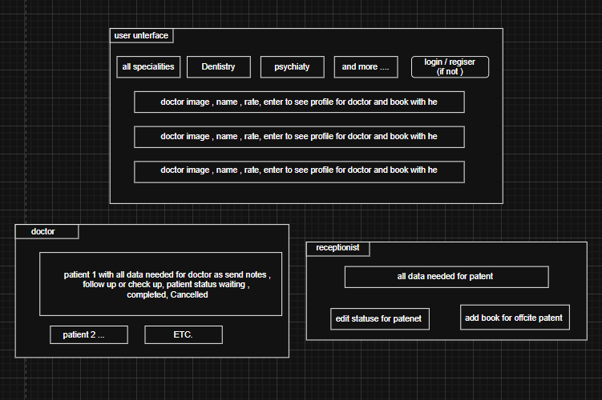

Hardware Interfaces
- Server must have at least 8GB RAM to run the Docker containers.
- No special sensor hardware is needed for this version

Software Interfaces
- Database : MySQL
- Email Service: JavaMailSender interface

Functional Requirements

Module 1: Identity Service
- The system shall allow the Patients to self-register by providing: Name, Email, Phone, and Password.

- The system shall provide a facility to the Admin for the registration of Staff accounts, comprising both Doctors and Receptionists.

- The system shall authenticate users via email/password and issue a JWT Token.

- In case of an invalid or expired JWT, the system shall not allow access to protected routes.

Module 2: Clinic Service
- The system shall allow the Admin to create Clinics. Attributes: Name, Location, Phone.

- The system shall connect each Doctor and each Receptionist to a particular Clinic.

- Users (Patients/Guests) shall be able to search for the Doctors by Specialization or Clinic Name.

- Doctors shall be able to set their working hours and slot duration.

3.2.3 Module 3: Appointment Service

- The system shall show the available time slots of the selected Doctor.

- A patient should be allowed to make a "Pending" appointment against an available slot.

- Receptionist Proxy: Receptionist shall be able to book an appointment on behalf of a patient (registered/walk-in).

- Queue Management - The Receptionist shall be able to change the appointment status to ARRIVED when the patient is physically present.
- The system shall prevent double-booking of the same slot.
- Patients can only cancel appointments ("Close Book") prior to 24 hours in advance.

3.2.4 Module 4: Notification & Record Service

- The Doctor should be able to write medical notes for an appointment that is complete.
- The patient shall be able to view their appointment history and doctor notes.
- Users (Patients/Guests) shall be able to search for the Doctors by Specialization or Clinic Name.
- (AOP): The system shall automatically send a confirmation email to the patient upon successful execution of bookAppointment().

Other Non-functional Requirements

Performance Requirements
Response Time: Key APIs, such as Search and Book, should respond within 2 seconds at normal load.
Concurrency: The system should support several users booking different doctors at the same time without corrupting data.

Safety and Security Requirements
Data Privacy: The patient medical notes should be accessible only to the assigned Doctor and the Patient.

Encryption: Passwords must be hashed using BCrypt prior to storage.

Software Quality Attributes
Maintainability: The code is segregated into Microservices; therefore, it's possible to update a module without taking the entire system down.

Other Requirements

5 System Diagrams
This section includes the visual models of the system.

Use Case Diagram
(Insert your Use Case Diagram here)

Class Diagram
(Insert your Class Diagram here)

Sequence Diagram

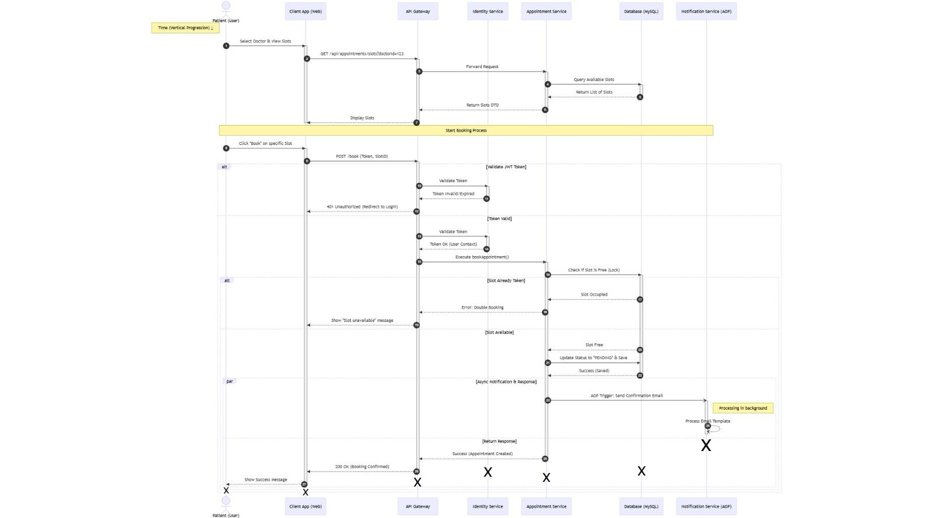

5.4 Activity Diagram

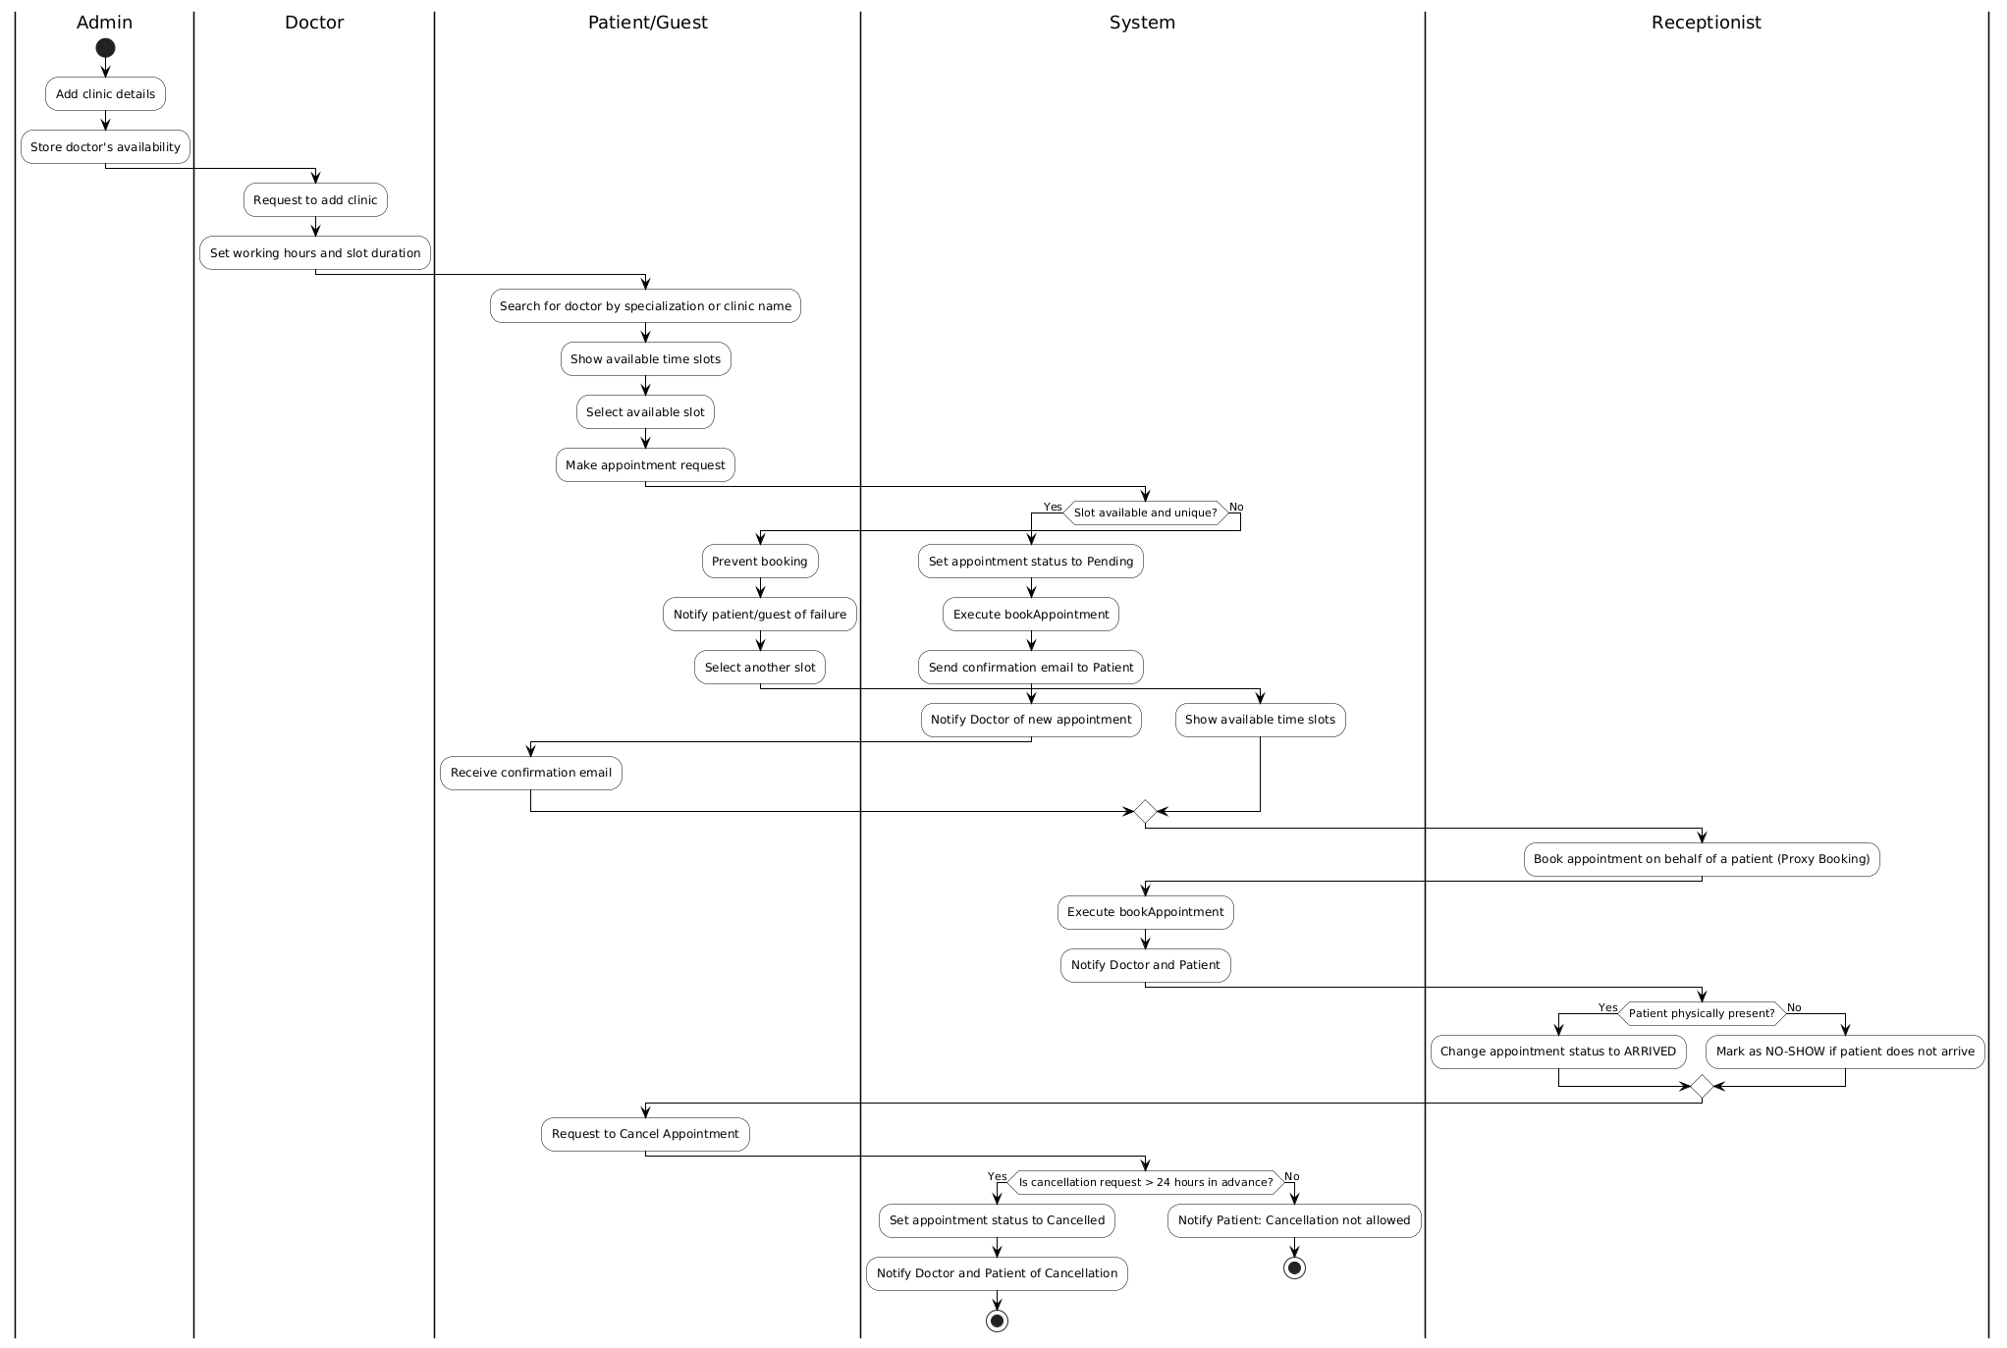Appendix A – Data Dictionar

Appendix A: Data Dictionary & ERD

A.1 Entity Relationship Diagram (ERD)
(Insert your ERD Image here)

A.2 Database Entities Description:

The database schema supports the relationship where Clinics contain Staff, and Patients link to Doctors via Appointments. Clinic Table: clinic_id (PK), name, address, phone_number. User Table Abstract: user_id (PK), email, password_hash, role (ENUM: ADMIN, DOCTOR, RECEPTIONIST, PATIENT). Doctor Table (extends User) doctor_id (FK), clinic_id (FK), specialization, bio Receptionist Table (Extends User): receptionist_id (FK), clinic_id (FK) Patient Table (Extends User): patient_id (FK), insurance_id (optional). Appointment Table: appointment_id, doctor_id, patient_id, date_time, status. Medical_Note Table: note_id (PK), appointment_id (FK), diagnosis_text.

Appendix B - Group Log
<Please include here all the minutes from your group meetings, your group activities, and any other relevant information that will assist in determining the effort put forth to produce this document>

