Nov 2021

Mastering embedded system online diploma by Eng. Keroles Shenouda  
[www.learn-in-depth.com](http://www.learn-in-depth.com)

First Term (Final Project 1)

Eng. Mazen Talaat

My profile: <https://bit.ly/3DUmnyz>

Table of contents

Case Study 2

Assumptions 2

Method 2

Requirements Diagram 3

System Analysis 4

Use case diagram 4

Activity diagram 4

Sequence diagram 5

Block Diagram 6

Pressure sensor 6

Alarm controller 6

Pressure controller 6

Alarm state machine 7

Pressure sensor state machine 7

Pressure controller state machine 8

Final Simulation 9

Code 10

driver.h/c 10

Pressure_Senor.h/c 11

Alarm_Controller.h/c 12

Pressure_Controller.h/c 13

main.c 14

startup.c 15

linker_script.ld 15

map_file.map 16

MakeFile 17

Proteus Simulation 18

Symbols table 21

Sections 22

# Case Study

A “client” expects to deliver the software of the following system:

* A pressure controller informs the crew of a cabin with an alarm when the pressure exceeds 20 bars in the cabin.
* The alarm duration equals 60 seconds.

# Assumptions

* The controller set up and shutdown procedures are not modeled
* The controller maintenance is not modeled
* The pressure sensor never fails
* The alarm never fails
* The controller never faces power cut

# Method

I will use the waterfall method which consists of

1. Requirements.
2. Analysis.
3. Design.
4. Coding.
5. Testing.
6. Deployment.

# Idea

1. Get the pressure sensor data.
2. If the pressure is greater than or equal to the threshold = 20 bars.
   1. Start the alarm for 60 seconds.
3. If the pressure is less than the threshold = 20 bars.
   1. Continue.
4. Repeat.

# Requirements Diagram

# Space Exploration

We will use ARM STM32 board as it meets our requirements and available in stores.

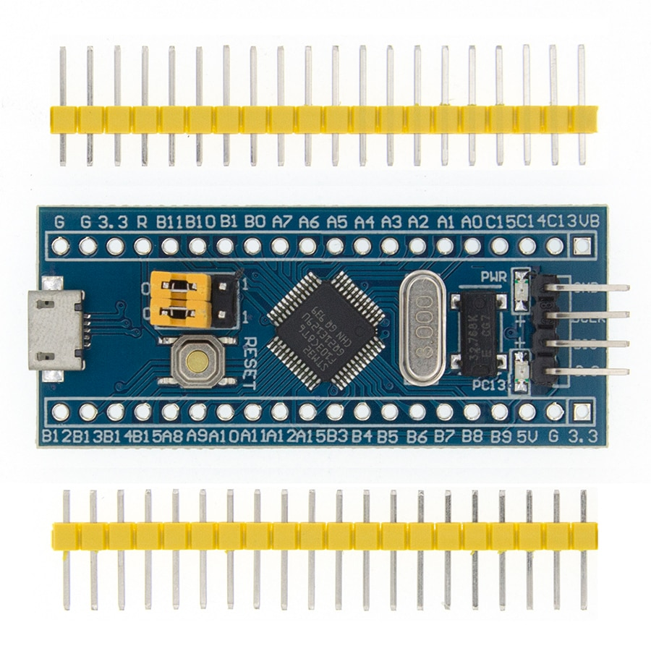

# System Analysis

## Use case diagram

## Activity diagram

## Sequence diagram

# Block Diagram

We will have 3 blocks:

1. Pressure sensor.
2. Pressure controller.
3. Alarm controller.

## Pressure sensor

This block will have the pressure variable and will set it by the function getPressureVal.

## Alarm controller

This block will have the control over the alarm actuator using the function Set_Alarm_actuator.

## Pressure controller

This block will have the control algorithm by retrieving, comparing and sending.

# Alarm state machine

The alarm actuator will be initialized and begin at idle state and will start or stop depending on the “en” variable.

# Pressure sensor state machine

The pressure sensor will be initialized and begin at busy state and keep sending the pressure value every 10 sec.

# Pressure controller state machine

The system will begin at the waiting state then sets the alarm off and get the pressure from the sensor then checks whether the pressure is greater than the threshold or not.  
If it is greater, it will switch to the alarm state and set the alarm on for 60 seconds then repeat the process.

# Final Simulation

All blocks started with initializing, then busy for sensor, waiting for the controller and idle for the alarm.  
Then, the controller sets the alarm off and get the pressure from the sensor which is equal to 18. It waits for 10 seconds to get the new pressure from sensor.  
When the pressure is equal to 21, it switches to the alarm state and set the alarm on for 60 seconds, after that it will read from the sensor again.

# Code

## driver.h/c

## Pressure_Senor.h/c

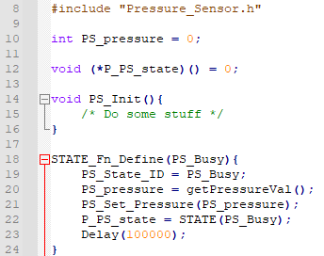

## Alarm_Controller.h/c

## Pressure_Controller.h/c

## main.c

## startup.c

## linker_script.ld

## map_file.map

## MakeFile

# Proteus Simulation

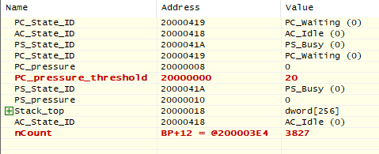

Pressure = 0, LED Off

Pressure = 32, LED On

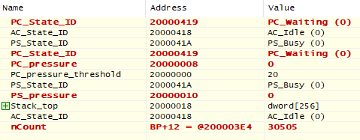

Pressure = 0, LED Off

After some time (nCount)

# Symbols table

# Sections

main.o

Alarm_Controller.o

driver.o

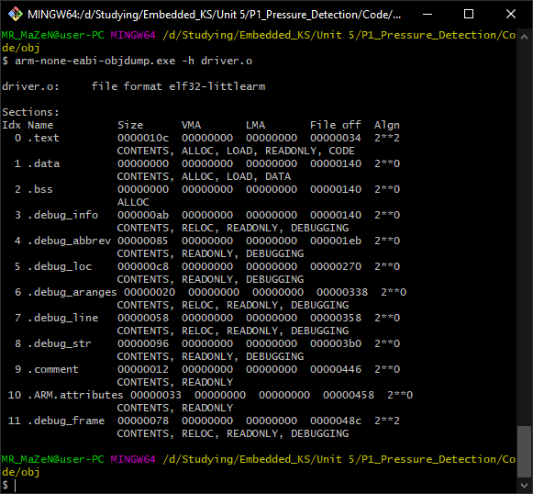

Pressure_Controller.o

Pressure_Sensor.o

startup.o

Project.elf

