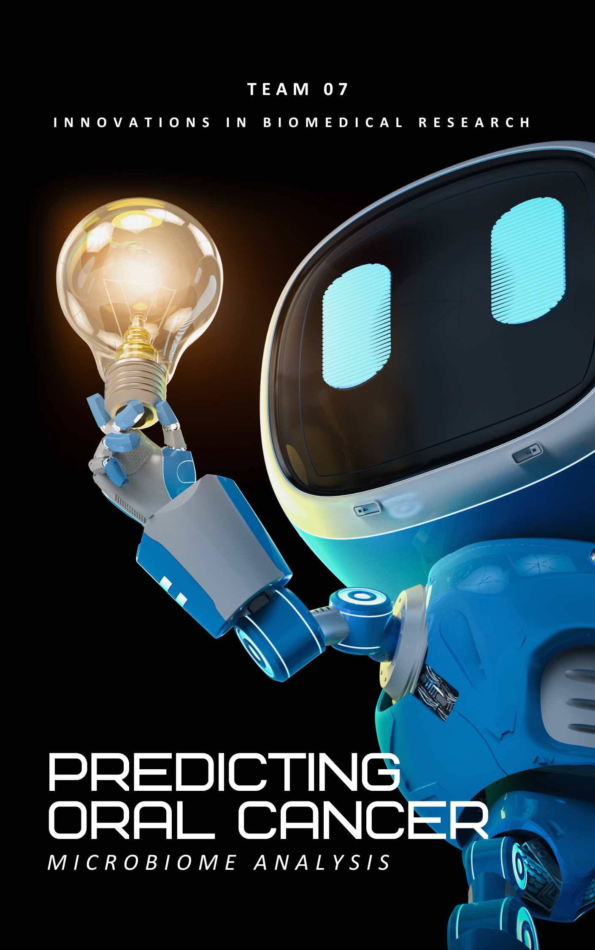

|  |  |
| --- | --- |
| Name | BN |
| Yassien Tawfik | xx |
| Mazen Marwan | xx |
| Madonna Mosaad | xx |

Preseneted To: Prof./ Inas Yassine

Eng./ Samar Alaa

*Table of Contents*

Introduction 2

Problem Definition 2

Objective 2

Significance 2

Methodolgy 3

Data Collection and Preparation 3

16S rRNA Sequencing Analysis 3

Use in Oral Cancer Prediction 4

Reference 5

# Introduction

The integration of machine learning with healthcare presents new opportunities for enhancing disease diagnosis. This project, "Predicting Oral Cancer Using Microbiome Data," leverages the human oral microbiome to develop a non-invasive predictive model for oral cancer. Oral cancer poses significant health challenges worldwide, and early, non-invasive detection methods are crucial for improving treatment outcomes.

This project aims to analyze the relationships between oral microbiome compositions and oral cancer using machine learning techniques, potentially offering a cost-effective tool for early diagnosis. In this report, we will outline the problem, describe the datasets used, and summarize the predictive modeling techniques that will be employed. This phase sets the groundwork for the model development and evaluation that will follow.

# Problem Definition

## **Objective**

The primary goal of this project is to predict the presence of oral cancer using data derived from the human oral microbiome. The microbiome's composition offers critical insights into host health, where dysbiosis (microbial imbalance) is often linked to various diseases, including cancer. By applying machine learning techniques to microbiome data, we aim to develop a predictive model that can potentially serve as a non-invasive diagnostic tool for early detection of oral cancer.

## **Significance**

* Medical Relevance: Early detection of oral cancer increases the survival rate significantly. Traditional diagnostic methods can be invasive and costly, whereas a microbiome-based approach offers a non-invasive alternative.
* Machine Learning Application: This project exemplifies how machine learning can intersect with biomedical research to address critical health issues, advancing the field of predictive diagnostics.
* Innovation: Utilizing microbiome data for cancer prediction is a relatively new and growing field of study, presenting an opportunity for breakthroughs in medical science.

# Methodolgy

## **Data Collection and Preparation**

The initial stage of our project involves collecting microbiome samples from the oral cavity, specifically from the tongue, where bacterial communities are abundant and diverse. After collection, these samples undergo a critical process of DNA extraction, which isolates the genetic material of all microorganisms present in the sample. This isolated DNA is then prepared for detailed analysis using the 16S rRNA sequencing technique.

## **16S rRNA Sequencing Analysis**

1. **Sample Collection**: A sample is taken from the tongue or another part of the oral cavity. This could be through swabs, scrapes, or other methods that collect cells and microbes from the surface.
2. **DNA Extraction**: DNA is extracted from the collected sample. This DNA includes the genetic material of all microorganisms present in the sample.
3. **PCR Amplification**: The 16S rRNA gene is targeted and amplified using PCR (Polymerase Chain Reaction). This gene is chosen because it contains regions that are conserved across all bacteria, making it possible to amplify the gene from virtually any bacterial DNA. It also contains variable regions that differ between bacterial species, allowing for differentiation and identification.
4. **Sequencing**: The amplified genes are then sequenced. Modern sequencing techniques can handle many sequences at once, providing data on a wide variety of bacteria from a single sample.
5. **Data Analysis**: The sequences obtained are compared against a database of known 16S rRNA sequences (such as those in the 16S rRNA RefSeq database). This comparison identifies the bacteria present in the sample by matching the sequences to known bacterial 16S rRNA sequences.
6. **Microbial Profiling**: The result is a profile of the microbial community in the sample. This profile indicates which bacteria are present and often their relative abundances.

## **Use in Oral Cancer Prediction**

* **Microbial Indicators**: Certain types of bacteria might be more prevalent or exclusively present in the oral microbiomes of individuals with oral cancer. Identifying these can provide critical biomarkers for the disease.

**Data for Machine Learning:**

* Input Features: The microbial profiles generated from 16S rRNA sequencing serve as input features for machine learning models. These features include the types and abundances of bacteria identified in each sample.
* Output Prediction: The output of the model is the likelihood of oral cancer presence, expressed as a binary outcome (1 for presence, 0 for absence). This predictive output allows for early intervention and further diagnostic testing where necessary.

**Predictive Analytics:** By analyzing the patterns and correlations between bacterial communities and cancer status across many samples, the model can predict whether a new, unseen sample might correspond to an oral cancer patient based on its microbial content.

# Reference