【系列】雅思A类小作文范文合辑（第一辑） 2012年11月21日 14:51:52
The chart below gives information about global sales of games software, CDs and DVD or video.
Write a report for a university lecturer describing the information.
- You should write at least 150 words.
- You should spend about 20 minutes on this task.
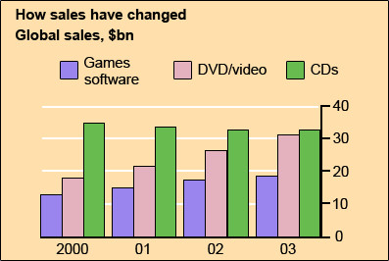
model answer:
The chart shows the changes in the sales of video material / DVDs, games software and CDs around the world in billions of dollars over a three-year period. It can be seen that the sales of videos / DVDs and games software have increased, while the sales of CDs have gone down slightly.
Between 2000 and 2003, the sale of videos and DVDs rose by approximately 13 billion dollars. In 2000, just under 20 billion dollars worth of these items were sold, but in 2003, this figure had risen to a little over 30 billion dollars.
The sales of games software also rose during this period, but less sharply. Sales increased from about 13 billion dollars in 2000 to just under 20 billion dollars three years later. By contrast, during the same time period, the sale of CDs fell from 35 billion dollars in 2000 to about 32.5 billion dollars in 2003.

Eating sweet foods produces acid in the mouth, which can cause tooth decay. (High acid levels are measured by low pH values)
Describe the information below and discuss the implications for dental health.
- You should write at least 150 words.
- Allow yourself 20 minutes for this task.
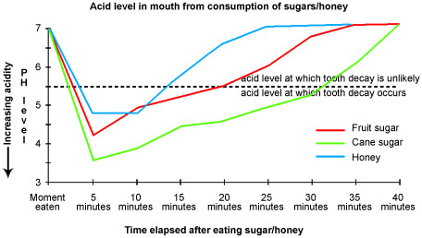
model answer:
Anyone who has visited a dentist has been told that eating excessive amounts of sweets risks harming the teeth. This is because sweets lower pH levels in the mouth to dangerous levels.
When the pH level in the mouth is kept above 5.5, acidity is such that teeth are unlikely to be in danger of decay. Sweet foods, however, cause pH in the mouth to drop for a time, and the longer pH levels remain below 5.5, the greater the opportunity for decay to occur.
By comparing fruit sugar, cane sugar and honey, which are all common ingredients of sweet foods, we find that cane sugar lowers pH levels for the longest period, thus producing the greatest risk of the three. Approximately five minutes aftfter consuming cane sugar, pH levels drop to as little as pH 3.5. They then begin to rise slowly, but do not rise above pH 5.5 until at least 30 minutes have elapsed. By contrast, fruit sugar, which causes the mouth's acidity to fall to just above pH 4, poses a danger for a shorter period: tooth decay is unlikely 20 minutes after consumption. Honey appears an even less risky substance. Though acidity falls to about pH 4.75 within five minutes of consumption, it returns to above pH 5.5 in under fifteen minutes.
The implications, then, are that people who insist on eating sweet foods should be aware of the ingredients, and that fruit sugar or honey appear preferable to cane sugar.

Write a report for a university lecturer describing the information in the two graphs below.
- You should write at least 150 words.
- Allow yourself 20 minutes for this task.
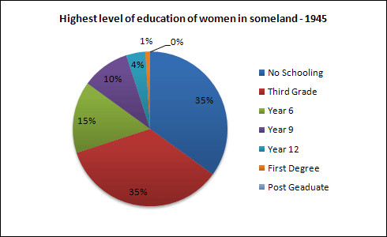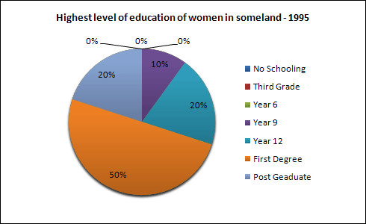
model answer:
The pie charts compare the highest level of education achieved by women in Someland across two years, 1945 and 1995. It can be clearly seen that women received a much higher level of education in Someland in 1995 than they did in 1945.
In 1945 only 30% of women completed their secondary education and 1% went on to a first degree. No women had completed post-graduate studies. This situation had changed radically by 1995. In 1995, 90% of women in Someland had completed secondary education and of those, half had graduated from an initial degree and 20% had gone on to postgraduate studies. At the other end of the scale we can see that by 1995 all girls were completing lower secondary, although 10% ended their schooling at this point. This is in stark contrast with 1945 when only 30% of girls completed primary school, 35% had no schooling at all and 35% only completed the third grade.
In conclusion, we can see that in the 50 years from 1945 to 1995 there have been huge positive developments to the education levels of women in Someland.

Write a report for a university lecturer describing the information in the table below.
- You should write at least 150 words.
- Allow yourself 20 minutes for this task.
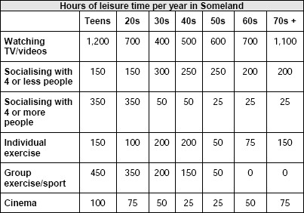
model answer:
The table shows how people in different age groups spend their leisure time in Someland over the course of a year. It can be clearly seen that the amount of leisure time available varies considerably across the age groups and that people of different age levels have very different ways of spending their leisure time.
According to the figures, as people age in Someland their social lives reduce. Teenagers and people in their twenties spend on average 500 hours per year on socialising and 350 hours of that time is with a group of more than 4 people. Although the total hours of socialising in their 30s, 40s, 50s and 60s is fairly constant (between 300-350), socialising with more than 4 people drops dramatically to 50 hours in the 30s and 40s age groups and only 25 from 50 years old. Group and individual exercise follow a similar pattern.
People of all ages spend a good part of their leisure time on entertainment such as TV/video viewing and cinema. In both cases, teenagers and retired people spend around twice as much time as those who are at working age. Home entertainment ranges from just over a thousand hours for teenagers and retired people and an average of 600 hours for everyone else. Cinema accounts for 100 hours of the teenagers and retired people’s leisure time and 25-50 hours for the rest.
In conclusion we can see there is a significant trend towards solitary and smaller group activities as people grow older and that teenagers and retired people spend a lot more time on entertainment than those of working age do.

The map below is of the town of Garlsdon. A new supermarket (S) is planned for the town. The map shows two possible sites for the supermarket.
Summarise the information by selecting and reporting the main features, and make comparisons where relevant.

【系列】雅思A类小作文范文合辑（第一辑）:http://page.renren.com/600009371/note/883539577
The chart and graph below give information about sales and share prices for Coca-Cola.
Write a report for a university lecturer describing the information shown below.
- You should write at least 150 words.
- You should spend about 20 minutes on this task.
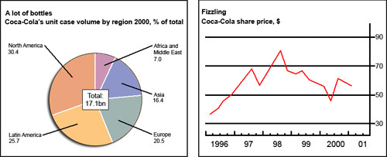
model answer:
The pie chart shows the worldwide distribution of sales of Coca-Cola in the year 2000 and the graph shows the change in share prices between 1996 and 2001.
In the year 2000, Coca-Cola sold a total of 17.1 billion cases of their fizzy drink product worldwide. The largest consumer was North America, where 30.4 per cent of the total volume was purchased. The second largest consumer was Latin America. Europe and Asia purchased 20.5 and 16.4 per cent of the total volume respectively, while Africa and the Middle East remained fairly small consumers at 7 per cent of the total volume of sales.
Since 1996, share prices for Coca-Cola have fluctuated. In that year, shares were valued at approximately $35. Between 1996 and 1997, however, prices rose significantly to $70 per share. They dipped a little in mid-1997 and then peaked at $80 per share in mid-98. From then until 2000 their value fell consistently but there was a slight rise in mid-2000.

The graphs below show the numbers of male and female workers in 1975 and 1995 in several employment sectors of the republic of Freedonia.
Write a report for a university teacher describing the information shown.
- You should write at least 150 words.
- You should spend about 20 minutes on this task.
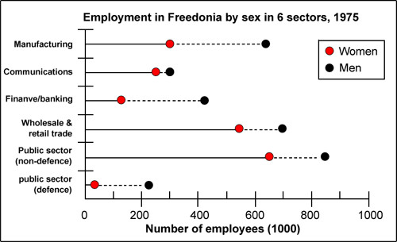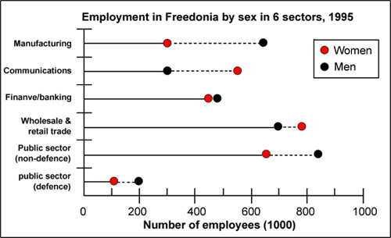
model answer:
The two decades between 1975 and 1995 brought significant changes in the representation of women in Freedonia's work force, according to the graphs.
In 1975, for example, some 300 000 men and 250 000 women worked in the communications sector. Twenty years later, though the number of men remained unchanged, the number of women rose to 550 000.
A similar situation was seen in the wholesale and retail trade sector, where the number of women rose from about 550 000 in 1975 to almost 800 000 two decades later. The number of men in this sector remained stable over the period, at around 700 000.
Women also made gains in both the finance/banking industries and in the defence-related public sector. Whereas some 125 000 women worked in finance and banking institutions in 1975, the number increased to 450 000 by 1995. The number of men grew only marginally from 425 000 to 480 000 over the same period. In defence, the number of men declined from 225 000 to 200 000, while the number of women rose from 25 000 to over 100 000.
Two sectors that retained stable employment numbers for both men and women were manufacturing, which had about 300 000 women and 650 000 men in both surveyed years, and the public sector (non-defence), which employed 650 000 women and 850 000 men.
Thus, women appear to have made gains in the Freedonian work force but not at the expense of men.

The table below shows social and economic indicators for four countries in 1994, according to United Nations statistics.
Describe the information shown below in your own words. What implications do the indicators have for the countries?
- You should write at least 150 words.
- Allow yourself 20 minutes for this task.
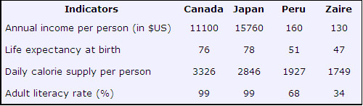
model answer:
A glance at four indicators of economic and social conditions in four countries, Canada, Japan, Peru and Zaire, in 1994 reflects the great differences that exist between wealthier and poorer nations.
The table shows that Japan and Canada had annual incomes of $15 760 and $11 100 per person, respectively. These figures were overwhelmingly greater than the corresponding figures of $160 in Peru and $130 in Zaire.
Health indicators, too, reflected overall levels of affluence in the four nations. Life expectancy at birth, for example, was higher among the more economically developed countries. Japan reported the highest life expectancy, 78. This was followed by Canada, 76; Peru, 51; and Zaire, 47; This suggests that richer societies are able to put more money into health care than poorer ones.
The amount of calories consumed daily per person roughly followed the same ranking. Canadians each consumed some 3 326 calories per day while the Japanese took 2846 calories. The corresponding figures for Peru and Zaire were 1927 and 1749, respectively.
Literacy rates among adults, too, were higher in wealthier countries, no doubt a reflection of ability to invest in education. Canada and Japan both reported literacy rates of 99%, while Peru claimed 68%. Zaire, the least economically developed of the four countries, had a literacy rate of 34%.
The data appear to confirm the often cited link between national wealth and health and education standards.

The diagram below shows the average hours of unpaid work per week done by people in different categories. (Unpaid work refers to such activities as childcare in the home, housework and gardening.)
Describe the information presented below, comparing results for men and women in the categories shown. Suggest reasons for what you see.
- You should write at least 150 words.
- You should spend about 20 minutes on this task.
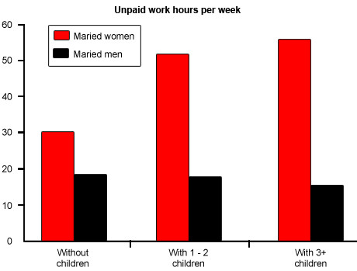
model answer:
The diagram reveals that the number of hours per week spent in unpaid work is unequally distributed between men and women.
In households where there are no children, women are reported to work some 30 hours per week in such tasks as housework and gardening. Men's contribution to these unpaid jobs averages a considerably lower 18 hours.
When children enter the household, however, the inequality becomes even more pronounced. In families of 1 - 2 children, men maintain approximately the same number of hours of unpaid work as in childless households, but the number of hours women work in the home rises to 52 per week, much of it, on doubt, due to childcare responsibilities.
Interestingly, when there are three or more children in the household, men are found to work even fewer hours around the house than before the appearance of the third child. Whereas women's unpaid hours rise to approximately 56 per week, the corresponding figure for men, 16, actually represents a decrease.
The data suggest that the increased presence of women in the paid work force has yet to lead to an increased role for men in the home.

Write a report for a university lecturer describing the information below.
- You should write at least 150 words.
- You should spend about 20 minutes on this task.
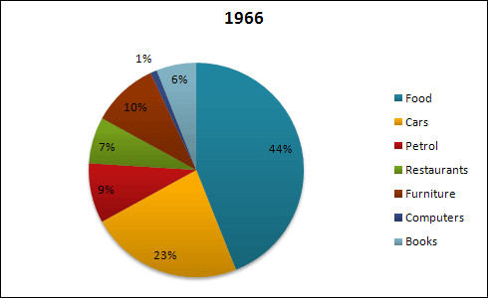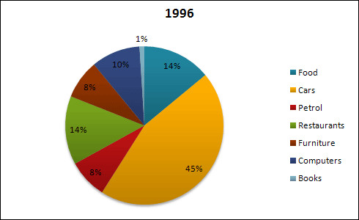
model answer:
The pie charts show changes in American spending patterns between 1966 and 1996.
Food and cars made up the two biggest items of expenditure in both years. Together they comprised over half of household spending. Food accounted for 44% of spending in 1966, but this dropped by two thirds to 14% in 199
...
The chart below gives information about global sales of games software, CDs and DVD or video.
Write a report for a university lecturer describing the information.
- You should write at least 150 words.
- You should spend about 20 minutes on this task.

model answer:
The chart shows the changes in the sales of video material / DVDs, games software and CDs around the world in billions of dollars over a three-year period. It can be seen that the sales of videos / DVDs and games software have increased, while the sales of CDs have gone down slightly.
Between 2000 and 2003, the sale of videos and DVDs rose by approximately 13 billion dollars. In 2000, just under 20 billion dollars worth of these items were sold, but in 2003, this figure had risen to a little over 30 billion dollars.
The sales of games software also rose during this period, but less sharply. Sales increased from about 13 billion dollars in 2000 to just under 20 billion dollars three years later. By contrast, during the same time period, the sale of CDs fell from 35 billion dollars in 2000 to about 32.5 billion dollars in 2003.

Eating sweet foods produces acid in the mouth, which can cause tooth decay. (High acid levels are measured by low pH values)
Describe the information below and discuss the implications for dental health.
- You should write at least 150 words.
- Allow yourself 20 minutes for this task.
model answer:
Anyone who has visited a dentist has been told that eating excessive amounts of sweets risks harming the teeth. This is because sweets lower pH levels in the mouth to dangerous levels.
When the pH level in the mouth is kept above 5.5, acidity is such that teeth are unlikely to be in danger of decay. Sweet foods, however, cause pH in the mouth to drop for a time, and the longer pH levels remain below 5.5, the greater the opportunity for decay to occur.
By comparing fruit sugar, cane sugar and honey, which are all common ingredients of sweet foods, we find that cane sugar lowers pH levels for the longest period, thus producing the greatest risk of the three. Approximately five minutes aftfter consuming cane sugar, pH levels drop to as little as pH 3.5. They then begin to rise slowly, but do not rise above pH 5.5 until at least 30 minutes have elapsed. By contrast, fruit sugar, which causes the mouth's acidity to fall to just above pH 4, poses a danger for a shorter period: tooth decay is unlikely 20 minutes after consumption. Honey appears an even less risky substance. Though acidity falls to about pH 4.75 within five minutes of consumption, it returns to above pH 5.5 in under fifteen minutes.
The implications, then, are that people who insist on eating sweet foods should be aware of the ingredients, and that fruit sugar or honey appear preferable to cane sugar.
Write a report for a university lecturer describing the information in the two graphs below.
- You should write at least 150 words.
- Allow yourself 20 minutes for this task.
model answer:
The pie charts compare the highest level of education achieved by women in Someland across two years, 1945 and 1995. It can be clearly seen that women received a much higher level of education in Someland in 1995 than they did in 1945.
In 1945 only 30% of women completed their secondary education and 1% went on to a first degree. No women had completed post-graduate studies. This situation had changed radically by 1995. In 1995, 90% of women in Someland had completed secondary education and of those, half had graduated from an initial degree and 20% had gone on to postgraduate studies. At the other end of the scale we can see that by 1995 all girls were completing lower secondary, although 10% ended their schooling at this point. This is in stark contrast with 1945 when only 30% of girls completed primary school, 35% had no schooling at all and 35% only completed the third grade.
In conclusion, we can see that in the 50 years from 1945 to 1995 there have been huge positive developments to the education levels of women in Someland.

Write a report for a university lecturer describing the information in the table below.
- You should write at least 150 words.
- Allow yourself 20 minutes for this task.
model answer:
The table shows how people in different age groups spend their leisure time in Someland over the course of a year. It can be clearly seen that the amount of leisure time available varies considerably across the age groups and that people of different age levels have very different ways of spending their leisure time.
According to the figures, as people age in Someland their social lives reduce. Teenagers and people in their twenties spend on average 500 hours per year on socialising and 350 hours of that time is with a group of more than 4 people. Although the total hours of socialising in their 30s, 40s, 50s and 60s is fairly constant (between 300-350), socialising with more than 4 people drops dramatically to 50 hours in the 30s and 40s age groups and only 25 from 50 years old. Group and individual exercise follow a similar pattern.
People of all ages spend a good part of their leisure time on entertainment such as TV/video viewing and cinema. In both cases, teenagers and retired people spend around twice as much time as those who are at working age. Home entertainment ranges from just over a thousand hours for teenagers and retired people and an average of 600 hours for everyone else. Cinema accounts for 100 hours of the teenagers and retired people’s leisure time and 25-50 hours for the rest.
In conclusion we can see there is a significant trend towards solitary and smaller group activities as people grow older and that teenagers and retired people spend a lot more time on entertainment than those of working age do.

The map below is of the town of Garlsdon. A new supermarket (S) is planned for the town. The map shows two possible sites for the supermarket.
Summarise the information by selecting and reporting the main features, and make comparisons where relevant.
- You should write at least 150 words.
- Allow yourself 20 minutes for this task.
model answer:
The first potential location (S1) is outside the town itself, and is sited just off the main road to the town of Hindon, lying 12 kms to the north-west. This site is in the countryside and so would be able to accommodate a lot of car parking. This would make it accessable to shoppers from both Hindon and Garlsdon who could travel by car. As it is also close to the railway line linking the who towns to Cransdon (25 km to the south-east), a potentially large number of shoppers would also be able to travel by train.
In contrast, the suggested location, S2, is right in the town centre, which would be good for local residents. Theorically the store could be accessed by road or rail from the surrounding towns, including Bransdon, but as the central area is a no-traffic zone, cars would be unable to park and access would be difficult.
Overall, neither site is appropriate for all the towns, but for customers in Cransdon, Hindon and Garlsdon, the out-of-town site (S1) would probably offer more advantages.
The diagram below shows the typical stages of consumer goods manufacturing, including the process by which information is fed back to earlier stages to enable adjustment.
Write a report for a university lecturer describing the process shown.
- You should write at least 150 words.
- You should spend about 20 minutes on this task.
model answer:
Most consumer goods go through a series of stages before they emerge as finished products ready for sale.
Raw materials and manufactured components comprise the initial physical input in the manufacturing process. Once obtained, these are stored for later assembly. But assembly first depends upon the production planning stage, where it is decided how and in what quantities the stored materials will be processed to create sufficient quantities of finished goods. The production planning stage itself follows the requirements of the goods' design stage that proceeds from extensive research. After assembly, the products are inspected and tested to maintain quality control l Those units that pass the inspection and testing stages are then packaged, despatched and offered for sale in retail outlets. The level of sales, which is the end point of the manufacturing process, helps determine production planning.
A product's design is not only the result of product research, but is also influenced by testing and market research. If the testing stage (after assembly and inspection) reveals unacceptable problems in the finished product, then adjustments will have to be made to the product's design. Similarly, market research, which examines the extent and nature of the demand for products, has the role of guiding product design to suit consumer demands which may change with time. Market research, while influenced by product sales, also serves to foster future sales by devising suitable advertising for the goods.
Thus the reality of consumer goods manufacturing goes well beyond a simple linear production process.
雅思, 作文

