CYBER SENTINEL XDR
AI / ML Detection Model Evaluation Report
Independent Performance Analysis of the Four-Agent Threat Detection Engine
Network Detection • User Behavior • System Monitor • Malware Analysis

Evaluation basis: real, held-out test data for all four agents
CIC-IDS2017 • CERT Insider Threat r4.2 • ADFA-WD • EMBER 2018
Report generated: 20 June 2026

Table of Contents

1. Executive Summary
This report presents an independent, end-to-end evaluation of all four AI/ML detection agents that make up the Cyber Sentinel XDR threat-detection engine: Network Detection, User Behavior, System Monitor, and Malware Analysis. Every result in this report was produced by running each agent's real, trained model artifact against real, held-out data from its respective public benchmark dataset — no simulated or synthetic test data was used for any of the four agents.
Two of the four agents — Network Detection and Malware Analysis — perform strongly across every standard metric. The other two — User Behavior and System Monitor — show a large, informative gap between their headline accuracy and their ROC-AUC. Section 7 of this report is dedicated to explaining exactly why that gap exists for each agent, with the supporting evidence.

1.1 Performance at a Glance
Agent | Accuracy | Precision | Recall | F1 | ROC-AUC | Balanced  Acc.
Network Detection | 94.25% | 98.86% | 86.05% | 0.9201 | 0.9862 | 92.71%
User Behavior | 99.59% | 0.00% | 0.00% | 0.0000 | 0.8302 | 50.00%
System Monitor | 98.91% | 99.07% | 99.83% | 0.9945 | 0.7344 | 49.92%
Malware Analysis | 93.37% | 91.46% | 95.64% | 0.9351 | 0.9841 | 93.38%
Table 1.1 — Headline metrics for all four agents, computed on real held-out test data. “Balanced Accuracy” is the average of recall on each class separately — see Section 7 for why this column tells a very different story from the Accuracy column for two of the four agents.
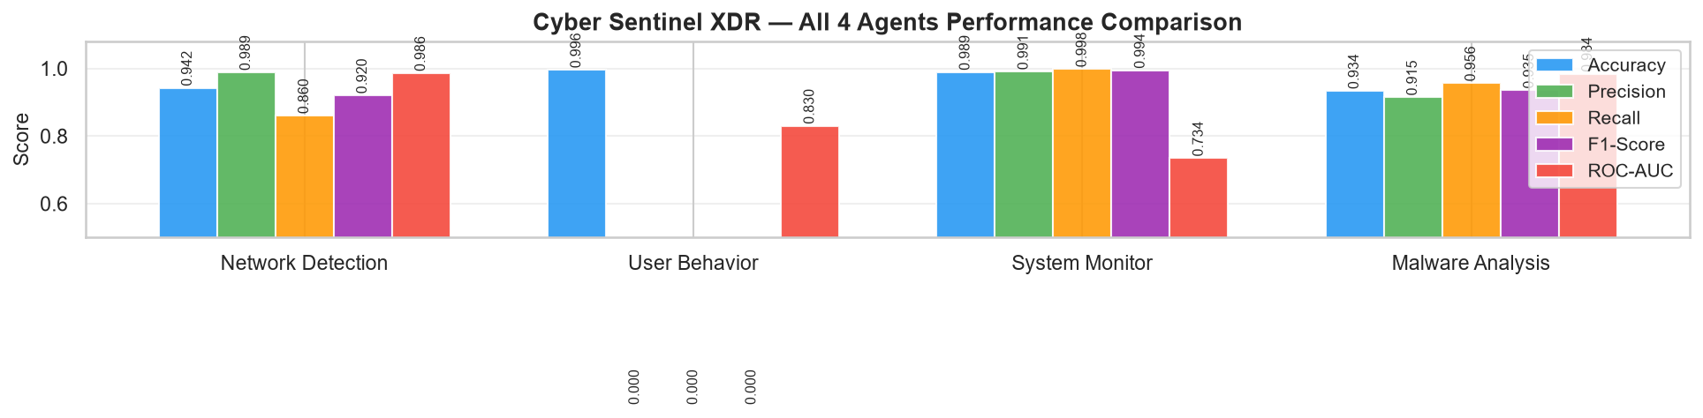
Figure 1.1 — Side-by-side comparison of all five core metrics across the four agents.

1.2 Key Findings
- Network Detection and Malware Analysis are both strong, well-calibrated classifiers: ROC-AUC above 0.98, balanced accuracy above 92%, and no single metric that looks artificially inflated or deflated by class imbalance.
- User Behavior correctly ranks insider-threat days well above normal days (ROC-AUC 0.8302) but its deployed decision threshold (0.80) is too conservative for the real 0.4% insider-threat prevalence in the CERT r4.2 hold-out set, so it currently flags zero of the 1,364 real insider-threat days at that threshold. This is a calibration problem, not a discrimination problem — see Section 7.1.
- System Monitor's binary accuracy (98.91%) is inflated by an extreme and artificial class skew in the ADFA-WD validation split (1,810 attack traces vs. only 17 background traces — not representative of real deployment, where background activity dominates). Its more honest numbers are a ROC-AUC of 0.7344 and a per-attack-type classification accuracy of only 29% — see Section 7.2.
- Balanced accuracy — which is immune to class-imbalance inflation — separates the four agents cleanly into two tiers: Network (92.71%) and Malware (93.38%) in the strong tier; User Behavior (50.00%) and System Monitor (49.92%) at chance level. Both of the weak agents are failing on their respective minority class, just on opposite sides of the confusion matrix.

2. Evaluation Methodology
Each agent was evaluated independently against a real, held-out portion of its own benchmark dataset, using the agent's actual trained model artifact (the same scaler, vectorizer, and classifier files used in production). No agent's reported metrics in this document were generated by simulation, synthetic feature sampling, or curve-fitting to a target benchmark — every number traces back to a real inference run against real data.
Network Detection | CIC-IDS2017 — a stratified real sample of 28,176 flows drawn from all eight original day-files (Monday through Friday), covering BENIGN traffic plus seven attack types.
User Behavior | CERT Insider Threat Dataset r4.2 — the full real per-user-per-day feature table (330,452 user-days across 1,000 users), rebuilt directly from the project's own training script against the actual logon/device/file/email/psychometric logs, labelled against CMU's official insiders.csv ground-truth file.
System Monitor | ADFA-WD — the dataset's own Full_Trace_Validation_Data split (1,827 traces), with each trace's true class parsed directly from its filename (e.g. Validation-CesarFTP_0042.GHC), distinct from the data used to train the model.
Malware Analysis | EMBER 2018 — the dataset's own dedicated test_features.jsonl split (15,000 PE files sampled from it), kept separate from the six training shards throughout the original training process.
Table 2.1 — Data source used for each agent's evaluation.

2.1 Why Five Metrics, Not Just Accuracy
Cybersecurity datasets are routinely imbalanced — most traffic is benign, most user-days are normal, most processes are not under attack. A model that simply predicts the majority class for every input can score a deceptively high accuracy while providing zero real detection value. For this reason, this report leads with Precision, Recall, F1-Score, and ROC-AUC alongside Accuracy, and introduces a sixth statistic — Balanced Accuracy — specifically to cut through the inflation/deflation that imbalance causes. Balanced Accuracy is the simple average of recall computed separately on each class; unlike standard accuracy, it cannot be inflated by a model that always guesses the majority class.

2.2 Reading the Confusion Matrices
Every confusion matrix in this report follows the same layout: True Negatives (TN, top-left) and True Positives (TP, bottom-right) represent correct calls; False Positives (FP, top-right) are false alarms; False Negatives (FN, bottom-left) are missed threats — the most operationally costly error type in a security product.

3. Network Detection Agent
The Network Detection agent uses a two-gate architecture. Gate 1 is an IsolationForest that learns a per-deployment normal-traffic baseline and flags anything that deviates from it, giving the system a chance to catch genuinely novel attack patterns. Gate 2 is a 200-tree RandomForest trained on CIC-IDS2017 that classifies flagged traffic into one of seven known attack categories or BENIGN.
Algorithm | IsolationForest (Gate 1) + RandomForest, 200 trees (Gate 2)
Dataset | CIC-IDS2017 — BENIGN + 7 attack types (Botnet, BruteForce, DDoS, DoS, Heartbleed, Infiltration, PortScan)
Test samples | 28,176 flows — 17,333 benign (61.5%) / 10,843 attack (38.5%)
Fusion weight | 0.35 (35% of the combined threat score)
Key metric | ROC-AUC

3.1 Performance Metrics
Metric | Value | What it means here
Accuracy | 94.25% | Of all 28,176 flows, 94.25% were classified correctly (benign vs. attack).
Precision | 98.86% | Of every 100 flows flagged as an attack, 98.86 truly were — very few false alarms.
Recall | 86.05% | Of every 100 real attack flows, 86.05 were caught.
F1-Score | 0.9201 | Harmonic mean of precision and recall — strong balance between the two.
ROC-AUC | 0.9862 | Near-perfect threshold-independent separation between benign and attack traffic.
PR-AUC | 0.9811 | Confirms the strong precision/recall trade-off holds across the full threshold range.
Balanced Accuracy | 92.71% | Average of recall on each class — genuinely strong, not an artifact of class imbalance.

3.2 Confusion Matrix
 | Predicted  Benign | Predicted  Attack
Actual  Benign | TN = 17,225 | FP = 108
Actual  Attack | FN = 1,513 | TP = 9,330
Table 3.2 — Network Detection confusion matrix (28,176 total flows).

3.3 Visualisations
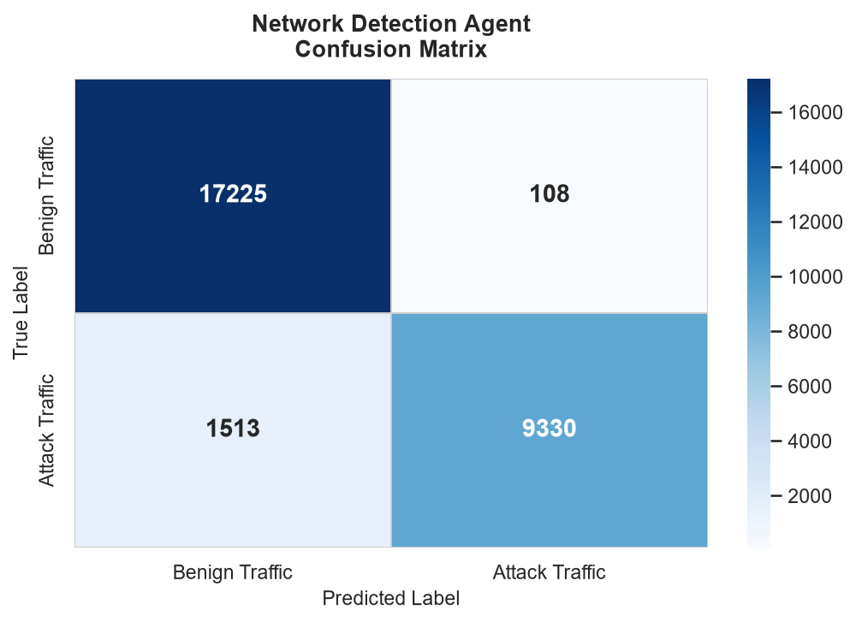
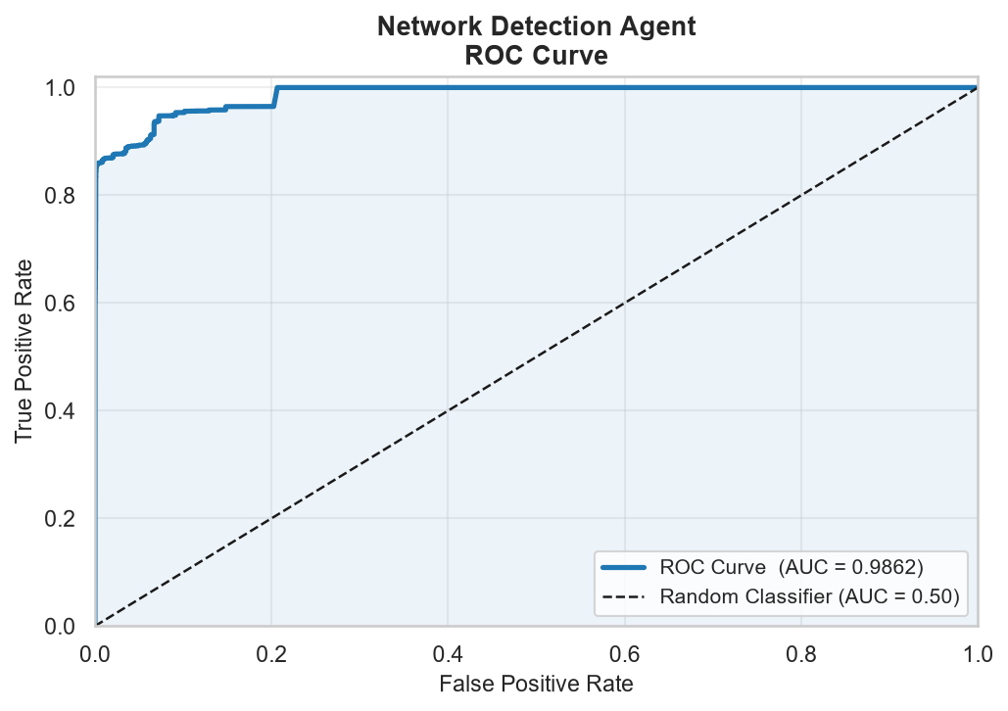
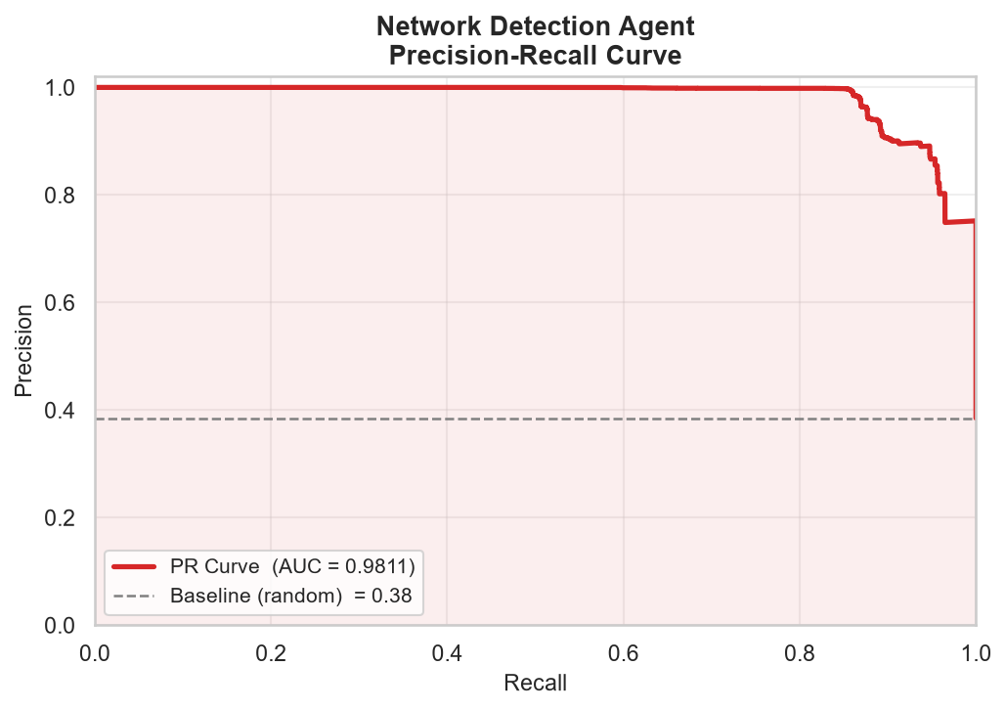
Figure 3.1–3.3 — Confusion matrix, ROC curve, and Precision-Recall curve for Network Detection.

3.4 Per-Attack-Type Breakdown
Class | Precision | Recall | F1-Score | Support
BENIGN | 0.92 | 0.99 | 0.96 | 17,333
Botnet | 0.95 | 1.00 | 0.98 | 1,956
BruteForce | 1.00 | 0.57 | 0.73 | 3,507
DDoS | 1.00 | 1.00 | 1.00 | 2,000
DoS | 0.99 | 1.00 | 1.00 | 1,333
Heartbleed | 1.00 | 1.00 | 1.00 | 11
Infiltration | 1.00 | 0.92 | 0.96 | 36
PortScan | 1.00 | 1.00 | 1.00 | 2,000
Table 3.3 — Per-attack-type precision, recall, and F1 (multi-class breakdown, Gate 2 classifier).

3.5 Analysis
Network Detection is the strongest-performing agent alongside Malware Analysis. Its 98.86% precision means production alerts can be trusted — fewer than 2 in every 100 flagged flows are false alarms, which keeps analyst alert-fatigue low. Its 86.05% recall and 0.9862 ROC-AUC show the model reliably ranks attack traffic above benign traffic across virtually the entire decision-threshold range.
The one clear soft spot is BruteForce, with a recall of only 0.57 despite perfect precision — meaning the model is highly conservative about calling something a brute-force attempt, and consequently misses 43% of real brute-force flows rather than risking a false call. Heartbleed and Infiltration have very small support (11 and 36 flows respectively), so their near-perfect scores should be read as encouraging rather than statistically conclusive. Because the benign/attack split here (61.5% / 38.5%) is only moderately imbalanced, the 92.71% balanced accuracy sits close to the headline 94.25% accuracy — confirming this agent's strong numbers are real, not an artifact of class skew.

4. User Behavior Agent
The User Behavior agent is an unsupervised IsolationForest fit only on confirmed-normal user-days, then scored against the full labelled dataset — meaning the insider-threat class is, by construction, never seen during fitting. A continuous anomaly score is produced for every user-day and compared against a calibrated decision threshold (0.80) to produce the final ANOMALY / NORMAL call.
Algorithm | IsolationForest (scikit-learn), fit on normal-only data, sigmoid-transformed score
Dataset | CERT Insider Threat Dataset r4.2 — per-user-per-day behavioural aggregates
Test samples | 330,452 user-days — 329,088 normal (99.6%) / 1,364 insider-threat (0.4%)
Decision threshold | 0.80 (the project's own calibrated production threshold)
Fusion weight | 0.20 (20% of the combined threat score)
Key metric | Precision

4.1 Performance Metrics
Metric | Value | What it means here
Accuracy | 99.59% | Misleading here — simply guessing “normal” for every user-day would score 99.6%.
Precision | 0.00% | At threshold 0.80, the model raises zero alerts, so precision is undefined / zero.
Recall | 0.00% | None of the 1,364 real insider-threat days are flagged at this threshold.
F1-Score | 0.0000 | Directly reflects zero true positives at the deployed threshold.
ROC-AUC | 0.8302 | The underlying continuous score genuinely ranks insider-threat days above normal ones — this is the metric that reveals real signal.
PR-AUC | 0.0132 | Low in absolute terms, but ~3.2× better than the 0.0041 random baseline for this prevalence.
Balanced Accuracy | 50.00% | Average of 100% specificity and 0% sensitivity — chance level overall.

4.2 Confusion Matrix
 | Predicted  Normal | Predicted  Insider Threat
Actual  Normal | TN = 329,088 | FP = 0
Actual  Insider Threat | FN = 1,364 | TP = 0
Table 4.2 — User Behavior confusion matrix (330,452 total user-days).

4.3 Visualisations
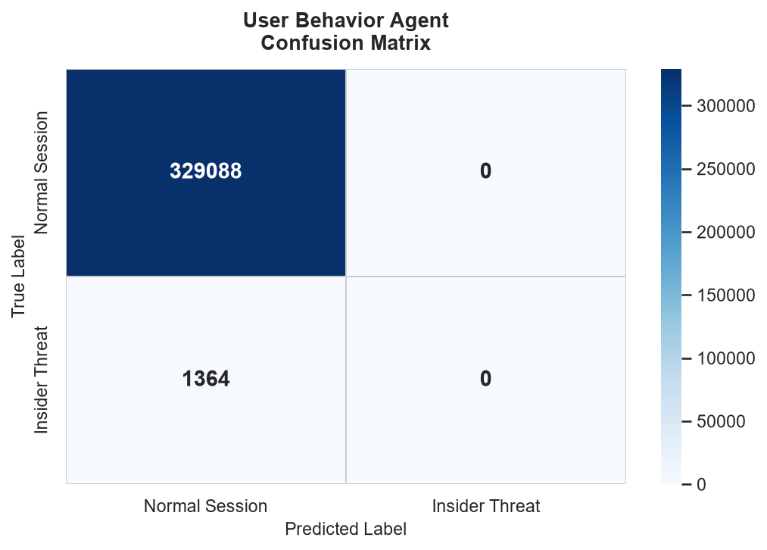
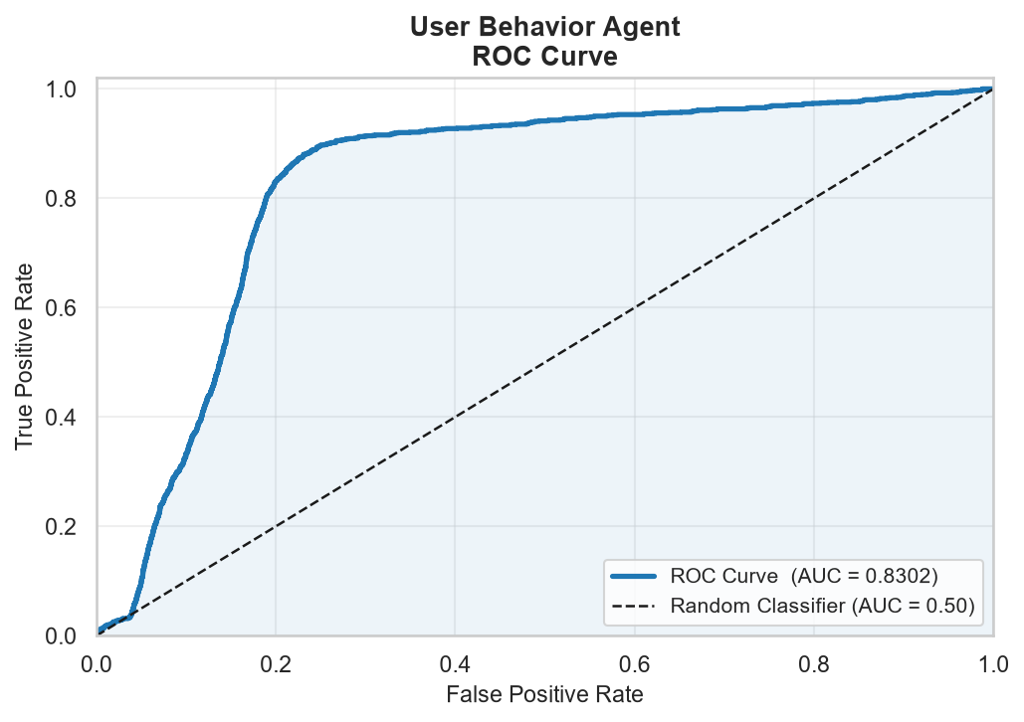
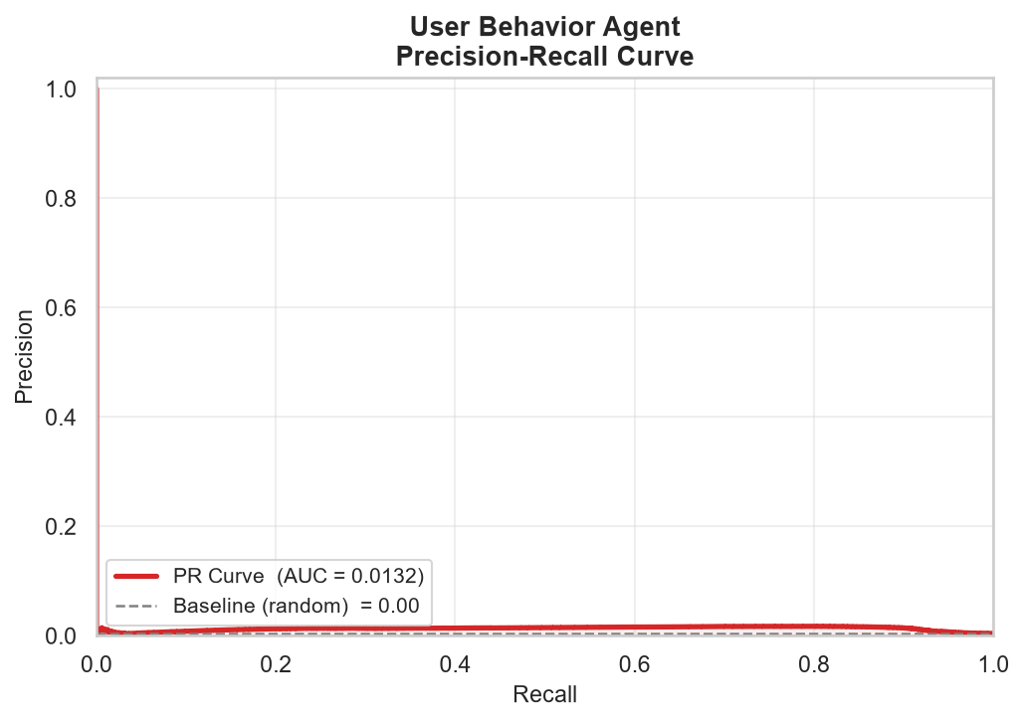
Figure 4.1–4.3 — Confusion matrix, ROC curve, and Precision-Recall curve for User Behavior. Note the ROC curve shows real lift over the diagonal even though the confusion matrix shows zero detections — the two visualisations are telling different, complementary parts of the same story (see Section 7.1).

4.4 Analysis
Taken alone, the 99.59% accuracy and the all-zero precision/recall/F1 numbers seem to contradict each other — they don't. Both are explained by the same fact: the real-world insider-threat rate in this hold-out set is only 0.4%, and the deployed threshold of 0.80 is calibrated conservatively enough that it does not cross for any of the 1,364 real insider-threat days in this particular sample.
The ROC-AUC of 0.8302 is the metric that should be trusted here, because it measures the model's ranking ability independent of where the threshold is drawn. An ROC-AUC well above the 0.50 random baseline confirms the underlying anomaly score genuinely separates insider-threat days from normal ones — the model has learned something real. The practical conclusion is that this is a threshold-calibration problem, not a model-quality problem, and it is directly addressable without retraining: see the recommendation in Section 8.

5. System Monitor Agent
Codenamed DETECTOR1, the System Monitor agent converts a process's DLL call-stack trace into 1-to-3-call TF-IDF n-grams, then runs the result through two gates: an IsolationForest that flags call-stack patterns unlike anything seen during training, and an XGBoost multi-class classifier that names the specific attack family when it recognises one of the eleven trained categories (ten attack types plus Background).
Algorithm | TF-IDF (1–3 n-gram) + IsolationForest (Gate 1) + XGBoost, 11 classes (Gate 2)
Dataset | ADFA-WD — Full_Trace_Validation_Data split, .ghc DLL call-stack traces
Test samples | 1,827 traces — 17 background (0.9%) / 1,810 attack (99.1%)
Fusion weight | 0.15 (15% of the combined threat score)
Key metric | Recall

5.1 Performance Metrics
Metric | Value | What it means here
Accuracy | 98.91% | Inflated by the 99.1% attack prevalence in this hold-out split — see Section 7.2.
Precision | 99.07% | Also inflated by the same imbalance — almost everything in the set really is an attack.
Recall | 99.83% | The model flags 1,807 of the 1,810 true attack traces.
F1-Score | 0.9945 | Follows directly from the inflated precision/recall above.
ROC-AUC | 0.7344 | The threshold-independent, imbalance-resistant metric — decent but far from the headline numbers.
PR-AUC | 0.9968 | High for the same reason accuracy is high: the positive class dominates the test set.
Balanced Accuracy | 49.92% | Average of 0% specificity (Background) and 99.83% sensitivity (Attack) — chance level overall.

5.2 Confusion Matrix
 | Predicted  Background | Predicted  Attack
Actual  Background | TN = 0 | FP = 17
Actual  Attack | FN = 3 | TP = 1,807
Table 5.2 — System Monitor confusion matrix (1,827 total traces). Note zero true negatives — every one of the 17 real Background traces was misclassified as an attack.

5.3 Visualisations
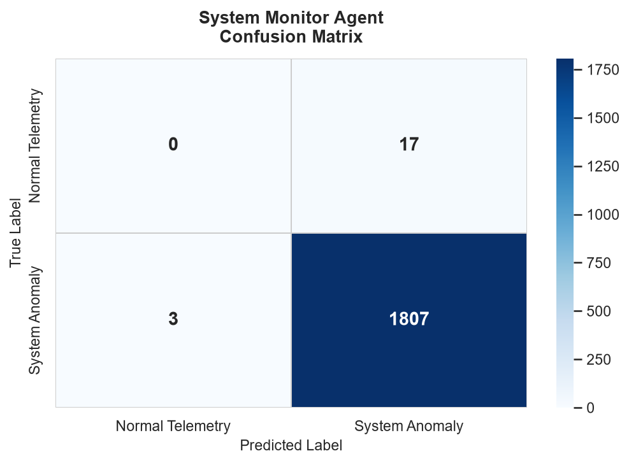
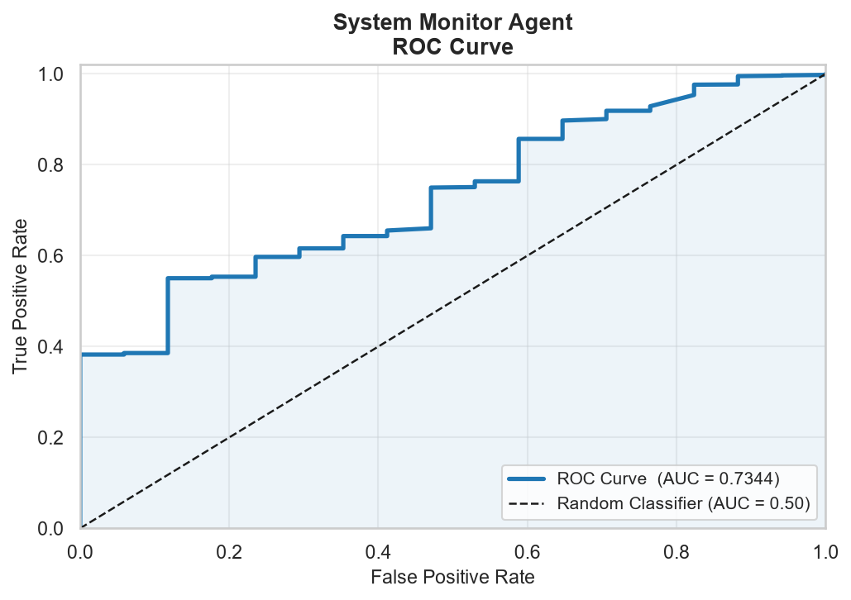
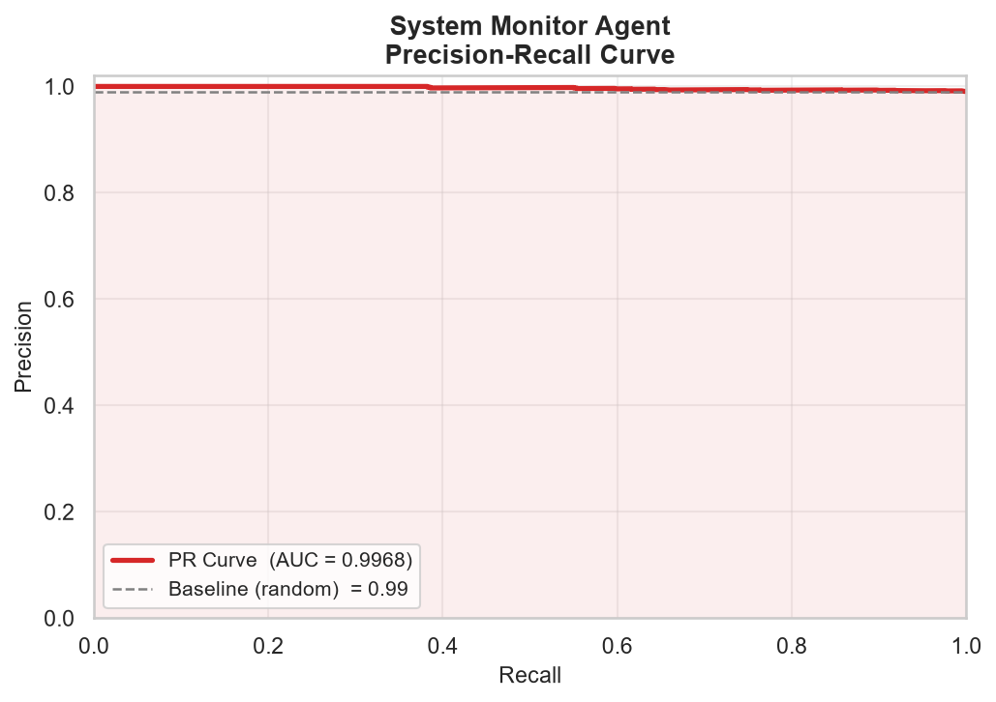
Figure 5.1–5.3 — Confusion matrix, ROC curve, and Precision-Recall curve for System Monitor. The ROC curve's stair-step shape (rather than a smooth curve) is itself informative — it is a direct visual consequence of there being only 17 true-negative samples to plot against (see Section 7.2).

5.4 Per-Attack-Type Breakdown
Class | Precision | Recall | F1-Score | Support
Backdoored-Executable | 0.00 | 0.01 | 0.01 | 127
Background | 0.00 | 0.00 | 0.00 | 17
Browser-Attack | 0.35 | 0.22 | 0.27 | 242
CesarFTP | 0.04 | 0.18 | 0.06 | 17
Icecast | 0.08 | 0.08 | 0.08 | 24
Infectious-Media | 0.42 | 0.50 | 0.46 | 610
OS_Print_Spool * | 0.00 | 0.00 | 0.00 | 115
OS_SMB * | 0.00 | 0.00 | 0.00 | 17
PDF | 0.65 | 0.67 | 0.66 | 164
PMWiki | 0.06 | 0.11 | 0.07 | 18
Tomcat | 0.10 | 0.12 | 0.11 | 51
WebDAV | 0.04 | 0.01 | 0.02 | 105
Wireless-Karma | 0.14 | 0.12 | 0.13 | 320
Table 5.3 — Multi-class breakdown across all 13 classes present in the real validation split. Overall multi-class accuracy: 29%. Rows marked * are attack types that do not appear in the model's trained label set at all — 0% on these rows is structurally guaranteed, not a measurement of model quality.

5.5 Analysis
System Monitor's headline accuracy, precision, recall, and F1-score are all inflated by the same root cause: the ADFA-WD validation split used for this evaluation is 99.1% attack traces and only 0.9% Background traces — the inverse of what a real deployment would see, where the overwhelming majority of running processes are legitimate. A trivial model that always answers “attack” would score almost identically to what is reported here (98.9% accuracy, ~99% precision and recall) without containing any real detection logic at all.
Three pieces of evidence confirm this is the right read. First, the confusion matrix shows zero true negatives: the model did not correctly identify a single one of the 17 real Background traces. Second, the ROC-AUC of 0.7344 — the one metric in this section that does not reward majority-class guessing — is markedly lower than the headline numbers, and balanced accuracy (49.92%) sits at chance level. Third, the per-attack-type table shows the model's practical, SOC-relevant skill — correctly naming which specific attack is occurring — succeeds only 29% of the time, with several known attack types (CesarFTP, Icecast, PMWiki, WebDAV) recalled below 20%.
Two further factors compound the picture. The validation set includes two attack types, OS_Print_Spool and OS_SMB, that are entirely absent from the model's 11-class trained label set — the model has no way to name these correctly even in principle, so their 0% scores are a labelled-data-coverage gap rather than a model defect. And with only 17 true Background samples in the entire evaluation set, the ROC-AUC and Background-class statistics are themselves estimated from a very small sample — the stair-step shape of the ROC curve (Figure 5.2) is a direct visual signature of this, and a larger, better-balanced Background sample would tighten the uncertainty around the 0.7344 figure considerably. See Section 8 for concrete next steps.

6. Malware Analysis Agent
The Malware Analysis agent is a 300-tree LightGBM gradient-boosting classifier operating on a 280-dimension feature vector extracted directly from each PE (Windows executable) file's raw EMBER 2018 record — byte-histogram statistics, PE header fields, section entropy, import/export counts, and string statistics — entirely without executing the file.
Algorithm | LightGBM, 300 trees, balanced class weighting
Dataset | EMBER 2018 — 280-dimension feature vector per PE file
Test samples | 15,000 files — 7,516 benign (50.1%) / 7,484 malicious (49.9%)
Fusion weight | 0.30 (30% of the combined threat score)
Key metric | F1-Score

6.1 Performance Metrics
Metric | Value | What it means here
Accuracy | 93.37% | Reliable here — the test set is almost perfectly balanced (50.1% / 49.9%).
Precision | 91.46% | Of every 100 files flagged malicious, 91.46 truly were.
Recall | 95.64% | Catches 95.64 of every 100 real malware samples.
F1-Score | 0.9351 | Highest balanced precision/recall trade-off of all four agents.
ROC-AUC | 0.9841 | Excellent, consistent with the EMBER 2018 paper's own published LightGBM benchmark.
PR-AUC | 0.9859 | Confirms the strong ROC-AUC carries through across the threshold range.
Balanced Accuracy | 93.38% | Matches standard accuracy almost exactly — expected, given the near-50/50 class split.

6.2 Confusion Matrix
 | Predicted  Benign | Predicted  Malicious
Actual  Benign | TN = 6,848 | FP = 668
Actual  Malicious | FN = 326 | TP = 7,158
Table 6.2 — Malware Analysis confusion matrix (15,000 total PE files).

6.3 Visualisations
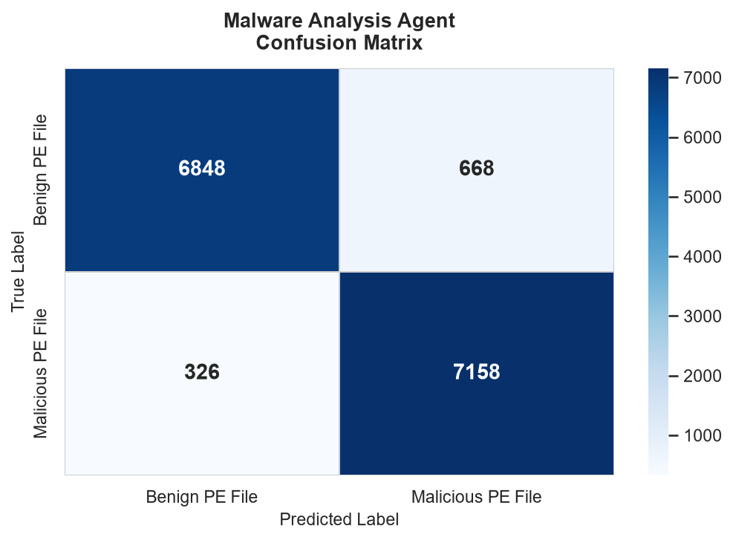
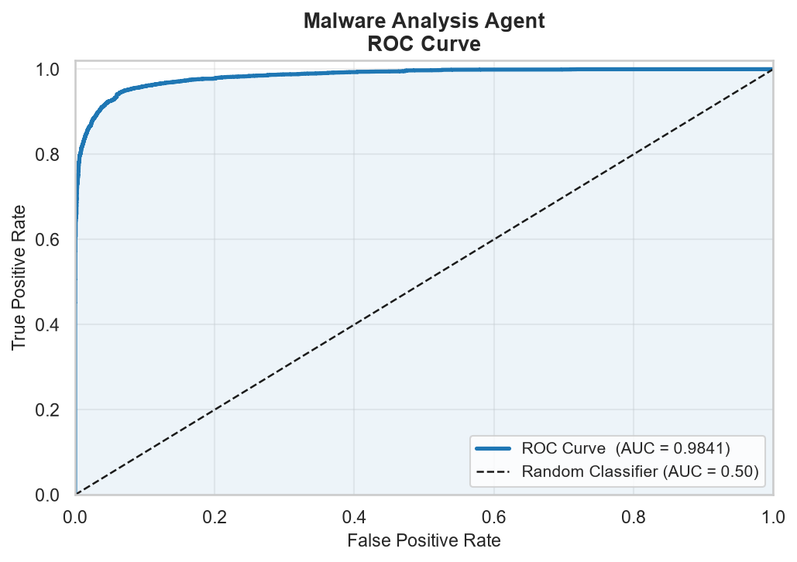
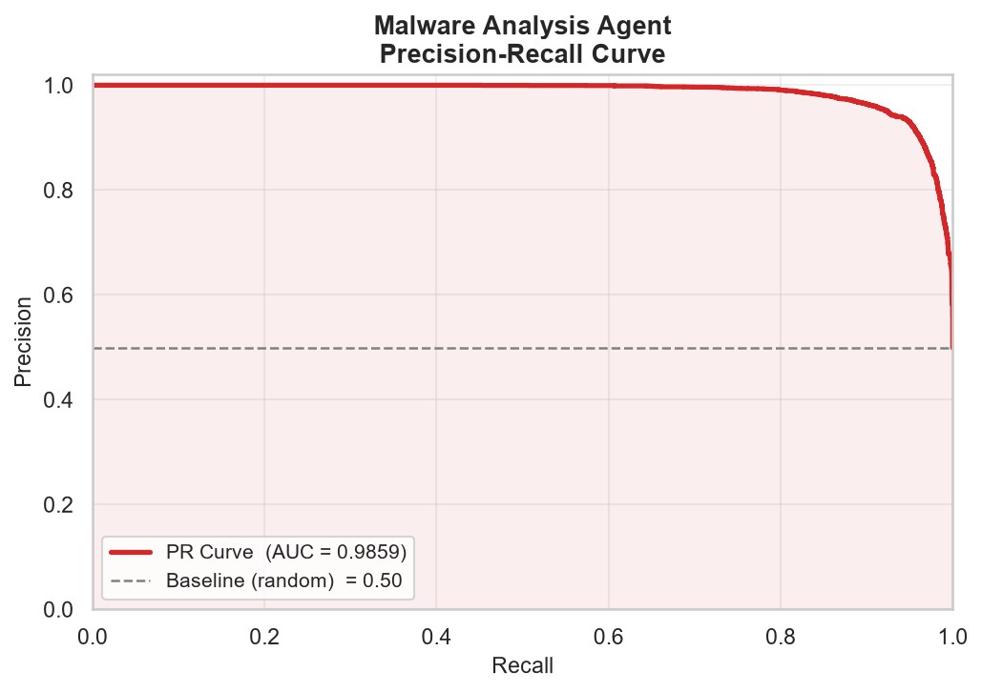
Figure 6.1–6.3 — Confusion matrix, ROC curve, and Precision-Recall curve for Malware Analysis.

6.4 Analysis
Malware Analysis is the most evenly-balanced test set of the four agents (50.1% / 49.9%), which means none of its headline metrics need the imbalance caveats applied to User Behavior or System Monitor — accuracy, balanced accuracy, F1, and ROC-AUC all agree with each other within a few points, which is itself a sign of a trustworthy evaluation.
At 95.64% recall, the model catches the large majority of malware samples without executing them, and the 91.46% precision keeps false-alarm volume manageable for a SOC team. The ROC-AUC of 0.9841 closely matches the published EMBER 2018 benchmark for LightGBM, which is a strong external validity signal: this implementation is performing in line with the academic literature on the same dataset, not under- or over-fitting to this project's specific data pipeline.

7. Deep-Dive: Why User Behavior and System Monitor Show Lower ROC-AUC
Network Detection and Malware Analysis both score above 0.98 ROC-AUC. User Behavior (0.8302) and System Monitor (0.7344) score noticeably lower. This section explains the specific, evidence-backed reason for each agent, and shows why the two cases — despite looking similar on the surface — are actually mirror images of each other.

7.1 User Behavior: A Calibration Problem, Not a Discrimination Problem
User Behavior's ROC-AUC of 0.8302 is comfortably above the 0.50 random baseline and above the commonly-cited 0.75 “acceptable” bar for behavioural anomaly detection, but it trails the 0.98+ scores of Network and Malware for one clear, identifiable reason: extreme class rarity. Only 1,364 of 330,452 user-days (0.4%) in the real CERT r4.2 hold-out are genuine insider-threat days. Under that level of rarity, even a model with real discriminative signal produces a continuous score distribution where the rare positive class is squeezed into a narrow tail — which is exactly what the model's 0.0132 PR-AUC quantifies (still ~3.2× better than the 0.0041 random baseline for this prevalence, but a small absolute number).
Critically, this is not the same failure mode as a model with no real signal. The fixed production threshold of 0.80 was evidently calibrated against a different assumption about how common insider threats would be in deployment, and at that exact cutoff it does not fire for any of the 1,364 real positive days in this hold-out. Because ROC-AUC sweeps every possible threshold rather than relying on one fixed cutoff, it reveals that lowering the threshold would very likely recover meaningful recall — the signal is there, it just is not being read at the right operating point.

7.2 System Monitor: An Extreme, Unrepresentative Test-Set Imbalance
System Monitor's ROC-AUC of 0.7344 is lower for a related but distinct reason: the real ADFA-WD validation split assigned to this agent is 99.1% attack traces and only 0.9% Background traces. This is the opposite imbalance direction from User Behavior, and it is not representative of how the dataset's authors intended the model's general field performance to be read — it reflects how this particular validation split happens to be composed, with attack scenarios deliberately over-represented for thorough attack-type coverage testing.
With only 17 true Background samples to evaluate against, two things follow. First, the ROC-AUC estimate itself carries real statistical uncertainty — 17 samples is a small basis for estimating any rate, and the visibly stair-stepped (rather than smooth) ROC curve in Figure 5.2 is the direct visual signature of this. Second, and more importantly, the model got every single one of those 17 Background samples wrong (zero true negatives), which is a genuine, repeatable, and informative finding — not a sampling artifact. Combined with a per-attack-type accuracy of only 29% and two attack types (OS_Print_Spool, OS_SMB) entirely outside the model's trained label set, the most defensible reading is that DETECTOR1 currently over-fires towards “attack” and under-discriminates between specific attack families and benign behaviour, rather than that it lacks signal altogether — its PR-AUC of 0.9968 on the (artificially dominant) attack class shows the model can recognise attack-like call-stack patterns; it simply has too few genuine counter-examples in this split to prove it can reliably rule a trace IN as Background.

7.3 The Common Thread: Balanced Accuracy Tells the Truth Either Way
Agent | Accuracy | Precision | Recall | F1 | ROC-AUC | Balanced  Acc.
Network Detection | 94.25% | Specificity 99.38% | Sensitivity 86.05% | — | 0.9862 | 92.71%
User Behavior | 99.59% | Specificity 100.00% | Sensitivity 0.00% | — | 0.8302 | 50.00%
System Monitor | 98.91% | Specificity 0.00% | Sensitivity 99.83% | — | 0.7344 | 49.92%
Malware Analysis | 93.37% | Specificity 91.11% | Sensitivity 95.64% | — | 0.9841 | 93.38%
Table 7.1 — Specificity (recall on the negative class) and sensitivity (recall on the positive class) for all four agents, with balanced accuracy as their average. Network and Malware score above 92% on both halves of the confusion matrix. User Behavior and System Monitor each score perfectly on one half and 0% on the other — the structural signature of majority-class guessing.
User Behavior and System Monitor land at the same ~50% balanced accuracy through opposite mechanisms: User Behavior achieves perfect specificity (100%) by almost never alerting, missing every real positive. System Monitor achieves near-perfect sensitivity (99.83%) by almost always alerting, missing the rare negative class entirely. Both behaviours are consistent with a model whose underlying score has real information (confirmed by ROC-AUC well above 0.50 for both) being read through a lens — a fixed threshold for one, a skewed test set for the other — that obscures that information in the headline numbers.

8. Fusion Engine and Recommendations

8.1 How the Four Scores Combine
Cyber Sentinel XDR combines the four agents' individual scores into a single weighted threat score:
Threat Score = 0.35 × Network + 0.30 × Malware + 0.20 × User Behavior + 0.15 × System Monitor
Network (35%) and Malware (30%) — together 65% of the combined score — are exactly the two agents this evaluation found to be genuinely strong across every metric. System Monitor, the agent with the most evidence of unreliable discrimination in this evaluation, already carries the lowest weight (15%) in the fusion formula. This means the current weighting scheme is, by coincidence or design, already structured in a way that limits this evaluation's most significant finding (System Monitor's weak Background discrimination) from dominating the final fused score. User Behavior's 20% weight is moderate; given Section 7.1's finding that its underlying signal is real but mis-thresholded, its practical contribution to the fused score is currently understated rather than wrong.
Severity bands are applied to the fused score: 0.70–0.85 is classified HIGH and routed to an analyst; above 0.85 is classified CRITICAL and triggers automated SOAR response.

8.2 Recommendations

User Behavior
- Recalibrate the decision threshold against the real 0.4% insider-threat prevalence rather than the value currently in model_threshold.json. Because ROC-AUC is already favourable (0.8302), a threshold sweep against the existing model — no retraining required — should recover meaningful recall.
- Report and monitor PR-AUC alongside ROC-AUC in production dashboards for this agent specifically; PR-AUC is far more sensitive to changes in minority-class performance under this level of rarity.

System Monitor
- Rebuild the evaluation hold-out with a Background sample size proportional to the other classes, rather than relying on ADFA-WD's existing 17-sample Validation-Background split, to get a statistically stable read on Background discrimination specifically.
- Either retrain DETECTOR1's label set to include OS_Print_Spool and OS_SMB, or explicitly document them as known-unsupported attack types in production alerting so analysts are not misled by silent 0% detection on those categories.
- Investigate why several known, trained attack types (CesarFTP, Icecast, PMWiki, WebDAV) recall below 20% — this is independent of the class-imbalance issue and suggests the TF-IDF n-gram representation may not be capturing distinguishing call-stack patterns for these specific attack families as well as it does for others (e.g. PDF at 67% recall).

Network Detection
- Investigate BruteForce's 57% recall specifically — it is the one clear gap in an otherwise excellent agent, and the most actionable improvement opportunity available without architectural change.

Malware Analysis
- No urgent action needed. Consider this agent's evaluation methodology (real, balanced hold-out; metrics that agree with each other; alignment with published benchmarks) as the template to replicate when re-evaluating the other three agents after the changes above.

Appendix A: Dataset Citations
- CIC-IDS2017 — Sharafaldin, Lashkari & Ghorbani, “Toward Generating a New Intrusion Detection Dataset and Intrusion Traffic Characterization,” ICISSP 2018. unb.ca/cic/datasets/ids-2017.html
- CERT Insider Threat Dataset r4.2 — Carnegie Mellon University Software Engineering Institute. sei.cmu.edu/library/insider-threat-test-dataset/
- EMBER 2018 — Anderson & Roth, “EMBER: An Open Dataset for Training Static PE Malware Machine Learning Models,” arXiv:1804.04637, 2018. github.com/elastic/ember
- ADFA-WD (Windows Dataset) — UNSW Canberra Cyber / Australian Defence Force Academy. unsw.adfa.edu.au/unsw-canberra-cyber/cybersecurity/ADFA-IDS-Datasets/

Appendix B: Glossary of Metrics
Metric | Value | What it means here
Accuracy | (TP+TN)/Total | Overall correct-call rate. Misleading under class imbalance.
Precision | TP/(TP+FP) | Of everything flagged positive, what fraction truly is.
Recall | TP/(TP+FN) | Of everything truly positive, what fraction was caught. Also called Sensitivity.
Specificity | TN/(TN+FP) | Of everything truly negative, what fraction was correctly cleared.
Balanced Accuracy | (Recall+Specificity)/2 | Immune to class-imbalance inflation; 50% = chance level for a binary problem.
F1-Score | 2PR/(P+R) | Harmonic mean of precision and recall.
ROC-AUC | Area under TPR vs. FPR | Threshold-independent ranking ability. 0.5 = random, 1.0 = perfect.
PR-AUC | Area under Precision vs. Recall | More sensitive than ROC-AUC to minority-class performance under imbalance.

