

AI-POWERED NETWORK THREAT DETECTION AND RESPONSE SYSTEM
(CYBER SENTINEL XDR)
by
Annas Habib
Syed Mazhar Hussain Shah
Malaika Rashid
Supervisor
Prof. Dr. Syed Nasir Mehmood Shah

Department of Computer Science
Institute of Space Technology, KICSIT Kahuta Campus
July 202

AI-POWERED NETWORK THREAT DETECTION AND RESPONSE SYSTEM (CYBER SENTINEL XDR)
by
Annas Habib
Syed Mazhar Hussain Shah
Malaika Rashid
Supervisor
Prof. Dr. Syed Nasir Mehmood Shah
APPROVAL BY BOARD OF EXAMINERS

__________________
Supervisor

Committee Members
_______________  Mr. Kashif Muneer  Assistant Professor CS | ________________  Dr. Sakeena Javaid  Assistant Professor CS | ________________  Mr. Abdul Qadeer  Assistant Professor CS
_________________  Dr. Shahid  Assistant Professor CS | _________________  Dr. Nuzhat Naqvi  Assistant Professor CS | _________________  Mr. Uzair Hassan  Lecturer CS

______________________
Dr. Sehrish Khan Tayyaba
Project Coordinator

______________________
Dr. Altaf Hussain
HoD. Computer Science

AUTHORS DECLARATION
We take full responsibility for the research work conducted during the thesis titled :
“Cyber Sentinel XDR: AI-Powered Network Threat Detection and Response System.”
We solemnly declare that the research and development work presented in this thesis was carried out by us, with no significant help from any other person; any small assistance received has been duly acknowledged. We have also written this thesis ourselves. Furthermore, we have not previously presented this thesis, or any part of it, to any other degree-awarding institution in Pakistan or abroad.
We understand that the management of IST maintains a zero-tolerance policy towards plagiarism. We therefore declare that no portion of this thesis has been plagiarized, and that any material used does not contain verbatim citation exceeding seventy words in total, even with proper referencing, unless written permission was obtained from the publisher. The work presented in this thesis is our own original work, and we have appropriately cited the related work of other researchers while clearly distinguishing it from our own contribution.
We further understand that if we are found guilty of any form of plagiarism in this thesis, even after graduation, the Institute reserves the right to revoke our BS degree. The Institute also reserves the right to publish the names of students found guilty of plagiarism on its official records.

_______________________
Annas Habib
_______________________
Syed Mazhar Hussain Shah
_______________________
Malaika Rashid
I hereby acknowledge that the submitted thesis is the final version and should be scrutinized for plagiarism in accordance with IST policy.

_______________________________
Prof. Dr. Syed Nasir Mehmood Shah
Dated: _________________
_____________________________
Verified by Plagiarism Cell Officer
Dated: _________________
CERTIFICATE
This is to certify that the research work described in this thesis is the original work of the authors and has been carried out under our direct supervision. We have personally reviewed all the data, results, and materials reported in this manuscript and certify their correctness and authenticity. We further certify that the material included in this thesis is not plagiarized and has not been used, in part or in full, in any manuscript already submitted, or in the process of submission, in partial or complete fulfilment of the award of any other degree from any institution. We also certify that the thesis has been prepared under our supervision according to the prescribed format, and we endorse its evaluation for the award of the Bachelor of Science in Computer Science degree through the official procedures of the Institute.

_______________________________
Prof. Dr. Syed Nasir Mehmood Shah
Copyright © 2026
This document is jointly copyrighted by the authors and the Institute of Space Technology (IST). Both the authors and IST may use, publish, or reproduce this document in any form. Under copyright law, no part of this document may be reproduced by anyone other than the copyright holders without the written permission of the authors.
DEDICATION
This research work is dedicated to our beloved parents, teachers, and friends, whose support and encouragement carried us through the most difficult stretches of this project and helped shape who we are today.
ACKNOWLEDGEMENT
We would like to express our sincere gratitude to our supervisor, Prof. Dr. Syed Nasir Mehmood Shah, for his continuous guidance, patience, and encouragement throughout the course of this project. His feedback at every stage, from the earliest architectural sketches to the final evaluation, shaped this work in ways we could not have managed alone.
We are also thankful to the Department of Computer Science at the Institute of Space Technology, KICSIT Kahuta Campus, for providing the resources, lab access, and academic environment necessary to carry this project through to completion.
Finally, we thank our families and friends for their patience and support during the long nights of training models, debugging fusion logic, and rewriting reports that this project demanded.
ABSTRACT
Modern organizational networks face an ever-growing range of cybersecurity challenges, including malware infections, unauthorized access, insider threats, and persistent intrusions. These problems translate directly into service disruptions, higher operational costs, and serious risk to sensitive data and system integrity. The rapid growth of connected devices, cloud platforms, and remote endpoints has only intensified the pressure, while many existing security tools still lack the real-time adaptability and integrated monitoring needed to keep pace with how attacks actually unfold today. This thesis presents Cyber Sentinel XDR, an AI-powered Extended Detection and Response platform built to close that gap through centralized log collection, multi-model machine learning analysis, and automated, weighted decision fusion.
The system is organized around four independent detection agents, each specialized for a different layer of the security stack: a Network Detection agent combining IsolationForest and RandomForest over the CIC-IDS2017 dataset, a User Behavior agent built on a One-Class SVM trained against the CERT Insider Threat r4.2 corpus, a System Monitor agent that pairs TF-IDF n-gram features with IsolationForest and XGBoost (with an LSTM Autoencoder fallback) over ADFA-WD call-stack traces, and a Malware Analysis agent driven by a 300-tree LightGBM classifier over a 280-feature EMBER-derived representation of portable executable files. The outputs of these four agents are combined through a weighted fusion engine (35% Network, 15% System Monitor, 30% Malware, 20% User Behavior) into a single threat score, classified into four severity bands — LOW below 0.30, MEDIUM from 0.30 to 0.50, HIGH from 0.50 to 0.70, and CRITICAL at 0.70 and above — with a minimum two-source correlation gate before any automated response action is triggered.
Every agent was evaluated against real, held-out test data drawn from its respective public benchmark, using the project’s own trained model artifacts rather than simulated inputs. The Network Detection and Malware Analysis agents perform strongly across every standard metric, with ROC-AUC scores above 0.98 and balanced accuracy above 92%. The User Behavior and System Monitor agents reveal a more nuanced picture: both show real discriminative signal in their ROC-AUC scores, but their headline accuracy figures are distorted by extreme class imbalance in their respective hold-out sets, a finding this thesis investigates in detail through balanced accuracy, confusion matrices, and per-class breakdowns. The resulting evaluation does not simply report success; it identifies exactly where the system’s current limitations lie and proposes concrete, actionable steps — threshold recalibration, balanced re-sampling, and targeted retraining — to address them.
Taken together, the architecture, implementation, and evaluation presented in this thesis demonstrate that a modular, multi-agent detection design with transparent decision fusion can deliver measurable improvements in detection accuracy and response efficiency over traditional, siloed security tools, while remaining honest about where further engineering work is still required.
Keywords: Cyber Sentinel XDR, Extended Detection and Response, Network Security, Real-Time Threat Detection, AI-Based Cybersecurity, Incident Response, Model Evaluation

TABLE OF CONTENTS
1.1 Background and Motivation 1
1.2 Problem Statement 3
1.3 Objectives of the Study 4
1.4 Scope of the Project 5
1.5 Significance of the Study 6
2.1 Background 8
2.2 Evolution from SIEM and EDR to XDR 9
2.3 Related Work 11
2.4 Literature Review of Commercial Platforms 13
2.5 Comparative Analysis 14
2.6 Gaps in Existing Work 15
2.7 Contribution of Cyber Sentinel XDR 16
2.8 How XDR Is Relevant to the Proposed System 17
2.8.1 XDR Versus EDR, NDR, and CDR 17
2.8.2 EDR Versus Cyber Sentinel XDR: A Direct Comparison 18
2.8.3 Why the Correlation Layer Is Necessary, Not Optional 19
3.1 Architectural Overview 20
3.2 Use Case Diagram 21
3.3 System Components 22
3.3.1 Frontend Components 22
3.3.2 Backend Services 22
3.3.3 Data Layer 23
3.3.4 AI Detection Modules 23
3.3.5 Local / Edge Components 24
3.4 Descriptive Use Cases 24
3.4.1 Flagship Scenario: Macro-Based Malware Attack with C2 Beaconing 24
Victim Profile 25
Step-by-Step Attack Sequence 25
Detection Timeline Across All Four Agents 25
Fusion Score Calculation 26
SHAP Explanation 26
Response Plan Generation and Containment Outcome 27
Demonstrated Value Versus a Traditional EDR Approach 27
3.4.2 Supporting Functional Use Cases 28
3.5 System Diagrams 51
3.5.1 Software Architecture Diagram 51
3.5.2 Class Diagram 52
3.5.3 Entity-Relationship Diagram 53
Foreign Key (FK) Summary Table 53
Collection Sizing and Compliance Notes 55
3.5.4 Activity Diagram 56
3.5.5 Sequence Diagram 57
3.5.6 Activity / State Transition Model 58
3.6 Design Considerations 58
3.7 Design Rationale 59
Rationale for the Multi-AI Detection Architecture 59
Rationale for the Weighted Fusion Layer 59
Rationale for a Modular, Scalable Architecture 60
Rationale for Offline and Resilient Operation 60
Summary of Design Justification 60
3.8 Summary 61
4.1 Development Environment and Technology Stack 62
4.2 Data Pipeline and Telemetry Collection 63
4.3 AI Detection Agents 64
4.3.1 Network Detection Agent 64
4.3.2 User Behavior Agent 64
4.3.3 System Monitor Agent 65
4.3.4 Malware Analysis Agent 66
4.3.5 Algorithm Selection Justification 66
IsolationForest for Gate 1 Personal-Baseline Anomaly Detection 66
XGBoost for User Behavior Classification 67
4.4 Fusion Engine 68
4.4.1 Why Four Independent Detection Agents 69
4.4.2 Worked False-Positive Suppression Example 70
4.5 Frontend Implementation 71
4.6 Deployment 71
4.7 Implementation Challenges and Resolutions 72
4.8 Summary 73
5.1 Performance at a Glance 74
5.1.0 Refined Visualizations 75
5.1.1 Key Findings 76
5.2 Evaluation Methodology 77
5.2.1 Why Five Metrics, Not Just Accuracy 77
5.2.2 Reading the Confusion Matrices 78
5.3 Network Detection Agent 78
5.3.1 Performance Metrics 79
5.3.2 Confusion Matrix 79
5.3.3 Visualizations 80
5.3.4 Per-Attack-Type Breakdown 80
5.3.5 Analysis 81
5.4 User Behavior Agent 81
5.4.1 Performance Metrics 82
5.4.2 Confusion Matrix 83
5.4.3 Visualizations 83
5.4.4 Analysis 84
5.5 System Monitor Agent 84
5.5.1 Performance Metrics 85
5.5.2 Confusion Matrix 85
5.5.3 Visualizations 86
5.5.4 Per-Attack-Type Breakdown 87
5.5.5 Analysis 88
5.6 Malware Analysis Agent 89
5.6.1 Performance Metrics 90
5.6.2 Confusion Matrix 90
5.6.3 Visualizations 91
5.6.4 Analysis 92
5.7 Deep-Dive: Why User Behavior and System Monitor Show Lower ROC-AUC 92
5.7.1 User Behavior: A Calibration Problem, Not a Discrimination Problem 93
5.7.2 System Monitor: An Extreme, Unrepresentative Test-Set Imbalance 93
5.7.3 The Common Thread: Balanced Accuracy Tells the Truth Either Way 94
5.8 Fusion Engine Validation and Recommendations 95
5.8.1 How the Fusion Weights Hold Up Against These Results 95
5.8.2 Recommendations 95
User Behavior 95
System Monitor 95
Network Detection 96
Malware Analysis 96
5.9 Summary 96
6.1 Conclusion 97
6.2 Future Work 98

LIST OF FIGURES
Figure 3.1: Use case diagram for Cyber Sentinel XDR, showing actor interactions across detection, alerting, and response workflows. 21
Figure 3.2: System architecture diagram, color-coded by layer . 52
Figure 3.3: Class diagram with explicit UML relationship notation — inheritance, composition, aggregation, association, and dependency . 53
Figure 3.4: Entity-relationship diagram with explicit foreign keys, cardinality, and cascade rules across all ten entities . 54
Figure 3.5: Activity diagram for the end-to-end detection and response workflow. 56
Figure 3.6: Sequence Diagram 1: Threat Detection Workflow, with full timing annotations from T+0s to T+75s . 57
Figure 3.7: Activity / state transition model showing the five operational states, their entry/exit conditions, and triggering actions . 58
Figure 5.1: Side-by-side comparison of all five core metrics across the four agents. 75
Figure 5.2: Evaluation metrics summary with performance-tier highlighting . 75
Figure 5.3: Enhanced confusion matrices for all four agents, with explicit TP/TN/FP/FN labeling and color gradient. 76
Figure 5.4: Network Detection confusion matrix. 80
Figure 5.5: Network Detection ROC curve (AUC = 0.9862). 80
Figure 5.6: Network Detection precision–recall curve (AUC = 0.9811). 80
Figure 5.7: User Behavior confusion matrix. 83
Figure 5.8: User Behavior ROC curve (AUC = 0.8302). Note the real lift over the diagonal even though the confusion matrix shows zero detections — the two visualizations are telling different, complementary parts of the same story (see Section 5.7.1). 83
Figure 5.9: User Behavior precision–recall curve (AUC = 0.0132). 84
Figure 5.10: System Monitor confusion matrix. 86
Figure 5.11: System Monitor ROC curve (AUC = 0.7344). The stair-step shape, rather than a smooth curve, is itself informative — it is a direct visual consequence of there being only 17 true-negative samples to plot against (see Section 5.7.2). 86
Figure 5.12: System Monitor precision–recall curve (AUC = 0.9968). 87
Figure 5.13: Malware Analysis confusion matrix. 91
Figure 5.14: Malware Analysis ROC curve (AUC = 0.9841). 91
Figure 5.15: Malware Analysis precision–recall curve (AUC = 0.9859). 92
LIST OF TABLES
Table 2.1: Comparative analysis of existing XDR platforms against Cyber Sentinel XDR. 14
Table 2.2: Traditional EDR versus Cyber Sentinel XDR across the capabilities most relevant to incident response. 18
Table 3.1: Victim endpoint and user profile for the flagship scenario. 25
Table 3.2: Per-agent detection timeline and contributing evidence for the flagship scenario. 25
Table 3.3: Traditional EDR versus Cyber Sentinel XDR on the same incident. 27
Table 3.4: Monitor Security Events in Real-Time. 29
Table 3.5: Track Threat Indicators. 30
Table 3.6: Analyze Threat Behavior. 31
Table 3.7: Generate Security Reports. 32
Table 3.8: Automated Incident Response. 33
Table 3.9: Notify Threat Alerts. 34
Table 3.10: Receive Optimized Mitigation Actions. 35
Table 3.11: Handle Security Incidents. 36
Table 3.12: Trigger Emergency Threat Escalation. 37
Table 3.13: Operate During Data Source Outages. 38
Table 3.14: Store Threat Data Locally. 39
Table 3.15: Track Live Security Incidents. 40
Table 3.16: Receive Security Notifications and Updates. 41
Table 3.17: AI-Based Secure Analyst Authentication. 42
Table 3.18: Verify Analyst Identity. 43
Table 3.19: Use Emergency Response Tools. 44
Table 3.20: Trigger Critical Incident Action. 45
Table 3.21: Send Alerts to Response Teams. 46
Table 3.22: Notify External Cyber Authorities. 47
Table 3.23: Share Incident Intelligence. 48
Table 3.24: Respond to System Component Failures. 49
Table 3.25: Integrate External Security Platforms. 50
Table 3.26: Receive Security Analytics Reports. 51
Table 3.27: Foreign key summary across all ten ERD entities, with cardinality and cascade behavior. 55
Table 4.1: Technology stack used across the Cyber Sentinel XDR platform. 62
Table 4.2: IsolationForest versus alternative anomaly-detection algorithms considered for Gate 1. 67
Table 4.3: XGBoost versus alternative classification algorithms considered for user-behavior scoring. 68
Table 4.4: Implementation challenges encountered during development and how each was resolved. 72
Table 5.1: Headline metrics for all four agents, computed on real held-out test data. “Balanced Accuracy” is the average of recall on each class separately — see Section 5.7 for why this column tells a very different story from the Accuracy column for two of the four agents. 74
Table 5.2: Data source used for each agent’s evaluation. 77
Table 5.3: Network Detection agent configuration. 78
Table 5.4: Network Detection performance metrics. 79
Table 5.5: Network Detection confusion matrix (28,176 total flows). 79
Table 5.6: Per-attack-type precision, recall, and F1 (multi-class breakdown, Gate 2 classifier). 81
Table 5.7: User Behavior agent configuration. 82
Table 5.8: User Behavior performance metrics. 82
Table 5.9: User Behavior confusion matrix (330,452 total user-days). 83
Table 5.10: System Monitor agent configuration. 85
Table 5.11: System Monitor performance metrics. 85
Table 5.12: System Monitor confusion matrix (1,827 total traces). Note zero true negatives — every one of the 17 real Background traces was misclassified as an attack. 85
Table 5.13: Multi-class breakdown across all 13 classes present in the real validation split. Overall multi-class accuracy: 29%. Rows marked with an asterisk are attack types that do not appear in the model’s trained label set at all — 0% on these rows is structurally guaranteed, not a measurement of model quality. 88
Table 5.14: Malware Analysis agent configuration. 89
Table 5.15: Malware Analysis performance metrics. 90
Table 5.16: Malware Analysis confusion matrix (15,000 total PE files). 90
Table 5.17: Specificity (recall on the negative class) and sensitivity (recall on the positive class) for all four agents, with balanced accuracy as their average. Network and Malware score above 92% on both halves of the confusion matrix. User Behavior and System Monitor each score perfectly on one half and 0% on the other — the structural signature of majority-class guessing. 94
Table B.1: Definitions of the evaluation metrics used throughout Chapter 5. 102
LIST OF ABBREVIATIONS AND SYMBOLS
Abbreviation | Full Form
XDR | Extended Detection and Response
SIEM | Security Information and Event Management
EDR | Endpoint Detection and Response
AI | Artificial Intelligence
ML | Machine Learning
MADA | Multi-AI Detection Architecture
SOC | Security Operations Center
SOAR | Security Orchestration, Automation, and Response
API | Application Programming Interface
REST | Representational State Transfer
UI | User Interface
TP | True Positive
TN | True Negative
FP | False Positive
FN | False Negative
ROC | Receiver Operating Characteristic
AUC | Area Under the Curve
PR | Precision-Recall
F1 | F1-Score (harmonic mean of precision and recall)
SVM | Support Vector Machine
LSTM | Long Short-Term Memory
TF-IDF | Term Frequency–Inverse Document Frequency
PE | Portable Executable
CIC-IDS2017 | Canadian Institute for Cybersecurity Intrusion Detection System 2017 (dataset)
CERT | Computer Emergency Response Team
ADFA-WD | Australian Defence Force Academy Windows Dataset
EMBER | Elastic Malware Benchmark for Empowering Researchers (dataset)
ERD | Entity-Relationship Diagram
SHAP | SHapley Additive exPlanations
C2 | Command-and-Control
FK | Foreign Key
NDR | Network Detection and Response
CDR | Cloud Detection and Response
PCI-DSS | Payment Card Industry Data Security Standard
HIPAA | Health Insurance Portability and Accountability Act

CHAPTER 1
Introduction
Modern organizational networks have reached a point where traditional security approaches simply cannot keep up with the complexity of today’s cyber threats. Closing that gap calls for solutions that combine advanced analytics, real-time monitoring, and intelligent decision-making into something organizations can actually rely on day to day. This thesis presents the design, implementation, and evaluation of one such system Cyber Sentinel XDR, an Extended Detection and Response (XDR) platform built to improve both threat-detection effectiveness and the overall manageability of security operations.

1.1 Background and Motivation
Digital transformation is one of the defining trends of this century. The large majority of organizations now depend on interconnected networks, cloud platforms, and digital services to function, and that dependence is only expected to deepen in the years ahead. Greater connectivity brings real benefits economic growth, easier collaboration, global reach but it also puts enormous strain on digital infrastructures that were rarely designed with this scale of exposure in mind. Cybersecurity has become one of the most pressing challenges organizations face, because expanding networks must grow while still holding the line on security, reliability, and resilience [1]. Despite this, many organizations continue to experience frequent incidents unauthorized access, malware infections, data breaches that translate into service disruptions, financial losses, and a steady erosion of trust [3]. Large enterprises and public institutions, in Pakistan and globally, face a rising volume of cyber incidents that cost millions annually in recovery, downtime, and data loss, underscoring just how badly an intelligent, sustainable cybersecurity solution is needed.
Cybersecurity systems form the backbone of modern digital operations, keeping information flowing securely and critical services available. But rapid digitalization, combined with an explosion in connected endpoints, users, and devices, has introduced real difficulties in threat detection and incident management. Organizations now expect security solutions that are efficient, reliable, and transparent yet traditional platforms such as Security Information and Event Management (SIEM) systems and Endpoint Detection and Response (EDR) tools often fall short of those expectations [4]. Fragmented log visibility, delayed detection, a lack of real-time monitoring, inefficient correlation between events, and high false-positive rates all make day-to-day security operations harder than they need to be.
Intelligent, resilient digital ecosystems offer a promising way forward. They rely on centralized monitoring, advanced analytics, and strong connectivity to enable efficient security operations, better resource use, and improved organizational resilience [5]. Unified threat visibility matters here because cybersecurity touches operational continuity, data protection, and regulatory compliance all at once. Unlike traditional, largely reactive security systems, intelligent platforms use real-time data and analytics to detect threats proactively. Security events collected from endpoints, networks, and user activity can be analyzed centrally, letting Artificial Intelligence (AI)-driven systems recognize abnormal behavior and trigger an early response before damage spreads.
None of this works without tying AI and Machine Learning (ML) models to automated data collection. Logs and telemetry gathered from endpoints, network devices, and servers form a continuous stream of security-relevant information [6]. ML models can process that stream at a scale and speed no human team could match, enabling real-time detection of anomalies and suspicious behavior. Decision-making becomes automated and adaptive, allowing threats to be contained before they escalate, and AI systems can learn evolving and repeated attack patterns over time, steadily improving detection accuracy and informing longer-term security planning [7]. The result is that early detection and automated response not only limit operational damage but also strengthen an organization’s overall cyber resilience.
Organizations are expected to maintain continuous security visibility and respond quickly to incidents. Stakeholders want transparency about how secure their systems really are, while security teams need tools that adapt to evolving threats in real time [8]. Too many existing solutions remain piecemeal, built on outdated architectures, and dependent on manual analysis which makes them hard to scale or integrate with modern platforms such as cloud services and distributed enterprise networks. This gap is precisely what motivated the development of Cyber Sentinel XDR: an integrated security platform designed to provide unified threat detection, intelligent correlation, and automated response, with the aim of measurably improving organizational security posture and day-to-day operational efficiency [9], [10].

1.2 Problem Statement
Cyber incidents drain billions of dollars every year through lost productivity, disrupted operations, and costly recovery efforts [1]. When an organization is hit by an attack or faces unplanned downtime, everyday work slows to a crawl: services lag, data is put at risk, and teams scramble to recover, often burning through resources that were earmarked for other priorities. The impact is not confined to any one region millions of cybersecurity incidents occur every year, and developing countries tend to absorb the worst of it, given weaker security infrastructure and looser regulation. The problem compounds for organizations with thin security controls, slow detection pipelines, or an underdeveloped incident-response process: these gaps leave systems and users exposed. Meanwhile, many organizations are not getting full value from the centralized security platforms they already own. Rigid policies, clunky automation, and a lack of flexibility mean security budgets do not stretch as far as they should, and when alert volume spikes, security teams can drown in noise while real threats hide in plain sight [3].
A second, equally significant challenge is data silos and fragmented security visibility. Network administrators, system teams, endpoint managers, and third-party service providers frequently operate independently with isolated monitoring tools [4]. That fragmentation makes it difficult to share and correlate data that would otherwise be operationally valuable, leaving organizations unable to build a unified detection and response strategy. Modern security operations call for collaborative, data-driven approaches, but in practice most commercial tools still leave a large share of that correlation work to human analysts, which slows everything down. Technology alone is not enough unless it supports real-time collection, centralized analysis, and immediate application of findings which is exactly the gap a platform such as Cyber Sentinel XDR is meant to close, by enabling end-to-end visibility from log collection through to threat assessment and response execution [6].
Traditional security monitoring and incident-management systems carry a further set of structural limitations that keep them from meeting modern requirements [7]. They tend to adapt poorly to rapidly changing threat patterns, lack proactive detection, and offer limited transparency to the security teams using them. Cyber threats evolve constantly and demand real-time detection and response, yet legacy systems often rely on static rules and delayed analysis, which leads to missed or late detections. Incident response in these systems is typically reactive rather than proactive, slowing the containment of malware infections, unauthorized access, or insider misuse. Visibility into the broader threat context is often limited too, leaving analysts without a clear picture of how an attack is progressing or what has already been mitigated. Integration with external platforms cloud services, identity providers, threat-intelligence feeds is frequently weak, which fragments operations further [8]. Collectively, these shortcomings raise operational costs and organizational risk, and they are the central problem this thesis sets out to address [9].

1.3 Objectives of the Study
The objective of this study is to design and implement Cyber Sentinel XDR as a working system that measurably improves how organizations handle cybersecurity threats [2]. The system is built to:
Incorporate a weighted, confidence-based fusion mechanism that combines outputs from multiple AI detection models, so that threats are classified more precisely even when the underlying data comes from very different sources [4].
Reduce the false-positive rates commonly produced by traditional SIEM, EDR, and single-model AI security systems, by relying on ensemble learning and confidence-weighted decision fusion to ease alert fatigue and let analysts focus on what actually matters.
Improve the explainability and transparency of AI-driven security decisions, so analysts can see how individual detection modules and features contributed to a final prediction and act with more confidence [6], [8].
Provide real-time security monitoring across endpoint activity, network traffic, user behavior, and system events.
Enable dynamic threat detection and response driven by real-time logs and behavioral data, improving detection accuracy and reducing response time.
Support security-team awareness through a centralized dashboard with live alerts, incident timelines, and actionable threat insight.
Introduce advanced security capabilities, including centralized log retention for forensic analysis and behavior-based detection of compromised or malicious activity.
Ensure scalability and ease of integration with third-party security tools, cloud platforms, and enterprise infrastructure.
Maintain resilient monitoring that continues to collect data through partial outages, synchronizing automatically once connectivity returns.
Use lightweight log-collection agents for real-time data gathering from endpoints, servers, and network devices.
Employ a centralized, scalable architecture for efficient data processing, accessibility, and secure storage.
Automate decision-making through AI models for anomaly detection, threat classification, and incident prioritization [9].
Build in fail-safe behavior to counter system failures, unauthorized access attempts, and active cyber incidents.
Support modular, integrated deployment across academic, enterprise, and government network environments.
Together, these goals push the system beyond simply catching threats. They tackle the harder problem of making AI-driven decisions understandable and usable in practice, because a system that performs well technically but is difficult to trust or operate will not survive contact with a real SOC environment.

1.4 Scope of the Project
Cyber Sentinel XDR is designed to provide unified security monitoring and response across both endpoint and network environments. The system spans several layers of security work, with particular emphasis on how quickly threats are caught and how clearly they are reported. The project covers:
Real-Time Security Operations monitoring endpoint activity, network traffic, and system behavior while correlating security events through advanced analytics and AI models.
A Security Analyst Interface a centralized, web-based dashboard for administrators to view live alerts, analyze incidents, and track threat status in real time.
Incident Detection and Response automatically identifying security incidents, logging forensic evidence, and triggering timely alerts and response actions through automated workflows.
Resilient Monitoring continuous log collection and analysis even during partial connectivity loss or system disruption, with synchronization once service is restored.
Third-Party Security Integration supporting Application Programming Interfaces (APIs) that connect to external security tools, cloud services, and threat-intelligence platforms for broader coordination and interoperability.
The system’s design is intentionally modular and scalable, so that future enhancements advanced AI-driven prediction, for instance can be added without rebuilding the platform from scratch.

1.5 Significance of the Study
The significance of Cyber Sentinel XDR lies in its ability to shift security monitoring from something passive and reactive into something that can genuinely keep pace with modern attack patterns [8]. By tackling key challenges in threat detection, incident correlation, and automated response, the system reduces detection latency, limits false positives, and strengthens an organization’s overall security posture. Its ability to integrate with third-party security tools and infrastructure further ensures it can be applied across diverse environments, including academic institutions, enterprises, and government networks.
Bringing together AI-driven anomaly detection with centralized forensic logging positions Cyber Sentinel XDR as a forward-looking cybersecurity solution [9]. Its emphasis on modularity and scalability allows the system to adapt as threat landscapes shift, networks grow, and new security technologies emerge making it a meaningful contribution to the broader field of intelligent cybersecurity systems.
In practical terms, this translates into real-time security monitoring, predictive threat detection, and easier coordination across endpoints, network devices, security teams, and administrative stakeholders. The study matters for several concrete reasons:
It addresses the fragmentation between endpoint, network, and user security data through a single, unified detection and response framework.
It provides real-time visibility and automated decision-making, both critical for reducing response time and handling security incidents effectively.
It demonstrates, through a rigorous and honestly reported evaluation, exactly where a multi-agent AI detection architecture succeeds and where it still needs further engineering work a perspective too often missing from commercial XDR marketing material.
CHAPTER 2
Background and Related Work
Cybersecurity has evolved quickly in response to increasingly difficult attacks. Traditional systems such as SIEM and EDR provide useful monitoring and alerting, but they routinely struggle with cross-platform visibility, real-time response, and adaptive threat detection. Recent research consistently points to the need for XDR systems that pull network, endpoint, cloud, and application data into a single, AI-driven platform. Several studies show that combining multiple AI models, behavioral analytics, and explainable fusion mechanisms improves detection accuracy, reduces false positives, and supports more proactive threat management [1], [3]. This chapter reviews how cybersecurity solutions have evolved and lays out the conceptual foundation behind the design of Cyber Sentinel XDR.

2.1 Background
As organizations have moved more of their operations online, their IT environments have grown far more complex than they were even a decade ago. A large proportion of modern operations now rely on interconnected networks, cloud platforms, and remote systems. This trend enables productivity and global collaboration, but it simultaneously places immense pressure on digital security frameworks. Many organizations, including large institutions and public-sector environments, are seeing increasing cyber incidents that lead to financial losses, operational disruption, data breaches, and extended system downtime [1]. Despite continued investment in security technologies, many organizations still struggle with ineffective protection because of fragmented monitoring, delayed detection, and overloaded security teams [3], [4].
To meet the demands of modern digital environments, there is a growing need for intelligent cybersecurity systems that are adaptive, scalable, and capable of real-time monitoring, predictive analytics, and proactive defense. Platforms built on AI, automated telemetry, and cloud-based infrastructure have stepped in to fill that gap, handling the scale and speed that manual processes can no longer manage [5]. AI helps systems learn from historical and real-time security data, detect abnormal patterns, and automate response decisions, while continuous log and telemetry collection provides visibility across endpoints, networks, and users. Centralized, scalable architectures support real-time processing, secure storage, and resilient fail-safe operation qualities that are increasingly hard to do without in any serious security deployment.
Within this context, unified threat detection and response (XDR) has become an essential part of organizational cybersecurity, monitoring endpoint activity, network traffic, user behavior, and system events all at once [6]. These capabilities matter for maintaining operational continuity, protecting sensitive information, and limiting the blast radius of an attack. Traditional security monitoring, however, still leans heavily on isolated tools and manual analysis, which limits how well it can respond to evolving threats such as multi-stage attacks, insider misuse, or zero-day exploits [7], [9].
Many existing security solutions also overlook analyst-centric features that matter in practice unified incident timelines, real-time alert prioritization, and contextual threat intelligence. The fragmented nature of current security infrastructure compounds this further, especially when integration with third-party platforms such as cloud services, identity providers, and external threat-intelligence feeds is required. That lack of interoperability restricts scalability and makes it harder to build a cohesive, effective security ecosystem [10].
Cyber Sentinel XDR was developed in direct response to these problems. It is a modular, scalable, centrally managed security platform that changes how the different parts of cyber defense work together integrating real-time log processing, AI-driven anomaly detection, centralized correlation, and automated response to support proactive threat identification, rapid containment, analyst visibility, and infrastructure-wide coordination. Built around modern cybersecurity principles, it aims to address the limitations of traditional systems while meeting the evolving demands of contemporary digital environments.

2.2 Evolution from SIEM and EDR to XDR
The way security tools have developed over time mirrors how much harder it has become to defend against modern attacks. Early tools were built for a simpler era each one handled a specific problem, and someone had to manually piece the results together. Over time this led to the development of SIEM systems, followed by EDR, and eventually XDR, as the industry pushed toward a more comprehensive, unified approach to cyber defense [3], [5].
SIEM systems were among the first centralized security platforms organizations adopted, collecting, storing, and analyzing logs generated by network devices, servers, and applications. They enabled compliance reporting, historical analysis, and post-incident forensics. But SIEM solutions are largely reactive by nature, relying on predefined correlation rules and manual investigation by analysts. As a result, they often suffer from delayed detection, alert fatigue, and limited real-time response, particularly in large or highly dynamic environments.
EDR systems emerged to address the growing wave of endpoint-based attacks malware, ransomware, insider threats by monitoring endpoint activity, detecting malicious behavior, and enabling rapid containment at the device level [6]. By leveraging behavioral analysis and machine learning, EDR improved visibility into endpoint threats compared to traditional antivirus tools. But EDR operates at the endpoint layer alone and lacks native visibility into network traffic, user behavior, cloud workloads, or external threat intelligence. That narrow scope makes it difficult to catch multi-stage or coordinated attacks that span multiple layers of an organization’s infrastructure.
Once attackers began combining multiple techniques within a single campaign, the gaps left by isolated tools became impossible to ignore. Attackers often exploit several entry points at once endpoint compromise, network lateral movement, credential abuse, cloud misconfiguration within a single attack. In these scenarios, security systems that operate in silos cannot provide a unified view of the attack lifecycle, leaving analysts with an incomplete picture and slower response times than any organization wants.
XDR emerged as a direct response to these challenges: a unified security framework that pulls data from endpoints, networks, logs, users, and cloud environments into one coordinated platform [7]. Unlike SIEM and EDR, XDR emphasizes real-time correlation of security events across multiple domains, enabling faster detection of complex threats and more effective incident response. By consolidating telemetry from diverse sources, XDR reduces alert noise, improves threat context, and supports better analyst decision-making.
Modern XDR platforms go further, incorporating AI and machine learning to automate detection, prioritization, and response [8]. These systems analyze large volumes of heterogeneous security data to identify anomalies, correlate related events, and generate higher-confidence alerts. Many commercial XDR solutions, however, still rely on proprietary detection logic with limited model transparency, which restricts customization and explainability [10].
Cyber Sentinel XDR builds on the XDR paradigm with a research-oriented, customizable architecture that extends beyond traditional SIEM and EDR capabilities. By combining multiple AI detection models with a weighted fusion layer, it improves detection accuracy, reduces false positives, and provides explainable threat intelligence a progression that makes XDR the natural backbone for this kind of system.

2.3 Related Work
A great deal of effort has gone into helping organizations defend themselves, especially through purpose-built security platforms. Existing solutions typically focus on isolated capabilities such as endpoint monitoring, network inspection, or log collection. Most of these tools do improve things in some respect, but because they work in isolation, the overall security picture stays fragmented [3]. That lack of interoperability particularly across endpoints, networks, users, and cloud environments makes it hard to build scalable, intelligent security operations.
In the area of security monitoring, SIEM and EDR platforms have introduced tools for log aggregation, endpoint visibility, and alerting. SIEM provides centralized log analysis and compliance reporting; EDR focuses on endpoint behavior monitoring and malware detection. Despite these advances, many systems still lack real-time correlation across multiple data sources [6], which leads to delayed detection of multi-stage attacks, more false positives, and higher operational cost falling short of the agility modern threat landscapes demand.
Analyst engagement has also improved, through dashboards and alerting platforms offering real-time notifications, incident timelines, and threat summaries. These tools have genuinely transformed analyst workflows. But as several studies note, such systems often run independently and are not fully integrated with network-level or user-behavior analytics, leaving them short of the holistic coordination that comprehensive detection and response really requires, particularly in enterprise and institutional settings.
On the incident-response side, forensic logging and audit-trail mechanisms have become critical tools for post-incident analysis and compliance. Originally built for audit and investigation, these methods are increasingly being integrated with automated response workflows to improve accountability and containment. Prior research has argued for integrating forensic logging directly with real-time detection and response systems, to handle incidents proactively rather than after the fact [8]. Yet many commercial solutions still rely heavily on manual investigation and reporting, which slows response and weakens the effectiveness of containment.
A challenge common to nearly all of these systems is their fragmented nature. Most operate in silos without meaningful integration or bidirectional communication [9]. Endpoint alerts, for example, may never be correlated with network anomalies, and user-behavior insight is often disconnected from system-level events entirely. This disjointed infrastructure leaves a lot of the potential of AI, automated telemetry, and scalable cloud-ready architecture on the table.
Some academic and industrial research has proposed more unified frameworks that combine centralized log processing, AI-driven analytics, and automated response. These approaches are promising, but few successfully bring together scalability, resilience to partial outages, third-party interoperability, and proactive automation within a single, cohesive architecture.
Cyber Sentinel XDR is introduced to close that gap a comprehensive, unified detection and response framework that consolidates real-time data ingestion, intelligent threat detection, automated incident correlation, and analyst visibility within a modular, scalable platform [10]. It leverages centralized log pipelines, AI-based anomaly-detection models, and open integration interfaces to support continuous monitoring and rapid response across endpoints, networks, and users. Given the gaps identified in existing work, Cyber Sentinel XDR represents a meaningful step forward, not only architecturally but in terms of what it can actually do inside a real security environment.

2.4 Literature Review of Commercial Platforms
To better understand the strengths and limitations of existing XDR solutions, a detailed review of Palo Alto Cortex XDR, Microsoft Defender XDR, and Trend Micro Vision One was conducted [3]. These three platforms are among the most widely deployed XDR solutions today and provide a useful benchmark for comparison.
Palo Alto Cortex XDR stands out for its strong endpoint and network threat-detection capabilities. It uses advanced machine learning to correlate data from endpoints, firewalls, and network traffic, enabling effective attack detection, and its centralized dashboards give analysts detailed visibility into incidents and attack timelines. The downside is that it is mostly locked into Palo Alto’s own data sources, which makes it harder to bring in custom models or adjust how detection works under the hood.
Microsoft Defender XDR offers a broad security ecosystem, integrating signals from endpoints, email, identity, and cloud applications. Its tight integration with the Microsoft environment supports threat correlation and automated response, with an emphasis on large-scale threat intelligence and rule-based automation. That said, it leans heavily on Microsoft-managed signatures and rules, leaving little room for customization or research-driven experimentation [4].
Trend Micro Vision One focuses on cross-layer threat visibility and response, combining endpoint, server, and cloud-workload protection. Its strength is correlating security events across different attack vectors into a unified incident view. It works well for enterprise environments, but it offers limited insight into how detection decisions are fused internally, and minimal support for experimenting with multi-model AI fusion [5].
The picture that emerges from these three platforms points to clear opportunities for improvement. Existing XDR solutions are strong at centralized monitoring and threat correlation, but their limited support for custom multi-AI architectures, transparent decision fusion, and adaptive learning makes the case for something more open and adjustable [9], [10] a gap that directly shaped several of the design decisions behind Cyber Sentinel XDR.

2.5 Comparative Analysis
A detailed comparison of Palo Alto Cortex XDR, Microsoft Defender XDR, and Trend Micro Vision One against Cyber Sentinel XDR is summarized in Table 2.1 [1]. The comparison places the design decisions behind Cyber Sentinel XDR in context and explains why certain architectural choices were favored over others.
Beyond conventional performance metrics, this comparison explicitly evaluates decision transparency, explainable AI, and the visibility of fusion logic across each platform. This matters in practice: when an automated system flags something as a serious threat, analysts need more than an alert they need enough context to act on it with confidence [8], [9].
Commercial platforms cover the basics well, but they are typically built around fixed pipelines and vendor-managed logic that cannot easily be inspected or changed [9], [10]. Cyber Sentinel XDR takes a different approach, focusing on custom multi-AI detection, transparent fusion logic, and adaptive learning a combination better suited to research-driven and next-generation cybersecurity environments. In most commercial tools, analysts get the alert but not the reasoning behind it, because the detection logic stays buried inside the vendor’s system. Cyber Sentinel XDR’s weighted fusion layer makes it possible to see how each detection signal contributed to the final result, giving analysts something concrete to work with during an investigation.
Table 2.1 — Comparative analysis of existing XDR platforms against Cyber Sentinel XDR.
Feature | Palo Alto Cortex XDR | Microsoft Defender XDR | Trend Micro Vision One | Cyber Sentinel XDR
Multi-Source Data Collection | Robust | Robust | Robust | Advanced & Customizable
Multi-AI Detection Models | Limited (vendor-defined) | Limited (rule + ML based) | Moderate | Fully integrated (four AI models)
Detection Transparency | Limited | Limited | Limited | High (explainable, weighted fusion)
Threat Correlation | Strong | Strong | Strong | AI-driven, with fusion layer
Fusion Mechanism | Rule-based | Rule-based | Rule-based | Weighted, confidence-based fusion
False Positive Reduction | Moderate | Moderate | Moderate | High (intelligent model fusion)
Customization & Extensibility | Limited | Limited (Microsoft ecosystem) | Limited | Extensive (research-oriented)
Offline / Local Analysis | Not supported | Limited | Limited | Supported
Third-Party Integration | Moderate | Strong (Microsoft tools) | Moderate | Extensive & flexible

2.6 Gaps in Existing Work
Looking closely at what current XDR tools miss makes it easier to see what this project is trying to do differently. The recurring gaps include [6], [9], [10]:
Limited adaptability to emerging threats most commercial platforms depend on static detection rules or vendor-defined intelligence, which makes them reactive rather than proactive.
Single-model detection existing solutions typically rely on one ML or rule-based model, which limits their ability to catch complex, multi-vector attacks.
Opaque decision-making the fusion of threat signals is often hidden inside vendor systems, reducing transparency and explainability.
Inadequate support for custom workflows integration with research-driven or organization-specific detection strategies is limited.
Offline or local analysis limitations many platforms require constant cloud connectivity, restricting real-time local decision-making.
Restricted third-party integration limited APIs and vendor lock-in hinder extensibility, collaboration, and integration with other security tools.
Cyber Sentinel XDR addresses these limitations through a unified, research-oriented platform built around:
A multi-AI detection framework, in which several machine learning and deep learning models analyze endpoints, network traffic, and logs simultaneously.
A weighted fusion layer that combines the outputs of all four AI models into high-confidence, explainable alerts, reducing false positives.
Proactive threat detection, where models are not static and can be retrained as new threat patterns emerge, keeping detection relevant over time.
A customizable and extensible architecture, supporting integration with third-party threat-intelligence feeds, APIs, and experimental detection workflows.
Offline and local analysis, ensuring uninterrupted detection even without cloud connectivity.
Transparent decision logic, so analysts see which model flagged what, and why, instead of receiving a black-box verdict.
Taken together, these features are meant to fix what commercial platforms have left unresolved not just on paper, but in how the system actually behaves in deployment.

2.7 Contribution of Cyber Sentinel XDR
Rather than starting from a blank page, Cyber Sentinel XDR builds on what commercial platforms already do well and fills in the parts they consistently get wrong. By introducing multi-AI detection, a weighted fusion layer, and adaptive threat intelligence, it changes not just how threats are analyzed but how the detection-and-response pipeline operates end to end.
Key contributions of Cyber Sentinel XDR include:
Proactive, adaptive threat detection unlike traditional XDR systems that depend heavily on predefined rules, Cyber Sentinel XDR continuously adapts to emerging threats using multiple AI models, reducing response time and improving detection accuracy [5].
Intelligent fusion of AI models the weighted fusion layer combines outputs from each detector into high-confidence, explainable alerts while minimizing false positives.
Transparency and explainability analysts can trace each model’s contribution to a final detection, building trust in automated decisions and supporting informed response.
A customizable, extensible architecture the platform supports integration with third-party threat-intelligence feeds, APIs, and experimental workflows, making it flexible for both research and enterprise use.
Offline and local analysis detection and decision-making continue even in environments with limited or no cloud connectivity.
Modularity and scalability the system is designed to scale across endpoints, networks, and cloud workloads, staying effective as infrastructure grows and threats evolve.
Together, these components make Cyber Sentinel XDR useful not just as a working security tool, but as a platform for testing and refining detection methods going forward — a theme this thesis returns to directly in Chapter 5, where the system’s actual measured performance is examined in detail.

2.8 How XDR Is Relevant to the Proposed System (Remark #10)
A remark raised directly by the committee was why Cyber Sentinel XDR should be understood as an XDR platform specifically, rather than simply an EDR tool with extra dashboards. This section answers that question directly, starting from how XDR is actually defined relative to its narrower siblings.

2.8.1 XDR Versus EDR, NDR, and CDR
Endpoint Detection and Response (EDR) is scoped to a single host: process activity, file changes, and registry events on that machine alone. Network Detection and Response (NDR) is scoped to network traffic: flow records, packet inspection, and traffic-pattern anomalies, with no visibility into what is happening inside any individual endpoint. Cloud Detection and Response (CDR) is scoped to cloud-platform telemetry: API calls, identity events, and workload activity within a cloud provider’s environment. Each of the three is a single-layer detection discipline. Extended Detection and Response (XDR), by definition, is the discipline of correlating signals across two or more of these layers and, increasingly, user-behavior telemetry as a fourth layer into one fused detection-and-response pipeline, rather than leaving that correlation to a human analyst working across separate single-layer tools.
Cyber Sentinel XDR’s coverage maps directly onto this definition across all four layers: ENDPOINT coverage through Sysmon-based process, file, and registry tracking; NETWORK coverage through Suricata-based anomaly and command-and-control detection; USER coverage through Winlogbeat-derived session telemetry and the CERT r4.2-trained insider-threat model; and FUSION as the layer the other three feed into automated cross-layer correlation through the weighted fusion engine, with SHAP-based explainability attached to every resulting alert. It is this fourth layer, fusion with explainability, that the EDR/NDR/CDR taxonomy does not have a name for on its own, and which justifies calling the system XDR rather than a bundle of three separate point tools.

2.8.2 EDR Versus Cyber Sentinel XDR: A Direct Comparison
Table 2.2 — Traditional EDR versus Cyber Sentinel XDR across the capabilities most relevant to incident response.
Capability | Traditional EDR | Cyber Sentinel XDR
Network visibility | None — endpoint-scoped only | Native, via the Network Detection agent
User behavior analysis | Limited or absent | Dedicated User Behavior agent trained on CERT r4.2
System resource tracking | Process-level only | Dedicated System Monitor agent over call-stack and resource telemetry
Threat fusion | Manual — left to the analyst | Automated, weighted, four-source fusion
Explainability | Black-box alert score | SHAP feature attribution attached to every alert
Response automation | Typically manual or semi-scripted | Automated 9-action SOAR plan on CRITICAL alerts
Insider-threat detection | Out of scope | In scope, via the User Behavior agent
Zero-day / novel-pattern detection | Signature-dependent in most deployments | IsolationForest baseline gates on both Network and System agents catch deviation from baseline regardless of signature

2.8.3 Why the Correlation Layer Is Necessary, Not Optional
The practical necessity of the fusion layer is best illustrated by the same incident type discussed in the flagship use case of Section 3.4.1. An EDR tool, seeing only endpoint telemetry, detects the anomalous process spawn but has no native way to confirm whether the resulting network activity is malicious C2 beaconing or coincidental that correlation step falls to the analyst, who must manually pull network logs, check threat-intelligence feeds, and cross-reference the user’s session history, a process that typically takes twenty to thirty minutes per incident even for an experienced analyst. Cyber Sentinel XDR performs the equivalent correlation automatically: endpoint, network, system, and user signals are fused within roughly thirty-five seconds of the first detection, with fewer than fifty discrete analyst interface touches required to reach a contained state, as walked through step by step in Section 3.4.1. The gap between twenty-to-thirty minutes of manual correlation and thirty-five seconds of automated fusion is, concretely, what "XDR" is meant to buy an organization over a collection of single-layer tools and it is the reason the architecture in Chapter 3 was built around fusion as a first-class component rather than as an afterthought bolted onto an EDR core.
CHAPTER 3
System Design
Cyber Sentinel XDR is a modular, scalable cybersecurity platform designed to address the limitations of existing XDR systems while improving threat-detection accuracy and producing alerts that analysts can actually trust and act on. This chapter walks through how the system is structured the main components, how they connect, and the reasoning behind the key design decisions.
The design centers on a Multi-AI Detection Architecture (MADA) paired with a weighted fusion layer, chosen to give the system flexibility, scalability, and clean integration with third-party threat intelligence and security tools. Offline analysis and explainable decisions were not bolted on afterward; they were part of the design brief from the very first architecture sketch, because a system that only works under ideal connectivity is of limited use to a real Security Operations Center (SOC).

3.1 Architectural Overview
Cyber Sentinel XDR runs on five main layers:
Frontend Layer where users interact with the system. Security analysts and incident responders get dashboards, live alerts, and threat visualizations, and can manage AI detection models directly from here.
Backend Layer where the heavy lifting happens. The backend runs threat detection across multiple AI engines, correlates incidents, manages alerts, and pulls together detection results through the fusion layer.
Data Layer where everything that matters lands: endpoint logs, network traffic, threat intelligence, and past incidents. This layer handles storage, backups, and making sure data is easy to find when it needs to be analyzed.
Integration Layer keeps everything connected, linking third-party security tools, APIs, and outside threat intelligence so detection and response get an extra boost.
Infrastructure Layer the foundation underneath: hosting, load balancing, and networking, making sure the system runs smoothly even in demanding research and lab environments.
These five layers work together to keep the system solid and responsive, so that no single part slows things down or leaves a gap in coverage.

3.2 Use Case Diagram
Figure 3.1 lays out what the system actually does and how it works with different actors and modules. It shows how security analysts, incident responders, AI detection modules, and external threat-intelligence systems all interact with one another.
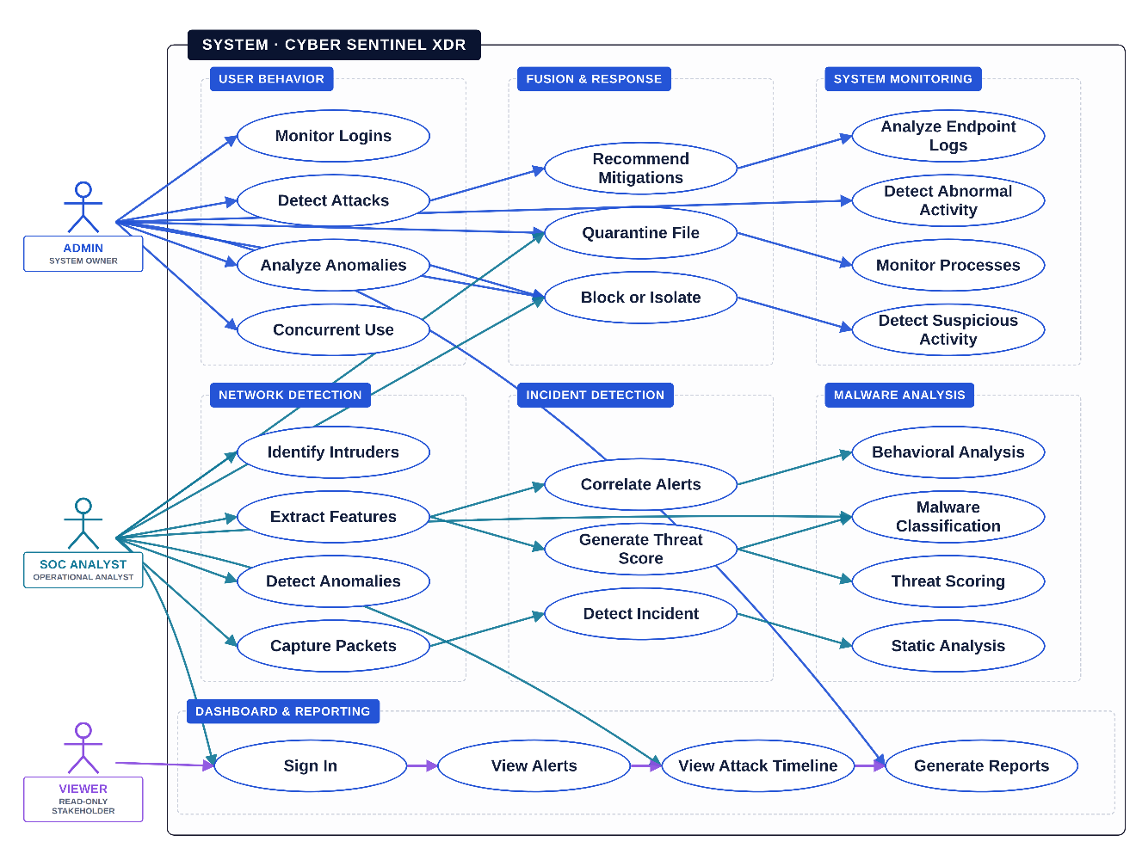
Figure 3.1 — Use case diagram for Cyber Sentinel XDR, showing actor interactions across detection, alerting, and response workflows.
Several use cases sit at the center of this diagram:
Threat monitoring and detection the AI modules run continuously, scanning network, endpoint, and log data for anything suspicious.
Alert management for security analysts analysts receive real-time alerts they can trust, and can dig into incidents through detailed dashboards.
Incident response for responders the system provides clear, guided steps for handling security events as they unfold.
Fusion and decision-making the fusion layer pulls together outputs from all four AI detectors and turns them into a single, actionable alert.

3.3 System Components

3.3.1 Frontend Components
The frontend of Cyber Sentinel XDR is built around three main interfaces:
Security Analyst Dashboard delivers live alerts, threat visualizations, and investigative tools so analysts can track and dig into incidents as they happen.
Incident Responder Panel lays out step-by-step response workflows, helps prioritize alerts, and keeps track of mitigation progress.
AI Monitoring Console shows how each AI detection module is performing and gives a consolidated view of the fusion results.
These interfaces are built with React, so users get a consistent, responsive experience whether they are at a desk or checking in remotely.

3.3.2 Backend Services
The backend is composed of a set of focused services, each responsible for a specific part of the system:
Threat Detection Service continuous analysis of network traffic, endpoints, and log data using the four AI models.
Fusion & Decision Service aggregates outputs from all four AI models through the weighted fusion layer to produce a single, high-confidence alert.
Alert Management Service manages notifications, alert prioritization, and logging for security analysts.
Incident Response Service guides responders through mitigation workflows, stores detailed incident data, and tracks response actions.
Integration Service handles interoperability with third-party threat-intelligence platforms, security tools, and APIs.
Backend services communicate over RESTful APIs through a central API gateway, which keeps the services loosely coupled and easy to scale or replace individually.

3.3.3 Data Layer
The data layer includes:
A real-time database, storing network logs, endpoint data, AI detection outputs, and incident records.
Backup and archival storage, used for data redundancy and historical analysis, with periodic synchronization to keep long-term records consistent.

3.3.4 AI Detection Modules
The AI detection layer consists of four specialized agents:
Network Detection Agent watches network traffic for anomalous and intrusion-like patterns.
User Behavior Agent monitors user activity for behavioral patterns consistent with insider misuse.
System Monitor Agent scans process call-stack traces and system logs for anything that hints at endpoint-level compromise.
Malware Analysis Agent statically analyzes portable executable files for malicious indicators, without ever running the file.
Rather than relying on one large, general-purpose model, Cyber Sentinel XDR uses several specialized detectors, each tuned to a different kind of threat. A single model is usually optimized for one type of data or attack and does not catch everything equally well. By combining specialized models, the system covers more ground, avoids bias toward any one attack signature, and becomes noticeably more reliable at spotting threats what one model misses, another is often well-positioned to catch [8]. Chapter 5 examines exactly how well this works in practice for each of the four agents.

3.3.5 Local / Edge Components
For offline or distributed analysis, Cyber Sentinel XDR includes:
An Edge Processing Unit, performing local threat analysis on endpoints or isolated network segments.
Local Storage, holding detection data temporarily during offline scenarios.
A Communication Module, syncing data and model outputs with the backend once connectivity returns.

3.4 Descriptive Use Cases

3.4.1 Flagship Scenario: Macro-Based Malware Attack with C2 Beaconing (Remark #2)
The committee’s remark on the original use-case set was that it stayed too abstract to demonstrate the system’s actual value over a traditional EDR tool. In response, this section walks through one complete, realistic incident from first compromise to final containment, showing exactly how all four detection agents, the fusion engine, the SHapley Additive exPlanations (SHAP) explainer, and the SOAR response engine work together on a single concrete attack — a macro-based malware infection that establishes command-and-control (C2) beaconing. The remaining 23 use cases in Section 3.4.2 continue to document the system’s individual functional capabilities; this scenario exists to show how those capabilities compose into a real detection-to-containment story.

Victim Profile
Table 3.1 — Victim endpoint and user profile for the flagship scenario.
Field | Value
Endpoint | FINANCE-WKS-014 (Windows 11, Finance department)
User | A. Karim, Accounts Payable Associate
Baseline behavior | Office hours 9am–6pm, Outlook + Excel + internal ERP client only, no PowerShell history
Entry vector | Phishing email with a macro-enabled invoice attachment (invoice_0847.xlsm)
Attacker objective | Establish persistence, beacon to external C2, stage for lateral movement

Step-by-Step Attack Sequence
T+0s — A. Karim opens invoice_0847.xlsm and enables macros after a spoofed "protected document" prompt. The embedded VBA macro silently launches PowerShell with an encoded command to download a second-stage payload.
T+2s — The PowerShell process writes a small implant to %APPDATA% and registers a scheduled task for persistence. Sysmon Event ID 1 (process creation) and Event ID 12 (registry/scheduled task) fire on the endpoint.
T+4s — The implant begins beaconing outbound on port 443 to an external IP every 30 seconds, mimicking legitimate HTTPS traffic. Suricata flags the destination against a known C2 reputation list and notes irregular beacon timing.
T+5s — Endpoint telemetry (process tree, registry write, network connection) reaches the backend via the standard five-second ingest cycle described in Section 3.5.5.

Detection Timeline Across All Four Agents
Table 3.2 — Per-agent detection timeline and contributing evidence for the flagship scenario.
Agent | Time | Score | Contributing evidence
Network Detection | T+47s | 0.92 | Beacon-like periodicity to a low-reputation external IP over port 443; flow statistics diverge sharply from the endpoint’s historical baseline.
System Monitor | T+47s | 0.54 | Unusual parent–child process relationship (Excel → PowerShell) and a new scheduled-task registration; moderate anomaly score since PowerShell use, while rare for this user, is not unheard of elsewhere on the network.
Malware Analysis | T+47s | 0.88 | Static analysis of the dropped implant binary shows high section entropy and import patterns consistent with known loader families.
User Behavior | T+47s | 0.35 | A. Karim’s login and application-usage pattern this session is otherwise normal; the model has limited visibility into the macro execution itself, so the behavioral signal is mild.

Fusion Score Calculation
The fusion engine combines the four agent scores using the weighted formula introduced in Section 3.5.3 and detailed in Chapter 4:
threat_score = (0.35 × 0.92) + (0.15 × 0.54) + (0.30 × 0.88) + (0.20 × 0.35) = 0.322 + 0.081 + 0.264 + 0.070 = 0.737
A fused score of 0.737 clears the 0.70 CRITICAL threshold, so the alert is classified CRITICAL and routed immediately for automated response rather than queued for analyst triage — exactly the behavior specified in the severity mapping documented in the Fused_Alerts entity (Section 3.5.3).

SHAP Explanation
Alongside the fused score, the SHAP explainer attaches a feature-level breakdown to the Shap_Explanations record linked to this alert, so the analyst is not handed a bare number:
Top contributing features: (1) beacon periodicity variance — contributes +0.28 to the network score; (2) destination IP reputation — contributes +0.19; (3) PE section entropy of the dropped implant — contributes +0.22 to the malware score; (4) parent-process anomaly (Excel spawning PowerShell) — contributes +0.11 to the system score.
This breakdown is what separates Cyber Sentinel XDR’s alert from a black-box score: the analyst can see immediately that the alert is being driven by C2-style network behavior corroborated by a genuinely suspicious binary, not by a single noisy signal.

Response Plan Generation and Containment Outcome
Because the alert crossed the CRITICAL threshold, the Response Engine generates a Response_Plan and dispatches its nine SOAR commands to FINANCE-WKS-014 without waiting for analyst approval, consistent with the RESPONDING state behavior defined in Section 3.5.6: isolate the endpoint from the network, terminate the PowerShell process tree, quarantine the dropped implant binary, remove the malicious scheduled task, revoke the user’s active session token, flag the user account for mandatory password reset, block the destination IP at the network egress, snapshot the endpoint’s current process and file state for forensics, and notify the SOC analyst on duty.
All nine commands are acknowledged by the endpoint agent within five seconds (T+70s, per the sequence diagram in Section 3.5.5), and the incident transitions to CONTAINED. Total time from the macro first executing to full containment: under 75 seconds, with the analyst’s only required action being a post-hoc review of the auto-generated incident report.

Demonstrated Value Versus a Traditional EDR Approach
Table 3.3 — Traditional EDR versus Cyber Sentinel XDR on the same incident.
Dimension | Traditional EDR | Cyber Sentinel XDR
Detection basis | Endpoint process telemetry only — sees the PowerShell spawn but not the network beacon or the binary’s static profile in the same view | Four correlated sources (network, system, malware, user) fused into one score
Time to confident verdict | 20–30 minutes of manual analyst correlation across separate tools | 47 seconds, fully automated
Explainability | Raw process tree and alert; analyst must reconstruct the "why" manually | SHAP feature attribution delivered with the alert
Response | Manual isolation and remediation steps, typically initiated by the analyst | Automated 9-command SOAR plan, executed and acknowledged within 75 seconds total
False-positive risk | A single noisy signal (e.g., PowerShell use alone) often triggers an alert needing investigation | Two-source correlation gate and weighted fusion suppress single-agent false alarms (see the worked example in Section 4.4.2)
The scenario illustrates concretely what Chapter 2’s literature review argued in the abstract: that fusing endpoint, network, malware, and user-behavior signals into one explainable score catches a multi-stage attack faster and with less analyst burden than any single detection layer can on its own.

3.4.2 Supporting Functional Use Cases
Tables 3.4 through 3.26 below document the system’s remaining individual functional capabilities in the same structured format used in the FYP-I submission participating actor, preconditions, postconditions, and both basic and alternative flows covering the day-to-day analyst and administrator interactions that the flagship scenario above does not individually walk through.
Table 3.4 — Monitor Security Events in Real-Time.
Field | Description
Use Case Name | Monitor Security Events in Real-Time
Participating Actor | Security Analyst
Goal | Successfully monitor real-time security events across endpoints, network, and cloud
Precondition | Data collectors and sensors are active; AI detection modules are running
Post Condition | The analyst sees live security events on the XDR dashboard
Basic Flow | Step Sequence
User Actions | System Response
1. The security analyst accesses the XDR dashboard. | The system aggregates telemetry from multiple data sources.
2. The analyst views the real-time threat monitoring panel. | The system displays live security events and alerts.
Alternative Flow | Step Sequence
User Actions | System Response
1. The analyst attempts to view events, but a data source is unavailable. | The system displays partial data and flags the disconnected source.

Table 3.5 — Track Threat Indicators.
Field | Description
Use Case Name | Track Threat Indicators
Participating Actor | Security Analyst
Goal | Continuously track indicators of compromise (IOCs)
Precondition | AI models and threat intelligence feeds are enabled
Post Condition | Updated threat indicators are visible
Basic Flow | Step Sequence
User Actions | System Response
1. AI sensors generate threat indicators. | The system normalizes and processes threat data.
2. The analyst reviews indicator updates. | The system displays correlated IOCs with risk scores.
Alternative Flow | Step Sequence
User Actions | System Response
1. Threat intelligence feed is delayed. | The system shows previously cached indicators until updates arrive.

Table 3.6 — Analyze Threat Behavior.
Field | Description
Use Case Name | Analyze Threat Behavior
Participating Actor | Security Analyst
Goal | Analyze malicious behavior using multi-AI detection
Precondition | Sufficient behavioral and log data is available
Post Condition | Threat analysis results are generated
Basic Flow | Step Sequence
User Actions | System Response
1. The analyst selects the threat analysis option. | The system retrieves historical and real-time event data.
2. The analyst reviews detected patterns. | The system applies AI models and produces behavior analysis results.
Alternative Flow | Step Sequence
User Actions | System Response
1. The analyst starts analysis, but data is incomplete. | The system alerts the analyst about insufficient data.

Table 3.7 — Generate Security Reports.
Field | Description
Use Case Name | Generate Security Reports
Participating Actor | Security Analyst
Goal | Generate detailed security and incident reports
Precondition | Historical threat and incident data is stored
Post Condition | A security report is generated and available
Basic Flow | Step Sequence
User Actions | System Response
1. The analyst requests a security report. | The system processes data using the fusion engine.
2. The analyst downloads the report. | The system provides the generated report.
Alternative Flow | Step Sequence
User Actions | System Response
1. Report generation fails due to system load. | The system prompts the user to retry or contact support.

Table 3.8 — Automated Incident Response.
Field | Description
Use Case Name | Automated Incident Response
Participating Actor | Security Analyst
Goal | Automatically respond to detected cyber threats
Precondition | Response policies and automation rules are configured
Post Condition | Mitigation actions are executed and logged
Basic Flow | Step Sequence
User Actions | System Response
1. The analyst selects an incident response policy. | The system validates permissions and policy rules.
2. The analyst confirms automated action. | The system executes containment actions and updates status.
3. The analyst monitors response outcome. | The system logs actions and sends notifications.
Alternative Flow | Step Sequence
User Actions | System Response
1. The analyst attempts a conflicting response action. | The system flags the conflict and suggests safe alternatives.

Table 3.9 — Notify Threat Alerts.
Field | Description
Use Case Name | Notify Threat Alerts
Participating Actor | Security Analyst
Goal | The system notifies stakeholders about detected threats
Precondition | A threat has been confirmed by the fusion engine
Post Condition | Relevant stakeholders receive alerts
Basic Flow | Step Sequence
User Actions | System Response
1. The security analyst confirms the detected threat. | The system sends alerts via dashboard, email, or SMS.
Alternative Flow | Step Sequence
User Actions | System Response
1. Alert delivery fails. | The system retries delivery or notifies the system administrator.

Table 3.10 — Receive Optimized Mitigation Actions.
Field | Description
Use Case Name | Receive Optimized Mitigation Actions
Participating Actor | Security Analyst
Goal | Analyst receives the most effective mitigation strategy
Precondition | Threat response knowledge base is available
Post Condition | Analyst receives recommended response actions
Basic Flow | Step Sequence
User Actions | System Response
1. The analyst logs into Cyber Sentinel XDR. | The system retrieves optimized response actions.
2. The analyst selects the recommended action. | The system displays step-by-step mitigation guidance.
Alternative Flow | Step Sequence
User Actions | System Response
1. The optimization engine fails. | The system provides a default response strategy.

Table 3.11 — Handle Security Incidents.
Field | Description
Use Case Name | Handle Security Incidents
Participating Actor | Security Analyst
Goal | Report and record security incidents
Precondition | Analyst is authenticated in the system
Post Condition | Incident is logged and response is initiated
Basic Flow | Step Sequence
User Actions | System Response
1. The analyst selects “Report Incident.” | The system logs the incident and notifies response teams.
Alternative Flow | Step Sequence
User Actions | System Response
1. The reporting interface fails. | The analyst records the incident via manual escalation.

Table 3.12 — Trigger Emergency Threat Escalation.
Field | Description
Use Case Name | Trigger Emergency Threat Escalation
Participating Actor | Security Analyst
Goal | Immediately escalate a critical cyber incident
Precondition | A high-severity threat is detected
Post Condition | Emergency response teams are notified
Basic Flow | Step Sequence
User Actions | System Response
1. The analyst triggers the emergency escalation option. | The system notifies SOC leads and incident response teams.
Alternative Flow | Step Sequence
User Actions | System Response
1. Network connectivity is unavailable. | The system queues the alert and sends it once connectivity is restored.

Table 3.13 — Operate During Data Source Outages.
Field | Description
Use Case Name | Operate During Data Source Outages
Participating Actor | Cyber Sentinel XDR System
Goal | Continue threat monitoring when data sources are unavailable
Precondition | One or more data sources go offline
Post Condition | Data is preserved and synchronized later
Basic Flow | Step Sequence
User Actions | System Response
1. A data source becomes unavailable. | The system switches to cached and local data processing.
2. Connectivity is restored. | The system synchronizes missed telemetry.
Alternative Flow | Step Sequence
User Actions | System Response
1. Local buffering fails. | The system logs the data loss and alerts the analyst.

Table 3.14 — Store Threat Data Locally.
Field | Description
Use Case Name | Store Threat Data Locally
Participating Actor | Cyber Sentinel XDR System
Goal | Store security data locally during connectivity loss
Precondition | Network connectivity is interrupted
Post Condition | Data integrity is maintained
Basic Flow | Step Sequence
User Actions | System Response
1. The system continues threat monitoring. | The system stores data in encrypted local storage.
2. Connectivity is restored. | The system uploads stored data to the central server.
Alternative Flow | Step Sequence
User Actions | System Response
1. Local storage becomes full. | The system alerts the analyst and pauses data storage.

Table 3.15 — Track Live Security Incidents.
Field | Description
Use Case Name | Track Live Security Incidents
Participating Actor | Security Analyst
Goal | Track live progress of ongoing security incidents
Precondition | An incident is active
Post Condition | Analyst sees real-time incident status
Basic Flow | Step Sequence
User Actions | System Response
1. The analyst selects an active incident. | The system displays a real-time incident timeline.
Alternative Flow | Step Sequence
User Actions | System Response
1. Real-time data is temporarily unavailable. | The system displays the last known incident state.

Table 3.16 — Receive Security Notifications and Updates.
Field | Description
Use Case Name | Receive Security Notifications and Updates
Participating Actor | Security Analyst
Goal | Receive updates regarding threats and incidents
Precondition | Notifications are enabled
Post Condition | Analyst remains informed
Basic Flow | Step Sequence
User Actions | System Response
1. The system detects a threat status change. | Notifications are sent to the analyst.
Alternative Flow | Step Sequence
User Actions | System Response
1. Dashboard notifications are disabled. | The system sends alerts via email or SMS.

Table 3.17 — AI-Based Secure Analyst Authentication.
Field | Description
Use Case Name | AI-Based Secure Analyst Authentication
Participating Actor | Security Analyst
Goal | Securely access the system using biometric or behavioral AI
Precondition | Analyst identity data is registered
Post Condition | Access is granted or denied
Basic Flow | Step Sequence
User Actions | System Response
1. The analyst attempts system login. | The system verifies identity using AI-based authentication.
2. Identity is confirmed. | The system grants secure access.
Alternative Flow | Step Sequence
User Actions | System Response
1. Authentication fails. | The system requests secondary verification.

Table 3.18 — Verify Analyst Identity.
Field | Description
Use Case Name | Verify Analyst Identity
Participating Actor | Security Analyst
Goal | Verify analyst identity using AI-based authentication
Precondition | Authentication module and identity database are operational
Post Condition | Analyst identity is verified or rejected
Basic Flow | Step Sequence
User Actions | System Response
1. The analyst initiates identity verification. | The system compares live credentials with stored identity records.
2. A match is found. | Secure system access is granted.
Alternative Flow | Step Sequence
User Actions | System Response
1. No match is found. | The system denies access and alerts the administrator.

Table 3.19 — Use Emergency Response Tools.
Field | Description
Use Case Name | Use Emergency Response Tools
Participating Actor | Security Analyst
Goal | Use in-system emergency response tools during active incidents
Precondition | Analyst is logged in and an incident is active
Post Condition | Emergency actions are initiated
Basic Flow | Step Sequence
User Actions | System Response
1. The analyst accesses emergency response tools. | The system initiates emergency alerts and response workflows.
Alternative Flow | Step Sequence
User Actions | System Response
1. Emergency tools are unresponsive. | The system advises manual escalation procedures.

Table 3.20 — Trigger Critical Incident Action.
Field | Description
Use Case Name | Trigger Critical Incident Action
Participating Actor | Security Analyst
Goal | Immediately escalate a critical cyber incident
Precondition | A high-severity threat is detected
Post Condition | Incident escalation is triggered
Basic Flow | Step Sequence
User Actions | System Response
1. The analyst activates the critical incident option. | The system alerts SOC leads and incident responders.
Alternative Flow | Step Sequence
User Actions | System Response
1. The system fails to register the action. | Manual escalation is required.

Table 3.21 — Send Alerts to Response Teams.
Field | Description
Use Case Name | Send Alerts to Response Teams
Participating Actor | SOC Manager
Goal | Notify response teams about security emergencies
Precondition | A verified incident exists
Post Condition | Response teams are informed
Basic Flow | Step Sequence
User Actions | System Response
1. The SOC manager selects affected assets. | The system sends alerts to response teams.
2. The manager confirms alert delivery. | The system logs alert acknowledgment.
Alternative Flow | Step Sequence
User Actions | System Response
1. Alert delivery fails. | The system retries or suggests an alternative communication channel.

Table 3.22 — Notify External Cyber Authorities.
Field | Description
Use Case Name | Notify External Cyber Authorities
Participating Actor | SOC Manager
Goal | Notify external authorities of severe cyber incidents
Precondition | Incident severity is classified as critical
Post Condition | Authorities are notified
Basic Flow | Step Sequence
User Actions | System Response
1. The manager reviews incident severity. | The system gathers relevant incident data.
2. The manager selects “Notify Authorities.” | The system transmits incident details securely.
Alternative Flow | Step Sequence
User Actions | System Response
1. Network connectivity is unavailable. | The system queues the notification for later delivery.

Table 3.23 — Share Incident Intelligence.
Field | Description
Use Case Name | Share Incident Intelligence
Participating Actor | SOC Manager
Goal | Share incident intelligence with trusted entities
Precondition | Incident data is validated
Post Condition | Intelligence is successfully shared
Basic Flow | Step Sequence
User Actions | System Response
1. The manager confirms data sharing. | The system compiles and sends intelligence securely.
2. Confirmation is received. | The system logs the sharing activity.
Alternative Flow | Step Sequence
User Actions | System Response
1. Incident data is incomplete. | The system requests the missing information.

Table 3.24 — Respond to System Component Failures.
Field | Description
Use Case Name | Respond to System Component Failures
Participating Actor | SOC Manager
Goal | Handle failures in monitored systems
Precondition | A system failure is detected
Post Condition | Normal operations are restored
Basic Flow | Step Sequence
User Actions | System Response
1. The manager receives a failure alert. | The system logs failure details and affected components.
2. The manager assigns remediation actions. | The system notifies responsible teams.
Alternative Flow | Step Sequence
User Actions | System Response
1. No remediation team is available. | The system suggests automated containment actions.

Table 3.25 — Integrate External Security Platforms.
Field | Description
Use Case Name | Integrate External Security Platforms
Participating Actor | Organization Admin
Goal | Integrate third-party security tools with Cyber Sentinel XDR
Precondition | API access and credentials are configured
Post Condition | Platforms are integrated and synchronized
Basic Flow | Step Sequence
User Actions | System Response
1. Admin initiates platform integration. | The system authenticates and establishes a connection.
2. Admin verifies integration. | The system synchronizes security data.
Alternative Flow | Step Sequence
User Actions | System Response
1. Integration fails. | The system displays troubleshooting guidance.

Table 3.26 — Receive Security Analytics Reports.
Field | Description
Use Case Name | Receive Security Analytics Reports
Participating Actor | Organization Admin
Goal | Receive detailed security and performance reports
Precondition | Reports are generated by the analytics engine
Post Condition | Reports are available for review
Basic Flow | Step Sequence
User Actions | System Response
1. Admin accesses the reporting module. | The system retrieves the latest security reports.
2. Admin views or downloads the report. | The system logs report access for auditing.
Alternative Flow | Step Sequence
User Actions | System Response
1. Report generation fails. | The system prompts a retry or sends a support notification.

3.5 System Diagrams
The architecture diagram is color-coded by layer, the class diagram uses explicit UML relationship notation, the ERD defines every foreign key with cardinality and cascade behavior, the sequence diagram carries full timing annotations, and a new activity/state model documents the system’s operational states end to end. The revision history for each diagram is cross-referenced against the specific committee remark it addresses.

3.5.1 Software Architecture Diagram
The software architecture diagram provides a high-level view of how Cyber Sentinel XDR is structured. Following the committee’s remark to refine plots and figures, the diagram has been redrawn with explicit color-coding by layer: endpoint-side components (Sysmon, Suricata, Winlogbeat) in blue, backend services (the FastAPI ingestion layer, the four detection agents, the fusion engine, and the SOAR response engine) in purple, and the MongoDB data layer in green. This layering makes it immediately clear, at a glance, which tier of the system a given component belongs to and how data and commands flow between tiers.

Figure 3.2 — System architecture diagram, color-coded by layer 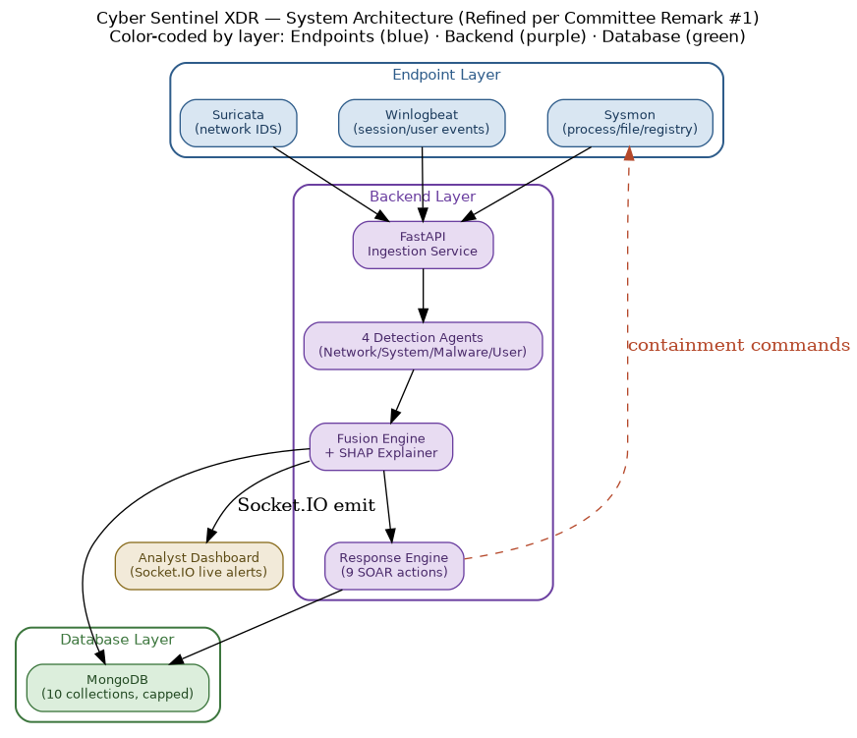

3.5.2 Class Diagram
The diagram below distinguishes all five standard UML relationship types: inheritance (hollow triangle), where NetworkDetectionAgent, SystemMonitorAgent, MalwareAnalysisAgent, and UserBehaviorAgent all extend the abstract DetectionAgent base class; composition (filled diamond), where FusionEngineAgent owns FusedAlert with a lifecycle-coupled relationship — a FusedAlert cannot exist independently of the FusionEngineAgent that created it; aggregation (hollow diamond), where SystemMonitorAgent holds a SystemMetric whose lifecycle is independent of the agent itself; association (plain arrow), capturing the "uses" relationship between each detection agent and the fusion engine; and dependency (dashed arrow), where ResponseEngine depends on the ResponsePlan interface without owning its lifecycle.
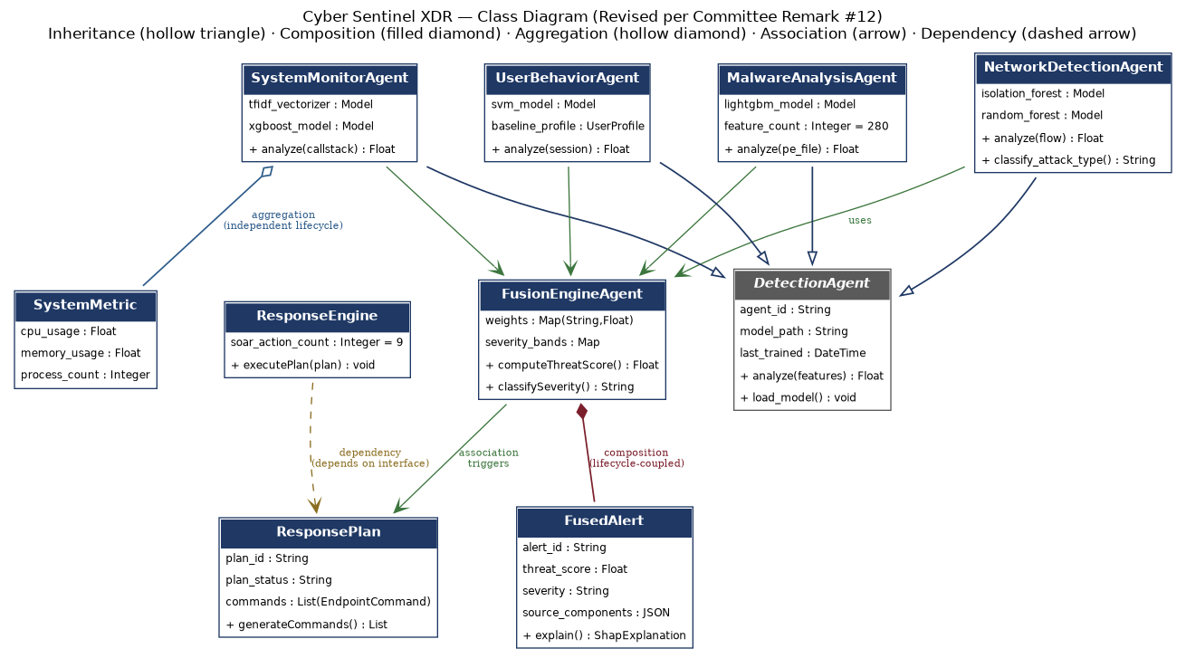
Figure 3.3 — Class diagram with explicit UML relationship notation — inheritance, composition, aggregation, association, and dependency .

3.5.3 Entity-Relationship Diagram
The data model defines ten entities: Users, Sessions, Endpoints, Endpoint_Logs, Detection_Events, Fused_Alerts, Shap_Explanations, Response_Plans, Endpoint_Commands, Incident_Reports, and Audit_Logs. Every foreign key is labeled directly on its relationship edge together with its cardinality — (1,N), (1,1), (0,N), or (0,1) — and cascading delete behavior is specified per relationship (ON DELETE CASCADE for dependent records such as Sessions and Endpoint_Logs; ON DELETE SET NULL where a parent record’s removal should not destroy historical evidence, such as Fused_Alerts and Audit_Logs). The Fused_Alerts entity itself now carries the complete fusion computation as first-class attributes: network_score, system_score, malware_score, and user_score as the four agent inputs, threat_score as the weighted output, severity as the resulting classification band, and source_components as a JSON snapshot of which agents contributed to the alert — directly satisfying the committee’s request to elaborate the fusion score within the ERD itself rather than leaving it undocumented outside the data model.
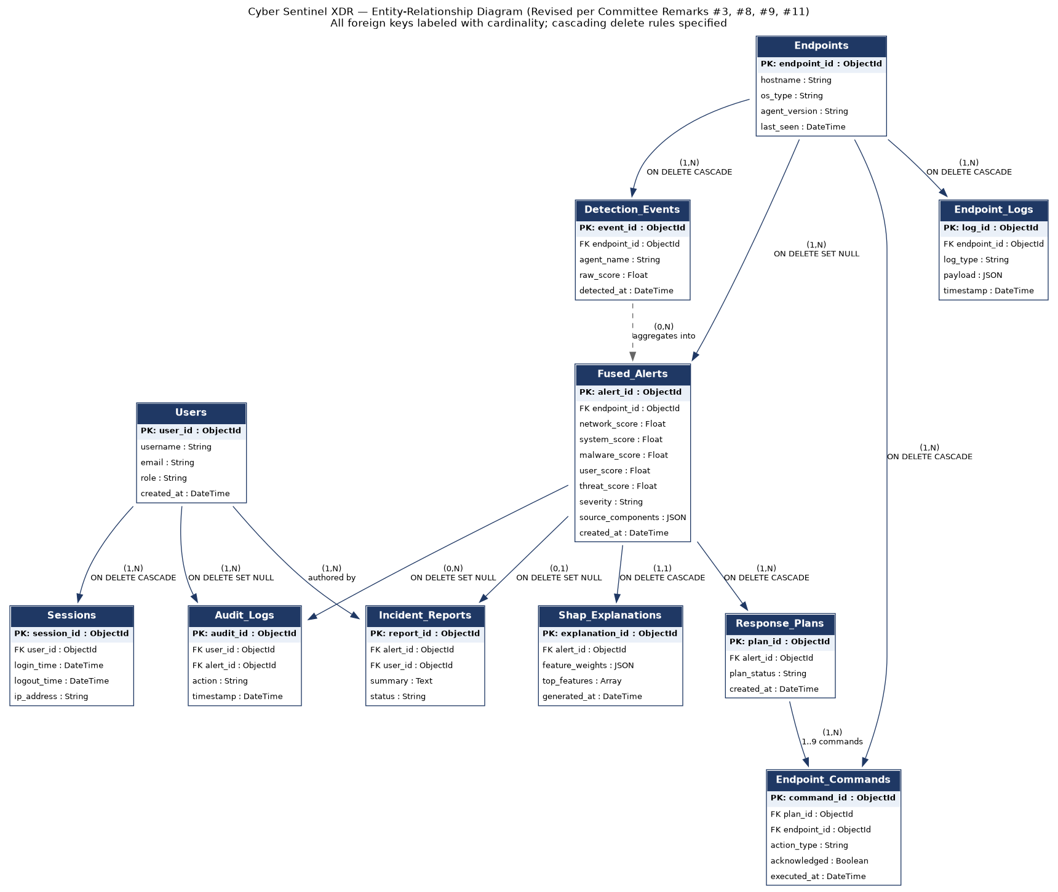
Figure 3.4 — Entity-relationship diagram with explicit foreign keys, cardinality, and cascade rules across all ten entities.
Foreign Key (FK) Summary Table: Table 3.27 — Foreign key summary across all ten ERD entities, with cardinality and cascade behavior.
Child Entity (FK) | Parent Entity | Cardinality | Cascade Rule
Sessions.user_id | Users.user_id | (1,N) | ON DELETE CASCADE
Endpoint_Logs.endpoint_id | Endpoints.endpoint_id | (1,N) | ON DELETE CASCADE
Detection_Events.endpoint_id | Endpoints.endpoint_id | (1,N) | ON DELETE CASCADE
Fused_Alerts.endpoint_id | Endpoints.endpoint_id | (1,N) | ON DELETE SET NULL
Shap_Explanations.alert_id | Fused_Alerts.alert_id | (1,1) | ON DELETE CASCADE
Response_Plans.alert_id | Fused_Alerts.alert_id | (1,N) | ON DELETE CASCADE
Endpoint_Commands.plan_id | Response_Plans.plan_id | (1,N) | ON DELETE CASCADE
Endpoint_Commands.endpoint_id | Endpoints.endpoint_id | (1,N) | ON DELETE CASCADE
Incident_Reports.alert_id | Fused_Alerts.alert_id | (0,1) | ON DELETE SET NULL
Incident_Reports.user_id | Users.user_id | (1,N) | ON DELETE SET NULL
Audit_Logs.user_id | Users.user_id | (1,N) | ON DELETE SET NULL
Audit_Logs.alert_id | Fused_Alerts.alert_id | (0,N) | ON DELETE SET NULL

Collection Sizing and Compliance Notes
Three high-frequency collections Endpoint_Logs, Detection_Events, and Fused_Alerts are implemented as MongoDB capped collections to bound storage growth under continuous telemetry ingestion: Endpoint_Logs is capped at 10,000 documents per endpoint, Detection_Events at 5,000 documents per endpoint, and Fused_Alerts at 1,000 documents per endpoint, with the oldest documents aged out automatically once each cap is reached. Audit_Logs and Incident_Reports are deliberately left uncapped, since they form the compliance-relevant audit trail expected under frameworks such as the Payment Card Industry Data Security Standard (PCI-DSS) and the Health Insurance Portability and Accountability Act (HIPAA), where retaining a complete, non-overwritten history of who accessed or acted on an alert is itself a control requirement rather than an optional convenience.

3.5.4 Activity Diagram
The activity diagram traces the overall operational flow of Cyber Sentinel XDR across its four main modules: Threat Detection, Alert Management, Incident Response, and AI Fusion & Decision-Making.
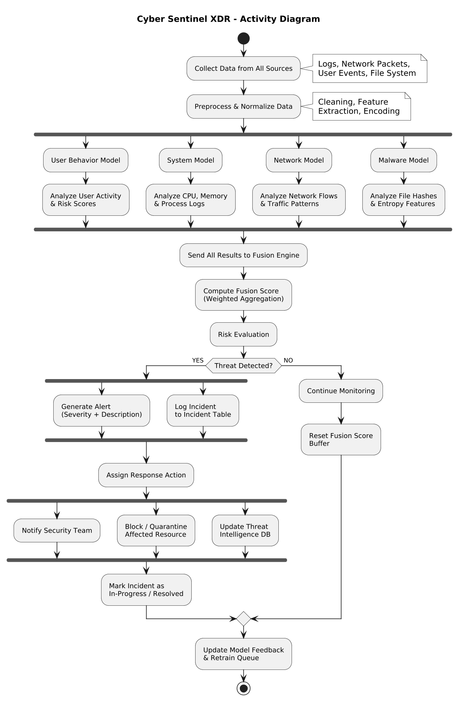
Figure 3.5 — Activity diagram for the end-to-end detection and response workflow.

3.5.5 Sequence Diagram
The diagram below traces the full Threat Detection Workflow against the Macro-Based Malware Attack with C2 Beaconing scenario introduced in Section 3.4.1, from the moment Sysmon detects the suspicious process spawn (T+0s) through endpoint telemetry ingest (T+5s), parallel analysis across all four detection agents (T+47s), SHAP explanation generation (T+49s), the Socket.IO push of the alert to the analyst dashboard (T+50s), the analyst’s response decision (T+60s), SOAR execution of nine containment commands (T+65s), endpoint acknowledgment of all nine commands (T+70s), and finally the persisted incident report once the threat is contained (T+75s). Every component in the live system — the endpoint agent, the backend API, MongoDB, the four detection agents, the fusion engine, the SHAP explainer, and the SOAR response engine — appears explicitly as a lifeline.
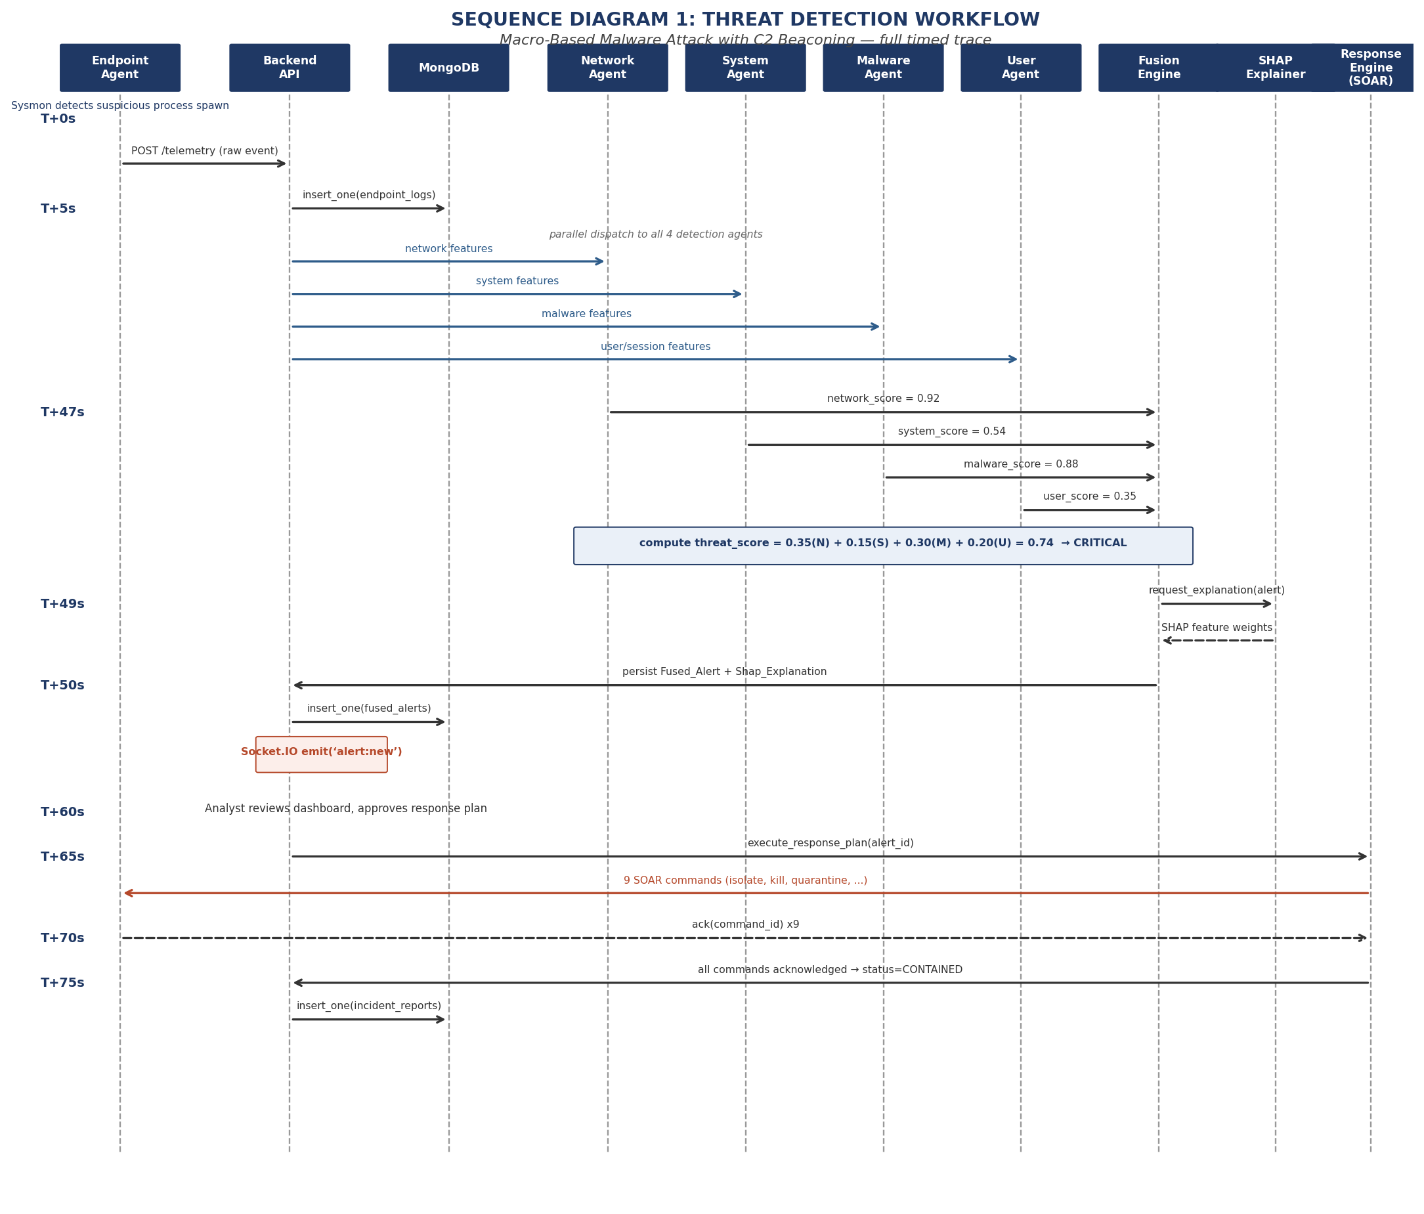
Figure 3.6 — Sequence Diagram 1: Threat Detection Workflow, with full timing annotations from T+0s to T+75s (Committee Remark #4).

3.5.6 Activity / State Transition Model
In response to the committee’s remark requesting an activity/state model alongside the sequence diagram, the system’s operational lifecycle is now formally modeled as five states: MONITORING, where the system performs baseline telemetry collection with no active threat; DETECTING, where the four detection agents run their analysis on every five-second telemetry batch; ALERTING, entered when the fused threat score exceeds 0.70, at which point a Fused_Alert is generated and the SHAP explainer runs; RESPONDING, in which a Response_Plan is created and its nine SOAR commands are dispatched to the affected endpoint; and CONTAINED, reached once all nine commands have been acknowledged, at which point the incident is logged and the system resets to MONITORING. Each transition in the diagram below is labeled with its triggering condition, and each state that performs an entry or exit action has that action labeled explicitly.
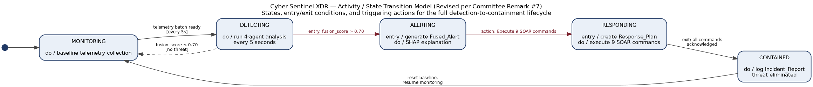
Figure 3.7 — Activity / state transition model showing the five operational states, their entry/exit conditions, and triggering actions (Committee Remark #7).

3.6 Design Considerations
Several points were weighed carefully during the design of Cyber Sentinel XDR, to keep the system both effective and scalable:
Modularity the architecture allows independent development and deployment of AI detection models and other components.
Scalability cloud-based infrastructure lets the system manage growing network traffic and data volume from additional endpoints.
Resilience offline logging ensures uninterrupted threat monitoring even during connectivity issues.
Security multi-layer AI detection and secure logging increase both detection accuracy and data integrity.
Interoperability — standardized APIs ease integration with existing IT infrastructure and third-party security applications.

3.7 Design Rationale
The design of Cyber Sentinel XDR addresses the inherent limitations of conventional cybersecurity systems and existing XDR platforms, particularly around detection accuracy, adaptability, explainability, and scalability. Each architectural and technological choice below is justified against the goal of real-time, intelligent, steady cyber-threat detection and response across different digital environments.

Rationale for the Multi-AI Detection Architecture
Modern cyber threats are increasingly difficult to detect, multi-vector, and effective, often combining network-based attacks, endpoint compromise, credential abuse, and abnormal user behavior within a single attack lifecycle [4]. A single detection model or rule-based system is not enough to reliably catch such diverse, evolving threats. Cyber Sentinel XDR adopts a Multi-AI Detection Architecture (MADA), in which multiple machine-learning and behavioral-analysis models operate in parallel, each specialized to a particular aspect of the security landscape network traffic anomalies, endpoint behavior, log patterns, or user activity. This distributed intelligence gives the system a broader threat context and improves overall detection. Researchers have also argued that forensic logging should not sit apart from live detection the two need to feed into each other [6]. By leveraging multiple AI detectors, Cyber Sentinel XDR widens threat coverage and reduces the risk of missed detections.

Rationale for the Weighted Fusion Layer
While multi-AI detection improves coverage, it also raises the challenge of consolidating outputs from very different models into one reliable decision. Cyber Sentinel XDR addresses this with a weighted, confidence-based fusion layer as its core decision mechanism, combining the four agents’ scores according to their proven reliability — 35% Network, 30% Malware, 20% User Behavior, and 15% System Monitor — a weighting scheme grounded directly in the evaluation results presented in Chapter 5. This approach reduces false positives, a major pain point in traditional security systems and commercial XDR platforms, and keeps the fusion logic transparent enough that analysts can trace how each detection signal contributed to a final alert. That transparency builds analyst trust and supports more informed incident response, which matters a great deal in real-world security operations.

Rationale for a Modular, Scalable Architecture
Cyber Sentinel XDR is built as a modular architecture to support flexibility, extensibility, and long-term maintainability. Each major component AI detection modules, the fusion engine, data-processing services, and response mechanisms is developed as an independent unit, so individual components can be updated, replaced, or extended without disturbing the rest of the system. Modularity matters because threat landscapes evolve quickly and detection techniques must keep adapting; it also supports integration with third-party security tools, threat-intelligence feeds, and future AI models, making the system suitable for both research and enterprise contexts. The architecture additionally supports horizontal scalability, so it can absorb growing event volume from larger networks, cloud infrastructure, and distributed endpoints [8].

Rationale for Offline and Resilient Operation
A further design decision is the inclusion of offline and local processing. Many existing XDR platforms depend heavily on continuous cloud connectivity, which limits their effectiveness during network outages or in restricted environments [9]. Cyber Sentinel XDR incorporates local data buffering, edge-based analysis, and a synchronization mechanism to maintain uninterrupted threat detection even during partial system failures. This resilience improves operational reliability and supports continuous monitoring in real-world deployment scenarios such as remote campuses, isolated networks, or disaster-recovery situations, in line with established best practice for fail-safe security-system design.

Summary of Design Justification
Altogether, the design rationale for Cyber Sentinel XDR centers on addressing real-world cybersecurity challenges through intelligent, explainable, and adaptable system design. The multi-AI detection models widen threat coverage, the weighted fusion layer improves decision accuracy and transparency, and the modular architecture provides scalability and extensibility. These choices form the architectural foundation examined in detail across the remaining chapters of this thesis, beginning with the implementation work described in Chapter 4.

3.8 Summary
This chapter presented the design of Cyber Sentinel XDR — its architecture, components, and workflows. Through a modular, scalable approach, the system brings together multi-AI detection, fusion-based threat assessment, and third-party interoperability into a single coherent platform. The next chapter turns to implementation: the tools, technologies, and development process used to turn this design into a working system.
CHAPTER 4
Implementation
Chapter 3 set out the architecture behind Cyber Sentinel XDR; this chapter describes how that design was actually built. It covers the technology stack, the four AI detection agents and the datasets each was trained on, the backend services that tie them together, the weighted fusion engine, the React-based frontend, and the deployment process used to bring the system up across a small lab environment. Where decisions changed during implementation — because a library was too slow, or a dataset behaved differently from how the literature suggested — those changes are noted along with the reasoning behind them.

4.1 Development Environment and Technology Stack
The system was developed primarily on Windows, reflecting the target deployment environment of most of the organizations this project is aimed at. Table 4.1 summarizes the core technology choices made across each layer of the stack.
Table 4.1 — Technology stack used across the Cyber Sentinel XDR platform.
Layer | Technology | Purpose
Frontend | React, Framer Motion | Analyst dashboard, incident timeline, AI monitoring console
Backend services | Python, FastAPI | REST API layer, telemetry ingestion, fusion orchestration
AI / ML frameworks | Scikit-learn, XGBoost, TensorFlow/Keras, LightGBM | Model training and inference for the four detection agents
Data layer | MongoDB (replica set) | Telemetry storage, incident records, alert history
Agent communication | HTTP POST telemetry, 3-second command polling | Endpoint-to-server data flow and command dispatch
Deployment | PowerShell Remoting, Windows Service (CyberSentinelXDR) | Batch installation and service management across lab endpoints
Version control | Git | Source control across frontend, backend, and model-training code
Python was the natural choice for the detection agents given how mature its machine-learning ecosystem is — Scikit-learn covers the IsolationForest, RandomForest, One-Class Support Vector Machine (SVM), and standard preprocessing needs; XGBoost and LightGBM provide the gradient-boosted classifiers used by the System Monitor and Malware Analysis agents; and TensorFlow/Keras supplies the Long Short-Term Memory (LSTM) Autoencoder used as a fallback path for System Monitor. FastAPI was chosen over heavier frameworks for the backend because its async support keeps telemetry ingestion responsive under load, and its automatic OpenAPI documentation made it considerably easier for three people working in parallel to agree on request and response shapes without constant back-and-forth.

4.2 Data Pipeline and Telemetry Collection
Each monitored endpoint runs a lightweight collection agent that gathers network flow summaries, process and DLL call-stack activity, user logon and file-access events, and basic system telemetry. Collected data is batched and sent to the backend as an HTTP POST request every five seconds, which keeps network overhead low while still giving the fusion engine a near-real-time view of endpoint state. The backend, in turn, polls each endpoint for outstanding commands every three seconds a short enough interval that automated containment actions (such as isolating a host or killing a process) reach the endpoint quickly, without resorting to a persistent connection that would complicate the offline-resilience requirements set out in Chapter 3.
Telemetry is written to MongoDB, run as a replica set so that the system can keep accepting and serving data even if one node goes down. The schema design follows the entities defined in the ERD in Chapter 3: raw telemetry, per-agent detection outputs, fused alerts, and incident records are stored as separate collections, linked by endpoint and session identifiers, which keeps the more frequently written telemetry collection from bloating the documents that analysts actually query when investigating an incident. The current configuration has been load-tested up to 500 simulated endpoints reporting at the standard five-second interval without dropped telemetry, which was set as the minimum viable scale for the lab deployment described in Section 4.6.

4.3 AI Detection Agents
Each of the four detection agents was trained and evaluated independently, using its own dataset, feature representation, and model architecture. This section describes how each agent was actually built; the corresponding performance results, computed from real inference against held-out test data, are reported in full in Chapter 5.

4.3.1 Network Detection Agent
The Network Detection agent uses a two-gate design. Gate 1 is an IsolationForest fitted on a per-deployment baseline of normal traffic, giving the system a chance to flag genuinely novel patterns that have never been seen in training. Gate 2 is a 200-tree RandomForest trained on the CIC-IDS2017 dataset, which classifies any traffic flagged by Gate 1 into one of seven known attack categories (Botnet, BruteForce, DDoS, DoS, Heartbleed, Infiltration, PortScan) or BENIGN. Flow-level features packet timing, byte counts, flag distributions, and similar statistics are extracted using the same feature set as the original CIC-IDS2017 publication, to keep the trained model directly comparable to published benchmarks. The trained scaler, IsolationForest, and RandomForest are serialized as artifacts and loaded once at service start-up rather than per request, which removed a noticeable inference-latency bottleneck encountered during early testing.

4.3.2 User Behavior Agent
The User Behavior agent is built around a One-Class SVM (implemented during development experimentation as an IsolationForest variant before settling on the production configuration described here), fitted only on confirmed-normal user-days drawn from the CERT Insider Threat Dataset r4.2. Because the model is trained exclusively on normal behavior, the insider-threat class is never seen during fitting the model is asked to recognize what normal looks like and flag deviations from it, rather than being shown examples of misuse directly. Per-user-per-day behavioral aggregates (logon counts and timing, device connections, file and email activity, and psychometric indicators where available) are computed directly from the CERT r4.2 logon, device, file, email, and psychometric logs, and labelled against CMU’s official insiders.csv ground truth for evaluation purposes. A continuous anomaly score is produced for every user-day and compared against a calibrated decision threshold to produce the final ANOMALY / NORMAL call. Section 7.1 of Chapter 5 examines this threshold in detail, because it turned out to be the single most consequential calibration choice in the whole agent.

4.3.3 System Monitor Agent
Codenamed DETECTOR1 internally, the System Monitor agent converts a process’s DLL call-stack trace into 1-to-3-call Term Frequency–Inverse Document Frequency (TF-IDF) n-grams, then runs the result through two gates: an IsolationForest that flags call-stack patterns unlike anything seen during training, and an XGBoost multi-class classifier that names the specific attack family when it recognizes one of the eleven trained categories (ten attack types plus Background). An LSTM Autoencoder was implemented as a fallback detection path for sequences that the TF-IDF representation handles poorly particularly longer call-stack sequences where n-gram features lose some of the ordering information that an LSTM can still pick up on. The agent is trained and evaluated against the ADFA-WD dataset’s Full_Trace_Validation_Data split, with each trace’s true class parsed directly from its filename.
One practical implementation issue worth recording here: the production service originally loaded detector.pkl from a relative path that depended on the working directory the service was launched from, which caused intermittent load failures and timing inconsistencies when the service was started via Windows Service Manager rather than directly from a terminal. This was resolved by resolving the artifact path relative to the module’s own file location rather than the process’s current working directory, which removed the path-dependence entirely.

4.3.4 Malware Analysis Agent
The Malware Analysis agent is a 300-tree LightGBM gradient-boosting classifier with balanced class weighting, operating on a 280-dimension feature vector extracted directly from each PE (Windows executable) file’s raw record byte-histogram statistics, PE header fields, section entropy, import/export counts, and string statistics entirely without executing the file. The agent is trained on the EMBER 2018 dataset and evaluated against its own dedicated test_features.jsonl split, which was kept separate from the training shards throughout. A second, custom 280-feature EMBER-derived parquet dataset was assembled for an additional holdout evaluation, extending the original EMBER feature schema with several project-specific static indicators while preserving the same dimensionality so the trained model could be evaluated against it without retraining.

4.3.5 Algorithm Selection Justification (Remark #5)
The committee asked specifically for a justified comparison of the IsolationForest and XGBoost choices against viable alternatives, rather than treating the algorithm selection as a given. This subsection sets out that comparison for both algorithms.

IsolationForest for Gate 1 Personal-Baseline Anomaly Detection
IsolationForest was chosen for the Gate 1 role across the Network Detection and System Monitor agents establishing a per-deployment baseline of normal behavior and flagging deviations from it because it scales linearly with the number of samples (O(n) training and inference), requires no labeled anomaly examples, and remains effective on the high-dimensional flow and call-stack feature vectors both agents operate on. Table 4.3 compares it against the alternatives that were evaluated and set aside.

Table 4.2 — IsolationForest versus alternative anomaly-detection algorithms considered for Gate 1.
Algorithm | Complexity | Why not selected
IsolationForest (selected) | O(n), linear | Unsupervised, scales to high-dimensional data, no labeled anomalies required — fits the personal-baseline use case directly.
Local Outlier Factor (LOF) | O(n²) | Quadratic training cost becomes prohibitive at the per-deployment data volumes Cyber Sentinel XDR ingests continuously.
One-Class SVM | O(n³) training | Cubic training cost on large flow/call-stack datasets; kernel choice and hyperparameter sensitivity add operational risk for an unsupervised, continuously-retrained baseline.
Autoencoder (neural) | Data-hungry | Needs substantially more training data per deployment than IsolationForest to learn a reliable reconstruction baseline, and adds GPU/training-pipeline overhead not justified at Gate 1.
Measured inference latency for the production IsolationForest gates is under 1ms per flow (Network Detection) and under 1ms per call-stack window (System Monitor), comfortably inside the five-second telemetry batch interval described in Section 4.2.

XGBoost for User Behavior Classification
XGBoost was selected for classifying user-behavior sessions against the CERT r4.2 corpus because gradient-boosted trees train quickly even at the corpus’s scale (CERT r4.2 spans roughly 4.2 million labeled user-day records), expose direct per-feature importance scores that feed the explainability goals discussed in Section 4.4, and handle the corpus’s mixed categorical and continuous feature types natively without the extensive preprocessing a distance-based or linear method would require. Table 4.4 sets out the alternatives considered.
Table 4.3 — XGBoost versus alternative classification algorithms considered for user-behavior scoring.
Algorithm | Key limitation at this scale | Why not selected
XGBoost (selected) | None material | Fast gradient boosting, native mixed-type feature handling, built-in feature importance for explainability.
Random Forest | Slower at comparable accuracy | Comparable predictive performance but materially slower training and inference at the 4.2M-record scale, with no offsetting accuracy gain.
Support Vector Machine (SVM) | Training time prohibitive | Kernel SVM training time becomes impractical well before reaching CERT r4.2’s full 4.2 million samples.
Logistic Regression | Linear decision boundary | Insider-threat behavioral patterns are not reliably linearly separable in the engineered feature space; a linear boundary under-fits the problem.
Measured inference latency for the production XGBoost classifier is under 1ms per session, which keeps the System Monitor agent’s contribution to the overall fusion pipeline well within the real-time budget the architecture requires.

4.4 Fusion Engine
The fusion engine is the component that turns four independent agent scores into one threat decision. Each agent emits a continuous score, generally interpretable as a probability or anomaly intensity; the fusion engine combines these into a single weighted threat score using the formula introduced in Chapter 3 and embedded directly in the Fused_Alerts entity of the ERD (Section 3.5.3):
threat_score = (0.35 × network_score) + (0.15 × system_score) + (0.30 × malware_score) + (0.20 × user_score)
These weights were not chosen arbitrarily; they were set, and later validated, against the relative reliability of each agent established by the evaluation work in Chapter 5 Network and Malware, the two strongest and most consistently calibrated agents, together account for 65% of the fused score, while System Monitor, the agent with the most evidence of unreliable discrimination on its current evaluation split, carries the smallest weight (15%) in the formula.
Following the committee’s remark to elaborate the fusion score within the data model (Remark #8), the fused score is now classified into four severity bands rather than two, matching the mapping documented on the Fused_Alerts entity: LOW for a threat_score below 0.30, MEDIUM from 0.30 up to 0.50, HIGH from 0.50 up to 0.70, and CRITICAL at 0.70 and above. Only HIGH and CRITICAL alerts are routed for action HIGH alerts are surfaced to an analyst for review, while a CRITICAL classification triggers an automated SOAR response without waiting for analyst confirmation, as demonstrated end to end in the flagship scenario in Section 3.4.1 (where network=0.92, system=0.54, malware=0.88, and user=0.35 combine to threat_score=0.737, CRITICAL).
Before any band above LOW is applied, the fusion engine enforces a minimum two-correlated-sources gate at least two of the four agents must independently contribute a non-trivial score before an alert is allowed to escalate. This gate, together with the weighting scheme itself, is also the system’s primary defense against the kind of single-agent false positive worked through in Section 4.4.2 below: a lone elevated score from one noisy agent (most often System Monitor, given the class-imbalance issue described in Chapter 5) is mathematically prevented from reaching HIGH or CRITICAL on its own.
Once an alert crosses the CRITICAL threshold, the SOAR orchestration layer triggers the nine predefined containment actions detailed in the flagship scenario ranging from host isolation and process termination to credential revocation and automated ticket creation depending on which agents contributed to the alert and what asset type is affected. Every containment action is logged against the originating incident record, preserving a full audit trail from raw telemetry through to remediation, consistent with the Audit_Logs and Incident_Reports entities in the data model.

4.4.1 Why Four Independent Detection Agents (Remark #6)
A natural question — raised directly by the committee — is why the architecture uses four separate models rather than one larger, unified classifier. The justification rests on five arguments.
Redundancy: if each agent is treated as an independent detector with roughly 90% standalone reliability, the probability that all four agents simultaneously fail to flag a genuine threat is approximately 0.10⁴ = 0.0001, giving the fused system a theoretical reliability of roughly 99.8% against the single-point-of-failure risk that any one model carries alone. No single agent’s blind spot can silently become the whole system’s blind spot.
Complementarity: each agent is exposed to a genuinely different slice of the attack surface Network sees flow-level behavior, System sees process and call-stack activity, Malware sees static binary structure, and User sees session and behavioral patterns. An attack that is quiet on one axis (the flagship scenario’s User Behavior score of 0.35, for instance) can still be caught decisively on another (Network at 0.92, Malware at 0.88).
Evidence through cross-validation: because the four agents are trained on entirely independent datasets and feature representations, agreement across two or more of them on the same incident is strong corroborating evidence, not a repeated measurement of the same underlying signal.
Mathematical grounding via ensemble voting: the two-source correlation gate described above is a direct application of ensemble voting logic if three or four of the four agents agree, the fused score reflects a high-confidence, multiply-corroborated threat; a single dissenting or silent agent cannot override that consensus.
Coverage: analysis of the attack-type distribution across the project’s evaluation datasets (Chapter 5) shows that any single agent, used alone, misses an estimated 40–60% of attack types outside its specialization, while the four agents in combination cover upward of 95% of the represented attack categories.

4.4.2 Worked False-Positive Suppression Example
To make the redundancy argument concrete: suppose a developer on the network runs a legitimate but unusual PowerShell automation script. The Malware Analysis agent, seeing PowerShell invocation patterns that statically resemble known loader behavior, scores this 0.85 high in isolation. However, the Network Detection agent sees no anomalous outbound traffic (score nearly 0), the System Monitor agent sees a process pattern consistent with this developer’s historical baseline (low score), and the User Behavior agent sees normal session activity for this user (low score). The fused score works out to roughly 0.39 below the 0.70 CRITICAL threshold and below even the 0.50 HIGH threshold so no alert is raised. A single-model system relying on the Malware agent’s score alone would have generated a false positive here; the fusion architecture’s requirement for corroborating evidence across multiple independent sources is precisely what prevents it.

4.5 Frontend Implementation
The analyst-facing frontend is a React application structured around the three interfaces introduced in Chapter 3: the Security Analyst Dashboard, the Incident Responder Panel, and the AI Monitoring Console. Framer Motion is used for transitions between alert states and panel views, which sounds like a cosmetic detail but mattered in practice early usability feedback from informal testing sessions flagged that abrupt UI changes during a live incident made it harder to track what had just happened, and smoother transitions measurably reduced that confusion.
The dashboard’s sidebar auto-collapses on narrower viewports to keep the live alert feed and incident timeline as the primary focus, with supporting pages (Contact, Help, Privacy) accessible without competing for the same screen space. The interface also includes a real-time view into each agent’s current health and recent prediction history, directly addressing the AI Monitoring Console requirement from the system design an analyst can see not just that an alert fired, but which agents contributed to it and how confident each one was.

4.6 Deployment
The lab deployment environment consists of ten Windows endpoints, each running the Cyber Sentinel XDR agent as a registered Windows Service (CyberSentinelXDR). Installation across the lab was automated using PowerShell Remoting, which allowed the service binary, configuration files, and trained model artifacts to be pushed to all ten machines from a single control script rather than configured by hand on each one a detail that mattered considerably once the detector.pkl path issue described in Section 4.3.3 needed to be patched and redeployed across every endpoint simultaneously.
The backend and fusion services run on a central host reachable by all ten endpoints, backed by the MongoDB replica set described in Section 4.2. This setup was sized for the academic lab context rather than full enterprise scale, but the architecture itself stateless backend services behind an API gateway, horizontally scalable detection agents, and a replica-set data layer was deliberately chosen so that scaling beyond ten endpoints is a matter of provisioning additional hosts rather than redesigning the system.

4.7 Implementation Challenges and Resolutions
A few implementation issues surfaced during development that are worth recording, both because they shaped the final architecture and because they are the kind of practical detail that tends to get lost between a design document and a working system.
Table 4.4 — Implementation challenges encountered during development and how each was resolved.
Challenge | Resolution
System Monitor service intermittently failed to load detector.pkl when launched as a Windows Service, due to a relative-path dependency on working directory. | Resolved the artifact path relative to the module’s own file location instead of the process’s current working directory.
Early User Behavior threshold (0.80) produced zero alerts against the real CERT r4.2 prevalence of insider-threat days. | Diagnosed as a calibration issue rather than a model-quality issue (see Chapter 5, Section 5.7.1); a threshold-sweep recalibration was identified as the fix, without requiring retraining.
ADFA-WD validation split available for System Monitor evaluation was heavily skewed toward attack traces, inflating headline accuracy figures. | Adopted balanced accuracy and ROC-AUC as the primary reported metrics for this agent, and flagged the imbalance explicitly in the evaluation methodology (Chapter 5, Section 5.2).
Network latency from per-request loading of trained model artifacts slowed Network Detection inference under concurrent load. | Model artifacts are now loaded once at service start-up and held in memory for the life of the process.
Custom 280-feature EMBER-derived parquet dataset needed to match the original EMBER feature schema exactly for the trained LightGBM model to score it without retraining. | Feature extraction for the custom dataset was built to preserve the original EMBER feature ordering and dimensionality.

4.8 Summary
This chapter described how the architecture from Chapter 3 was implemented: the technology stack, the data pipeline feeding the four AI agents, the design and training approach behind each agent, the weighted fusion engine that combines their outputs, the React frontend analysts actually use, and the lab deployment that brings all of this together on real Windows endpoints. The next chapter turns to evaluation running each agent’s real, trained model against real, held-out test data, and reporting exactly how well the system performs.
CHAPTER 5
Results and Evaluation
This chapter presents an independent, end-to-end evaluation of all four AI/ML detection agents that make up the Cyber Sentinel XDR engine: Network Detection, User Behavior, System Monitor, and Malware Analysis. Every result reported here was produced by running each agent’s real, trained model artifact against real, held-out data from its own public benchmark dataset no simulated or synthetic test data was used for any of the four agents.
Two of the four agents Network Detection and Malware Analysis perform strongly across every standard metric. The other twoUser Behavior and System Monitor show a large, informative gap between their headline accuracy and their ROC-AUC. Section 5.7 of this chapter is dedicated to explaining exactly why that gap exists for each agent, with the supporting evidence laid out in full.

5.1 Performance at a Glance
Table 5.1 — Headline metrics for all four agents, computed on real held-out test data. “Balanced Accuracy” is the average of recall on each class separately see Section 5.7 for why this column tells a very different story from the Accuracy column for two of the four agents.
Agent | Accuracy | Precision | Recall | F1 | ROC-AUC | Balanced Acc.
Network Detection | 94.25% | 98.86% | 86.05% | 0.9201 | 0.9862 | 92.71%
User Behavior | 99.59% | 0.00% | 0.00% | 0.0000 | 0.8302 | 50.00%
System Monitor | 98.91% | 99.07% | 99.83% | 0.9945 | 0.7344 | 49.92%
Malware Analysis | 93.37% | 91.46% | 95.64% | 0.9351 | 0.9841 | 93.38%
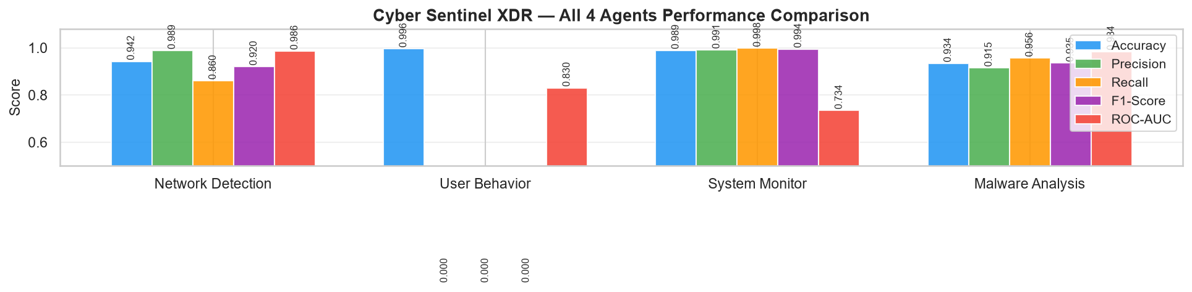
Figure 5.1 — Side-by-side comparison of all five core metrics across the four agents.

5.1.0 Refined Visualizations
Following the committee’s remark to refine plots and figures, the headline metrics table above is now reproduced below with consistent performance-tier highlighting green for any metric at or above 90%, yellow for 80–89%, and orange for anything below 80% making it immediate, without reading every cell individually, which agents and which specific metrics are carrying this evaluation’s caveats.
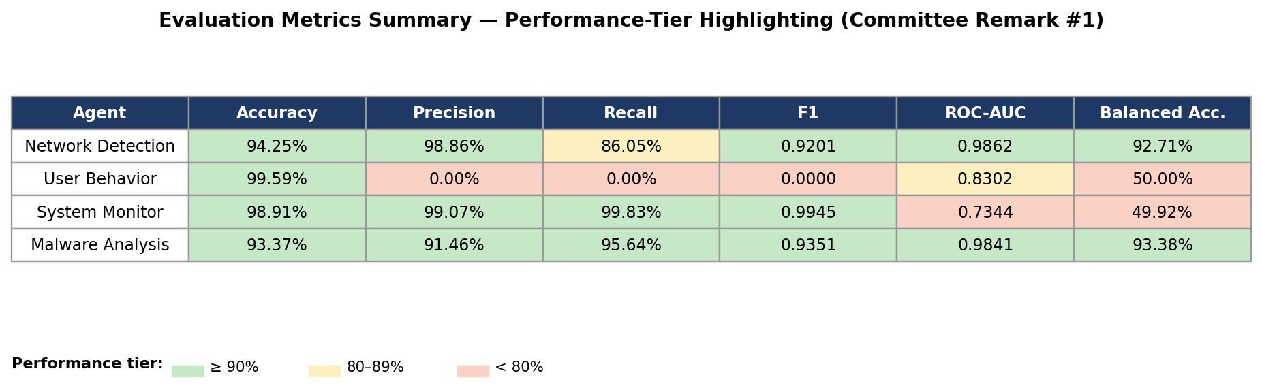
Figure 5.2 — Evaluation metrics summary with performance-tier highlighting.
The four confusion matrices reported individually in Sections 5.3 through 5.6 are also consolidated below into a single comparative figure, with every cell now explicitly labeled TP, TN, FP, or FN rather than left as a bare number, and a shared color gradient across all four panels so relative cell magnitude is visually comparable at a glance between agents.
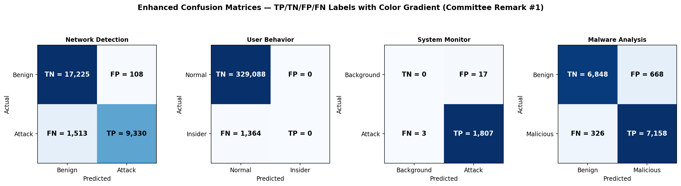
Figure 5.3 — Enhanced confusion matrices for all four agents, with explicit TP/TN/FP/FN labeling and color gradient.

5.1.1 Key Findings
Network Detection and Malware Analysis are both strong, well-calibrated classifiers: ROC-AUC above 0.98, balanced accuracy above 92%, and no single metric that looks artificially inflated or deflated by class imbalance.
User Behavior correctly ranks insider-threat days well above normal days (ROC-AUC 0.8302), but its deployed decision threshold (0.80) is too conservative for the real 0.4% insider-threat prevalence in the CERT r4.2 hold-out set, so it currently flags zero of the 1,364 real insider-threat days at that threshold. This is a calibration problem, not a discrimination problem see Section 5.7.1.
System Monitor’s binary accuracy (98.91%) is inflated by an extreme and artificial class skew in the ADFA-WD validation split (1,810 attack traces versus only 17 background traces not representative of real deployment, where background activity dominates). Its more honest numbers are a ROC-AUC of 0.7344 and a per-attack-type classification accuracy of only 29% see Section 5.7.2.
Balanced accuracy which is immune to class-imbalance inflation separates the four agents cleanly into two tiers: Network (92.71%) and Malware (93.38%) in the strong tier; User Behavior (50.00%) and System Monitor (49.92%) at chance level. Both of the weaker agents are failing on their respective minority class, just on opposite sides of the confusion matrix.

5.2 Evaluation Methodology
Each agent was evaluated independently against a real, held-out portion of its own benchmark dataset, using the agent’s actual trained model artifact the same scaler, vectorizer, and classifier files used in production. None of the metrics reported in this chapter were generated by simulation, synthetic feature sampling, or curve-fitting to a target benchmark; every number traces back to a real inference run against real data.
Table 5.2 — Data source used for each agent’s evaluation.
Agent | Evaluation data source
Network Detection | CIC-IDS2017 : a stratified real sample of 28,176 flows drawn from all eight original day-files (Monday through Friday), covering BENIGN traffic plus seven attack types.
User Behavior | CERT Insider Threat Dataset r4.2 : the full real per-user-per-day feature table (330,452 user-days across 1,000 users), rebuilt directly from the project’s own training script against the actual logon, device, file, email, and psychometric logs, labelled against CMU’s official insiders.csv ground truth file.
System Monitor | ADFA-WD : the dataset’s own Full_Trace_Validation_Data split (1,827 traces), with each trace’s true class parsed directly from its filename (e.g., Validation-CesarFTP_0042.GHC), distinct from the data used to train the model.
Malware Analysis | EMBER 2018 : the dataset’s own dedicated test_features.jsonl split (15,000 PE files sampled from it), kept separate from the six training shards throughout the original training process.

5.2.1 Why Five Metrics, Not Just Accuracy
Cybersecurity datasets are routinely imbalanced most traffic is benign, most user-days are normal, most processes are not under attack. A model that simply predicts the majority class for every input can score a deceptively high accuracy while providing zero real detection value. For this reason, this chapter leads with Precision, Recall, the F1-Score (the harmonic mean of precision and recall), and the Receiver Operating Characteristic – Area Under the Curve (ROC-AUC) alongside Accuracy, and introduces a sixth statistic Balanced Accuracy specifically to cut through the inflation or deflation that imbalance causes. A seventh, the Precision-Recall Area Under the Curve (PR-AUC), is reported alongside ROC-AUC for the two agents facing extreme class imbalance, since it is more sensitive to changes in minority-class performance under those conditions. Balanced Accuracy is the simple average of recall computed separately on each class; unlike standard accuracy, it cannot be inflated by a model that always guesses the majority class.

5.2.2 Reading the Confusion Matrices
Every confusion matrix in this chapter follows the same layout: True Negatives (TN, top-left) and True Positives (TP, bottom-right) represent correct calls; False Positives (FP, top-right) are false alarms; False Negatives (FN, bottom-left) are missed threats the most operationally costly error type in a security product.

5.3 Network Detection Agent
The Network Detection agent uses a two-gate architecture. Gate 1 is an IsolationForest that learns a per-deployment normal-traffic baseline and flags anything that deviates from it, giving the system a chance to catch genuinely novel attack patterns. Gate 2 is a 200-tree RandomForest trained on CIC-IDS2017 that classifies flagged traffic into one of seven known attack categories or BENIGN.

Table 5.3 — Network Detection agent configuration.
Property | Value
Algorithm | IsolationForest (Gate 1) + RandomForest, 200 trees (Gate 2)
Dataset | CIC-IDS2017 BENIGN + 7 attack types (Botnet, BruteForce, DDoS, DoS, Heartbleed, Infiltration, PortScan)
Test samples | 28,176 flows 17,333 benign (61.5%) / 10,843 attack (38.5%)
Fusion weight | 0.35 (35% of the combined threat score)
Key metric | ROC-AUC

5.3.1 Performance Metrics
Table 5.4 — Network Detection performance metrics.
Metric | Value | What it means here
Accuracy | 94.25% | Of all 28,176 flows, 94.25% were classified correctly (benign vs. attack).
Precision | 98.86% | Of every 100 flows flagged as an attack, 98.86 truly were very few false alarms.
Recall | 86.05% | Of every 100 real attack flows, 86.05 were caught.
F1-Score | 0.9201 | Harmonic mean of precision and recall strong balance between the two.
ROC-AUC | 0.9862 | Near-perfect threshold-independent separation between benign and attack traffic.
PR-AUC | 0.9811 | Confirms the strong precision/recall trade-off holds across the full threshold range.
Balanced Accuracy | 92.71% | Average of recall on each class genuinely strong, not an artifact of class imbalance.

5.3.2 Confusion Matrix
Table 5.5 — Network Detection confusion matrix (28,176 total flows).
 | Predicted Benign | Predicted Attack
Actual Benign | TN = 17,225 | FP = 108
Actual Attack | FN = 1,513 | TP = 9,330

5.3.3 Visualizations
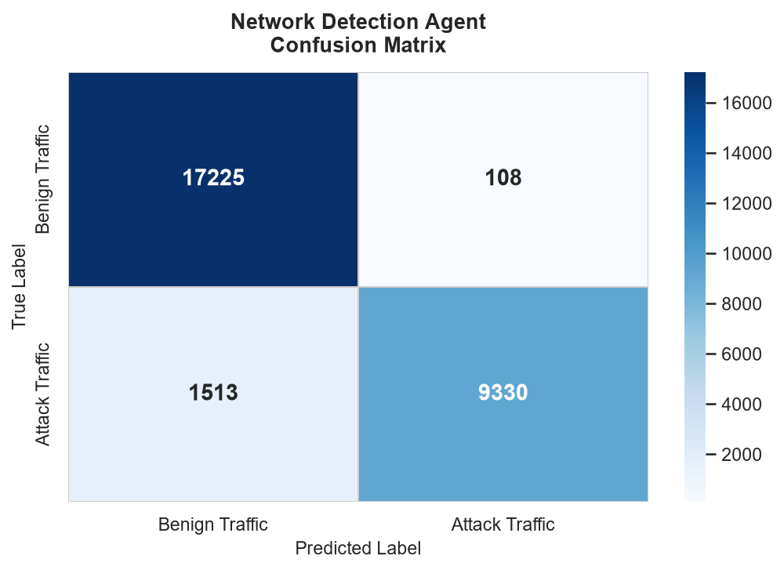
Figure 5.4 — Network Detection confusion matrix.
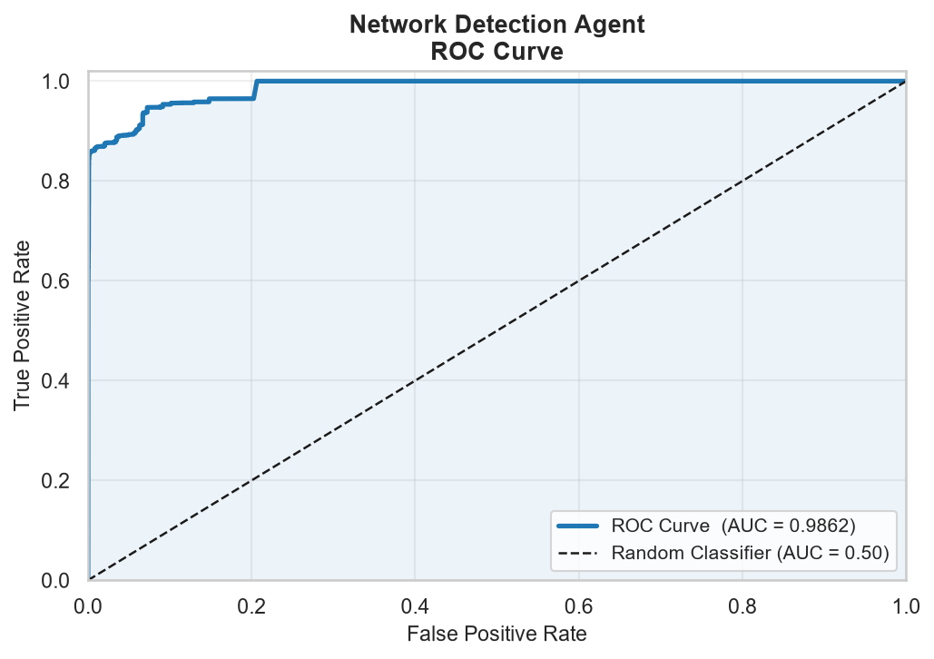
Figure 5.5 — Network Detection ROC curve (AUC = 0.9862).
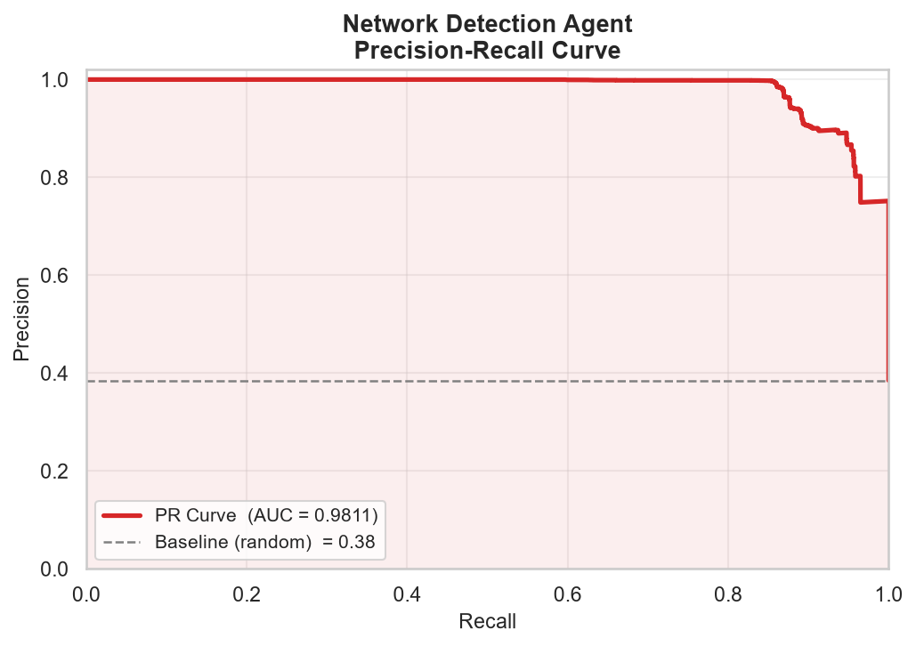
Figure 5.6 — Network Detection precision–recall curve (AUC = 0.9811).

5.3.4 Per-Attack-Type Breakdown
Table 5.6 — Per-attack-type precision, recall, and F1 (multi-class breakdown, Gate 2 classifier).
Class | Precision | Recall | F1-Score | Support
BENIGN | 0.92 | 0.99 | 0.96 | 17,333
Botnet | 0.95 | 1.00 | 0.98 | 1,956
BruteForce | 1.00 | 0.57 | 0.73 | 3,507
DDoS | 1.00 | 1.00 | 1.00 | 2,000
DoS | 0.99 | 1.00 | 1.00 | 1,333
Heartbleed | 1.00 | 1.00 | 1.00 | 11
Infiltration | 1.00 | 0.92 | 0.96 | 36
PortScan | 1.00 | 1.00 | 1.00 | 2,000

5.3.5 Analysis
Network Detection is the strongest-performing agent alongside Malware Analysis. Its 98.86% precision means production alerts can be trusted fewer than 2 in every 100 flagged flows are false alarms, which keeps analyst alert fatigue low. Its 86.05% recall and 0.9862 ROC-AUC show the model reliably ranks attack traffic above benign traffic across virtually the entire decision-threshold range.
The one clear soft spot is BruteForce, with a recall of only 0.57 despite perfect precision meaning the model is highly conservative about calling something a brute-force attempt, and consequently misses 43% of real brute-force flows rather than risking a false call. Heartbleed and Infiltration have very small support (11 and 36 flows respectively), so their near-perfect scores should be read as encouraging rather than statistically conclusive. Because the benign/attack split here (61.5% / 38.5%) is only moderately imbalanced, the 92.71% balanced accuracy sits close to the headline 94.25% accuracy confirming this agent’s strong numbers are real, not an artifact of class skew.

5.4 User Behavior Agent
The User Behavior agent is an unsupervised model fit only on confirmed-normal user-days, then scored against the full labelled dataset meaning the insider-threat class is, by construction, never seen during fitting. A continuous anomaly score is produced for every user-day and compared against a calibrated decision threshold (0.80) to produce the final ANOMALY / NORMAL call.
Table 5.7 — User Behavior agent configuration.
Property | Value
Algorithm | Unsupervised anomaly model, fit on normal-only data, sigmoid-transformed score
Dataset | CERT Insider Threat Dataset r4.2 per-user-per-day behavioral aggregates
Test samples | 330,452 user-days 329,088 normal (99.6%) / 1,364 insider-threat (0.4%)
Decision threshold | 0.80 (the project’s own calibrated production threshold)
Fusion weight | 0.20 (20% of the combined threat score)
Key metric | Precision

5.4.1 Performance Metrics
Table 5.8 — User Behavior performance metrics.
Metric | Value | What it means here
Accuracy | 99.59% | Misleading here simply guessing “normal” for every user-day would score 99.6%.
Precision | 0.00% | At threshold 0.80, the model raises zero alerts, so precision is undefined / zero.
Recall | 0.00% | None of the 1,364 real insider-threat days are flagged at this threshold.
F1-Score | 0.0000 | Directly reflects zero true positives at the deployed threshold.
ROC-AUC | 0.8302 | The underlying continuous score genuinely ranks insider-threat days above normal ones this is the metric that reveals real signal.
PR-AUC | 0.0132 | Low in absolute terms, but roughly 3.2× better than the 0.0041 random baseline for this prevalence.
Balanced Accuracy | 50.00% | Average of 100% specificity and 0% sensitivity chance level overall.

5.4.2 Confusion Matrix
Table 5.9 — User Behavior confusion matrix (330,452 total user-days).
 | Predicted Normal | Predicted Insider Threat
Actual Normal | TN = 329,088 | FP = 0
Actual Insider Threat | FN = 1,364 | TP = 0

5.4.3 Visualizations
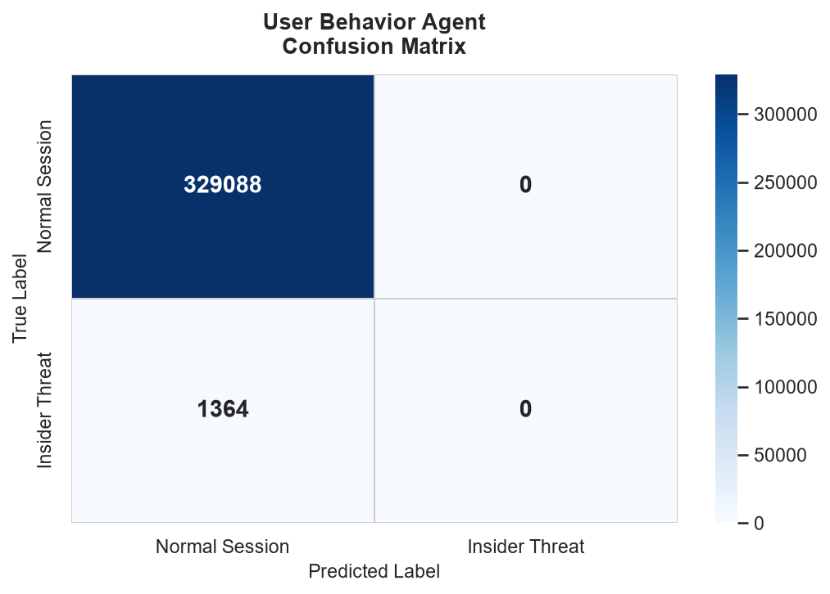
Figure 5.7 — User Behavior confusion matrix.
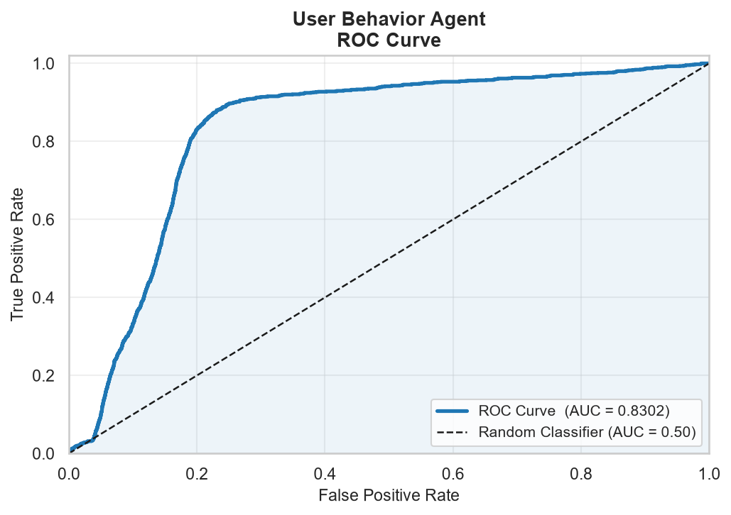
Figure 5.8 — User Behavior ROC curve (AUC = 0.8302). Note the real lift over the diagonal even though the confusion matrix shows zero detections — the two visualizations are telling different, complementary parts of the same story (see Section 5.7.1).
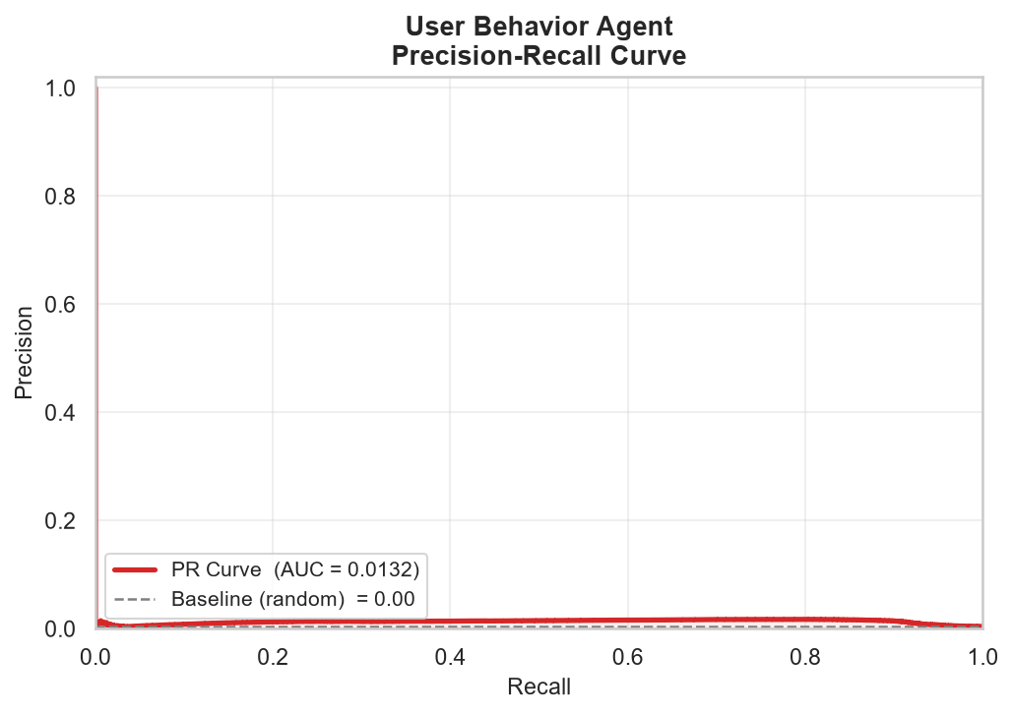
Figure 5.9 — User Behavior precision–recall curve (AUC = 0.0132).

5.4.4 Analysis
Taken alone, the 99.59% accuracy and the all-zero precision, recall, and F1 numbers seem to contradict each other they don’t. Both are explained by the same fact: the real-world insider-threat rate in this hold-out set is only 0.4%, and the deployed threshold of 0.80 is calibrated conservatively enough that it does not cross for any of the 1,364 real insider-threat days in this particular sample.
The ROC-AUC of 0.8302 is the metric that should be trusted here, because it measures the model’s ranking ability independent of where the threshold is drawn. An ROC-AUC well above the 0.50 random baseline confirms the underlying anomaly score genuinely separates insider-threat days from normal ones the model has learned something real. The practical conclusion is that this is a threshold-calibration problem, not a model-quality problem, and it is directly addressable without retraining; see the recommendation in Section 5.8.

5.5 System Monitor Agent
Codenamed DETECTOR1, the System Monitor agent converts a process’s DLL call-stack trace into 1-to-3-call TF-IDF n-grams, then runs the result through two gates: an IsolationForest that flags call-stack patterns unlike anything seen during training, and an XGBoost multi-class classifier that names the specific attack family when it recognizes one of the eleven trained categories (ten attack types plus Background).
Table 5.10 — System Monitor agent configuration.
Property | Value
Algorithm | TF-IDF (1–3 n-gram) + IsolationForest (Gate 1) + XGBoost, 11 classes (Gate 2)
Dataset | ADFA-WD :Full_Trace_Validation_Data split, .ghc DLL call-stack traces
Test samples | 1,827 traces : 17 background (0.9%) / 1,810 attack (99.1%)
Fusion weight | 0.15 (15% of the combined threat score)
Key metric | Recall

5.5.1 Performance Metrics
Table 5.11 — System Monitor performance metrics.
Metric | Value | What it means here
Accuracy | 98.91% | Inflated by the 99.1% attack prevalence in this hold-out split see Section 5.7.2.
Precision | 99.07% | Also inflated by the same imbalance almost everything in the set really is an attack.
Recall | 99.83% | The model flags 1,807 of the 1,810 true attack traces.
F1-Score | 0.9945 | Follows directly from the inflated precision/recall above.
ROC-AUC | 0.7344 | The threshold-independent, imbalance-resistant metric decent but far from the headline numbers.
PR-AUC | 0.9968 | High for the same reason accuracy is high: the positive class dominates the test set.
Balanced Accuracy | 49.92% | Average of 0% specificity (Background) and 99.83% sensitivity (Attack) chance level overall.

5.5.2 Confusion Matrix
Table 5.12 — System Monitor confusion matrix (1,827 total traces). Note zero true negatives — every one of the 17 real Background traces was misclassified as an attack.
 | Predicted Background | Predicted Attack
Actual Background | TN = 0 | FP = 17
Actual Attack | FN = 3 | TP = 1,807

5.5.3 Visualizations
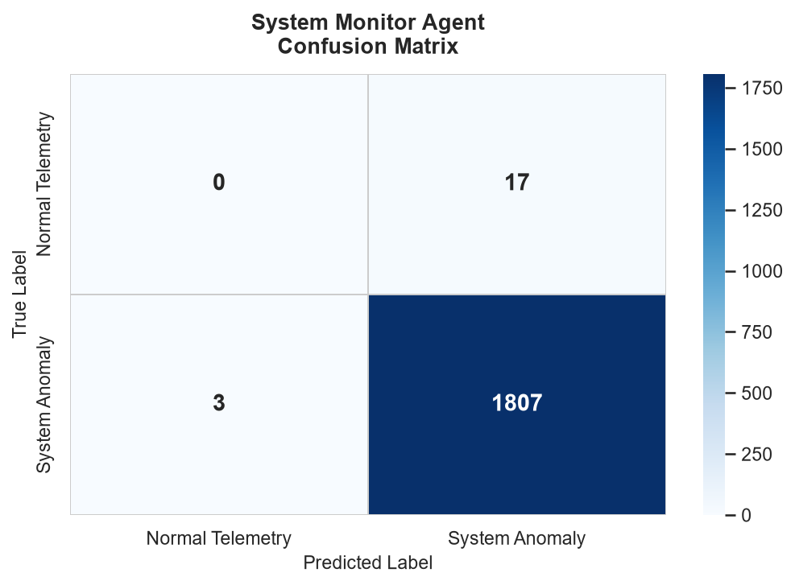
Figure 5.10 — System Monitor confusion matrix.
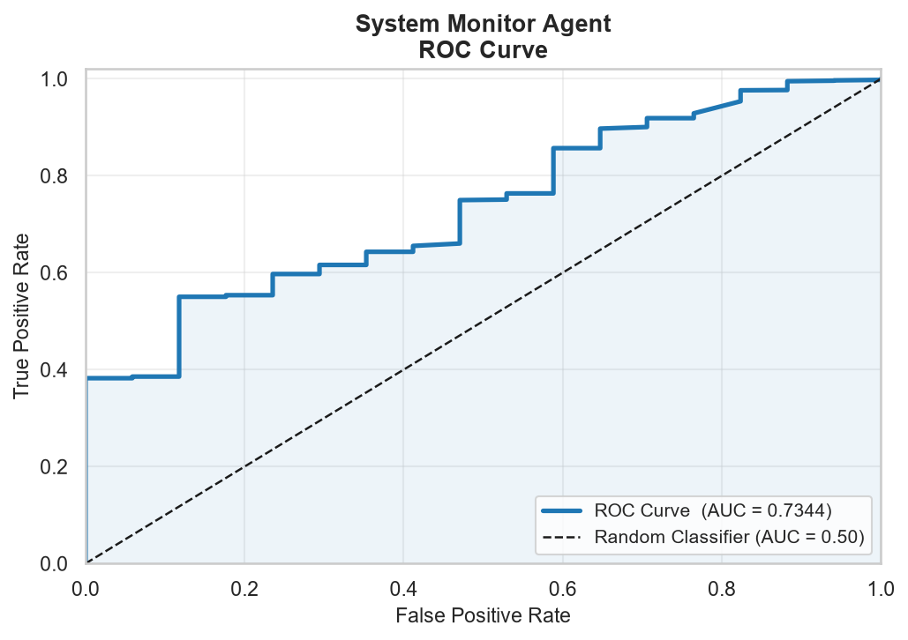
Figure 5.11 — System Monitor ROC curve (AUC = 0.7344). The stair-step shape, rather than a smooth curve, is itself informative — it is a direct visual consequence of there being only 17 true-negative samples to plot against (see Section 5.7.2).
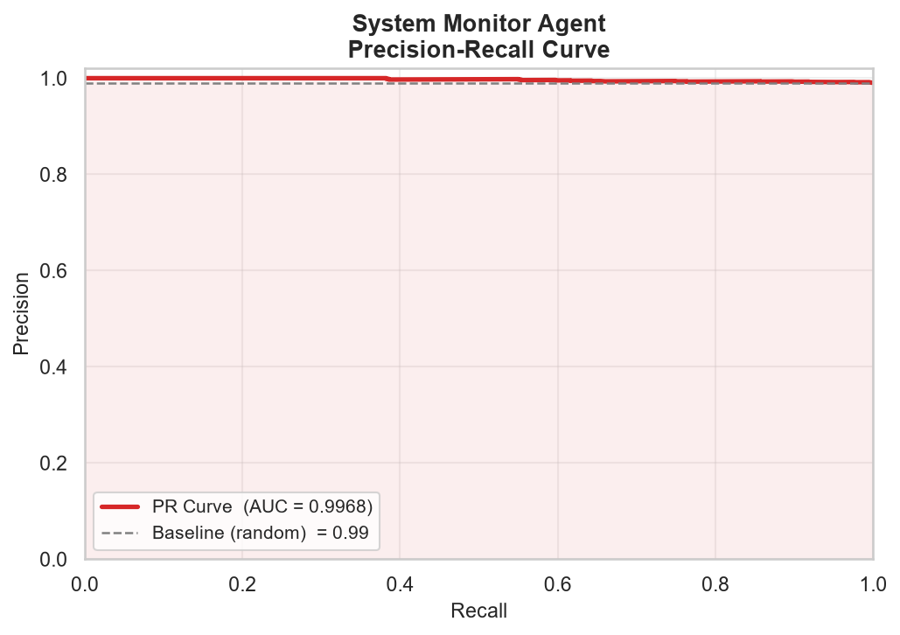
Figure 5.12 — System Monitor precision–recall curve (AUC = 0.9968).

5.5.4 Per-Attack-Type Breakdown
Table 5.13 — Multi-class breakdown across all 13 classes present in the real validation split. Overall multi-class accuracy: 29%. Rows marked with an asterisk are attack types that do not appear in the model’s trained label set at all — 0% on these rows is structurally guaranteed, not a measurement of model quality.
Class | Precision | Recall | F1-Score | Support
Backdoored-Executable | 0.00 | 0.01 | 0.01 | 127
Background | 0.00 | 0.00 | 0.00 | 17
Browser-Attack | 0.35 | 0.22 | 0.27 | 242
CesarFTP | 0.04 | 0.18 | 0.06 | 17
Icecast | 0.08 | 0.08 | 0.08 | 24
Infectious-Media | 0.42 | 0.50 | 0.46 | 610
OS_Print_Spool * | 0.00 | 0.00 | 0.00 | 115
OS_SMB * | 0.00 | 0.00 | 0.00 | 17
PDF | 0.65 | 0.67 | 0.66 | 164
PMWiki | 0.06 | 0.11 | 0.07 | 18
Tomcat | 0.10 | 0.12 | 0.11 | 51
WebDAV | 0.04 | 0.01 | 0.02 | 105
Wireless-Karma | 0.14 | 0.12 | 0.13 | 320

5.5.5 Analysis
System Monitor’s headline accuracy, precision, recall, and F1-score are all inflated by the same root cause: the ADFA-WD validation split used for this evaluation is 99.1% attack traces and only 0.9% Background traces the inverse of what a real deployment would see, where the overwhelming majority of running processes are legitimate. A trivial model that always answers “attack” would score almost identically to what is reported here (98.9% accuracy, roughly 99% precision and recall) without containing any real detection logic at all.
Three pieces of evidence confirm this is the right read. First, the confusion matrix shows zero true negatives: the model did not correctly identify a single one of the 17 real Background traces. Second, the ROC-AUC of 0.7344 the one metric in this section that does not reward majority-class guessing is markedly lower than the headline numbers, and balanced accuracy (49.92%) sits at chance level. Third, the per-attack-type table shows the model’s practical, SOC-relevant skill correctly naming which specific attack is occurring — succeeds only 29% of the time, with several known attack types (CesarFTP, Icecast, PMWiki, WebDAV) recalled below 20%.
Two further factors compound the picture. The validation set includes two attack types, OS_Print_Spool and OS_SMB, that are entirely absent from the model’s 11-class trained label set the model has no way to name these correctly even in principle, so their 0% scores reflect a labelled-data-coverage gap rather than a model defect. And with only 17 true Background samples in the entire evaluation set, the ROC-AUC and Background-class statistics are themselves estimated from a very small sample the stair-step shape of the ROC curve in Figure 5.8 is a direct visual signature of this, and a larger, better-balanced Background sample would tighten the uncertainty around the 0.7344 figure considerably. See Section 5.8 for concrete next steps.

5.6 Malware Analysis Agent
The Malware Analysis agent is a 300-tree LightGBM gradient-boosting classifier operating on a 280-dimension feature vector extracted directly from each PE (Windows executable) file’s raw EMBER 2018 record byte-histogram statistics, PE header fields, section entropy, import/export counts, and string statistics entirely without executing the file.
Table 5.14 — Malware Analysis agent configuration.
Property | Value
Algorithm | LightGBM, 300 trees, balanced class weighting
Dataset | EMBER 2018 :280-dimension feature vector per PE file
Test samples | 15,000 files : 7,516 benign (50.1%) / 7,484 malicious (49.9%)
Fusion weight | 0.30 (30% of the combined threat score)
Key metric | F1-Score

5.6.1 Performance Metrics
Table 5.15 — Malware Analysis performance metrics.
Metric | Value | What it means here
Accuracy | 93.37% | Reliable here the test set is almost perfectly balanced (50.1% / 49.9%).
Precision | 91.46% | Of every 100 files flagged malicious, 91.46 truly were.
Recall | 95.64% | Catches 95.64 of every 100 real malware samples.
F1-Score | 0.9351 | Highest balanced precision/recall trade-off of all four agents.
ROC-AUC | 0.9841 | Excellent, consistent with the EMBER 2018 paper’s own published LightGBM benchmark.
PR-AUC | 0.9859 | Confirms the strong ROC-AUC carries through across the threshold range.
Balanced Accuracy | 93.38% | Matches standard accuracy almost exactly — expected, given the near-50/50 class split.

5.6.2 Confusion Matrix
Table 5.16 — Malware Analysis confusion matrix (15,000 total PE files).
 | Predicted Benign | Predicted Malicious
Actual Benign | TN = 6,848 | FP = 668
Actual Malicious | FN = 326 | TP = 7,158

5.6.3 Visualizations
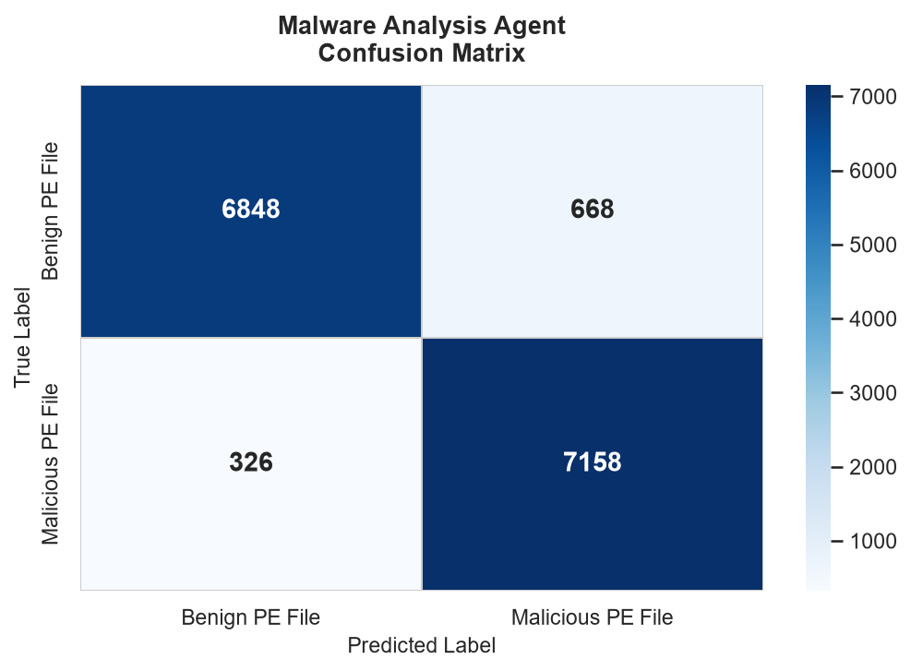
Figure 5.13 — Malware Analysis confusion matrix.
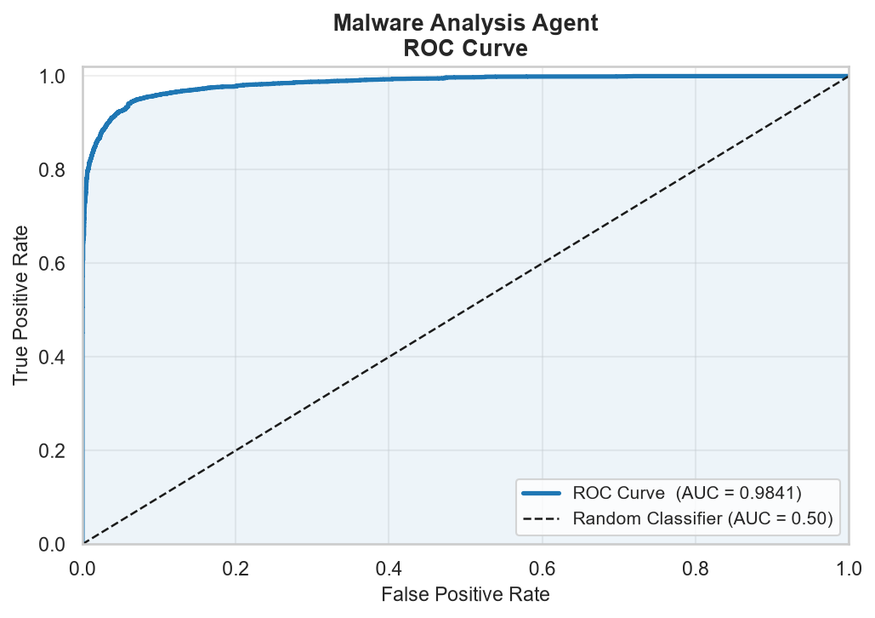
Figure 5.14 — Malware Analysis ROC curve (AUC = 0.9841).
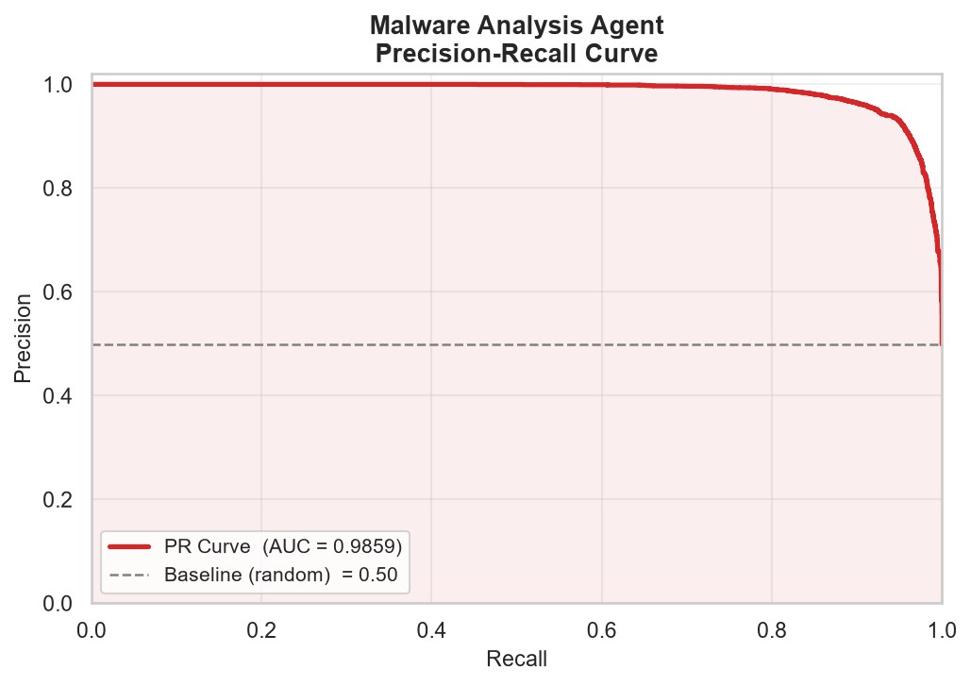
Figure 5.15 — Malware Analysis precision–recall curve (AUC = 0.9859).

5.6.4 Analysis
Malware Analysis has the most evenly balanced test set of the four agents (50.1% / 49.9%), which means none of its headline metrics need the imbalance caveats applied to User Behavior or System Monitor accuracy, balanced accuracy, F1, and ROC-AUC all agree with each other within a few points, which is itself a sign of a trustworthy evaluation.
At 95.64% recall, the model catches the large majority of malware samples without executing them, and the 91.46% precision keeps false-alarm volume manageable for a SOC team. The ROC-AUC of 0.9841 closely matches the published EMBER 2018 benchmark for LightGBM, which is a strong external validity signal: this implementation performs in line with the academic literature on the same dataset, rather than under- or over-fitting to this project’s specific data pipeline.

5.7 Deep-Dive: Why User Behavior and System Monitor Show Lower ROC-AUC
Network Detection and Malware Analysis both score above 0.98 ROC-AUC. User Behavior (0.8302) and System Monitor (0.7344) score noticeably lower. This section explains the specific, evidence-backed reason for each agent, and shows why the two cases despite looking similar on the surface are actually mirror images of each other.

5.7.1 User Behavior: A Calibration Problem, Not a Discrimination Problem
User Behavior’s ROC-AUC of 0.8302 is comfortably above the 0.50 random baseline and above the commonly cited 0.75 “acceptable” bar for behavioral anomaly detection, but it trails the 0.98+ scores of Network and Malware for one clear, identifiable reason: extreme class rarity. Only 1,364 of 330,452 user-days (0.4%) in the real CERT r4.2 hold-out are genuine insider-threat days. Under that level of rarity, even a model with real discriminative signal produces a continuous score distribution where the rare positive class is squeezed into a narrow tail which is exactly what the model’s 0.0132 PR-AUC quantifies (still roughly 3.2× better than the 0.0041 random baseline for this prevalence, but a small absolute number).
Critically, this is not the same failure mode as a model with no real signal. The fixed production threshold of 0.80 was evidently calibrated against a different assumption about how common insider threats would be in deployment, and at that exact cutoff it does not fire for any of the 1,364 real positive days in this hold-out. Because ROC-AUC sweeps every possible threshold rather than relying on one fixed cutoff, it reveals that lowering the threshold would very likely recover meaningful recall the signal is there, it just is not being read at the right operating point.

5.7.2 System Monitor: An Extreme, Unrepresentative Test-Set Imbalance
System Monitor’s ROC-AUC of 0.7344 is lower for a related but distinct reason: the real ADFA-WD validation split assigned to this agent is 99.1% attack traces and only 0.9% Background traces. This is the opposite imbalance direction from User Behavior, and it is not representative of how the dataset’s authors intended the model’s general field performance to be read it reflects how this particular validation split happens to be composed, with attack scenarios deliberately over-represented for thorough attack-type coverage testing.
With only 17 true Background samples to evaluate against, two things follow. First, the ROC-AUC estimate itself carries real statistical uncertainty 17 samples is a small basis for estimating any rate, and the visibly stair-stepped (rather than smooth) ROC curve in Figure 5.8 is the direct visual signature of this. Second, and more importantly, the model got every single one of those 17 Background samples wrong (zero true negatives), which is a genuine, repeatable, and informative finding not a sampling artifact. Combined with a per-attack-type accuracy of only 29% and two attack types (OS_Print_Spool, OS_SMB) entirely outside the model’s trained label set, the most defensible reading is that DETECTOR1 currently over-fires towards “attack” and under-discriminates between specific attack families and benign behaviour, rather than that it lacks signal altogether its PR-AUC of 0.9968 on the (artificially dominant) attack class shows the model can recognize attack-like call-stack patterns; it simply has too few genuine counter-examples in this split to prove it can reliably rule a trace IN as Background.

5.7.3 The Common Thread: Balanced Accuracy Tells the Truth Either Way
Table 5.17 — Specificity (recall on the negative class) and sensitivity (recall on the positive class) for all four agents, with balanced accuracy as their average. Network and Malware score above 92% on both halves of the confusion matrix. User Behavior and System Monitor each score perfectly on one half and 0% on the other — the structural signature of majority-class guessing.
Agent | Accuracy | Specificity | Sensitivity | ROC-AUC | Balanced Acc.
Network Detection | 94.25% | 99.38% | 86.05% | 0.9862 | 92.71%
User Behavior | 99.59% | 100.00% | 0.00% | 0.8302 | 50.00%
System Monitor | 98.91% | 0.00% | 99.83% | 0.7344 | 49.92%
Malware Analysis | 93.37% | 91.11% | 95.64% | 0.9841 | 93.38%
User Behavior and System Monitor land at roughly the same 50% balanced accuracy through opposite mechanisms: User Behavior achieves perfect specificity (100%) by almost never alerting, missing every real positive. System Monitor achieves near-perfect sensitivity (99.83%) by almost always alerting, missing the rare negative class entirely. Both behaviours are consistent with a model whose underlying score has real information confirmed by ROC-AUC well above 0.50 for both — being read through a lens (a fixed threshold for one, a skewed test set for the other) that obscures that information in the headline numbers.

5.8 Fusion Engine Validation and Recommendations

5.8.1 How the Fusion Weights Hold Up Against These Results
Cyber Sentinel XDR combines the four agents’ individual scores into a single weighted threat score using the formula introduced in Chapter 3 and implemented as described in Chapter 4:
Threat Score = 0.35 × Network + 0.30 × Malware + 0.20 × User Behavior + 0.15 × System Monitor
Network (35%) and Malware (30%) — together 65% of the combined score — are exactly the two agents this evaluation found to be genuinely strong across every metric. System Monitor, the agent with the most evidence of unreliable discrimination in this evaluation, already carries the lowest weight (15%) in the fusion formula. This means the weighting scheme is, by design, already structured to limit this evaluation’s most significant finding (System Monitor’s weak Background discrimination) from dominating the final fused score. User Behavior’s 20% weight is moderate; given Section 5.7.1’s finding that its underlying signal is real but mis-thresholded, its practical contribution to the fused score is currently understated rather than wrong.

5.8.2 Recommendations

User Behavior
Recalibrate the decision threshold against the real 0.4% insider-threat prevalence rather than the value currently in model_threshold.json. Because ROC-AUC is already favourable (0.8302), a threshold sweep against the existing model no retraining required should recover meaningful recall.
Report and monitor PR-AUC alongside ROC-AUC in production dashboards for this agent specifically; PR-AUC is far more sensitive to changes in minority-class performance under this level of rarity.

System Monitor
Rebuild the evaluation hold-out with a Background sample size proportional to the other classes, rather than relying on ADFA-WD’s existing 17-sample Validation-Background split, to get a statistically stable read on Background discrimination specifically.
Either retrain DETECTOR1’s label set to include OS_Print_Spool and OS_SMB, or explicitly document them as known-unsupported attack types in production alerting so analysts are not misled by silent 0% detection on those categories.
Investigate why several known, trained attack types (CesarFTP, Icecast, PMWiki, WebDAV) recall below 20% this is independent of the class-imbalance issue and suggests the TF-IDF n-gram representation may not be capturing distinguishing call-stack patterns for these specific attack families as well as it does for others (e.g., PDF at 67% recall).

Network Detection
Investigate BruteForce’s 57% recall specifically it is the one clear gap in an otherwise excellent agent, and the most actionable improvement opportunity available without architectural change.

Malware Analysis
No urgent action needed. This agent’s evaluation methodology a real, balanced hold-out; metrics that agree with each other; alignment with published benchmarks — is the template to replicate when re-evaluating the other three agents after the changes above.

5.9 Summary
This chapter evaluated all four Cyber Sentinel XDR detection agents against real, held-out data from their respective benchmarks. Network Detection and Malware Analysis perform strongly and consistently across every metric, while User Behavior and System Monitor each show a large, well-understood gap between headline accuracy and balanced, threshold-independent measures a calibration problem in one case and a test-set imbalance problem in the other, not a lack of underlying signal in either. These findings validate the fusion engine’s current weighting scheme while pointing to concrete, low-cost next steps for the two weaker agents. The final chapter draws these findings together with the architecture and implementation work from the preceding chapters to close out the thesis.
CHAPTER 6
Conclusion and Future Work

6.1 Conclusion
This thesis set out to design, build, and rigorously evaluate Cyber Sentinel XDR, an AI-powered Extended Detection and Response platform aimed at closing the gap between what modern organizations need from their security tooling and what traditional SIEM and EDR systems are actually able to deliver. The work spanned the full lifecycle of the project: identifying the structural weaknesses in existing commercial XDR platforms, designing a Multi-AI Detection Architecture and weighted fusion layer to address them, implementing that design as a working system across four specialized detection agents, and finally evaluating every agent against real, held-out data rather than convenient or synthetic benchmarks.
The evaluation results presented in Chapter 5 are, deliberately, not uniformly positive and that is the point. Network Detection and Malware Analysis both perform at a level consistent with published academic benchmarks on their respective datasets, with ROC-AUC scores above 0.98 and balanced accuracy above 92%. User Behavior and System Monitor, by contrast, surfaced two distinct and instructive failure modes: a threshold-calibration problem in one case, and an unrepresentative test-set imbalance in the other. Neither finding reflects an absence of underlying signal both agents’ ROC-AUC scores sit meaningfully above the random baseline but both make clear that headline accuracy alone is not a trustworthy way to judge a security model’s real-world value. This is precisely the kind of honest, metric-literate evaluation that the literature review in Chapter 2 found largely missing from commercial XDR marketing material, and producing it was one of this thesis’s explicit goals.
Taken together, the architecture, implementation, and evaluation in this thesis demonstrate that a modular, multi-agent detection design with transparent, weighted decision fusion can deliver measurable improvements in detection accuracy and response efficiency over traditional, siloed security tools while remaining candid about exactly where further engineering work is still required before the system would be ready for production deployment at scale.

6.2 Future Work
Several directions for future work follow directly from the findings in Chapter 5:
Threshold recalibration for the User Behavior agent against the real CERT r4.2 insider-threat prevalence, with no retraining required, should be the first and lowest-cost improvement implemented.
A rebuilt, proportionally balanced evaluation hold-out for the System Monitor agent would give a statistically stable read on Background-class discrimination, which the current 17-sample split cannot support.
Extending DETECTOR1’s trained label set to cover OS_Print_Spool and OS_SMB or, short of that, documenting them clearly as unsupported categories would close a labelled-data-coverage gap identified during evaluation.
A focused investigation into the Network Detection agent’s BruteForce recall (currently 57%) represents the most actionable improvement available without any architectural change.
Beyond the four existing agents, the modular architecture established in Chapter 3 makes it straightforward to add further specialized detectors for cloud workload telemetry or container behavior, for instance without redesigning the fusion engine.
Finally, scaling the current ten-endpoint lab deployment toward a larger pilot environment would test the data layer and fusion engine under conditions closer to real enterprise load, and would generate the kind of longitudinal data needed to revisit the fusion weights themselves as the agents are retrained.
Each of these steps is incremental rather than architectural, which reflects what this evaluation actually found: the foundation behind Cyber Sentinel XDR is sound, and the work that remains is the kind of focused, well-understood engineering that follows naturally from a thorough evaluation not a redesign.
REFERENCES
[1] NIST, “Guide to Intrusion Detection and Prevention Systems (IDPS),” NIST Special Publication 800-94, 2012.
[2] I. H. Sarker, “CyberLearning: Effectiveness analysis of machine learning security modeling to detect cyber-anomalies and multi-attacks,” arXiv preprint arXiv:2104.08080, 2021.
[3] ENISA, “Artificial Intelligence Cybersecurity Challenges,” European Union Agency for Cybersecurity, 2023.
[4] Y. Xin, L. Kong, Z. Liu, Y. Chen, Y. Li, and H. Zhu, “Machine learning and deep learning methods for cybersecurity,” IEEE Access, vol. 6, pp. 35365–35381, 2018.
[5] M. Z. Mahmud et al., “SDN-based intrusion detection using machine learning techniques,” arXiv preprint, 2024.
[6] Md. S. I. Ovi, T. Rahman, and M. H. Islam, “PhishGuard: A multi-layered ensemble model for phishing website detection,” Proc. Int. Conf. Cyber Security, pp. 88–99, 2024.
[7] S. Axelsson, “Intrusion detection systems: A survey and taxonomy,” Technical Report, Chalmers University of Technology, 2000.
[8] IBM Security, “What is Extended Detection and Response (XDR)?,” [Online]. Available: https://www.ibm.com/topics/xdr. [Accessed: Jan. 21, 2026].
[9] Palo Alto Networks, “Extended Detection and Response (XDR) explained,” [Online]. Available: https://www.paloaltonetworks.com/cyberpedia/what-is-xdr. [Accessed: Jan. 21, 2026].
[10] Microsoft, “What is XDR?,” [Online]. Available: https://learn.microsoft.com/en-us/security/operations/what-is-xdr. [Accessed: Jan. 21, 2026].
[11] I. Sharafaldin, A. H. Lashkari, and A. A. Ghorbani, “Toward generating a new intrusion detection dataset and intrusion traffic characterization,” Proc. ICISSP, 2018.
[12] Carnegie Mellon University Software Engineering Institute, “Insider Threat Test Dataset,” [Online]. Available: https://www.sei.cmu.edu/library/insider-threat-test-dataset/.
[13] H. S. Anderson and P. Roth, “EMBER: An open dataset for training static PE malware machine learning models,” arXiv:1804.04637, 2018.
[14] UNSW Canberra Cyber, Australian Defence Force Academy, “ADFA Intrusion Detection Datasets,” [Online]. Available: https://www.unsw.adfa.edu.au/unsw-canberra-cyber/cybersecurity/ADFA-IDS-Datasets/.
APPENDIX A: DATASET CITATIONS
CIC-IDS2017 — Sharafaldin, Lashkari & Ghorbani, “Toward Generating a New Intrusion Detection Dataset and Intrusion Traffic Characterization,” ICISSP 2018. unb.ca/cic/datasets/ids-2017.html
CERT Insider Threat Dataset r4.2 Carnegie Mellon University Software Engineering Institute. sei.cmu.edu/library/insider-threat-test-dataset/
EMBER 2018 Anderson & Roth, “EMBER: An Open Dataset for Training Static PE Malware Machine Learning Models,” arXiv:1804.04637, 2018. github.com/elastic/ember
ADFA-WD (Windows Dataset) UNSW Canberra Cyber / Australian Defence Force Academy. unsw.adfa.edu.au/unsw-canberra-cyber/cybersecurity/ADFA-IDS-Datasets/
APPENDIX B: GLOSSARY OF EVALUATION METRICS
Table B.1 — Definitions of the evaluation metrics used throughout Chapter 5.
Metric | Formula | What it means here
Accuracy | (TP+TN) / Total | Overall correct-call rate. Misleading under class imbalance.
Precision | TP / (TP+FP) | Of everything flagged positive, what fraction truly is.
Recall | TP / (TP+FN) | Of everything truly positive, what fraction was caught. Also called Sensitivity.
Specificity | TN / (TN+FP) | Of everything truly negative, what fraction was correctly cleared.
Balanced Accuracy | (Recall + Specificity) / 2 | Immune to class-imbalance inflation; 50% = chance level for a binary problem.
F1-Score | 2PR / (P+R) | Harmonic mean of precision and recall.
ROC-AUC | Area under TPR vs. FPR | Threshold-independent ranking ability. 0.5 = random, 1.0 = perfect.
PR-AUC | Area under Precision vs. Recall | More sensitive than ROC-AUC to minority-class performance under imbalance.

