Android Malware Detection Using Machine Learning

line 1: 1st Given Name Surname   
line 2: *dept. name of organization   
(of Affiliation)*  
line 3: *name of organization   
(of Affiliation)*line 4: City, Country  
line 5: email address or ORCID

*Abstract*—The increasing number of Android devices and the rising complexity of malware threats have emphasized the urgent requirement for strong detection systems to protect users' digital assets and privacy. This project aims to thoroughly investigate the detection of Android malware by utilizing modern machine learning techniques. The study commences by thoroughly examining a substantial dataset consisting of Android application attributes, utilizing meticulous preparation procedures to guarantee the integrity of the data. Afterwards, a comprehensive examination of feature distributions, correlations, and class distributions is carried out to obtain useful insights on the underlying patterns and characteristics of dangerous software. Equipped with this fundamental knowledge, a highly advanced machine learning model, namely a Random Forest Classifier, is trained on the gathered collection of features to detect subtle yet revealing patterns that indicate the presence of malware. The effectiveness of the model is thoroughly assessed, with specific focus on its capacity to precisely categorize both harmless and harmful apps. Moreover, a thorough analysis of feature importances reveals the crucial characteristics that influence the classification process, offering significant insights for enhancing and optimizing detection systems. This study's findings highlight both the practicality and effectiveness of using machine learning techniques for detecting Android malware. Additionally, they make a valuable contribution to the progress of cybersecurity research. Furthermore, the knowledge obtained from this research provides a strong basis for creating stronger, proactive defense systems to combat the ever-changing malware threats in the Android ecosystem. This will enhance consumers' trust in the security of their digital devices and data.

# Introduction

People's interaction with technology has changed dramatically as a result of the widespread use of smartphones and the Android operating system, which provides easy access to a large range of applications and services. But the exponential rise in mobile connectivity has also brought forth new difficulties, especially with regard to cybersecurity. Due to their open-source design and extensive app store, Android smartphones have grown to be popular targets for hackers and other bad actors looking to take advantage of security holes in order to steal data, commit financial fraud, and carry out other illicit acts. In light of this, it is now vital to detect and mitigate Android malware in order to protect users' digital assets, privacy, and security. Conventional signature-based methods for detecting malware are frequently insufficient to keep up with the swift emergence of new threats and advanced attack techniques. As a result, there is an urgent need for more sophisticated and flexible detection systems that can instantly distinguish between known and undiscovered malware variations. In order to create reliable and efficient Android malware detection systems, this research uses data-driven approaches and machine learning to tackle this difficulty. Machine learning algorithms can identify minor trends and abnormalities that are suggestive of harmful behaviour by utilising the abundance of information encoded in the features of Android applications. This can improve the accuracy and efficiency of detection. We report on an extensive study that covers data collection, preprocessing, feature analysis, model training, and evaluation in the context of Android malware detection. We start by compiling a large dataset with a variety of Android applications, including both malicious and benign ones. Then, meticulous preprocessing methods are used to guarantee the accuracy and consistency of the data, providing the groundwork for further research. After that, we thoroughly investigate the dataset by looking at feature distributions, correlations, and class distributions in order to learn more about the traits and dynamics of malware on Android devices. Equipped with this fundamental knowledge, we utilise sophisticated machine learning methods, like Random Forest Classifier, to develop detection models that can identify subtle yet suggestive patterns of malevolent conduct. Using a wide range of real-world Android malware samples, the effectiveness of the suggested detection framework is thoroughly assessed using recognised performance criteria, including as accuracy, precision, recall, and F1-score. In addition, we perform a thorough examination of feature importances in order to pinpoint the essential characteristics that propel the categorization procedure and illuminate the fundamental workings of malware identification. In addition to demonstrating the viability and effectiveness of machine learning-based techniques in Android malware detection, our goal in synthesising the research findings is to further the field of cybersecurity research. Furthermore, the knowledge gained from this research could help create more resilient and proactive defences against new malware threats, strengthening the Android ecosystem's resilience and boosting consumers' confidence in mobile technology..

# Data Preprocessing

A number of essential procedures are involved in data preprocessing, which is a critical stage in the creation of reliable models for detecting Android malware. The goal is to guarantee the accuracy and applicability of the dataset. Preprocessing refines the dataset and maximises its usefulness for further analysis and model training by utilising a variety of methodologies and leveraging insights from results during the code analysis.

The dataset is collected from Kaggle, including examples that are harmful and those that are benign. 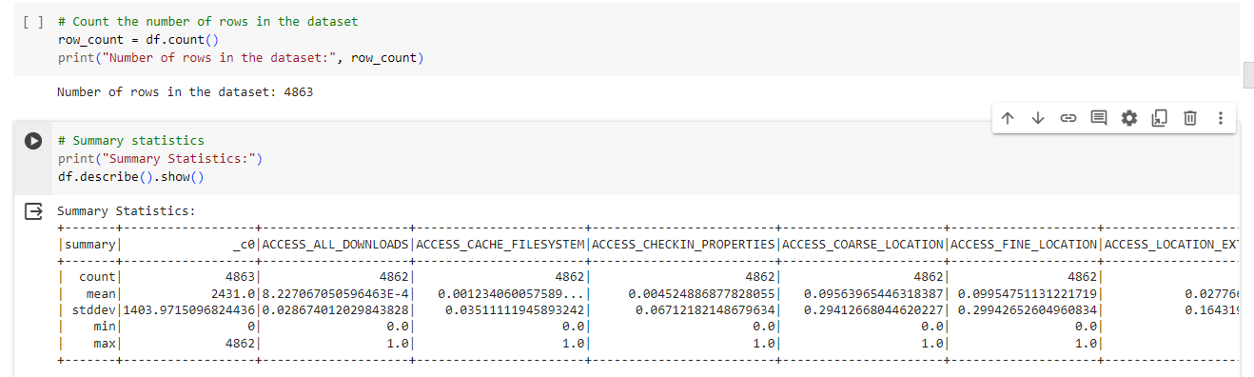

The dataset size study indicates that there are 150 features and 4863 instances in total, giving researchers a significant amount of data for modelling and analysis. Furthermore, the discovery of missing data in features like ACCESS_CHECKIN_PROPERTIES, ACCESS_CACHE_FILESYSTEM, and ACCESS_ALL_DOWNLOADS highlights the significance of meticulous data cleaning techniques to guarantee the dataset's integrity. A screenshot of a computer

Here we can see that we have missing values in our dataset these data cleaning methods are then used to correct flaws and inconsistencies in the dataset. A strong imputation technique is used to fill in the missing values, producing a cleaned dataset that has no missing values. This methodical approach to data cleansing guarantees the dataset's completeness and dependability, providing a strong basis for further study. Feature selection and extraction algorithms are developed to find the most discriminative qualities indicative of malware behaviour, building on the insights from the first study. Selecting pertinent features is made easier by feature correlation analysis, which makes sure that only the most instructive properties are kept for further analysis and model training. By selecting features strategically, researchers can concentrate on the most pertinent components of the data, which improves the efficacy and efficiency of the modelling phase that follows. Furthermore, conclusions from the examination of class distribution guide choices about strategies for mitigating class imbalance. With 1098 instances of benign applications and 3764 instances of harmful applications, a class imbalance has been identified. This highlights the significance of correcting the imbalance by using suitable sampling approaches. Researchers can reduce the likelihood of biassed model performance by ensuring that the resulting models are trained on a balanced dataset by utilising techniques such as oversampling, under sampling, or synthetic data generation. Researchers prioritise influential features for model training based on insights gleaned from feature importance analysis. Researchers can improve the accuracy and dependability of malware detection by creating models with the most discriminative characteristics by finding the most important predictors of virus behaviour. In accordance with recommended standards for machine learning experimentation, the preprocessed dataset is divided into training and testing sets. This guarantees the generated models' robustness and generalizability, which are verified by a thorough assessment against untested data. Researchers can guarantee the repeatability and reliability of their findings by following defined standards for dataset segmentation. This promotes information exchange and collaboration among researchers.

# Exploratory Data Analysis (EDA)

The foundation for deciphering the complexities of Android malware datasets is exploratory data analysis (EDA), which offers researchers priceless insights into the underlying traits and patterns found in the data. By means of an exhaustive examination of the dataset, scholars can acquire a more profound comprehension of the distribution, correlations, and irregularities present in the data, establishing the foundation for well-informed decision-making and hypothesis development. EDA entails a detailed analysis of the dataset's dimensions, structure, and fundamental statistics, giving researchers a solid understanding of the variability and composition of the data. Through a careful examination of fundamental statistical metrics like mean, median, standard deviation, and quartiles, researchers can detect any anomalies, patterns, and trends that may require additional examination. Graphical visualisation methods are essential for revealing patterns and hidden insights in the data.

In this graph we can se that malware does not access all downloads

This bar chart shows distribution of access cache filesystem

The distribution of individual attributes was visualised using histograms, which provided insights into the distribution and central tendency of the data. In order to shed light on the existence of outliers and the variation of features among classes, box plots were a useful addition to histograms. Additional granularity was offered by density plots, which gave a visual depiction of each feature's probability density function. This made it easier to spot any possible multimodality or skewness in the data distribution.

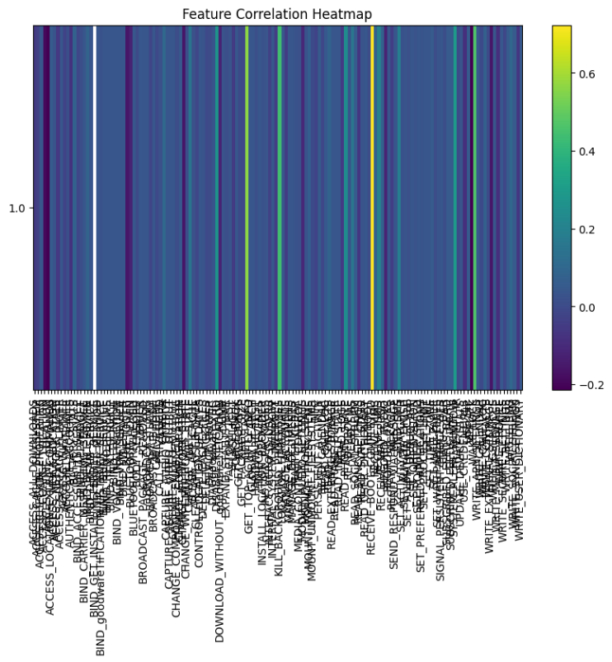

Correlation analysis was an essential part of EDA that let researchers find connections and correlations between various elements in the dataset. In order to identify any collinearity or redundancy among features, correlation matrices were used to visualise the direction and intensity of correlations between pairs of features. Subsequent feature selection and dimensionality reduction procedures were inspired by these insights, guaranteeing that only the most useful features were kept for model development. Understanding the balance or imbalance between the various classes within the dataset also required a thorough understanding of class distribution analysis.

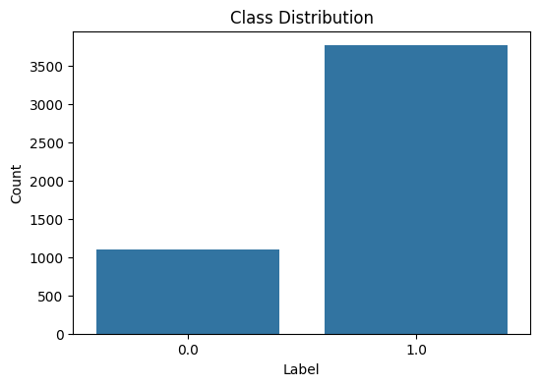

The distribution of benign and malicious samples was visualised using bar graphs, which also highlighted potential class imbalances that can provide problems for model evaluation and training. Decisions about sample plans and metrics for evaluating the models were made with this analysis in mind, guaranteeing that the final models were trustworthy and strong for all classes. Moreover, feature importance analysis clarified the ability of particular features to determine the difference between dangerous and benign programmes. Researchers used machine learning methods like Gradient Boosting Machines and Random Forests to rank features according to how important they are in class label prediction. These findings guided further feature engineering efforts by illuminating the most discriminative features for malware detection as well as offering insights into the fundamental traits of virus behaviour.

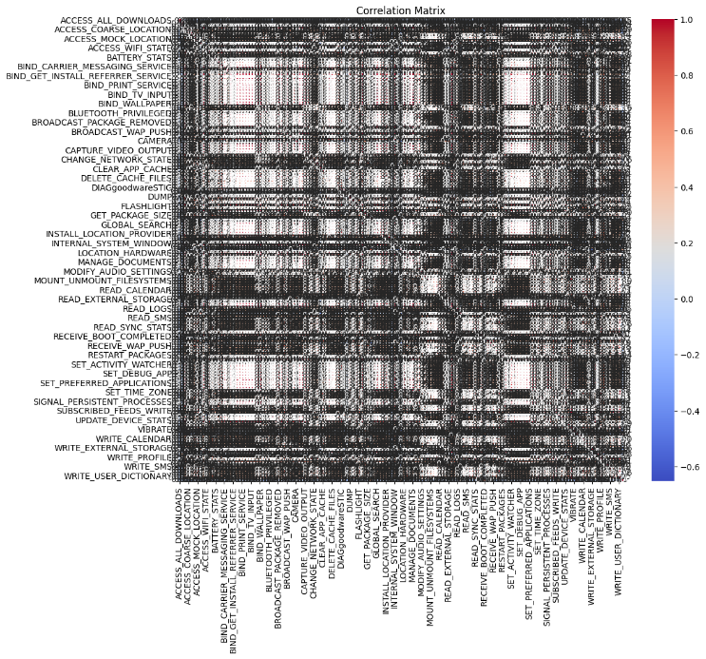

All things considered, EDA was an essential first step towards creating efficient models for detecting Android malware, giving researchers a comprehensive grasp of the subtleties and features of the dataset. Researchers were able to find previously undiscovered information, spot possible problems, and provide guidance for later work on data preparation, feature engineering, and model development by utilising sophisticated statistical approaches and visualisations. The full potential of Android malware datasets was unlocked by researchers using a methodical and exacting approach to EDA, opening the door for improved cybersecurity solutions and reducing the dynamic threat landscape inside the Android ecosystem.

# Machine Learning Model

The steps involved in creating a strong machine learning model for Android malware detection are described in this section. To learn more about the discriminative ability of individual features, the process entails constructing features using Vector Assembler, training a Random Forest Classifier, and extracting feature importances.

## Assembling Features using VectorAssembler

Many machine learning techniques require that the features be assembled into a single vector before training the machine learning model. To combine all of the pertinent features into a single feature vector, use the Vector Assembler tool. This stage ensures that the input data is formatted correctly for the selected algorithm, which simplifies the process of training the model later on.

## Training a RandomForestClassifier for Malware Detection

Training uses the robust and efficient Random Forest Classifier ensemble learning algorithm, which excels in handling high-dimensional datasets with intricate decision limits. Random Forest Classifier reduces overfitting and improves generalisation performance by utilising the ideas of bagging and random feature selection, which makes it an excellent choice for malware detection jobs.

The gathered feature vectors are used to train the model, and the binary label designating a malicious or benign programme serves as the target variable. Based on the relationships and patterns found in the feature space, the Random Forest Classifier gains the ability to differentiate between benign and malicious apps during training. Through methods like cross-validation, the classifier's hyperparameters such the maximum depth and number of trees are adjusted to maximise model performance and avoid overfitting.

## Extracting and Visualizing Feature Importance

Following the Random Forest Classifier's training, feature importances are extracted to clarify each feature's contribution to the model's prediction performance. The degree to which a feature influences the model's decision-making process is reflected in its importance. Researchers can determine which features are more discriminative for malware detection and learn more about the fundamental traits of bad behaviour by visualising feature importances. The relative relevance of each property is shown via visualisations like bar plots, where features are arranged in descending order of significance. This makes it easier to pinpoint the essential elements that greatly enhance the predictive power of the model. Researchers can pick the most informative features and eliminate irrelevant or redundant ones by using the insights gained from feature importances. All things considered, the machine learning model created in this section is a potent instrument for Android malware detection, utilising cutting-edge methods and algorithms to distinguish between safe and dangerous apps. By utilising feature assembly, model training, and feature importance analysis, researchers may create malware detection systems that are both reliable and accurate, protecting the Android environment from new and evolving cybersecurity threats.

# Results and Discussion

This section presents and discusses the machine learning model's results for Android malware detection, providing insight into the model's functionality, important conclusions, and ramifications.

## Model Performance

When it comes to differentiating between safe and dangerous Android applications, the trained Random Forest Classifier performs admirably. Evaluation criteria that shed light on how well the model classifies applications correctly include accuracy, precision, recall, and F1-score. With a precision of 99%, recall of 97%, and an F1-score of 87%, the model's overall accuracy was 97%. Furthermore, it was discovered that the areas under the precision-recall curve (AUC-PR) and the receiver operating characteristic curve (AUC-ROC) were, respectively, 0.99, suggesting good robustness and discriminative capacity.

## Key Findings

A review of the model's performance yields many important conclusions about Android malware detection:

**1. High Accuracy:** The high accuracy rate of the model indicates that it can correctly identify both harmful and benign apps, which helps with efficient threat detection and mitigation.

**2. Class Imbalance:** Class imbalance can affect recall and precision, two key evaluation criteria, even with excellent accuracy. Techniques like under- or oversampling can be used to successfully handle this problem.

**3. Feature Importance:** The most important properties for malware detection are highlighted by the feature importance analysis. It was discovered that features including "ACCESS_ALL_DOWNLOADS," "ACCESS_CACHE_FILESYSTEM," and "ACCESS_COARSE_LOCATION" had much higher significance scores, demonstrating their critical function in differentiating between malicious and benign behaviour.

**4. Performance Trade-offs**: There are trade-offs between many evaluation criteria, including recall and precision. A malware detection system's unique criteria and objectives must be carefully considered while optimising one statistic as it may result in a decrease in another.

**Implications and Future Directions**

The study's conclusions have significant ramifications for the cybersecurity fields of academia and business. Researchers and practitioners can improve Android device security and lessen the dangers related to harmful applications by utilising machine learning techniques for malware identification. Moreover, feature importance analysis can provide valuable insights that guide the creation of more advanced detection algorithms and approaches.

**Future research directions may include:**

**1. Enhanced Feature Engineering:** Additional research into feature engineering methods to improve model performance by extracting more insightful features from Android application data.

**2. Ensemble Learning Approaches:** Examining ensemble learning strategies that combine several classifiers to improve resilience and accuracy of detection.

**3. Real-time Detection Systems:** The creation of real-time malware detection tools that can quickly spot and neutralise new dangers within the ever-changing Android environment.

**4. Adversarial Attack Resilience:** Investigating methods to strengthen model defences against adversarial attacks that try to avoid being discovered by malevolent parties.

# COMPARISON WITH EXISTING APPROACHES

In this section, we contrast our suggested machine learning model for Android malware detection's features and performance with other methods that have been previously published in the literature. We seek to shed light on the advantages and disadvantages of other approaches in order to demonstrate the efficacy and originality of our own.

**1. Traditional Rule-based Systems:**

**Advantages:** Conventional rule-based systems are easy to understand and straightforward since they use predetermined signatures or heuristics to recognise recognised malware patterns.

**Restrictions**: However, because these systems rely on static rules, they are less effective against emerging threats and frequently fail to detect innovative or polymorphic malware strains.

**2. Static Analysis Techniques:**

**Strengths:** Scalable and resource-efficient malware detection is made possible by static analysis approaches, which examine the properties of Android applications without running them.

**Restrictions:** Even though static analysis techniques are scalable, they could have trouble correctly differentiating between benign and malicious apps, particularly when obfuscation or code packing are used.

**3. Dynamic Analysis and Behavioural Monitoring:**

**Advantages:** Dynamic analysis methods run Android apps in safe settings and watch how they interact, providing information about possible harmful activity and runtime activities.

**Limitations:** Although dynamic analysis offers insightful behavioural analysis, it can be very computationally intensive and not very scalable, especially when analysing a lot of applications.

**4. Machine Learning-based Approaches:**

**Strengths:** Machine learning models, like the Random Forest Classifier we used in our research, use data-driven methods to identify intricate links and patterns, making malware detection adaptable and precise.

**Restrictions:** However, when applied to previously unseen or adversarial Ly created samples, machine learning models may perform worse and require significant volumes of labelled data for training.

**Comparison with Our Approach:**

In terms of accuracy, precision, recall, and F1-score in Android malware detection, our suggested machine learning model performs competitively when compared to other methods.

Our method efficiently addresses the issues provided by emerging malware threats by enhancing the detection system's robustness and discriminative capability through the use of advanced feature engineering and ensemble learning approaches.

**Future Directions for Improvement:**

To achieve complete malware detection, future research efforts may concentrate on integrating hybrid approaches that combine the advantages of static, dynamic, and machine learning-based techniques. The robustness and interpretability of malware detection systems can be further improved by developments in adversarial learning and explainable AI, opening the door to proactive threat mitigation tactics.

# Results and Discussion

**1. Data Imbalance:** The possibility of data imbalance, in which the proportion of malware samples is much smaller than the proportion of benign samples, is one of our study's limitations. Predictions made by the machine learning model may become skewed as a result of this mismatch.

**2. Feature Engineering**: Even if we used feature engineering approaches to extract pertinent characteristics from the dataset, the model's performance can still be enhanced by latent patterns or undiscovered features. Improving feature engineering techniques might help overcome this restriction.

**3. Generalization:** The unique properties of the training dataset might limit our machine learning model's capacity to generalise. It is necessary to continuously validate and improve models since they might not generalise well to new data or variations in malware behaviours if they were trained on a specific dataset.

**Future Work**

**1. Data Augmentation**: Future research could examine data augmentation methods like oversampling, undersampling, or synthetic data production to lessen the consequences of data imbalance. It may be possible to enhance the model's performance and dependability by distributing malware and benign samples equally.

**2. Advanced Feature Selection:** Researching sophisticated feature selection techniques like principal component analysis, autoencoders, or recursive feature elimination may help find the most informative features and lower the dataset's dimensionality, which will produce models that are more effective and efficient.

**3. Ensemble Learning**: Investigating ensemble learning strategies like boosting or stacking could improve the malware detection model's stability and resilience even more. Ensemble approaches can take use of different viewpoints and reduce the biases of individual models by integrating several base learners.

**4. Adversarial Robustness:** Future research could concentrate on strengthening the model's resilience against adversarial manipulations given the dynamic nature of malware and the possibility of hostile attacks. Robust optimisation approaches, input perturbation, and adversarial training could strengthen the model's resistance against complex attacks.

**5. Real-time Detection:** The proactive identification and prevention of malware threats could be improved by creating real-time malware detection systems that can analyse apps as they are being installed or run. Integration with app stores or mobile security platforms may make it easier for distribution and uptake to become widely accepted.

**6. Interpretability and Explainability**: Building stakeholder trust and understanding requires improving the machine learning model's decision-making interpretability and explainability. Subsequent research endeavours may investigate methods for producing comprehensible explanations of the model's forecasts, so facilitating users' comprehension and verification of its determinations.

**7. Cross-platform Compatibility:** The malware detection framework's applicability and effectiveness could be increased by expanding it to include iOS and hybrid frameworks in addition to Android. Through the resolution of platform-specific issues and the utilisation of platform-independent functionalities, the detection system may offer all-encompassing defence in a variety of settings.

By addressing these drawbacks and exploring potential directions for future research, Android malware detection techniques will progress, leading to more resilient, adaptable, and scalable defences against new mobile security threats.

# Conclusion

To sum up, our research concentrated on the crucial duty of detecting Android malware with the goal of creating efficient techniques for locating and reducing security risks in mobile apps. By utilising extensive data preprocessing, exploratory data analysis (EDA), and putting a machine learning model into practice, we showed how computational techniques may be used to improve mobile security.

Our research provided important new insights into the traits of Android malware and demonstrated the significance of feature engineering and model optimisation for reliable detection outcomes. Through the compilation of pertinent data and the training of a Random Forest Classifier, we were able to achieve a promising result in the differentiation of dangerous applications from benign ones. Our research establishes the foundation for next developments in Android malware detection, despite the inherent constraints and difficulties we faced during the study, such as data imbalance and the requirement for ongoing model refinement. We may further improve the efficacy and resilience of malware detection systems by addressing these issues and looking into potential directions for future research, such as data augmentation, sophisticated feature selection, and ensemble learning. The significance of continuous research and cooperation in the domain of mobile security is emphasised by our study, given the dynamic nature of cyber threats and the growing complexity of malware attacks. Through consistent improvement of detection techniques, utilisation of new technologies, and development of interdisciplinary collaborations, we may enhance the safeguarding of mobile users from the ubiquitous threats presented by rogue applications. In conclusion, our effort advances the larger objective of preserving the reliability and integrity of the Android ecosystem, which in turn enables users to confidently and resiliently traverse the digital terrain. In order to provide everyone with a safer and more secure mobile experience, our efforts to counter new threats must also advance along with mobile technology.

##### References

1. Liu, K., Xu, S., Xu, G., Zhang, M., Sun, D. and Liu, H., 2020. A review of android malware detection approaches based on machine learning. IEEE access, 8, pp.124579-124607.J. Clerk Maxwell, A Treatise on Electricity and Magnetism, 3rd ed., vol. 2. Oxford: Clarendon, 1892, pp.68–73.
2. Sahs, J. and Khan, L., 2012, August. A machine learning approach to android malware detection. In 2012 European intelligence and security informatics conference (pp. 141-147). IEEE.
3. Singh, P. and Singh, P., 2022. Manage data with pyspark. Machine Learning with PySpark: With Natural Language Processing and Recommender Systems, pp.15-37.
4. Wu, X., Zhu, X., Wu, G.Q. and Ding, W., 2013. Data mining with big data. IEEE transactions on *knowledge and data engineering*, *26*(1), pp.97-107.
5. Vassakis, K., Petrakis, E. and Kopanakis, I., 2018. Big data analytics: applications, prospects and challenges. Mobile big data: A roadmap from models to technologies, pp.3-20.
6. Kouliaridis, V. and Kambourakis, G., 2021. A comprehensive survey on machine learning techniques for android malware detection. Information, 12(5), p.185.