**Git**

1. git init :-

To convert a folder into git repository.

1. git add <file_name>

Add a file to staging.

1. git add . :-

It will add all the files to staging area.

1. git status :-

List the files you’ve changed and those you still need to add or commit.

1. git commit -m “commit message” :-

commit changes to head.

1. git commit -am “commit message” :-

add files to staging area and commit at same time.

1. git rm --cached <file_name> :-

To remove files from stagin area(unstage).

1. git log :-

Will display all the commit history.

1. git branch <branch_name> :-

To create a new branch with name as <branch_name>.

1. git checkout <branch_name> :-

To move into particular branch.

1. git checkout -b <branch_name> :-

This will create the branch and directly take you into that branch.

1. git merge <branch_name> :-

To merge a branch into current branch.

**Git flow :-**

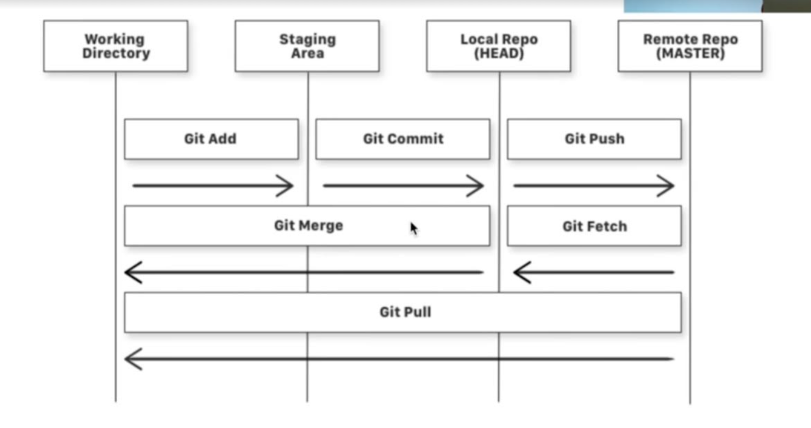

Initial setup :-

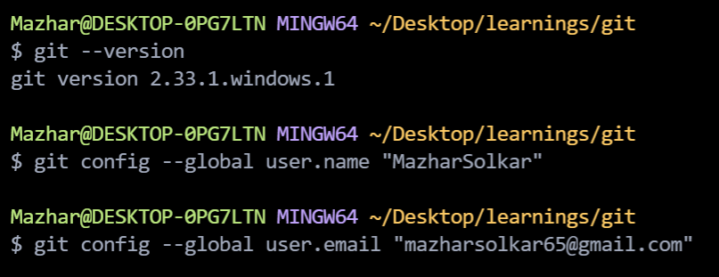

Fired git init command inside LearnGitRepo folder to turn it into git repository :-

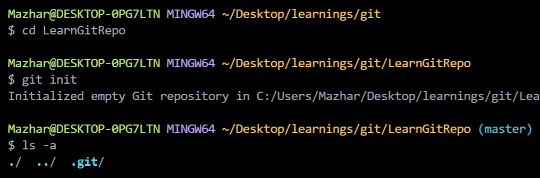

Created sum.py file wrote some code in it :-

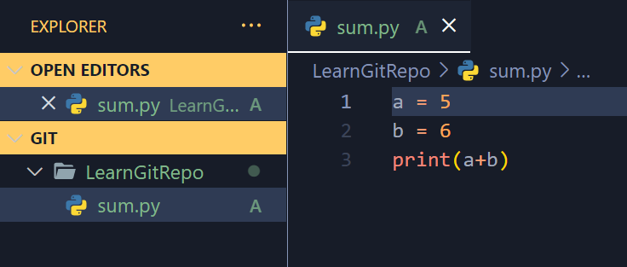

Fired git status command to check the status.

Fired git add sum.py command to add this file in tracking area.

Fired git status command again to check the status.

Fired git commit -m “some message” command to commit.

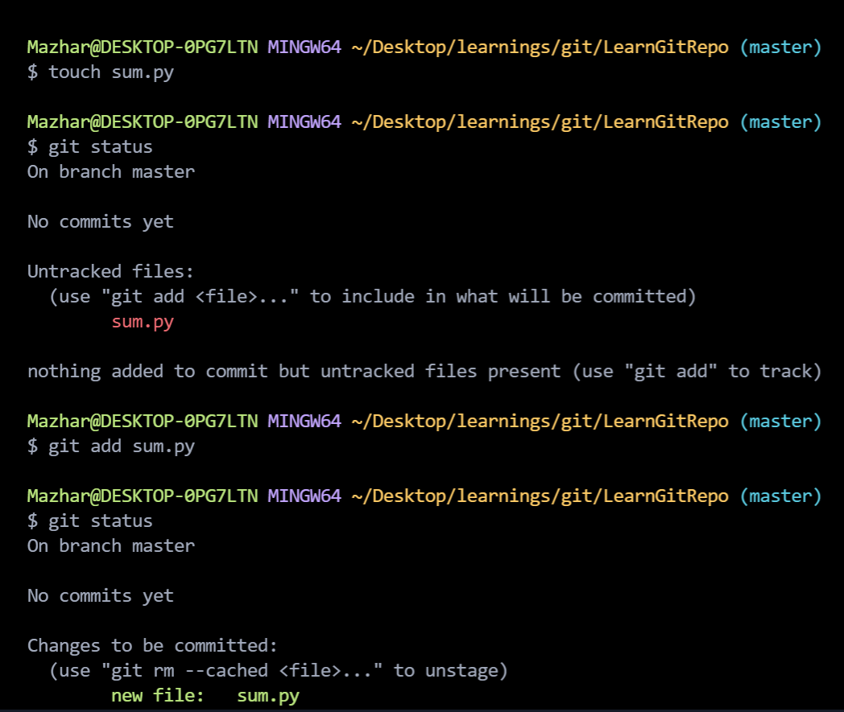

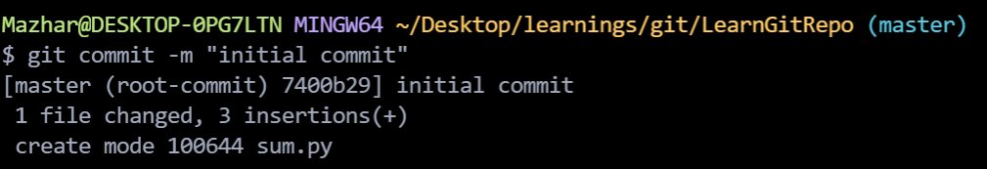

Created diff.py file.

Fired git status command.

Fired git add . command that will add all the files in staging area.

Fired git commit -m “added diff.py” command.

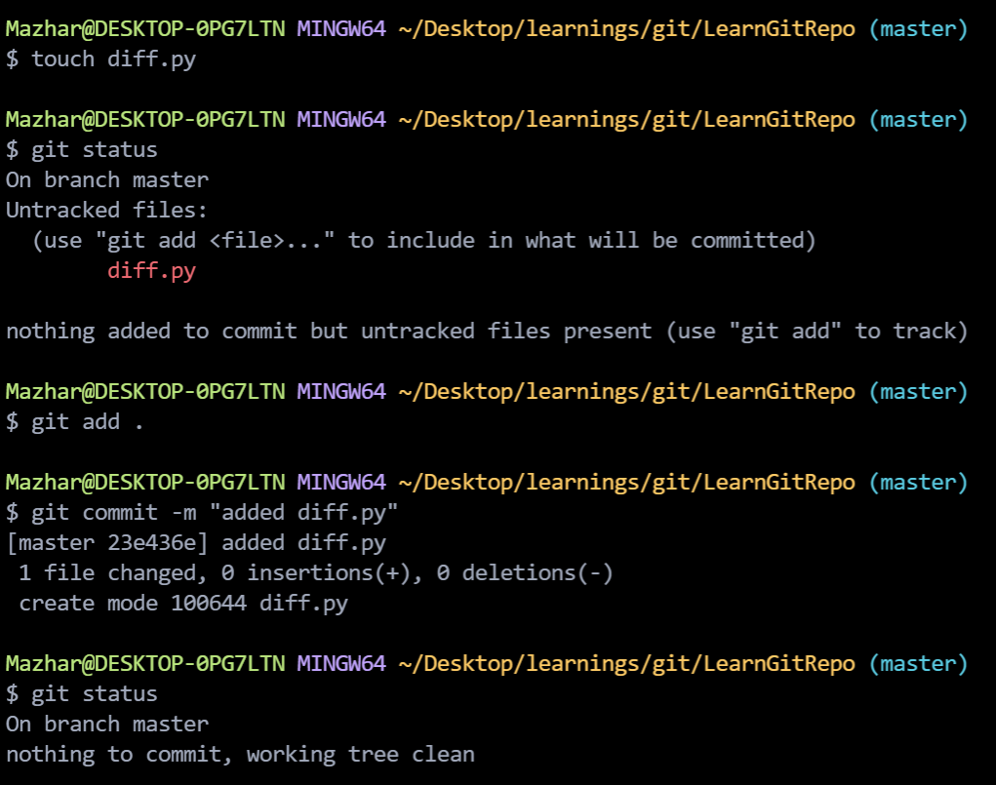

Added “this is sum”, change in sum.py.

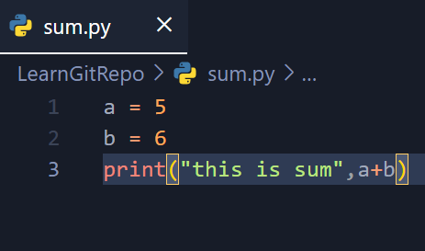

Fired git status command which is displaying sum.py with modified status.

Fired git commit -am “added change in sum.py” which will add sum.py in staging area as well as commit at the same time.

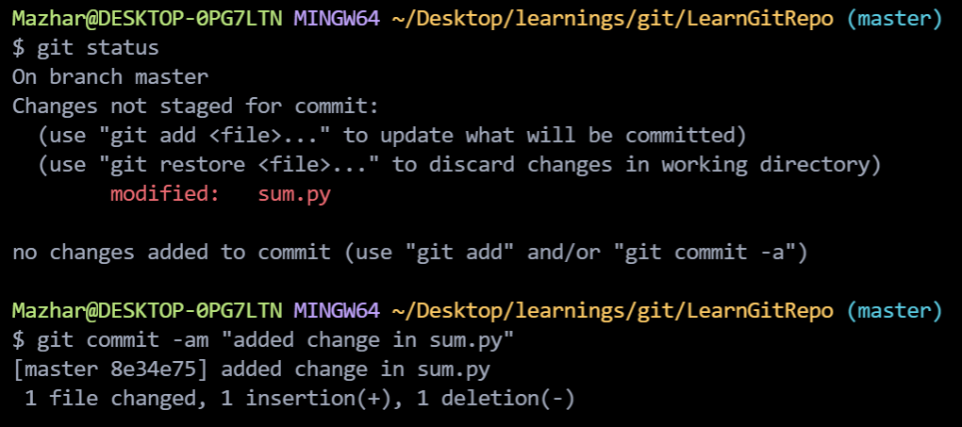

Fired git log command which will display all the commits that has been made.

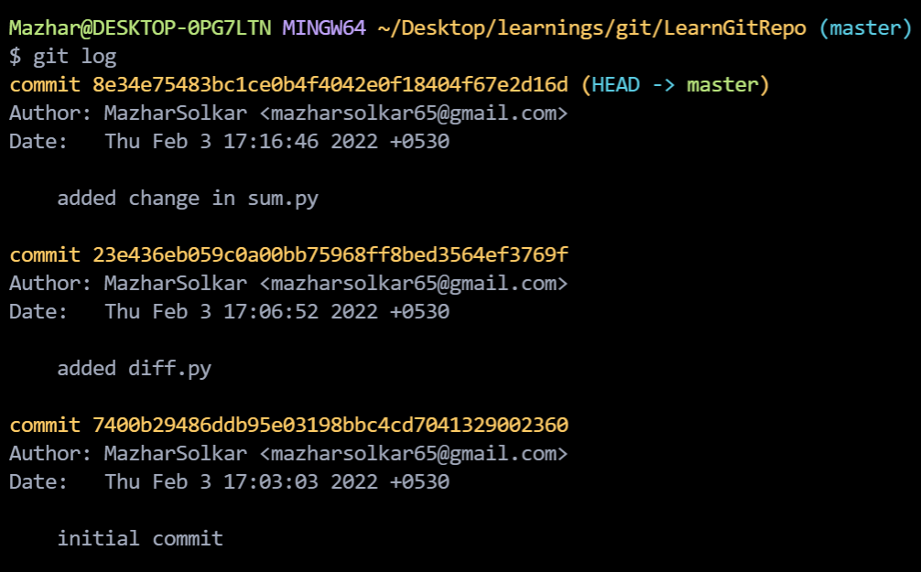

If you want to rollback to previous commit then you can use git commit hashOfThatCommit

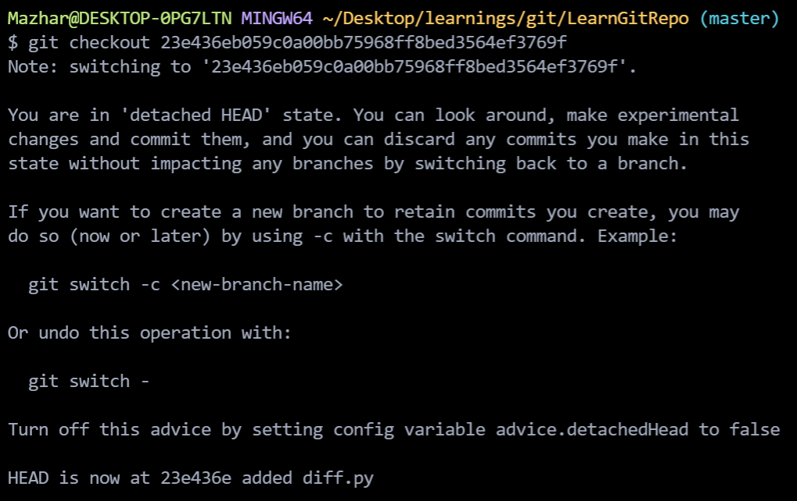

Here you can see that head is now at that commit.

If you do git log here then you will only see two commit because you are at that commits branch at that time we did only two commits and all those three commits are in master branch.

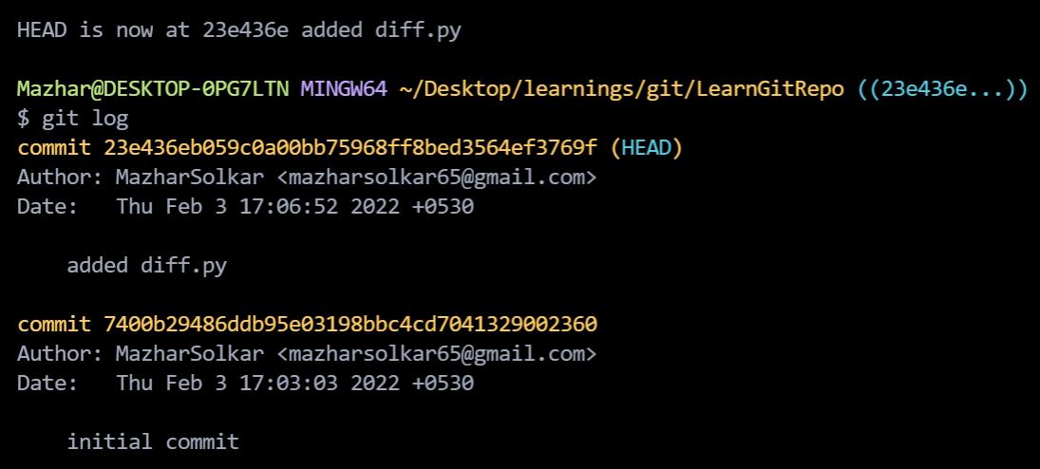

If you fire git branch command then you can see that head is at that commits branch in which you did git checkout “hashcodeofthatbranch”.

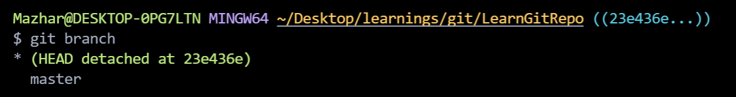

This is useful when you want to rollback to previous commit and want to make a branch from there.

Fire git checkout master then you will come into master branch.

Fired git log here you can see that three commits.

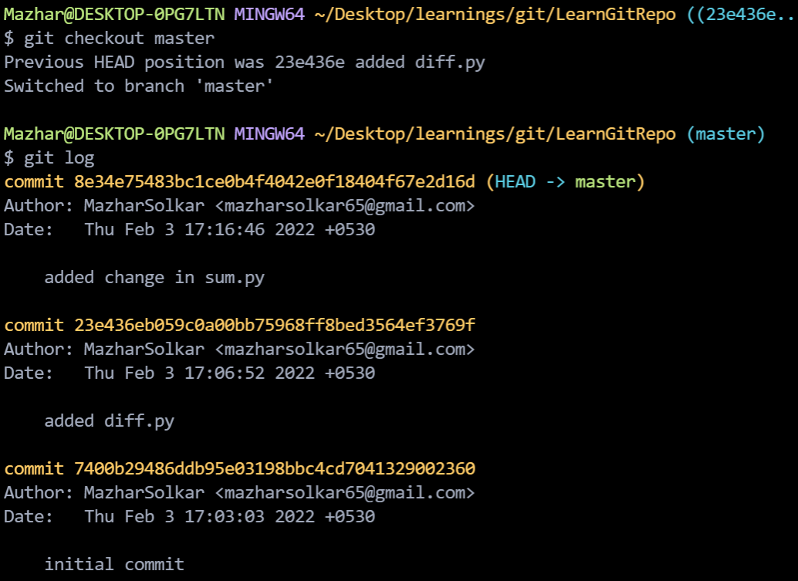

**Branching**

Fire git branch <branch_name> in the branch from where you want to make a new branch.

Fired git branch dev to create dev branch from master branch.

Fired git branch multiply to create multiply branch from dev branch.

In dev multiply.py file is created added to staging area and commited.

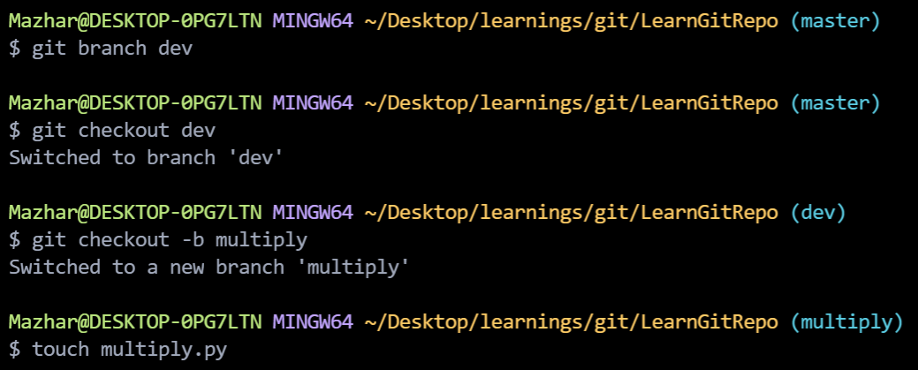

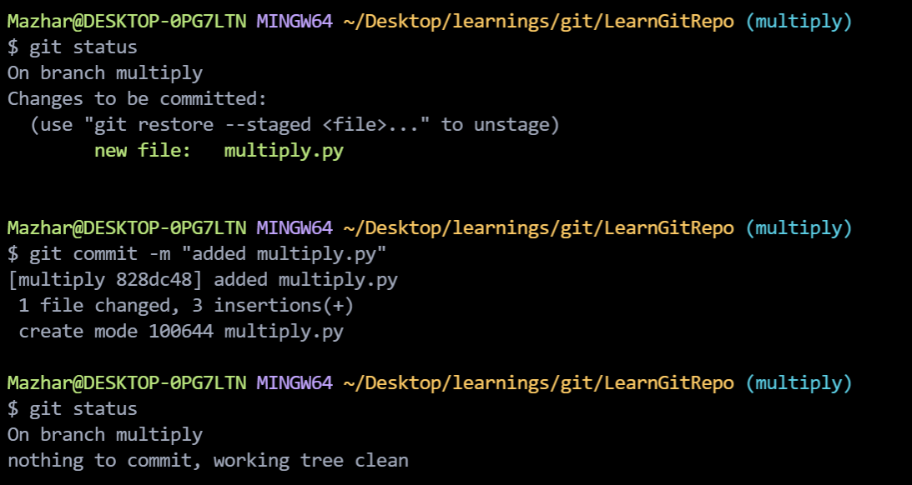

This changes will only be visible in multiply branch and they won’t affect other branch.

**Merge :-**

If you want all the changes of multiply branch into dev branch then you have to merge that branch in dev branch.

Come into dev branch since we want to merge multiply branch into dev branch.

Fired git merge multiply.

Now all the changes of multiply branch come into dev branch.

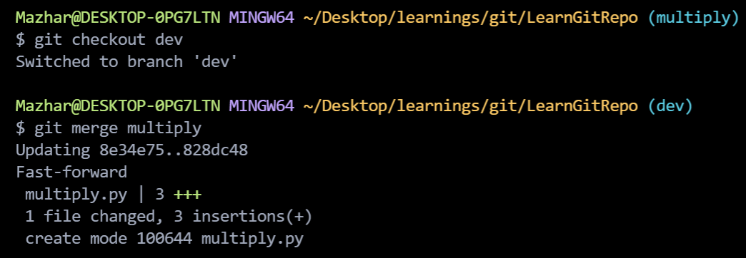

Now will merge dev branch into master branch.

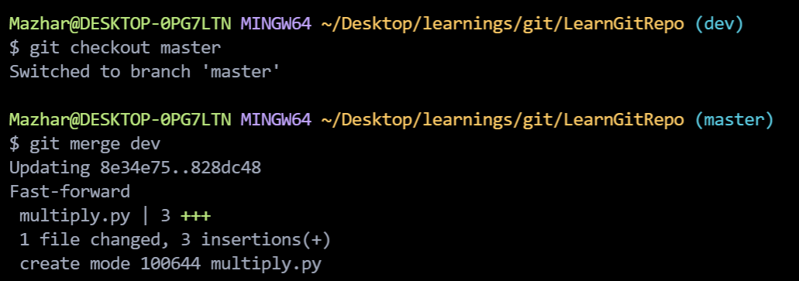

**GitHub**

First creat one repository

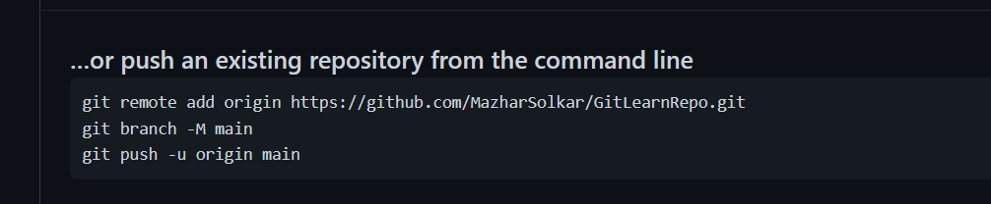

git remote add origin <https://github.com/MazharSolkar/GitLearnRepo.git>

run this in your terminal it tells local repo where is remote

repo or where it have to push the code.

git branch -M main

run above command in terminal

then run this

git push -u origin main

now refresh your browser you will see that code has been pushed there

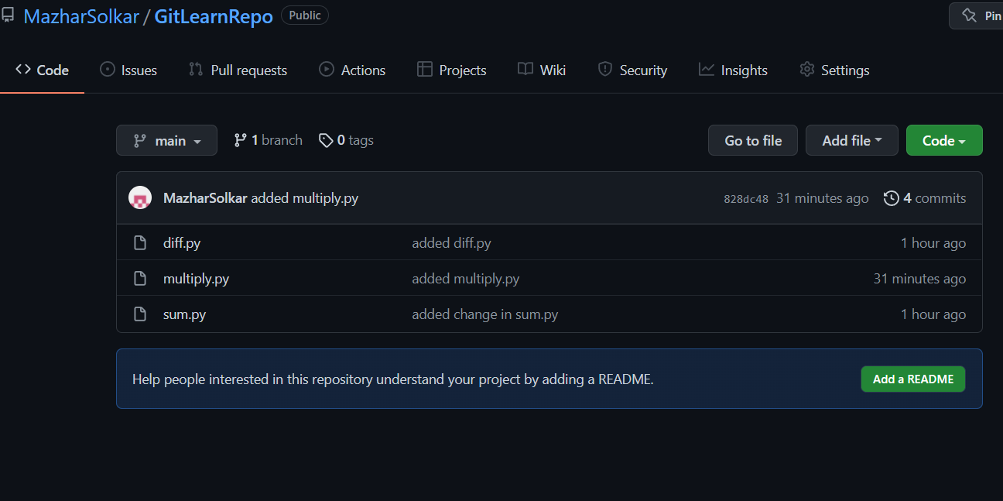

Now I will add some code in diff.py of main branch.

Add it in staging area and commit.

And push that on remote repository.

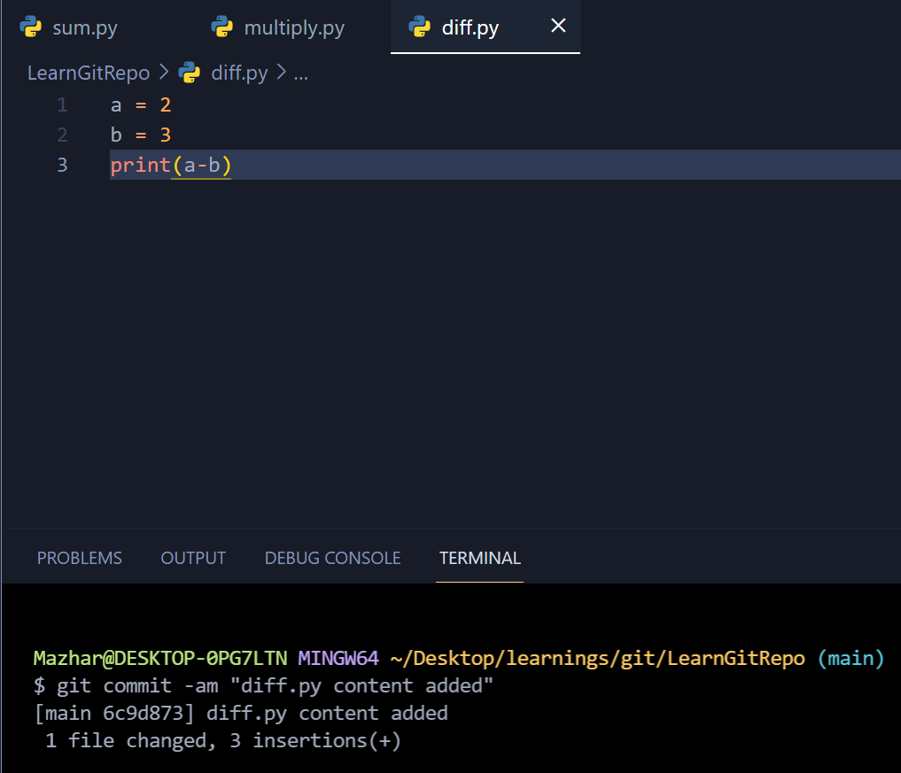

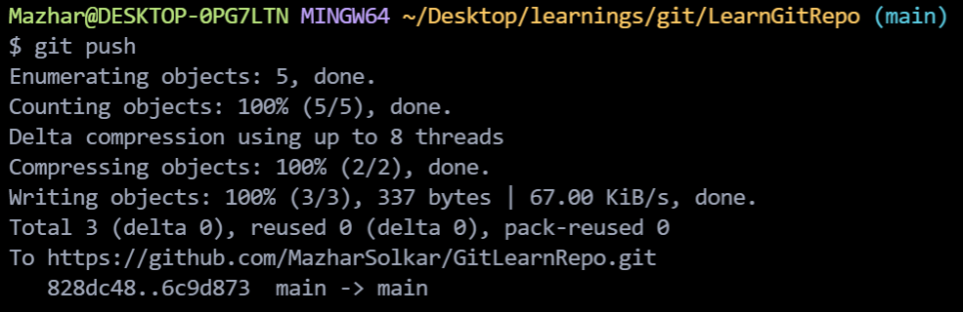

This time I can do git push instead of git push -u origin it will do the job (note: only in main branch to push other branches you have to write git push -u origin).

We only pushed our main branch now I will push my dev branch also

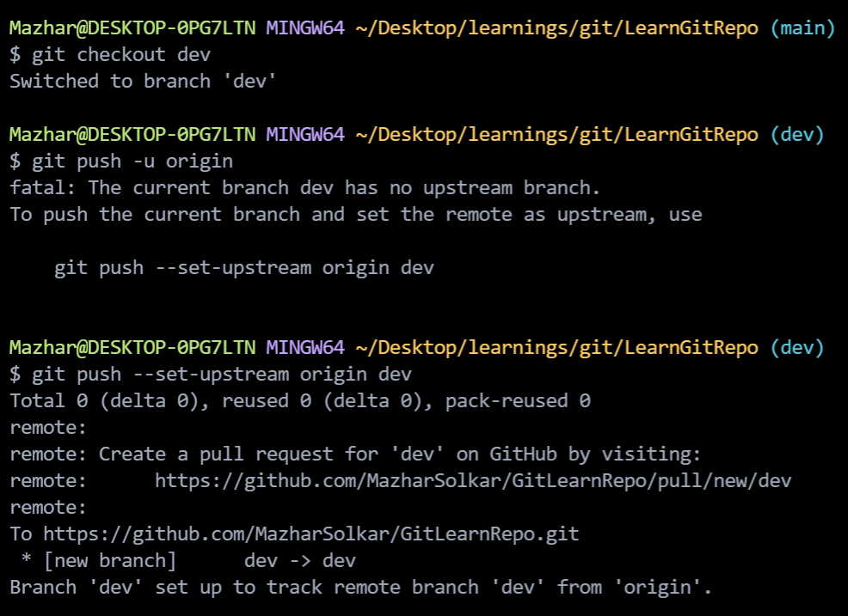

Now I will push my multiply branch

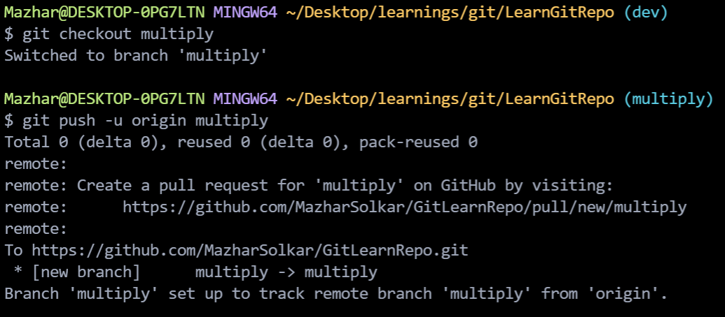

git pull command is used to pull the changes that are made on remote repository into local repo.

Print(“some new line”) is added in remote repos diff.py.

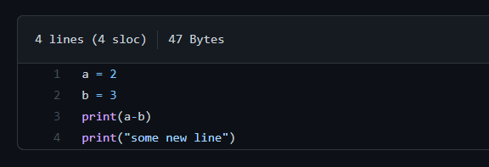

Fire git pull command to pull that changes in local repo.

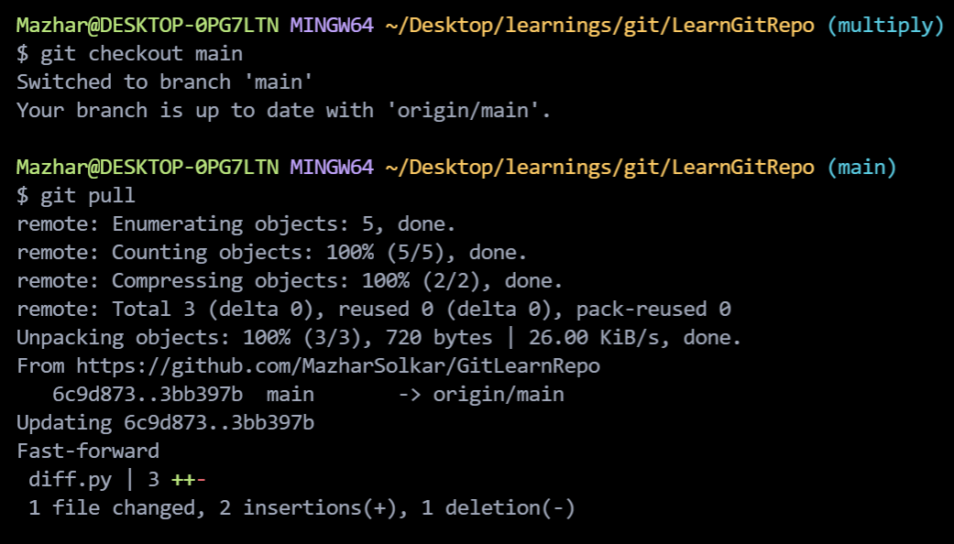

git push command is used to push the changes that are made on local repository to remote repository.

README.md :-

In this file we write description about our project.

.gitignore :-

Files that you don’t want to share aur sensitive files that you don’t want to other to see you mention those files name in .gitignore file.