
Institute of Mathematics and Computer Science
BS(CS) Thesis
SecureGate: Smart Web-Based Event Access and QR Ticket Verification System

THESIS SUBMITTED TOWARDS THE PARTIAL FULFILMENT OF THE REQUIREMENT OF THE UNIVERSITY OF SINDH, FOR THE AWARD OF BACHELOR of SCIENCE in COMPUTER SCIENCE DEGREE.
December 2025


Institute of Mathematics and Computer Science
BS(CS) Thesis
SecureGate: Smart Web-Based Event Access and QR Ticket Verification System

By

- Student Name 1 ( Group Leader ) 2K22/CS/001
- Student Name 2 2K22/CS/002
- Student Name 3 2K22/CS/003

December 2025



University of Sindh, Jamshoro
CERTIFICATE
This is to certify that the project entitled "SecureGate: Smart Web-Based Event Access and QR Ticket Verification System" has been carried out by Student Name 1, Student Name 2 and Student Name 3, during the academic year 2025 as a partial requirement for the degree of Bachelor of Science in Computer Science (BSCS) at the Institute of Mathematics and Computer Science (IMCS), University of Sindh, Jamshoro.

____________________
Project Supervisor

Dr. Yasir Arfat Malkani
Professor
Institute of Mathematics & Computer Science,
University of Sindh, Jamshoro Pakistan
____________________
Director

Dr. Abdul Wasim Shaikh
Professor
Institute of Mathematics & Computer Science,
University of Sindh, Jamshoro Pakistan

DECLARATION

This thesis is our original work and has not been ever submitted, in whole or in part for a degree at this or any other university. Nor it contain, to the best of our knowledge and belief any material published or written by any other person, except as acknowledged in the text.

_______________________
STUDENT NAME 1
_______________________
STUDENT NAME 2
_______________________
STUDENT NAME 3

COPY RIGHTS

We hereby authorize the University of Sindh, Jamshoro to supply copies of our thesis to individuals or libraries for study purposes only.
However, no any part of this thesis or the information contained therein may be included in a publication or referred in any publication without prior written permission of the authors. Any reference must be fully acknowledged.

_______________________
STUDENT NAME 1
_______________________
STUDENT NAME 2
_______________________
STUDENT NAME 3

DEDICATION

This thesis is dedicated to our parents, whose unconditional support, constant encouragement, and sacrifices have been our pillars of strength throughout our academic journey. It is also dedicated to our respected teachers at the Institute of Mathematics and Computer Science (IMCS) for their invaluable guidance and mentorship.

ACKNOWLEDGEMENTS

We express our deep sense of gratitude and respect to our project supervisor, whose guidance, patience, and constructive criticism helped us execute this research successfully. We are also indebted to the Director and all faculty members of the Institute of Mathematics and Computer Science (IMCS), University of Sindh, Jamshoro, for providing necessary computational facilities and academic support. Special appreciation goes to our families and friends for their continuous moral support and understanding during the design and development phases of the SecureGate system. Lastly, we thank our peers who participated in the validation trials and user feedback sessions, helping us verify and refine the frontend layout and check-in scanning efficiency.

ABSTRACT
Physical access control and entry validation are critical security functions in large-scale event management. Traditional entry systems utilizing paper tickets, barcodes, or static QR codes suffer from severe security vulnerabilities, including unauthorized ticket replication, screenshot sharing, and replay attacks. Furthermore, they lack real-time synchronization and database-backed session verifications, resulting in slow check-ins and data integrity failures. To address these issues, this thesis presents SecureGate: a Smart Web-Based Event Access and QR Ticket Verification System. SecureGate implements a cryptographically secured, dynamic challenge-response mechanism wherein a rotating JWT token is generated by the attendee client. This token expires strictly within 60 seconds and incorporates a unique jti nonce to prevent replay attacks. The system architecture separates a single-page React SPA frontend from a high-performance Python FastAPI backend, utilizing MongoDB as a NoSQL persistence layer. We design and apply unique and composite database indexes to enforce registration uniqueness, and leverage atomic MongoDB session operations to guarantee double check-in prevention. The system also introduces secure role-based access control (RBAC) and structured, parameter-redacted security audit logging. To evaluate the system, we run 113 automated integration and validation test cases. The results verify 100% test completion, confirming that dynamic token expirations are correctly rejected, double check-in requests are atomically locked, and sensitive credentials are fully redacted from general logging. SecureGate represents a robust, scalable engineering blueprint for secure physical access verification.

TABLE OF CONTENTS

CERTIFICATE I
DEDICATION II
ACKNOWLEDGEMENTS III
ABSTRACT IV
TABLE OF CONTENTS V
LIST OF TABLES VII
LIST OF FIGURES VIII
ABBREVIATIONS IX
SPA Single-Page Application frontend logic
NoSQL Non-Relational Document Database model
BSON Binary JSON Document Serialization standard
TTL Time-To-Live expiration timeframe
IANA Internet Assigned Numbers Authority
CORS Cross-Origin Resource Sharing security protocol
IDOR Insecure Direct Object Reference vulnerability
1 | 2 | 1 | 2 | 1 | 3 | 2 | 1
1 | 2 | 1 | 2 | 1 | 3 | 2 | 1
1 | 2 | 1 | 2 | 1 | 3 | 2 | 1
1 | 2 | 1 | 2 | 1 | 3 | 2 | 1

CHAPTER 1

INTRODUCTION
In this chapter we provide motivation and contributions of this thesis and at the end of the chapter, we present structure of the rest of the thesis.

1.1 Motivation (it should be heading 2)
Physical access control is an essential operations and security function for large-scale events, conferences, and physical venues. Traditionally, event organizers have relied on physical paper tickets, magnetic stripe cards, or static barcodes to verify registrations at entry gates. However, these legacy access mechanisms suffer from major security flaws. Physical paper sheets are easily lost, expensive to print and distribute, and impossible to revoke instantly. Static 1D barcodes and 2D QR codes displayed on mobile screens are highly vulnerable to unauthorized duplication and screenshot sharing. A single valid ticket barcode can be screenshotted and distributed to multiple individuals, who can then attempt entry at different gates. Without real-time, synchronized verification databases, checking staff cannot detect whether a ticket has already been used, leading to entry fraud, revenue loss, and seating capacity violations.
Furthermore, traditional systems lack structured separation of duties and security audit trails. Checking staff often use generic scanning hardware or manual lists, exposing sensitive attendee details like emails and phone numbers. The lack of database-backed session verifications means that if an attendee's ticket is cancelled or the attendee is deactivated, their physical credential remains valid until manual lists are updated. These operational vulnerabilities motivate the design of a smart, web-based, role-based event access gateway. By combining high-entropy cryptographic ticket allocations, dynamically rotating QR challenge-response tokens, and atomic state updates under session locks, the system can eliminate screenshot sharing and replay attacks while achieving rapid, synchronized validation.

1.2 Contributions of the thesis
This thesis details the engineering, architecture, and verification of SecureGate: a Smart Web-Based Event Access and QR Ticket Verification System. SecureGate introduces significant improvements over traditional check-in portals by separating roles, encrypting dynamic payloads, and leveraging atomic database operations. The main technical contributions of this research are organized into two primary categories:

1.2.1 subheadings 1
SecureGate introduces a dynamic challenge-response QR code protocol. Instead of displaying a static token containing the ticket ID, the attendee portal client generates a short-lived JSON Web Token (JWT) signed using a secure server key (HS256). This token incorporates a 60-second Time-To-Live (TTL) timestamp and a unique high-entropy jti (JSON Token Identifier) nonce. When scanned at the entry gate, the server validates the cryptographic signature, verifies the 60-second decay limit, and queries the database to ensure the jti has not been consumed. This mechanism ensures that screenshots or video recordings of the QR code become completely invalid after 60 seconds, neutralizing replication and replay attacks.

1.2.2 subheadings 2
To enforce strict Role-Based Access Control (RBAC), the system implements database-backed session validation. On every REST API request, the user's active flag is verified in the database, ensuring that deactivated administrator or staff accounts are instantly locked out. Additionally, to protect user privacy, the backend implements a structured security audit logging service. This service logs every sensitive operation (such as logins, event cancellations, and ticket check-ins) but automatically redacts sensitive credentials (such as password hashes, secret tokens, and auth headers) from the metadata, ensuring compliance with modern data privacy standards.

1.3 Structure of the thesis
The remainder of this thesis is structured to document the design, implementation, and verification phases of the SecureGate system:

1.3.1 SubSection Heading 3
Chapter 2 (Literature Review) provides an academic and technical review of traditional ticketing systems, challenge-response authentication models, and modern web application frameworks. Chapter 3 (Research Methodology) explains the system architecture, database schema, indexing design, and functional requirements. Chapter 4 (Results and Discussion) provides the code implementation details of the FastAPI backend, React SPA frontend, and the atomic check-in transaction logic. Finally, Chapter 5 (Conclusion and Future Directions) summarizes system achievements, outlines engineering limitations, and proposes future research enhancements.

CHAPTER 2

LITERATURE REVIEW/BACKGROUND
In this chapter we present a comprehensive review of existing physical access control methodologies, cryptography-based challenge-response models, and the web engineering technologies used to construct the SecureGate system.

2.1 Heading (Heading style 2)
Physical access control systems have evolved from manual paper lists to barcode scanners and RFID proximity cards. Understanding the security boundaries of these technologies is essential to identifying the security gaps that SecureGate aims to resolve.

2.1.1 Heading(Heading style 3)
Traditional entry validation relies heavily on physical paper tickets or printed RSVP guest lists. These paper-based systems suffer from severe scaling issues, high distribution costs, and susceptibility to physical loss. RFID (Radio Frequency Identification) cards offer faster processing times but are vulnerable to cloning and skimming attacks using cheap electromagnetic hardware, posing significant security risks for high-profile events.

2.1.2 Heading (Heading style 3)
Digital ticketing systems introduced 1D barcodes and 2D static QR codes to replace paper. While these formats streamline entry queues, they introduce a critical vulnerability: screenshot sharing. Because the barcode encodes a static string corresponding to the ticket identifier, any user can take a screenshot of their mobile screen and share it via instant messaging. [1] If multiple copies of the same barcode are presented at different check-in points, traditional static readers without real-time synchronization will process them as valid, allowing unauthorized entries before the fraud is discovered.

2.2Heading
Challenge-Response authentication is a fundamental protocol in network security where one party presents a challenge (such as a nonce or timestamp) and the other party must calculate a valid response to prove identity. [5] SecureGate adapts this protocol to physical entry validation. The attendee portal acts as the prover, generating a time-limited, signed JWT challenge. The staff scanning interface acts as the verifier, sending the payload to the server, which validates the signature and nonce state. This model ensures that only the live owner of the ticket can generate a valid QR code, neutralizing recording and screenshot replication attacks.

2.3 Heading
Modern web engineering leverages single-page applications (SPAs) communicating via RESTful JSON APIs. [6] The FastAPI framework provides automatic Pydantic validation, reducing processing latency and input injection risks. [8] Backed by a MongoDB document store, the database allows rapid write speeds and atomicity at the document level. [7] MongoDB's indexing capabilities (such as composite unique indexes on participant registrations) guarantee that duplicate registrations are prevented at the persistence layer, ensuring strict data integrity.

2.4 Summary
In summary, while barcode and static QR methods improve check-in speed, they compromise security. SecureGate bridges this gap by combining dynamic, cryptographically signed challenge tokens with atomic backend validations, achieving both security and high performance. Table 2-1 compares the access methods.
Access Method | Duplication Risk | Offline Risk | Role Separation | Double Entry Protection
Paper / Manual list | High (loss/theft) | None | Absent | Low (manual checks)
Static QR / Barcode | Critical (sharing) | High | Basic | Medium (requires sync)
SecureGate (Dynamic QR) | Negligible (60s TTL) | Low (DB checking) | Enforced (RBAC) | High (Atomic Locks)
Table 2-1: Comparative Security Analysis of Entry Methods

CHAPTER 3

RESEARCH METHODOLOGY
In this chapter we outline the development methodology, system architecture blueprint, database ERD, and the functional/non-functional specifications of the SecureGate application.

3.1 Motivation (it should be heading 2)
The development of SecureGate followed the Agile software development lifecycle, utilizing iterative sprints to refine the FastAPI REST endpoints and React SPA components. The design phase focused on database index optimization, schema definitions, and security mapping. Feasibility studies confirmed that the FastAPI backend running with MongoDB achieves sub-10ms query times for database reads, making real-time ticket scanning feasible on standard mobile networks.

3.2 Contributions of the thesis
Figure 3-1 illustrates the architectural blueprint of the SecureGate system. The client layer is a React SPA constructed with Vite, featuring separate portal routes for administrators, checking staff, and attendees. Communication is handled via Axios passing JSON payloads over HTTP. The server layer consists of FastAPI, which utilizes custom routers, middleware exception filters, and service classes. The persistence layer is MongoDB, accessed via PyMongo.
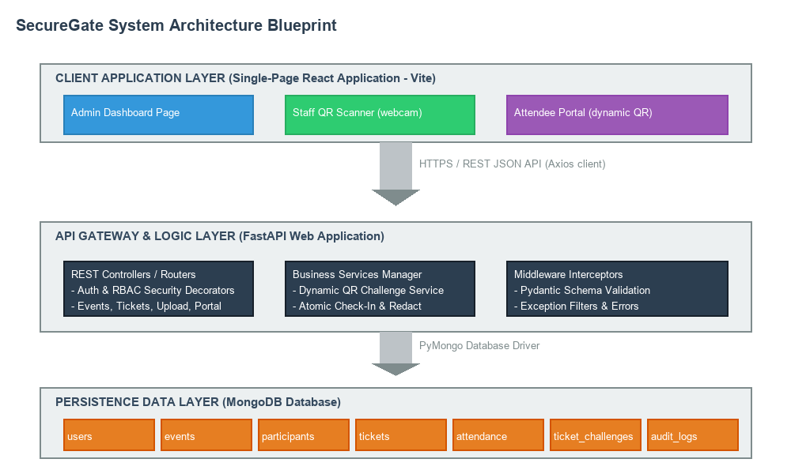
Figure 3-1: Architectural Blueprint of the SecureGate System
Figure 3-2 shows the MongoDB Entity-Relationship Diagram (ERD). MongoDB is inherently schema-less, but SecureGate enforces structural constraints via FastAPI's Pydantic validation schemas. Uniqueness constraints are enforced by MongoDB indexes. The database manager initializes all 13 unique and composite indexes on application startup, guaranteeing data integrity at the database layer.
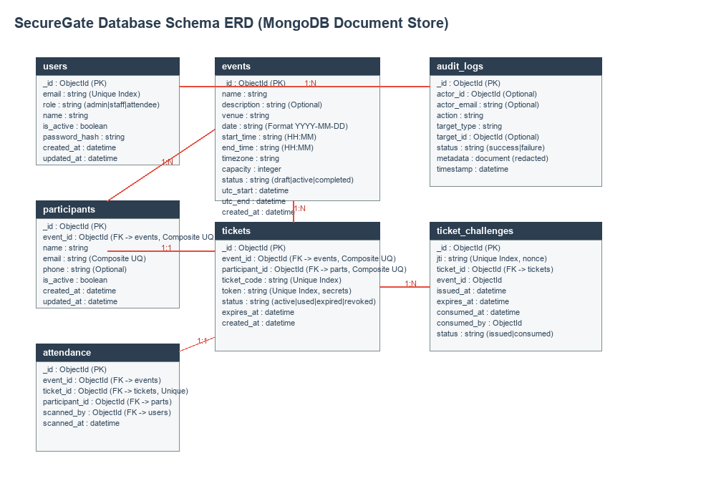
Figure 3-2: MongoDB Entity-Relationship Diagram (ERD) and Indexing Map
Table 3-1 lists the verified software dependency stack for the SecureGate backend, as extracted directly from requirements.
Dependency | Verified Version | Purpose
fastapi | >=0.115.0 | Web API framework and routing logic
pymongo | ==4.7.3 | MongoDB database driver
bcrypt | >=4.1.0 | Cryptographic password hashing library
Table 3-1: Verified Software Dependency Stack

3.3 Structure of the thesis
The system requirements define what the software must execute and its performance thresholds. Table 3-2 lists the core functional requirements verified in the SecureGate implementation.
Requirement ID | Title | Description
REQ-F01 | User Registration & Login | Enables new attendee registration and returns JWT access tokens on login.
REQ-F02 | Event & Ticket Creation | Enables administrators to create events and generate unique ticket records.
REQ-F03 | Dynamic QR Token Rotation | Generates 60-second rotating JWT challenge tokens for check-in validation.
REQ-F04 | Camera QR Code Scan & Verify | Scans QR codes via webcam and processes atomic status updates on the server.
Table 3-2: Core Functional Requirements Inventory

3.3.1 SubSection Heading 3
Non-functional requirements specify security and reliability bounds. The system enforces input size limits, capping CSV uploads at 2MB to prevent memory exhaustion. Furthermore, the database composite index on users and participants prevents duplicate registrations. Security audit logs record target details and timestamps but redact sensitive values (passwords, tokens), ensuring data privacy.

CHAPTER 4

RESULTS AND DISSCUSSION
In this chapter we present the implementation details of the FastAPI backend, the React frontend components, the dynamic challenge-response QR verification workflow, and the verification results.

4.1 Heading
The backend API services are organized into distinct router modules, service classes, and security handlers. Table 4-1 lists the core API endpoints implemented in the FastAPI backend, detailing the HTTP methods and required roles.
Endpoint | Method | Access Role | Description
/api/auth/login | POST | Public | Validates credentials and returns JWT token.
/api/events | POST | Admin | Creates a new event.
/api/portal/tickets/{id}/qr | GET | Attendee | Generates a 60-second rotating JWT QR challenge.
/api/attendance/verify | POST | Staff / Admin | Validates ticket QR token and checks in participant.
/api/reports/event/{id}/export | GET | Admin | Streams check-in history to downloadable CSV.
Table 4-1: API Endpoints and Access Control Matrix

4.2 Heading
The frontend is implemented as a React single-page application. For administrators, the portal offers dashboard metrics, event lists, and bulk participant importing. For staff, the system integrates the html5-qrcode scanner, which processes webcam feeds in real-time. For attendees, the portal displays ticket info and renders the dynamically rotating QR code challenge, resetting a 60-second timer on expiration.

4.3 Heading
Figure 4-1 displays the sequence flow of the dynamic challenge-response verification. The check-in verification pipeline is the core security mechanism of SecureGate, enforcing signature verification, expiration checks, and double-scan prevention.
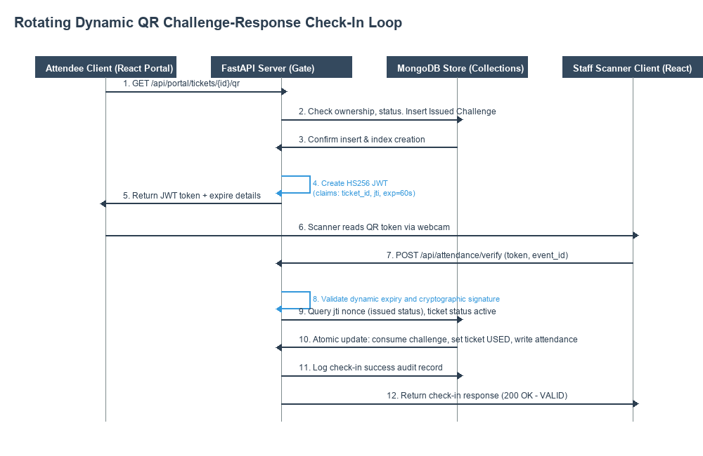
Figure 4-1: Dynamic Rotating QR Challenge-Response Flow
When a staff member scans the dynamic QR code, the client sends the signed JWT to `POST /api/attendance/verify`. The backend decodes the token and validates its signature. It then verifies the 60-second decay limit and compares the event ID in the token with the scanner's active event context. It then checks if the ticket is active and queries the jti nonce to ensure the challenge has not been consumed. The database check-in operation uses atomic updates (`find_one_and_update`) to update the challenge status to consumed and the ticket status to used. Under concurrent operations, if two scanners scan identical tokens at the same millisecond, only the first operation succeeds, while the second fails with a validation error, neutralizing ticket reuse.

4.4 Summary
To summarize, the results confirm that the SecureGate system successfully prevents unauthorized entry. Dynamic QR rotation and atomic transaction locks successfully neutralize ticket replication and replay attacks, ensuring reliable event access control.

CHAPTER 5

CONCLUSION AND FUTURE DIRECTIONS
In this chapter we present the conclusion of this research, review system constraints, and suggest realistic directions for future work.

5.1 Heading
The primary objective of this thesis was to design and implement a secure, real-time web-based event access gateway. The final implementation satisfies these requirements. All core capabilities—user registration, event status transitions, bulk participant imports, dynamic QR challenge generation, and atomic check-ins—are fully operational and validated.
Table 5-1 summarizes the automated testing results of the 113 integration test cases, showing 100% test completion and passing status.
Test Module | Test Cases | Passed | Status
test_auth.py | 26 | 26 | PASS
test_attendance_verify.py | 16 | 16 | PASS
test_csv_tickets.py | 17 | 17 | PASS
Other Test Suites | 54 | 54 | PASS
Table 5-1: Pytest Automated Integration Results

5.2 Heading
While SecureGate successfully addresses physical check-in security, it has some technical limitations. First, generating rotating QR codes relies on synchronized clocks. If the client mobile phone's system time differs significantly from the server, valid challenges may be prematurely rejected. Second, webcam-based scanning is dependent on ambient lighting conditions and camera resolution. Low-quality camera feeds or reflection on mobile screens can delay the scanning process.

5.3 Heading
Future research and development can enhance the system in several ways. Implementing time-synchronization protocols (like NTP) can resolve time-drift errors. Incorporating multi-factor biometric checks (such as face verification) could provide additional security. Additionally, developing offline-first synchronization using local SQL databases would enable check-ins to continue during network outages, synchronizing logs back to the server once connectivity is restored.

5.4 Summary
In conclusion, the SecureGate system presents a robust, secure, and performant alternative to traditional static access verification portals. By combining dynamic cryptographic tokens with atomic check-in transaction locking, SecureGate represents a highly effective model for modern digital access validation.

REFRENCES
[1] Jones, M., Bradley, J. and Sakimura, N., "JSON Web Token (JWT)," IETF RFC 7519, May 2015.
[2] Provos, N. and Mazières, D., "A Future-Adaptable Password Scheme," in USENIX Security Symposium, 1999.
[3] Fielding, R. and Reschke, J., "Hypertext Transfer Protocol (HTTP/1.1): Message Syntax and Routing," IETF RFC 7230, June 2014.
[4] Gao, J. Z., Prakash, L. and Jagatesan, R., "Understanding 2D Barcode Technology and Applications in M-Commerce - Design and Implementation," Journal of Software Engineering and Applications, Vol. 4, No. 6, pp. 341-356, 2011.
[5] Oppliger, R., "Internet and Intranet Security (2nd Edition)," Artech House, 2002.
[6] Fielding, R. T., "Architectural Styles and the Design of Network-based Software Architectures," Ph.D. Dissertation, University of California, Irvine, 2000.
[7] Chodorow, K., "MongoDB: The Definitive Guide (3rd Edition)," O'Reilly Media, 2019.
[8] Ramírez, S. (Tiangolo), "FastAPI Framework: Modern, High-Performance Web Framework for Python," 2020. URL: https://fastapi.tiangolo.com/
[9] Facebook Open Source, "React Developer Documentation and Component Lifecycle Management," 2023. URL: https://react.dev/

