Superior University, Lahore
Gold Campus
Department of Computer Science
Final Year Project
Project Documentation
(Software Requirements & Design Specification)
Journey Junction
AI-Powered Smart Travel Planning & Document Verification Web Application
Submitted To
Sir Talha (Project Supervisor)
Submitted By — Group 12
Session 2023–2027 | October 2026

Table of Contents
Table of Contents
Abstract
1. Introduction
1.1 Overview
1.2 Problem Statement
1.3 Proposed Solution
1.4 Objectives
1.5 Scope
1.6 Target Users
1.7 Significance
2. Functional Requirements
2.1 Trip Planning
2.2 AI Travel Assistant
2.3 Document Verification (flagship)
2.4 Travel Requirements & Visa Types
2.5 Subscriptions & Entitlements
2.6 Admin Panel
2.7 Notifications
3. Non-Functional Requirements
Security
Performance
Scalability
Usability & Responsiveness
Reliability
4. System Architecture
5. Technology Stack
6. Database Design
7. AI Modules & Evaluation
7.1 Chatbot
7.2 Document OCR
7.3 Measured Accuracy
8. External Integrations
9. Security
10. Testing & Quality Assurance
11. Deployment
12. Conclusion & Future Work
13. System Design Diagrams
13.1 Use Case Diagram
13.2 Block Diagram
13.3 System Architecture Diagram
13.4 Sequence Diagram — Plan a Trip
13.5 Sequence Diagram — Verify Document
13.6 Activity Diagram — Document Verification
13.7 Class Diagram — Identity, Travel & Documents
13.8 Class Diagram — Billing, Locations & AI
13.9 Entity-Relationship (ER) Diagram
13.10 Deployment Diagram

Abstract
Journey Junction is an AI-powered smart travel planning web application that lets a traveller plan an entire trip from a single destination input. It assembles flights, hotels and a budget-aware day-by-day itinerary, answers visa and travel questions through a grounded AI assistant, and — as its flagship feature — verifies and corrects travel documents using AI-powered OCR before departure. For each trip it also presents the destination's full travel requirements: the available visa types with fees and conditions, a document-compliance check against the traveller's own verified documents, health and customs rules, and a step-by-step preparation guide (passport, attestation, visa, vaccinations, booking) with official-source links.
The system is built with a free-and-open-source-first philosophy. The backend uses Python with FastAPI and an async SQLAlchemy data layer (PostgreSQL in production, SQLite for tests); the frontend uses Next.js, React and TypeScript with Tailwind CSS and Framer Motion. AI is provided by Google Gemini 2.5 Flash (chat and vision OCR), flights by Travelpayouts/Aviasales, hotels by Geoapify, payments by Stripe, email/marketing by Klaviyo and messaging by the Meta WhatsApp Cloud API — each with a graceful mock fallback. The initial market covers Pakistan, the United Arab Emirates and Saudi Arabia, including Umrah and Hajj pilgrimage support, and is fully data-driven for expansion. All six external integrations are live, the backend passes 95 automated tests, and the measured chatbot and OCR accuracy meet the project's 90% target.

1. Introduction

1.1 Overview
Travel planning today is fragmented. A traveller typically visits many different websites to search for flights, compare hotels, estimate budgets, check visa rules and prepare documents, then stitches the results together manually. Journey Junction unifies this into one intelligent platform that plans the trip, advises the traveller and verifies their documents, reducing the time, cost and risk involved.

1.2 Problem Statement
Planning a trip, whether domestic or international, is often complex, time-consuming and error-prone:
- Travellers must visit multiple platforms to search for flights, hotels, prices and travel requirements.
- Information is often scattered, inconsistent or outdated.
- Travel agents charge high fees for basic services such as document verification and correction.
- Many travellers face visa rejections or delays due to small mistakes in travel documents.
- Non-technical or first-time travellers struggle to plan a complete trip efficiently.
- There is no single intelligent platform offering end-to-end planning together with AI document verification.

1.3 Proposed Solution
We propose an AI-powered smart travel planning web application that acts as a one-stop solution: destination-based planning, real flight and hotel options, budget-aware itineraries, a grounded AI travel assistant, and AI OCR document verification with correction and visa-compliance checking — all behind secure authentication, role-based access and subscription-based feature control.

1.4 Objectives
- Provide destination-based, end-to-end travel planning from a single input.
- Deliver real flight and hotel search with price, schedule and amenity comparison, plus authentic booking links.
- Generate personalised, budget-aware itineraries.
- Offer an AI travel assistant for travel and visa guidance, with official-source links and follow-up suggestions.
- Provide AI-powered OCR document verification, correction and compliance checking.
- Present complete destination travel requirements: visa types, fees, documents, health rules and a preparation guide.
- Enforce secure authentication, role-based access and subscription-based feature control.
- Achieve a measured accuracy of at least 90% for the chatbot and OCR modules.

1.5 Scope
The current version supports Pakistan (the home market), the United Arab Emirates and Saudi Arabia — including Umrah and Hajj pilgrimage journeys — implemented through a fully configurable, database-driven model (countries, cities, currencies, visa rules, requirements and preparation guides are data, not code). This allows expansion to further markets without rewriting the application.

1.6 Target Users
- Domestic and international travellers
- Umrah and Hajj pilgrims
- Business travellers
- Families and tourists
- First-time travellers
- Budget and luxury travellers
- Individuals planning trips without travel agents

1.7 Significance
Journey Junction reduces the time, cost and uncertainty of travel planning. Its unique AI document-verification feature helps travellers avoid visa rejections caused by small document errors, and its requirement and preparation guidance makes complex journeys — especially Umrah and Hajj — approachable for non-expert travellers.

2. Functional Requirements

2.1 Trip Planning
A user enters a destination, optional origin, dates, budget tier (low/medium/luxury), traveller count and trip purpose (tourism, Umrah or Hajj). The system returns suggested flights and hotels, a day-by-day itinerary, and the destination's travel requirements. Flights come from Travelpayouts (real cached fares) and hotels from Geoapify (real hotels), each with a booking/verify link; a mock provider fills in when live data is unavailable so the UI is never empty.

2.2 AI Travel Assistant
A chatbot answers questions about visas, flights, hotels and planning. It is grounded on the application's own verified knowledge base (visa rules, visa types, required documents, health rules and market data) so it does not invent facts; when unsure it says so and points to official sources. Each reply includes official-source links to verify the answer and context-aware follow-up questions the user can tap.

2.3 Document Verification (flagship)
A user uploads a passport, visa, ticket or ID (JPG/PNG/PDF). The file is validated (magic-byte check), encrypted at rest and auto-deleted after a retention period. AI OCR (Gemini Vision) extracts the fields; rule validation detects expiry, missing fields, bad formats and mismatches; the result lists issues with suggested corrections and a confidence score, and checks the document against the destination's requirements.

2.4 Travel Requirements & Visa Types
Each trip shows the destination's entry requirements: available visa types (e.g. UAE 30/60-day and 5-year multi-entry; Saudi tourist eVisa, Umrah visa via Nusuk, Hajj visa) with duration, fee and conditions; a required-document compliance check that marks each document verified or not based on the user's uploaded documents; passport-validity, health/vaccination, currency, customs and emergency information; and a numbered step-by-step preparation guide with indicative fees, timelines and official-source links.

2.5 Subscriptions & Entitlements
Free, Pro and Business plans are seeded with per-feature monthly limits (e.g. chatbot messages, OCR documents). Limits are enforced server-side via usage counters. Paid plans use Stripe Checkout and the Billing Portal, with webhook signature verification keeping subscription state in sync.

2.6 Admin Panel
Permission-gated administration: dashboard statistics and real integration health; user management (search, enable/disable, verify, roles); a plan-entitlement editor (enable/disable features and set monthly limits); visa-rule create/update/delete; and an audit log of every administrative action.

2.7 Notifications
Event-driven notifications (welcome, trip created, document verified) are sent over WhatsApp (Meta Cloud API) and email/marketing events to Klaviyo (which drives Klaviyo Flows). WhatsApp business-initiated messages fall back to an approved template outside Meta's 24-hour window.

3. Non-Functional Requirements

Security
Argon2id password hashing, JWT access tokens with rotating single-use refresh tokens, server-side RBAC, input validation, security headers, strict CORS, rate limiting, upload hardening, PII encryption with short retention, and webhook signature verification.

Performance
Async I/O throughout, selectin eager-loading, database indexes and an in-process TTL cache for reference data; the production frontend ships stable, optimised bundles.

Scalability
A clean modular monolith with well-defined module boundaries that can later be split into services; stateless API suitable for horizontal scaling.

Usability & Responsiveness
A modern, animated interface that is fully responsive from phones to large monitors; honest AI (confidence shown, sources linked); accessibility via reduced-motion support.

Reliability
Every external integration has a graceful mock/fallback path, so the application remains functional even when a provider is unavailable or rate-limited.

4. System Architecture
Journey Junction is a modular monolith. The Next.js frontend communicates with a FastAPI backend over a versioned REST API (/api/v1). The backend is organised into modules: authentication, users, admin, subscriptions, payments, travel, documents, AI/chatbot, OCR, notifications, locations/requirements, audit and configuration. External travel, AI, payment and messaging providers sit behind provider abstractions so they can be swapped or mocked.
Data is stored in PostgreSQL (SQLite in tests via a portable UUID type). Uploaded documents are encrypted and stored as blobs. The system boots without any external service — a health/readiness endpoint reports the live/mock status of each dependency.
Request flow: the browser calls the frontend, which calls the FastAPI API; the API applies authentication and RBAC, executes business logic, calls providers (with fallback), persists to the database, and returns typed responses. Administrative writes are recorded in an audit log.

5. Technology Stack
Layer | Technology
Backend | Python 3.12, FastAPI, SQLAlchemy (async), Alembic migrations, Pydantic v2
Frontend | Next.js 16, React 19, TypeScript, Tailwind CSS v4, Framer Motion
Database | PostgreSQL 16 (production); SQLite (tests, via portable GUID type)
AI | Google Gemini 2.5 Flash — chat and vision OCR
Flights | Travelpayouts / Aviasales (free cached fares) + mock fallback
Hotels | Geoapify Places (real hotels; prices estimated) + mock fallback
Payments | Stripe (test mode) — Checkout, Billing Portal, webhooks
Email / marketing | Klaviyo (event-driven Flows)
Messaging | Meta WhatsApp Cloud API
DevOps | Docker, docker-compose, GitHub Actions CI/CD
Note: the project originally planned Amadeus Self-Service for flights and hotels, but Amadeus retired its free self-service tier in July 2026. Flights therefore use Travelpayouts and hotels use Geoapify; the Amadeus adapter remains in the codebase but is unused.

6. Database Design
The schema (PostgreSQL only) is organised into logical groups with UUID primary keys, timestamp mixins, encrypted PII and ownership-based (IDOR-safe) access:
- Identity & access: users, roles, permissions, role_permissions, user_roles, refresh_tokens, email_verifications, password_resets.
- Billing: plans, plan_features, subscriptions, payments, usage_counters.
- Locations & requirements: countries, cities, currencies, visa_rules, country_requirements (visa types, documents, health, preparation), app_config.
- Travel: trips (with purpose: tourism/umrah/hajj), trip_items.
- Documents: documents, document_files (encrypted), document_analyses, extracted_fields.
- AI & chat: chat_conversations, chat_messages, ai_requests.
- Operations: notifications, audit_logs.

7. AI Modules & Evaluation

7.1 Chatbot
The assistant detects intent, extracts the route, and grounds its answer on verified facts from the database (visa rules, visa types, required documents, health rules and market data). Gemini generates the natural reply; if Gemini is unavailable or rate-limited, a deterministic grounded fallback composes the same facts into a complete answer. Each reply carries official-source links and context-aware follow-up suggestions.

7.2 Document OCR
Uploaded documents are processed by Gemini Vision to extract structured fields, which are then validated by rules (expiry, missing fields, format, nationality/issuing-country mismatch). The result reports issues, suggested corrections, a confidence score and a compliance check against the destination's requirements.

7.3 Measured Accuracy
Accuracy is measured, not assumed. Evaluation datasets and results are recorded in AI_EVALUATION.md (chatbot intent and grounding) and OCR_EVALUATION.md (document field extraction). Both modules meet the project's 90% accuracy target.

8. External Integrations
Integration | Purpose | Status
Google Gemini | Chatbot + vision OCR | Live
Travelpayouts / Aviasales | Flight fares + booking links | Live (mock fallback)
Geoapify Places | Real hotels + booking links | Live (mock fallback)
Stripe | Subscriptions & payments | Live (test mode)
Klaviyo | Email / marketing events | Live
Meta WhatsApp Cloud API | Notifications | Live (template fallback)
Amadeus Self-Service | Flights/hotels (legacy) | Retired by provider; unused
All secrets are stored only in a gitignored environment file and are never committed. Each integration degrades gracefully to a mock if its key is absent.

9. Security
- Passwords hashed with Argon2id; JWT access tokens (short-lived) with rotating, single-use, revocable refresh tokens.
- Role-based access control enforced server-side via roles and permissions.
- Input validation (Pydantic), security headers, correlation IDs, strict CORS and request rate limiting.
- File-upload hardening (type and magic-byte checks, size limits), PII encryption and short retention with auto-delete.
- Stripe and WhatsApp webhook signature verification; a production boot guard that refuses to start with a default secret key.
- Dependency scanning (pip-audit, npm audit) and secret scanning (gitleaks) run in CI on every push.

10. Testing & Quality Assurance
The backend has 95 automated tests (pytest) covering authentication and RBAC, travel planning with requirements, visa types and pilgrimage rules, the chatbot and its grounding evaluations, document OCR and its evaluations, billing and entitlement enforcement, the admin panel, notifications, a full end-to-end user journey, an access-control matrix and an adversarial security audit. Tests run on in-memory SQLite for speed and portability.
The frontend production build compiles cleanly (TypeScript and lint pass) across all routes. GitHub Actions CI runs the backend tests, the frontend build, dependency audits and secret scanning on every push and pull request.

11. Deployment
The application is containerised (Docker for the backend and the frontend, orchestrated by docker-compose) and includes a Render blueprint (render.yaml) for the API and a managed PostgreSQL database, with the frontend intended for Vercel. Continuous integration runs on GitHub Actions.
For demonstration, the application is served from a production Next.js build and the FastAPI backend behind a secure public tunnel (ngrok), using a single-origin proxy so one URL serves both the frontend and the API. This temporary hosting is available while the development machine and tunnel are running; a permanent Render + Vercel deployment is the final optional step.

12. Conclusion & Future Work
Journey Junction delivers an end-to-end, AI-powered travel planning experience with a unique document-verification capability and comprehensive, data-driven travel-requirement guidance for Pakistan, the UAE and Saudi Arabia, including Umrah and Hajj. All six external integrations are live, the system is secure and well-tested (95 passing tests), and the interface is modern and fully responsive.
Future work includes a permanent cloud deployment (Render + Vercel), approved custom WhatsApp message templates, expansion to additional markets and languages, deeper personalisation, and native mobile applications.

13. System Design Diagrams
This section presents the software-engineering design diagrams for Journey Junction. They model the system's actors and functions, structure, behaviour, data and deployment, and reflect the implemented application.

13.1 Use Case Diagram
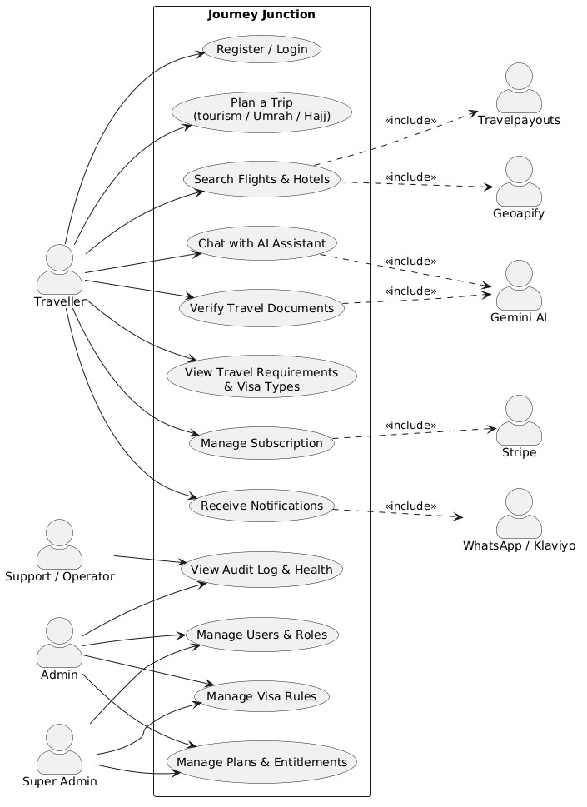
Figure 13.1 — Actors (Traveller, Support, Admin, Super Admin, and external services) and the system's use cases.

13.2 Block Diagram
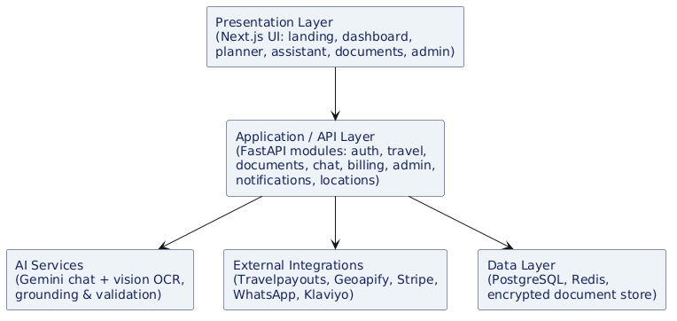
Figure 13.2 — High-level layered blocks: presentation, application/API, AI services, external integrations and data.

13.3 System Architecture Diagram
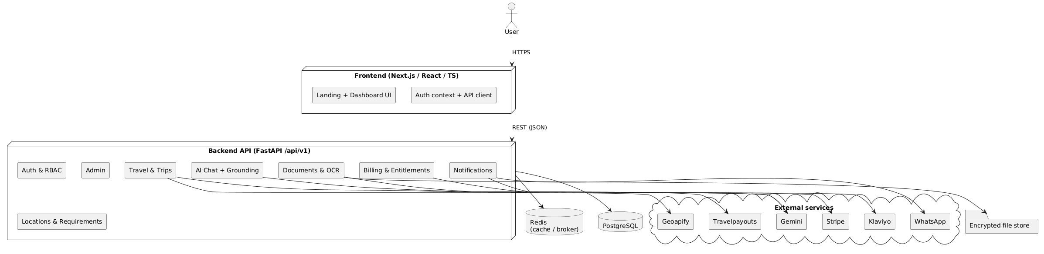
Figure 13.3 — Frontend, FastAPI backend modules, data stores and external providers.

13.4 Sequence Diagram — Plan a Trip
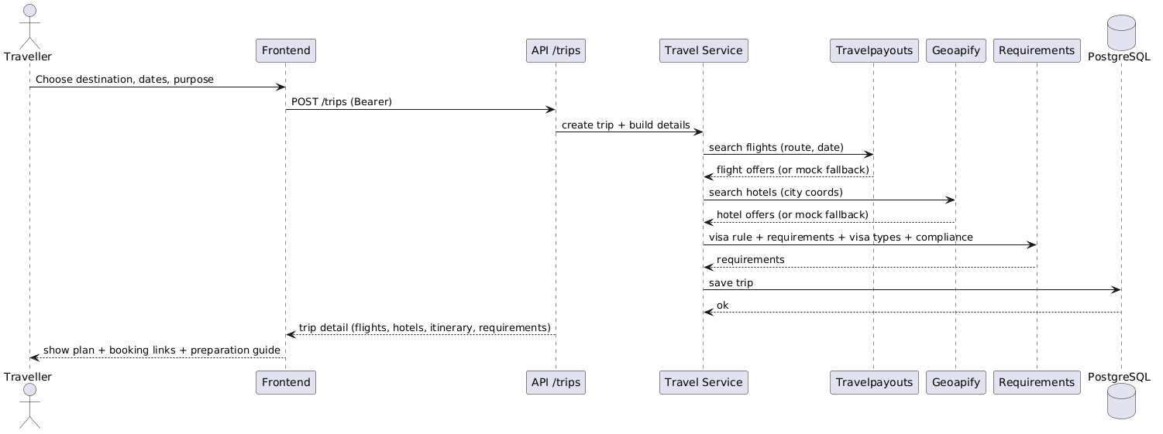
Figure 13.4 — Interaction when a user plans a trip (flights, hotels, requirements).

13.5 Sequence Diagram — Verify Document
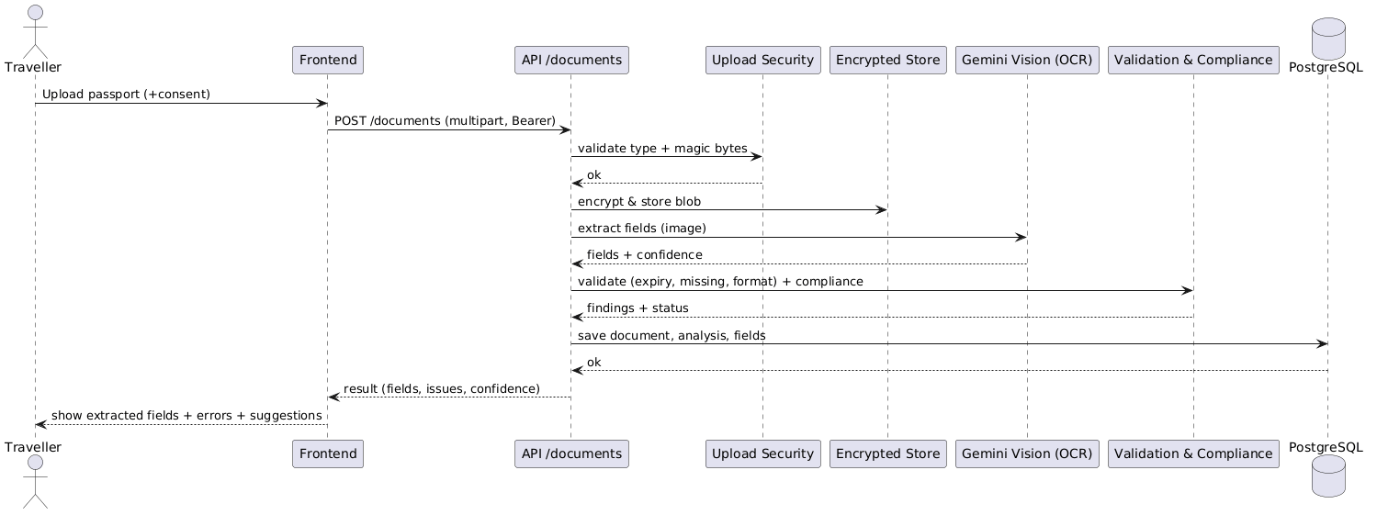
Figure 13.5 — Interaction for AI document verification (upload, OCR, validation, compliance).

13.6 Activity Diagram — Document Verification
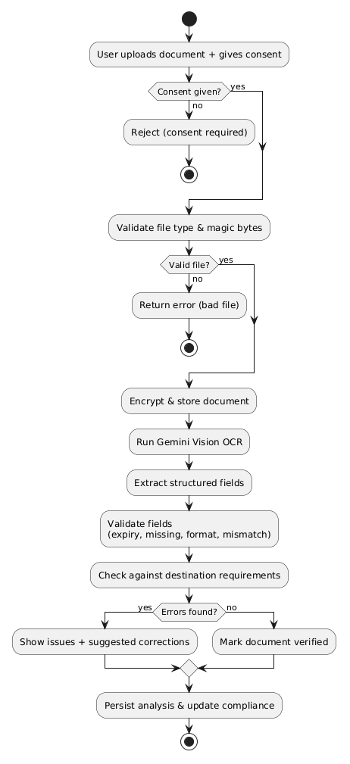
Figure 13.6 — Workflow and decisions of the document-verification process.

13.7 Class Diagram — Identity, Travel & Documents
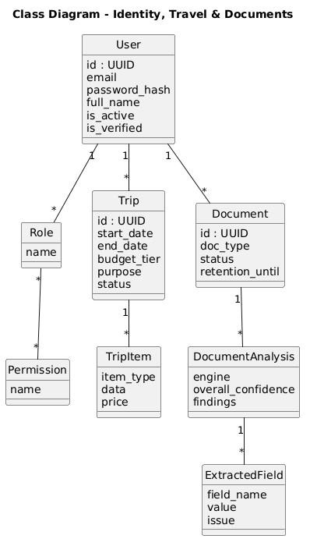
Figure 13.7 — Core domain classes for users, trips and documents.

13.8 Class Diagram — Billing, Locations & AI
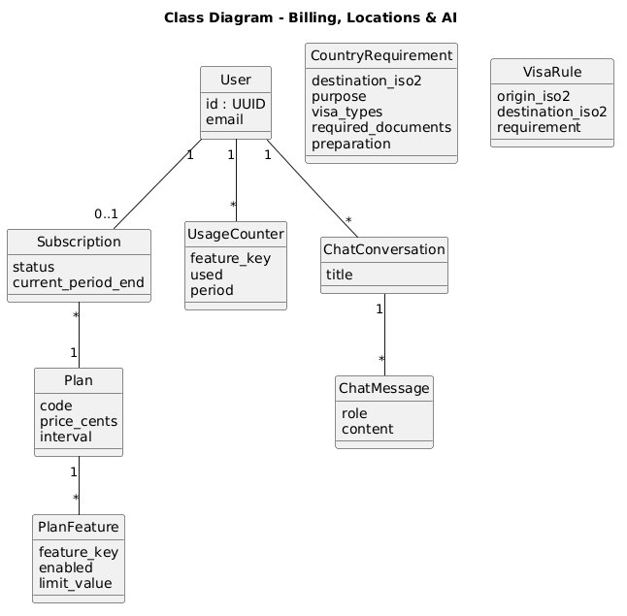
Figure 13.8 — Classes for subscriptions, requirements and the AI assistant.

13.9 Entity-Relationship (ER) Diagram
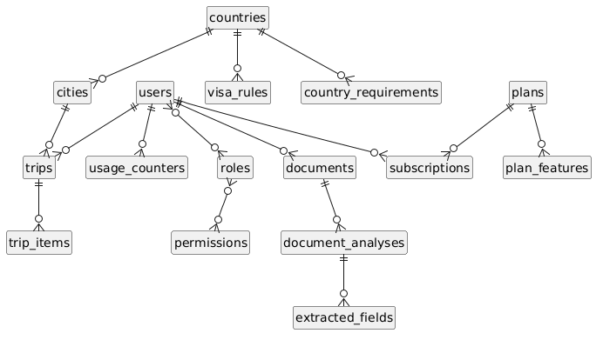
Figure 13.9 — Database entities and their relationships.

13.10 Deployment Diagram
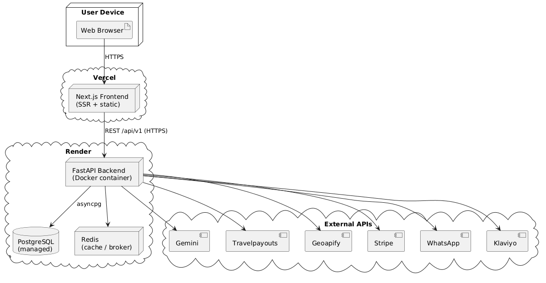
Figure 13.10 — Runtime nodes: browser, Vercel frontend, Render backend + Postgres + Redis, and external APIs.

