**Assignment:**

1. Create the following charts using your project dataset:

* One line chart
* One bar chart
* One scatter plot
* One pie chart

1. Save each chart using:
2. plt.savefig('filename.png')
3. Submit a short presentation (PPT or PDF) of your visualizations with interpretations.

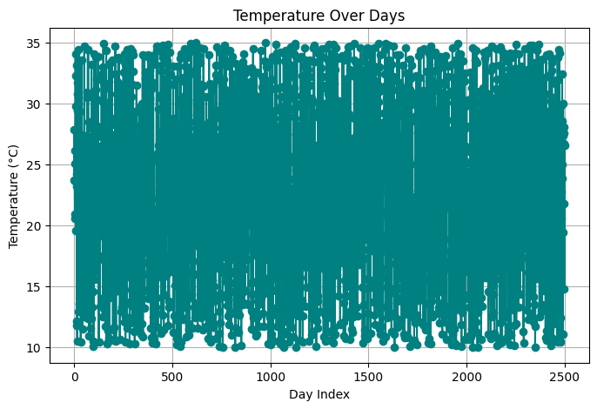

Fig 1: Line Graph

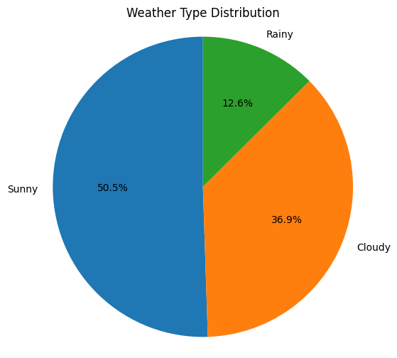

Fig 2: Pie Chart

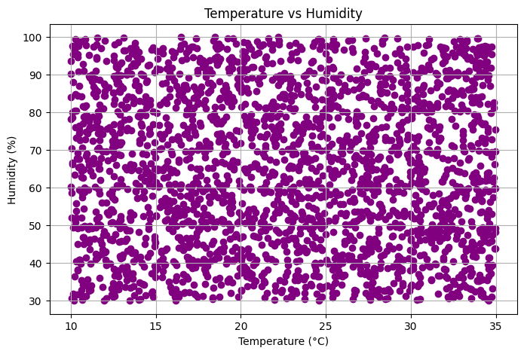

Fig 3: Scatter plot

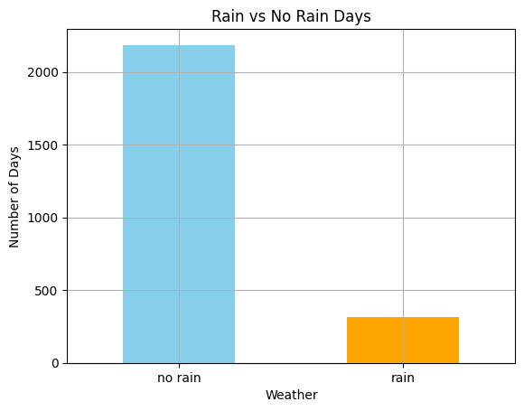

Fig 4: Bar Chart