Assignment

1)

#include<stdio.h>

float sumaver(int x,int y)

{

int sum;

sum = x +y;

printf("\nSum of %d and %d = %d\n",x,y,sum);

return sum/2;

}

void printeven(int x,int y)

{

int i;

printf("\n\nThe even numbers between %d and %d are \t",x,y);

if(y>x)

{

for(i=x+1;i<y;i++)

{

if(i%2==0)

{

printf("%d\t",i);

}

}

}

else if(x>y)

{

for(i=y+1;i<x;i++)

{

if(i%2==0)

{

printf("%d\t",i);

}

}

}

else

{

printf("NONE");

}

}

int main()

{

int a,b,c,x,y;

float avg;

printf("Enter any three numbers:\n");

scanf("%d%d%d",&a,&b,&c);

if(a>c && b>c)

{

x=a;

y=b;

}

else if(a>b && c>b)

{

x=a;

y=c;

}

else

{

x=b;

y=c;

}

printf("\nThe two greater numbers are %d and %d\n",x,y);

avg = sumaver(x,y);

printf("\nAverage of the numbers %d and %d = %.2f",x,y,avg);

printeven(x,y);

return 0;

}

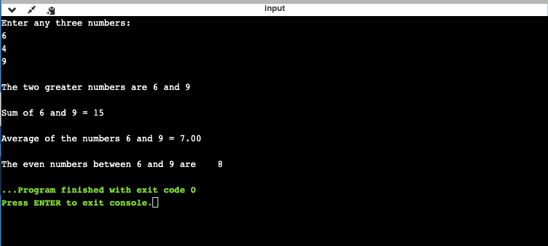

2)1

#include<stdio.h>

int main()

 {

int a,b,c,i;

while(1)

 {

printf("PRESS THE NUMBER TO CHOOSE THE OPERATION :\n"); printf("1) Add\n");

 printf("2)Subtract\n");

printf("3)Multiply\n");

printf("4)Divide\n");

printf("5)Modulus\n");

 printf("6)Greater than\n");

printf("7)Lesser than\n");

 printf("8)Equal to\n");

printf("9)Not equal to\n");

 printf("10)Increement\n");

 scanf("%d",&i);

 printf("Enter two numbers to perform the selected operation:\n"); scanf("%d%d",&a,&b);

switch(i)

{

case 1:printf("%d + %d = %d \n",a,b,a+b);break;



case 2:printf("%d - %d = %d \n",a,b,a-b);break;

case 3:printf("%d x %d = %d \n",a,b,a*b);break;

case 4:printf("%d / %d = %d \n",a,b,a/b);break;

case 5:printf("%d mod %d = %d \n",a,b,a%b);break;

case 6:if(a>b)

{

printf("%d > %d \n",a,b);

}

else

{

printf("%d > %d \n",b,a);

}

break;

case 7:if(a<b)

{

printf("%d < %d \n",a,b);

}

else

{

printf("%d < %d \n",b,a);

}

break;

case 8:if(a==b)

{

printf("%d = %d \n",a,b);

}

else

{

printf("%d != %d \n",b,a);

}

break;

case 9:if(a!=b)

{

printf("%d != %d \n",a,b);

}

else

{

printf("%d = %d \n",b,a);

}

break;

case 10:

printf("%d++ = %d \n",a,a+1);

printf("%d++ =%d \n",b,b+1);

break;

default:printf("WRONG INPUT!\n");

}

printf("Press 1 to perform calculation again\nPress any other key to exit\n");

scanf("%d",&c);

if(c!=1)

{

break;

}

}

}

