1)

class program1{

public static void main(String args[]){ int A[][] = new int[4][];

A[0] = new int[1];

A[1] = new int[2];

A[2] = new int[3];

A[3] = new int[4];

int i,j,k;

k=1;

for(i=0;i<4;i++){

for(j=0;j<i+1;j++){

A[i][j]=k;

k++;

}

}

for(i=0;i<4;i++){

for(j=0;j<i+1;j++){ System.out.print(A[i][j]+" ");

}

System.out.println();

}

} }

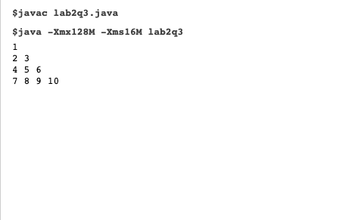

2)

class program2

{

public static void main(String args[]) {

float cie=42,see=88,totalmarks; System.out.println("CIE MARKS : "+cie); System.out.println("SEE MARKS : "+see); see=see/2;

totalmarks=cie+see;

System.out.println("TOTAL MARKS : "+totalmarks);

if(totalmarks>=91 && totalmarks<=100) {

System.out.println("Grade : S"); }

else if(totalmarks>=81 && totalmarks<91) {

System.out.println("Grade : A"); }

else if(totalmarks>=71 && totalmarks<81) {

System.out.println("Grade : B"); }

else if(totalmarks>=61 && totalmarks<71) {

System.out.println("Grade : C"); }

else if(totalmarks>=51 && totalmarks<61) {

System.out.println("Grade : D"); }

else if(totalmarks>=40 && totalmarks<51) {

System.out.println("Grade : E"); }

else if(totalmarks>=0 && totalmarks<40) {

System.out.println("Grade : F");

}

}

}

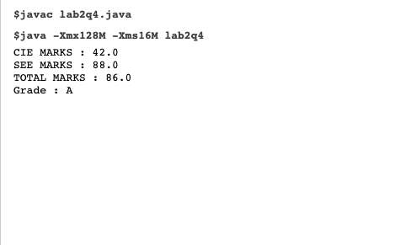

3)

class program3{

public static void main(String args[])

{

int a=12,b=60,i,j,flag;

System.out.print("The Prime Numbers between "+a+" and "+b+" are: ");

for(i=a;i<=b;i++)

{

flag = 1;

for(j=2;j<=i/2;++j)

{

if(i%j == 0)

flag = 0;

break;

}

if(flag==1)

System.out.print(" "+i);

}

}

}

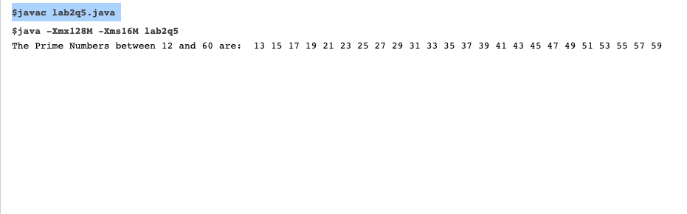

4)

#include<stdio.h> #include<math.h>

int main() {

int i,j;

float r,h,area,vol; float pi=3.1416;

while(1) {

printf("\nEnter the number to choose a shape to view the Area and Volume:\n\n");

printf("[1]CYLINDER\n"); printf("[2]CONE\n"); printf("[3]SPHERE\n");

scanf("%d",&i);

switch(i) {

case 1:

printf("\nEnter the radius of the Cylinder: "); scanf("%f",&r);

printf("Enter the height of the Cylinder: "); scanf("%f",&h);

area=(2\*pi\*r\*h)+(2\*pi\*r\*r);

vol=pi\*r\*r\*h;

printf("\nArea of the Cylinder:%.2f",area); printf("\nVolume of the Cylinder:%.2f\n",vol); break;

case 2:

printf("\nEnter the radius of the Cone: "); scanf("%f",&r);

printf("Enter the height of the Cone: "); scanf("%f",&h); area=pi\*r\*(r+sqrt((h\*h)+(r\*r))); vol=(pi\*r\*r\*h)/3;

printf("\nArea of the Cone: %.2f",area); printf("\nVolume of the Cone: %.2f\n",vol); break;

case 3:

printf("\nEnter the radius of the Sphere: "); scanf("%f",&r);

area=4\*pi\*r\*r;

vol=(4\*pi\*r\*r\*r)/3;

printf("\nArea of the Sphere: %.2f",area); printf("\nVolume of the Sphere: %.2f\n",vol); break;

default: printf("INVALID INPUT!!!PLEASE TRY AGAIN!!!\n"); }

printf("\n\nPress 0 to find the Area and Volume of another shape:\n");

printf("Press any other number to exit\n"); scanf("%d",&j);

if(j!=0) {

break; }

}

return 0; }

