SQL ASSINGMENT 7

1) Write a query that counts all orders for OCTOBER 3.
Sol--
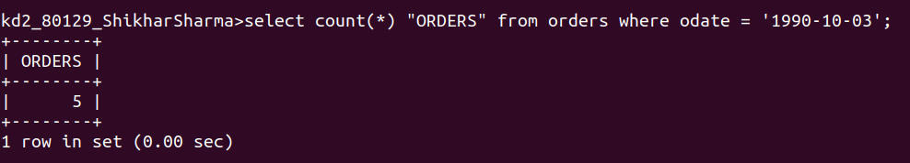
2) write a query that counts the number of diiferent non-NULL city values in the customers table.
Sol --
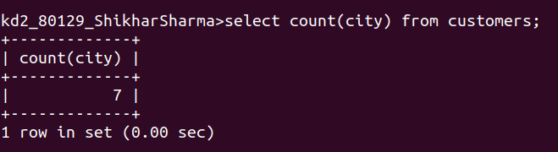

3)Write a query that selects each customer’s smallest order.
Sol--
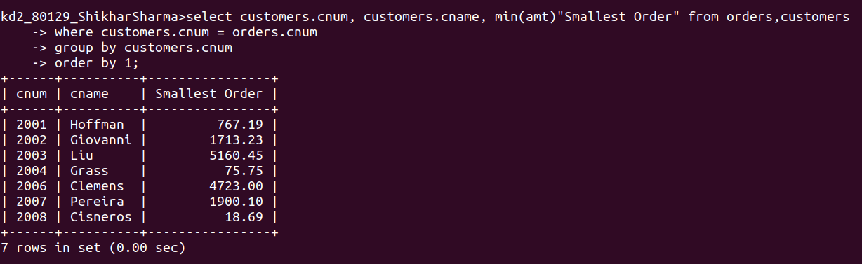
4) Write a query that selects that the first customer, in alphabetical order, whose names begins with G.
Sol--
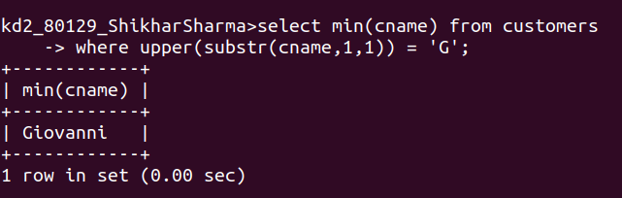
5) Write a query that selects the highest rating.
Sol --
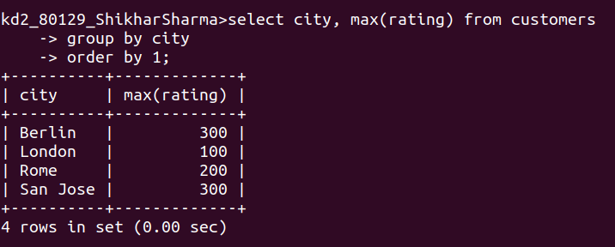
6)Write a query that counts the number of salespeople registering orders for each day.(if a salespeople has more than one order on a givenday, he or she should be counted only once.).
Sol --

