SQL ASSINGMENT 8
1)Assume each salesperson has a 12% commission. Write a query on the orders table that will produce the order number, the salesperson number, and the amount of the salesperson’s commission for that order.
Sol --

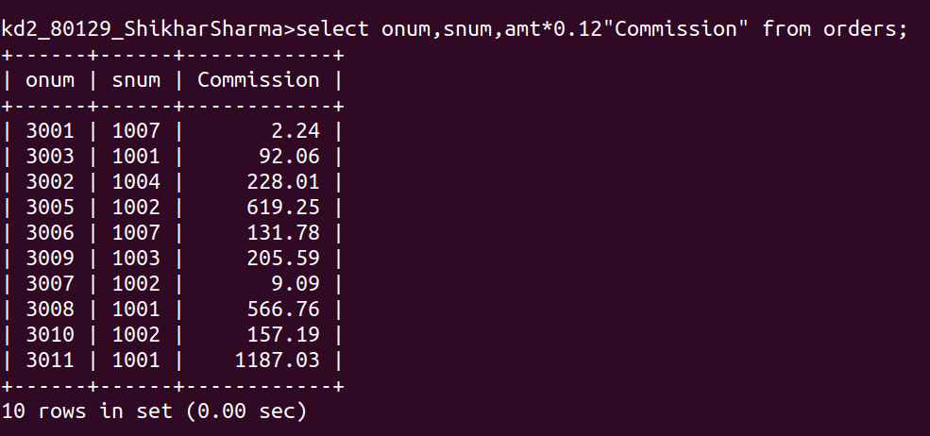
2) Write a query on the customers table that will find the highest rating in each city. Put the output in this form :
For the city (city), the highest rating is (rating).
Sol --
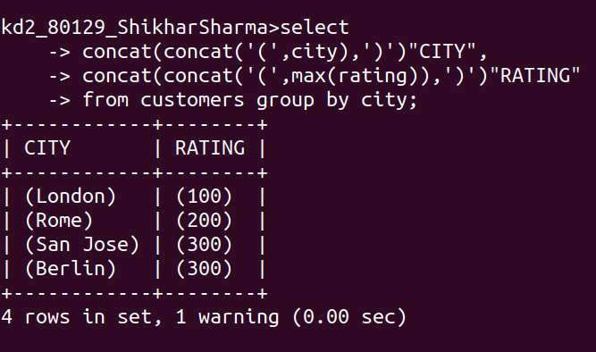
3) Write a query that lists customers in descending order of rating. Output the rating field first, followed by customer’s name and number.
Sol--
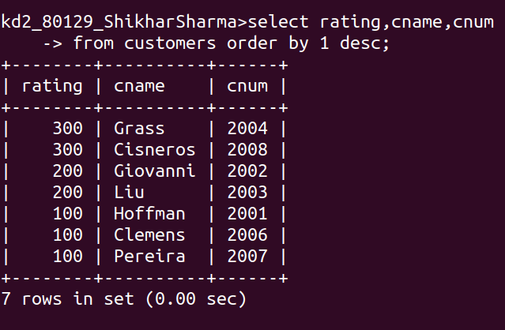
4)Write a query that totals the orders for each day and places the results in descending order.
Sol --
