SQL ASSINGMENT 9

1)Write a query that lists each order number followed by the name of the customer who made the order.

Sol --

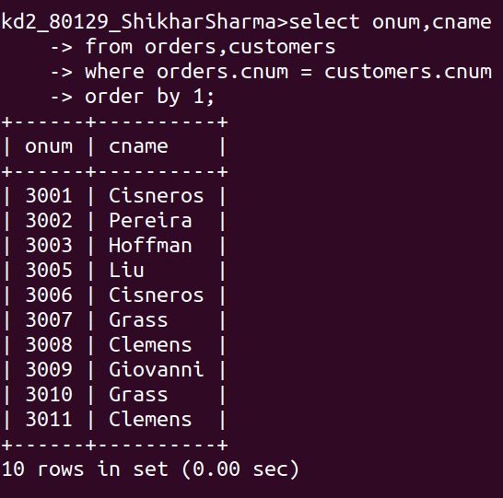

2)Write a query that gives the names of both the salesperson and the customer fro each order along with the order number.

Sol --

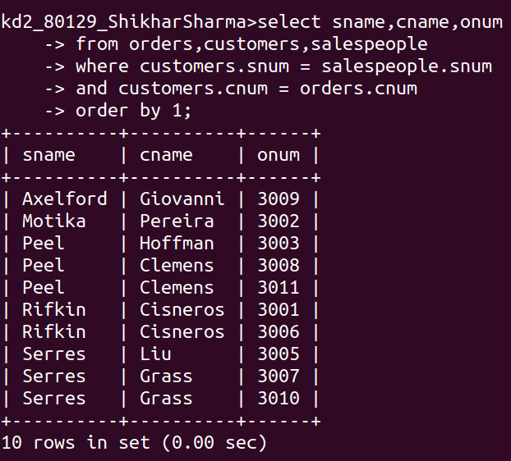

3)Write a query that produces all customers serviced by salespeople with a commission above 12%. Output the customer’s name,salesperson’s name, and the salesperson’s rate of commission.

Sol --
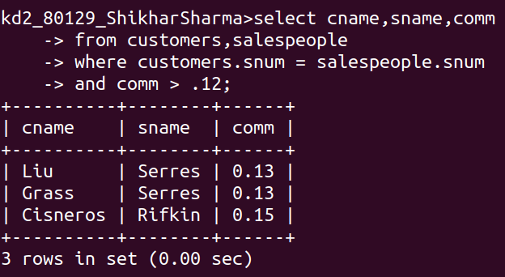
4)Write a query that calculates the amount of the salesperson’s commission on each order by a customer with a rating above 100.
Sol --
