SQL ASSINGMENT 6
Ques 1) Write two different queries that would produce all orders taken on october 3rd or 4th, 1990.

Sol --
1st Type of Query :--
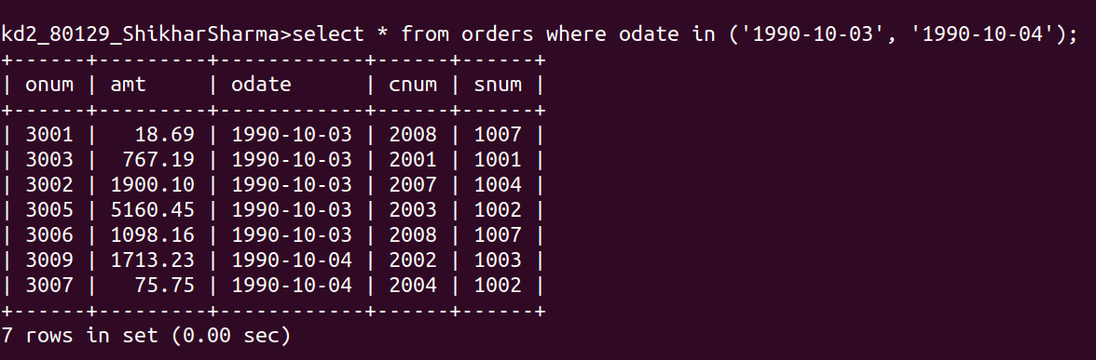
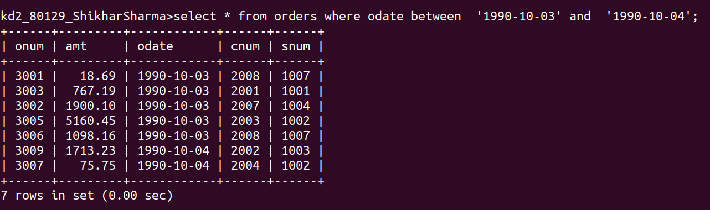
2nd Type of Query :--

Ques 2) write a query that selects all of the customers serviced by peel and motika.

Sol --
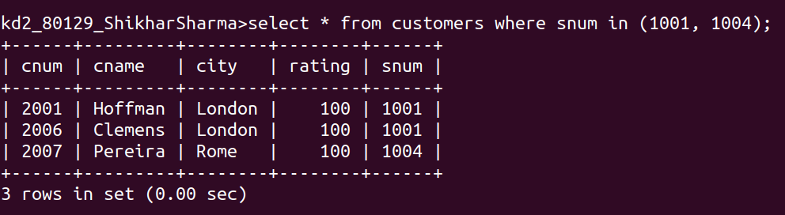

Ques 3) Write a query a that will produce all the customers whose names begin with a letter from ‘A’ to ‘G’.

Sol --

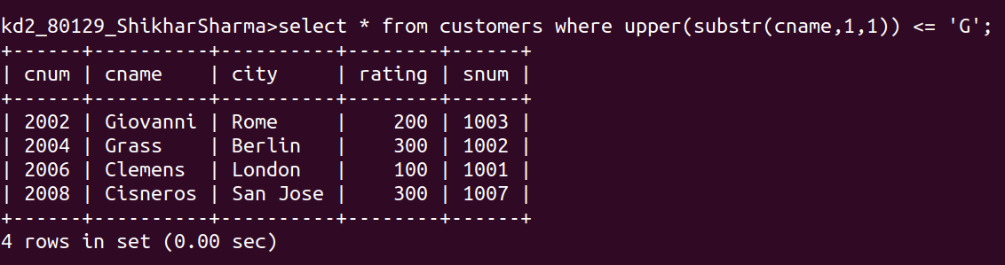

Ques 4) Write a query that selects all customers whose names begin with letter ‘C’.

Sol --

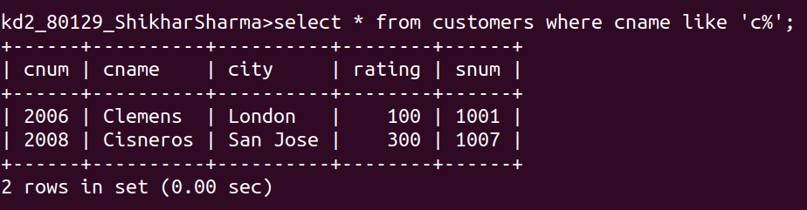

Ques 5) Write a query that selects all orders except those with zeroes or NULLS in the amt field.

Sol --

