SQL ASSINGMENT 12
1)Write a query that selects all customers whose ratings are equal to or greater than ANY of the Serres’.
Sol --
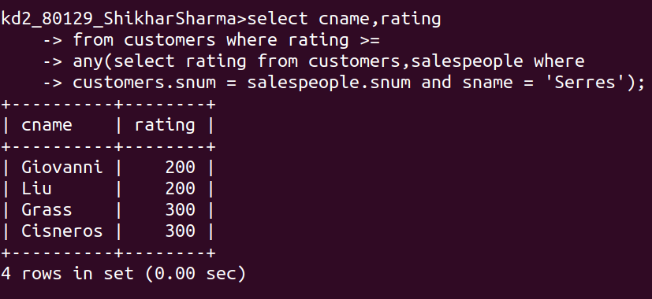
2)Write a query using ANY or ALL that will find all salespeople who have no customers located in their city.
Sol --
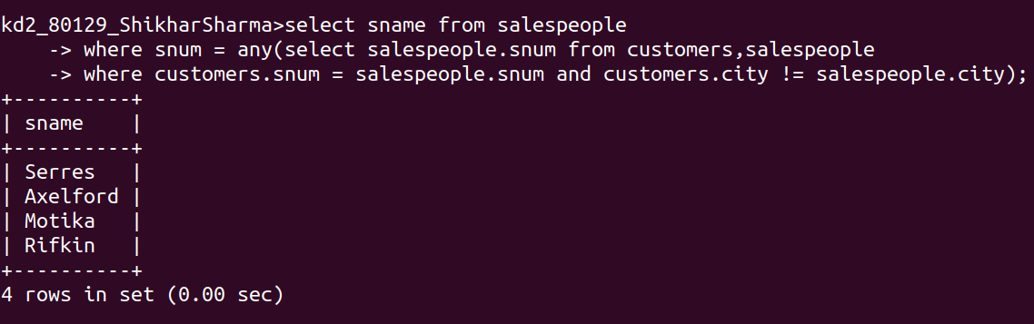

3)Write a query that selects all orders for amounts greater than any of the customers in London.
Sol --
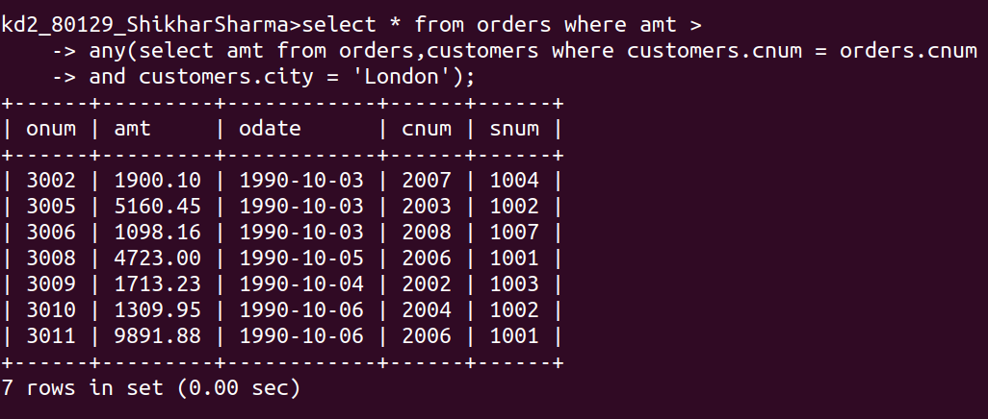
4)Write the above query using MIN or MAX.
Sol --
For min:--
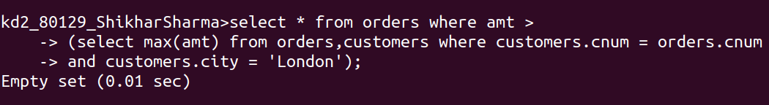
For max:--
