SQL ASSINGMENT 10
1)Write a query that produces all pairs of salespeople who are living in the same city. Exclude combinations of salespeople with themselves as well as duplicate row with the order reversed.

Sol --
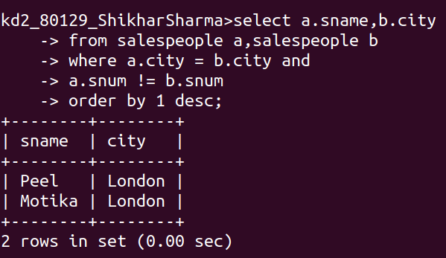

2)Write a query that produces the names and cities of all customers with the same rating as Hoffman.

Sol --
