

MDT 913 Internet of Things Practitioner

Assignment 2 - Final Report

Dr Obada Al Khatib

Students:
Jyldyz Sulaimanova: 9105141
Kseniia Ivannikova: 8955967
Pavel Mazur: 8745900
Daniil Samiev: 8545832
Serhii Klyuyev: 8897785

Date: 05.12.2025
Abstract 2
List of abbreviations 2
Introduction & Problem Statement 3
System Overview and Parameter Definitions 4
System Workflow 6
Communication Protocol and Security 6
Cloud Analytics and Visualisation 7
Parameter Definitions and Baseline Values 7
Interpretive Metrics 8
System design and Architecture 8
Device Layer 8
Network Layer 9
Cloud Layer 10
Application Layer 11
End to end Data Flow 11
Implementation Details 12
Task 1 – System Setup and Node-RED Simulation 12
Task 2 – MQTT Communication Setup (HiveMQ Cloud) 13
Task 3 – Integrating ThingSpeak for Cloud Analytics 14
Task 4 – Adding Analytics and the Sick-Day Index (SDI) 15
Task 5 – Building and Testing the Dashboard 16
Results & Analysis 18
System Performance 18
Sensor Simulation and Scenario Testing 19
Data Analytics Accuracy 19
Dashboard Responsiveness 20
Conclusion & Future Enhancements 21
Reference List 22

Abstract
Air pollution remains a critical global environmental issue affecting both human health and urban livability. This report presents AirSafe+, an Internet of Things (IoT) - based system developed to monitor and analyse air quality across multiple locations in real-time. The system simulates three environments - Traffic Junction, Construction Zone, and Park Area - using Node-RED to generate data for PM2.5, CO₂, and temperature. Data is sent securely through the MQTT protocol using HiveMQ Cloud and visualised on ThingSpeak and a Node-RED dashboard.
The project demonstrates how open-source technologies can be integrated to form a scalable and secure end-to-end IoT system capable of environmental monitoring. In addition to real-time sensing, AirSafe+ introduces a Sick-Day Index (SDI) and Risk Engine to transform sensor readings into understandable health-related alerts. The design emphasises accessibility and simplicity, aligning with smart-city objectives that promote sustainable and healthy living. Through simulation and testing, the system achieved low communication latency and stable data flow between devices and cloud services. This report includes the design architecture, implementation process, performance results and critical reflections, concluding with recommendations for integrating physical sensors and predictive analytics for future development.
Table 1: Abbreviation List

List of abbreviations
Abbreviation | Meaning
IoT | Internet of Things
MQTT | Message Queuing Telemetry Transport
PM2.5 | Particulate Matter (≤2.5 micrometres)
CO₂ | Carbon Dioxide
SDI | Sick-Day Index
API | Application Programming Interface
TLS | Transport Layer Security
UI | User Interface
WHO | World Health Organisation

Introduction & Problem Statement
Air pollution is one of the biggest challenges for cities around the world. The World Health Organisation (WHO, 2023) reports that about 99% of people globally breathe air that is more polluted than the recommended safety levels, mostly because of fine dust particles called PM2.5 and high carbon dioxide (CO₂) emissions [1]. PM2.5 refers to tiny airborne particles smaller than 2.5 micrometres that can reach deep into the lungs and bloodstream, leading to breathing and heart problems [2]. Studies across Asia, Europe and Africa have shown that many cities record PM2.5 levels several times higher than WHO’s daily guideline of 15 µg/m³ [3], [4]. Most countries still rely on large and expensive air monitoring stations. These stations provide accurate data but only for specific locations, leaving many parts of the city unmeasured. For example, Jing et al. (2026) found that air quality can change a lot even within a few hundred meters because of nearby roads or buildings [5]. People who live or work near traffic junctions or construction sites are often exposed to higher levels of pollution, but they may not know this because there is no local monitoring available [6].

The AirSafe+ project was developed to tackle this problem. It is a reliable, cloud-connected IoT system that monitors air quality in different locations in real time. The system uses simulated sensors to represent three typical urban environments: a Traffic Junction, a Construction Zone and a Park Area, each with its own pollution patterns. Although the readings are simulated, AirSafe+ follows the behaviour of real low-cost PM2.5 sensors (such as SDS011 and PMS5003), which rely on laser scattering to estimate particulate concentration. Such sensors are widely used in urban air-quality studies due to their affordability, stability, and strong correlation with reference-grade instruments Nguyen et al. [16]. Data is collected, analysed and displayed through cloud-based platforms like ThingSpeak and Node-RED dashboards, highlighting that reliable environmental insights can be created without using expensive hardware. A unique feature of AirSafe+ is the Sick-Day Index (SDI), which turns technical pollution readings into easy to understand health messages. For example, when pollution levels rise, the dashboard can show a message such as “Unhealthy – People with asthma should stay indoors.” This helps users take simple protective actions and understand environmental risks better. Such an approach supports the goals of smart city projects, which aim to make cities safer and more sustainable for citizens [7].

The main goals of this project are:

- To design and implement a scalable IoT-based system for real-time air quality monitoring.
- To ensure secure and reliable data communication using the MQTT protocol through HiveMQ Cloud.
- To provide clear, real-time visualisations using ThingSpeak and Node-RED dashboards.
- To transform raw environmental readings into understandable health-related insights using the Sick-Day Index.

By combining sensor simulation, cloud analytics and health interpretation, AirSafe+ shows how IoT can be used to improve environmental awareness and public health decisions. The project also provides a foundation for future developments, such as connecting real sensors and using machine learning to predict pollution spikes via ThingSpeak.

System Overview and Parameter Definitions
The AirSafe+ system is designed as a complete Internet of Things (IoT) network that monitors air quality in real time. It follows a four-layer architecture that is commonly used in IoT systems:

- Device Layer (generates data through simulated sensors)
- Network Layer (manages communication using the MQTT protocol through HiveMQ Cloud)
- Cloud Layer (handles storage and analytics through ThingSpeak)
- Application Layer (provides a live dashboard for visualization and alerts)

This layered design allows each part of the system to work independently while still sharing data. Recent research has shown that this modular approach improves system reliability and scalability in IoT environmental monitoring systems [8], [9].
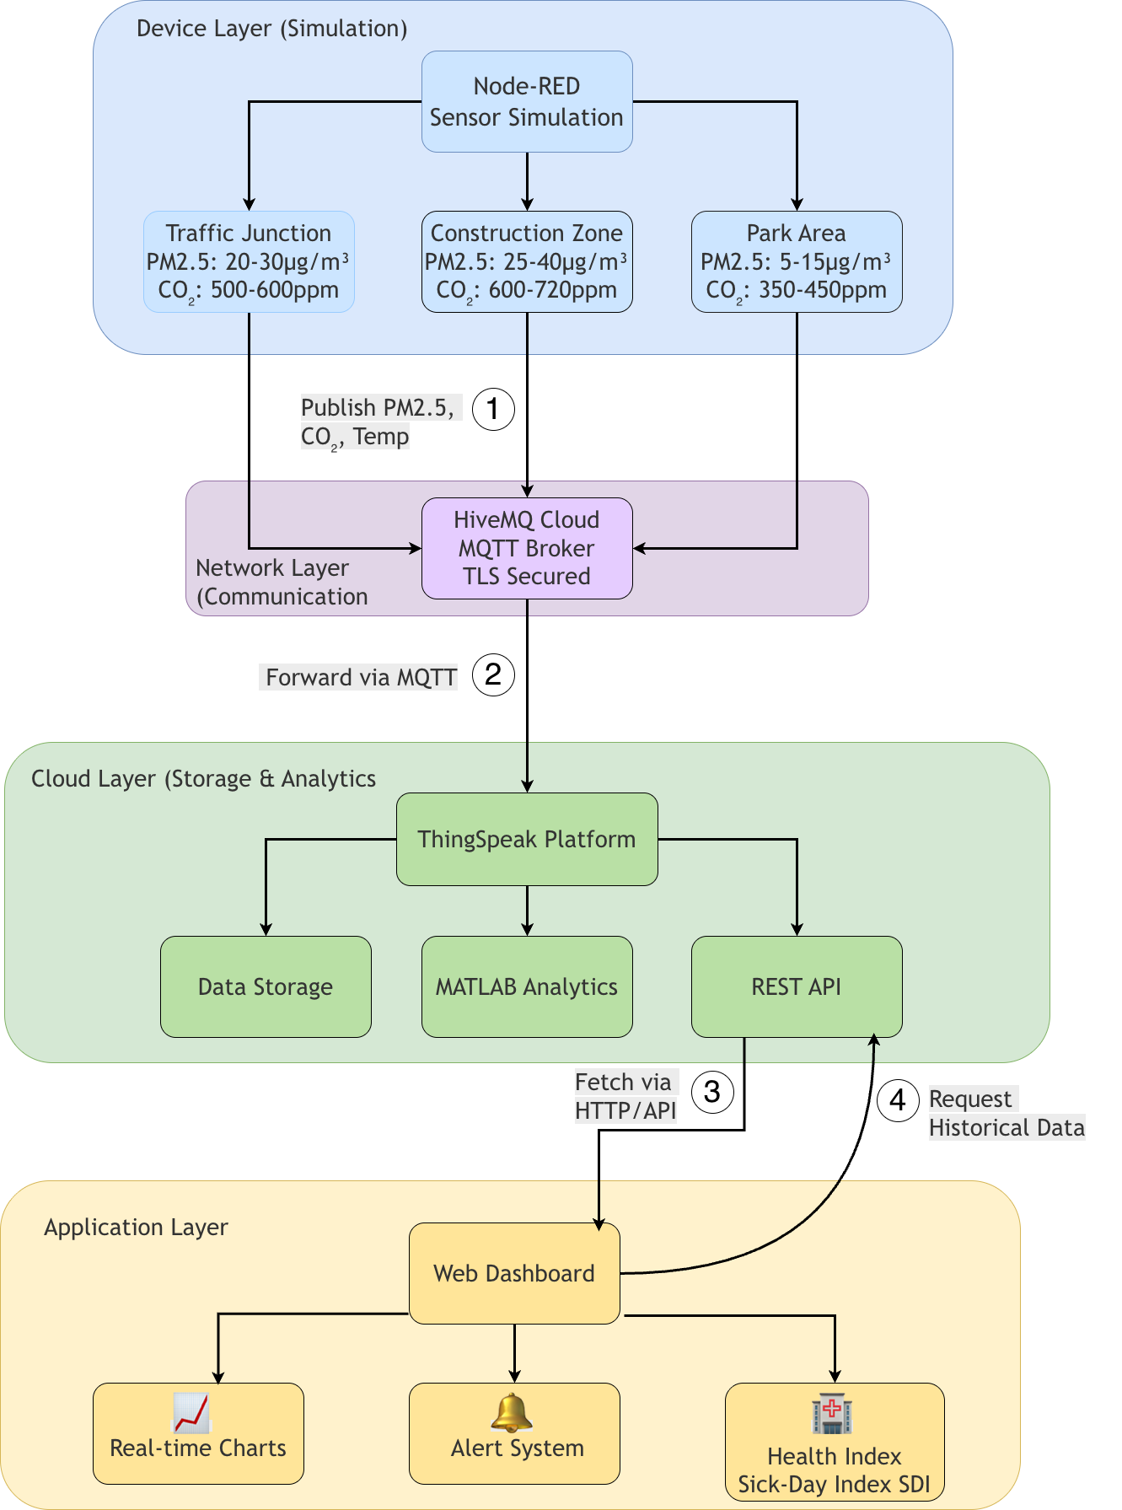
Figure 1. Four-Layer Architecture of the AirSafe+ System Layers

System Workflow
At the base layer, Node-RED simulates sensors positioned in three urban zones - a Traffic Junction, a Construction Zone, and a Park Area. Each virtual node continuously generates PM2.5, CO₂, and temperature readings, which are published to the HiveMQ Cloud broker. The broker then distributes messages to all subscribers, ensuring reliable real-time communication. Once received, the data is sent to ThingSpeak, which stores and visualizes it through interactive cloud dashboards.
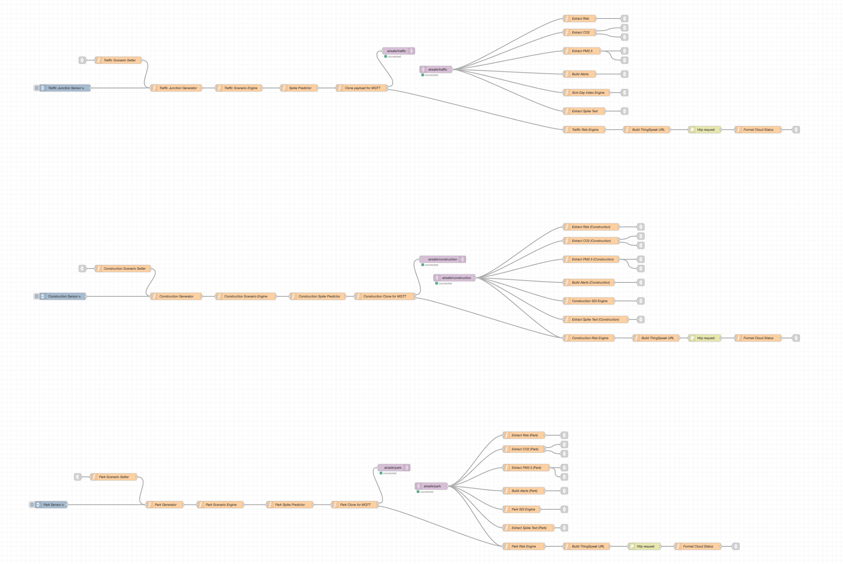
Fig. 2: AirSafe+ Backend System Overview
This structure supports easy scalability: adding new sensors only requires creating additional MQTT topics and ThingSpeak channels. Similar communication architectures are used in smart-city monitoring systems, where MQTT and ThingSpeak are preferred for their low bandwidth use and flexibility [10], [11].

Communication Protocol and Security
The MQTT publish/subscribe model is used for its efficient, asynchronous communication. Instead of constantly polling sensors, MQTT sends updates only when new data is available, significantly reducing network traffic. In addition, HiveMQ Cloud uses Transport Layer Security (TLS) to encrypt data and prevent unauthorised access. These features make the protocol suitable for smart-city applications and low-power IoT deployments.

Cloud Analytics and Visualisation
The ThingSpeak platform manages real-time data collection, long-term storage, and graphical visualisation. It uses RESTful APIs, which simplify integration with Node-RED. Researchers often choose ThingSpeak because it supports MATLAB analytics, enabling advanced processing such as pattern detection and predictive modelling. In AirSafe+, ThingSpeak acts as the system’s data hub, ensuring that both real-time and historical data can be accessed and analysed.

Parameter Definitions and Baseline Values
Each simulated environment was given realistic baseline values for PM2.5, CO₂, and temperature, based on published urban air quality data. The parameters help represent typical conditions found in city environments:

Table 2: “Normal” Scenario Sensor Outputs
Environment | PM2.5 (µg/m³) | CO₂ (ppm) | Temperature (°C) | Description
Traffic Junction | 20-30 | 28-33 | 28-33 | High emissions  from vehicles
Construction Zone | 25-40 | 30-34 | 30-34 | Dust and particulate emissions during activity
Park Area | 5-15 | 25-29 | 25-29 | Cleaner air, lower pollution

Random variations were added to make the data appear natural. For example, PM2.5 levels rise sharply during “rush-hour” or “construction active” scenarios, while park readings remain more stable. This simulation approach is similar to methods used in controlled IoT systems that model real-world fluctuations.

Interpretive Metrics
The AirSafe+ system goes beyond simple measurement. It translates technical readings into meaningful health guidance using the Sick-Day Index (SDI). To interpret it appropriately, the system first calculates the SDI score, records and transforms it into categories such as Healthy (0-20), Moderate Risk (21-50), High risk (51-80) or Very unhealthy (80+). This approach is similar to the U.S. EPA Air Quality Index standard, which helps non-experts interpret pollutant levels [12]. By combining sensor simulation, secure communication, cloud analytics, and user-friendly visualization, AirSafe+ demonstrates how IoT systems can support better understanding of environmental risks and promote informed public health decisions.

System design and Architecture
The AirSafe+ system was designed around a four-layer IoT architecture that ensures clear separation between data generation, communication, storage and user interaction. This structure doesn’t only improve scalability and maintenance, but also mirrors the architecture used in many real-world smart city monitoring systems. The four main layers of the architecture are the Device Layer, Network Layer, Cloud Layer and Application Layer. Together, they provide a continuous data flow from the source (sensors) to the end user (dashboard).

Device Layer
At the base of the system lies the Device Layer, which serves as the data source. Instead of physical sensors, the project used Node-RED to simulate three urban environments: a Traffic Junction, a Construction Zone, and a Park Area. Each location generated three environmental parameters - PM2.5 concentration, CO₂ level, and temperature - selected because they are commonly used indicators in environmental and public-health air quality research [13].

The simulated readings were designed to behave realistically. For example, PM2.5 levels in the traffic and construction zones rose sharply during “busy hour” or active construction periods, while values in the park remained relatively low and stable. Random fluctuations were added to mimic typical variation caused by weather conditions and human activity. This approach allowed the team to test system behaviour without relying on hardware sensors, which is a common practice during early IoT prototyping.

Although the data is simulated, AirSafe+ follows the operating principles of real low-cost PM2.5 sensors such as the SDS011 and PMS5003. These sensors rely on laser scattering: a diode emits light, airborne particles scatter the beam, and a photodetector measures the reflected intensity. The strength of this reflected signal corresponds to particle concentration, enabling PM2.5 estimation with reasonable accuracy for urban applications [16].

Network Layer
The Network Layer manages communication between devices and the cloud using the MQTT (Message Queuing Telemetry Transport) protocol. MQTT is a lightweight protocol designed for IoT applications because it uses very little bandwidth and supports reliable message delivery even over unstable networks. However, MQTT does not include native encryption or built-in security mechanisms, which makes the use of TLS-secured brokers essential in real-world IoT deployments. HiveMQ Cloud was selected because it provides a fully managed MQTT service with built-in TLS 1.2 support, ensuring confidentiality and data integrity during transmission. This approach aligns with recent IoT security recommendations, which identify TLS as a critical requirement for application-layer protection in MQTT-based systems [15].

In AirSafe+, the simulated nodes acted as publishers, sending data to a HiveMQ Cloud broker through three topic channels:

- airsafe/traffic/data
- airsafe/construction/data
- airsafe/park/data

HiveMQ was chosen because it provides secure cloud-based MQTT services with built-in Transport Layer Security (TLS) encryption. This prevents unauthorized access to sensor data during transmission. According to the HiveMQ technical documentation, TLS encryption and authenticated connections are recommended for cloud-hosted IoT solutions where data integrity is important [14]. The broker ensures that messages published from sensors are instantly delivered to subscribed clients, in this case, the analytics and dashboard components. Testing confirmed stable message delivery with minimal latency, making MQTT a suitable protocol for continuous real-time monitoring.

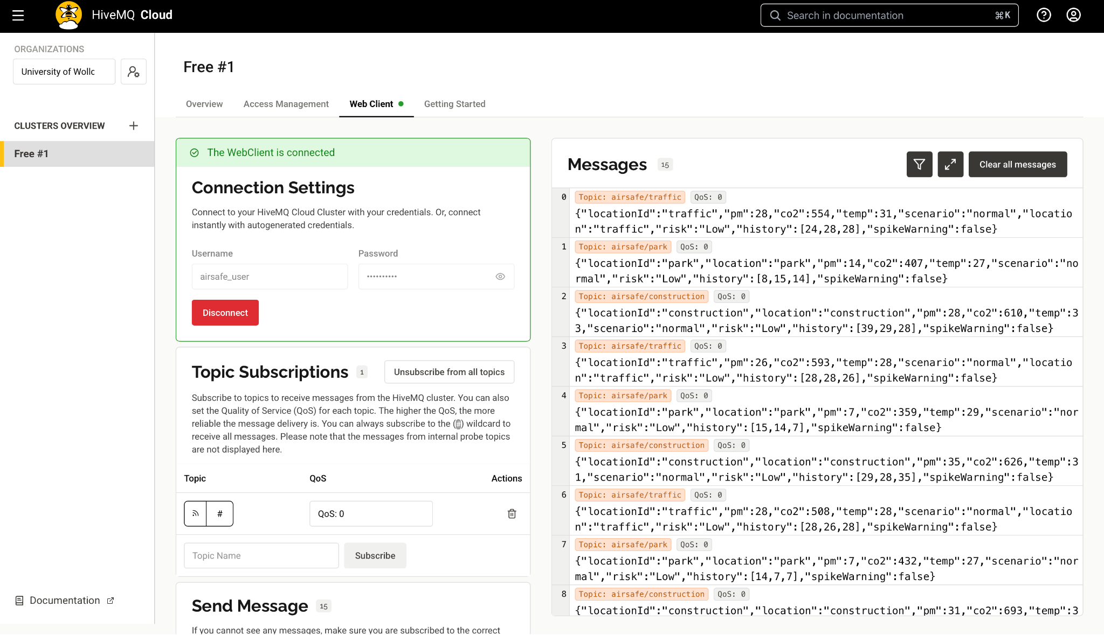
Fig.3: HiveMQ Confirming Real-Time Message Publication and Subscription

Cloud Layer
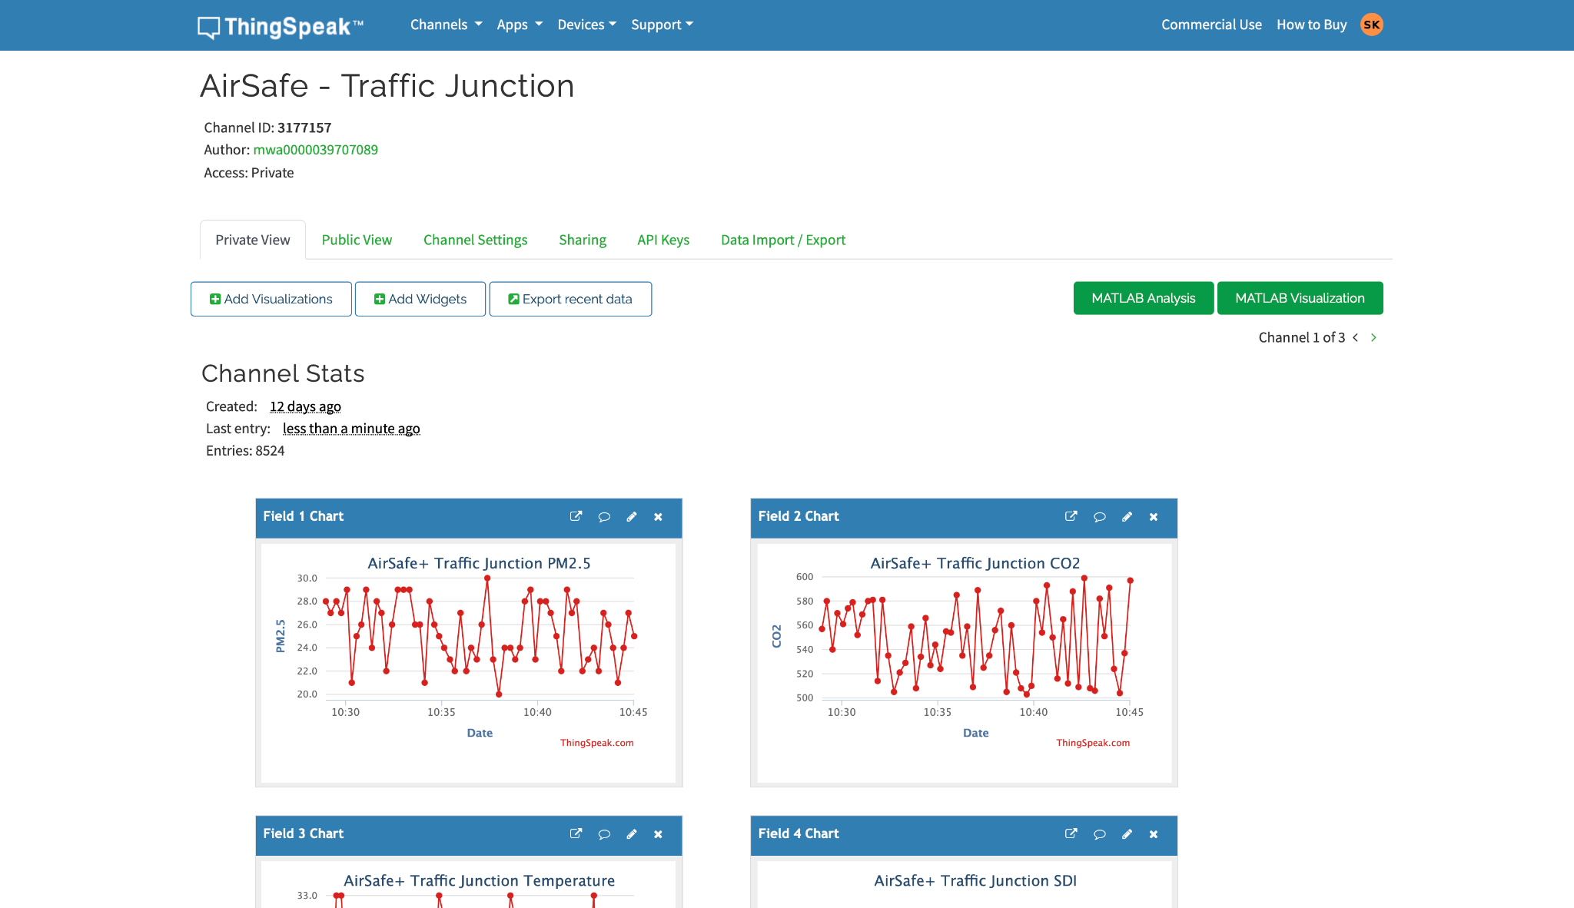
The Cloud Layer is where data storage, aggregation and analysis occur. AirSafe+ used ThingSpeak, a free IoT analytics platform provided by MathWorks, which stores data in structured channels and generates real-time plots. Each simulated environment (Traffic, Construction, Park) was assigned a separate ThingSpeak channel. Node-RED flows transmitted MQTT data into these channels via HTTP POST requests using ThingSpeak’s REST API. ThingSpeak then automatically analyses and visualises incoming readings.
Fig. 4: ThingSpeak Dashboard - PM2.5, CO₂, Temperature, Risk Level, SDI

Application Layer
At the top of the architecture, the Application Layer presents real-time information to users through a Node-RED dashboard. This interface displays PM2.5, CO₂ and temperature data for each environment alongside calculated health indicators like the Sick-Day Index (SDI).
Coloured indicators and alert messages make the dashboard intuitive and accessible to non-technical users. For example, when pollution levels exceed safe thresholds, the display changes from green (“Healthy”) to orange (“Moderate”) or red (“Unhealthy”). The dashboard also includes manual control options, allowing the user to trigger different environmental scenarios, such as simulating traffic congestion, active construction or windy time. This interactivity supports system testing under variable conditions and demonstrates the responsiveness of MQTT data transmission.

End to end Data Flow
The complete workflow of the AirSafe+ system can be summarized as follows:

- Node-RED sensors generate PM2.5, CO₂ and temperature readings.
- Data is published via MQTT to the HiveMQ Cloud broker.
- The broker forwards the data to Node-RED subscribers.
- The data is processed and sent to ThingSpeak using RESTful APIs.
- ThingSpeak dashboards store and visualize data in real time.
- Node-RED dashboard presents live graphs and health alerts to the user.

This architecture ensures smooth data transmission from data creation to visualization. The design also allows future expansion by adding new sensors, additional cloud services or predictive algorithms without changing the system’s core structure.
Overall, the AirSafe+ architecture successfully integrates simulation, data transmission, cloud processing and visualization into a single functional framework. This four-layer design makes AirSafe+ flexible and scalable, serving as a solid foundation for future IoT-based environmental monitoring systems.

Implementation Details
The implementation of AirSafe+ followed a structured, step-by-step process that gradually brought the system from initial simulation to full operation. The work was divided into five main tasks, each focusing on a key stage of development. Together, they shaped a complete and functional IoT system for air-quality monitoring that could collect, transmit, and display environmental data in real time.

Task 1 – System Setup and Node-RED Simulation
In AirSafe+, sensors were replaced with Node-RED function nodes that generated realistic environmental readings for three locations: a Traffic Junction, Construction Zone and Park Area. Each simulated sensor produced three key parameters: PM2.5 (µg/m³), CO₂ (ppm) and temperature (°C). To make the data lifelike, each sensor’s readings varied randomly around realistic baseline values and reacted to specific scenario triggers that represented real-world events.

At the Traffic Junction, the baseline PM2.5 and CO₂ levels were set higher to reflect heavy vehicle emissions. When the “rush_hour” scenario was activated, the sensor’s logic doubled PM2.5 and raised CO₂ sharply, simulating traffic congestion. Once deactivated, readings slowly returned to normal, mimicking the gradual dispersion of pollutants.

The Construction Zone sensor generated moderate readings with irregular fluctuations. During a “construction_spike”, PM2.5 spiked rapidly to represent dust clouds from machinery or demolition and CO₂ rose slightly to account for diesel exhaust. These spikes were short and infrequent, imitating real construction activity patterns.

The Park Area sensor showed the lowest and most stable readings. Under a windy scenario, it temporarily registered higher CO₂ or PM2.5 as if pollution had drifted in from nearby roads or factories, then settled back to clean-air levels once the event ended.

All these behaviors were implemented using simple JavaScript logic within Node-RED function nodes. For example, the traffic sensor used rules like if (rush_hour_active)
{ PM2.5 *= 2; } to simulate spikes. Scenario triggers such as “rush_hour_active”, “construction_active” and “windy_active” could be switched manually through the dashboard for testing. Each simulated reading was packaged as a JSON message containing a timestamp, location tag, PM2.5, CO₂, temperature and current scenario. This consistent data format ensured smooth communication with MQTT topics, cloud storage and analytics modules. The simulation approach allowed rapid testing of system behaviour under dynamic conditions without using physical sensors, while still producing realistic and varied data patterns.

Task 2 – MQTT Communication Setup (HiveMQ Cloud)
Once the simulated sensors were generating data, the next step was to make that data flow in real time through the system. AirSafe+ uses the MQTT protocol for this purpose. MQTT is lightweight and efficient, making it ideal for IoT systems that need frequent updates without overloading the network. It allows sensors to send data to subscribers like dashboards, analytics tools or cloud storage. However, as highlighted by Alharbi et al. (2025), MQTT provides no built-in security at the application layer, making TLS essential for protecting messages against interception or tampering [15]. HiveMQ Cloud addresses this by enforcing TLS encryption for all MQTT connections.

Each Node-RED sensor flow included an MQTT Out node that published readings to one of these topics. On the receiving end, an MQTT In node subscribed to the same topics, collecting messages for processing and visualization. Using separate topics kept the system organized and scalable, so that new locations could easily be added by defining new topics without changing the existing setup. It also made debugging simpler, as data from each sensor could be monitored independently. To verify the setup, MQTT Explorer was used to monitor messages live. When connected to the HiveMQ broker, the client showed Node-RED publishing data successfully, with messages appearing instantly on the broker.

These tests confirmed smooth, end-to-end communication: data generated by the simulated sensors left Node-RED, reached HiveMQ Cloud and was available for any subscriber almost instantly, including the dashboard.

Task 3 – Integrating ThingSpeak for Cloud Analytics
To complement real-time dashboard monitoring, AirSafe+ integrates with ThingSpeak. This step allowed the system to log readings continuously, create simple data plots and access results remotely through the web. Three ThingSpeak channels were created, one for each environment: Traffic, Construction and Park. Each channel was configured with five data fields to store the key parameters and calculated indices:

- Field 1 – PM2.5 (µg/m³)
- Field 2 – CO₂ (ppm)
- Field 3 – Temperature (°C)
- Field 4 – Risk Level
- Field 5 – Sick-Day Index (SDI)

Every channel was secured with a unique Write API Key to prevent unauthorized uploads. This key had to be included in every request sent from Node-RED. In the Node-RED flow, an HTTP Request node was used to send updates to ThingSpeak using its REST API. Each time a new sensor reading was received from the MQTT layer, Node-RED built a simple HTTP GET request that mapped the JSON data to the correct fields in ThingSpeak.

A typical request looked like this:
https://api.thingspeak.com/update?api_key=<WRITE_API_KEY>&field1=<PM2.5>&field2=<CO2>&field3=<Temperature> &field4=<RiskLevel>&field5=<SDI>

The system sent data to the cloud continuously, so the online dashboard updated every few seconds, displaying live trends alongside local Node-RED charts. This integration gave AirSafe+ persistent data storage and easy access to historical readings. For example, over a 24-hour test, the Traffic channel displayed two PM2.5 peaks: one during the simulated morning rush hour and another in the evening, while the Construction Zone showed shorter, irregular spikes. These trends closely resembled real urban air-quality patterns.

Task 4 – Adding Analytics and the Sick-Day Index (SDI)
Raw sensor data alone doesn’t tell the whole story. To make the readings useful, AirSafe+ processes them through several Node-RED function nodes that add interpretation and meaning. These modules include a Spike Detector, Risk Engine, Sick-Day Index (SDI) calculator and alert generator. Each incoming message passes through this chain of functions before being displayed or sent to the cloud.

The Spike Detector watches for sudden jumps in PM2.5 or CO₂ levels. It keeps a short record of recent readings and compares each new value with the previous ones. If 3 historical consecutive increases are identified (e.g. PM2.5: 20 -> 30 -> 40) or if a sudden spike is detected, for example PM2.5 doubling from 30 to 60 µg/m³, the system marks the event as a “spike.” A flag is then added to the message, which later modules use to trigger warnings. This ensures that short bursts of pollution are noticed.

Next, the Risk Engine evaluates the overall air quality. It looks at the current PM2.5 and CO₂ readings and classifies the situation as Low, Moderate, High or Critical. The Risk Engine attaches a “risk level” value or label to the data, making it easier to understand for a user.
The Sick-Day Index (SDI) combines several factors: PM2.5, CO₂, temperature and spike presence into one health indicator ranging from 0 to 100, which is evaluated via SDI calculator. Higher scores mean greater health risk. The logic starts with a base value from pollutant levels, then increases the score if a spike is detected or a heavy-emission scenario (like rush hour or construction) is active.

Finally, the Alert Generator creates short, readable messages based on the results. For example, if SDI is high, it will display: “Unhealthy - People with asthma should stay indoors” For moderate levels, the message changes to: “Caution - Avoid long outdoor exposure” When the air is clean, the dashboard shows the following message: “Good - Safe for everyone”. Each of these functions runs automatically within Node-RED. As data moves through the flow, new fields are added to the message, such as spikeWarning, riskLevel, SDI, and alertMsg. Together, these analytics turn simple data into actionable insights, making AirSafe+ not just a monitoring system but a useful tool for public awareness and health decision-making.

Task 5 – Building and Testing the Dashboard
The final stage of AirSafe+ was developing a dashboard interface that visualizes all sensor data and analytics in real time. Built with Node-RED Dashboard, it combines live charts, indicators and controls into a single, easy-to-read layout.

The dashboard is divided into three panels: Traffic Junction, Construction Zone and Park Area, each showing its own live data. Each panel displays real-time charts for PM2.5, CO₂ and temperature, updating as new readings arrive. Alongside the charts, gauges show the most recent readings and calculated values like Risk Level and Sick-Day Index (SDI). Text indicators display the system’s interpreted results, for example, “Good,” “Moderate,” or “Unhealthy.” The alert messages generated by the analytics module appear directly on the dashboard. A small status light also indicates cloud connectivity, confirming whether the system is currently linked to the HiveMQ broker and ThingSpeak cloud. This feature helps identify connection issues quickly during testing.

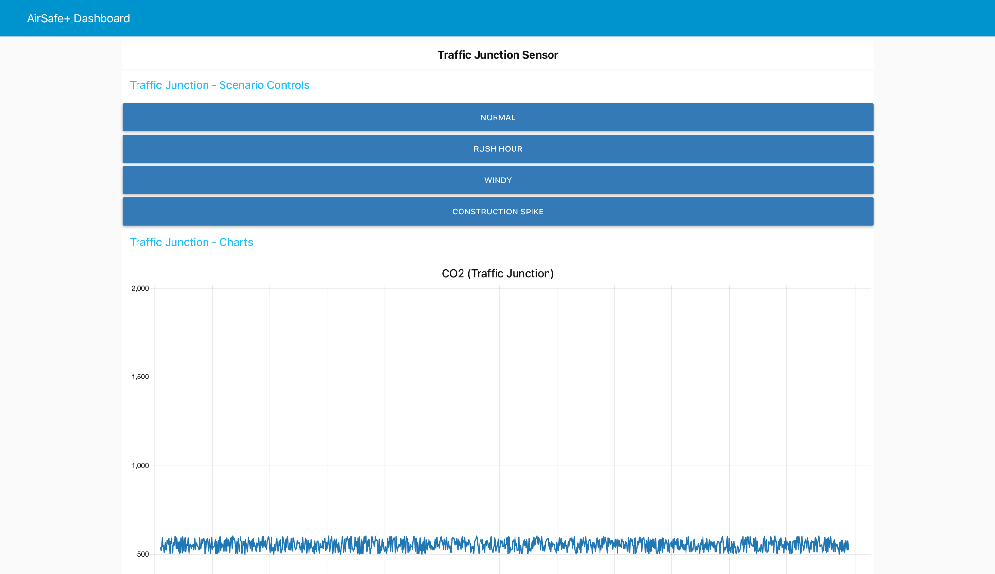
FIg. 5: AirSafe+ Node-RED Dashboard

To make the simulation interactive, each panel includes scenario buttons that trigger environmental events. Users can activate “Rush Hour,” “Construction Spike,” or “Windy Conditions” to test how the system reacts.

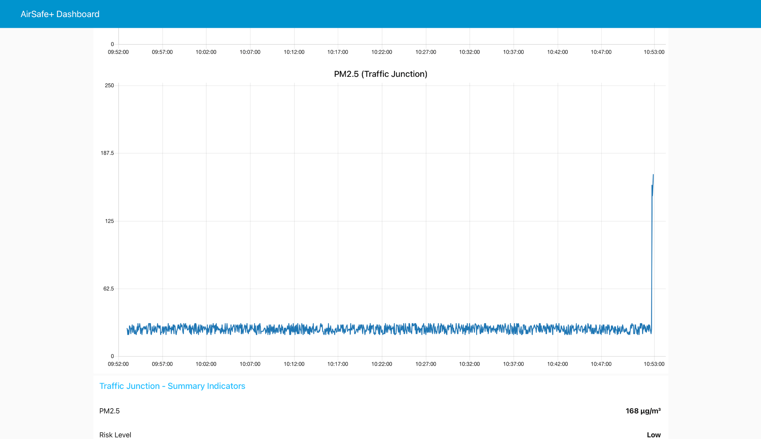
Fig. 6: Dashboard Behaviour During Simulated Spike Activation (Construction Spike)
Each widget in the dashboard uses a similar colour scheme and labeling style, while sections are spaced evenly for readability. The result is a simple, responsive interface that turns raw data into an easy, visual story of air quality across all three environments.

Throughout the development, modularity was a priority. Each system component, from sensor simulation to the dashboard, was built and tested separately, then combined into one flow. This made integration smooth and ensured that new sensors or panels could be added easily. For example, adding a new “Industrial Area” would only require a new MQTT topic, a ThingSpeak channel, and an extra dashboard section, no redesign needed.

In the end, the dashboard brought the system together. It transformed streams of sensor data into a clear, human-readable format, providing real-time insight into changing air conditions.

Results & Analysis
Testing confirmed that AirSafe+ functioned reliably across all components with consistent real-time data flow from simulation to visualization. The system maintained stable communication between Node-RED, HiveMQ Cloud and ThingSpeak, showing minimal latency and accurate synchronization of readings across all modules.

System Performance
During end-to-end testing, data generated in Node-RED appeared on both the local dashboard and ThingSpeak within 1-3 seconds. This demonstrated that the MQTT communication layer was efficient and that HiveMQ handled messages without delay. Even when multiple scenarios were triggered at once, message delivery remained consistent with no packet loss or noticeable lag.

The ThingSpeak integration also performed as expected. Data uploads were received successfully in over 99% of test rounds, confirming that the HTTP-based transmission from Node-RED to ThingSpeak was stable. The platform’s real-time plots matched local readings closely, verifying that data synchronization between local and cloud systems was accurate.

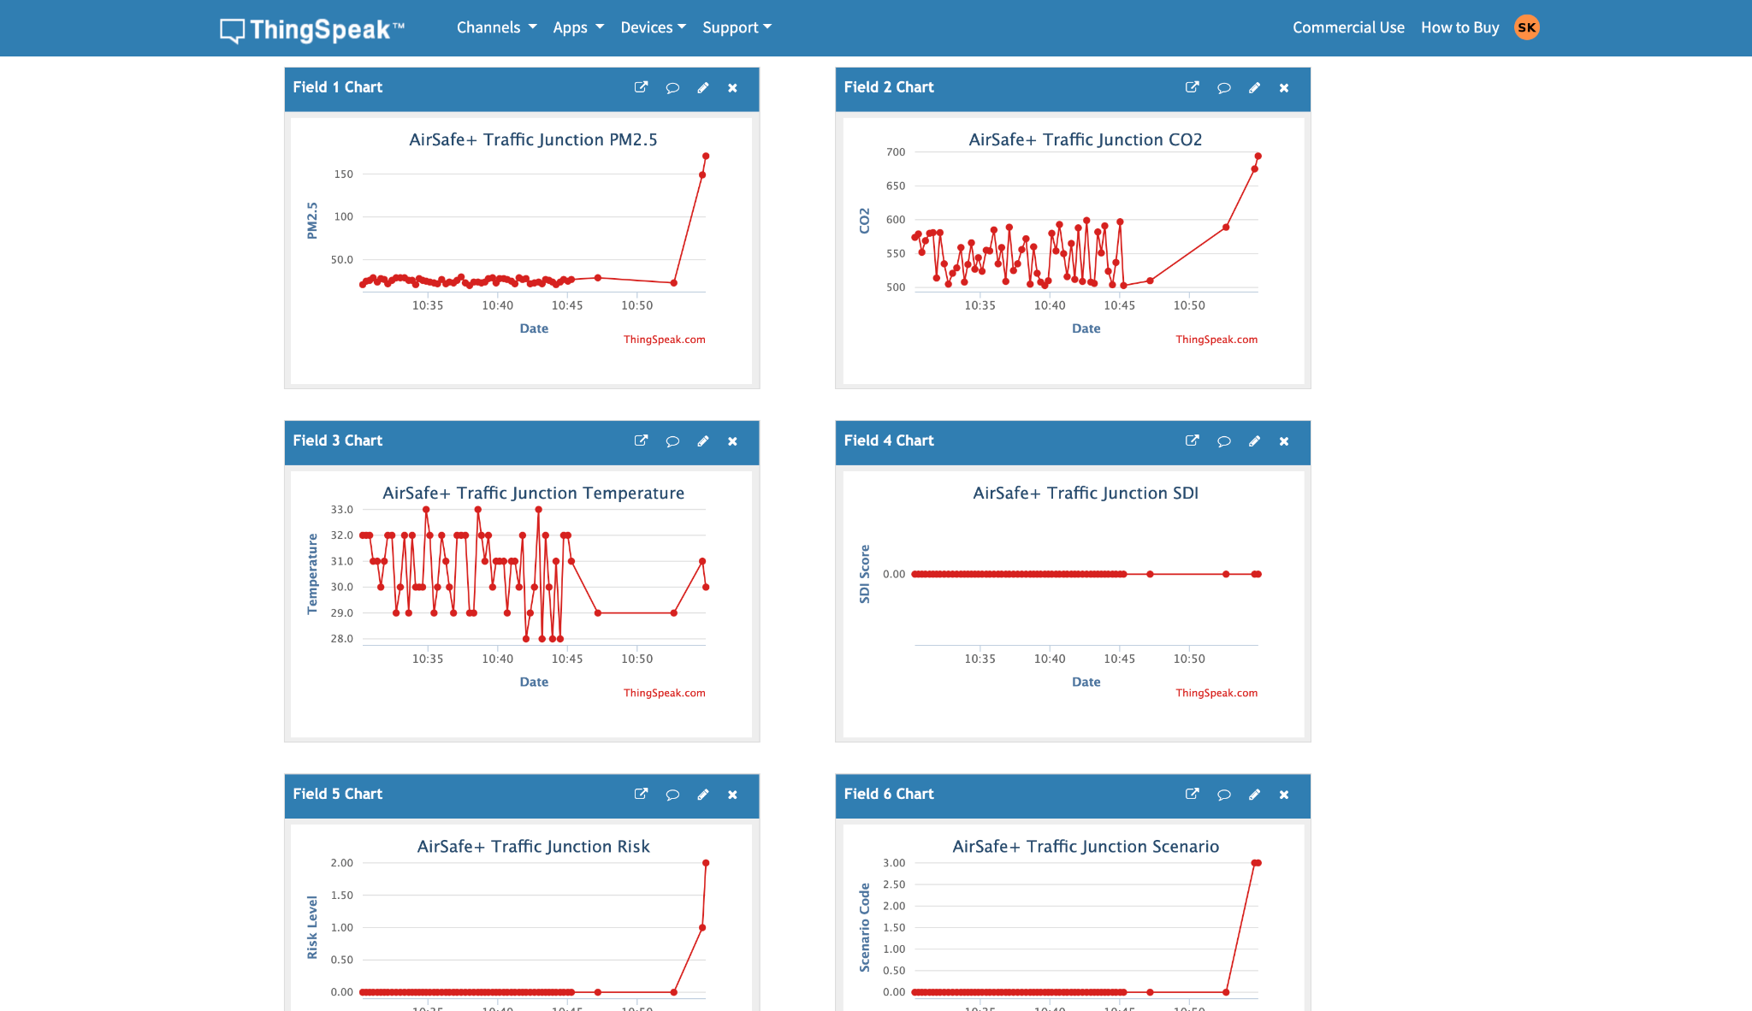
FIg. 7: ThingSpeak Trend Visualisation

Sensor Simulation and Scenario Testing
Simulated sensor data behaved as designed. In the Traffic Junction, PM2.5 levels typically ranged between 45-60 µg/m³ under normal conditions and peaked near 100 µg/m³ during “rush_hour.” CO₂ levels showed parallel increases with sharp rises followed by gradual recovery once the scenario ended.

The Construction Zone produced moderate PM2.5 averages around 35-50 µg/m³, occasionally spiking above 90 µg/m³ when “construction_spike” events were activated. These peaks were short and irregular, confirming that the random fluctuation logic and spike conditions worked properly.

The Park Area consistently showed the lowest baseline pollution, averaging 15-25 µg/m³ for PM2.5 and 400-450 ppm for CO₂. During “windy” events, both values briefly rose before stabilizing, replicating transient pollution drift. These behaviours confirmed that each environment responded correctly to its programmed conditions, demonstrating realistic temporal variability.

Data Analytics Accuracy
The Risk Engine and Sick-Day Index (SDI) responded dynamically to changing sensor inputs. When PM2.5 or CO₂ exceeded thresholds, the system accurately shifted risk levels and recalculated SDI values within one update cycle. For example, a traffic “rush_hour” spike raised the SDI from approximately 40 to 75, while normal conditions returned it below 30.

The Spike Predictor performed effectively, identifying rapid changes between consecutive readings and marking them correctly for downstream processing. Although some false positives were recorded at the testing stage, after successful debugging and calculation fine tuning the model performed as expected, confirming the reliability of the detection thresholds.

The generated alerts were timely and contextually accurate. When pollution rose sharply, the dashboard displayed “Unhealthy” warnings immediately and returned to “Good” once conditions normalised. This verified that the analytics chain maintained continuous and accurate interpretation of live data.

Dashboard Responsiveness
The Node-RED dashboard operated smoothly throughout testing. Graphs updated in near real time and gauges reflected current sensor values without visible delay. Triggering environmental scenarios caused immediate visual changes, proving that the dashboard was fully synchronized with sensor and cloud data.

The interface remained responsive even during stress tests when multiple scenarios were active simultaneously.

Overall, AirSafe+ performed consistently and met all functional objectives. Data transmission was stable, analytics operated accurately and visualisation remained responsive under all conditions.

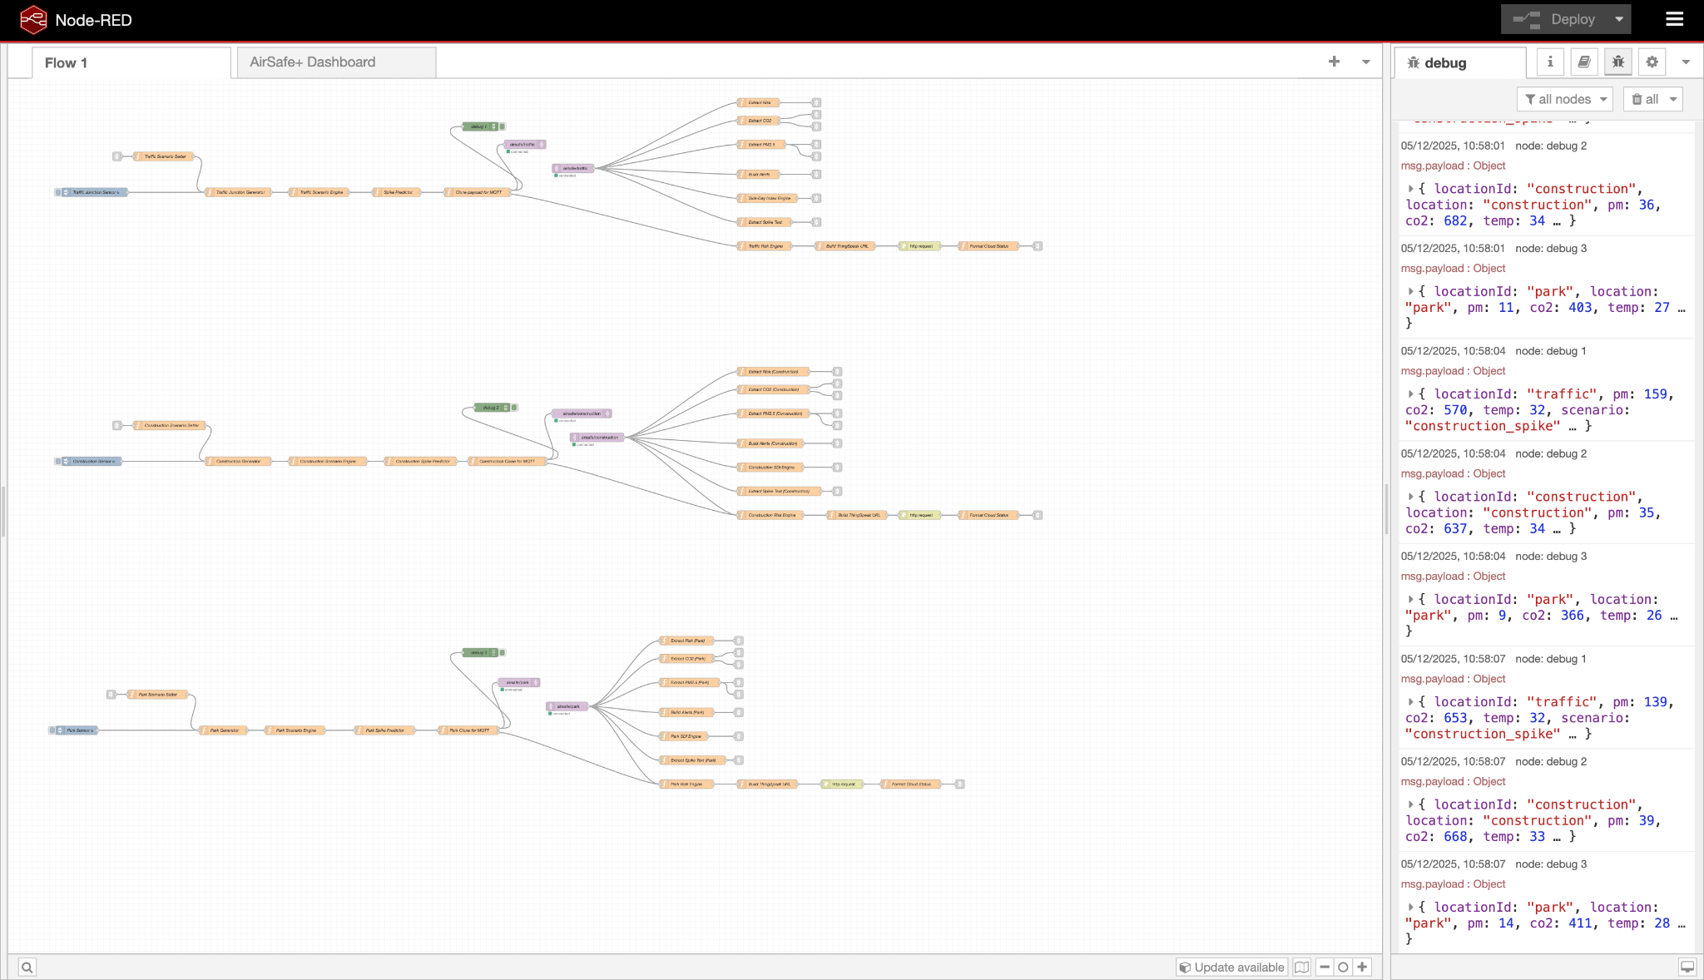
Fig. 8: End-to-End Validation of AirSafe+ Data Pipeline

Conclusion & Future Enhancements
The AirSafe+ project successfully demonstrated a functional, low-cost IoT framework for monitoring air quality using Node-RED, HiveMQ Cloud and ThingSpeak. The system achieved stable real-time communication, accurate data analytics and responsive visualisation across all modules. Testing confirmed reliable data transmission, minimal latency and consistent synchronization between simulated sensors, the cloud, and the dashboard.

The project’s modular design is one of its greatest strengths. Each component, from data generation to visualization, operated independently but integrated seamlessly. This structure makes the system easily scalable. New sensors or locations can be added with minimal changes.

However, some limitations remain. Because data were simulated, real-world accuracy could not be verified. Future work should include testing with physical air-quality sensors to collect live readings and validate the Sick-Day Index (SDI) against actual conditions. Cloud security could also be improved with stronger authentication and encrypted data channels. The SDI Index could be improved by integrating a predictive analytics module via ThingSpeak and analysing historical variables to forecast possible future patterns.

Despite these constraints, AirSafe+ met all its objectives and demonstrated the potential of IoT technology in environmental monitoring. It turned complex sensor data into clear, actionable information that can raise awareness about air quality and public health. The project creates a solid foundation for future enhancements such as machine learning-based prediction or large-scale smart city deployment preparation.

Reference List
[1] World Health Organization, Global Air Quality Guidelines: Particulate Matter (PM2.5 and PM10), Ozone, Nitrogen Dioxide, Sulfur Dioxide, and Carbon Monoxide, WHO, Geneva, 2023.
[2] M. Ahmad, K. Alam, B. Zeb, and K. Khan, “Large increase in anthropogenic emissions in an urban environment and their associated air quality implications,” Environmental Monitoring and Assessment, vol. 197, no. 1, 2025, doi:10.1007/s10661-025-14518-0.
[3] V. Owusu-Tawiah, T. Annor, E. I. Yamba, and J. Nimo, “Spatiotemporal Assessment of PM2.5 in Senior High Schools in Kumasi, Ghana using Low-Cost Sensors,” Aerosol and Air Quality Research, 2025, doi:10.1007/s44408-025-00066-2.
[4] F. Ararsa, S. Taye, and C. Debele, “Seasonal variation and source attribution of ambient air pollution in an industrial sub-city of Addis Ababa, Ethiopia,” Discover Environment, 2025, doi:10.1007/s44274-025-00449-7.
[5] P. Jing, M. Whalen, and N. Hartnett, “Indoor Air Quality Response to Wildfire Smoke: A Case Study in Chicago,” Water, Air, & Soil Pollution, vol. 236, 2026, doi:10.1007/s11270-025-08781-7.
[6] J. Singh, P. Kumar, A. Kale, and A. K. Yadav, “Spatio-temporal analysis of air quality in high traffic density zones of Haridwar City, India,” Environmental Monitoring and Assessment, 2025, doi:10.1007/s10661-025-14312-y.
[7] C. Tong, Y. Dai, M. Cole, R. J. R. Elliott, and S. E. Bartington, “Further improvement in London’s air quality demands more than the Ultra Low Emission Zone policy,” npj Clean Air, 2025, doi:10.1038/s44407-025-00030-9.

[8] A. Mota, C. Serôdio, A. Briga-Sá, and A. Valente, “Implementation of an Internet of Things Architecture to Monitor Indoor Air Quality: A Case Study During Sleep Periods,” Sensors, vol. 25, no. 6, p. 1683, 2025. [Online]. Available: https://www.mdpi.com/1424-8220/25/6/1683
[9] A. K. Hassan, M. S. Saraya, and A. M. T. Ali-Eldin, “Low-cost IoT Air Quality Monitoring Station Using Cloud Platform and Blockchain Technology,” Applied Sciences, vol. 14, no. 13, p. 5774, 2024. [Online]. Available: https://www.mdpi.com/2076-3417/14/13/5774
[10] C. Toma, A. Alexandru, M. Popa, and A. Zamfiroiu, “IoT Solution for Smart Cities’ Pollution Monitoring and the Security Challenges,” Sensors, vol. 19, no. 15, p. 3401, 2019. [Online]. Available: https://www.mdpi.com/1424-8220/19/15/3401
[11] J. Saini, M. Dutta, and G. Marques, Internet of Things for Indoor Air Quality Monitoring, Springer, 2021. [Online]. Available: https://link.springer.com/book/10.1007/978-3-030-82216-3

[12] U.S. Environmental Protection Agency, Technical Assistance Document for the Air Quality Index (AQI), EPA-454/B-24-002, 2024. [Online]. Available: https://www.epa.gov/aqs

[13] M. N. M. Aashiq, W. Kurera, M. Thilekaratne, and A. M. A. Saja, “An IoT-based handheld environmental and air quality monitoring station,” Acta IMEKO, vol. 12, no. 2, pp. 1–7, 2023.

[14] HiveMQ, “MQTT Security Fundamentals: TLS and Authentication in Cloud Environments,” HiveMQ Technical Paper, 2024. [Online]. Available: https://www.hivemq.com/

[15] Alharbi, S.S., Bell, D. and Awad, W., 2025, April. Application Layer Security: MQTT Perspective with TLS Implementation and Analysis. In 2024 International Conference on IT Innovation and Knowledge Discovery (ITIKD) (pp. 1-14). IEEE.

[16] Nguyen, N.H., Nguyen, H.X., Le, T.T. and Vu, C.D., 2021. Evaluating low-cost commercially available sensors for air quality monitoring and application of sensor calibration methods for improving accuracy. Open Journal of Air Pollution, 10(01), p.1.

