PART III #4: Experiment with at least five different combinations of settings for K, iters, R. Write a brief report (report.pdf or report.docx) documenting your findings about these, and include the image results inside the document.

Values used:

|  |  |  |  |  |  |
| --- | --- | --- | --- | --- | --- |
| **Run #** | **1** | **2** | **3** | **4** | **5** |
| **K** | 2 | 5 | 10 | 15 | 50 |
| **iters** | 2 | 5 | 10 | 15 | 50 |
| **R** | 2 | 5 | 10 | 15 | 50 |

Image Results:

Run 1 🡪 Run 2 🡪 Run 3 🡪 Run 4 🡪 Run 5

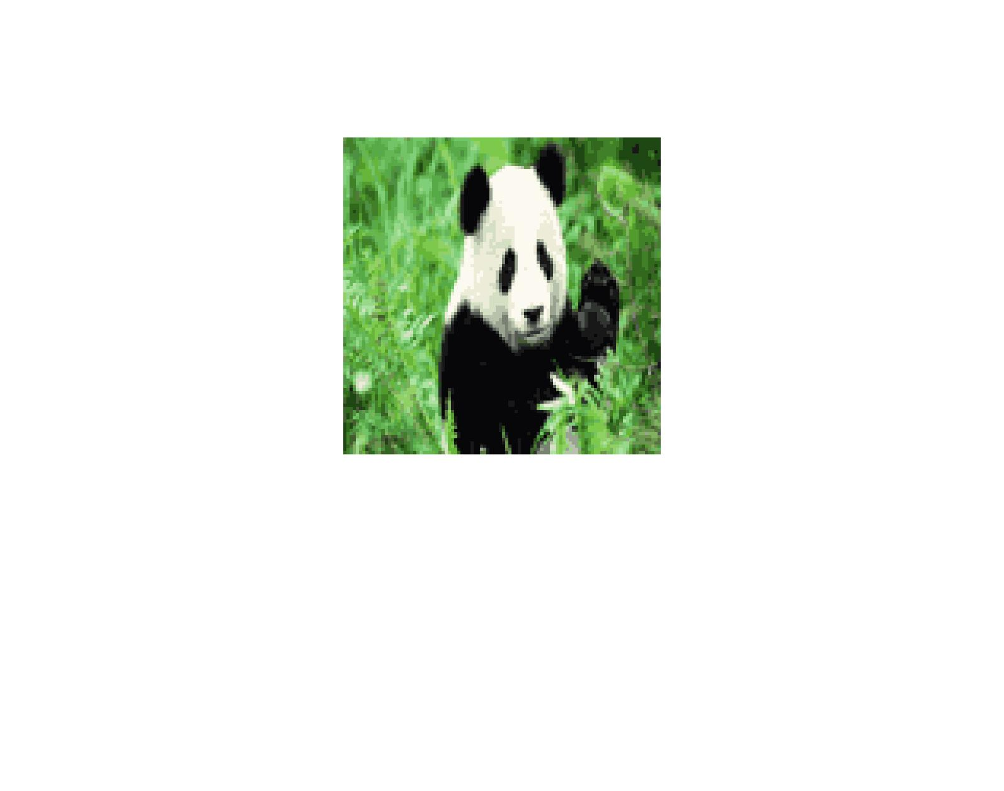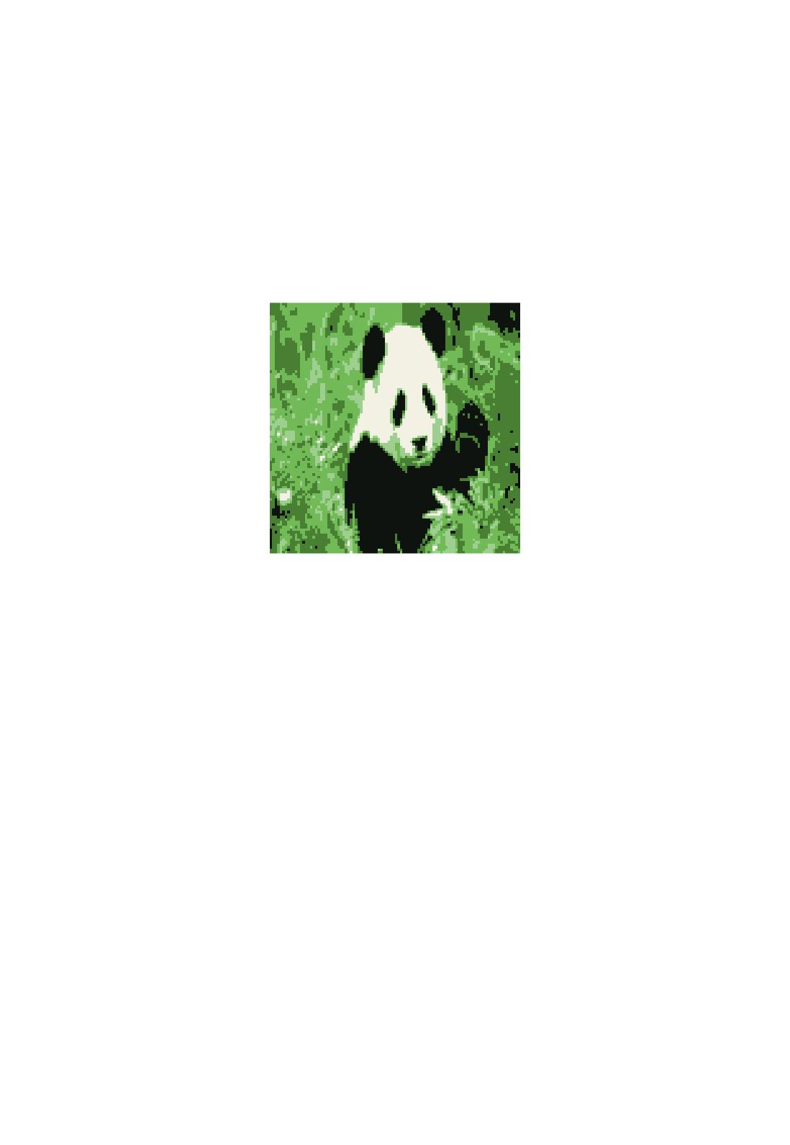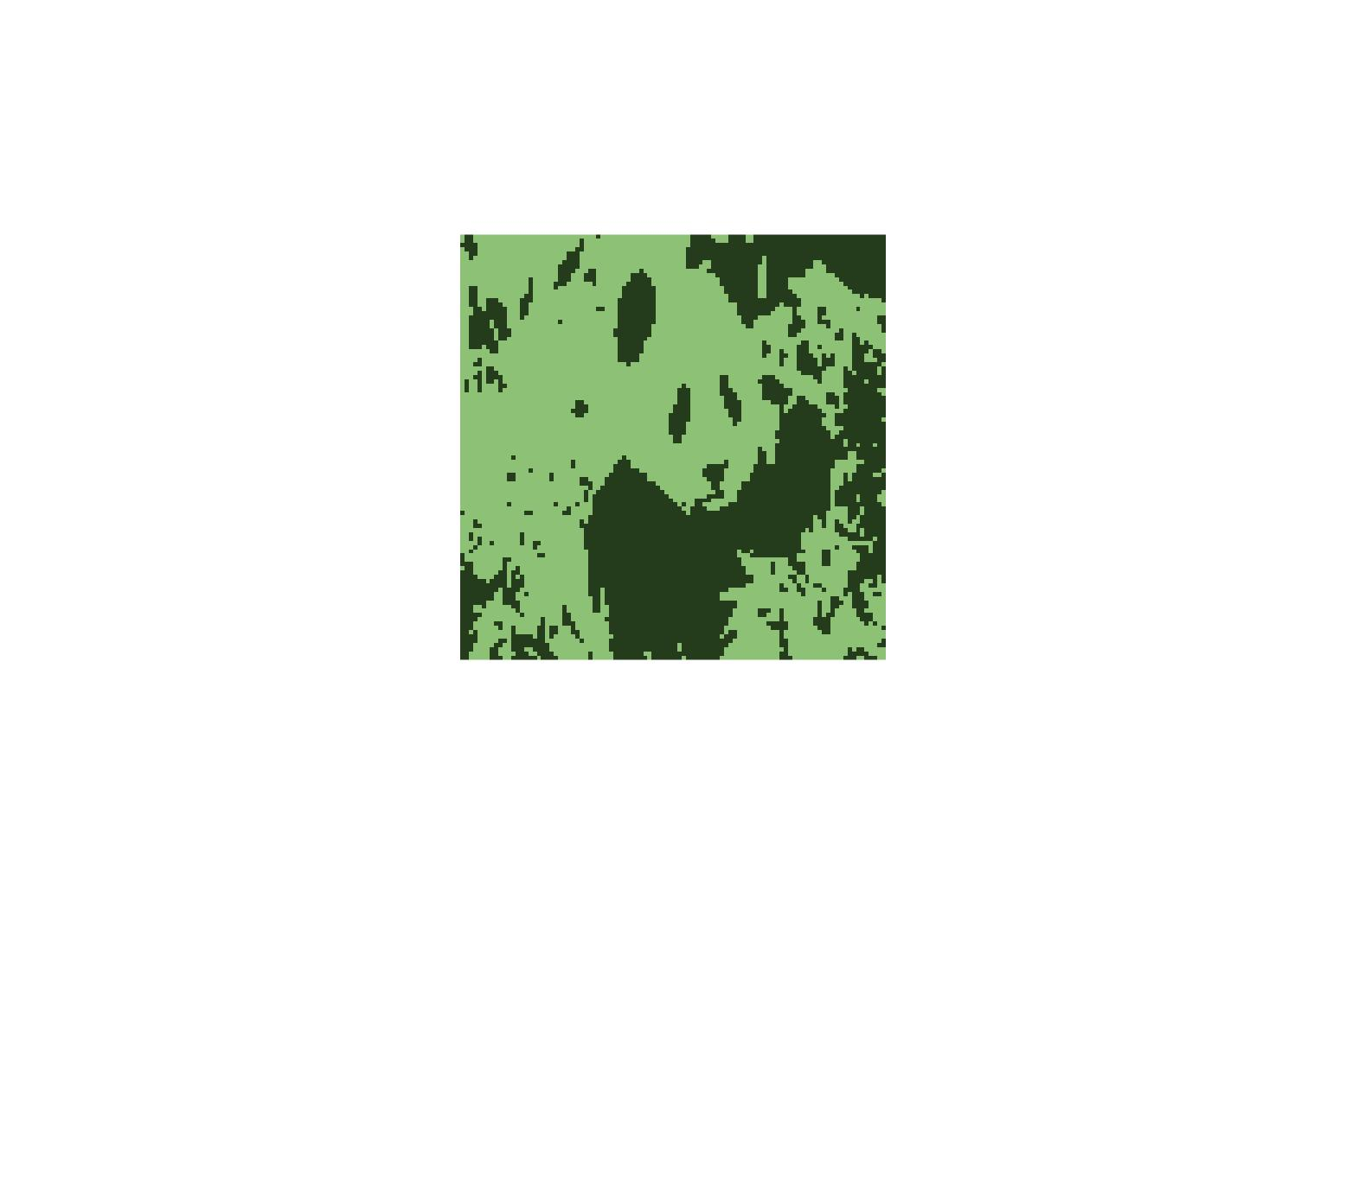

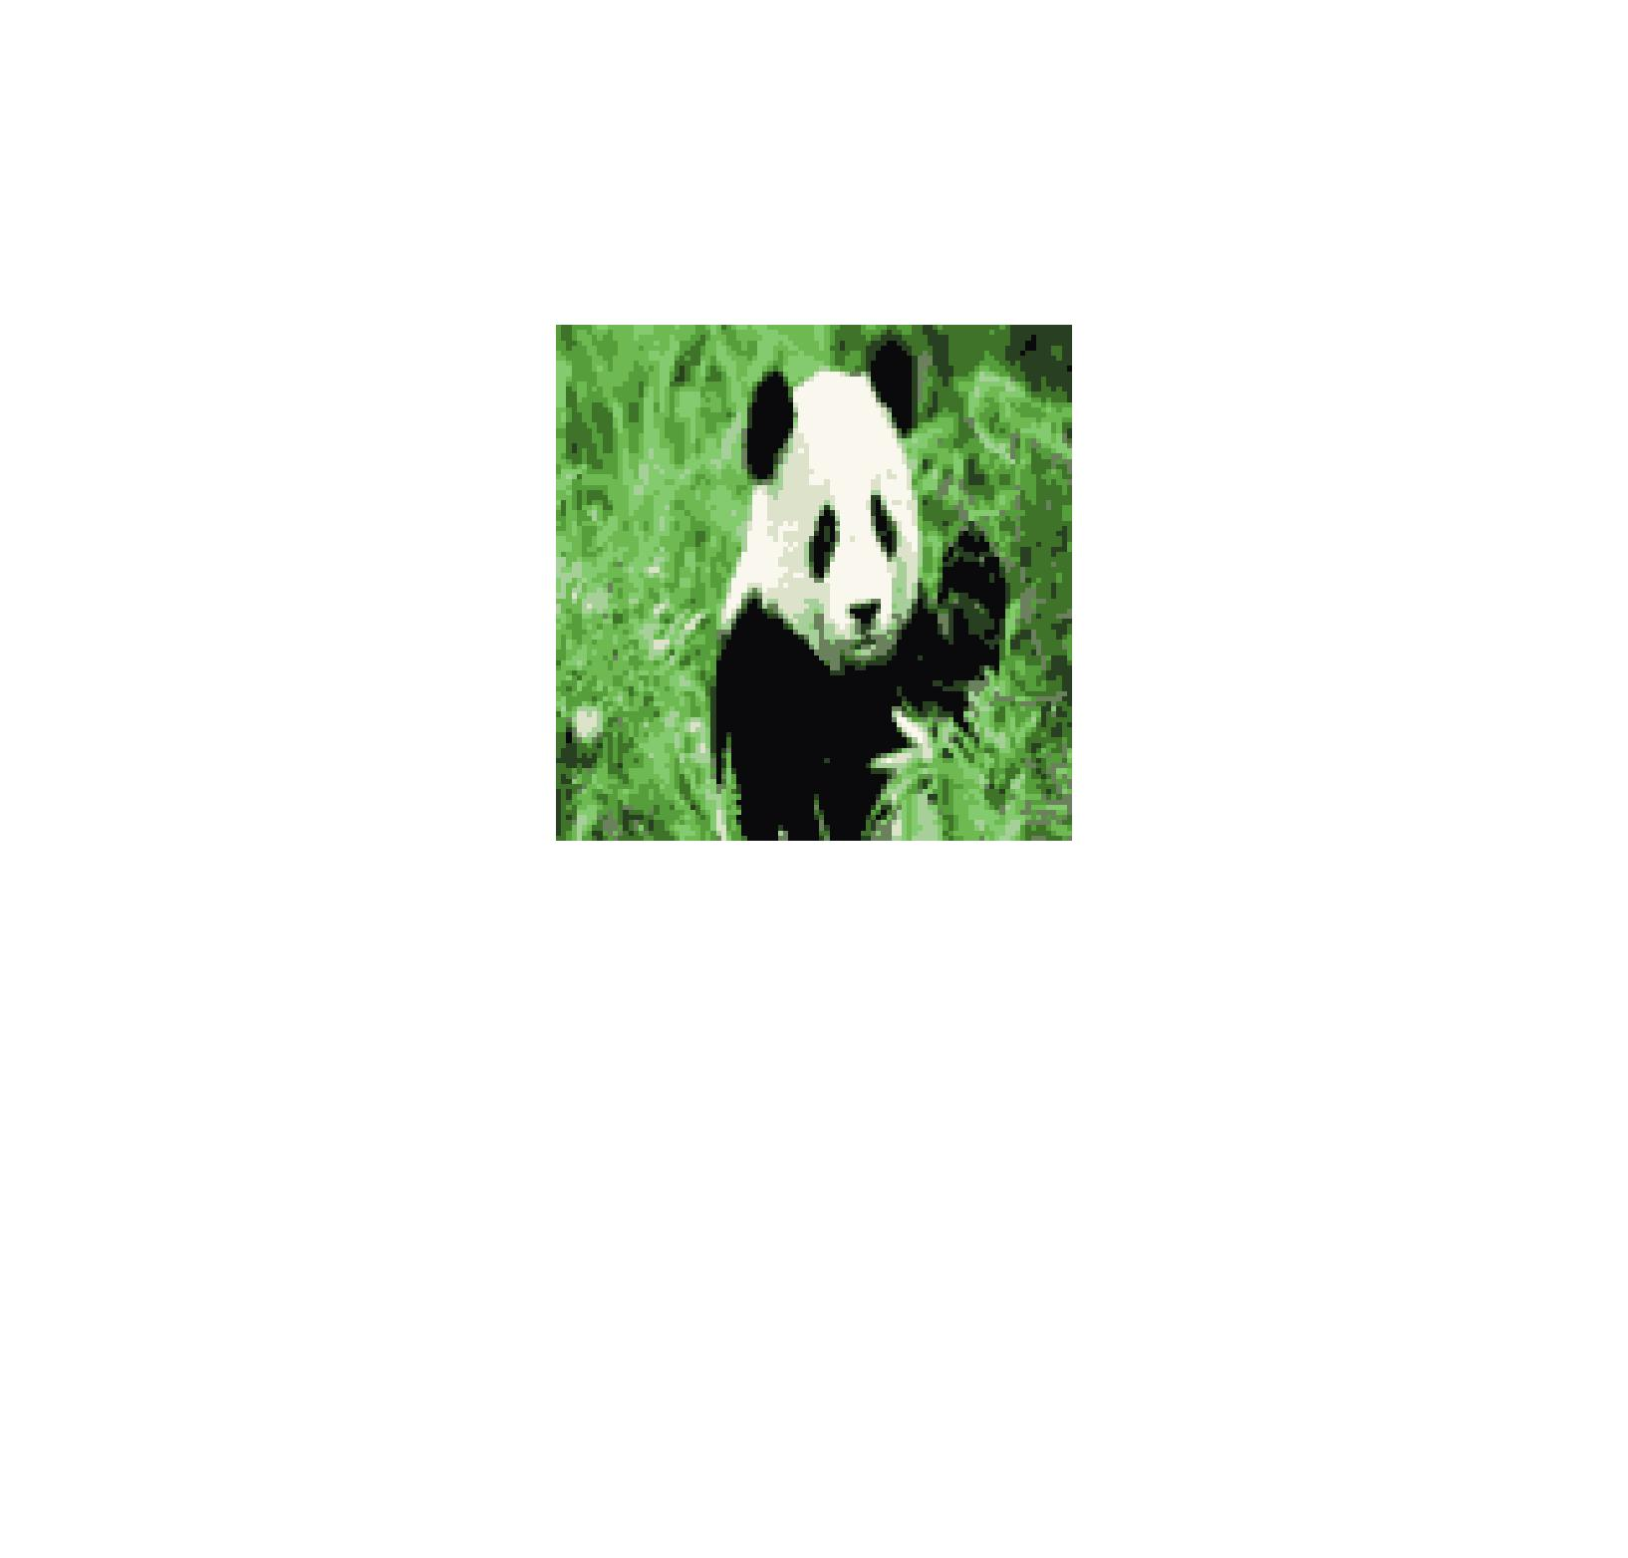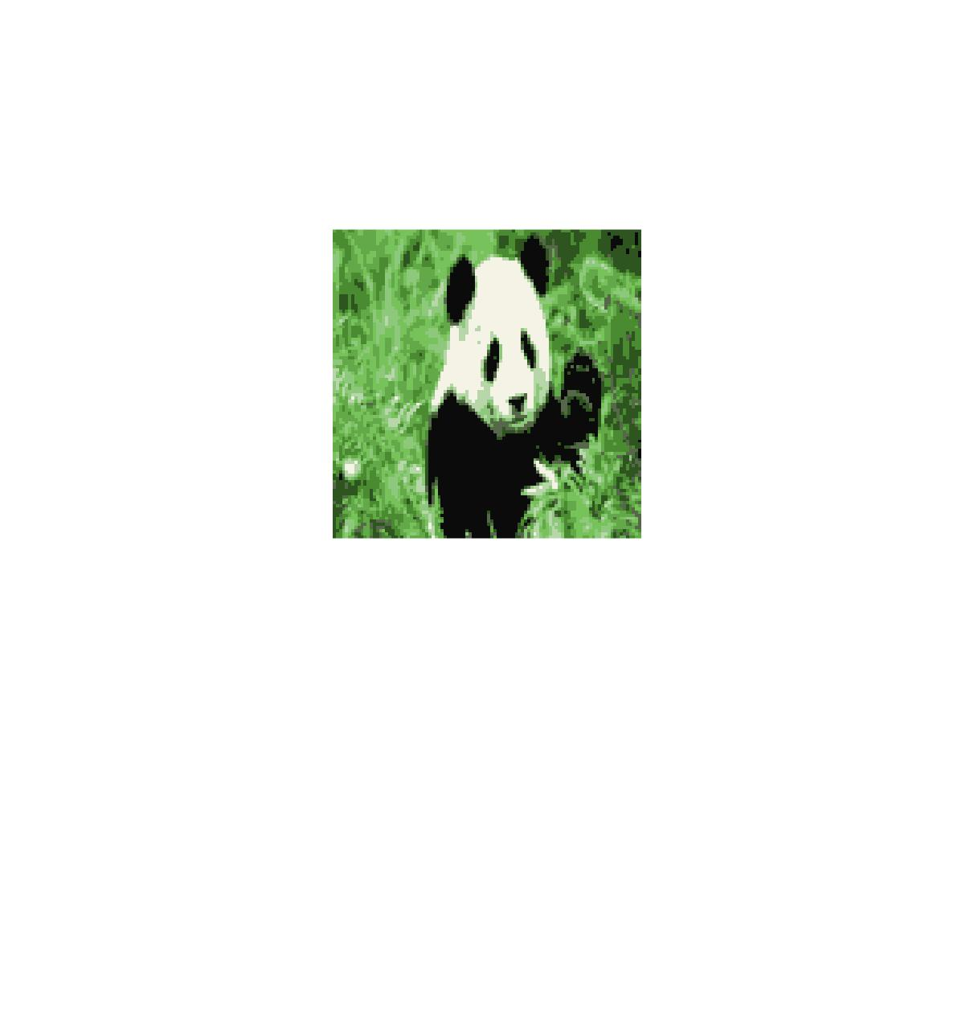

There images represent the iterations of runs 1 through 5. It’s immediately obvious that as we increase our dimensionality, number of iterations, and number of restarts, the clarity and sharpness of our image increases. In the first image, our K is only 2, and as such there are only two colors displayed. Even in the second image, where we have K equal to 5, there is a great increase in the clarity of the picture. Increasing the number of iterations we perform causes the image to be better because we are recalculating the means more often. By increasing R, the number of random restarts, we will (hopefully) be protected against poor initial random cluster choices, together with increasing the number of iterations. The higher the number of dimensions, the more clear our image is, and the more colors we will have. This is especially clear in the detail found in the panda’s face and in the plant life around the panda. By the time we reach image 5,our photo is just about as clear as the original photo.