K (x) versus accuracy (y)

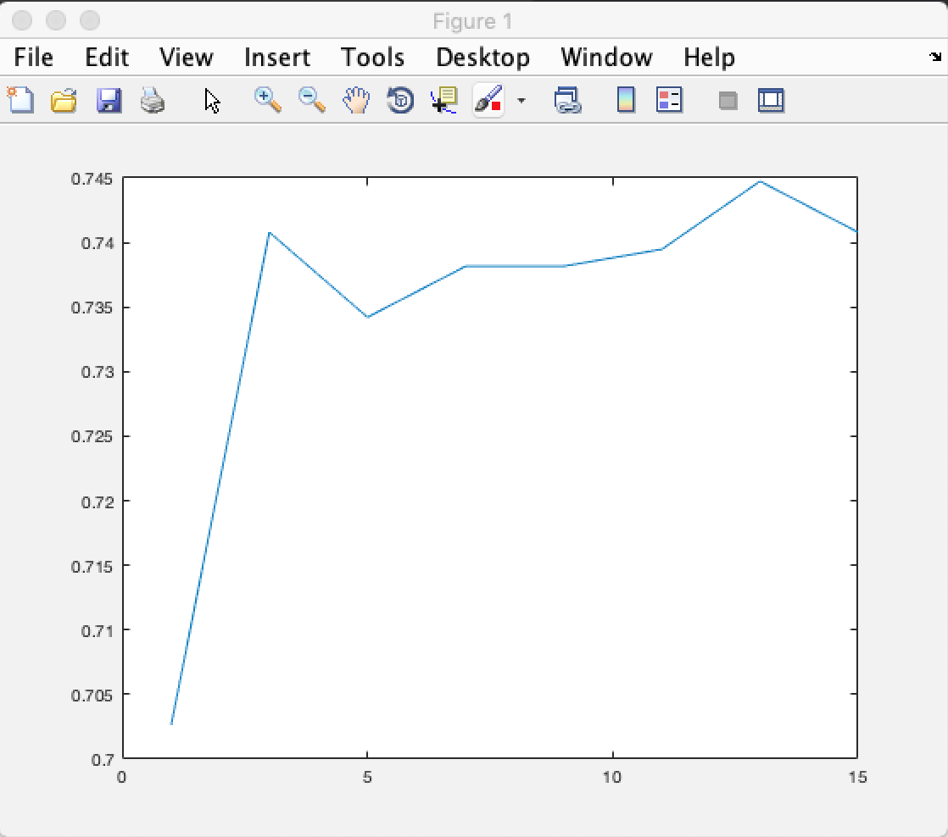

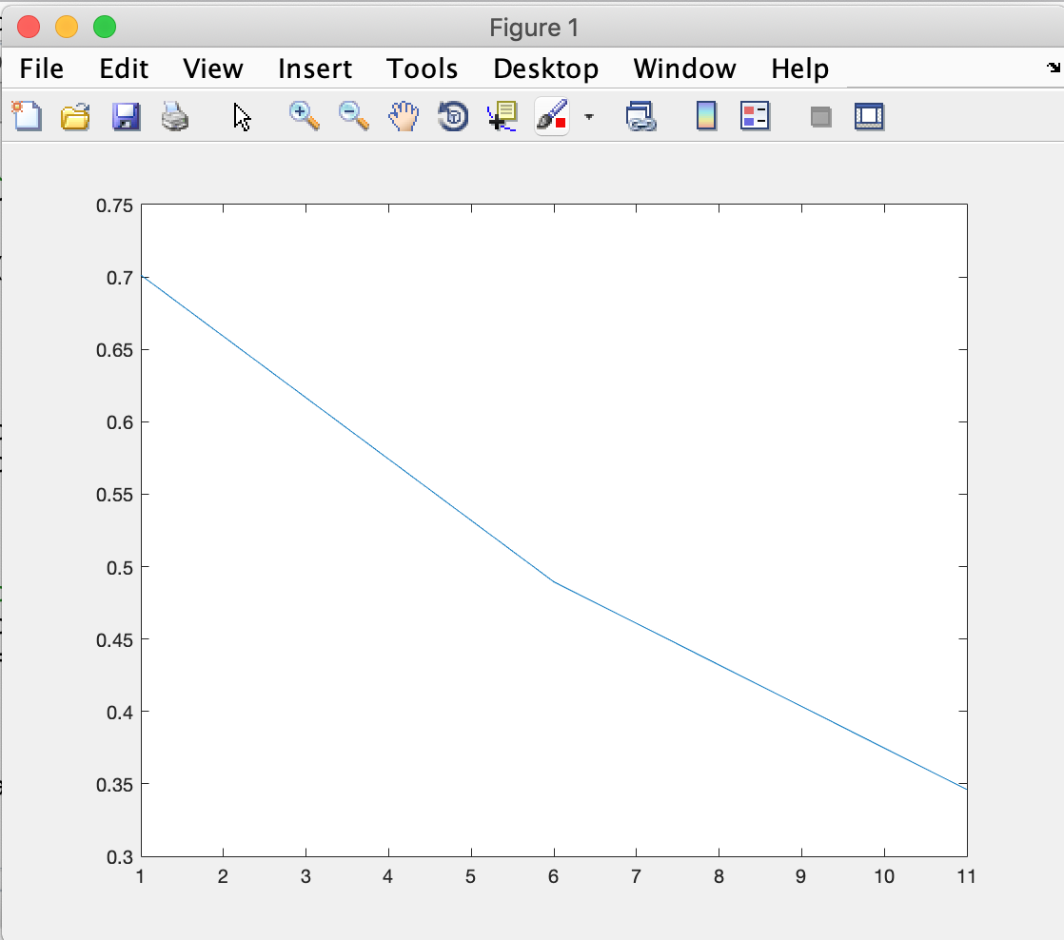 Sigma (x) versus accuracy (y)