

[Document title]

[Document subtitle]



[Date]

[Company name]

[Company address]

Table of Contents

List of Figures

List of Tables

## **Introduction**

## **Purpose of Document**

This is a Requirements Specification document for the implementation of an ERP/CRM system for Ken Grill. Ken Grill is a local chain of restaurants specialized in serving chicken meals. The company partially imports and partially manufactures its product range. The new system will replace the paper based, manual invoicing workflow to provide customers and employees customized browsing of the product catalog and the ability to complete product orders on-line. This document describes the scope, objectives, and goal of the new system. In addition to describing non-functional requirements, this document models the functional requirements with use cases and interaction diagrams. This document is intended to direct the design, planning and implementation of the ERP/CRM system in an object-oriented way.

## **Project Summary**

|  |  |
| --- | --- |
| **Project Name:** | KEN Grill ERP/CRM System |
| **Project Manager:** |  |
| **Project Analysts:** |  |
| **Responsible Users:** |  |

## **Background**

Ken Grill Mauritius is local chain of restaurants specialized in serving chicken meals. The company partially imports and partially manufactures its product range. While Ken Grill aims to supply its services as the basis for helping its customers grow their business, Ken Grill was held back in achieving its own growth aims by inconsistent, inaccurate, and delayed information.

Problems with the current system

1. Paper-based, manual invoicing and workflow processes led to business process delays.
2. Difficulty in forecasting due to lack of data and information control.
3. Inaccurate stock management.
4. Sales agents have difficulty reaching product owners.

The executive manager has requested that an analysis be done with a view to implement and ERP/CRM system to allow customers direct access to product information and ordering as well as managing stock, manage staff, Manage customers. Provide POS for its outlets. (The company has 5 outlets and would want a dedicated staff for the POS at each outlet). Provide a dashboard for viewing status of stock, enable forecasting. Provide a bank management module.

## **Project Scope**

The scope of this project is an ERP/CRM system that supports the business of KEN Grill in supplying products directly to customers as well as through the existing sales agent network. Inventory control, and account billing. Website is not in scope.

The manual day to day activities will be replaced by this new system. The ERP/CRM to be implemented is Dolibarr. Issues of website security, other than password protection within the site, are not part of this project.

## **System Purpose**

## **Users**

Those who will primarily benefit from the new system and those who will be affected by the new system include

Customers:

Upon implementation of the new system xxxxxxxxxxxxx

Human Resource Department:

xxxxxxxxxxxxxxxxxxxxxxxxxxxxxxxxxxxxxxxxxxxxxxxxxxxxx

Product Owners:

Product owners will be allowed to maintain the data about their products directly. This will eliminate delays in getting new products or changed product specifications into the system.

Customer Service Department:

The new system should reduce the workload of Customer Service as customers are able to find the information they need from the application

Marketing Department:

Site navigation data could be sent to the Marketing Department. Understanding how a customer uses the web site to make a purchase will result in improvements in getting and keeping customers.

Accounting Department:

Purchase information will be sent directly to accounting, allowing for more accurate and timely billing.

Information Technology Department:

This department will be responsible for hosting the website and maintaining the system.

## **Location**

The system will be available to any user of Ken Grill using the Internet. Ken Grill employees may also use the system from any location and will be able to access restricted areas of the site through a password protection scheme.

## **Responsibilities**

The primary responsibilities of the new system:

* provide customers direct access to up-to-date, accurate product information on which they can make a decision to buy
* allow differential access to web pages based on type of user
* allow customers to request the assistance of a sales agent
* provide sales agents improved access to product information and product owners

Other desired features of the new system:

* a consistent "look and feel" throughout the website
* full-text searches of the web pages a user has permission to access
* on-line help in website navigation
* password protection scheme for non-public web pages
* translation of a web page to another language

The system will not be responsible for xxxxxxxxxxxxxx.

## **Functional Objectives**

## **High Priority**

1. The system shall allow for on-line product ordering by either the customer or the sales agent. For customers, this will eliminate the current delay between their decision to buy and the placement of the order. This will reduce the time a sales agent spends on an order by x%. The cost to process an order will be reduced to $y.
2. The system shall reflect a new and changed product description within x minutes of the database being updated by the product owner. This will reduce the number of incidents of incorrectly displayed information by x%. This eliminates the current redundant update of information, saving $y dollars annually.
3. The system shall allow employees to view the owner of any product. An employee should be able to contact the correct owner in one phone call x% of the time.
4. The system shall allow a customer to directly contact the nearest sales office in his region. This will improve service by reducing the time to respond to a customer request to no more than x days.
5. The system shall provide accounting with accurate purchase transaction data. This will improve customer service by reducing billing complaints by x% and save $y in correcting inaccurate accounts.

## **Medium Priority**

1. The system shall provide a search facility that will allow full-text searching of all web pages that the user is permitted to access. The system must support the following searches:
   * find all words specified
   * find any word specified
   * find the exact phrase
   * Boolean search

## **Low Priority**

1. The system shall allow the user's status to be stored for the next time he returns to the web site. This will save the user x minutes per visit by not having to reenter already supplied data.
2. The system shall translate web pages into the languages of the countries where the company's products are available. This will improve customer service and reduce the number of support calls from foreign customers by x%.

## **Non-Functional Objectives**

## **Reliability**

* The system shall be completely operational at least x% of the time.
* Down time after a failure shall not exceed x hours.

## **Usability**

* A sales agent should be able to use the system in his job after x days of training.
* A user who already knows what product he is interested in should be able to locate and view that page in x seconds.
* The number of web pages navigated to access product information from the top page should not exceed x.

## **Performance**

* The system should be able to support x simultaneous users.
* The mean time to view a web page over a 56Kbps modem connection shall not exceed x seconds.

## **Security**

* The system shall provide password protected access to web pages that are to be viewed only by employees.
* Transaction data must be transmitted in encrypted form.

## **Supportability**

* The system should be able to accommodate new products and product lines without major reengineering.
* The system web site shall be viewable from Internet Explorer 4.0 or later, Google Chrome and Mozilla Firefox.

## **Online user Documentation and Help**

* xxxxxxxxxxxxxxxxxxxxxxxxxxxxxxxxxxxxxx

## **Purchased Components**

* A language translation tool from English to French and English to Xxxx will be needed.
* A web site search engine will be needed.

## **Interfaces**

* xxxxxxxxxxxxxxxxxxxxxxxxxxxxxxx

## **Use Case Model**

### **Login User**

|  |  |
| --- | --- |
| Use Case Name: | Login User |
| Summary: | In order to get personalized or restricted information, place orders or do other specialized transactions a user must login so that that the system can determine his access level. |
| Basic Flow: | 1. The use case starts when a user indicates that he wants to login. 2. The system requests the username and password. 3. The user enters his username and password. 4. The system verifies the username and password against all registered users. 5. The system starts a login session and displays a welcome message based on the user's preferences. |
| Alternative Flows: | Step 4:  if username is invalid, the use case goes back to step 2.  Step 4:  if the password is invalid the system requests that the user re-enter the password. When the user enters another password the use case continues with step 4 using the original username and new password. |
| Extension Points: | none |
| Preconditions: | The user is registered. |
| Postconditions: | The user can now obtain data and perform functions according to his registered access level. |

### **Place Order (Customer)**

|  |  |
| --- | --- |
| Use Case Name: | Place Order Scenario: Customer places his own order. |
| Summary: | This use case allows a registered customer to place an order for a product. |
| Basic Flow: | 1. The use case start when a customer indicates he wants to place an order for the current product being displayed. 2. The system displays the customer's information: name, street, city, zip, phone, email. 3. The customer may add or change any of the information. 4. The system stores any changes. If the zipcode has changed, the system modifies the customer's location. 5. The system requests the quantity to order and the shipping address. 6. The customer enters quantity and shipping address. 7. The system displays the payment options available to this customer. 8. The customer selects a payment option. 9. The system completes the payment by executing use case Charge Customer or Bill Customer depending on which option was selected. 10. The system stores the order information, decreases the quantity on hand for the product and sends the order details to Shipping. 11. The system displays a order completion message and sends a receipt to the user. |
| Alternative Flows: | Step 9:  If the selected payment method could not be validated, go to step 8 to get another payment option.  Step 10:  If the quantity on hand is not sufficient for this order, a message is sent to the customer and the use case is canceled. |
| Extension Points: | Charge Customer; Bill Customer |
| Preconditions: | The customer is logged in and has completed a search for the product to be ordered |
| Postconditions: | The product is sold. |
| Business Rules: | If a customer has been previously authorized for billing by a sales agent, the customer may billed for the order. Otherwise the customer must pay in full by credit card at the time of the order. |

### **Place Order (Sales Agent)**

|  |  |
| --- | --- |
| Use Case Name: | Place Order Scenario: Sales agent places an order for a customer. |
| Summary: | This use case allows a sales agent to place an order for a registered customer. It also allows the sales agent to change the customers access level and payment options. |
| Basic Flow: | 1. The use case starts when a sales agent indicates he wants to place an order for a customer. 2. The system requests the customers username. 3. The sales agent enters the username. 4. The system displays the registered customer's information, including access level and payment options. 5. The sales agent makes changes to the customer information. 6. The system stores any updated information. 7. The system requests the product id, quantity and shipping address. 8. The sales agent enters the product id, quantity and shipping address. 9. The system displays payment options for this customer. 10. The sales agent selects a payment option. 11. The system completes the payment by executing use case Charge Customer or Bill Customer 12. The system stores the order information, decreases the quantity on hand for the product, sends the order details to Shipping. 13. The system displays a order completion message and sends a receipt to the customer. |
| Alternative Flows: | Step 11:  If the selected payment method could not be validated, go to step 10 to get another payment option.  Step 12:  If the quantity on hand is not sufficient for this order, a message is sent to the sales agent and the use case is canceled. |
| Extension Points: | Charge Customer; Bill Customer |
| Preconditions: | The sales agent is logged in, knows the username of the customer, his payment method and the product to be ordered. |
| Postconditions: | The product is sold and the sales agent is credited with the sale. |
| Business Rules: | Sales agent have the authority to allow a customer to be billed. They may also increase the customer's access level to product data. |

### 

### **Charge Customer**

|  |  |
| --- | --- |
| Use Case Name: | Charge Customer |
| Summary: | This use case charges the order currently being placed to a credit card. |
| Basic Flow: | 1. The use case begins when a user selects "Credit Card" as a payment option, while in use case Place Order 2. The system requests the credit card number, type and expiration date. 3. The user enters the information. 4. The system verifies that the credit card is valid for the amount to be charged and completes the credit card transaction. 5. The system stores the payment details and returns a success message |
| Alternative Flows: | Step 4: If the credit card cannot be validated the use case ends, returning a failure message |
| Extension Points: | none |
| Preconditions: | The system is executing use case Place Order. |
| Postconditions: | The customer has been charged for the order. |
| Business Rules: | Credit cards accepted are Visa, MasterCard and Discover. |

### 

### **Bill Customer**

|  |  |
| --- | --- |
| Use Case Name: | Bill Customer |
| Summary: | This system gets the billing details for the order. They will be part of the Daily Transactions Report sent to Accounting in use case Report Daily Transactions. Billing and collection is handled outside this system by Accounting. |
| Basic Flow: | 1. The use case begins when a user selects "Bill me" as a payment option, while in use case Place Order 2. The system requests the billing address. 3. The user enters the billing address. 4. The system stores the payment details. |
| Alternative Flows: | none |
| Extension Points: | none |
| Preconditions: | The system is executing use case Place Order and the customer is authorized for billing. |
| Postconditions: | Accounting can bill the customer for this order. |
| Business Rules: | Customers can be billed if it was previously authorized by a sales agent. |

## **Business Process Modelling**

**Order-to-cash process**



## **Planning Artifacts**

**Project Plan**

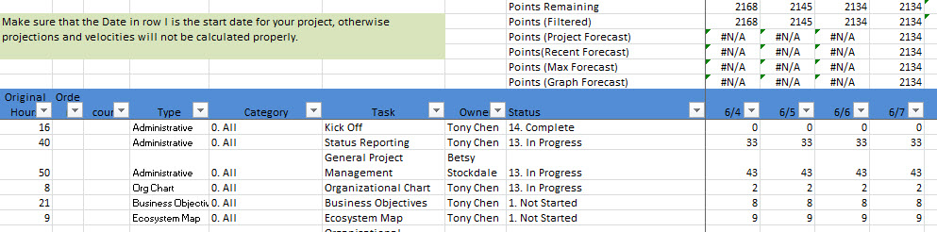

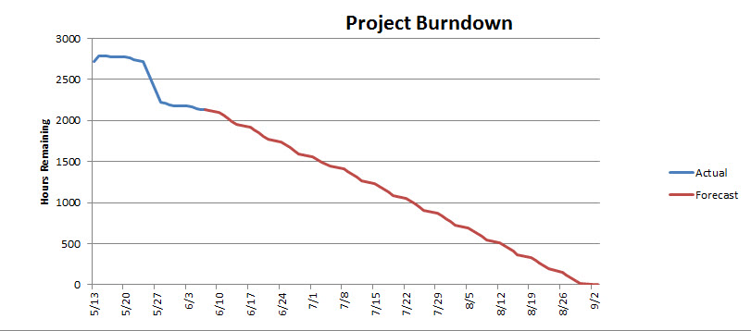

## **Implementation**

Installation of Dolibarr.

Configuration of ERP/CRM screenshot and step by step explanations.

## **Testing**

Test each functionalities implemented

## **Critical Evaluation**

## **Conclusion**

## **References**

Use Harvard referencing

<https://dkit.ie.libguides.com/harvard/citing-referencing>

Sample below

