**Aufgabe 2:**

|  |  |
| --- | --- |
| SHOW SGA; | siehe Folie 1/12  siehe Google |

SELECT * FROM v$sgainfo;

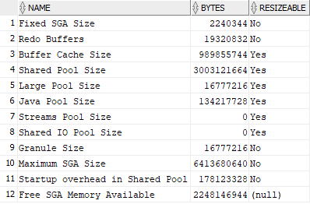

SELECT bytes / 1024 / 1024 AS "Current max. SGA Size in MB"

FROM v$sgainfo

WHERE name = 'Maximum SGA Size';

**Aufgabe 3:**

***Teilaufgabe a)***

|  |  |
| --- | --- |
| SELECT * FROM correlated;  desc correlated;  SELECT * FROM dba_tab_columns  WHERE table_name = 'DATA_CORRELATED'  ORDER BY column_id; | Spalten:  ID Number 38,  Val1 Number,  Val2 Number |

***Teilaufgabe b)***

|  |  |
| --- | --- |
| SELECT COUNT(*) FROM correlated; | 3000 Einträge |

***Teilaufgabe c)***

|  |  |
| --- | --- |
| SELECT  MIN(ID), MAX(ID),  MIN(VAL1), MAX(VAL1),  MIN(VAL2), MAX(VAL2)  FROM correlated; |  |

***Teilaufgabe d)***

SELECT id, ROUND(2*VAL1)/2, ROUND(2*VAL2)/2 FROM correlated;

***Teilaufgabe e)***

SELECT *

FROM correlated

WHERE id <= 100 AND (id/3) = TRUNC(id/3);

SELECT *

FROM correlated

WHERE id <= 100 AND MOD(id,3) = 0;

***Teilaufgabe f)***

SELECT

TO_CHAR(TRUNC(id/100), '09')||'xx' AS bereich,

ROUND(AVG(VAL1),10) AS avg1,

ROUND(AVG(VAL2),10) AS avg2

FROM correlated

GROUP BY TRUNC(id/100)

ORDER BY bereich;