Martin Baca
Module 1.2 Assignment
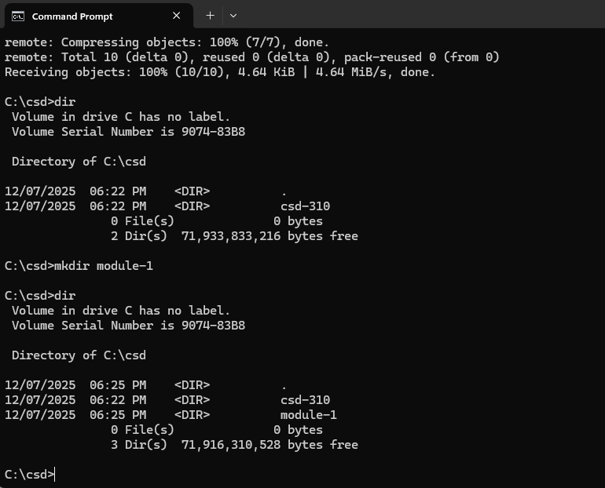
https://github.com/Mbaca81/csd-310.git

