
Microsoft Word
Financial Statement Analysis Template

- Financial Overview
Describe the purpose and context for this financial statement analysis.

- Ratio Analysis
Use this section to highlight key financial ratios extracted from your financial statements. Examples can include:

- Profitability ratios
- Liquidity ratios
- Leverage ratios
- Activity ratios

- Break-Even Analysis
Use this section to include a table and/or chart that provides information on the number of units your business needs to sell to cover your costs and make a profit.

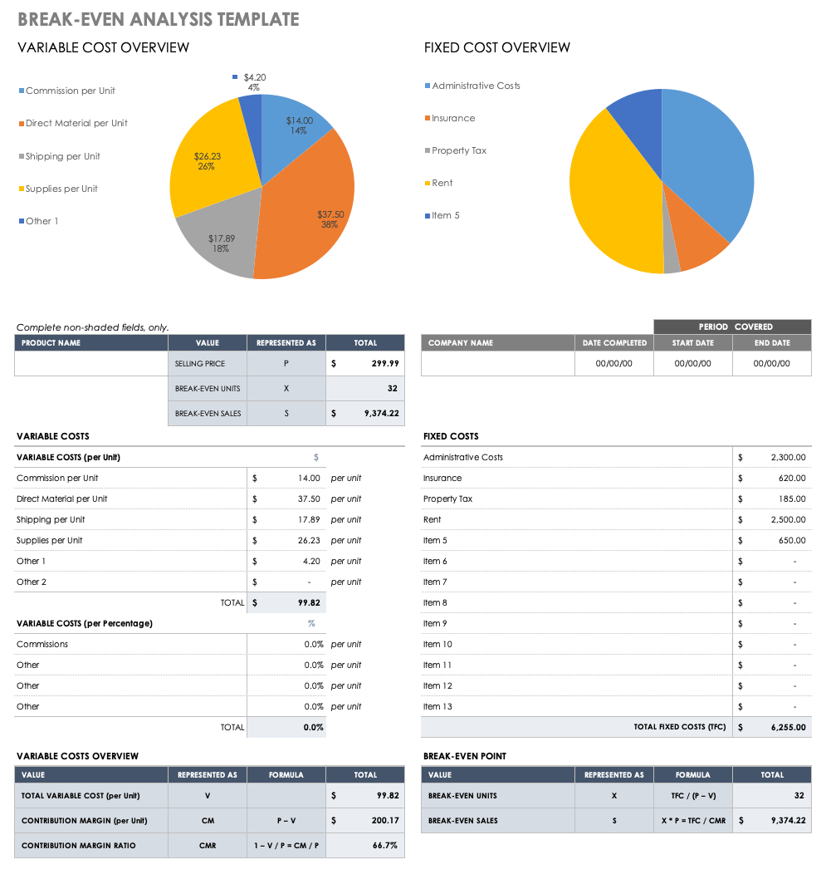

- Financial Statements
Profit and Loss Statement
Use this section to provide a profit and loss statement.

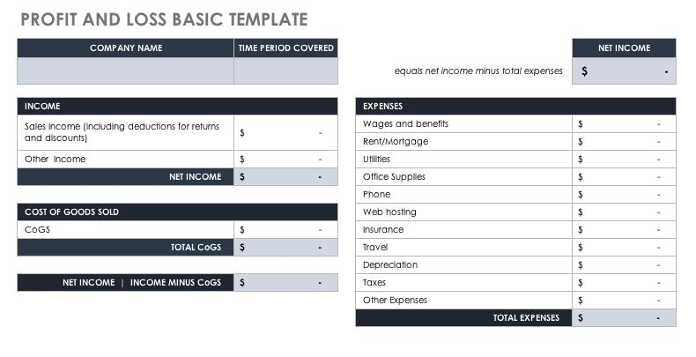

Cash Flow Statement
Use this section to provide a cash flow statement detailing cash inflows and outflows from operating, financing, and investing activities over a specific timeframe.

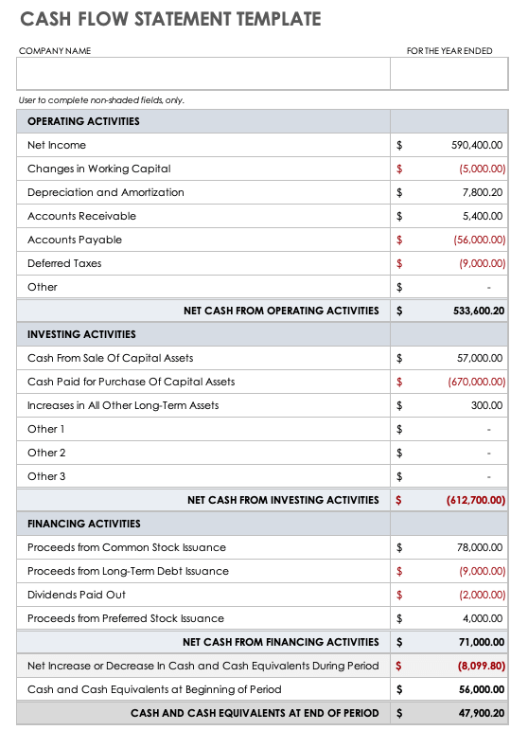

Balance Sheet
Use this section to add a balance sheet statement.

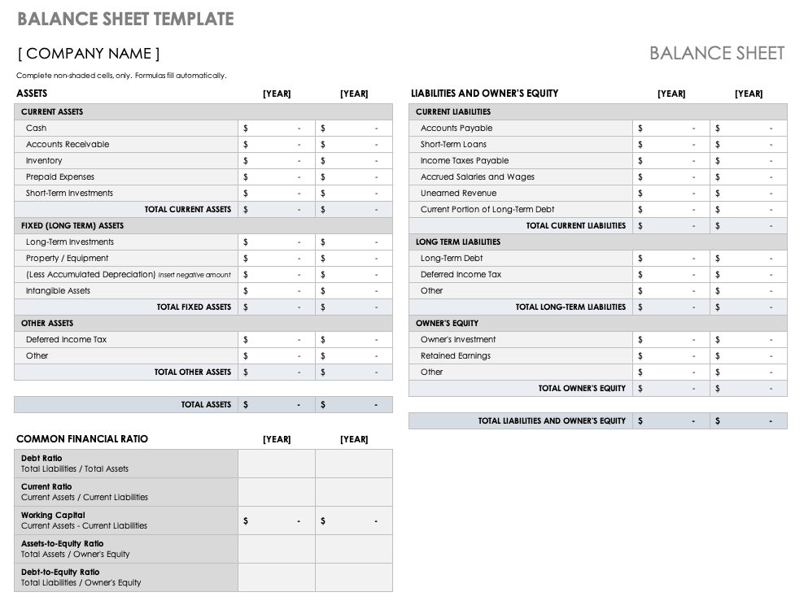

- Conclusions and Recommendations
Provide a summary of risks, opportunities, and key findings.

DISCLAIMER

Any articles, templates, or information provided by Smartsheet on the website are for reference only. While we strive to keep the information up to date and correct, we make no representations or warranties of any kind, express or implied, about the completeness, accuracy, reliability, suitability, or availability with respect to the website or the information, articles, templates, or related graphics contained on the website. Any reliance you place on such information is therefore strictly at your own risk.

