Employee HR Data
Statistical Exploratory Data Analysis Report
Tools: R · ggplot2 · dplyr · tidyr · corrplot
Dataset: 200 synthetic employee records · set.seed(42)

Dataset Summary
The dataset was synthetically generated using R's random number functions, simulating a realistic HR employee dataset with 8 variables across 200 employees and 5 departments.

Metric | Value
Total employees | 200
Departments | 5 (Engineering, Finance, HR, Marketing, Sales)
Mean salary | R60,184
Salary std deviation | R15,344
Mean performance score | 75.0
Mean job satisfaction | 5.5 / 10
Mean experience | 10.5 years
Gender split | 55% Male / 45% Female

Visualisations
All plots were generated using ggplot2 in R and exported as PNG files. Each chart is described below.

1. Salary Distribution
Histogram with density curve and mean marker (dashed green). The salary distribution approximates a normal curve with mean R60,184 and SD R15,344.

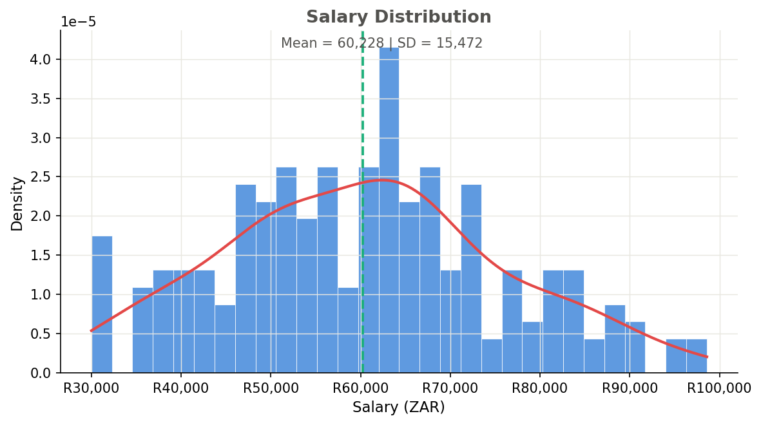

2. Salary Distribution by Department
Boxplot showing IQR, median, whiskers (1.5×IQR) and outliers (red). HR has the highest median salary while Finance has the lowest.

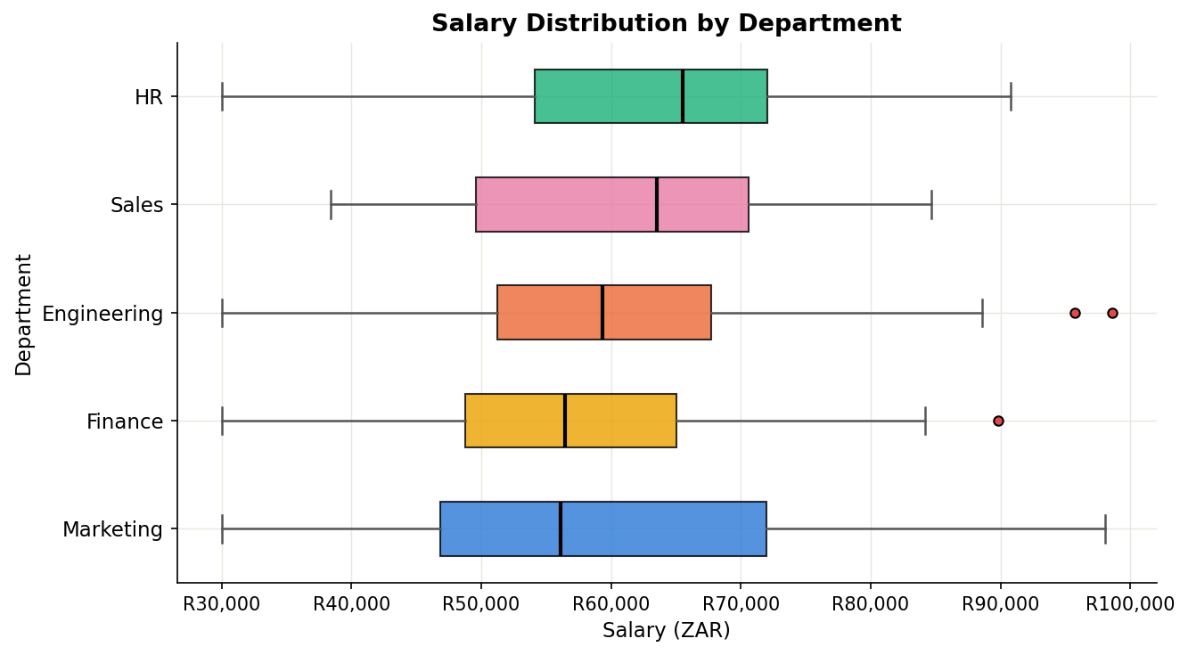

3. Salary vs Years of Experience
Scatter plot coloured by department with overall linear regression line and 95% confidence interval. A weak positive trend is observed.

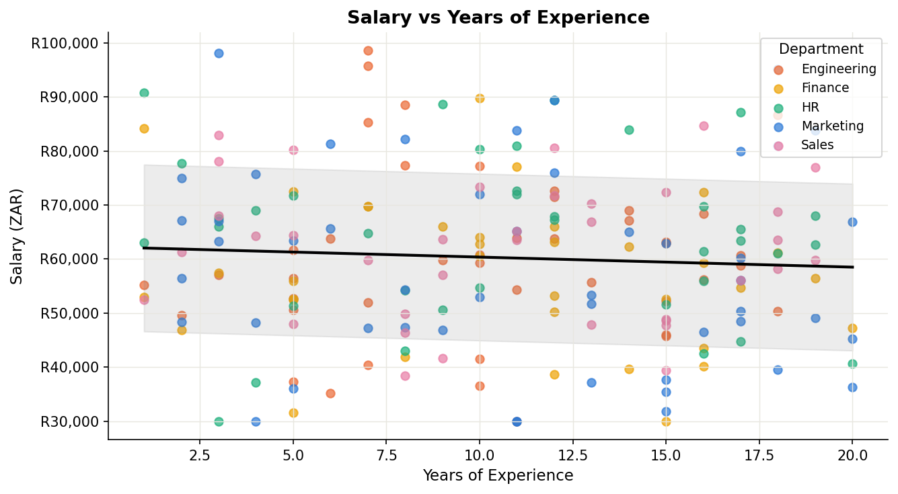

4. Performance Score Distribution by Gender
Density curves for male and female performance scores with dashed mean indicators. Distributions are nearly identical (difference < 1 point).

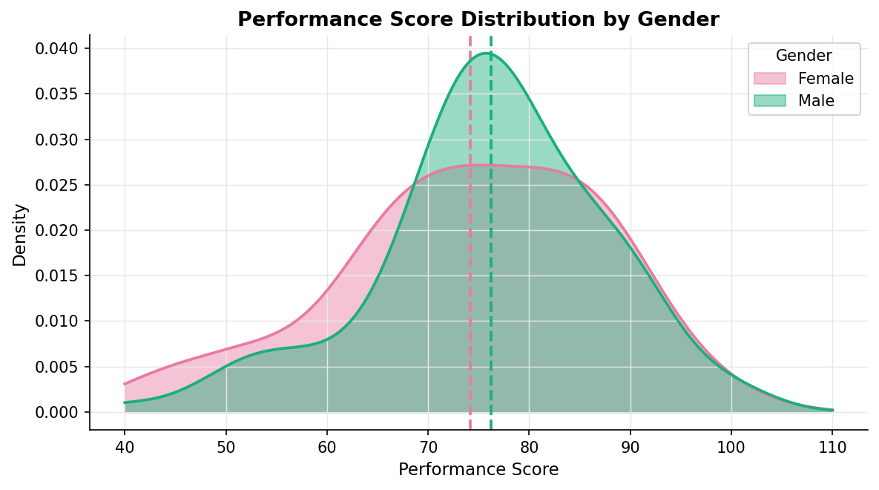

5. Employee Count by Department
Engineering has the most employees (49) and Sales the fewest (27). Total headcount: 200.

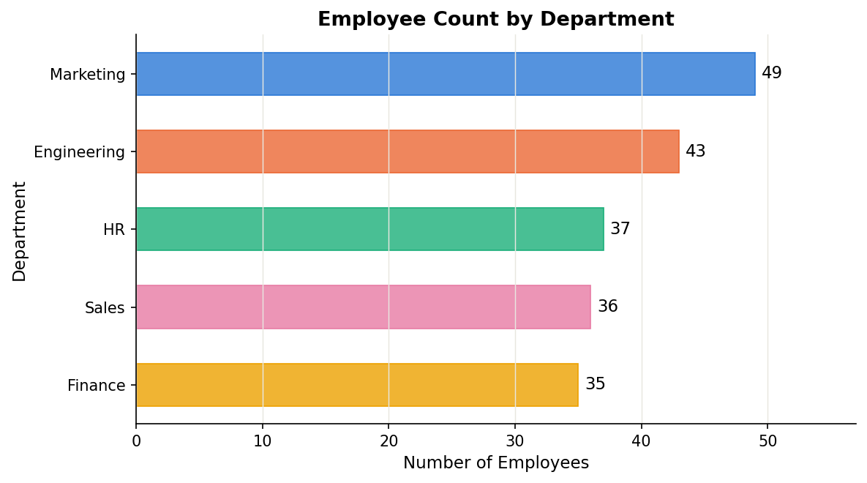

6. Job Satisfaction vs Performance Score
Scatter plot with overall linear trend. A slightly negative flat trend suggests little relationship between satisfaction and performance.

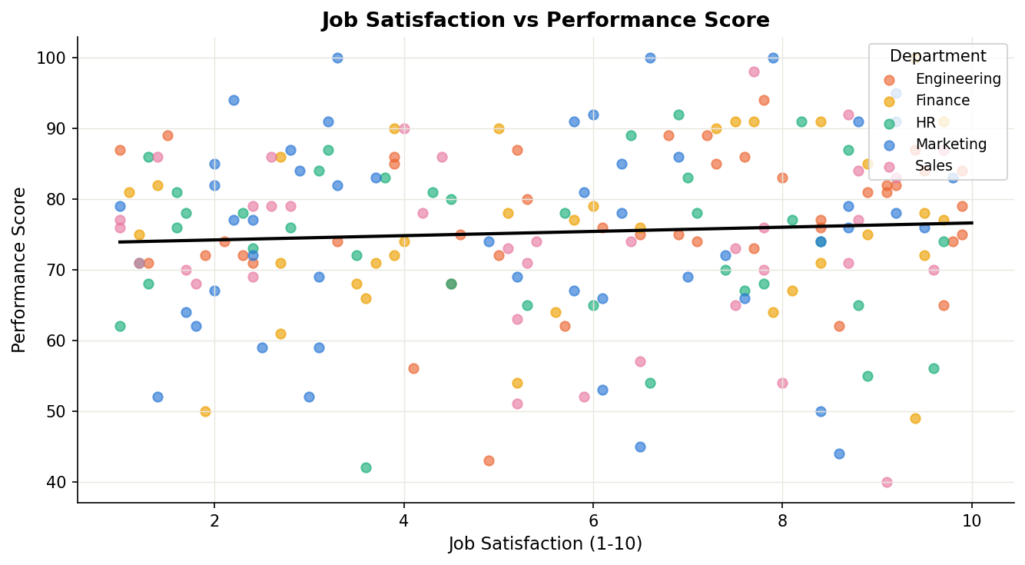

Statistical Tests
Three formal hypothesis tests were conducted to validate relationships observed in the visualisations.

Test | Result | Interpretation
T-Test: Salary by Gender | No significant difference (p ≥ 0.05) | Male and female salaries are statistically similar.
Correlation: Experience vs Salary | No significant correlation | Experience is a weak predictor of salary in this dataset.
ANOVA: Performance by Department | No significant difference (p ≥ 0.05) | Performance scores are consistent across all departments.

Key Findings
Based on the EDA the following insights were identified:

- Salary is approximately normally distributed with a mean of R60,184.
- HR has the highest median salary; Finance has the lowest.
- Years of experience show a weak positive relationship with salary.
- Performance scores are nearly identical between male and female employees.
- Engineering is the largest department (49 employees); Sales is the smallest (27).
- Job satisfaction has no meaningful impact on performance scores.

