**Reflection**

1: Michael Bartninkas, 000370838, Lab1

2: Within Lab 1A Non required fields in the car and member controller are being considered required due to data annotations

3:

Learning how to manipulate multiple aspects of a project and the identity system in MVC .net Core (I did not take the updated course for ASP).

How to perform data migrations and use scaffolding to create CRUD operations on a database.

Using restful API’s and manipulating a database.

4: I believe I should work on:

Fully understanding the MVC Framework and, Annotation attributes and what is possible to accomplish using them for data integrity in a code first database.

Understanding various datatypes and parameters for controllers in a API (I had some issues receiving data after posting to the Dealership API JObject vs string, JSON vs Text).

Be cautious when reading lab Instructions.

5: Screenshots SEE BELOW

**Lab1A**

**Tests pass picture**

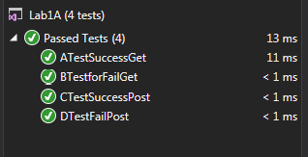

Figure 1Tests have passed

Member Controller

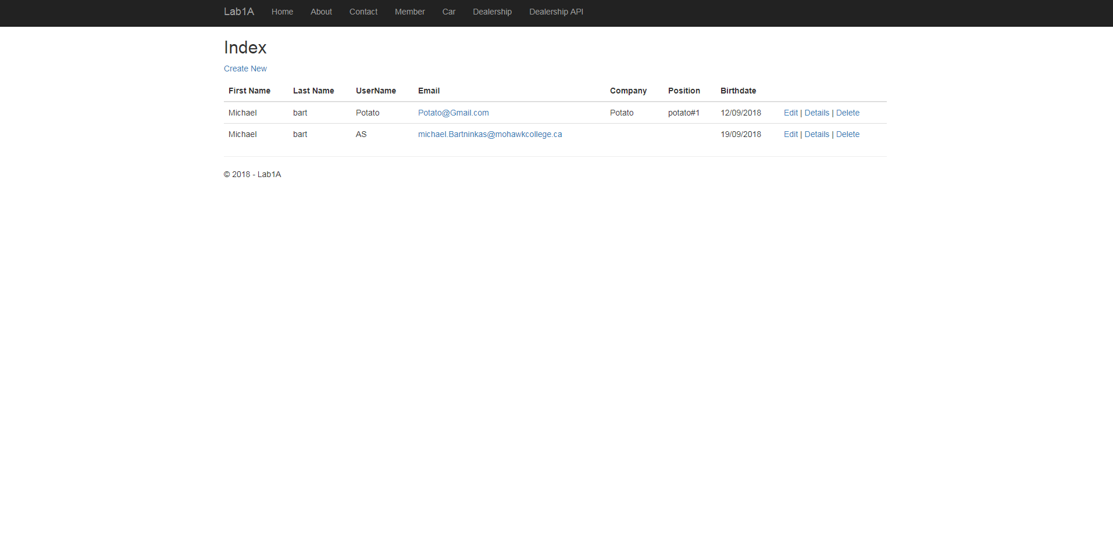

Figure 2 A user is viewing the member controller

Car controller

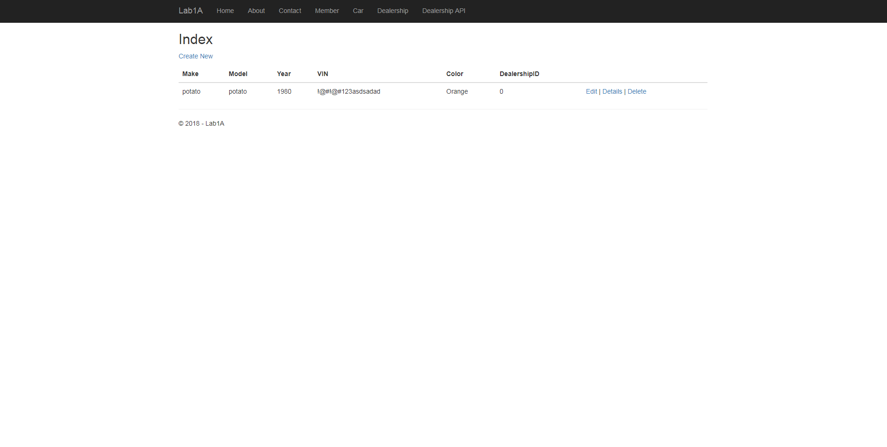

Figure 3 A Get Using the Car Controller

Dealership Controller

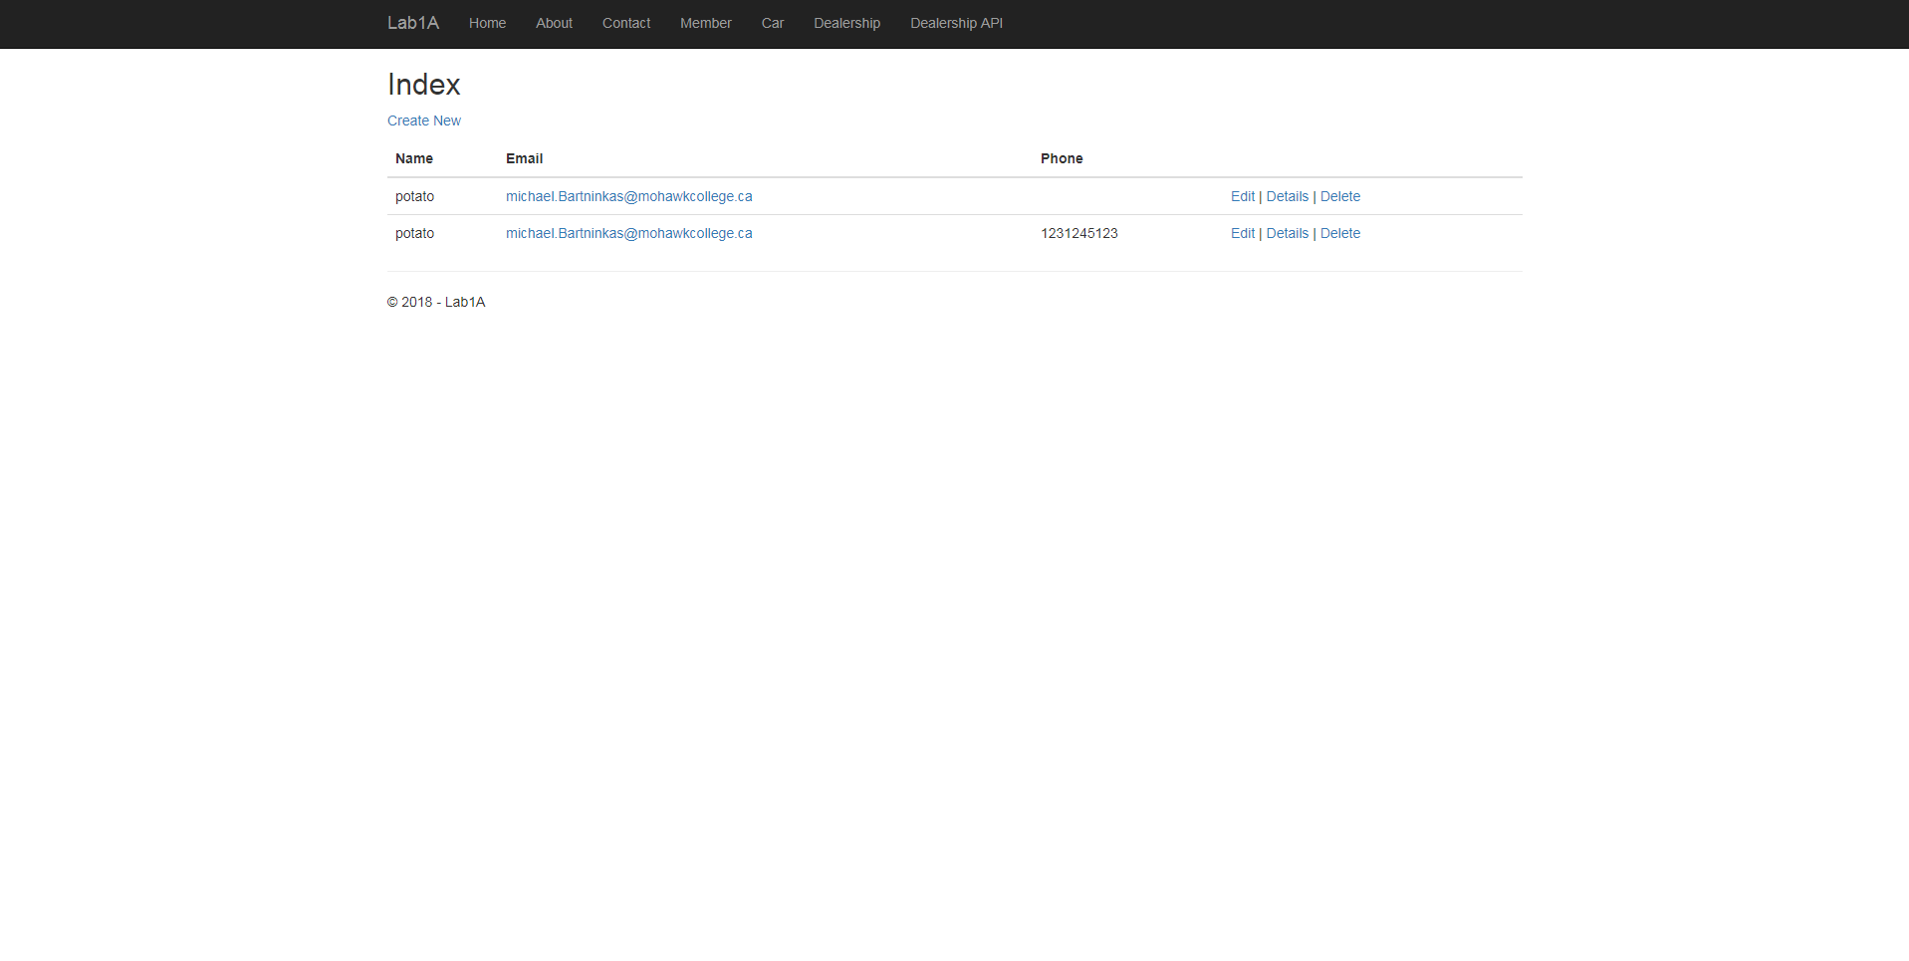

Figure 4 A get using the Dealership Controller

Dealership API Controller



Figure 5 A Get Using the Dealership API controller without ID

**LAB1B**

**Employee Create**

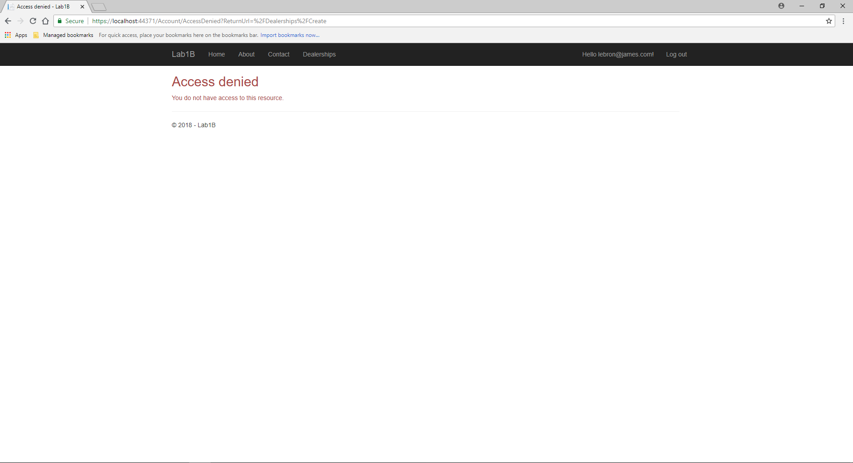

Figure 6 Employee user attempts to navigate to the create action of the dealership controller.

**Manager Create**

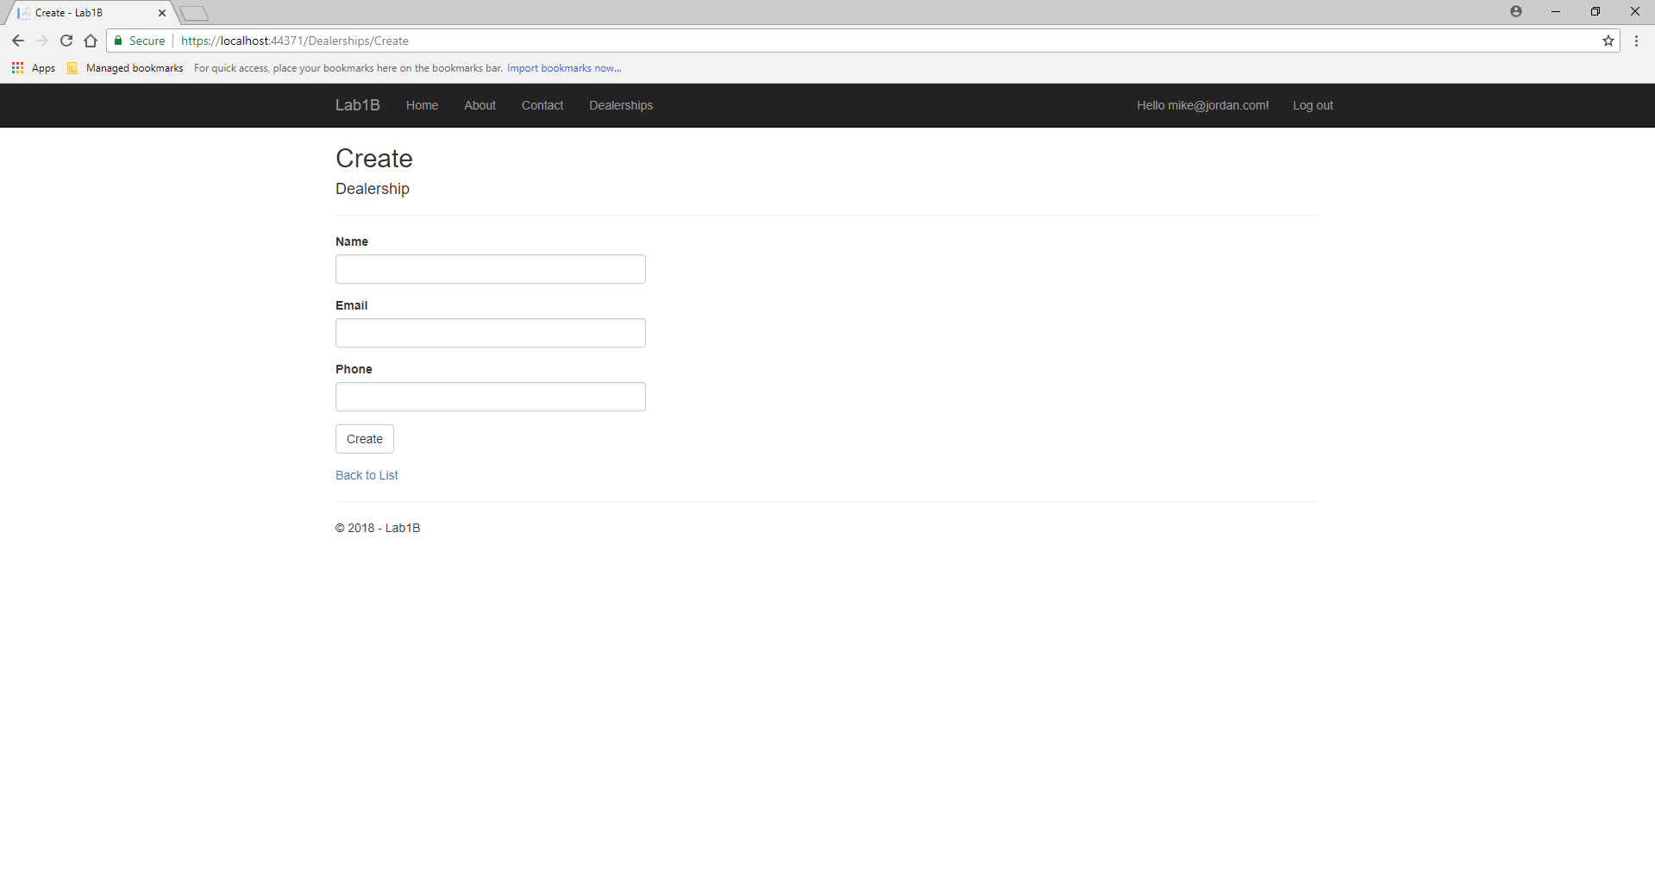

Figure 7 Manager user attempts to navigate to the create action of the dealership controller.

**Unauthenticated Create**

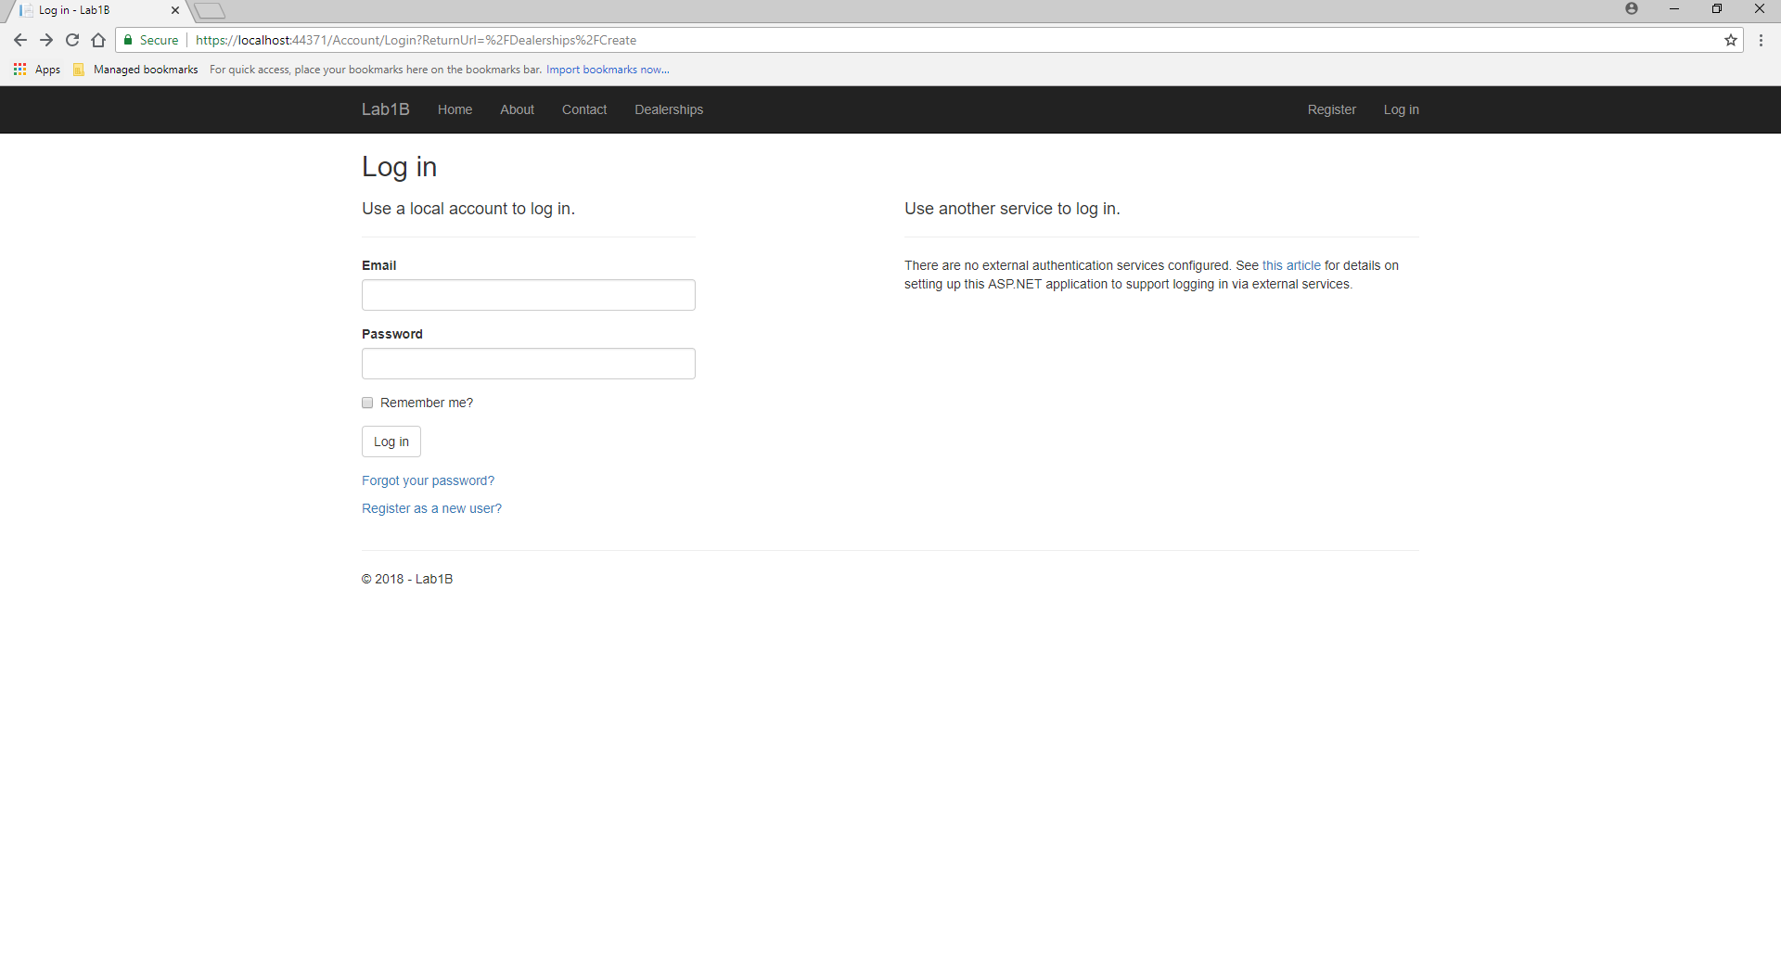

Figure 8 Unauthenticated user attempts to navigate to the create action of the dealership controller.