Pantry Filler

This app seeks to track all the contents of the users pantry.
Ingredients are added by the user and can be removed by the user.
The main way ingredients will be removed will be by being used in a recipe.
Recipes will be listed in the app and when a recipe is created the ingredients are removed from the pantry and placed on a shopping list.

Version 1
Everything will be manually entered by the user at the local computer. Create initial list of ingredients.

Version 2
The app will be moved to a website in order to be accessed by more people.

Version 3
Create a GUI so that it is more user friendly.

Version 4
OCR will be implemented so that users can take a picture of their receipt and have the object added to the pantry.

Version 5
Will add times for some ingredients for example, shampoo will be removed every X months as it is used by the user and placed on the shopping list before it runs out.

Version 6
The app will connect with Coles, Woolworths, Foodland and Aldi API’s in order to track where to get the best prices for the ingredients on the shopping list.

Version 7
This will add very specific walk-throughs for some recipes and be dubbed “cooking for bachelors”. This recipe will be extremely specific in the instructions by telling the user exactly what utensils they require to create the recipe, when to clean their utensils during cooking and exactly how to do every possible thing in the recipe. This is so that single men that have little to no experience cooking should be able to make some basic meals and begin learning how to cook.

Version 8
Track use of ingredients and identify areas where expenses can be saved. This will be things like buying home brand products instead of other products. Also separate recipes into quick recipes (some ingredients are things like curry paste), from scratch (all ingredients are single items and nothing is created for the user) and improvements (things like a basic pizza from coles which the user can put mushroom, garlic powder, cheese etc to make it better).

Version 9
Release diet plans on the app. These will cater for different family sizes and different goals. Will have vegetarian, vegan and other recipe types. Goals could include save money, lose weight, gain weight, eat healthy, try vegetarian etc.
Functions version 1

Menu (controller class)
Should show the options for navigating the app. Will have 1. Add to pantry, 2. Create shopping list, 3. Create recipe, 4. Remove recipe and 5. Quit. Each function will have the option to return to menu.

Database
Create a database of ingredients so that basic recipes can be created. All ingredients will be generic so that they do not require a brand. This will have str:name, int:quantity, int:size as parameters. Does not require quantity unless it is something that is weighed. Example tinned tomatoes 400 grams vs tomato. The user might get 12 tomatoes however there only needs to be one in the database.

Add to pantry
One function to add the pantry to a list. This will require str:name, int: quantity, int:size. Size will be tricky as there are multiple ways to measure. Litres, grams, large etc. Might have to create variable for each ingredient for example diced tomatoes 400 grams as if there are multiple brands they might not line up with the shopping list and creating the recipe.

Create shopping list
This function will also be a list. It will have the same parameters as add to pantry name, quantity and size. This function will remove the object from the pantry and add it to the shopping list. Need to find a way to create multiples… If in list then object += 1.

Create Recipe
This function will let the user create a recipe that can be called at a later date. This will be a list of recipes. When creating a recipe it will require a title followed by each ingredient which will require a name, quantity and size. This should also allow the user to add another recipe if they wish to continue. Add rating.

Select Recipe
This function will select the recipe. If the ingredients are in the pantry then it will tell the user that this recipe can be created. If the ingredients are not in the pantry the app will ask the user if they want to add the ingredients to the shopping list and will do so if the user selects yes.

Plan weekly meals
This function will add multiple recipes to a list. It will then check to see if the ingredients are in the pantry. If ingredients are not in the pantry then it asks the user if they would like to add the ingredients to the shopping list and will do so if the user says yes.

Remove Recipe
This will simply remove the recipe from recipe list.
Parents will use this app to save time and remove the thinking from preparing food. By tracking what is in the pantry and having a recipe selection function this will stop parents from having to check the pantry physically and can help them do shopping on the way home from work.

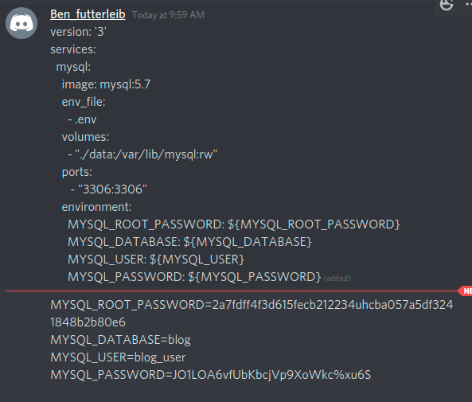
Create data folder
Create recipe_user and give password
MYSQL work bench

3 tables graphical interface then MYSQL.

3 seperate files.
Store array of mappings between recipes and ingredients in the third file.
Unique ID’s for recipes and ingredients.
Recipe ID, Ingredient ID and quantity.

Dictionary = json stream. Can store a row in the same row as a format as using it.

Parse json into dictionary. Search for how.

Don’t forget hidden characters in files.

Libraries and methods for stingifying dictionaries and parsing json strings into dictionaries.

