**LAB-3 DC Motor Rotational Velocity Estimation with Encoder**

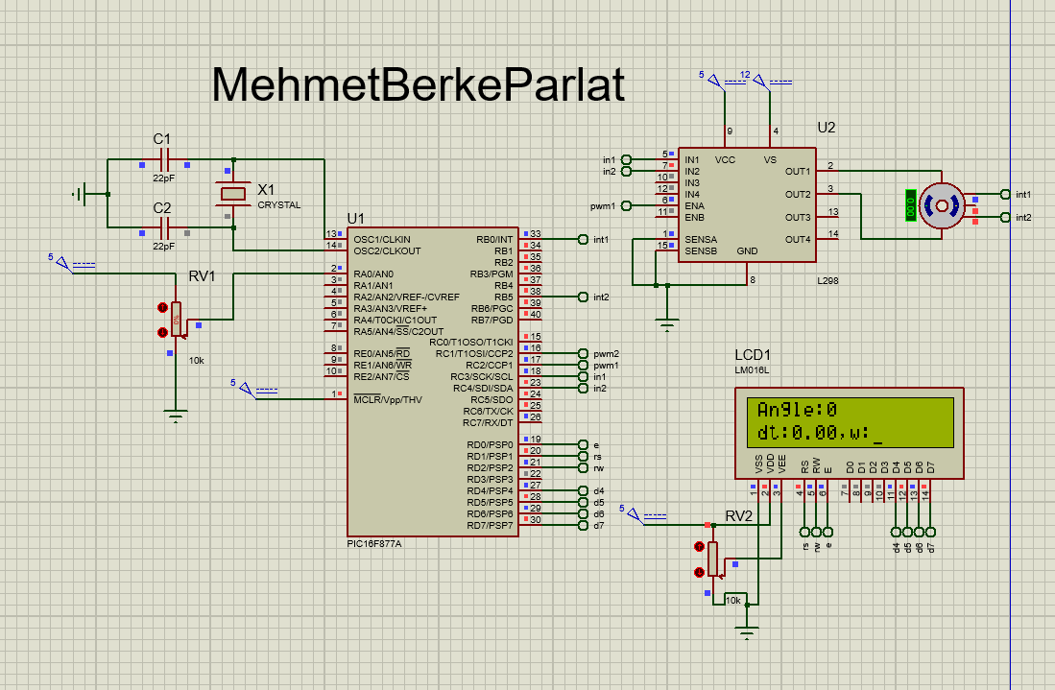

1. The resolution of the encoder is 360.
2. When button 2 is pressed, led 2 is turn on. When released, led 2 turns off.
3. 44.4 rpm
4. The code estimates velocity by calculating the change in angle over time. The line "dx_dt = (revAngle - prevAngle)/3.0f;" calculates the difference between the current angle and the previous angle, divided by a scaling factor of 3.0. The result represents the change in angle per unit time. The caution mentioned in the code ("Caution here") indicates that there may be specific considerations or potential issues related to this calculation.
5. In the code (code-2), the velocity is estimated by calculating the change in angle over time. The time between external interrupts is measured using the variables t1 and t2. The caution lines indicate the need for caution or potential issues related to these calculations. The velocity is then determined by dividing a constant value by the time difference. The calculated velocity is displayed on the LCD screen.
6. If the modified external_interrupt() function is used with the line velo = 1666.667/deltaT; // Caution here [3], the calculation of velocity would change. The line adjusts the scaling or conversion factor used in the velocity calculation from 166.667 to 1666.667. The caution mentioned in the code ("Caution here [3]") implies the need for caution when using this specific calculation, potentially due to accuracy, overflow/underflow concerns, or specific application requirements.
7. In terms of performance, both simulations (code-1 and code-2) estimate the velocity of the DC motor based on the change in angle over time. However, they have certain limitations. The first simulation (code-1) assumes a maximum of 2400 pulses per revolution (PPR) and a maximum speed of 333 RPM. If the PPR exceeds 2400 or the motor rotates faster than 333 RPM, the accuracy and reliability of the velocity estimation may be compromised. The second simulation (code-2) also relies on angle and time measurements but with different calculations. In cases where the PPR is higher than 2400 or the motor rotates faster than 333 RPM, modifications to the code or alternative techniques may be required to accurately estimate the velocity. This could involve using higher-resolution encoders or implementing more advanced algorithms to handle higher speeds and resolutions.