**LAB-4 Serial Communication via UART Application**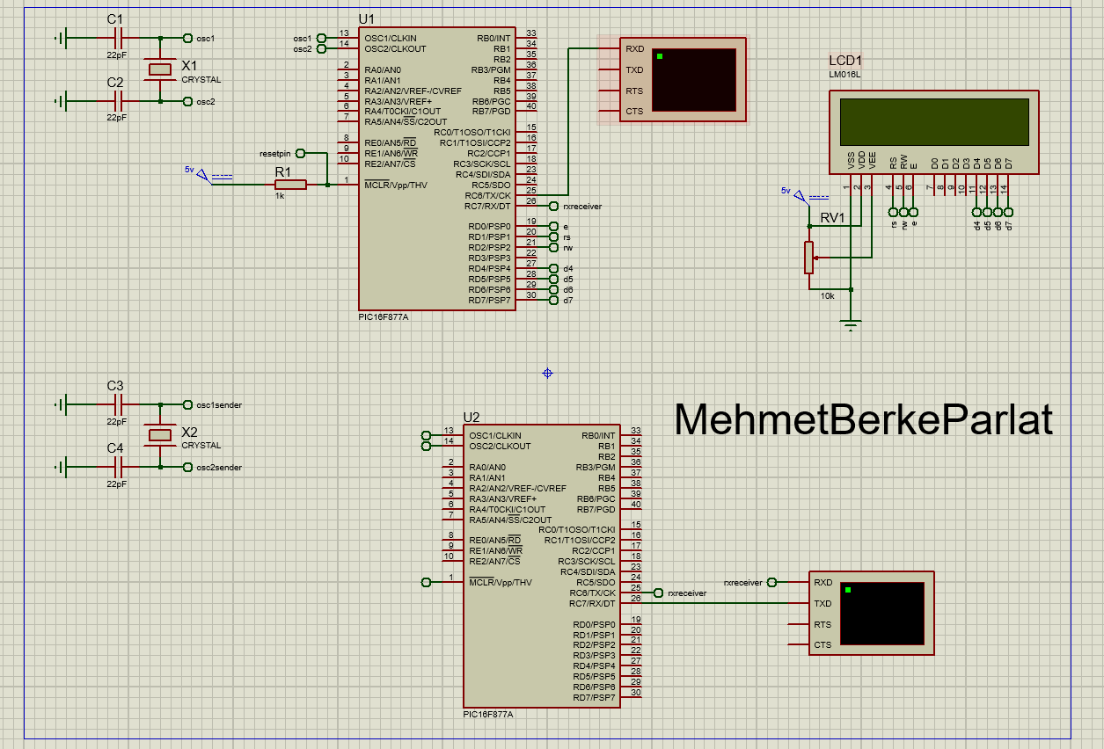

1. Code 1 receives characters from a serial input and performs operations based on the received characters. When a complete input string is received (indicated by '*'), the code prints the string, converts it to a long variable, multiplies it by 2, and prints the modified value on both the screen and LCD display. The string array is then cleared for the next input.Code 2 is a separate program that continuously prints numbers from 1 to 4 on the screen with a delay of 500 milliseconds between each print. After printing '4', it adds a '*' character and waits for 5 seconds before repeating the sequence.