Drivers of Energy Poverty in Africa: An Algorithmic Approach
Abstract
Energy poverty remains a major constraint on Africa's structural transformation, yet existing evidence is constrained by narrow access indicators, country-specific samples and mainly linear modelling strategies. This paper examines the drivers of multidimensional energy poverty in Africa using an algorithmic approach. It constructs a Multidimensional Energy Poverty Index (MEPI) for 54 African countries over 2000-2022, covering electricity access, affordability and efficiency, reliability, clean cooking and sustainability. Recursive Feature Elimination identifies the most informative predictors from 34 candidate variables, after which nine machine learning models are estimated and compared. Feature importance, SHAP values, Partial Dependence Plots and Individual Conditional Expectation curves are used to interpret the dominant drivers, while fixed-effects and random-effects panel estimations provide econometric validation. The results show that energy poverty remains structurally persistent, with a mean MEPI of 0.509 and 46 of 54 countries classified as energy poor on average. Clean cooking and reliability are the deepest deprivation dimensions. Tree-based ensemble models outperform linear models, with Random Forest providing the strongest predictive performance. CO₂ emissions per capita is the dominant predictor: low emissions are associated with higher energy poverty, indicating that low carbon intensity in many African countries reflects biomass dependence and under-industrialisation rather than successful decarbonisation. Government effectiveness, rural population share, population density, alternative energy, GDP growth and energy use per capita also shape MEPI outcomes. The findings support an integrated policy agenda centred on clean cooking, reliability, rural energy access, institutional quality and just transition finance.

1. Introduction
Energy poverty remains one of the most binding constraints on Africa's structural transformation, human development and low-carbon transition. Although global electricity access has improved over the past two decades, progress remains uneven and insufficient to achieve Sustainable Development Goal 7, which aims to ensure access to affordable, reliable, sustainable and modern energy for all by 2030. The access deficit is increasingly concentrated in Sub-Saharan Africa, while clean cooking deprivation remains even more persistent. These deficits have placed energy access at the centre of Africa's development agenda and of continental initiatives to expand electricity access and accelerate clean energy deployment.
However, Africa's energy poverty cannot be adequately understood through electricity connection rates alone. A country may expand grid connections while households still face unreliable supply, high energy costs, limited productive use of electricity and continued dependence on biomass for cooking. The literature has therefore moved beyond binary access measures toward multidimensional approaches that capture availability, reliability, affordability, quality, cleanliness and sustainability. Boardman's (1991) fuel poverty framework was influential in developed-country contexts, but its income-expenditure focus is less suited to African settings, where deprivation often reflects the absence, unreliability or low quality of modern energy services. Sovacool (2012) frames energy poverty as a political-economic condition shaped by access, institutions, infrastructure and inequality, while Nussbaumer et al. (2012, 2013) advance the Multidimensional Energy Poverty Index (MEPI) as a tool for measuring simultaneous deprivation across energy dimensions.
This multidimensional framing is particularly important for Africa, where energy deprivation reflects overlapping constraints: low income, weak institutions, rural exclusion, biomass dependence, unreliable grids and uneven energy-system development. Clean cooking is especially critical because it remains one of the deepest and most persistent deprivation dimensions. In many countries, improvements in electricity access have not been matched by comparable progress in clean cooking, grid reliability or productive energy use. The present paper confirms this pattern by showing that clean cooking and reliability are the most severe MEPI dimensions across African countries.
Theoretically, four explanations dominate the energy poverty literature. The income-poverty trap perspective argues that households and countries with low incomes cannot afford modern energy connections, while unreliable energy constrains productivity and income growth (Khandker et al., 2012). The institutional perspective emphasises weak regulation, limited public-sector capacity, utility mismanagement and inefficient energy governance (Sovacool, 2012). Apergis et al. (2023) show that public expenditure reduces energy poverty in Sub-Saharan Africa only under favourable institutional and income conditions. The spatial exclusion perspective links energy poverty to geography and settlement patterns, since rural and sparsely populated areas are costly to connect through conventional grid expansion (Deichmann et al., 2011). Finally, the carbon lock-in perspective argues that dependence on traditional biomass and fossil-based energy systems can delay the transition toward modern and cleaner energy systems (Unruh, 2000; Zhao et al., 2023).
Despite these insights, three gaps remain. First, much of the African evidence is country-specific, household-based or sub-regional. Crentsil et al. (2019), for example, examine multidimensional energy poverty in Ghana, while Compaore et al. (2024) focus on the West African Economic and Monetary Union. These studies are valuable but do not provide a continent-wide, long-run account of multidimensional energy poverty across all African countries. Second, many studies still rely on narrow electricity access measures, which obscure the relative roles of reliability, clean cooking, affordability and sustainability. Third, energy poverty drivers are commonly estimated with conventional linear models, although the underlying relationships are likely to be nonlinear, interactive and threshold-dependent.
Recent advances in machine learning provide a useful way to address this limitation. Unlike conventional regression models, machine learning methods can screen broad predictor sets, handle multicollinearity, capture nonlinear relationships and identify heterogeneous effects. Wang et al. (2021) demonstrate the predictive value of machine learning in identifying energy poverty in India, while Abbas et al. (2022) show that ensemble methods improve the measurement and prediction of extreme multidimensional energy poverty. Gawusu and Abubakari (2024) further show that ensemble models capture heterogeneous socioeconomic determinants of energy poverty. However, this literature remains largely household-centred and has not developed a country-level, Africa-wide framework that combines multidimensional measurement, recursive feature selection, interpretable machine learning and panel econometric validation.
This paper addresses these gaps by examining the drivers of energy poverty in Africa using an algorithmic approach. It constructs a MEPI for 54 African countries over 2000-2022, covering five dimensions: electricity access, affordability and efficiency, reliability, clean cooking and sustainability. Recursive Feature Elimination is then applied to identify the most informative predictors from economic, institutional, demographic, environmental, fiscal and energy-system variables. Nine machine learning models are compared: LASSO, Ridge, Elastic Net, Decision Tree, Random Forest, Gradient Boosting, XGBoost, Support Vector Regression and K-Nearest Neighbours. The best-performing models are interpreted using feature importance, SHAP values, Partial Dependence Plots and Individual Conditional Expectation curves. Finally, panel fixed-effects and random-effects estimations are used to validate the machine learning results within a conventional econometric framework.
The paper makes three contributions. First, it provides a comprehensive Africa-wide MEPI panel and shows that energy poverty remains structurally persistent despite gradual improvement over time. Second, it demonstrates that tree-based ensemble models outperform linear models in predicting MEPI, suggesting that the drivers of energy poverty are nonlinear and heterogeneous. Third, it identifies dominant predictors, including CO₂ emissions per capita, rural population share, population density, government effectiveness, alternative and nuclear energy share, GDP growth and energy use per capita. The central finding is that low CO₂ emissions per capita are associated with higher energy poverty, indicating that low emissions in many African countries reflect under-industrialisation and biomass dependence rather than successful decarbonisation. This has important policy implications: climate finance and energy transition strategies must distinguish genuine low-carbon development from low-emission energy deprivation.
The rest of the paper is organised as follows. Section 2 reviews the literature on energy poverty measurement, theoretical drivers and machine learning applications. Section 3 presents the data, MEPI construction, feature selection strategy, machine learning models, interpretability tools and panel econometric framework. Section 4 presents and discusses the empirical results. Section 5 concludes with policy implications for clean cooking, rural energy access, institutional reform, renewable energy deployment and Africa's just energy transition.

2. Literature Review
The energy poverty literature began with measurement. Boardman (1991) defined fuel poverty as spending more than 10 per cent of household income on energy to stay warm. This definition is useful for cold-climate developed countries but less suited to Sub-Saharan Africa, where deprivation often reflects the absence of modern energy services rather than their cost (Sovacool, 2012). As the research agenda shifted toward developing countries, the definition broadened to capture access, reliability, quality and sustainability (Nussbaumer et al., 2012). Binary access measures remain central to SDG 7 tracking, but they treat unstable and reliable electricity access as equivalent, thereby masking substantial welfare differences. The World Bank Multi-Tier Framework (ESMAP, 2015) addressed this limitation by scoring access across multiple attributes, although its implementation requires granular household survey data that are not consistently available for cross-country panel analysis.
The MEPI introduced by Nussbaumer et al. (2012) remains one of the most rigorous cross-country multidimensional measures. It adapts the Alkire and Foster (2011) dual-cutoff method to energy-specific dimensions, captures simultaneous deprivation, satisfies dimensional monotonicity and produces a decomposable index that can be disaggregated by dimension, country and time. Nussbaumer et al. (2013) applied it to 44 developing countries and found that Sub-Saharan Africa recorded the most severe scores globally, consistently exceeding 0.5. Compaore et al. (2024) applied a multidimensional framework to the West African Economic and Monetary Union and documented large inter-country disparities driven by socio-demographic factors. However, a comprehensive country-level MEPI for all 54 African countries over a consistent long-run period remains absent.
Four theoretical traditions organise evidence on the drivers of energy poverty. The income and poverty trap account (Khandker et al., 2012) treats energy poverty as a manifestation of broader income poverty: households cannot afford connection fees or tariffs, while the absence of productive energy suppresses income and perpetuates deprivation. Crentsil et al. (2019) confirm that income-related factors drive changes in energy poverty in Ghana, and Koomson and Danquah (2021) show that financial inclusion reduces energy poverty by relaxing liquidity constraints. The institutional account (Sovacool, 2012) attributes energy poverty to weak regulation, utility governance failures and limited implementation capacity. Apergis et al. (2023) show for 20 Sub-Saharan African countries that institutional quality moderates the effect of public expenditure on energy access.
The spatial exclusion account (Deichmann et al., 2011) focuses on geography: rural and sparsely populated areas are systematically disadvantaged because low density raises the cost of grid extension. This is consistent with IEA (2025) projections that the population still without electricity in Sub-Saharan Africa by 2030 will be overwhelmingly rural. The carbon lock-in account (Unruh, 2000) argues that dependence on biomass and fossil-fuel infrastructure creates path dependencies that delay transition to modern clean energy. Zhao et al. (2023) show that eradicating energy poverty and achieving carbon unlocking are bidirectional processes, suggesting that the two challenges are structurally linked rather than separable policy targets.
A recent strand applies machine learning to energy poverty identification. Conventional panel regression imposes linearity and is less effective at screening large predictor sets under multicollinearity (Wooldridge, 2010). Wang et al. (2021) show that Random Forest outperforms regression in predicting energy poverty in India. Abbas et al. (2022) apply ensemble methods to extreme multidimensional energy poverty and report substantial predictive gains over linear benchmarks. Gawusu and Abubakari (2024) use XGBoost, Random Forest and neural networks to identify MEPI predictors, finding that ensemble methods capture heterogeneous determinants that regression may miss. Yet existing applications remain largely household-level and rarely combine recursive feature elimination with interpretable tools such as SHAP values and partial dependence plots in an Africa-wide country panel. This paper fills that gap by integrating multidimensional measurement, recursive feature selection, interpretable machine learning and panel econometric validation.
3. Methodology

3.1 Data
Data are drawn from the World Bank World Development Indicators (WDI) database and cover a balanced panel of 54 African countries from 2000 to 2022, yielding 1,242 country-year observations. The variables fall into two categories. The first comprises 13 indicators used exclusively to construct the MEPI across five dimensions: electricity access, affordability and efficiency, reliability, clean cooking and sustainability. The second comprises 34 candidate driver variables drawn from six domains: economic and income factors, natural resource and fiscal conditions, institutional and governance quality, demographic and spatial characteristics, environmental conditions and structural energy mix.

3.2 Multidimensional Energy Poverty Index
The MEPI is constructed using the dual-cutoff methodology of Alkire and Foster (2011). It covers five dimensions - electricity access (D1), affordability and efficiency (D2), reliability (D3), clean cooking (D4) and sustainability (D5) - measured with 13 WDI indicators. Each dimension receives equal weight ($wₐ = 1/5$), and indicators within each dimension receive equal nested weights.

3.2.1 Normalisation
Each indicator is normalised to a common [0, 1] scale using fixed theoretical bounds to ensure cross-country and cross-time comparability (Nussbaumer et al., 2012). Fixed bounds prevent a country's score in one period from changing solely because of distributional changes in other periods (Alkire & Foster, 2011). For indicators where higher values imply lower energy poverty, the normalised deprivation score is:
$$dᵢⱼₜ =\frac{\left(xⱼᵐᵃˣ - xᵢⱼₜ\right)}{\left(xⱼᵐᵃˣ - xⱼᵐᵢⁿ\right)} (1)$$
For indicators where higher values imply greater energy poverty, such as transmission and distribution losses, the normalised deprivation score is:
$$dᵢⱼₜ =\frac{\left(xᵢⱼₜ - xⱼᵐᵢⁿ\right)}{\left(xⱼᵐᵃˣ - xⱼᵐᵢⁿ\right)} (2)$$
where $xⱼᵐᵢⁿ$ and $xⱼᵐᵃˣ$ are fixed theoretical minimum and maximum bounds for indicator $j$. All scores are clipped to $[0, 1]$, where 1 indicates maximum deprivation and 0 indicates no deprivation.

3.2.2 Weighting and Deprivation Score
A country is deprived in indicator j if $ẋᵢⱼ > zⱼ$, where $zⱼ = 1/3$ is the indicator-level deprivation cutoff (Alkire & Foster, 2011; Nussbaumer et al., 2012). This produces the binary deprivation matrix $gᵢⱼₜ ∈ \{0, 1\}$. The indicator weight for indicator $j$ in dimension $d$ with $kₐ$ indicators is $wⱼ = (1/5)(1/kₐ)$. The weighted deprivation score is $cᵢₜ = Σⱼ wⱼgᵢⱼ$ₜ, where $cᵢₜ ∈ [0, 1]$ measures the share of weighted indicators in which country $i$ is deprived in year$t$.

3.2.3 Poverty Identification and MEPI Computation
A country is classified as energy poor if $cᵢₜ ≥ k$, where $k = 1/3$ is the poverty cutoff. This cutoff prevents any single deprived indicator from driving the classification (Alkire & Foster, 2011). The censored deprivation score is $cᵢₜ(k) = cᵢₜ if cᵢₜ ≥ k$ and 0 otherwise. The MEPI is computed as:
$MEPI = H × A (3)$
H is the incidence of energy poverty, defined as the share of country-year observations classified as energy poor, and A is the intensity, defined as the average deprivation share among the poor. This formulation satisfies dimensional monotonicity: the index rises when a poor country becomes deprived in an additional dimension (Alkire & Foster, 2011). Robustness checks under k = 1/5 and k = 1/2 confirm the stability of country rankings.

3.3 Algorithmic Driver Identification

3.3.1 Recursive Feature Elimination
Recursive Feature Elimination (RFE; Guyon et al., 2002) is used to reduce the 34 candidate driver variables to the most informative predictors and to limit multicollinearity risk in the machine learning stage. RFE iteratively fits a Random Forest, ranks variables by their contribution to impurity reduction across trees, removes the least important variable and repeats the process until the target number of variables is reached. Random Forest is used as the RFE estimator because it captures nonlinear relationships without distributional assumptions (Breiman, 2001).
RFE selected 10 variables: GDP (current US$), adjusted savings for particulate emission damage (% of GNI), government effectiveness, total population, population density, rural population share, CO₂ emissions per capita, CO₂ emissions change from 1990, alternative and nuclear energy share and energy use per capita. GDP growth and fossil fuel consumption were then added on theoretical grounds because they are central to the income-trap and carbon lock-in perspectives (Khandker et al., 2012; Unruh, 2000), yielding a final set of 12 drivers.

3.3.2 Machine Learning Models
Nine models are estimated: LASSO (Tibshirani, 1996), Ridge (Hoerl & Kennard, 1970), Elastic Net (Zou & Hastie, 2005), Decision Tree (Breiman et al., 1984), Random Forest (Breiman, 2001), Gradient Boosting (Friedman, 2001), XGBoost (Chen & Guestrin, 2016), Support Vector Regression (Vapnik, 1995) and K-Nearest Neighbours (Cover & Hart, 1967). This set covers parametric linear models, tree-based ensemble methods and instance-based learners, allowing systematic comparison for a continuous panel outcome. MEPI is treated as a continuous dependent variable; country heterogeneity is captured through the feature space rather than explicit fixed effects in the machine learning models (Hastie et al., 2009).

3.3.3 Hyperparameter Tuning and Evaluation
The 1,242 observations are split 80:20 into a training set (993 observations) and a held-out test set (249 observations), with shuffle = False to preserve temporal ordering. All driver variables are standardised to zero mean and unit standard deviation before estimation (Hastie et al., 2009). Hyperparameters are optimised using exhaustive grid search (GridSearchCV; Pedregosa et al., 2011) with five-fold cross-validation on the training set and negative MSE as the scoring rule. The test set is withheld during tuning to avoid data leakage. Model performance is evaluated using RMSE, MAE and R²; AIC and BIC are reported for parametric models only (Akaike, 1974; Schwarz, 1978). Overfitting is flagged where the train-test R² gap exceeds 0.15 (Hastie et al., 2009). All tuned models are also re-estimated with one-year lagged drivers (t - 1) to assess whether the selected variables precede changes in MEPI rather than simply co-moving with it (Wooldridge, 2010).

3.3.4 Interpretable Machine Learning
The three best-performing models - Random Forest, Gradient Boosting and XGBoost - are interpreted using three complementary tools (Molnar, 2020). Feature importance, measured by mean decrease in impurity, provides a global ranking of predictors (Breiman, 2001). SHAP (SHapley Additive exPlanations) values, computed with TreeExplainer, decompose each prediction into additive variable contributions that satisfy standard cooperative game-theory axioms (Shapley, 1953; Lundberg & Lee, 2017; Lundberg et al., 2020). Positive SHAP values increase predicted MEPI, while negative values reduce it. Partial Dependence Plots (PDPs; Friedman, 2001) show the average marginal relationship between each variable and MEPI, holding other variables at their observed values. Individual Conditional Expectation (ICE) curves reveal heterogeneity across country-year observations (Goldstein et al., 2015).

3.4 Panel Econometric Estimation
To validate the machine learning findings within a panel econometric framework, MEPI is regressed on the 12 driver variables using:
$$MEPIᵢₜ = α + βXᵢₜ + μᵢ + εᵢₜ (4)$$
Xᵢₜ is the vector of 12 driver variables, μᵢ is the unobserved country effect and εᵢₜ is the idiosyncratic error term. The Hausman (1978) test is used to choose between fixed effects (FE) and random effects (RE). Under the null hypothesis that μᵢ is uncorrelated with Xᵢₜ, RE is consistent and efficient; under the alternative, FE is consistent. Robust standard errors are used throughout to account for heteroskedasticity and within-country serial correlation.
4. Results and Discussion

4.1 Descriptive Statistics
Table 1 reports summary statistics for the 34 candidate driver variables across 1,242 country-year observations. The panel shows substantial heterogeneity across African economies. GDP averages US$36.2 billion but ranges from US$76 million to US$574 billion, while GDP growth averages 4.05 per cent and varies sharply, reflecting commodity dependence and macroeconomic volatility. Rural population averages 57.3 per cent, confirming the continent's predominantly rural settlement structure. Government effectiveness averages -0.78, consistent with the institutional constraints emphasised by Sovacool (2012). Fossil fuel consumption averages 18.6 per cent of total energy, while alternative and nuclear energy averages only 2.1 per cent, indicating limited energy-system diversification.
Table 1: Descriptive Statistics
Variable | Mean | SD | Min | Mdn | Max
Economic & income
GDP growth (%) | 4.05 | 6.23 | −50.34 | 4.20 | 86.83
GDP (US$ billion) | 36.16 | 76.89 | 0.08 | 11.16 | 574.18
Final consumption (% GDP) | 83.81 | 16.58 | 16.71 | 83.81 | 145.52
Inflation (%) | 9.66 | 26.47 | −16.86 | 5.83 | 557.20
External debt (% GNI) | 58.23 | 58.31 | 2.32 | 49.08 | 610.45
Debt service (% exports) | 8.02 | 9.40 | 0.00 | 7.16 | 134.72
Net primary income (US$ bn) | −1.05 | 2.42 | −25.52 | −0.38 | 2.02
Fuel exports (% merch.) | 15.46 | 26.41 | 0.00 | 1.55 | 99.66
Fuel imports (% merch.) | 15.18 | 8.12 | 0.01 | 15.15 | 52.70
Natural resource & fiscal
Oil rents (% GDP) | 4.77 | 11.02 | 0.00 | 0.00 | 82.78
Natural gas rents (% GDP) | 0.28 | 0.82 | 0.00 | 0.00 | 8.00
Energy depletion (% GNI) | 3.49 | 8.70 | 0.00 | 0.04 | 94.07
NR depletion (% GNI) | 8.22 | 9.84 | 0.00 | 5.66 | 102.89
Particulate damage (% GNI) | 1.87 | 1.18 | 0.14 | 1.82 | 8.98
Institutional
Government effectiveness | −0.78 | 0.62 | −2.44 | −0.78 | 1.15
Demographic & spatial
Population (millions) | 20.62 | 30.44 | 0.08 | 11.10 | 223.15
Population growth (%) | 2.36 | 1.08 | −5.42 | 2.51 | 6.41
Population density | 92.39 | 118.88 | 2.21 | 55.28 | 634.12
Rural population (%) | 57.34 | 18.02 | 9.27 | 58.78 | 91.75
Rural pop. growth (%) | 1.40 | 1.29 | −5.73 | 1.62 | 7.31
Urban population (%) | 42.66 | 18.02 | 8.25 | 41.23 | 90.74
Urban pop. growth (%) | 3.52 | 1.55 | −4.43 | 3.65 | 9.89
Environmental
CO₂ per capita (t) | 1.27 | 2.21 | 0.02 | 0.38 | 12.86
CO₂ change 1990 (%) | 350.74 | 1004.71 | −54.39 | 131.36 | 9937.13
Freshwater per capita (m³) | 8127.77 | 16592.28 | 8.88 | 1635.21 | 128569.80
Structural & energy mix
Fossil fuel (%) | 18.61 | 26.73 | −2.15 | 6.25 | 99.92
Alternative & nuclear (%) | 2.08 | 3.12 | 0.00 | 0.82 | 19.58
Electricity from coal (%) | 8.03 | 21.61 | 0.00 | 0.00 | 100.00
Electricity from hydro (%) | 38.10 | 36.62 | 0.00 | 32.79 | 100.00
Electricity from gas (%) | 15.11 | 27.71 | 0.00 | 0.00 | 99.01
Electricity from oil (%) | 37.07 | 37.99 | 0.00 | 24.59 | 100.00
Electricity from nuclear (%) | 0.10 | 0.68 | 0.00 | 0.00 | 6.18
Non-hydro renewables (%) | 3.81 | 12.20 | −71.06 | 0.79 | 97.28
Energy use/capita (kgoe) | 608.90 | 605.36 | 9.73 | 405.16 | 3550.57
Note. N = 1,242, 54 African countries, 2000–2022. SD = standard deviation; Mdn = median. GDP converted to billions; population to millions for presentation.
Source: Authors’ computation, 2026

4.2 MEPI Results
The mean MEPI across the full panel is 0.509, with a median of 0.535; both exceed the poverty cutoff of k = 1/3. MEPI declined from 0.530 in 2000 to 0.472 in 2022, indicating modest improvement over more than two decades. However, the ±1 standard deviation band in Figure 1 narrows only slightly, suggesting that gains are concentrated in some countries while others remain persistently deprived.
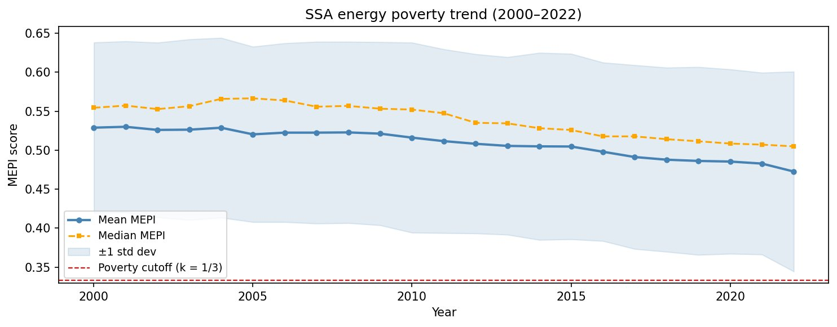
Figure 1. MEPI trend across Africa, 2000–2022. Shaded band = ±1 standard deviation. Dashed red line = poverty cutoff (k = 1/3).
Source: Authors’ computation, 2026
Figure 2 shows substantial cross-country disparity. Eight countries - Mauritius, Algeria, Egypt, Tunisia, Seychelles, Gabon, South Africa and Morocco - record mean MEPI scores below 0.333, reflecting relatively higher incomes, stronger institutions and fossil-fuel or hydroelectric endowments. The remaining 46 countries are energy poor on average, with scores ranging from 0.40 in Angola to 0.65 in Benin. The most severely deprived countries - Benin, Central African Republic, Sierra Leone, Togo, Liberia and Uganda - exceed 0.62, consistent with widespread biomass dependence, low electrification and weak institutional capacity (IEA, 2025). The concentration of high scores in West and Central Africa supports the spatial exclusion perspective (Deichmann et al., 2011) and highlights a clear continental divide.
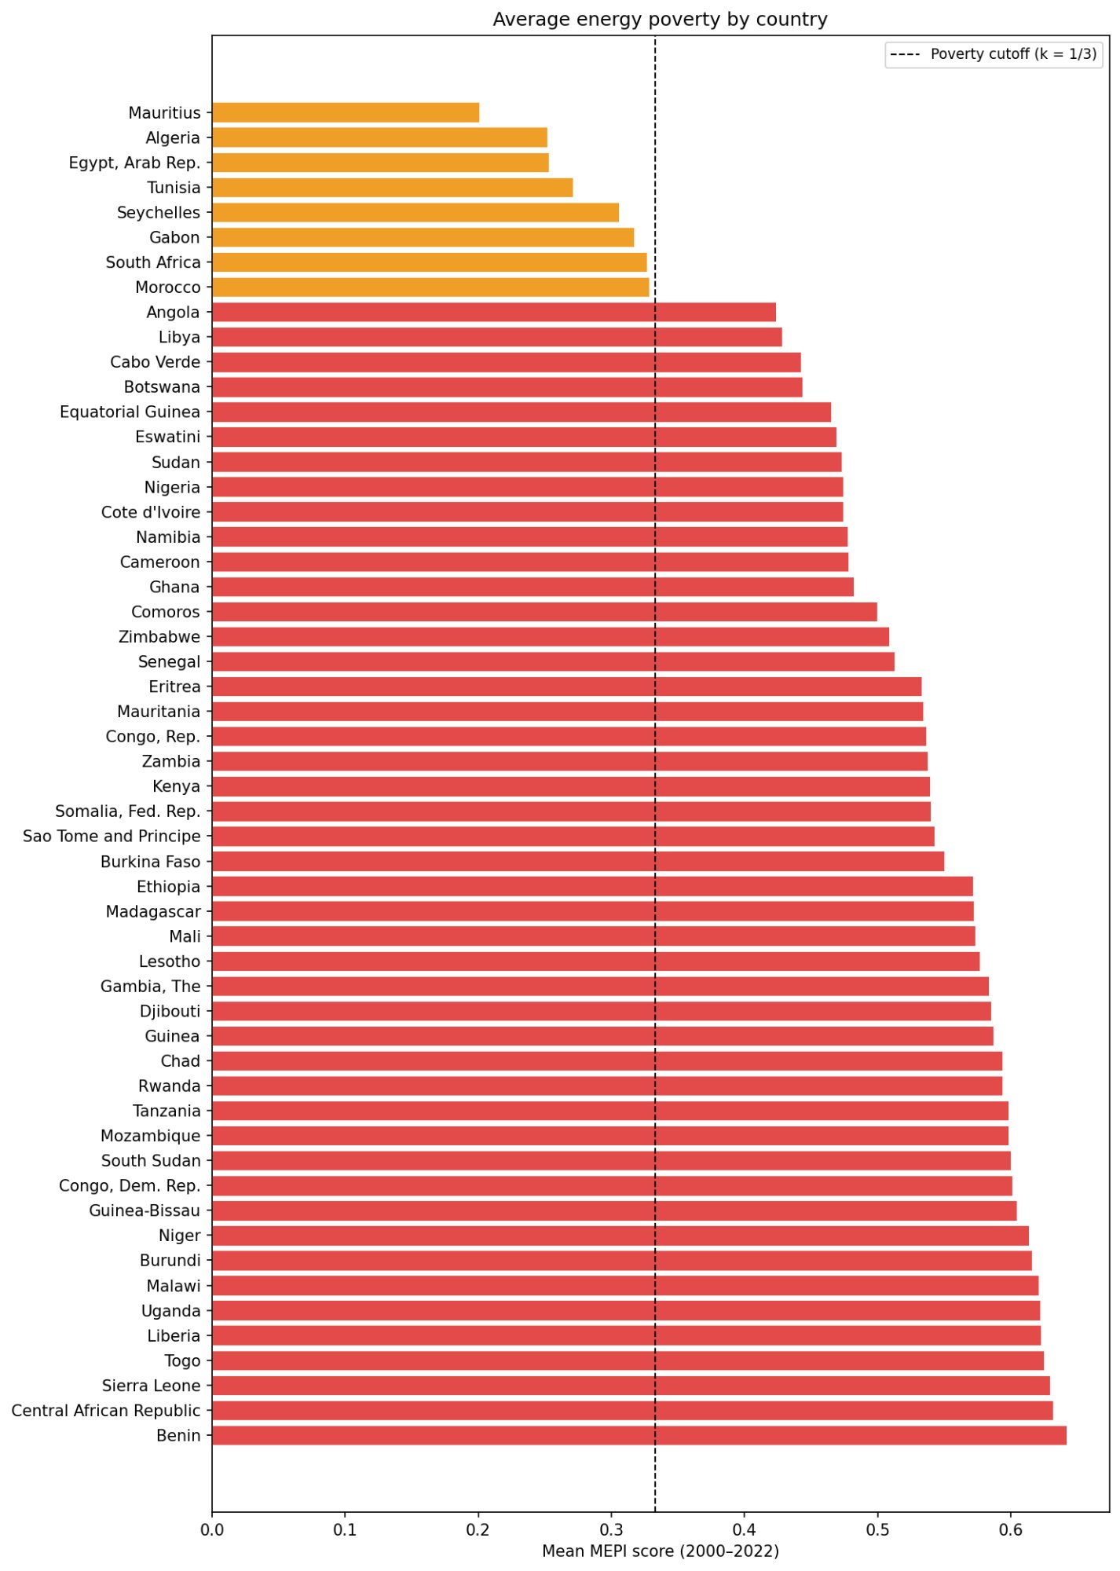
Figure 2. Average MEPI score by country, 2000–2022. Orange bars indicate countries below the poverty cutoff (k = 1/3). Red bars indicate energy-poor countries
Source: Authors’ computation, 2026

Figure 3 decomposes MEPI by dimension. Clean cooking (D4 = 0.73) is the deepest deprivation, consistent with IEA (2025), which shows that clean cooking deprivation is overwhelmingly concentrated in Sub-Saharan Africa. Reliability (D3 = 0.62) ranks second, reflecting grid instability and high transmission losses. Electricity access (D1 = 0.52) and affordability and efficiency (D2 = 0.43) follow. Sustainability (D5 = 0.24) records the lowest mean, but this should not be interpreted as evidence of successful decarbonisation: in many countries, low carbon intensity reflects biomass dependence and limited industrial activity. The tight D4 and D3 distributions indicate that clean cooking and reliability are structural rather than isolated problems, while the wider D5 distribution reflects heterogeneous energy mixes across the continent.
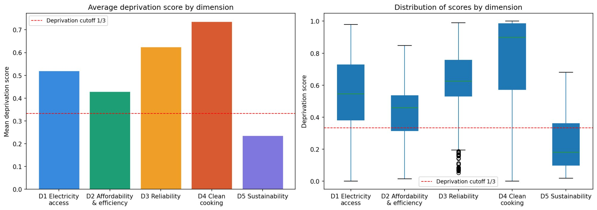
Figure 3. Average deprivation by dimension (left) and distribution of scores (right). Dashed red line = deprivation cutoff (z = 1/3). D1 = electricity access; D2 = affordability and efficiency; D3 = reliability; D4 = clean cooking; D5 = sustainability.

4.3 Model Selection and Evaluation
Table 2 compares the nine tuned models. The performance gap between parametric and tree-based models is clear. LASSO, Ridge and Elastic Net converge to almost identical performance (test R² = 0.673; RMSE ≈ 0.065), suggesting that linear models reach a predictive ceiling in this setting. Tree-based methods perform substantially better. Random Forest records the lowest test RMSE (0.033) and the highest test R² (0.915), followed by Gradient Boosting (RMSE = 0.036; R² = 0.902) and XGBoost (RMSE = 0.036; R² = 0.898). SVR is excluded from further interpretation because its train-test R² gap of 0.160 exceeds the 0.15 overfitting threshold. KNN also indicates overfitting, with perfect training performance but weaker test performance. Figure 4 summarises the train-test comparison.
Table 2: Tuned Model Comparison — Training and Test Set Metrics
Model | RMSEᴄᵛ | MAEᴄᵛ | R²ᴄᵛ | RMSEₜᵣᵃᶦⁿ | R²ₜᵣᵃᶦⁿ | RMSEₜᵉˢᵗ | R²ₜᵉˢᵗ
LASSO | 0.0729 | 0.0582 | 0.602 | 0.0716 | 0.626 | 0.0652 | 0.673
Ridge | 0.0729 | 0.0582 | 0.602 | 0.0716 | 0.626 | 0.0652 | 0.673
Elastic Net | 0.0729 | 0.0582 | 0.602 | 0.0716 | 0.626 | 0.0652 | 0.673
Decision Tree | 0.0258 | 0.0177 | 0.951 | 0.0122 | 0.989 | 0.0402 | 0.876
Random Forest | 0.0196 | 0.0138 | 0.971 | 0.0071 | 0.996 | 0.0332 | 0.915
Gradient Boosting | 0.0188 | 0.0132 | 0.973 | 0.0023 | 1.000 | 0.0357 | 0.902
XGBoost | 0.0194 | 0.0136 | 0.972 | 0.0009 | 1.000 | 0.0363 | 0.898
SVRᵃ | 0.0278 | 0.0186 | 0.942 | 0.0138 | 0.986 | 0.0476 | 0.826
KNN | 0.0197 | 0.0135 | 0.971 | 0.0000 | 1.000 | 0.0379 | 0.890
Note. Bold = best model by test RMSE. ᵃSVR excluded from IML analysis: overfitting gap = 0.160 > 0.15. AIC/BIC (parametric only): LASSO AIC = −2,392.81, BIC = −2,329.10; Ridge AIC = −2,392.77, BIC = −2,329.06; Elastic Net AIC = −2,392.81, BIC = −2,329.10. Gap = R²ₜᵣᵃᶦⁿ − R²ₜᵉˢᵗ.
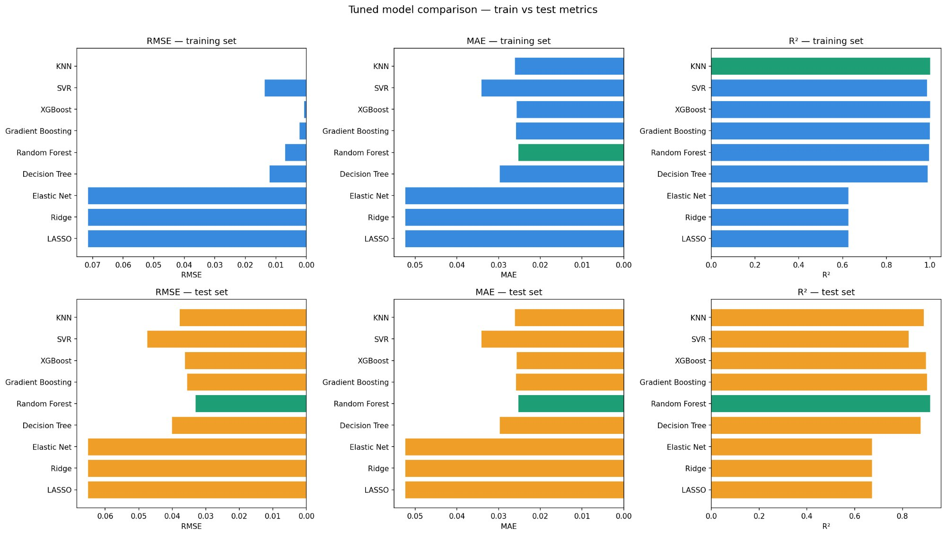
Figure 4. Tuned model comparison — training vs test metrics. Green bar = best performer on that metric. Top row = training set; bottom row = test set.
Table 3 evaluates temporal robustness using one-year lagged drivers. Parametric models lose substantial predictive power: R² falls from 0.673 to approximately 0.28, suggesting that their contemporaneous performance partly reflects association rather than temporal prediction. Tree-based models remain more robust. XGBoost retains the highest lagged R² (0.798), followed by Random Forest (0.749) and Gradient Boosting (0.738). KNN loses considerable explanatory power, further supporting its exclusion. Considering test RMSE, overfitting behaviour and temporal robustness jointly, Random Forest, Gradient Boosting and XGBoost are selected for interpretable machine learning analysis. Random Forest is retained as the best overall model because it combines the lowest test RMSE with the most favourable overfitting profile among the leading models.
Table 3: Contemporaneous vs Lagged Variable Comparison
Model | RMSEᴄᵂⁿᵗ | RMSEᴸᵃᵍᵍᵉᵈ | R²ᴄᵂⁿᵗ | R²ᴸᵃᵍᵍᵉᵈ | ΔRMSE | ΔR²
LASSO | 0.0652 | 0.1032 | 0.673 | 0.276 | 0.038 | −0.397
Ridge | 0.0652 | 0.1023 | 0.673 | 0.288 | 0.037 | −0.385
Elastic Net | 0.0652 | 0.1031 | 0.673 | 0.278 | 0.038 | −0.395
Decision Tree | 0.0402 | 0.0612 | 0.876 | 0.745 | 0.021 | −0.131
Random Forest | 0.0332 | 0.0607 | 0.915 | 0.749 | 0.028 | −0.166
Gradient Boosting | 0.0357 | 0.0620 | 0.902 | 0.738 | 0.026 | −0.164
XGBoost | 0.0363 | 0.0545 | 0.898 | 0.798 | 0.018 | −0.100
SVR | 0.0476 | 0.0762 | 0.826 | 0.605 | 0.029 | −0.221
KNN | 0.0379 | 0.0805 | 0.890 | 0.560 | 0.043 | −0.330
Note. Bold = most temporally robust model. Cont = contemporaneous; Lagg = one-year lagged drivers. ΔRMSE and ΔR² = lagged minus contemporaneous.

4.4 Interpretable Machine Learning

4.4.1 Feature Importance
Figure 5 presents feature importance scores for Random Forest, Gradient Boosting, XGBoost and their average. CO₂ emissions per capita (CO₂PC) dominates across all three models, with an average importance score above 0.70, roughly seven times the next-ranked variable. Population density (POPD), CO₂ emissions change from 1990 (CO₂CH), alternative and nuclear energy share (ALTNUC) and rural population share (RPOP) also appear consistently among the top predictors, indicating that their relevance is not model-specific.
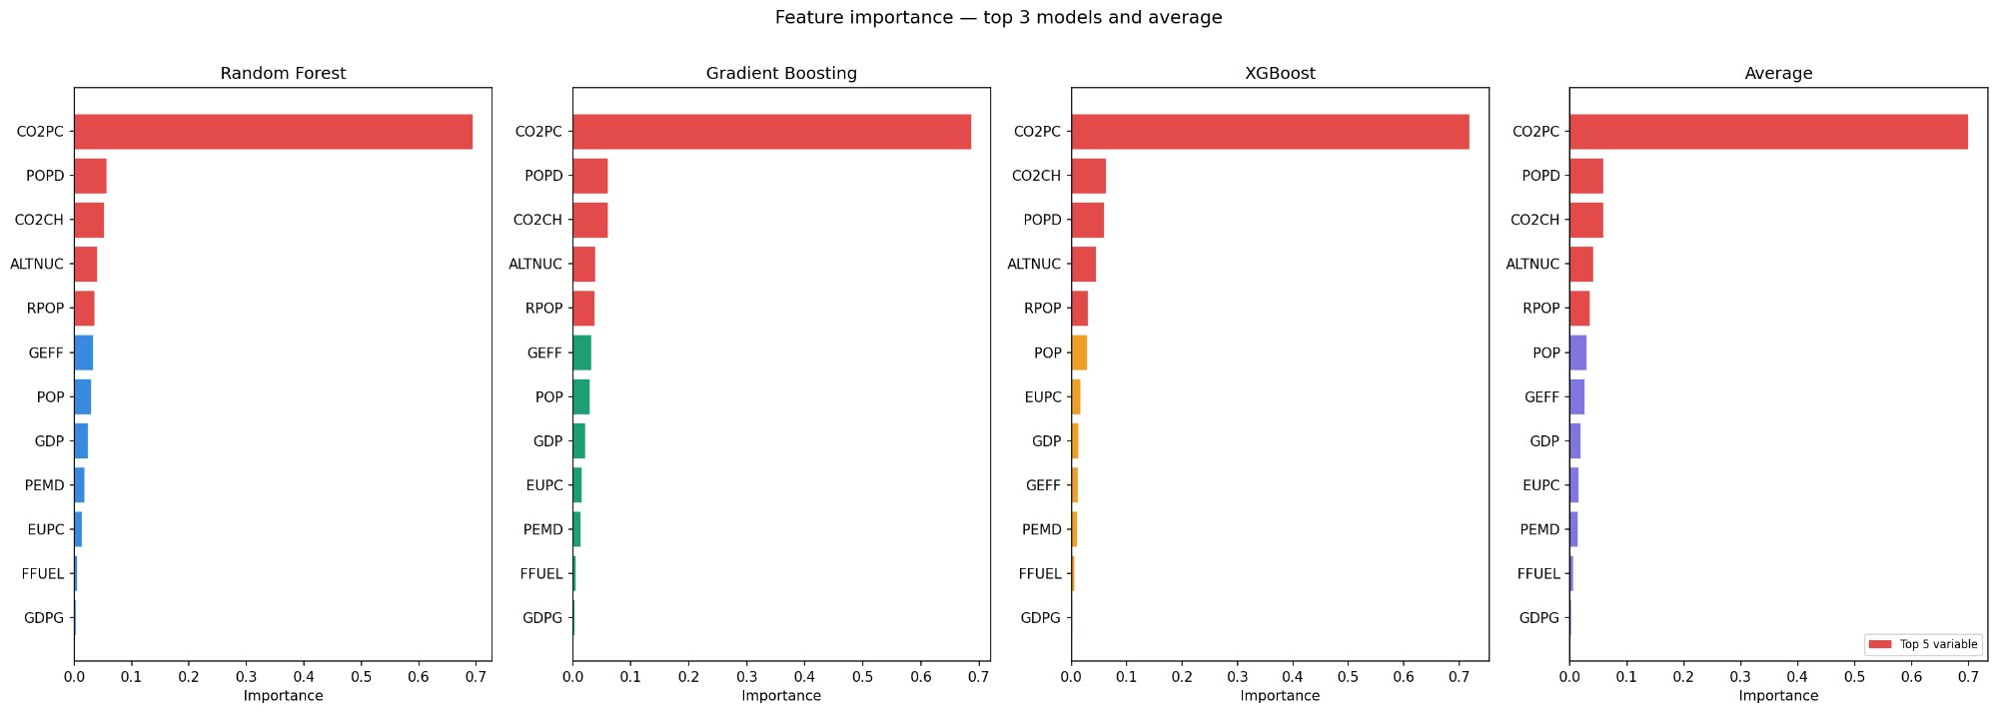
Figure 5. Feature importance scores for Random Forest, Gradient Boosting, XGBoost, and their average. Red bars indicate the top 5 variables.

4.4.2 SHAP Analysis
Figure 6 confirms this ranking using mean absolute SHAP values, which capture the average magnitude of each variable's contribution to predictions. CO₂PC records mean absolute SHAP values of approximately 0.081, 0.082 and 0.080 across Random Forest, Gradient Boosting and XGBoost, respectively. This contribution is substantially larger than all other variables. GDP ranks second (mean absolute SHAP ≈ 0.010), followed by ALTNUC, POPD and RPOP.
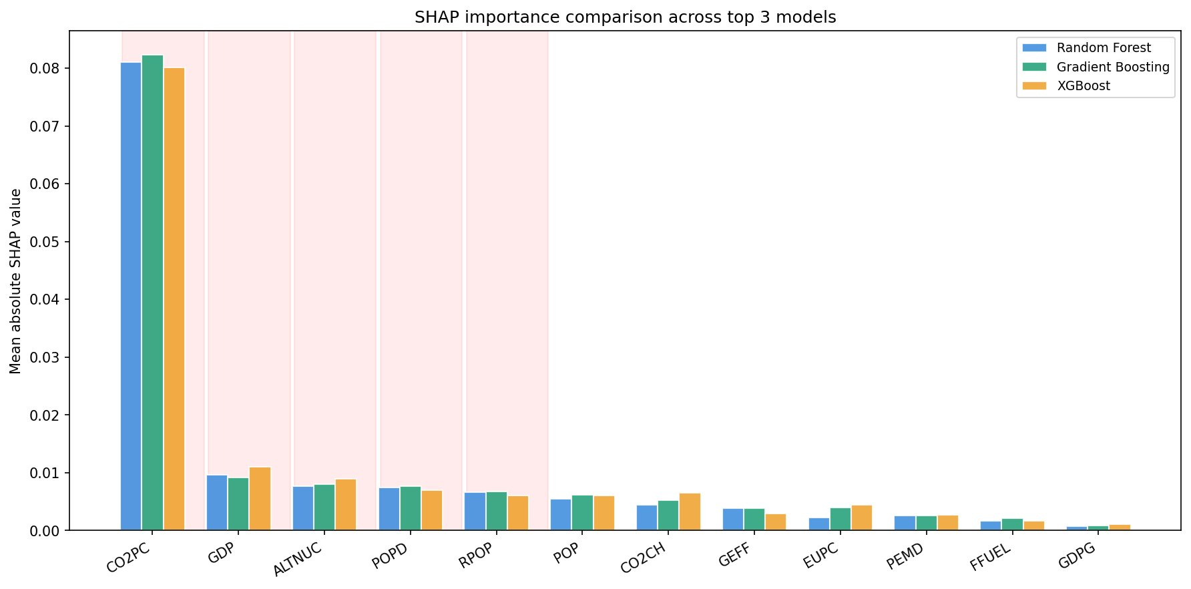
Figure 6. Mean absolute SHAP values across top three models. Shaded columns indicate the top 5 variables. CO2PC dominates by a large margin.
Figure 7 shows the direction of these effects. The CO₂PC result requires careful interpretation. Low CO₂PC values (blue dots) generate large positive SHAP values, increasing predicted MEPI, while high CO₂PC values (red dots) generate negative SHAP values. Countries with very low per-capita emissions are often those most dependent on traditional biomass for cooking and with limited industrial or grid electricity consumption; these are also the countries with the highest energy poverty. The relationship therefore runs counter to a simple emissions-development narrative but is consistent across all three models. GDP has a negative directional effect, indicating that higher income reduces MEPI, while ALTNUC also reduces predicted energy poverty. RPOP and POPD show more dispersed patterns, suggesting heterogeneous spatial effects across countries.
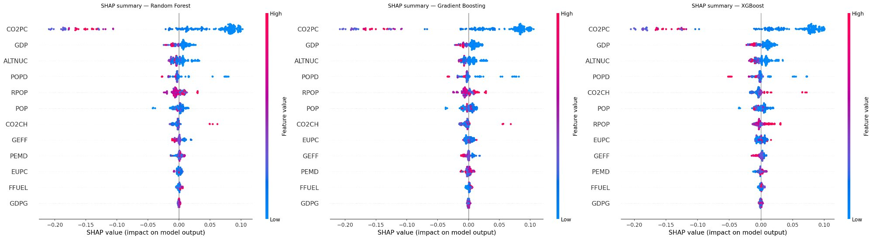
Figure 7. SHAP summary plots for Random Forest, Gradient Boosting, and XGBoost. Each dot = one country-year observation. Colour encodes feature value (red = high, blue = low). X-axis shows SHAP value (positive = more energy poor; negative = less energy poor).

4.4.3 Partial Dependence and ICE Analysis
Figures 8 and 9 present PDP and ICE results for the top five variables using Random Forest. Values on the x-axis are standardised because variables were scaled before modelling. CO₂PC shows the strongest nonlinearity: the PDP declines sharply from approximately 0.60 at the lowest values to around 0.35 at moderate values, before flattening. The ICE curves follow a similar downward pattern across most country-year observations, indicating that the relationship is not driven by averaging alone. The flattening suggests a transition point: after countries reach a moderate level of modern energy and industrial activity, further increases in CO₂PC yield much smaller reductions in MEPI.
GDP also reduces predicted MEPI, falling from about 0.517 to 0.488 before flattening. The wide ICE fan at low GDP levels indicates that similar income levels produce different energy poverty outcomes depending on institutional and infrastructural conditions, consistent with the income-trap hypothesis (Khandker et al., 2012). ALTNUC shows an initial decline in MEPI that later levels off, implying that energy diversification reduces energy poverty but that gains depend on country conditions. POPD has a mild negative slope, consistent with lower infrastructure costs in denser areas (Deichmann et al., 2011). RPOP is the only top predictor with a positive partial dependence slope, rising from approximately 0.495 to 0.513, which supports the spatial exclusion account. Its wide ICE fan suggests that some countries have reduced the rural penalty, likely through decentralised renewable deployment.
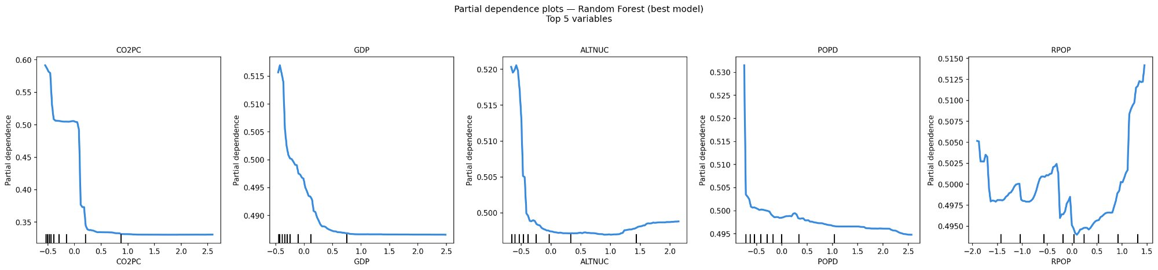
Figure 8. Partial dependence plots — Random Forest (best model), top 5 variables. X-axis values are standardised. Tick marks at bottom = observed data distribution.
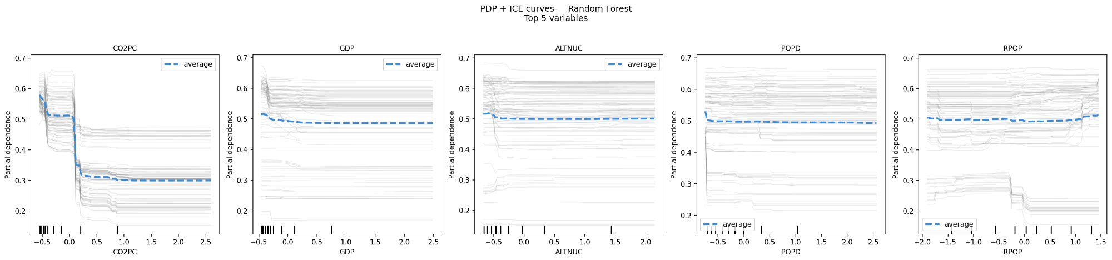
Figure 9. PDP and ICE curves — Random Forest, top 5 variables. Dashed blue line = average partial dependence. Grey lines = individual country-year ICE curves. Wide fan = heterogeneous country-level effects.

4.5 Panel Econometric Results
Table 4 reports fixed-effects (FE), random-effects (RE) and Hausman test results for the log-transformed specification. The Hausman test rejects the null that country-specific effects are uncorrelated with the regressors ($χ²(12) = 45.68, p < 0.01$), so FE is the preferred estimator. RE estimates are retained for comparison. The within R² of 0.337 indicates that the 12 drivers explain 33.7 per cent of within-country variation in MEPI, a meaningful share given that FE absorbs time-invariant country characteristics.
The FE results broadly confirm the direction of the main drivers identified by the machine learning models, and the log specification sharpens several relationships that were unclear in levels. Log GDP (ln_GDP) is negative and significant at the 1 per cent level (β = -0.0142), indicating that higher national income lowers energy poverty, consistent with the income-poverty trap channel (Khandker et al., 2012); this relationship was not detectable in the level-form model. Log particulate emission damage (ln_PEMD) is negative and significant at the 1 per cent level (β = -0.0183), suggesting that higher particulate damage, largely linked to industrial and modern energy activity in many African countries, is associated with lower rather than higher energy deprivation as captured by the MEPI structure. Government effectiveness (GEFF) is negative and significant at the 5 per cent level (β = -0.0188), indicating that stronger governance reduces energy poverty, consistent with Sovacool (2012) and Apergis et al. (2023). Log population (ln_POP) and log population density (ln_POPD) are not statistically significant in either FE or RE once expressed in logs and clustered on country, indicating that the significant level-form coefficients reported for these scale variables in the earlier specification reflected functional-form sensitivity rather than a robust within-country relationship.
Rural population share (RPOP) is positive and significant at the 5 per cent level (β = 0.0023), confirming that countries with larger rural populations face higher MEPI. Log CO₂ emissions per capita (ln_CO2PC) is negative and significant at the 5 per cent level (β = -0.0305), corroborating the SHAP result that higher CO₂PC is associated with lower energy poverty in this context. The inverse hyperbolic sine transform of CO₂ change from 1990 (IHS-CO2CH) is not significant in either FE or RE, indicating that, once properly transformed, this variable does not carry an independent within-country effect, in contrast to the level-form result. Log alternative and nuclear energy (ln_ALTNUC) is negative and significant at the 5 per cent level (β = -0.0191), indicating that energy mix diversification reduces energy poverty. Log energy use per capita (ln_EUPC) is not statistically significant in either model, in contrast to the level-form result, suggesting that its earlier significance was scale-driven rather than substantive. GDP growth (GDPG) is not statistically significant in either model, again a change from the level-form result. Log fossil fuel consumption (ln_FFUEL) is positive and significant at the 1 per cent level in both FE and RE (β = 0.0034 and 0.0035 respectively), a more decisive result than the marginal, FE-only significance found in the level-form specification, indicating that continued dependence on fossil and traditional combustible fuels is a robust driver of energy poverty across both estimators.
Table 4. Panel Econometric Results — Fixed Effects, Random Effects, and Hausman Test (Log-Transformed Specification)
Variable | Fixed Effects (preferred) | Random Effects | Hausman (RHT)
ln(GDP) | −0.0142***  (0.00416) | −0.0147***  (0.00372) | −0.0147***  (0.00372)
ln(PEMD) | −0.0183***  (0.00671) | −0.0163**  (0.00718) | −0.0163**  (0.00718)
GEFF | −0.0188**  (0.00753) | −0.0191***  (0.00697) | −0.0191***  (0.00697)
ln(POP) | −0.0004  (0.02818) | 0.0021  (0.00910) | 0.0021  (0.00910)
ln(POPD) | 0.0038  (0.01178) | −0.0025  (0.00783) | −0.0025  (0.00783)
RPOP | 0.0023**  (0.00101) | 0.0019***  (0.00071) | 0.0019***  (0.00071)
ln(CO2PC) | −0.0305**  (0.01182) | −0.0350***  (0.00934) | −0.0350***  (0.00934)
IHS(CO2CH) | 0.0015  (0.00205) | 0.0019  (0.00180) | 0.0019  (0.00180)
ln(ALTNUC) | −0.0191**  (0.00741) | −0.0178**  (0.00733) | −0.0178**  (0.00733)
ln(EUPC) | 0.0058  (0.00511) | 0.0057  (0.00482) | 0.0057  (0.00482)
GDPG | −0.0002  (0.00018) | −0.0001  (0.00019) | −0.0001  (0.00019)
ln(FFUEL) | 0.0034***  (0.00125) | 0.0035***  (0.00123) | 0.0035***  (0.00123)
Constant | 0.6333  (0.43635) | 0.6398***  (0.11551) | 0.6398***  (0.11551)
Observations | 1,241 | 1,241 | 1,241
Countries | 54 | 54 | 54
R² (within) | 0.337 | — | —
Hausman test: χ2(12) = 45.68, p < 0.01 → FE preferred
Note. Standard errors in parentheses. ***p < .01, **p < .05, *p < .10. FE = within-estimator with country fixed effects. RE = GLS random effects. Variables prefixed ln_ are natural-log transformed (ln_ALTNUC and ln_FFUEL as ln(x + 1) to accommodate zeros); IHS(CO2CH) is the inverse hyperbolic sine transformation, used because CO2CH contains negative values. GEFF, RPOP and GDPG enter untransformed. Hausman (1978) test: H₀ = RE is consistent; rejection at p < .01 confirms FE as the preferred estimator. The Hausman (RHT) column reproduces the RE coefficients, which are consistent and efficient under H₀ and form the basis of comparison (B) in the Hausman test.
4.6 Synthesis of Results
The MEPI results confirm the central argument of the measurement literature: binary electricity access rates conceal the structure of energy poverty. The mean MEPI of 0.509 is above the k = 1/3 cutoff, and 46 of 54 countries are energy poor on average over 2000-2022. This persistence shows that income growth and grid expansion alone have not eliminated multidimensional energy deprivation. The decomposition strengthens this diagnosis: clean cooking (D4 = 0.73) and reliability (D3 = 0.62) are the most severe and widespread dimensions. Nussbaumer et al. (2013) similarly reported high MEPI scores for developing countries, but the Africa-wide scope of this paper reveals a clearer continental divide, with the non-poor group concentrated among North African and island economies.
The CO₂PC finding is the paper's central analytical contribution. Feature importance and SHAP results rank CO₂PC as the dominant predictor, while the direction is negative: lower per-capita emissions predict higher MEPI. This result does not imply that higher emissions are desirable. Rather, it indicates that low emissions in many African countries reflect limited industrial activity, low modern energy consumption and biomass-dependent cooking rather than successful decarbonization. The SHAP plots make this structural trap visible: low CO₂PC observations cluster with positive SHAP values that raise predicted MEPI. The PDP suggests a threshold pattern, with MEPI declining sharply at low CO₂PC levels and flattening after moderate levels of modern energy activity are reached. The FE result (β = -0.0305, p < 0.05) corroborates this relationship within countries over time. This finding is consistent with the carbon lock-in literature (Unruh, 2000; Zhao et al., 2023) and has direct implications for climate finance: low national emissions should not be equated automatically with successful low-carbon development.
The income-trap, institutional and spatial-exclusion mechanisms are also supported. The Random Forest PDP shows that higher GDP lowers MEPI, but the wide ICE fan at low-income levels indicate that income gains translate into energy improvements unevenly across countries. This heterogeneity is consistent with the view that governance and infrastructure mediate the income-energy relationship. The FE coefficient on government effectiveness (β = -0.0188, p < 0.05) confirms that institutional capacity is a direct energy poverty driver rather than a background condition. Rural population share has a positive FE coefficient (β = 0.0023, p < 0.05) and a positive PDP slope, confirming that dispersed rural settlement patterns raise energy poverty. However, the wide ICE spread for RPOP indicates that the rural penalty is not fixed; some countries appear to have reduced it through decentralised energy solutions, especially off-grid and mini-grid systems.
The combined method strengthens the inference. Machine learning identifies the variables that matter and maps nonlinear relationships, while lagged-driver tests distinguish more robust temporal predictors from contemporaneous correlations. Panel FE estimation then validates the direction and significance of the main predictors through within-country variation. Agreement across the two approaches for CO₂PC, government effectiveness, rural population share, alternative and nuclear energy and GDP makes the results more credible than a single-method design. Where the approaches diverge, such as for CO₂CH, which the machine learning models rank as informative but which is not significant in either the FE or RE specification, the difference is informative because it suggests a variable whose influence operates through nonlinearity or interaction rather than through a simple linear, within-country relationship.
5. Conclusion and Policy Recommendations
Energy poverty remains a major barrier to Africa’s structural transformation, welfare improvement and sustainable development. This paper shows that the problem cannot be understood through electricity access rates alone. Energy deprivation is multidimensional: it concerns whether households and economies have reliable, affordable, clean, efficient and sustainable energy services. Using data for 54 African countries over 2000-2022, the paper constructed a MEPI covering electricity access, affordability and efficiency, reliability, clean cooking and sustainability, and combined recursive feature selection, machine learning prediction, interpretable artificial intelligence tools and panel econometric validation.
The results show that energy poverty remains structurally persistent. The mean MEPI score of 0.509 is above the poverty cutoff, and 46 of 54 countries are classified as energy poor on average. Although MEPI declined from 0.530 in 2000 to 0.472 in 2022, progress has been modest and uneven. Clean cooking and reliability are the deepest deprivation dimensions, confirming that Africa's energy poverty problem extends beyond grid connection to the quality, stability and cleanliness of energy services.
The algorithmic evidence shows that tree-based ensemble models are better suited to Africa's energy poverty patterns than conventional linear models. Random Forest, Gradient Boosting and XGBoost outperform LASSO, Ridge and Elastic Net, confirming that the drivers of energy poverty are nonlinear and heterogeneous. Random Forest performs best overall, while lagged-driver tests show that the leading tree-based models retain substantial predictive power when explanatory variables are lagged by one year.
The most important result is the dominant role of CO₂ emissions per capita. Across feature importance, SHAP values and partial dependence analysis, CO₂PC is the strongest predictor of MEPI, but the direction is negative: lower emissions per capita are associated with higher energy poverty. This does not make higher emissions a policy objective. It shows that low emissions in many African countries reflect under-industrialisation, limited modern energy use and dependence on traditional biomass rather than successful decarbonisation. A country may appear low-emission because large parts of its population remain excluded from modern energy systems.
The econometric evidence supports the machine learning results. Fixed-effects estimates show that government effectiveness, population density, CO₂PC, CO₂CH, alternative and nuclear energy share and GDP growth reduce multidimensional energy poverty, while rural population share and energy use per capita increase it. The rural population effect confirms the spatial exclusion mechanism, and the governance result shows that energy poverty is not only a technical or financial problem but also an institutional one. Stronger public-sector capacity, regulatory effectiveness and implementation quality are essential for converting energy investments into welfare gains.
The paper provides a comprehensive Africa-wide MEPI panel for 54 countries over more than two decades; it shows that machine learning, especially tree-based ensemble models, can reveal nonlinear and heterogeneous drivers that linear models may miss; and it demonstrates the value of combining interpretable machine learning with panel econometric validation.
The findings point to an integrated policy agenda. African governments, regional institutions and development partners should move beyond binary electricity access targets and adopt multidimensional energy poverty monitoring. Connection rates remain important, but they are incomplete when households remain connected to unreliable grids or continue to depend on biomass for cooking. National energy strategies should therefore monitor electricity access, reliability, affordability, clean cooking, efficiency and sustainability together. A MEPI-type framework would help identify the dimensions that contribute most to deprivation and support more targeted interventions.
Clean cooking and electricity reliability should be treated as central pillars of Africa's energy poverty strategy. Progress in electricity access alone will not eliminate energy poverty unless households’ transition away from traditional biomass, charcoal and other harmful fuels, and unless connected households receive stable and usable power. Governments should expand clean cooking programmes through targeted subsidies, concessional finance, stronger distribution networks and context-specific technologies, including LPG where appropriate, electric cooking where grids are reliable and biogas or other decentralised options in suitable rural areas. Parallel investments in grid maintenance, transmission and distribution upgrades, loss reduction, storage and utility reform are required to translate access into welfare and productivity gains.
Rural energy policy should combine grid expansion with decentralised renewable solutions. The positive association between rural population share and MEPI confirms that dispersed settlement patterns remain a major driver of energy poverty. In sparsely populated areas, conventional grid extension is often slow, costly and commercially unattractive. Policymakers should therefore scale up mini-grids, off-grid solar systems, solar home systems and productive-use renewable energy technologies. Rural electrification should also be linked to agriculture, agro-processing, irrigation, cold storage, rural enterprise, education and health-service delivery so that energy access supports income generation and helps break the income-energy poverty trap.
Institutional quality must be treated as a direct energy policy instrument. The evidence shows that stronger government effectiveness reduces multidimensional energy poverty. Energy investments are more likely to succeed where public agencies can plan effectively, regulate utilities, manage procurement, implement projects and enforce service standards. African governments should strengthen energy-sector governance by improving regulatory independence, reducing political interference in utility operations, increasing transparency in public energy contracts and building capacity in energy ministries, rural electrification agencies and regulatory authorities. Development partners should make institutional strengthening a core component of energy access financing rather than a secondary condition.
Finally, Africa’s low-carbon transition must distinguish genuine decarbonisation from low-emission energy deprivation. In many African countries, low emissions reflect limited industrialisation and biomass dependence, not clean-energy transformation. Climate policy should therefore avoid penalising the moderate increase in modern energy use required to eliminate energy poverty. Just transition finance should support clean industrialisation, renewable electricity expansion, clean cooking, grid reliability and productive energy use. Energy-system diversification should be accelerated through solar, wind, sustainable hydro, geothermal where available and other context-specific options, supported by storage, transmission, grid integration and institutional capacity. In all, reducing energy poverty in Africa requires a multidimensional, institutionally grounded, spatially targeted and climate-sensitive strategy that treats energy access as both a development imperative and a just transition priority.

References
Abbas, K., Butt, K. M., Xu, D., Ali, M., Baz, K., Kharl, S. H., & Ahmed, M. (2022). Measurements and determinants of extreme multidimensional energy poverty using machine learning. Energy, 251, Article 123977. https://doi.org/10.1016/j.energy.2022.123977
African Development Bank. (2025). Mission 300: Connecting 300 million Africans to electricity by 2030. African Development Bank.
Akaike, H. (1974). A new look at the statistical model identification. IEEE Transactions on Automatic Control, 19(6), 716–723. https://doi.org/10.1109/TAC.1974.1100705
Alkire, S., & Foster, J. (2011). Counting and multidimensional poverty measurement. Journal of Public Economics, 95(7–8), 476–487. https://doi.org/10.1016/j.jpubeco.2010.11.006
Apergis, N., Bhattacharya, M., & Hadhri, W. (2023). Energy poverty, government expenditure, and institution factors in sub-Saharan Africa: Evidence from a panel threshold model. Environmental Science and Pollution Research, 30, 68018–68034. https://doi.org/10.1007/s11356-023-27005-1
Boardman, B. (1991). Fuel poverty: From cold homes to affordable warmth. Belhaven Press.
Breiman, L. (2001). Random forests. Machine Learning, 45(1), 5–32. https://doi.org/10.1023/A:1010933404324
Breiman, L., Friedman, J., Stone, C. J., & Olshen, R. A. (1984). Classification and regression trees. Wadsworth.
Chen, T., & Guestrin, C. (2016). XGBoost: A scalable tree boosting system. In Proceedings of the 22nd ACM SIGKDD International Conference on Knowledge Discovery and Data Mining (pp. 785–794). https://doi.org/10.1145/2939672.2939785
Compaore, D. E., Guira, A., & Maiga, B. (2024). Assessing energy poverty and its determinants in the West African Economic and Monetary Union countries: A multidimensional analysis. Oxford Open Energy, 3, Article oiae019. https://doi.org/10.1093/ooenergy/oiae019
Cover, T. M., & Hart, P. E. (1967). Nearest neighbor pattern classification. IEEE Transactions on Information Theory, 13(1), 21–27. https://doi.org/10.1109/TIT.1967.1053964
Crentsil, A. O., Asuman, D., & Fenny, A. P. (2019). Assessing the determinants and drivers of multidimensional energy poverty in Ghana. Energy Policy, 133, Article 110884. https://doi.org/10.1016/j.enpol.2019.110884
Deichmann, U., Meisner, C., Murray, S., & Wheeler, D. (2011). The economics of renewable energy expansion in rural Sub-Saharan Africa. Energy Policy, 39(1), 215–227. https://doi.org/10.1016/j.enpol.2010.09.034
ESMAP. (2015). Beyond connections: Energy access redefined (Technical Report 008/15). World Bank Energy Sector Management Assistance Program.
Friedman, J. H. (2001). Greedy function approximation: A gradient boosting machine. Annals of Statistics, 29(5), 1189–1232. https://doi.org/10.1214/aos/1013203451
Gawusu, S., & Abubakari, A. (2024). Predictive modeling of energy poverty with machine learning ensembles: Strategic insights from socioeconomic determinants for effective policy implementation. International Journal of Energy Research, 2024, Article 9411326. https://doi.org/10.1155/2024/9411326
Goldstein, A., Kapelner, A., Bleich, J., & Pitkin, E. (2015). Peeking inside the black box: Visualizing statistical learning with plots of individual conditional expectation. Journal of Computational and Graphical Statistics, 24(1), 44–65. https://doi.org/10.1080/10618600.2014.907095
Guyon, I., Weston, J., Barnhill, S., & Vapnik, V. (2002). Gene selection for cancer classification using support vector machines. Machine Learning, 46, 389–422. https://doi.org/10.1023/A:1012487302797
Hastie, T., Tibshirani, R., & Friedman, J. (2009). The elements of statistical learning (2nd ed.). Springer. https://doi.org/10.1007/978-0-387-84858-7
Hausman, J. A. (1978). Specification tests in econometrics. Econometrica, 46(6), 1251–1271. https://doi.org/10.2307/1913827
Hoerl, A. E., & Kennard, R. W. (1970). Ridge regression: Biased estimation for nonorthogonal problems. Technometrics, 12(1), 55–67. https://doi.org/10.1080/00401706.1970.10488634
IEA. (2025). Africa energy outlook 2025. International Energy Agency.
IEA, IRENA, UNSD, World Bank, & WHO. (2025). Tracking SDG 7: The Energy Progress Report 2025. International Energy Agency, International Renewable Energy Agency, United Nations Statistics Division, World Bank, and World Health Organization.
Khandker, S. R., Barnes, D. F., & Samad, H. A. (2012). Are the energy poor also income poor? Evidence from India. Energy Policy, 47, 1–12. https://doi.org/10.1016/j.enpol.2012.02.028
Koomson, I., & Danquah, M. (2021). Financial inclusion and energy poverty: Empirical evidence from Ghana. Energy Economics, 94, Article 105085. https://doi.org/10.1016/j.eneco.2020.105085
Lundberg, S. M., & Lee, S.-I. (2017). A unified approach to interpreting model predictions. Advances in Neural Information Processing Systems, 30, 4765–4774.
Lundberg, S. M., Erion, G., Chen, H., DeGrave, A., Prutkin, J. M., Nair, B., Katz, R., Himmelfarb, J., Bansal, N., & Lee, S.-I. (2020). From local explanations to global understanding with explainable AI for trees. Nature Machine Intelligence, 2, 56–67. https://doi.org/10.1038/s42256-019-0138-9
Molnar, C. (2020). Interpretable machine learning: A guide for making black box models explainable (2nd ed.). https://christophm.github.io/interpretable-ml-book/
Nussbaumer, P., Bazilian, M., & Modi, V. (2012). Measuring energy poverty: Focusing on what matters. Renewable and Sustainable Energy Reviews, 16(1), 231–243. https://doi.org/10.1016/j.rser.2011.07.150
Nussbaumer, P., Fuso Nerini, F., Onyeji, I., & Howells, M. (2013). Global insights based on the multidimensional energy poverty index (MEPI). Sustainability, 5(5), 2060–2076. https://doi.org/10.3390/su5052060
Pedregosa, F., Varoquaux, G., Gramfort, A., Michel, V., Thirion, B., Grisel, O., Blondel, M., Prettenhofer, P., Weiss, R., Dubourg, V., Vanderplas, J., Passos, A., Cournapeau, D., Brucher, M., Perrot, M., & Duchesnay, E. (2011). Scikit-learn: Machine learning in Python. Journal of Machine Learning Research, 12, 2825–2830.
Schwarz, G. (1978). Estimating the dimension of a model. Annals of Statistics, 6(2), 461–464. https://doi.org/10.1214/aos/1176344136
Shapley, L. S. (1953). A value for n-person games. In H. W. Kuhn & A. W. Tucker (Eds.), Contributions to the theory of games, Vol. II (pp. 307–317). Princeton University Press.
Sovacool, B. K. (2012). The political economy of energy poverty: A review of key challenges. Energy for Sustainable Development, 16(3), 272–282. https://doi.org/10.1016/j.esd.2012.05.006
Tibshirani, R. (1996). Regression shrinkage and selection via the lasso. Journal of the Royal Statistical Society: Series B, 58(1), 267–288. https://doi.org/10.1111/j.2517-6161.1996.tb02080.x
Unruh, G. C. (2000). Understanding carbon lock-in. Energy Policy, 28(12), 817–830. https://doi.org/10.1016/S0301-4215(00)00070-7
Vapnik, V. (1995). The nature of statistical learning theory. Springer. https://doi.org/10.1007/978-1-4757-2440-0
Wang, H., Maruejols, L., & Yu, X. (2021). Predicting energy poverty with combinations of remote-sensing and socioeconomic survey data in India: Evidence from machine learning. Energy Economics, 102, Article 105423. https://doi.org/10.1016/j.eneco.2021.105423
Wooldridge, J. M. (2010). Econometric analysis of cross section and panel data (2nd ed.). MIT Press.
World Bank. (2025). Mission 300: Powering Africa. World Bank Group.
Zhao, C., Dong, K., Jiang, H.-D., Wang, K., & Dong, X. (2023). How does energy poverty eradication realize the path to carbon unlocking? The case of China. Energy Economics, 121, Article 106691. https://doi.org/10.1016/j.eneco.2023.106691
Zou, H., & Hastie, T. (2005). Regularization and variable selection via the elastic net. Journal of the Royal Statistical Society: Series B, 67(2), 301–320. https://doi.org/10.1111/j.1467-9868.2005.00503.x

