Try This

7)
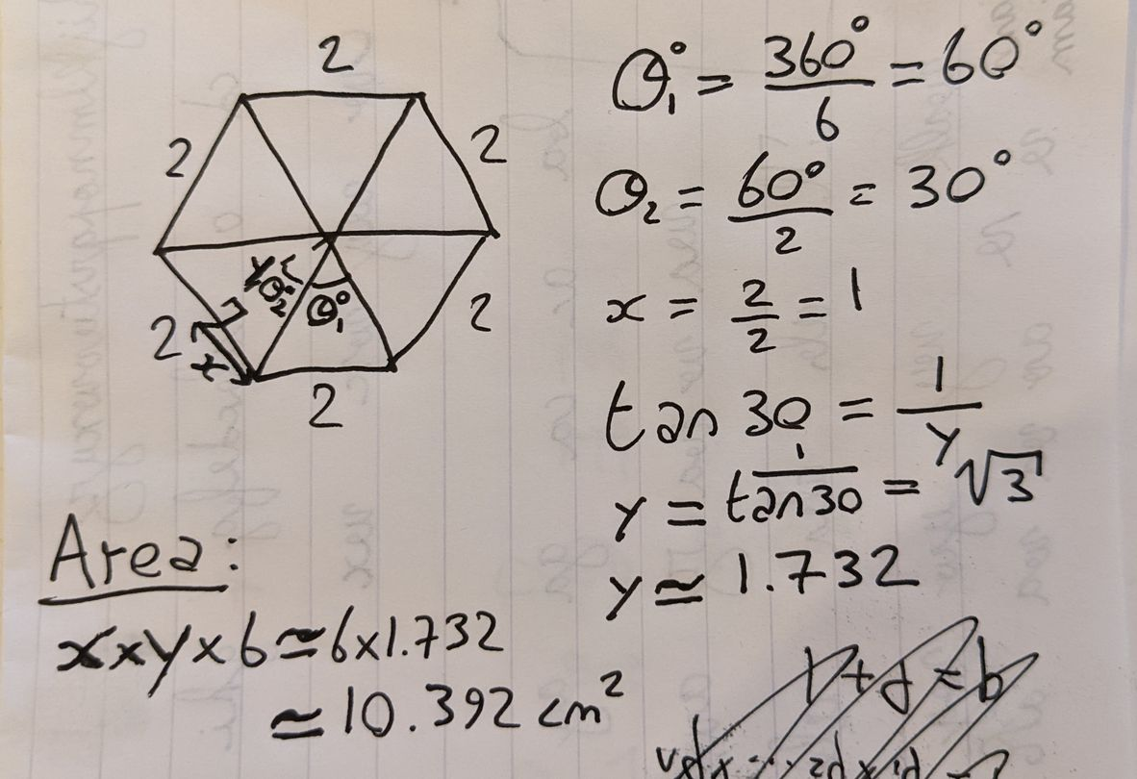

Yes, the answer was correct.
8)
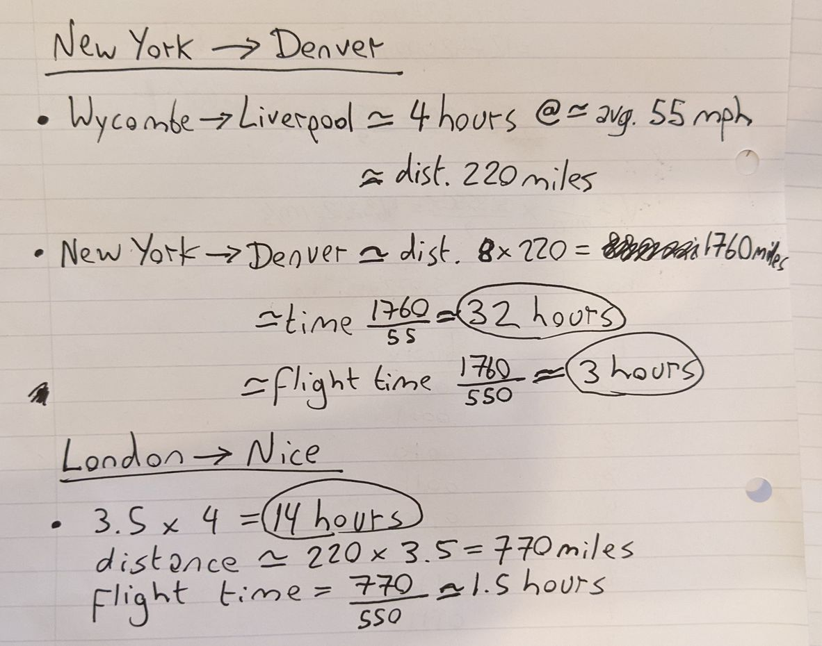

Google maps estimates:

Route | Driving Time | Flying Time
New York to Denver | 26 hours | 4 hours 15 mins
London to Nice | 14hours 13 mins | 1 hour 55 mins

My estimates were fairly decent. Certainly close enough to know if a number is reasonable.

9) Width 2,000,000,000 and length 2 are values that could be used. They would pass the pre-condition of both values being positive but when 2 billion is multiplied by 2, it would exceed the max value of an int and wrap back around to give a negative value for the area which then fails the post-condition.

Review
1)
- Narrowing Errors: These are when a value is put into a container that cannot hold it. For example, converting from a double to an int could cause a narrowing error since the value could be truncated.
- Range Error: A range error is when you attempt to access a member of a list that is outside the range of that list. For example, a very common type of range error is the “out-by-one” error where you accidentally try to access an element one greater than the size of vector in a for loop.
- Bad Argument: A bad argument is when you attempt to call a function but provide an argument with a value or a type not accepted by the function.
- Bad Input: This is when input is used that is not handled. For example, you might have a cin statement for entering weather temperatures but a user could input an impossible value.
2) We can ignore hardware or system software errors in student programs. We shouldn’t ignore any type of error within our program, even in student programs. Although we may decide not to do much once the error has been detected. We could for example simply quit the program with an error message rather than attempting to handle the error within the program.
3) Any completed project should guarantee that all potential sources of error have been considered.
4)
- “Let the callee beware”: This approach says that functions should try to detect errors from bad input. These checks on input are called pre-conditions.
- A second approach is to use post-conditions. They are similar to pre-conditions in that the function is doing the checking, however they check that the return value of the function is correct before returning it.
- Another approach is to divorce the error detection from the error handling using exceptions. A function can throw an exception that can be caught somewhere else in the program. Neither the thrower nor the catcher need know about the other.

Of course, these three approaches are in fact best used in tandem with each other rather than either or.

5) We try to avoid debugging because it takes a great deal of time to achieve very little. Incorporating error detection and handling throughout the design phase can drastically reduce the number of bugs produced in the first place as well as the time taken to find the ones that slip through.
6) A syntax error is the programming equivalent of a grammatical or spelling error. It is an error from the misuse of the rules of the coding language.
Examples:
- cout >> “hello”; //here we have used an incorrect operator with cout. We should have used the >> operator.
- Int x = 0; //here we have misspelled int
- int x = 0 //here we have forgotten to end the statement with a semi-colon
- foo(98; //here we have forgotten to close the parenthesis
- double float = 9.3; //here we have attempted to use a keyword as a name for a variable
7) A type error is an error involving using an incorrect type when calling a function, assigning a variable, etc…
Examples:
- char c = “hello”; //here we have attempted to initialise a char with a string literal
- int area(int x, int y) return x*y;
int a = area (10, “two”) //here we have used a string as the second parameter for calling the area() function instead of an int

- vector<int> v;
v.pushback(“hello”); //here we have inserted a string literal into a vector of ints
- string s;
cin >> s;
switch(s){ //here we have used a switch on a string. Switch statements can only be used with int, char and enumeration types.
case “hello”:
// ...
break;
// ...
default:
break;
}
- int area(int x, int y) return x*y;
int a = area (10, 2, 3) //here we have used three parameters instead of two
8) A linker error is an error arising from the linker not being able to consolidate all the translation units into a single program.
Examples:
- int area(int x, int y) return x*y;
int a = area (10, 2, 3) //although this is the same error as from the previous type error questions, it could also be construed as a linking error if we in fact did have an area() function that takes three arguments but that we haven’t included it in the program so that the compiler knows its definition
- using cout without #include <iostream>
- #include <iostrem> //here we have misspelled the name of the library that we wished to include which causes the linker to be unable to find it
9) A logic error is the last and most tedious error to correct. This is because the program will compile and run but the ouput may be unexpected or wrong. They arise from programmer mistakes in the logic of the problem they are trying to solve.
Examples:
- int area(int x, int y){
return x/y; //the wrong formula for calculating an area has been used
}
- int x = 1000000;
char c = x; //here the value of x will suffer from a narrowing conversion when stored inside the char c. This could cause problems if we were not expecting it
- for (int i = 0; i < 100; ++i){
cout << i;
++i; //here we have incremented i for a second time inside the
} for loop. This will cause only every other value to be ouput. This is probably a logic error resulting from a while loop being swapped out for a for loop
10) Logic errors, Unexpected state, Unexpected input, Unclear program specification
11) To quickly know if a result is plausible, we can use a combination of estimation and guess work to quickly arrive at an approximate expected result. We can use the limited information that we know to make educated guesses for values that we don’t. If the actual result differs greatly then we know we have an error. Certain errors are immediately obvious even without the estimation. For example, if the value ouput for an age is negative.

12) Pros of “Caller beware”:
- Fast function execution. This can be important if it is a small function that is called many times. The check could even be more computationally expensive than the main logic of the function.
- The caller will know more about why the information it was about to pass to the function is wrong. It knows how it arrived at these values. This can lead to a more helpful error message.
- We may not be able to modify the function. For example, we may not have the source code, or it may be a library used by others that don’t want it changed, or it may be part of a library that is frequently updated and would require being re-modified every time an update occurs,...
Pros of “Callee beware”:
- We only have to perform a check in one place leading to less bloated code that is simpler to read and understand.
- The caller needn’t have knowledge of the internal workings of the function. A central tenet of abstraction.

Ideally, handling run-time errors should be done inside the function unless there’s a good reason not to.

13) Exceptions are preferable to returning an error value for a few reasons.
- Exceptions have the built in safety mechanism that if no one catches the exception, the program terminates. Whereas we may forget to handle an a returned error value.
- Exceptions divorce the detection of an error from its handling. This is clean, especially in large programs where we may not wish to modify someone else’s code.
- A function may not always have a spare value to return. In the case of a function that returns a char for example, it may wish to use the full spectrum of chars as valid returns leaving none spare to dedicate to error codes.
14) To test if an input operation succeeded, we can simply test cin. This is because cin has a flag that is either true or flase depending on whether the last input operation succeeded.
If (cin)
cout << “cin success”;
else
cout << “cin fail”;
15) Exceptions are thrown at the point where the error is detected. When an error is detected, a function may throw an exception of a specific type that indicates the issue. From that point, the function has nothing more to do with it. It’s done it’s job by signalling the error. It may be that no one will catch the exception in which case the program will terminate with an unhandled exception.
Exceptions are caught by a function that has directly or indirectly called the function which threw the exception. The catcher doesn’t know who threw it, only that it has caught it. It can then take appropriate action such as outputting an error message and terminating the program.

16) v[v.size()] is a range error because the indices of containers all start at 0 whereas the size() member function returns the number of elements. Therefore the index of the final element will always be one less than the value of size().
Attempting to call this would result in a standard exception of type out_of_range being thrown.
17) A pre-condition is an error detection that a function performs before executing the rest of its body. The purpose is to check that the inputs it has received as arguments are valid before proceeding to use them. If the pre-condition tests fail, the function could throw an exception or return an error value.
A post-condition meanwhile, is an error detection that a function performs after executing the rest of its body but just before returning its ouput value. The purpose is to check that whatever is has just computed is valid before returning. If the post-condition tests fail, the function could throw an exception or return an error value.

Neither guarantees that the function will compute correct values however they provide basic sanity checks against obviously wrong values such as negative ages. Validity is based on the design spec of the function.

Example:
//Takes a list of ages input by the user and outputs the average

#include "..\..\std_lib_facilities.h"

double avg_age(vector<int> ages) { // calculates the avergage age from a list

//Precondtions:
if (ages.size() == 0)
error("avg_age: No ages in list.");
for (int x : ages)
if (x < 0)
error("avg_age: Non positive age.");

int sum = 0;
for (int x : ages)
sum += x;

//Postconditions:
if (double(sum) / ages.size() < 0)
error("avg_age: Non positive average age calculated.");

return double(sum) / ages.size();
}

int main()
try {
cout << "Please enter a list of ages(positive integers) separated by spaces. To terminate input, type 'ctrl+z' followed by 'enter'.\n"
<< "The average age will then be calculated.\n";

vector<int> ages;

for (int x=0; cin >> x;)
ages.push_back(x);

cout << "Average age: " << avg_age(ages) << '\n';
}
catch(exception& e) {
cerr << "error: " << e.what() << '\n';
keep_window_open();
}

18) There are a few reasons you may not wish to use preconditions.
- The most common is that it may be too complicated figure out how to perform the necessary precondition check. It may either overcomplicate the function and take a lot of time to implement. It may even be impossible to validate something is indeed what we wanted.
- It may be too computationally expensive, it may cost more computation than the rest of the function. You should be wary of this excuse though since these checks can always be removed later or in release builds and may save time tracking down errors, especially early on.
- You may know the code that will call the function and you may happen to know that the precondition will always be met however this is the most shaky of the three excuses.

19) The reasons you may not wish to use postconditions are much the same as those for not using preconditions with perhaps the addition of one.
- You may know that it is unnecessary since given a valid precondition check, there may be no computations in the function that could produce an invalid output. Be wary of this excuse though since the function may be updated at a later stage.
20) The steps in debugging a program:
- Get it to compile
- Get it to link
- Fix any logic errors
21) Commenting can express in English what can’t be easily conveyed in code. It can give an idea of the purpose of a portion of code.

This means we get extra information that we don’t get from the code. It also helps us to skim read the code so as to traverse and understand it quickly. This means we find the bugs more quickly.

It makes clear what we were expecting the code to do. This means we fix the bugs by comparing this with what it is actually doing.

22) Debugging is the process of finding and fixing bugs. In other words, altering code. Testing meanwhile is focussed on using the already written program in a (supposedly) stable state and coming up with a strategy to test a range of inputs designed to break the code. In other words, identifying the bugs.

Exercises
06)
