Review
1) “Programming is understanding” means that in order to solve a problem (through the creation a program), one must first fully understand said problem. You must keep this in mind when designing a program since you don’t want to solve the wrong problem.

2) A calculator must be able to:
- Get expressions from the user
- Solve arbitrarily complex expressions made of:
  - Digits 0-9
  - Decimal numbers with ‘.’
  - Operators +, -, * and /
  - Parenthesis, ()
- Give back answers to the user

3) To break a problem into smaller manageable parts, first we check if any of the work is already done for us. This could be through libraries, tools, etc. Any work that doesn’t need to be done already puts us ahead.

Next, we try to identify what the different parts of the solution to the problem are. Ideally, these are self contained and can be created and tested on their own. For example, we may wish to have a ball that bounces on the screen when the user presses a button. This problem can actually be broken down into many parts, but the first basic breakdown could split it into 3 parts: obtaining the user input; displaying a ball on the screen; and calculating the movement of the ball. If we consider the last of these, we can see this problem can itself be subdivided into: a timer so that we can move it at a desired speed, a gravitational force, an initial upwards force, a way to make it bounce back up when it hits the floor, etc.

We can create smaller stripped down versions of the problem that attack the key part of it so that we can focus on that rather than the other details. It may help to direct later development if you discover that a certain design was a dead end before too much work goes into it.

Finally, we bring all these things together. We include the libraries, integrate the parts (functions, classes, etc.) and use the solutions and learnings from our small scale versions. All in order to grow a working solution piece by piece until it checks all the initial requirements. This method also allows us to add features later on.

4) A smaller version of a program allows us to focus on the crux of the issue and find a solution without complicating matters with details of other features. We may also learn, before wasting too much time, which approach might work best and can then design the other parts around it.

5) Feature creep is bad because it leads to many half working features. This means that the primary problems that need solving may go neglected. It also means that you are working on way to many parts of the problem at once and may get bogged down in the overall complexity. Furthermore, if you are working on multiple parts of the program at once, it means that when an error occurs, there is far more to sift through to find the source and the interaction causing it could be that much more complicated.

6)
- Analysis – description of the problem and the requirements of the solutions
- Design – layout of the program
- Implementation – writing the code, testing and debugging
7) Use cases are ways in which a program will be used. In the calculator example, a use case would be the user typing in 2+2= and expecting the computer to reply with 4. By giving examples of how a program will be used, use cases, serve to show what the program must be able to do.

8) Testing serves to find logic errors. These are errors that won’t be caught by the compiler or the linker. They make the program perform incorrectly or unexpectedly. It’s important that the tests are as comprehensive as possible to catch niche issues.

9)
- Expression: A term. OR A left-hand expression, a middle ‘+’ or ‘-’ and a right-hand term.
- Term: A primary. OR A left-hand term, a middle ‘*’ or ‘/’ and a right-hand primary.
- Primary: A number. OR A left-hand ‘(‘, a middle expression and a right-hand ‘)’.
- Number: A literal composed of digits 0-9 and optionally a ‘.’ for decimals.

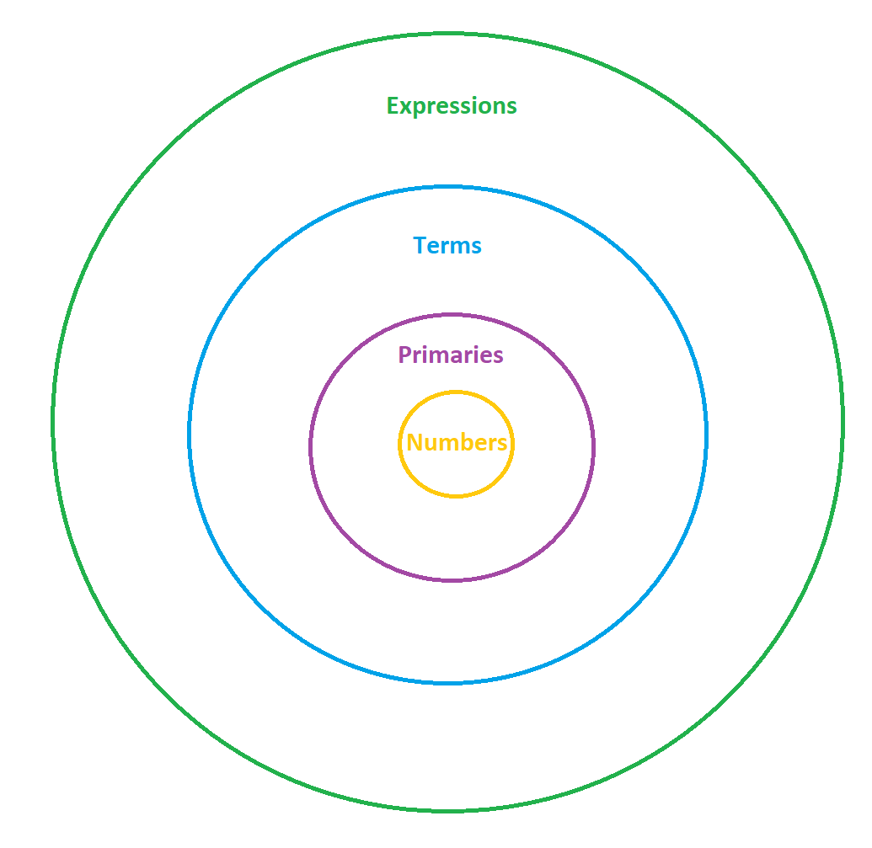
The Venn diagram shows how a number is a primary is a term is an expression.
i.e. All primaries are expressions but not all expressions are primaries.

10) (17+4)/(5-1)
Numbers:17, 4, 5, 1
Primaries: Numbers, (17+4), (5-1)
Terms: Primaries, (17+4)/(5-1)
Expressions: Terms, 17+4, 5-1

11) In the program, there is no function number() because there is no need for one. We would begin with expression() as usual and cascade down through to primary() where we would come to the case’8’: for numbers. At which point, we would have to unnecessarily putback() the token and then call number() which would then get() that token straight back and having nothing else to do, return its value. Its body would be empty other than getting the token and returning its value. We may as well return that value directly from primary().

12) A token (in our program and in general use) is an intelligible discrete unit of characters. If we have a section of text, we can sort through it, grouping the information into discrete tokens. For example, “44.1+3+4q” is a logically meaningless string unless we tokenise it. We can do this by reading from the left, and creating a new token every time a logical unit ends. In this case we get tokens: 44.1, +, 3, 4, q.

13) A grammar is a set of rules defining how information is to be understood, what the text means. This is much the same meaning as it is for English grammar. For example, “A panda eats shoots and leaves.” means something very different to “A panda eats, shoots, and leaves.”. These commas allow us to interpret the sentence according to the English grammar rules. Although English grammar rules tend to be too loose for computers, so program grammars have to be precise. Grammars allow the computer to quickly parse a section of text or series of tokens and apply the rules to arrive at a correct solution or meaning.

14) A class is a user defined type. It is a blueprint for an object. It is much like a variable in the way it can be used except that it can contain multiple variables and objects of its own. It can also have member functions. Classes allow you to group together associated values, functions, etc. that have relevance to the class. They allow the creation of multiple instances of themselves that come ready equipped with all the data storage and facilities of the class, without the need for redefining. Consequently, if a change is made to the class, all instances would reflect that change which makes adding to or changing them a lot easier.

15) There are a few ways to provide default values for class members.
- One is to simply use an in-line class initialisation. In other words, when declaring a variable within a class, you can initialise it there as you would with any other variable. When an instance of the class is created, the variable is initialised with that value.
- Another is to use a constructor to initialise variables in a case where the object is created without providing any values for those members.
- The third is similar to the second in that it involves the use of a constructor, except that variables can also be initialised with initialiser lists outside of the body of the constructor.

Ideally, all variables (including members) should be initialised to safeguard against accidentally using the unpredictable value they may contain. For members, any one of the above will be fine however if given the choice, “class in-line” and “initialiser lists” are the cleanest and safest ways.

16) In the expression() function, the default is to putback() the token because that is the case where it has exhausted all of the ‘+’s and ‘-’s. In order to know that no more pluses or minuses were coming though, it had to look ahead and check by using get() a token. This means that whatever came after the expression, for example an ‘x’ for quit or an ‘=’ has been removed from the input stream. If expression() were to return the answer to its evaluation without putting this token back into the token stream, then that token would be lost. This would mean that input from the user such as an ‘=’ won’t get acted upon.

The term() function will behave similarly for the same reasons. The only time a token gets discarded or overwritten without having been putback() is when that information has been used, i.e. acted upon. So in the case of expression(), it would not putback() a ‘+’ or a ‘-’ and in the case of term(), it would not putback() a ‘*’, or ‘/’.

The primary() function doesn’t putback() any tokens since it is the lowest level of the function flow. It has no loop and only gets one token without checking the next. If it can’t use the token it gets, something has gone wrong and it calls error() since in theory all other kinds of valid token would have already been checked for at this point.

17) “Look-ahead” in this case, is a function using get() to get the next token in the token stream and then putting it back using putback() if it is not a token that it is responsible for dealing with. It’s called “looking ahead” because the function can’t know that the tokens within its purview have come to an end without checking what the next token is.

18) The putback() function is actually logically distinct from get(), though it is intended to be used as its opposite. The fact that it isn’t is more of an implementation detail.

The get() function, actually uses cin to read the standard input stream of characters from the user. It then takes the next discrete logical unit (see tokens) and creates a token. That token is then returned to the caller of get().

The putback() function is distinct since rather than undoing the tokenisation process and returning the characters to the input stream. It instead uses a second stream called the token stream to store the token for later use. The next time get() is called, get() will first check the token stream and return its token if it already has one stored rather than creating a new one from the standard input stream.

putback() is usefull since it allows “looking ahead” without losing the next token.

19) The modulus operation ‘%’ is difficult to implement since it has the same priority as ‘*’ and ‘/’ and therefore ought to be dealt with inside the term() function. However, in all of the functions, numbers are treated as floating-point numbers to allow for decimal input and calculation. The modulus operator returns the remainder of a division which only exists in integer calculations. To implement it, we would need to convert the numbers into integers (checking for truncation) and then convert the answer into floating-point for returning.

20) The “Token” member “kind”, is used to store what kind of token it is. Whether it is a number, a ‘*’, a ‘/’, etc.
The member “value” is used only when the “kind” is a number and is used to store its value.

The reason that an extra value member is required for numbers and not operators is because there are only a handful of different operator kinds and so the literals serve to represent themselves and can be used in a switch statement. However, there are virtually infinite different numbers and so we can’t have a different kind for each of them.

21) Private and public members are split into these two sections to separate the user interface of the class from the implementation. Any functions or variables that are intended to be interacted with by another part of the program go in the public section. The rest go in the private section.
This separation serves to protect against errors by stopping users from directly manipulating variables or functions and inadvertently bypassing error checks. It also serves to simplify understanding of the class by presenting its facilities in one place.

22) When there is a token in the buffer and get() is called, get() will see in its initial check that the full flag of its token stream is set and so that it is already storing a token. It will then unset the full flag and return the token, rendering the token stream’s buffer empty (note that it would still technically contain the token however there is no way to extract this remnant memory since the buffer is private).

23) ‘;’ and ‘q’ were added to the get() function switch statement since they too must be tokenised if we wish to act upon them (evaluate and quit). It is the job of get() to handle all direct input from the user. The other functions then read tokens. Handling ‘;’ and ‘q’ elsewhere as non-tokens would be very messy and impractical.

24) Testing should ideally be done after completing each part of the program or after completing a small scale version. Hopefully these parts have already been identified during the design stage of development. This is to make sure that each part works before moving on to the next so that if an error occurs, we are not searching enormous amounts of freshly written code for the culprit.

25) User-defined types offer the ability to tailor an object to store and structure data as needed for the program at hand as well as offer member functions to manipulate data within the remit of the object. They also serve to group all these members in one location.

26) The interface of a user-defined type is its public section. Most often, this will include constructors and other member functions that offer facilities to the user. They should be accompanied by comments explaining what arguments must be passed to them and what they will do or return.

27) We want to rely on libraries when possible since the fastest code to write is code that’s already written. Using libraries will leave us with more time to work on the rest of our program. Mainstream libraries such as the standard c++ library also tend to be more efficient and far less likely to contain errors than newly written code.

Exercises
05)

Sentence:
Noun Verb // e.g., birds fly
Article Noun Verb // e.g., the birds fly
Sentence Conjunction Sentence // e.g., birds fly but fish swim,
the birds fly but the fish swim
Conjunction:
"and"
"or"
"but"
Article:
"the"
Noun:
"birds"
"fish"
"C++"
Verb:
"rules"
"fly"
"swim"

06)
Analysis:
- accepts input sentence from the user
- checks input to determine whether a sentence is correct
- tell user whether the sentence was correct

Design:

-greeting to explain to user what to do (including about whitespace and dot)

-read input words into vector of strings with cin and a loop, these will read in one at a time due to the whitespace between each word

while (input != .)
cin >> input
pushback(input)

-create flag sentence_correct = false; this will only become true if it all checks out

-begin check loop according to the grammar
-call sentence()
-…
-if all checks out, sentence_correct = true, break;

-if (sentence_correct)
cout >> ok
else
cout >> not ok

This design ended up being changed during the implementation.

07)
Expression:
Secondary
Expression | Secondary // or

Secondary:
Primary
Secondary ^ Primary // exclusive or

Primary:
Unary
Primary & Unary // and

Unary:
Integer
! Integer // not
~ Integer // complement

Integer:
Binary value // e.g. 0110101111
10)
Analysis:
- Asks user for 2 numbers
- Asks user whether they want to calculate number of permutations or combinations
- Calculate it
- Return result to the user
- Handle all input
Design:
We’re going to split the program into parts in order to work on it:

- User input and program output, including erroneous input handling. For initial testing, permutation() and combination() can simply be replaced by 1:

cout << Welcome to the permutation/combination calculator.
<< First, please enter two numbers separated by spaces;

int num1;
int num2;

cin >> num1;
cin >> num2;
if (!cin) error;

cout >> Would you like to calculate the number of permutations or combinations?
>> Please enter p or c;

char c;
cin >> c;
if (!cin) error;
switch (c)
case p:
cout >> Number of permutations >> permutation(num1, num2);
case c:
cout >> Number of combinations >> combination(num1, num2);
default:
error;

- Calculating permutations:

int factorial(num)
for (int I = num -1; I > 0; ++i)
return num *= I;

int permutations(a, b)
return factorial(a) / factorial(a-b);

- Calculating combinations:

int combinations(a, b)
return permutations(a,b) / factorial(b);

