**Web Technology Applications**

Assignment-1

**1. Write a JavaScript to design a simple calculator to perform the following operations: sum, product, difference and quotient**

<!DOCTYPE HTML>

<html>

<head>

<style>

table, td, th

{

border: 1px solid black;

width: 33%;

text-align: center;

background-color: DarkGray;

border-collapse:collapse;

}

table { margin: auto; }

input { text-align:right; }

</style>

<script type="text/javascript">

function calc(clicked_id)

{

var val = parseFloat(document.getElementById("value1").value);

var va2 = parseFloat(document.getElementById("value2").value);

if(isNaN(val1)||isNaN(val2))

alert("ENTER VALID NUMBER");

else if(clicked_id=="add")

document.getElementById("answer").value=va1+va2;

else if(clicked_id=="sub")

document.getElementById("answer").value=va1-va2;

else if(clicked_id=="mul")

document.getElementById("answer").value=va1*va2;

else if(clicked_id=="div")

document.getElementById("answer").value=va1/va2;

}

function cls()

{

value1.value="0";

value2.value="0";

answer.value="";

}

</script>

</head>

<body>

<table>

<tr>

<th colspan="4"> SIMPLE CALCULATOR </th>

</tr>

<tr>

<td>value1</td><td><input type="text" id="value1" value="0"/></td>

<td>value2</td><td><input type="text" id="value2" value="0"/> </td>

</tr>

<tr>

<td><input type="button" value="Addition" Id = "add" onclick="calc(this.id)"/></td>

<td><input type="button" value="Subtraction" id = "sub" onclick="calc(this.id)"/></td>

<td><input type="button" value="Multiplication" id = "mul"onclick="calc(this.id)"/></td>

<td><input type="button" value="Division" id ="div" onclick="calc(this.id)"/></td>

</tr>

<tr>

<td>Answer:</td><td> <input type="text" id="answer" value=""disabled></td>

<td colspan="2"><input type="button" value="CLEAR ALL" onclick="cls()"/></td>

</tr>

</table>

</body>

</html>

Output:



Test cases:

|  |  |  |  |  |
| --- | --- | --- | --- | --- |
| Test No. | Input  Parameters | Expected Output | Obtained Output | Remarks |
| 1.  2. | value1=60.56 value2=34.39  value1= 0  value2= 54 | Addition =94.95 | Addition =94.95 | PASS |
| Subtraction =26.17 | Subtraction =26.17 |
| Multiplication=2082.65 | Multiplication=2082.65 |
| Division=1.76097703 | Division=2. Division=1.76097703 |
| Addition =54 | Addition =54 | PASS |
| Subtraction =-54 | Subtraction =-54 |
| Multiplication=0 | Multiplication=0 |
| Division=0 | Division=0 |
| 3. | value1= 45  value2= 0 | Addition =45 | Addition =45 | PASS |
| Subtraction =45 | Subtraction =45 |
| Multiplication=0 | Multiplication=0 |
| Division=Infinity | Division=Infinity |
| 4. | value1 =abc  value2 = 23 | ENTER VALID NUMBER | ENTER VALID NUMBER | PASS |
| 5 | value1 = 50  value2=xyz | ENTER VALID NUMBER | ENTER VALID NUMBER | PASS |

**CHALLENGE:**

<html>

<head>

<script>

//function that display value

function dis(val)

{

document.getElementById("result").value+=val

}

//function that evaluates the digit and return result

function solve()

{

let x = document.getElementById("result").value

let y = eval(x)

document.getElementById("result").value = y

}

//function that clear the display

function clr()

{

document.getElementById("result").value = ""

}

</script>

<!-- for styling -->

<style>

table {

border-color:purple;

margin:auto;

width:352px;

height:352px;

background-color:lightpink;

box-shadow: 5px 5px 5px red;

}

h1{

margin-bottom: 50px;

text-align:center;

align-content: center;

font-size:3rem;

font-family:times new roman;

width: 1550px;

color:blue;

text-shadow:2px 2px 4px red;

}

input[type="button"]

{

background-color: lightpink;

font-size: 30px;

box-shadow: 2px 2px red;

color: black;

border: solid lightpink 2px;

width:100%

}

input[type="text"]

{

background-color:white;

font-size: 30px;

border: solid white 20px;

width:100%;

}

h1:hover{

color: green;

}

[type="button"]:hover{

color: red;

}

</style>

</head>

<title>calculator</title>

<!-- create table -->

<body>

<h1><u>Simple Calculator</u></h1>

<table border="10">

<tr>

<td colspan="3"><input type="text" id="result"/></td>

<!-- clr() function will call clr to clear all value -->

<td><input type="button" value="c" onclick="clr()"/> </td>

</tr>

<tr>

<!-- create button and assign value to each button -->

<!-- dis("1") will call function dis to display value -->

<td><input type="button" value="1" onclick="dis('1')"/> </td>

<td><input type="button" value="2" onclick="dis('2')"/> </td>

<td><input type="button" value="3" onclick="dis('3')"/> </td>

<td><input type="button" value="/" onclick="dis('/')"/> </td>

</tr>

<tr>

<td><input type="button" value="4" onclick="dis('4')"/> </td>

<td><input type="button" value="5" onclick="dis('5')"/> </td>

<td><input type="button" value="6" onclick="dis('6')"/> </td>

<td><input type="button" value="-" onclick="dis('-')"/> </td>

</tr>

<tr>

<td><input type="button" value="7" onclick="dis('7')"/> </td>

<td><input type="button" value="8" onclick="dis('8')"/> </td>

<td><input type="button" value="9" onclick="dis('9')"/> </td>

<td><input type="button" value="+" onclick="dis('+')"/> </td>

</tr>

<tr>

<td><input type="button" value="." onclick="dis('.')"/> </td>

<td><input type="button" value="0" onclick="dis('0')"/> </td>

<!-- solve function call function solve to evaluate value -->

<td><input type="button" value="=" onclick="solve()"/> </td>

<td><input type="button" value="*" onclick="dis('*')"/> </td>

</tr>

</table>

</body>

</html>

**OUTPUT:**

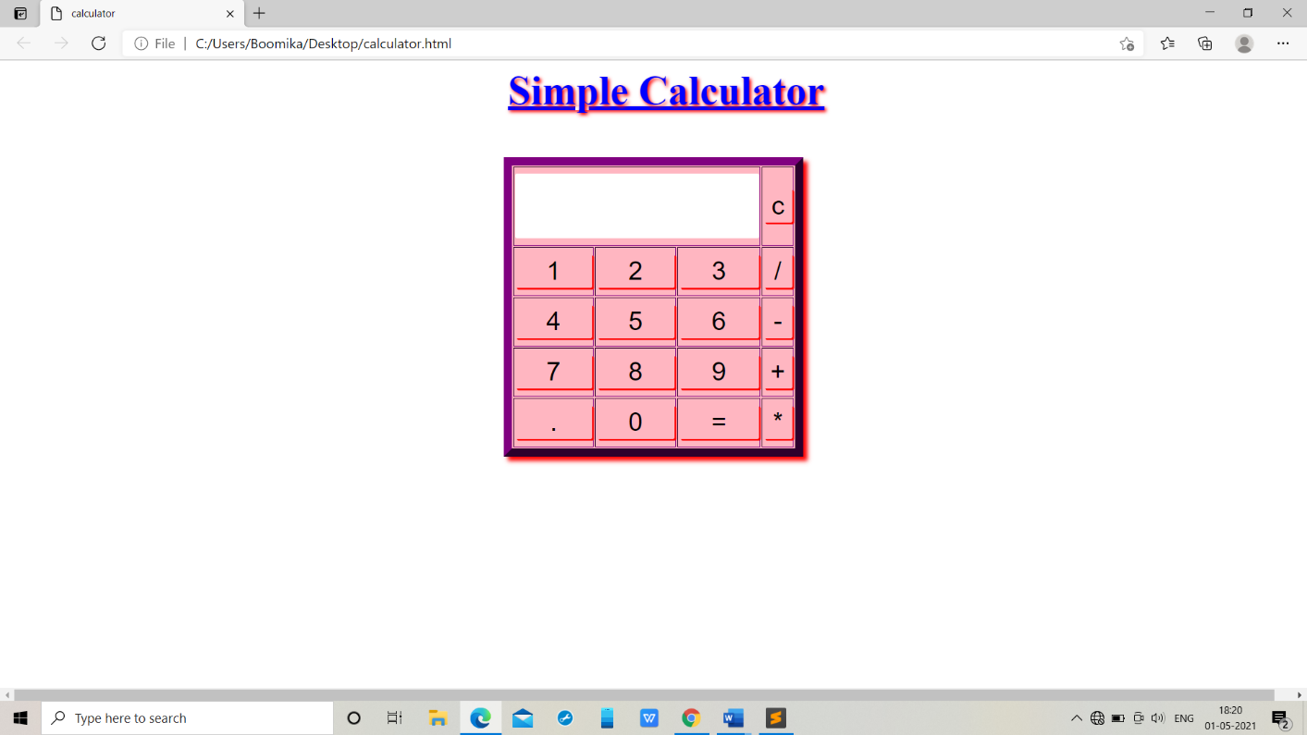

|  |  |  |  |  |
| --- | --- | --- | --- | --- |
| Test No. | Input  Parameters | Expected Output | Obtained Output | Remarks |
| 1.  2. | value1=60.56 value2=34.39  value1= 0  value2= 54 | Addition =94.95 | Addition =94.95 | PASS |
| Subtraction =26.17 | Subtraction =26.17 |
| Multiplication=2082.65 | Multiplication=2082.65 |
| Division=1.76097703 | Division=2. Division=1.76097703 |
| Addition =54 | Addition =54 | PASS |
| Subtraction =-54 | Subtraction =-54 |
| Multiplication=0 | Multiplication=0 |
| Division=0 | Division=0 |
| 3. | value1= 45  value2= 0 | Addition =45 | Addition =45 | PASS |
| Subtraction =45 | Subtraction =45 |
| Multiplication=0 | Multiplication=0 |
| Division=Infinity | Division=Infinity |

**TESTCASES:**