# Web Technology Applications

Assignment-2

2. Write a JavaScript that calculates the squares and cubes of the numbers from 0 to 10 and outputs HTML text that displays the resulting values in an HTML table format.

## Name:M.BOOMIKA

**USN:1JT18IS033**

<!DOCTYPE html>

<html lang="en">

<head>

<title> squares </title>

<style>

tr,td{

border:solid black;

width: 40%;

text-align: center;

color: rgb(16, 17, 17);

background-color: lightblue;

font-size: 20px;

font-family:'Times New Roman', Times, serif ;

M.BOOMIKA

} 1JT18IS033

table{

margin:auto;

border-collapse: collapse;

}

h3{

font-size: 20px;

font-family: cursive;

text-decoration-line: underline;

color:purple;

text-underline-offset: set;

}

@keyframes blink{

50%{

opacity: 0;

}

80%{

opacity: .5;

}

}

h1{

text-align: center;

padding: 50px;

font-family: Verdana, Geneva, Tahoma, sans-serif;

M.BOOMIKA

1JT18IS033

color: rgb(17, 2, 17);

font-size: 30px;

animation: blink 3s linear infinite;

}

</style>

</head>

<body>

<table>

<tr>

<th colspan="3"><h3>Numbers from 0 to 10 with their squares and cubes</h3></th>

</tr>

<tr>

<td> Numbers </td>

<td> Squares </td>

<td> Cubes </td>

</tr>

<script>

for(var i=0; i<=10; i=i+1)

{

M.BOOMIKA

1JT18IS033

document.write( "<tr><td>" + i + "</td><td>" + i*i + "</td><td>" + i*i*i + "</td></tr>" )

}

</script>

</table>

<h1> Assignment-2 Challenge Completed </h1>

</body>

</html>

Output :

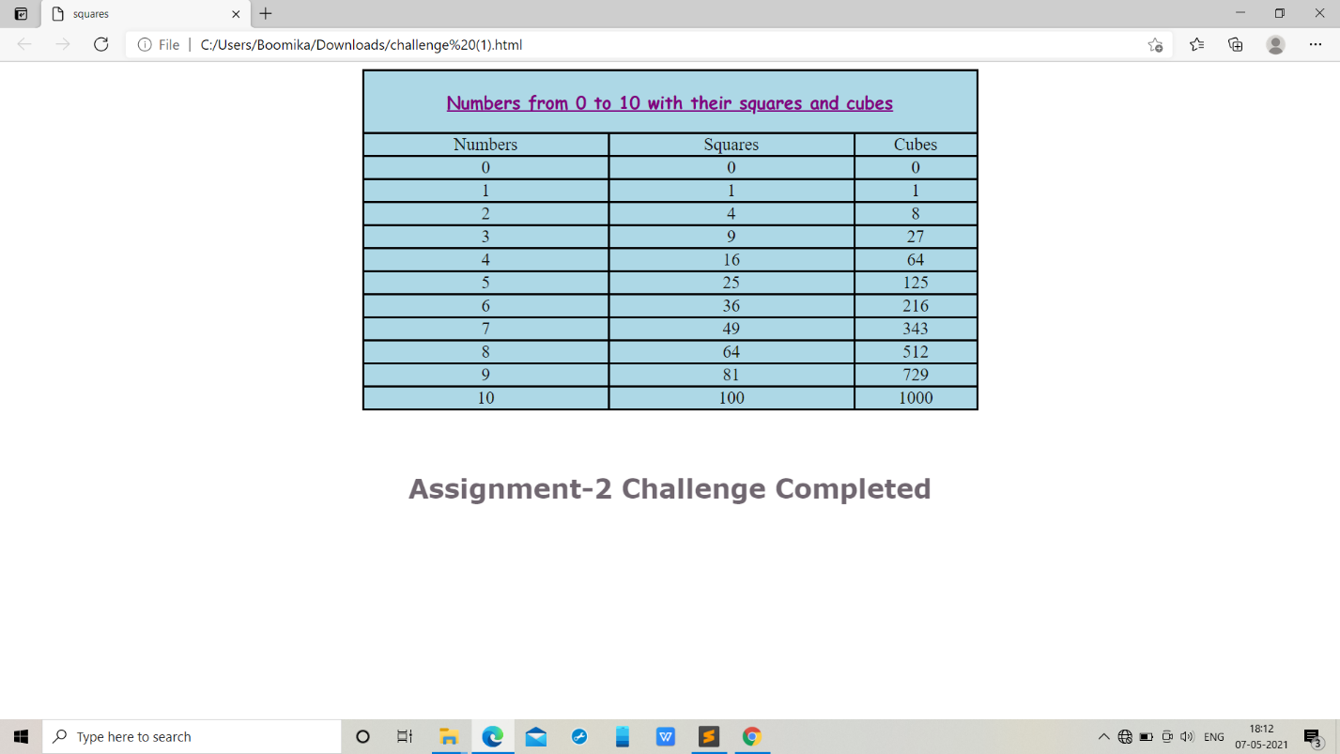

M.BOOMIKA

1JT18IS033

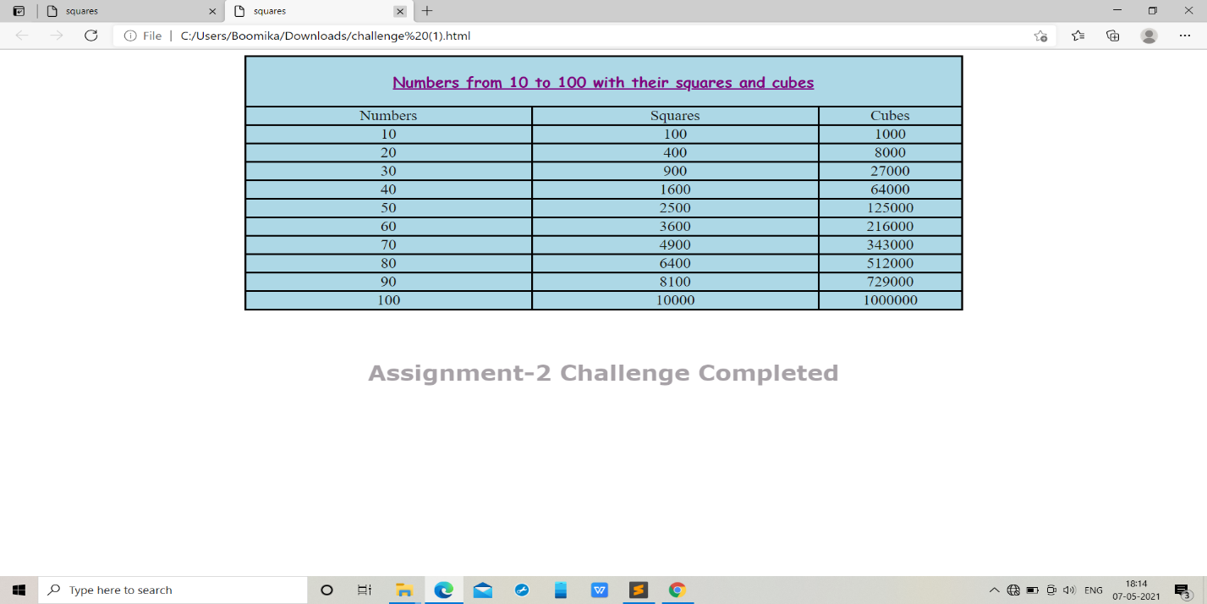

M.BOOMIKA

1JT18IS033

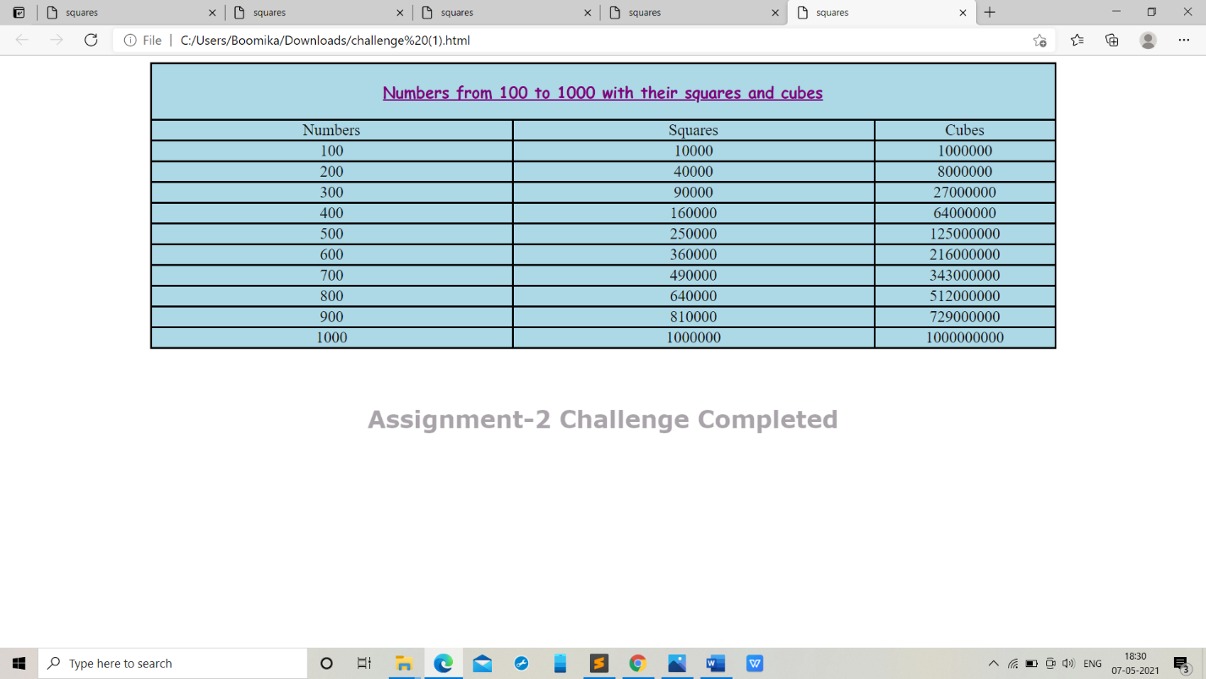

Test Cases for challenge:

|  |  |  |
| --- | --- | --- |
| TEST NO | Input Parameters | Output Image |

|  |  |  |
| --- | --- | --- |
| 1 | i=0to10,  increment of i+1 |  |
| 2 | i=10 to 100, increment of i+10 |  |
| 3 | i=100 to 1000, increment of i+100 |  |

1. BOOMIKA

1JT18IS033